India City Air Quality Analytics
and Next-Day AQI Forecasting
Project Report
Submitted by: Siddhi Pandhere
Institution: Pillai College of Engineering, New Panvel
Programme: AICTE | IBM SkillsBuild Data Analytics with AI Internship 2026
Organised by: BharatCares (SMEC Trust) in collaboration with IBM
Duration: 17 August to 30 September 2026
Trainer: Mr. Kartik Hooda

Contents
Contents 1
Abstract 2
1. Introduction 2
2. Problem Statement and Objectives 2
3. Dataset 2
4. Tools and Technologies 3
5. Methodology 3
5.1 Data cleaning and preparation 3
5.2 Analysis approach 4
5.3 Forecasting approach 4
6. Exploratory Data Analysis 4
6.1 Key performance indicators 4
6.2 Pollution by city 5
6.3 Seasonal and yearly trends 6
6.4 The 2020 lockdown as a natural experiment 6
7. Pollution Drivers 7
8. Next-Day AQI Forecast Model 8
8.1 Results on unseen test data 8
9. Dashboard 9
9.1 Executive overview 9
9.2 Trends and seasons 9
9.3 Pollution drivers 11
9.4 Next-day AQI forecast 12
9.5 Insights and actions 12
10. Insights, Risks, Opportunities and Actions 13
Risks 13
Opportunities 13
Recommended actions 13
11. Limitations 13
12. Conclusion and Future Scope 14
13. References 14

Abstract
Air pollution is one of the most serious public health risks in India, yet raw sensor readings do not tell decision-makers where, when or why air becomes dangerous. This project analyses 29,531 daily records from 26 Indian cities (2015 to 2020), published by the Central Pollution Control Board (CPCB), and turns them into an interactive analytics dashboard built with Python and Streamlit.
The analysis finds that 26.0% of city-days with an AQI reading were Poor or worse, that winter air is on average 1.9 times as polluted as monsoon air, and that AQI fell by 39.1% during the 2020 lockdown compared with the same weeks in 2019. A random forest model forecasts the next day's AQI with an average error of 18.6 AQI points, 16.1% better than assuming tomorrow will be the same as today, and correctly flags 87.9% of days that turned out Poor or worse. The findings are translated into risks, opportunities and recommended actions for city authorities.

1. Introduction
The Air Quality Index (AQI) summarises the concentration of several pollutants into one number and six categories, from Good (0 to 50) to Severe (above 400), as defined by the CPCB National Air Quality Index. Prolonged exposure to Poor or worse air causes breathing discomfort for most people and serious harm to children, older adults and those with heart or lung disease.
Following the business intelligence approach taught in this internship (data, then information, then insight, then decision, then action), this project does not stop at charts. It moves from key performance indicators to trends, drivers, risks and opportunities, and ends with concrete recommended actions.

2. Problem Statement and Objectives
Problem statement: City authorities need to know which cities have the most dangerous air, when pollution peaks, which pollutants drive it, and whether unsafe days can be predicted early enough to warn the public.
The objectives of the project are to:
- Clean and prepare five years of daily city-level air quality data.
- Measure how often air quality is unsafe and rank cities by pollution.
- Identify seasonal and yearly patterns, including the effect of the 2020 lockdown.
- Find which pollutants move most closely with AQI.
- Build and evaluate a model that forecasts the next day's AQI.
- Present everything in an interactive dashboard with data-driven recommendations.

3. Dataset
Item | Details
Name | Air Quality Data in India (2015 to 2020)
Source | Central Pollution Control Board (CPCB), published on Kaggle
Link | https://www.kaggle.com/datasets/rohanrao/air-quality-data-in-india
File used | city_day.csv (daily readings per city)
Size | 29,531 rows, 16 columns, 26 cities
Period | 1 January 2015 to 1 July 2020
Columns | City, Date, PM2.5, PM10, NO, NO2, NOx, NH3, CO, SO2, O3, Benzene, Toluene, Xylene, AQI, AQI_Bucket

Monitoring coverage grew over time: 7 cities reported AQI in 2015, rising to 26 cities by 2020. This matters when comparing years, and the analysis accounts for it (see Section 6).

4. Tools and Technologies
Tool | Purpose
Python | Programming language for the whole project
Pandas and NumPy | Data loading, cleaning, transformation and aggregation
Scikit-learn | Random forest model, preprocessing pipeline and evaluation metrics
Plotly | Interactive charts in the dashboard
Streamlit | Web dashboard with filters, pages and a live forecast form

5. Methodology

5.1 Data cleaning and preparation
- Converted dates to date format and all pollutant readings to numbers.
- Treated negative concentrations as sensor errors and set them to missing.
- Checked for duplicate city-date rows (none were found).
- Filled short pollutant gaps of up to 3 consecutive days by linear interpolation within each city, so a gap in one city is never filled with another city's data.
- Did not impute AQI itself. Days without an official AQI (15.9%) are excluded from AQI analysis, leaving 24,850 city-days.
- Recomputed the AQI category from AQI using CPCB breakpoints, and added year, month and season (Winter: Dec to Feb, Summer: Mar to May, Monsoon: Jun to Sep, Post-monsoon: Oct and Nov).
Missing values before and after cleaning for the main pollutants:
Column | Missing before | Missing after
PM2.5 | 15.6% | 13.1%
PM10 | 37.7% | 35.1%
NO2 | 12.1% | 9.3%
CO | 7.0% | 4.2%
SO2 | 13.1% | 9.7%
O3 | 13.6% | 10.1%
Xylene | 61.3% | 59.4%
AQI | 15.9% | 15.9% (not imputed)

5.2 Analysis approach
The analysis follows the internship's decision hierarchy: KPIs (what is happening), trends (how it changes over time), drivers (why it happens), risks and opportunities (what could go wrong or better), and actions (what to do).

5.3 Forecasting approach
AQI is officially calculated from the same pollutant readings, so a model that estimates today's AQI from today's pollutants would simply relearn the formula. This project instead forecasts tomorrow's AQI, which is useful for early warnings. Each training row uses today's pollutant levels, today's AQI, the 7-day average AQI, the month and the city to predict the next day's AQI.
- Model: Random Forest Regressor (200 trees, maximum depth 16) inside a Scikit-learn pipeline with median imputation and one-hot encoding of the city.
- Time-based split: trained on data before 1 July 2019 (16,284 city-days) and tested on 8,059 later city-days the model never saw. A random split would leak future information into training.
- Baseline: the model is compared with the simple guess that tomorrow's AQI equals today's (persistence).

6. Exploratory Data Analysis

6.1 Key performance indicators
KPI | Value
Average AQI (all cities, 2015 to 2020) | 166 (Moderate)
City-days Poor or worse (AQI above 200) | 26.0%
Severe city-days (AQI above 400) | 1,338
Most polluted city (average AQI) | Ahmedabad (452)
Cleanest city (average AQI) | Aizawl (35)

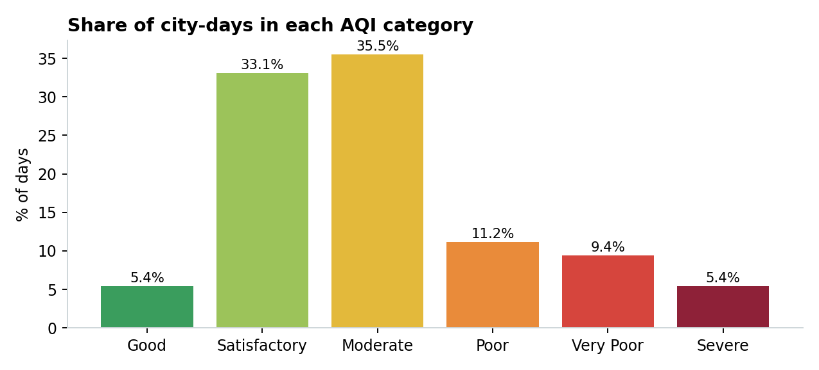
Figure 1: Share of city-days in each AQI category
Only 5.4% of city-days had Good air. Moderate (35.5%) and Satisfactory (33.1%) are the most common categories, but about one day in four is Poor, Very Poor or Severe.

6.2 Pollution by city
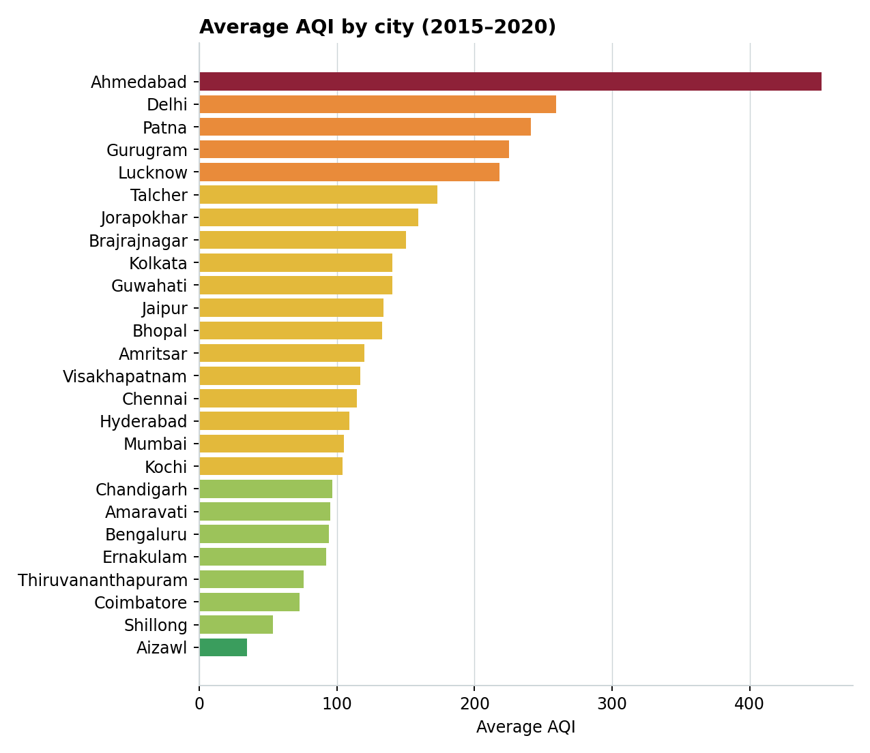
Figure 2: Average AQI by city, coloured by CPCB category
Ahmedabad, Delhi, Patna, Gurugram and Lucknow have the worst air. In Ahmedabad, 81.9% of recorded days were Poor or worse, and in Delhi 65.1%. Cities in the north-east and south, such as Aizawl, Shillong, Coimbatore and Thiruvananthapuram, have the cleanest air. Ahmedabad's very high average is partly driven by unusually high carbon monoxide readings, which is discussed under Limitations.

6.3 Seasonal and yearly trends
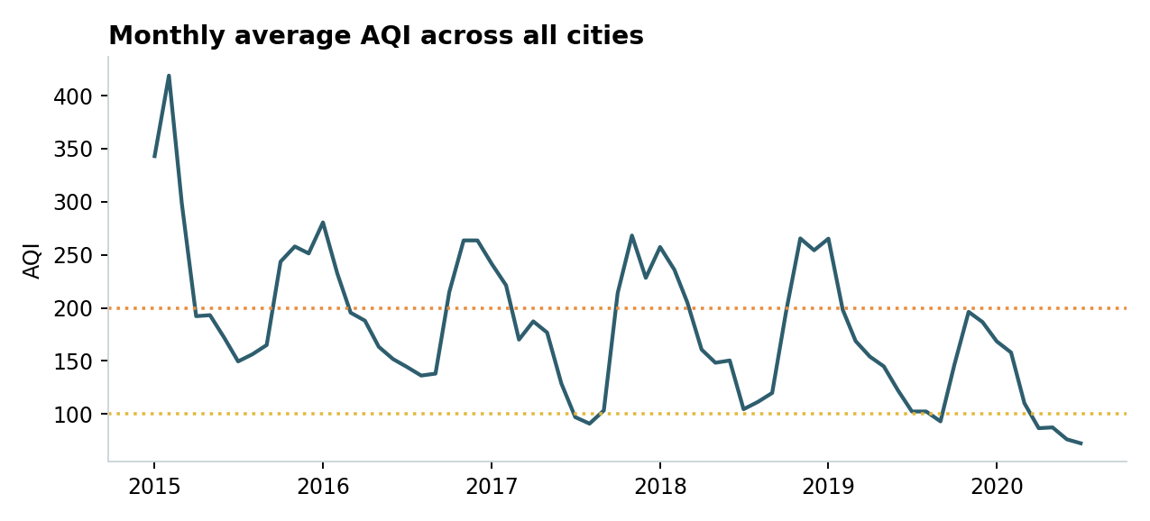
Figure 3: Monthly average AQI across all cities (dotted lines mark AQI 100 and 200)
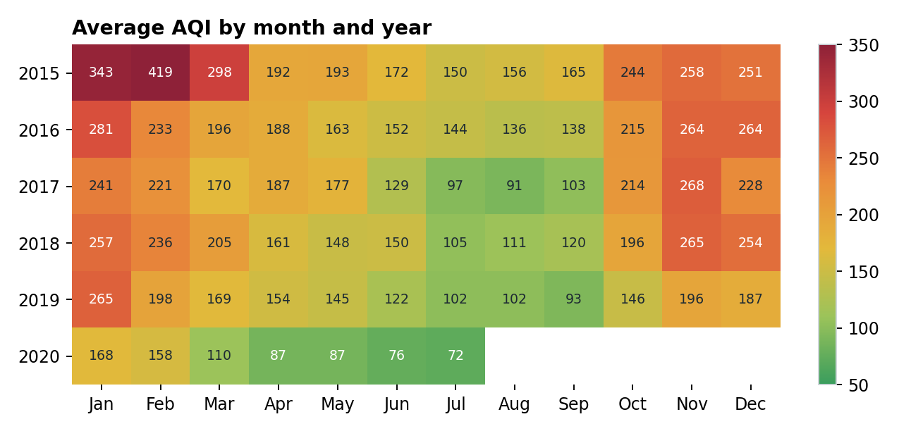
Figure 4: Average AQI by month and year
Pollution follows a clear yearly cycle. November (242), January (232) and December (227) are the worst months, while July (112) is the cleanest. Winter averages 221 and post-monsoon 215, compared with 116 in the monsoon, so winter air is about 1.9 times as polluted. Cold, still air traps pollutants near the ground in winter, while crop-residue burning and festival fireworks add to the October and November peak. Monsoon rain washes particles out of the air.
Because the number of monitored cities grew from 7 in 2015 to 26 in 2020, simply comparing yearly averages would be misleading. Comparing only the 7 cities that reported in both 2015 and 2019, average AQI fell by just 2.7%, meaning there was little lasting improvement before 2020.

6.4 The 2020 lockdown as a natural experiment
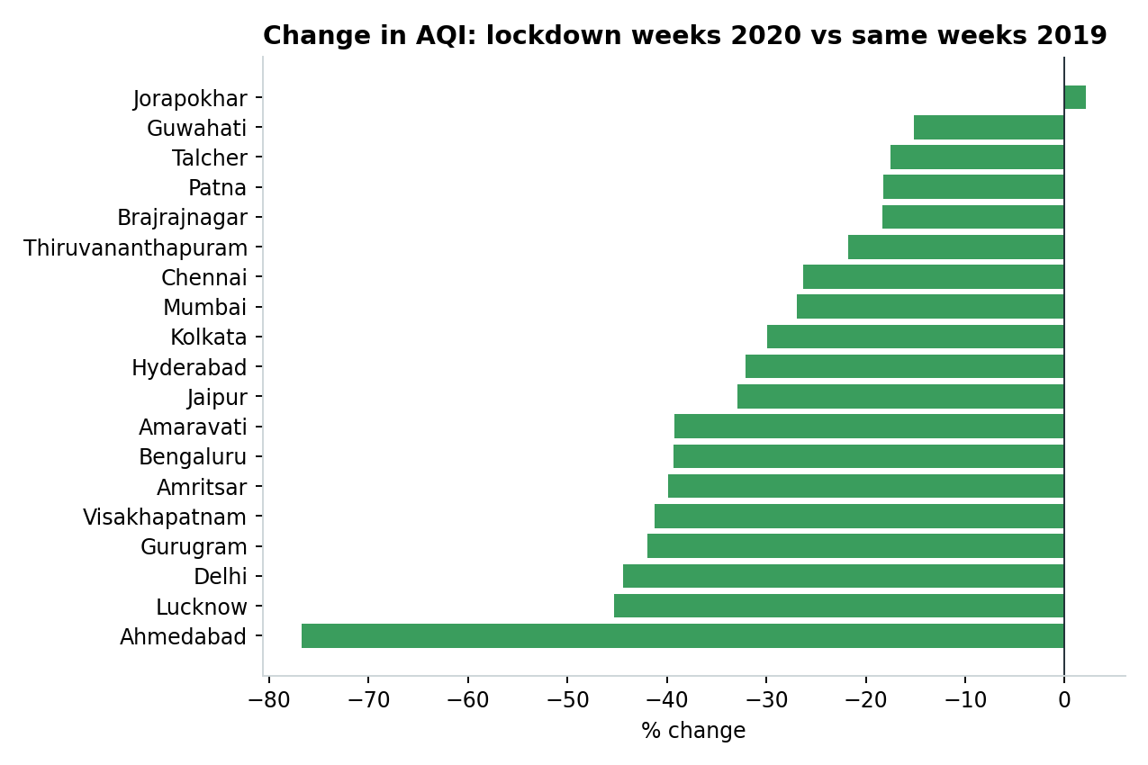
Figure 5: Change in average AQI during the lockdown weeks (25 March to 31 May) of 2020 against the same weeks of 2019
During the nationwide lockdown, average AQI across 19 cities fell by 39.1% compared with the same weeks of 2019. The largest falls were in Ahmedabad (76.7%), Lucknow (45.3%), Delhi (44.4%) and Gurugram (41.9%). Only Jorapokhar, an industrial and mining area, did not improve (+2.1%). This shows that a large share of urban pollution comes from traffic and human activity, and can be reduced.

7. Pollution Drivers
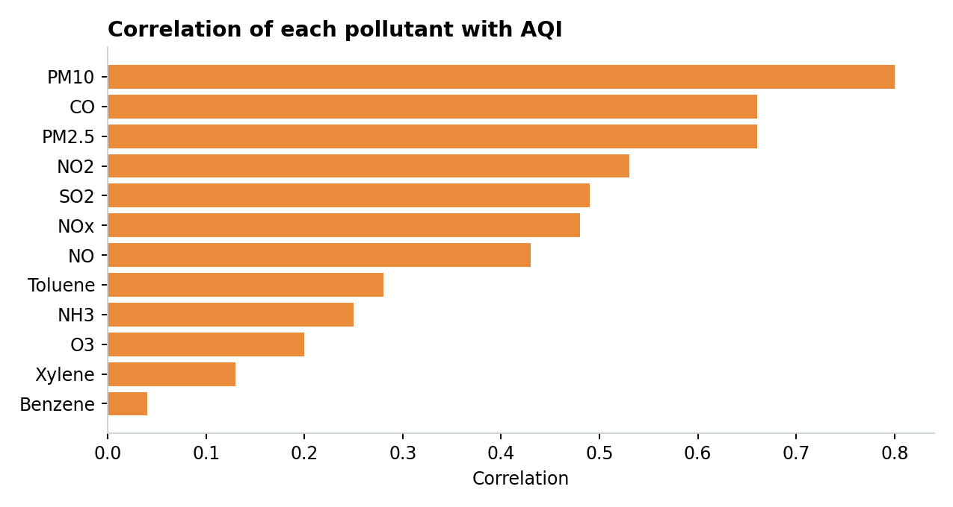
Figure 6: Correlation of each pollutant with AQI
Particulate matter moves most closely with AQI: PM10 (correlation 0.80) and PM2.5 (0.66), followed by carbon monoxide (0.66) and nitrogen dioxide (0.53). These come mainly from road dust, construction, vehicle exhaust and biomass burning, which makes them the most important targets for control measures. Benzene, xylene and ozone have weak relationships with AQI.

8. Next-Day AQI Forecast Model

8.1 Results on unseen test data
Metric | Value | Meaning
Mean absolute error (MAE) | 18.6 | Average forecast is 18.6 AQI points off
Baseline MAE (tomorrow = today) | 22.2 | Error of the naive guess
Improvement over baseline | 16.1% | Model beats the naive guess
RMSE | 38.5 | Penalises large errors more heavily
R squared | 0.87 | Share of variation in tomorrow's AQI explained
Correct AQI category | 77.0% | Forecast lands in the right CPCB category
Unsafe days caught | 87.9% | Days above AQI 200 that the model also forecast above 200

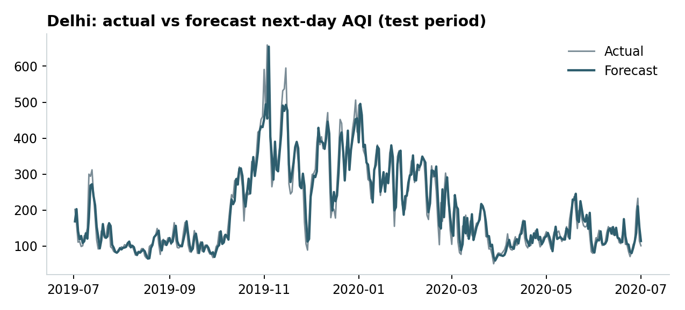
Figure 7: Actual and forecast next-day AQI for Delhi over the test period
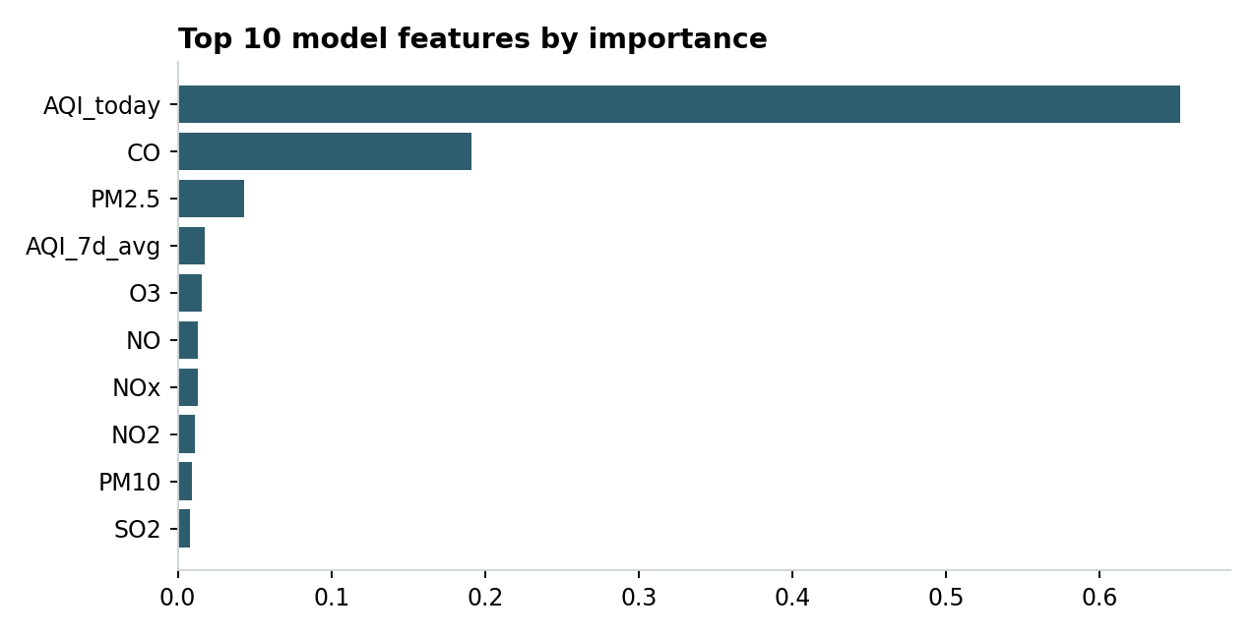
Figure 8: Most important features in the model
Today's AQI is by far the strongest predictor (importance 0.65), which is expected because air quality changes gradually from day to day. Carbon monoxide (0.19) and PM2.5 (0.04) add information about where pollution is heading. The model follows Delhi's winter build-up and the fall during the lockdown closely. Catching 87.9% of unsafe days makes it useful as an early-warning tool.

9. Dashboard
The dashboard is a single Streamlit application with five pages. Sidebar filters for cities and years update every analysis page, and colours always follow the CPCB AQI categories, so colour on screen always means an air quality level.

9.1 Executive overview
Headline AQI on the CPCB colour scale, KPIs, city ranking, category distribution and a data cleaning summary. 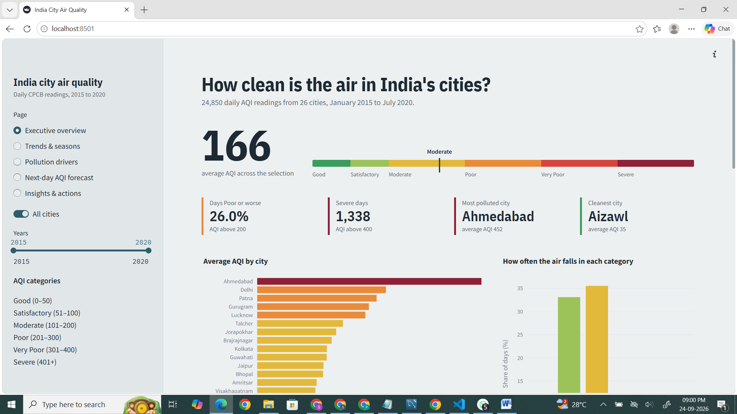
Dashboard: Executive overview page

9.2 Trends and seasons
Monthly trend, month by year heatmap, seasonal comparison and the lockdown analysis.

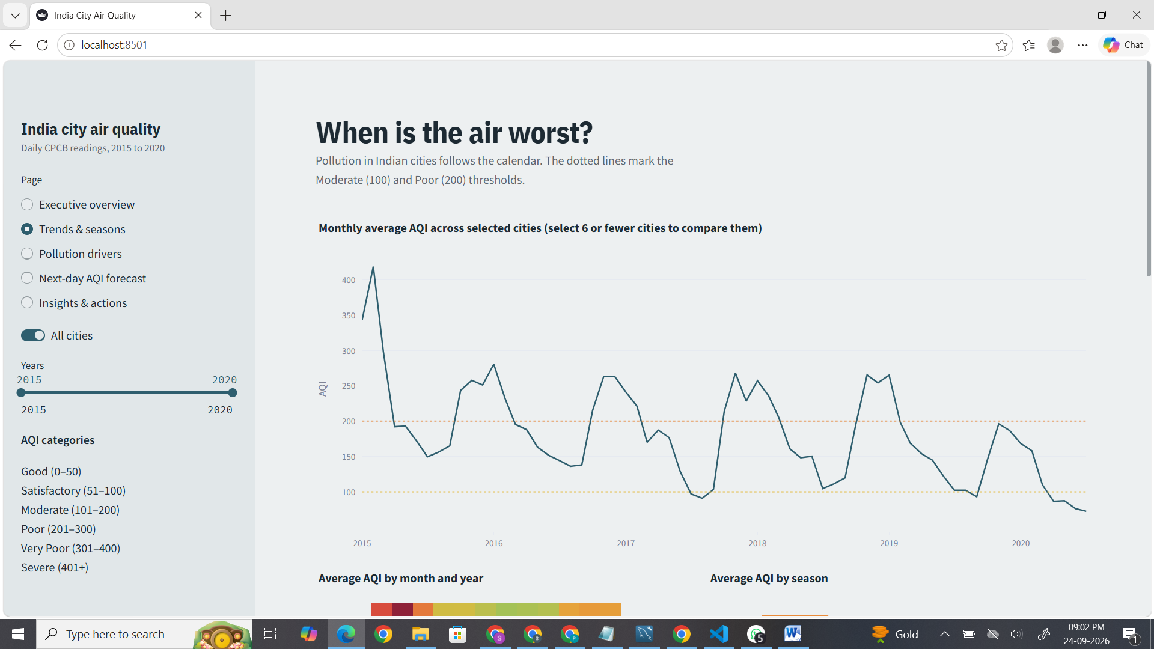
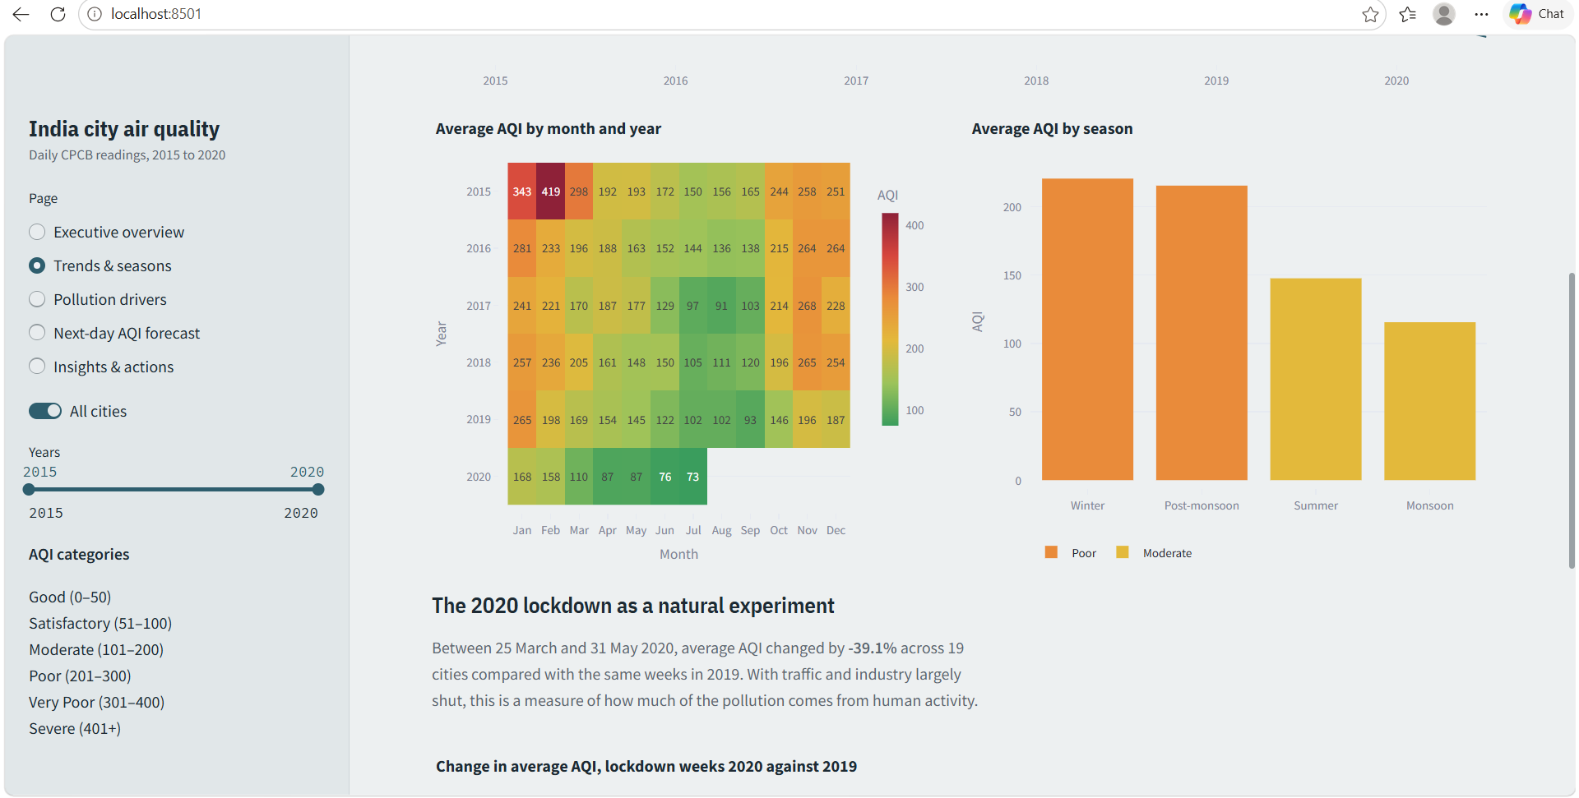
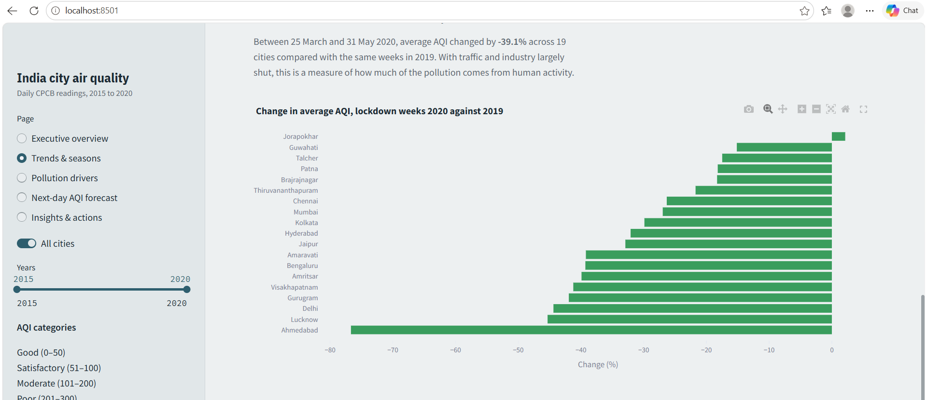
Dashboard: Trends and seasons page

9.3 Pollution drivers
Pollutant correlations, seasonal pollutant levels and city pollution profiles.
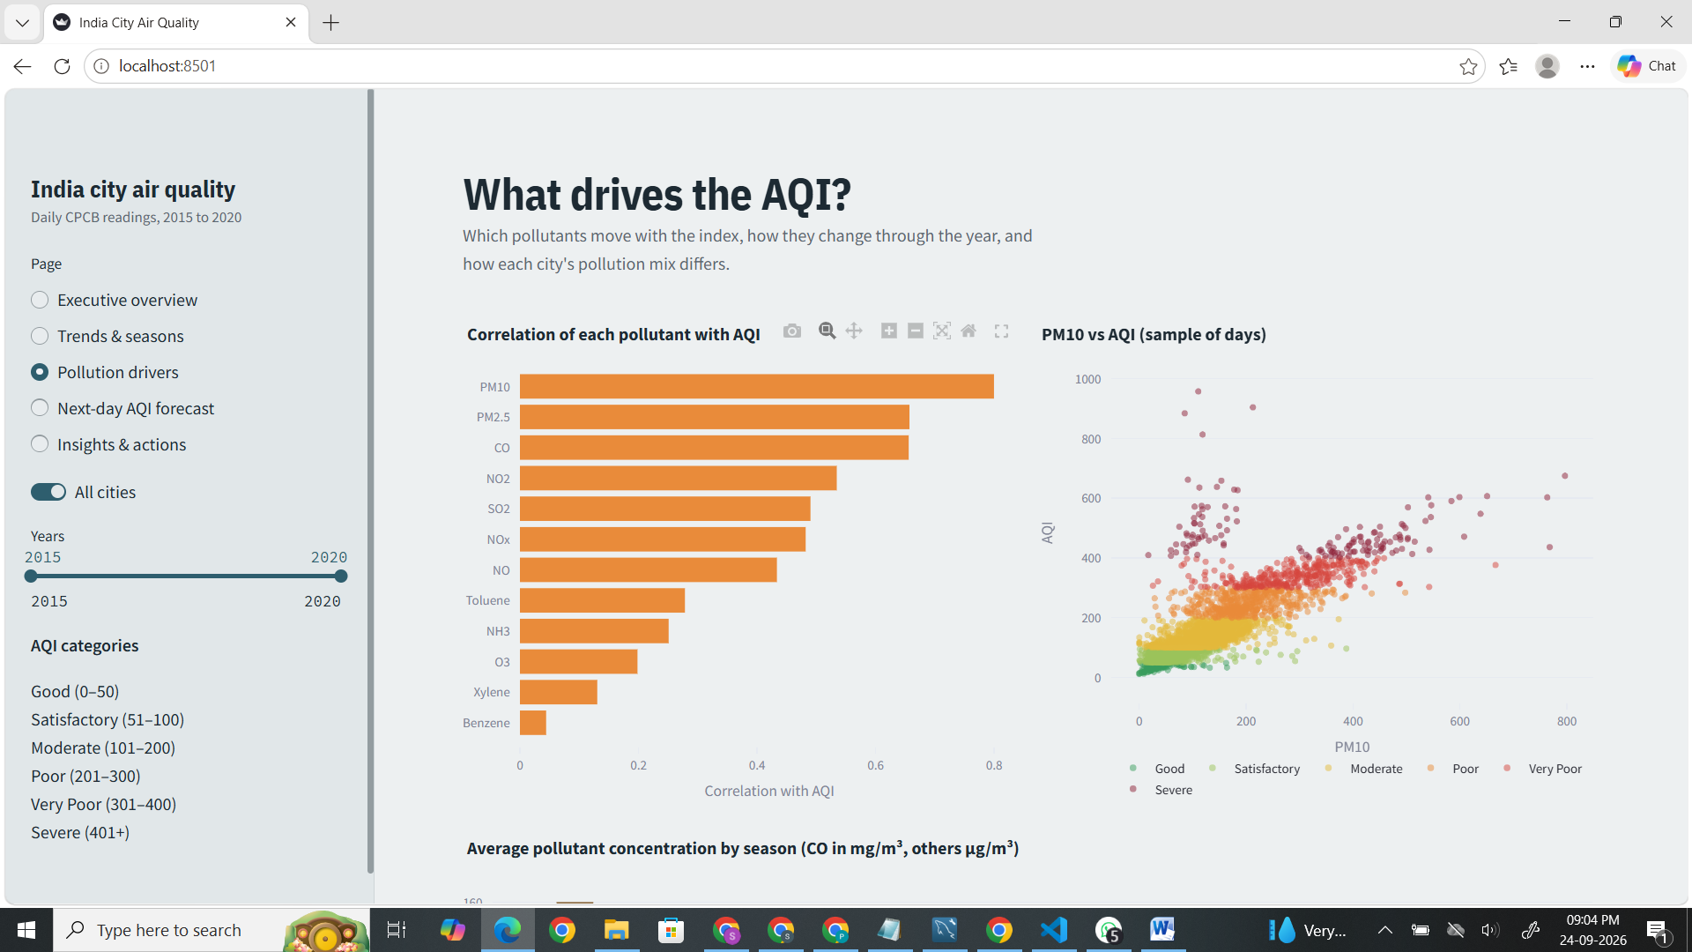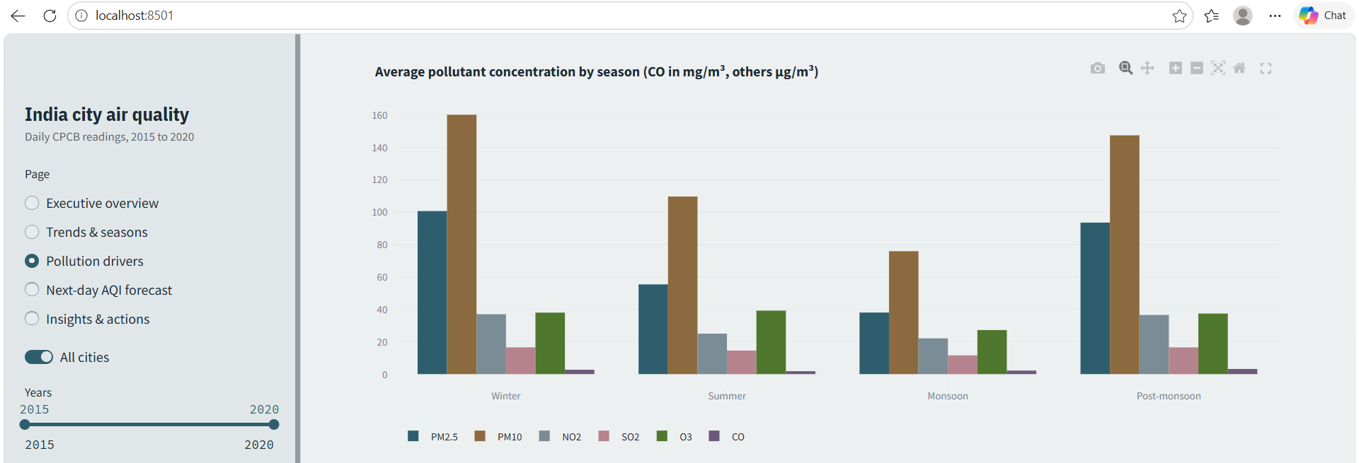
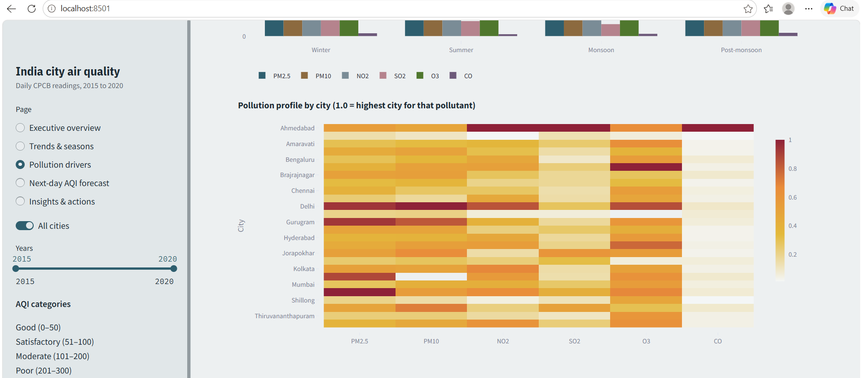Dashboard: Pollution drivers page

9.4 Next-day AQI forecast
Model metrics, actual against forecast chart, feature importance and an interactive form that forecasts tomorrow's AQI with a health advisory.
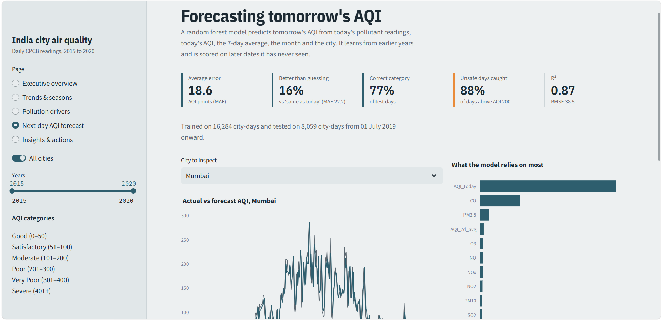
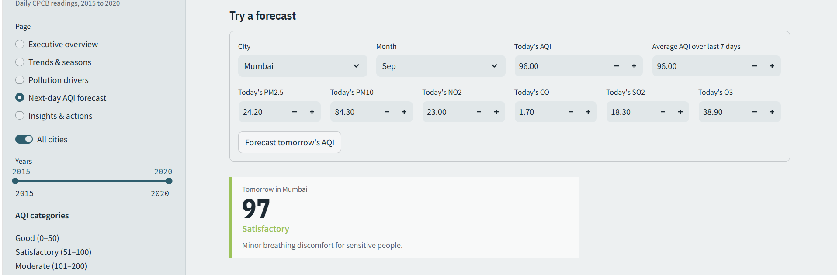
Dashboard: Next-day AQI forecast page, including a forecast result

9.5 Insights and actions
Key facts, risks, opportunities and recommended actions generated from the current filter selection. 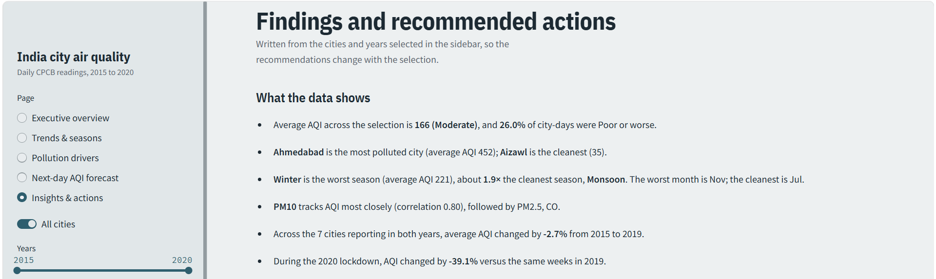
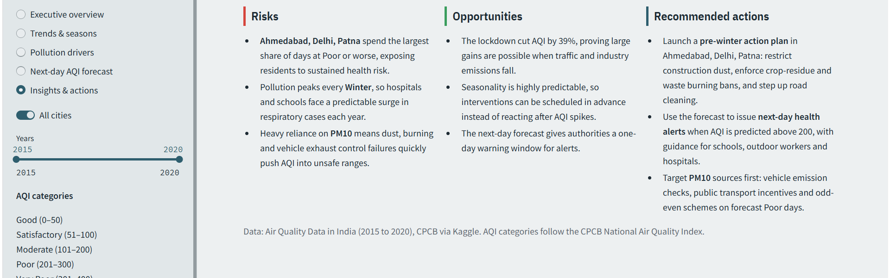
Dashboard: Insights and actions page

10. Insights, Risks, Opportunities and Actions

Risks
- Sustained exposure: Ahmedabad, Delhi and Patna spend more than half of recorded days at Poor or worse, putting residents at continuous health risk.
- Predictable seasonal surge: Every November to January, AQI roughly doubles, bringing a yearly rise in respiratory illness that hospitals and schools must absorb.
- No lasting progress: Among cities monitored since 2015, AQI improved by only 2.7% by 2019. The lockdown gains are likely to reverse as activity returns.

Opportunities
- Pollution is reducible: The 39.1% lockdown fall proves that cutting traffic and industrial emissions produces large, fast improvements.
- Timing is predictable: Because the seasonal pattern repeats every year, measures can be scheduled before the peak instead of reacting after it.
- Early warning: The forecast model catches about 9 in 10 unsafe days one day ahead, giving time to warn the public.

Recommended actions
- Pre-winter action plan from October in the most polluted cities: control construction dust, enforce bans on crop-residue and waste burning, and increase mechanised road cleaning.
- Next-day health alerts whenever the forecast exceeds AQI 200, with guidance for schools, outdoor workers and hospitals.
- Target particulate and vehicle sources: emission checks, public transport incentives, and traffic restrictions on forecast Poor days, since PM10, PM2.5 and CO drive AQI most.
- Improve monitoring: expand stations and fix data gaps (PM10 is missing on over a third of days), and audit unusual readings such as Ahmedabad's carbon monoxide.

11. Limitations
- The data ends in July 2020, so it does not reflect later policies or conditions.
- Monitoring coverage differs by city and year, and several pollutants have many missing values (Xylene 59%, PM10 35%).
- Ahmedabad's AQI is heavily influenced by very high carbon monoxide readings that may reflect sensor or reporting problems, so its ranking should be treated with caution.
- The model forecasts only one day ahead and does not use weather data such as wind speed, temperature or rainfall, which strongly affect pollution.

12. Conclusion and Future Scope
This project turned raw CPCB readings into a decision-ready dashboard. It shows that unsafe air is common, concentrated in northern and western cities, strongly seasonal, and largely driven by particulate matter and combustion. The 2020 lockdown demonstrates that major improvements are possible, and the forecast model makes it practical to warn people a day in advance.
Future work could add weather data to improve the forecast, extend it to three to seven days ahead, use station-level and hourly data for neighbourhood-level insights, include data after 2020, and deploy the dashboard online for public use.

13. References
- Rohan Rao, Air Quality Data in India (2015 to 2020), Kaggle: https://www.kaggle.com/datasets/rohanrao/air-quality-data-in-india
- Central Pollution Control Board, National Air Quality Index: https://cpcb.nic.in
- Scikit-learn documentation: https://scikit-learn.org
- Streamlit documentation: https://docs.streamlit.io
- AICTE | IBM SkillsBuild Data Analytics with AI Internship masterclass materials, BharatCares, 2026.

