3.55 (a) Derive planar density expressions for BCC (100) and (110) planes in terms of the atomic radius R.
(b) Compute and compare planar density values for these same two planes for vanadium.

BCC CRYSTAL

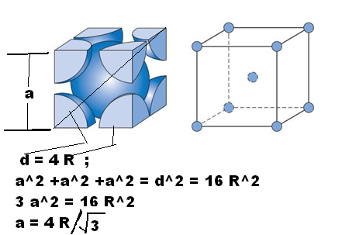

Solution
(a) A BCC unit cell within which is drawn a (100) plane is shown below.

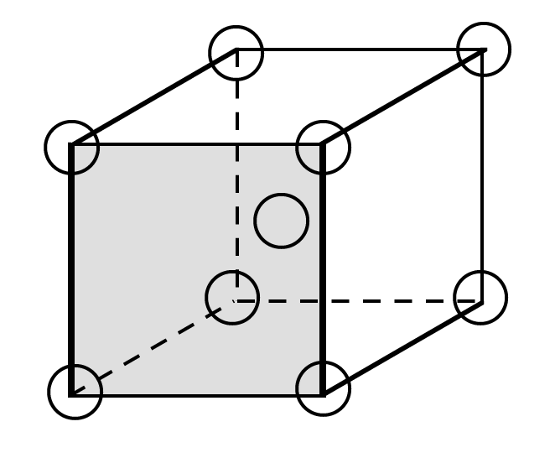

For this (100) plane there is one atom at each of the four cube corners, each of which is shared with four adjacent unit cells. Thus, there is the equivalence of 1 atom associated with this BCC (100) plane. The planar section represented in the above figure is a square, wherein the side lengths are equal to the unit cell edge length, 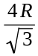 (Equation 3.3); and, thus, the area of this square is just 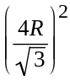 = 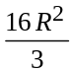. Hence, the planar density for this (100) plane is just

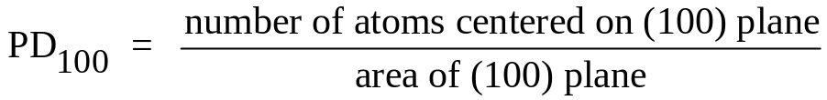

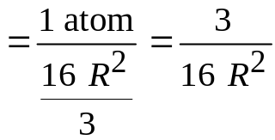

A BCC unit cell within which is drawn a (110) plane is shown below.

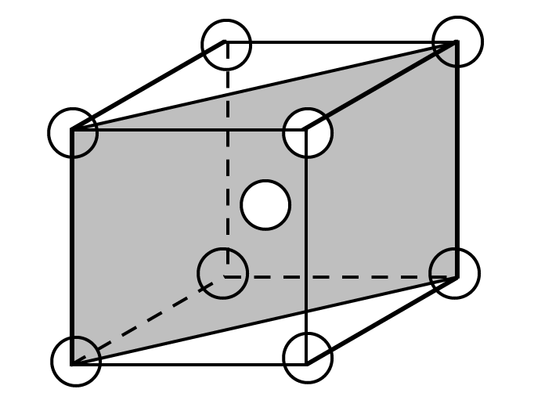

For this (110) plane there is one atom at each of the four cube corners through which it passes, each of which is shared with four adjacent unit cells, while the center atom lies entirely within the unit cell. Thus, there is the equivalence of 2 atoms associated with this BCC (110) plane. The planar section represented in the above figure is a rectangle, as noted in the figure below.

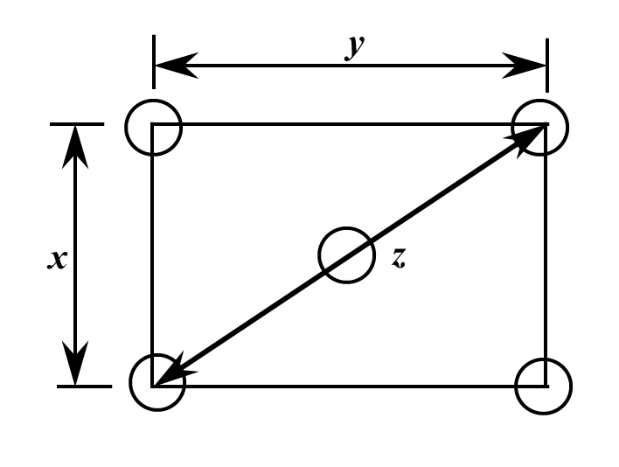

From this figure, the area of the rectangle is the product of x and y. The length x is just the unit cell edge length, which for BCC (Equation 3.3) is . Now, the diagonal length z is equal to 4R. For the triangle bounded by the lengths x, y, and z

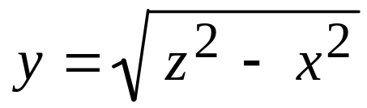
Or

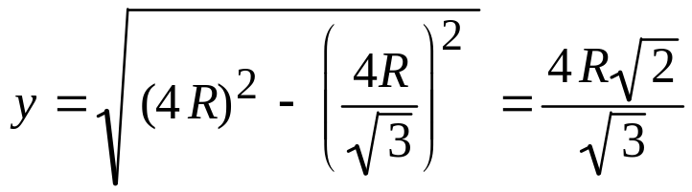

Thus, in terms of R, the area of this (110) plane is just

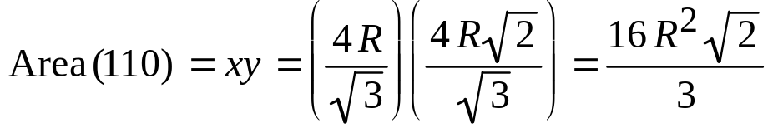

And, finally, the planar density for this (110) plane is just

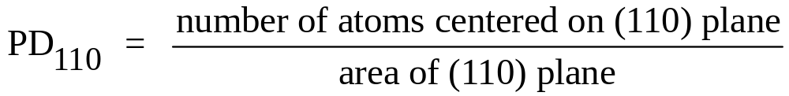

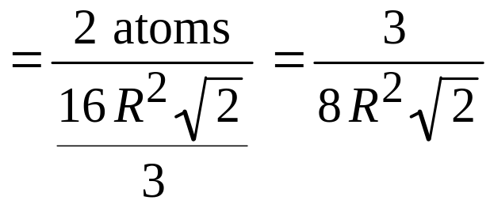

(b) From the table inside the front cover, the atomic radius for vanadium is 0.132 nm. Therefore, the planar density for the (100) plane is

While for the (110) plane

