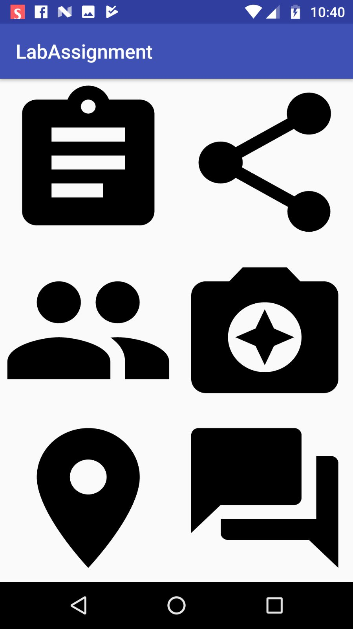

The screenshot shows the main layout of the app. From here the user will be able to navigate to different options – About, Share, Interact, Camera, Maps, Comment.

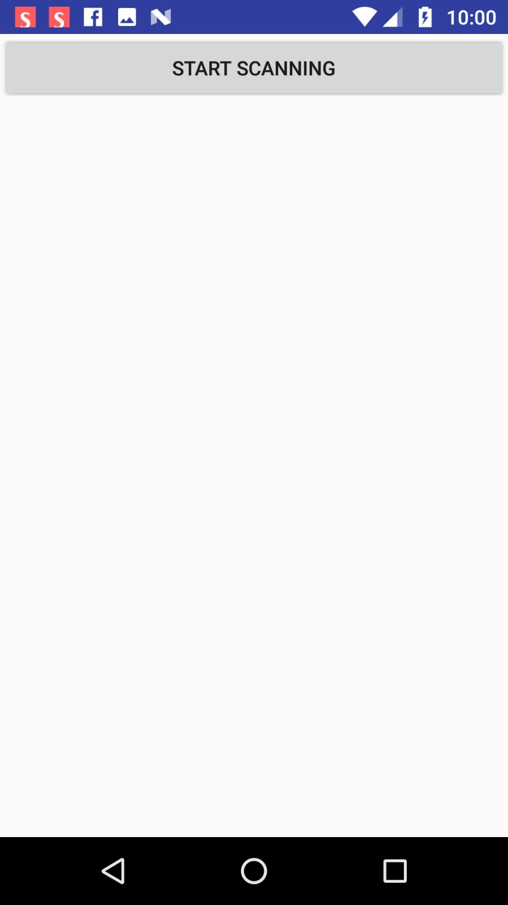

When he clicks on about from main page, he/she is redirected to scan the ORcode. He can start scanning.

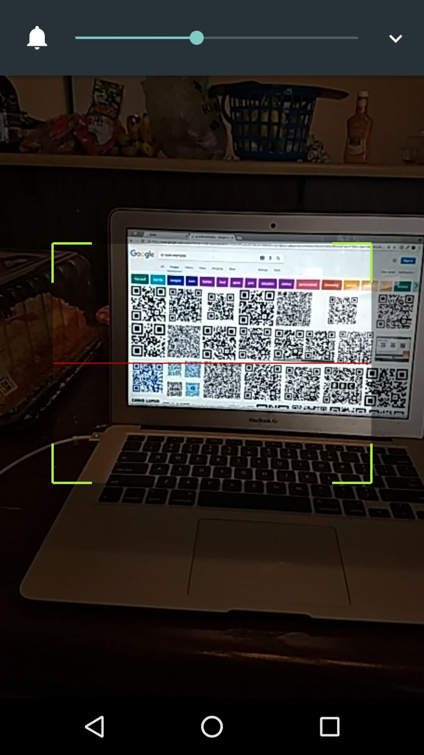

The scanning option is activated.

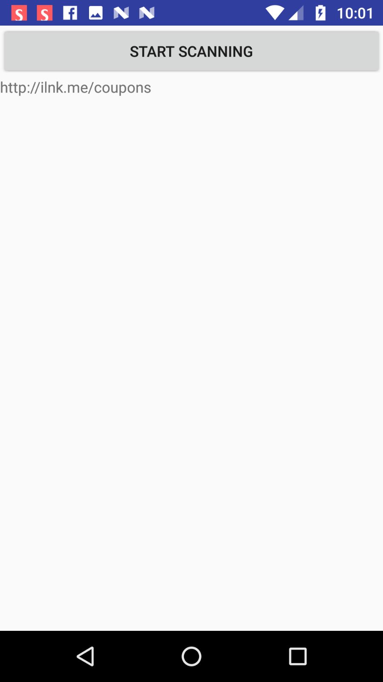

Once the QRcode is scanned the information related to it is returned.

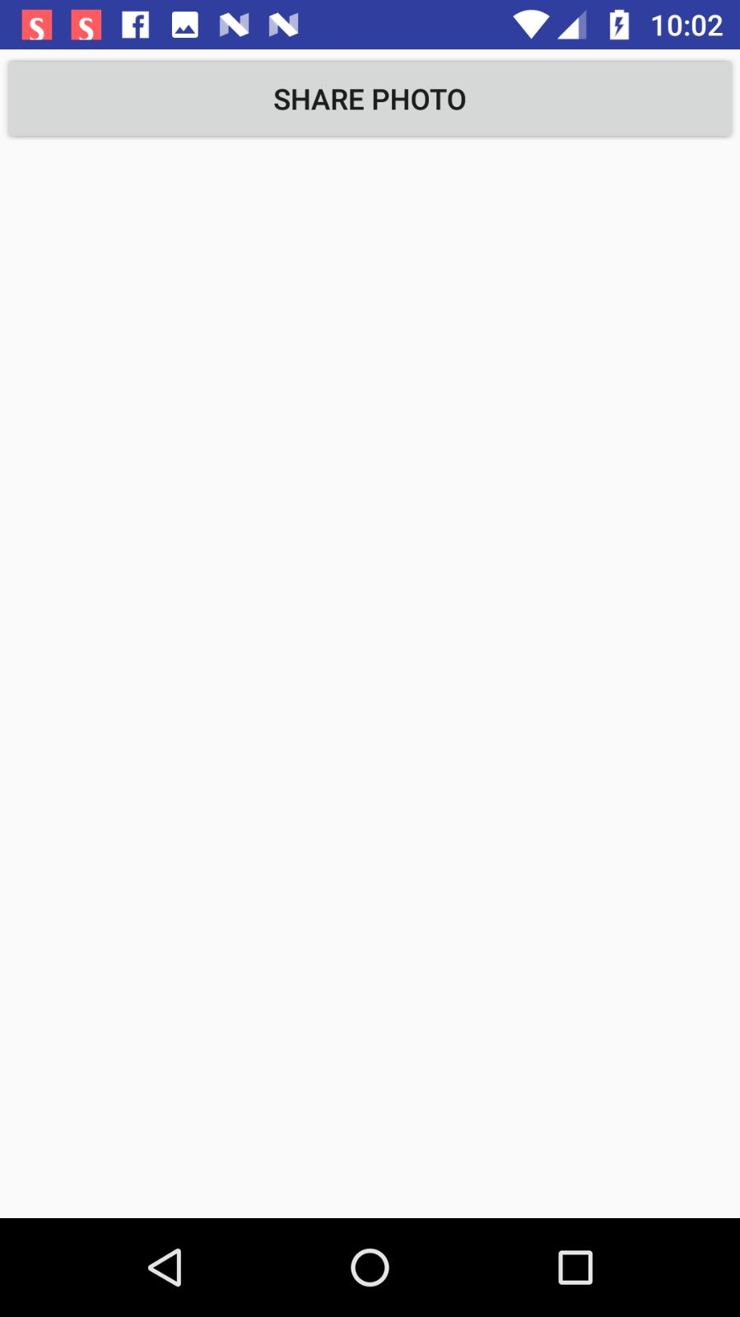

From the main layout, the user can be redirected to a page to share a photo to Facebook.

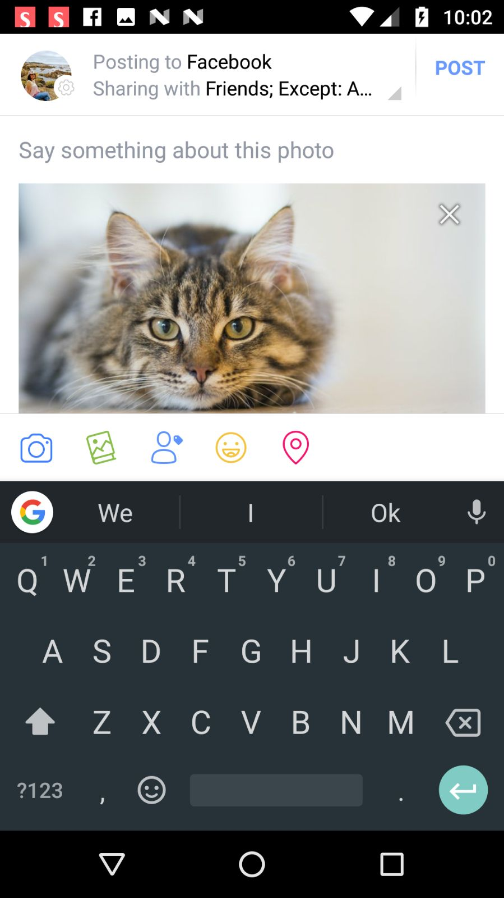

You can see the picture is shared to Facebook.

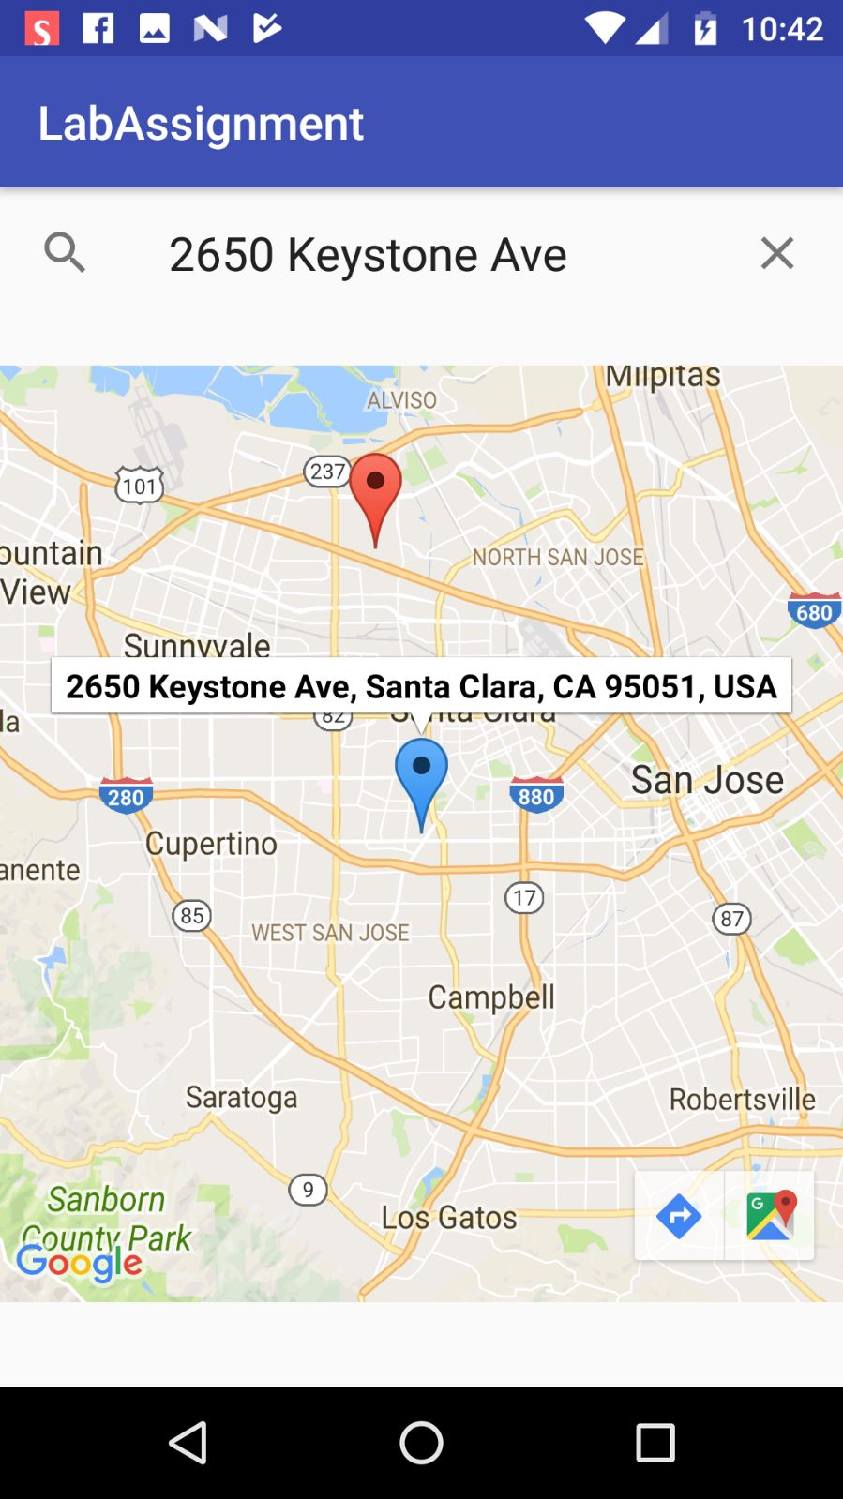

From the main layout, the user can be redirected to view his current location from maps. Current location is in red. Destination is in blue. On the bottom right, you can view the driving directions option.

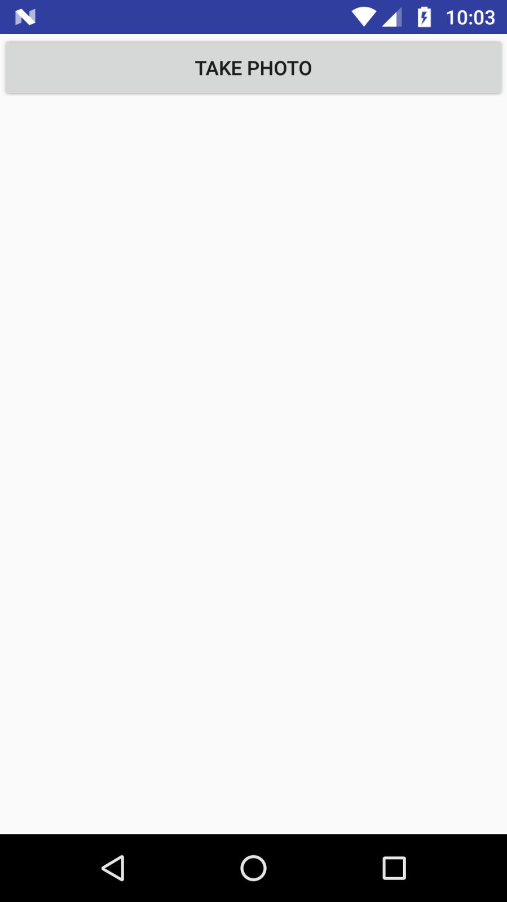

From the main layout, the user is redirected to take a photo from the camera app.

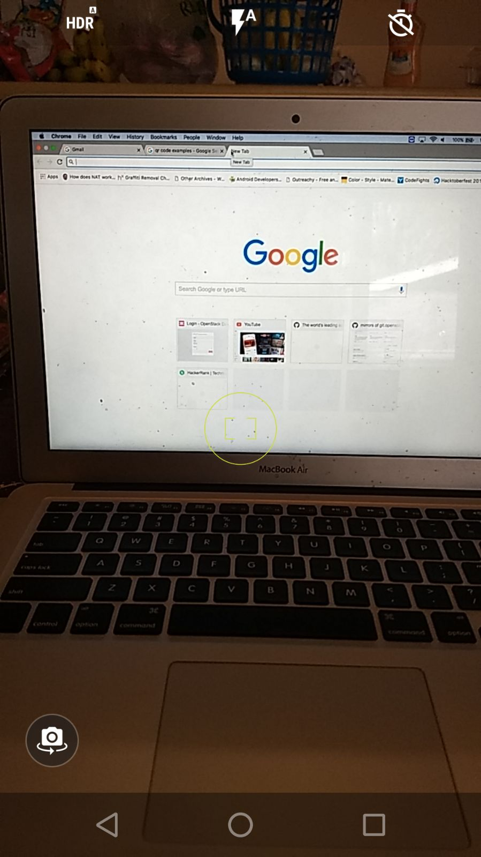

The camera in action.

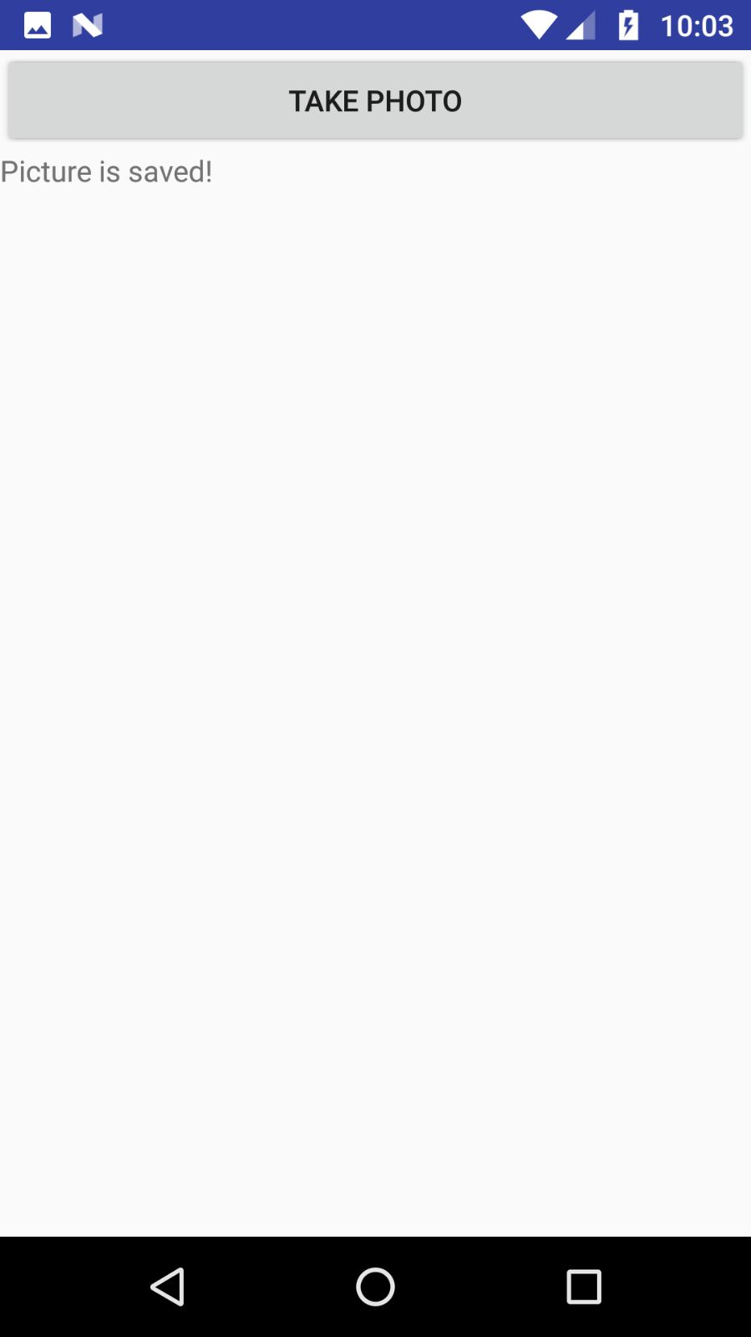

Once the picture is taken, it is saved to SD card and message is displayed.

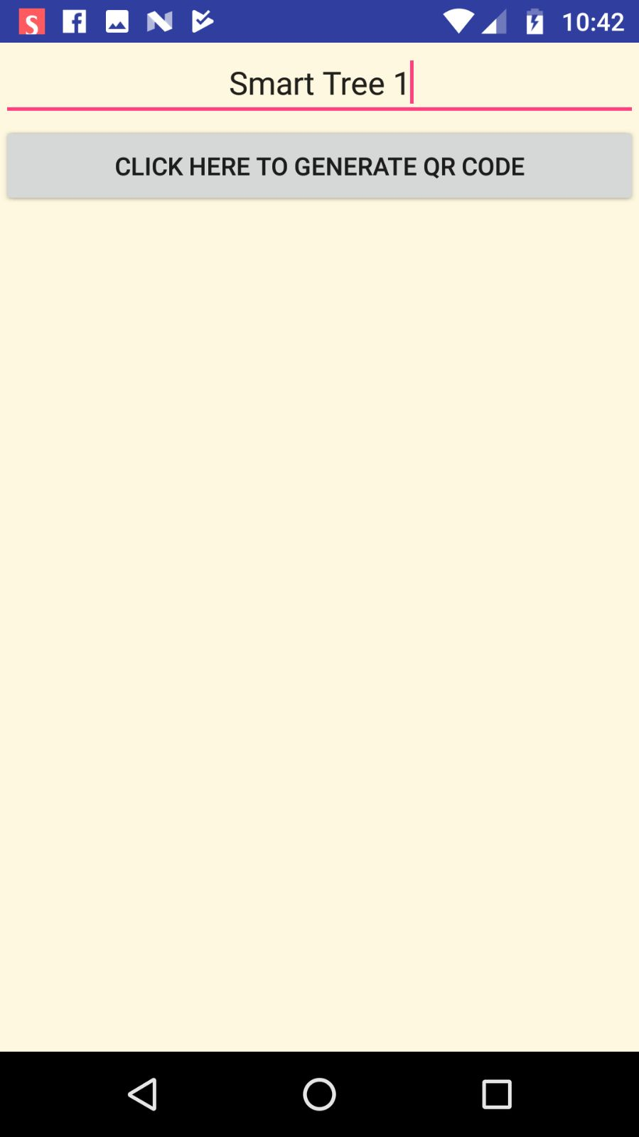From the main layout, the user can generate QR code about the smart tree and open the doors for future interactions.

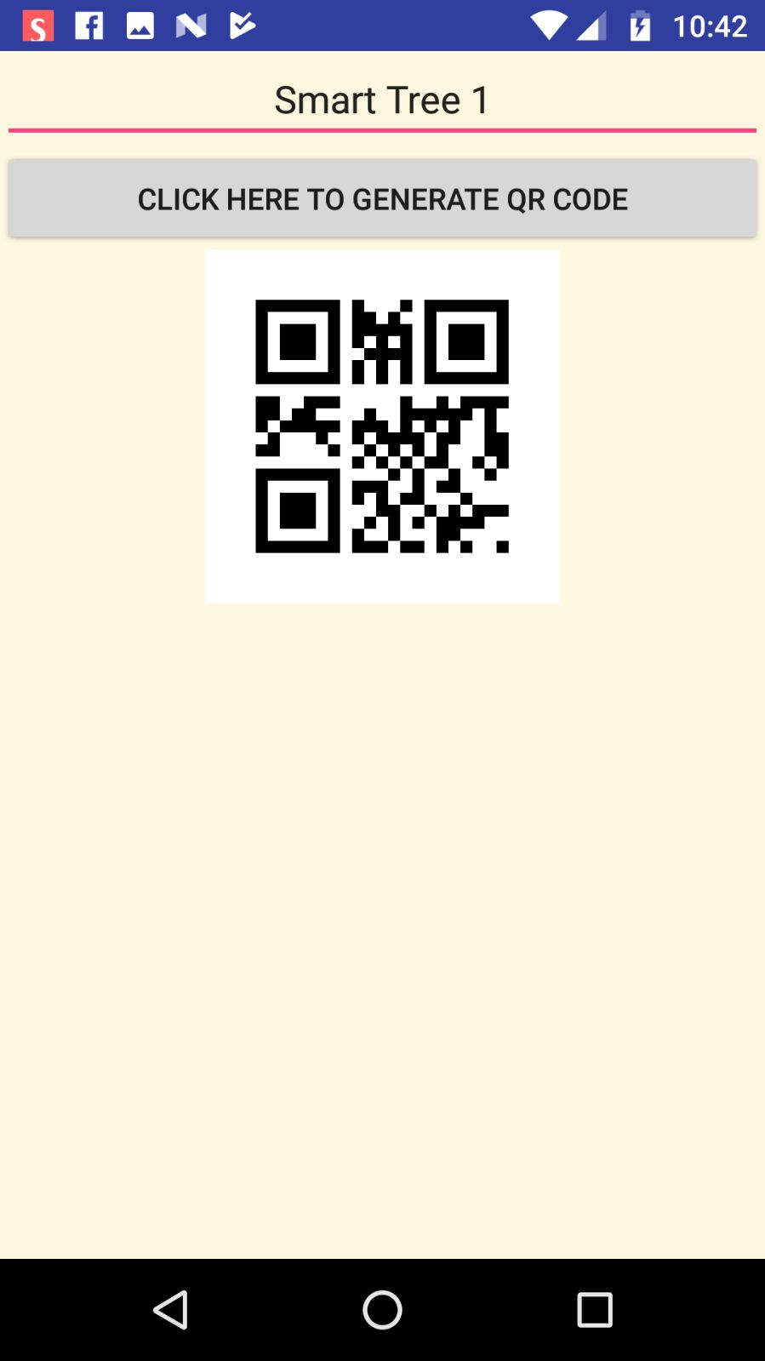

You can see the OR code is generated.

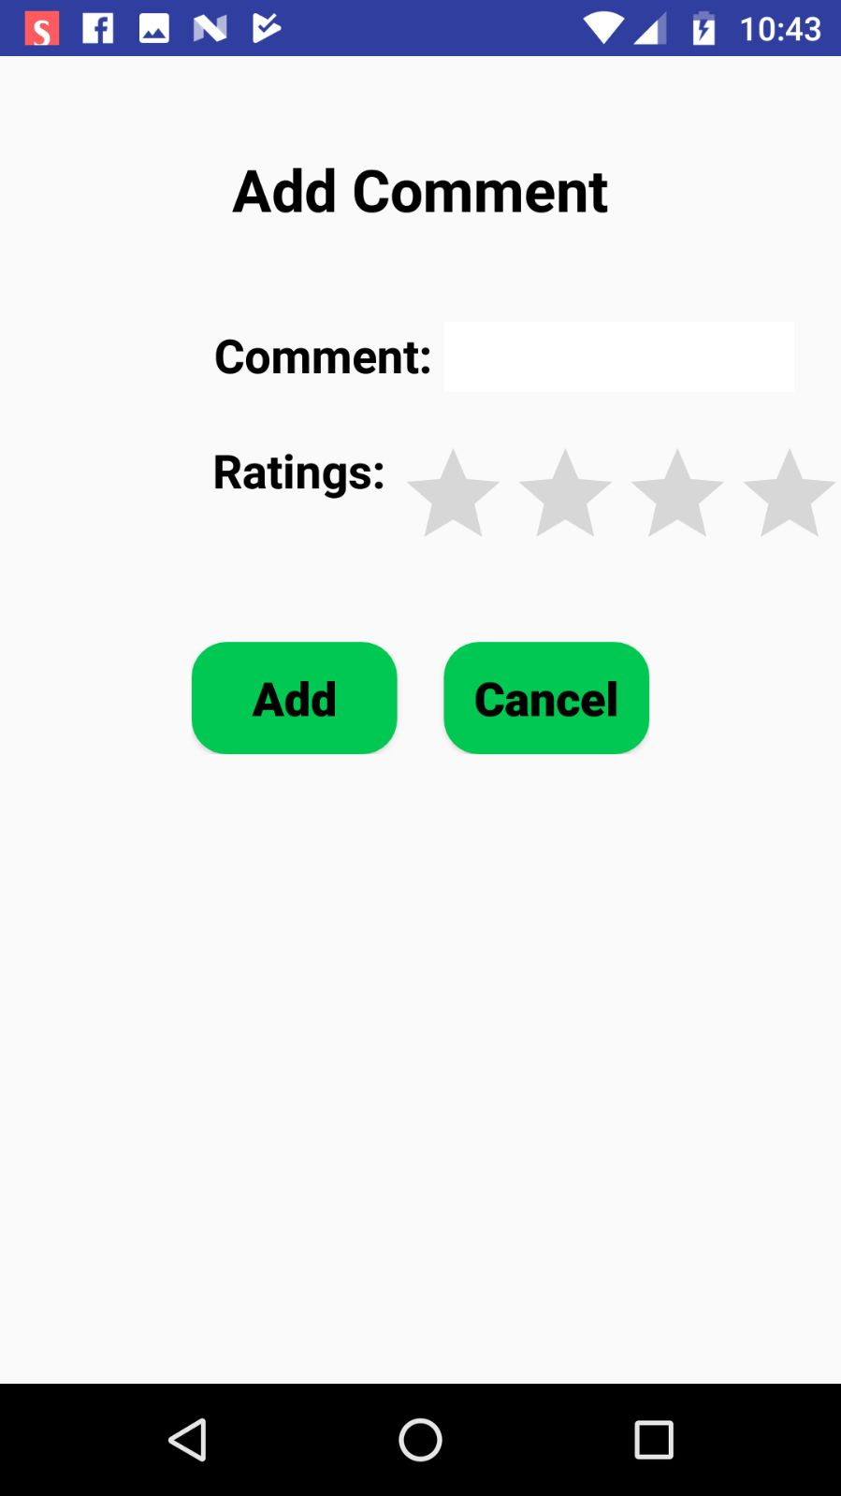

From the main layout, the user can add his/her comments of the smart tree with ratings.

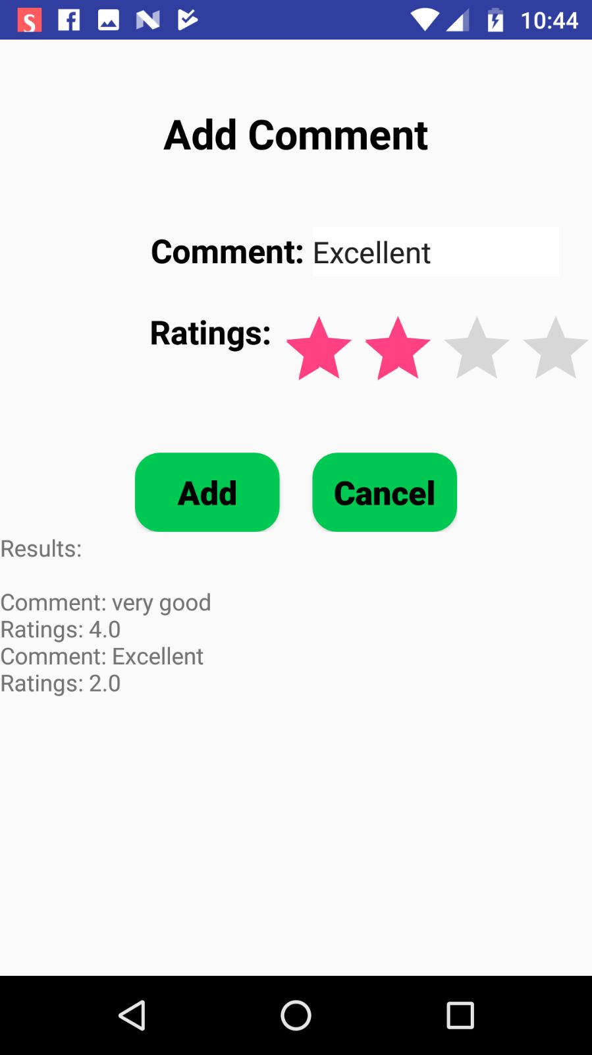You can see the comment has been added to the comment repository. He can also view what others have commented regarding this tree.