DEVNCO DEV TEAM
On-the-Job Training — Project Report

BAZAAR
A Classifieds Marketplace with PostgreSQL-Powered Search
Search · Filter · Post Ads · Save · Negotiate — over 100,000 real listings
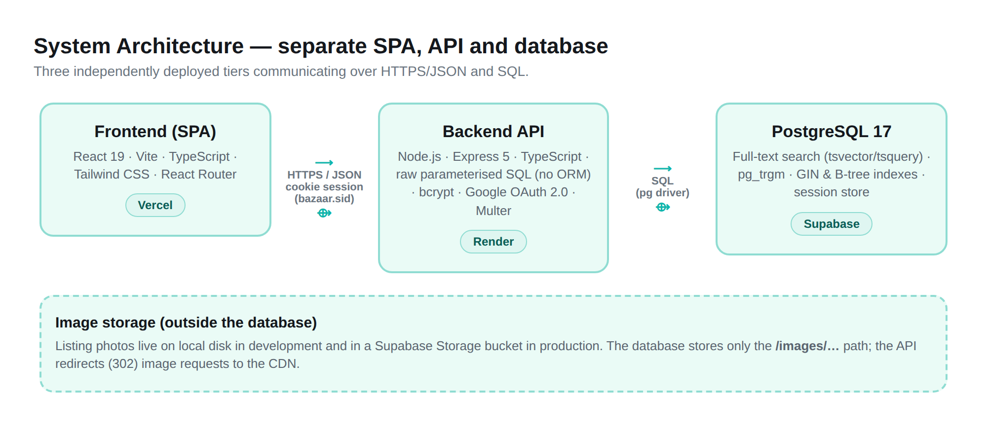
Submitted by
Siddhi Sarote
siddhi.sarote@devnco.co
Project Brief 05 — Marketplace Search
August 2026

Certificate

This is to certify that the project report titled “Bazaar — A Classifieds Marketplace with PostgreSQL-Powered Search” is a record of the bona fide work carried out by Siddhi Sarote as part of the On-the-Job Training with the Devnco Dev Team. The work described in this report was carried out under my guidance and supervision, and to the best of my knowledge represents the candidate’s own effort.

_____________________________  Veenit (Senior / Guide)  Devnco Dev Team | _____________________________  Date & Place  _____________________________

Declaration

I, Siddhi Sarote, hereby declare that the project report titled “Bazaar — A Classifieds Marketplace with PostgreSQL-Powered Search” submitted to the Devnco Dev Team is an original piece of work done by me. Every feature described in this report is actually implemented in the project’s source code and, where stated, in its live deployment. I have not copied content from any project report available online; such material was referred to only to understand the expected structure and presentation of an engineering project report. Any external tools, libraries and references used are duly acknowledged in the References section.

_____________________________
Siddhi Sarote
siddhi.sarote@devnco.co

Acknowledgement

I would like to sincerely thank my senior and guide, Veenit, for giving me the opportunity to work on this project and for the guidance and feedback that shaped it at every stage. The clear project brief and the freedom to make my own technical decisions helped me learn far more than following a fixed recipe would have.
I am also grateful to the Devnco Dev Team for providing the environment, review discussions and encouragement that kept the work moving. Building a marketplace that has to search across more than a hundred thousand listings pushed me to understand databases, indexing and API design at a level I had only read about before. Finally, I thank the open-source community behind PostgreSQL, React, Express and the many libraries this project depends on, without which a project of this scope would not have been possible for a single developer in a few weeks.

Abstract

Bazaar is a classifieds marketplace — a website where people can buy and sell second-hand items such as phones, laptops, cars, bikes and furniture near them. It was built to the Devnco “Project Brief 05 — Marketplace Search”, whose central challenge is not simply showing a list of products, but making search, filtering, sorting and counting fast and correct at real scale — over one hundred thousand listings living in a real, deployed database.
The project is a single-page React application talking to a genuinely separate Node/Express API, which in turn talks to a PostgreSQL database. There is no separate search engine such as Elasticsearch or Algolia: all searching, filtering, sorting, pagination and facet counting is done by PostgreSQL itself, using its built-in full-text search, trigram similarity for typo tolerance, and a carefully designed set of indexes. The database is seeded with 145,000 realistic listings (of which roughly 100,000+ are active and searchable at any time), so every performance claim in this report is measured against a genuinely large dataset rather than a toy example.
The application supports full-text search with relevance ranking, typo-tolerant fallback, combinable filters with live facet counts, four sort orders, keyset (cursor) pagination that stays fast even at very deep pages, email/password and Google sign-in, posting and managing listings with photo upload, saved searches and saved listings, and a price-negotiation (offers) feature between buyer and seller. This report documents what was actually built, why each design decision was made, how the system performs, how it was tested, and the honest limitations that remain.

Table of Contents

Certificate 2
Declaration 3
Acknowledgement 4
Abstract 5
1. Introduction 7
2. Problem Statement 8
3. Objectives 8
4. Existing System 9
5. Proposed System 9
6. Scope 10
7. Requirements 11
8. Technologies Used 11
9. System Architecture 12
10. Modules 13
11. User / Seller Flow 13
12. Search & Filtering 14
13. Authentication 17
14. Listing Management 18
15. Saved Listings & Saved Searches 19
16. Price Negotiation / Offers 19
17. Database Design 20
18. API / Backend 22
19. Implementation 23
20. Testing & Test Cases 23
21. Performance Testing 24
22. Results / Screenshots 24
23. Limitations 25
24. Future Scope 25
25. Conclusion 26
26. References 26

1. Introduction
An online classifieds marketplace is a website where ordinary people list things they no longer need, and other people search for and buy those things. Popular real-world examples include OLX and Facebook Marketplace. Unlike a shop (where one seller sells brand-new stock), a classifieds marketplace has many independent sellers, mostly second-hand items, and a huge, constantly changing catalogue. The single most important thing such a site must do well is help a visitor find the right item quickly — by typing a few words, narrowing down with filters, and browsing page after page — no matter how many listings exist.
Bazaar is my implementation of exactly this kind of site. It was built to a written brief (“Project Brief 05 — Marketplace Search”) that deliberately puts the hard part front and centre: the brief requires a deployed database with at least one hundred thousand listings, and asks that every search stay fast at that volume. The brief specifically forbids using a dedicated search product like Elasticsearch or Algolia, so that the project genuinely demonstrates how far PostgreSQL’s own search and indexing can be pushed. This report describes the finished system, the reasoning behind each part of it, and how it behaves under real load.
The site is live and can be visited at devnco-bazaar.vercel.app. It requires no login to browse, search, or open a listing — an account is only needed to post an item, save a search, or manage your own listings.
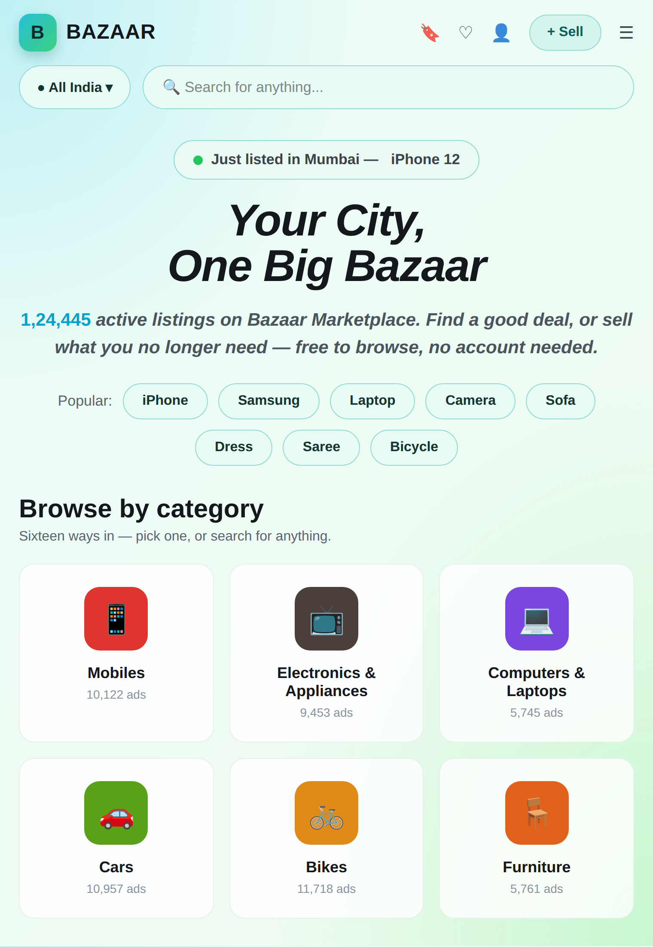
Figure 1: The Bazaar home page on the live site, showing the live count of active listings and the sixteen browsable categories with their real counts.

2. Problem Statement
When a marketplace only has a few hundred items, almost any approach to search “feels” fast. The real engineering problem appears at scale. When there are more than a hundred thousand listings, several things that are easy at small size become genuinely hard:
- Search speed: a full-text search across every listing’s title and description must still return in a fraction of a second.
- Deep pagination: the brief states plainly that “page 500 must return as quickly as page 2.” A naïve approach using SQL OFFSET gets slower the deeper you go, because the database has to walk past and throw away every earlier row.
- Correct filter counts: next to each filter option (for example, each city) the site must show how many listings match — and these counts must update as other filters are applied, without one slow query per option.
- Stable results while data changes: sellers post, sell and delete items constantly, and listings expire automatically. Paging through results must not silently skip or repeat an item when the data shifts underneath the user.
- Vague and misspelled queries: a real user types “bycicle” or a word that appears in a category name but in no listing text, and still expects something sensible back.
The problem statement of this project, therefore, is: build a complete, deployed classifieds marketplace in which searching, filtering, sorting, counting and pagination are all performed by PostgreSQL, correctly and quickly, over a database of more than one hundred thousand listings — and be able to explain and defend every design decision behind it.

3. Objectives
The objectives of the project, taken directly from the brief and from what the finished system actually does, are:
- Build a separate frontend and backend. A React single-page application and a genuinely independent Node/Express HTTP API, deployable and scalable on their own.
- Use PostgreSQL as the only datastore. All search, filter, sort, count and pagination logic runs inside PostgreSQL using its full-text search and query planner — no external search engine.
- Deliver fast full-text search at scale. Search titles and descriptions, rank by relevance, tolerate typos, over 100,000+ live listings.
- Provide combinable filters with live facet counts. Category, city, condition, size, colour, price and “posted within”, each independent, each showing an accurate count.
- Make deep pagination fast. Use a keyset (cursor) approach so a deep page is as fast as an early one.
- Support secure accounts. Email/password with hashed passwords, plus Google OAuth 2.0 sign-in, with secure server-side sessions.
- Let sellers manage listings. Post, edit, mark sold, delete and renew listings, with photo upload stored outside the database, and server-enforced ownership.
- Add saved searches, saved listings and offers. Per-user features persisted server-side, including a price-negotiation flow between buyer and seller.
- Prove it works. Automated tests for the trickiest parts, measured performance numbers, and honest documentation of what remains.

4. Existing System
Well-known classifieds platforms already exist — OLX, Quikr, Facebook Marketplace and similar sites. They are mature, feature-rich products with mobile apps, in-app chat, payments and recommendation engines. Studying them is useful, but they also illustrate why a student or training project cannot simply “clone” one of them: the interesting engineering (how their search scales) is hidden, and most of their surface features are outside the point of this exercise.
More importantly, many small or tutorial-level marketplace projects take shortcuts that do not survive real scale. Common weaknesses in such existing systems include: performing searching or filtering in application code after fetching rows from the database (which does not scale); using SQL OFFSET for pagination (which slows down on deep pages); showing filters without accurate counts, or computing each count with a separate query; and testing only against a handful of rows so that performance problems never appear. This project was deliberately built to avoid each of these shortcuts, and to be honest about the cases where a limitation genuinely remains.

5. Proposed System
The proposed system — Bazaar — is a three-tier web application in which PostgreSQL does the heavy lifting. A React single-page application provides the user interface. A separate Express API exposes a clean, documented set of HTTP endpoints. PostgreSQL stores all data and performs all search, filter, sort, count and pagination work using its own capabilities.
The key ideas that make the proposed system different from a naïve implementation are: (1) a generated full-text search column on every listing, weighted so a title match ranks above a description match; (2) trigram similarity as a typo-tolerant fallback that only runs when an exact search finds nothing; (3) a single SQL statement that computes all six filter-groups’ counts at once; (4) keyset (cursor) pagination so deep pages stay fast; and (5) a carefully chosen set of indexes, each of which exists to support a specific query. Every one of these is described in detail later in this report.
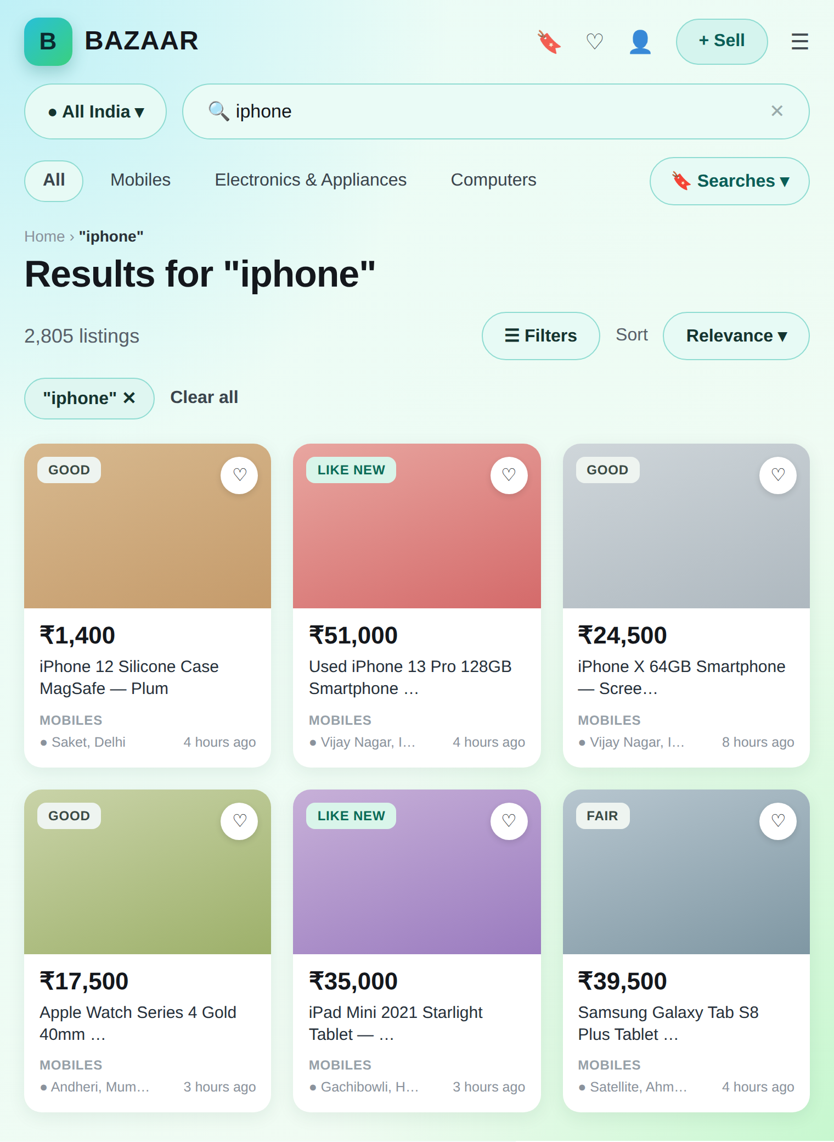
Figure 2: A live search for “iphone” returning 2,805 matching listings, each card showing condition, price, category and location.

6. Scope

In scope (built and working)
- Full-text search over titles and descriptions with relevance ranking and typo tolerance.
- Combinable filters (category, city, condition, size, colour, price, posted-within) with live facet counts.
- Four sort orders (relevance, newest, price low→high, price high→low) and keyset pagination.
- Search-as-you-type suggestions and complete search state stored in the URL.
- Email/password and Google sign-in with secure server-side sessions.
- Posting, editing, marking sold, deleting and renewing listings, with photo upload and expiry.
- Saved searches (with a “new since you last looked” badge) and saved listings.
- A price-negotiation (offers) feature between buyer and seller.
- A deployed database of 145,000 listings and a live, public website.

Out of scope (deliberately not built)
The brief explicitly lists features that must not be built, so that effort stays on the search problem. None of the following exist in the code: online payments, checkout or escrow; in-app messaging/chat between buyer and seller; map views or radius search (location is city-level only); recommendation or “similar listings” engines; moderation queues, reporting or admin tooling; real email or SMS delivery; seller ratings and reviews; and a native mobile app. Keeping these out was a conscious discipline, and is reflected honestly in the code.

7. Requirements

Functional requirements
- A visitor can search, filter, sort and browse listings without logging in.
- A registered user can post a listing with photos, and edit, mark sold, delete or renew it.
- Only the user who created a listing can change it — enforced on the server for every such action.
- A user can save searches and listings, and make, accept, reject or counter price offers.
- The system computes accurate result counts and per-filter facet counts for every search.

Non-functional requirements
- A deployed database holding at least 100,000 listings (145,000 seeded; ~100,000+ active).
- Searches that include a term or a filter should return quickly (tens of milliseconds at the database).
- All searching, filtering, sorting and counting must happen inside the database.
- No N+1 query pattern on a results page; every user input parameterised (safe from SQL injection).
- Passwords stored only as bcrypt hashes; secrets kept out of source control.
- Consistent, machine-readable API responses with meaningful HTTP status codes.

Software requirements
Node.js 20+, PostgreSQL 15+ (PostgreSQL 17 in production via Supabase), a modern web browser, and npm for dependency management. Development uses TypeScript throughout, with Vite for the frontend build and tsx to run the TypeScript backend directly.

8. Technologies Used
The technology choices were guided by the brief (React SPA, Node API, PostgreSQL) with free choice of the surrounding tools. The versions below are taken directly from the project’s package files.
Layer | Technology | Why it is used
Frontend | React 19 + TypeScript | Component-based single-page UI with type safety.
Build tool | Vite | Fast dev server and optimised production build.
Styling | Tailwind CSS v4 | Utility-first styling, responsive layouts.
Routing | React Router v7 | Client-side routing; URL holds full search state.
Icons | react-icons | Consistent icon set across the UI.
Backend | Node.js + Express 5 (TypeScript) | Separate, documented HTTP API.
Database access | pg (node-postgres), no ORM | Plain parameterised SQL — full control over each query.
Passwords | bcryptjs (cost 12) | One-way password hashing.
Sessions | express-session + connect-pg-simple | Secure cookie sessions stored in PostgreSQL.
Social login | Google OAuth 2.0 | Authorization-code flow with CSRF state.
File upload | multer + sharp | Photo upload with real image-content verification.
Database | PostgreSQL 17 (Supabase) | Full-text search, pg_trgm, indexes, query planner.
Image storage | Disk (dev) / Supabase Storage (prod) | Listing photos kept outside the database.
Testing | Vitest | Unit and integration tests for both packages.
Hosting | Vercel (frontend), Render (API) | Independently deployed tiers.

9. System Architecture
Bazaar is built as three independent tiers. The React frontend and the Express backend are genuinely separate programs, deployed on different services (Vercel and Render), that communicate only over a documented HTTP/JSON API — exactly the way a third-party client would. Nothing is shared in-process between them. The backend talks to PostgreSQL (hosted on Supabase) using plain, parameterised SQL, with no ORM in between, so what the database actually runs is always just one function call away from the source code.

Figure 3: High-level architecture: a React SPA on Vercel, a separate Express API on Render, and PostgreSQL on Supabase, with listing photos stored outside the database.
Within the backend, every request flows through the same ordered pipeline of middleware before it reaches a handler, and the handling code is split into clear layers so that each layer has one job: controllers deal with HTTP, validators check and clean input, services hold the business rules, and repositories contain the SQL. This separation makes the system easier to read, test and reason about.
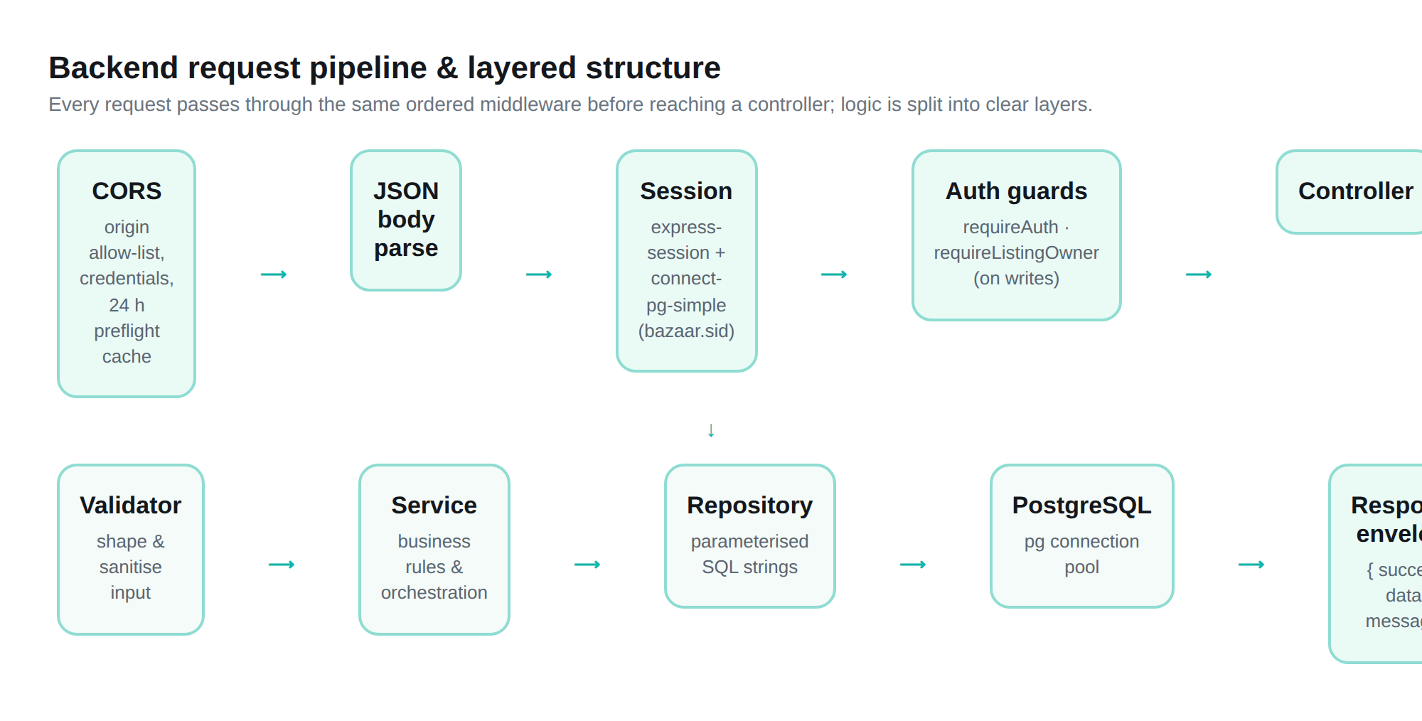
Figure 4: The backend request pipeline (CORS → JSON → session → auth guards → controller) and the layered structure beneath it.
Listing photos are deliberately kept outside the database, as the brief requires. In development they are written to disk; in production they live in a Supabase Storage bucket. The database only ever stores a short /images/… path, and the API redirects image requests to the storage CDN, so image traffic never ties up an API process and the storage provider can be changed without a data migration.

10. Modules
The system is organised into the following main modules. Each is described in its own section later in the report.
Module | What it does
Search & Filtering | Full-text search, typo tolerance, filters, facet counts, sorting, pagination.
Authentication | Register, log in, log out, Google sign-in, sessions, ownership checks.
Listing Management | Post, edit, mark sold, delete, renew; photo upload; automatic expiry.
Saved Searches & Listings | Per-user saved searches with a “new since” badge, and a saved-listings wishlist.
Offers / Price Negotiation | Buyer offers, seller accept / reject / counter, with server-side rules.
Dashboard & Browse | Home page counts, category browse, and the seller’s own listings dashboard.
API / Backend | The documented HTTP endpoints and the layered logic behind them.

11. User / Seller Flow
An important design decision is that Bazaar has exactly one type of account. There is no separate “buyer” and “seller” account. Anyone who signs in can post an item, and “seller” simply describes whoever owns a particular listing. Whether a signed-in person may edit or delete a given listing is an ownership question, and only the server can answer it. (Older separate seller sign-in links still exist but simply redirect to the single login.)

Typical visitor (no account) flow
Open the site → land on a welcome screen → enter the marketplace → search or pick a category → narrow down with filters and sorting → open a listing to see its photos, description and seller → optionally try to save it or make an offer, at which point the site prompts a login. Browsing, searching and viewing never require an account.

Seller flow
Sign in (email/password or Google) → click “Sell” → fill in the Post-Ad form (title, description, category, condition, price, city, photos) → the listing goes live → manage it from the seller dashboard, where it can be edited, marked sold, renewed or deleted. Each listing shows its status, view count and expiry date. Every one of these actions calls a real, ownership-checked API endpoint; the buttons in the interface are only a convenience on top of that server-side enforcement.
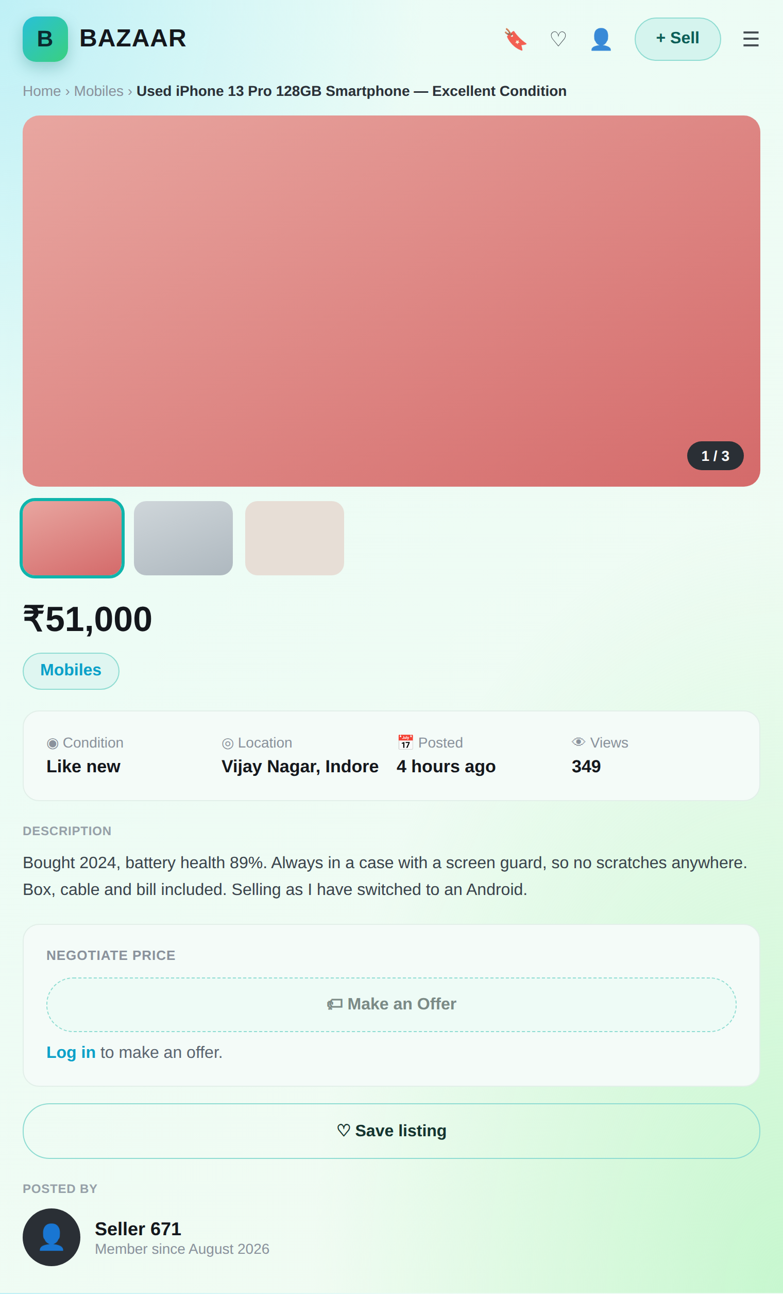
Figure 5: A listing detail page: image gallery, price, condition/location/views, description, seller card and the “Make an Offer” action (which prompts login).

12. Search & Filtering
This is the core of the whole project. Everything below is performed by PostgreSQL, not in application code.

Full-text search and relevance
Every listing has a special generated column called search_vector — a PostgreSQL tsvector that is built automatically from the listing’s title, description, brand and colour. These are weighted A, B, C and D respectively, which means a word found in the title ranks higher than the same word found only in the description. So when someone searches “iphone”, a listing that is an iPhone comes above one that merely mentions iPhone in its description. A GIN index on this column makes the match fast even across the whole table.
A two-word query means “all words” (AND), using PostgreSQL’s websearch_to_tsquery, which is the same syntax a search engine box already trains people to expect: quotes make an exact phrase, and a leading minus excludes a word. This is a deliberate choice — treating “denim jacket” as “denim OR jacket” would bury the exact thing being searched for.

Typo tolerance (“did you mean”)
If an exact search returns nothing and the user typed something, the system falls back to trigram similarity using the pg_trgm extension, and can offer a “did you mean” suggestion. The word-similarity threshold was lowered from the library default of 0.6 to 0.2, because the listing titles here are full phrases (like “Kids Bicycle 20-inch — Barely Used”), which dilutes a single-word match. The fuzzy path only runs after an exact miss, because it is the more expensive path and most searches do not need it.
Honesty note: the lowered threshold requires the backend to be redeployed to take full effect. On the currently deployed instance, a search for “bycicle” returns zero results (the fix is present in the code but not yet live). The site handles this gracefully with a clear zero-result state that suggests trying another keyword, a wider price range, or another category — itself a required feature.
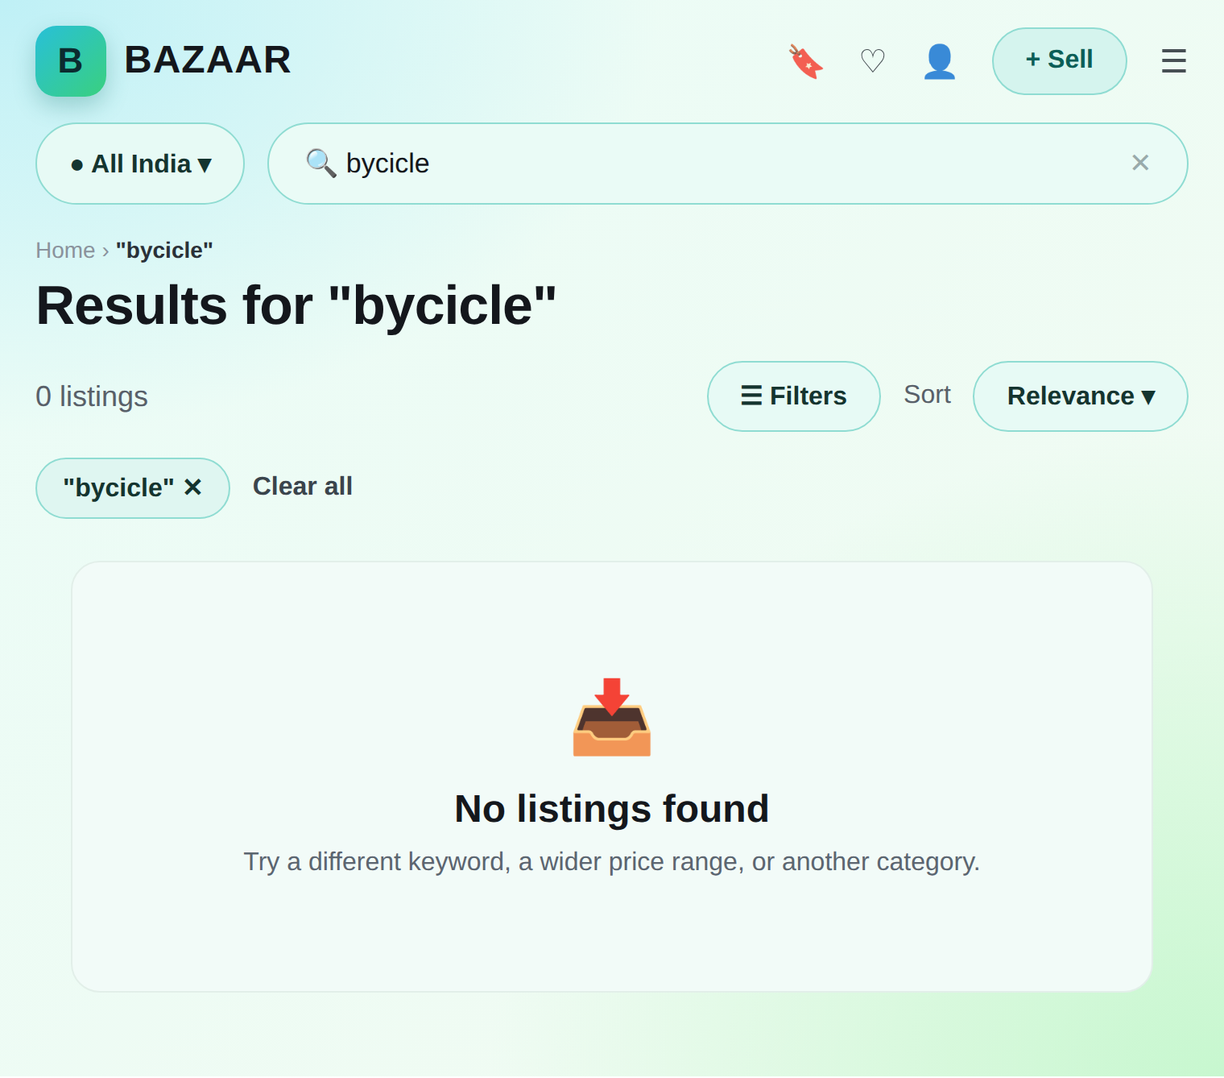
Figure 6: The zero-result state on the live site for the misspelling “bycicle”, offering the user a way forward.

Filters and facet counts
Filters — category, city, condition, size, colour, price and “posted within” — all combine, and each one clears independently. Beside every filter option the site shows a count of how many listings match. The clever part is that each group’s count is computed with every other filter applied but not its own — otherwise choosing “Mobiles” would show every other category as zero, and there would be no way to switch. All six groups’ counts are produced by a single SQL statement over one materialised set of candidate rows, rather than one query per option.
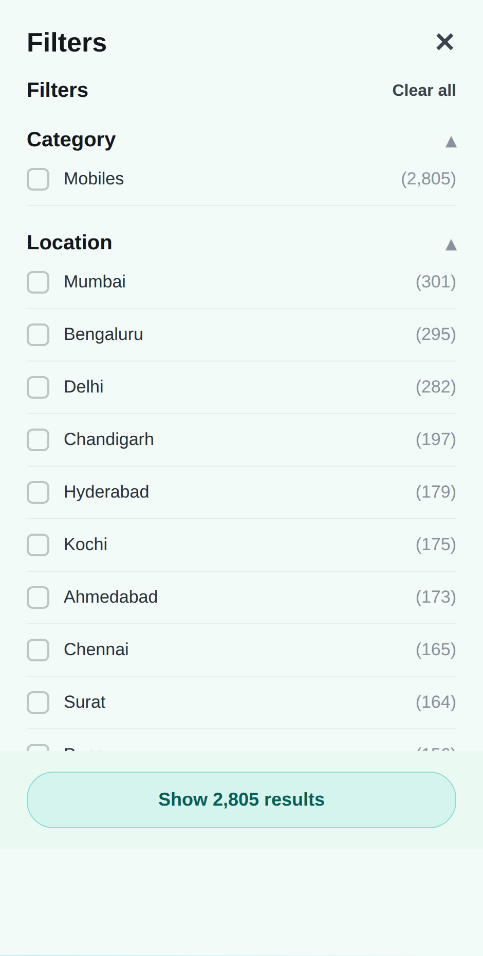
Figure 7: The filter panel for the “iphone” search, showing live facet counts per city (Mumbai 301, Bengaluru 295, Delhi 282, …) computed in a single query.

Sorting and search-as-you-type
Four sort orders are supported: relevance (only meaningful when there is a query), newest, price low→high and price high→low. Every sort ends with the listing id as a final tiebreaker, so the order is total and stable — two items with the same price or time can never swap places between requests. A separate search-as-you-type endpoint powers the suggestions dropdown, debounced by 250 ms so it fires only after the user pauses typing.

Search state in the URL
The complete state of a search — the query, every filter, the sort order and the page or cursor — is stored in the page’s URL, not just in memory. This means a search result page can be bookmarked, shared, reloaded, and navigated with the browser’s back button, and it will show exactly the same thing. This behaviour is covered by an automated round-trip test.
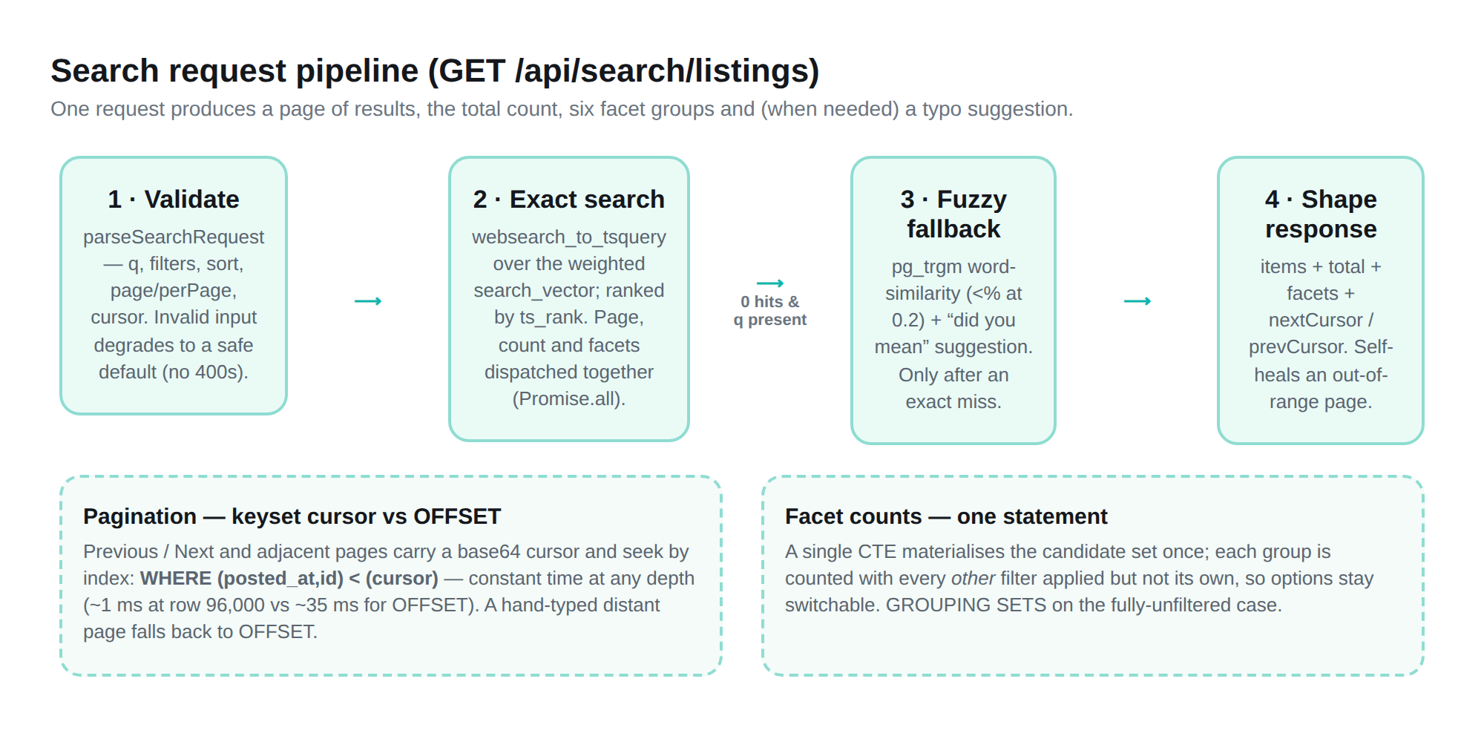
Figure 8: The search request pipeline: validate → exact full-text search → fuzzy fallback on a miss → shape the response, with facet counting and keyset pagination.

13. Authentication
Bazaar supports two ways to sign in: a traditional email and password, and “Continue with Google” (OAuth 2.0). Both were verified end-to-end on the live site.

Passwords and sessions
Passwords are never stored or logged in plain text. They are hashed with bcrypt at cost factor 12, a one-way function: the system can check whether a password matches a stored hash, but cannot turn a hash back into the password. Sessions are cookie-based (cookie name bazaar.sid), signed, HTTP-only, and stored server-side in PostgreSQL via connect-pg-simple, with a rolling 7-day lifetime. On login and registration the session id is regenerated to prevent session-fixation attacks, and logout destroys the session on the server, not just in the browser.
The login endpoint deliberately returns the same “Incorrect email or password” message and takes roughly the same time whether the email is unknown, the password is wrong, or the account has no local password — so it cannot be used to discover which email addresses have accounts.
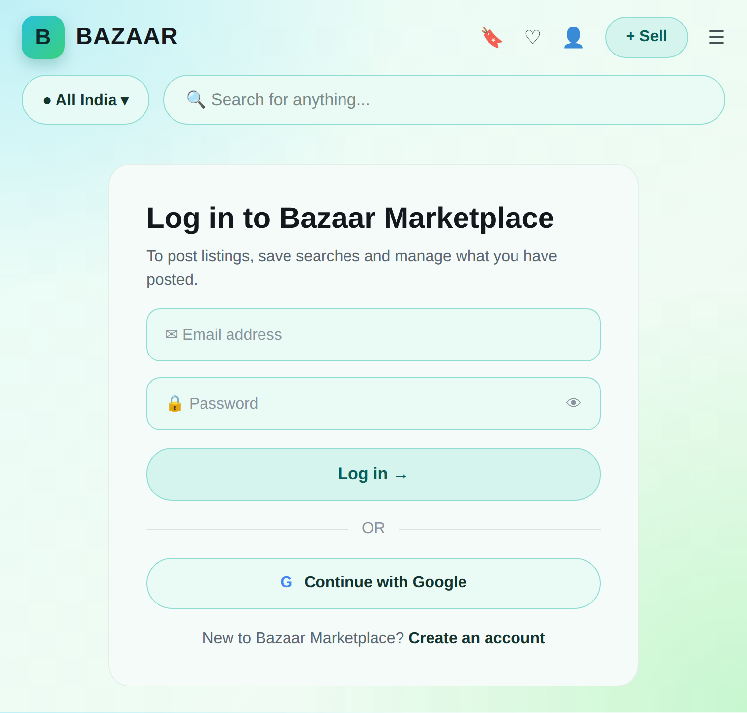
Figure 9: The login screen on the live site, offering email/password sign-in and Google OAuth.

How a Google sign-in resolves to one account
Google sign-in uses the authorization-code flow with an anti-CSRF “state” value. When a Google profile comes back, the system resolves it to a single account using three cases, in order: (1) if this Google identity has signed in before, use that account; (2) if not, but the email Google returns matches an existing account, link Google to that account rather than creating a duplicate; (3) otherwise, create a new account with no local password. The identity check runs before the email check, so a linked Google account keeps working even if the user later changes their Google email — because the link is keyed on Google’s stable user id, not on the email address.

Who can do what
Two server-side guards protect the API. requireAuth rejects any request without a valid session (HTTP 401). requireListingOwner additionally checks that the signed-in user actually owns the listing they are trying to change, returning 403 if it belongs to someone else and 404 if it does not exist (the two are made indistinguishable to a probe). These guards — not the interface — are the real enforcement point.

14. Listing Management
A signed-in user can post a new listing and fully manage it afterwards. Creating a listing takes the seller’s identity from the session, never from the request body, so a caller can never post an item in someone else’s name.

Creating and editing
The Post-Ad form collects a title (3–120 characters), a description (10–4,000 characters), a category and optional subcategory (both checked against the database), condition, price, city and up to eight photos. Every field is validated on the server, and the category/subcategory pairing is confirmed to be real. Editing uses the same rules but every field is optional — omitted fields are left unchanged.

Photo upload
Photos are uploaded through a dedicated endpoint using multer. Uploads are limited to 8 files per request and 5 MB per file, and only real image types (JPEG, PNG, WebP, AVIF) are accepted — checked by the file’s actual decoded content using sharp, not merely by its filename, so a renamed non-image is rejected. Stored filenames are server-generated random hex, so two files named “photo.jpg” cannot collide and a caller cannot choose a path on disk. A resized 480-pixel thumbnail is generated once at upload time for use in list and grid views.

Status, selling, expiry and renewal
A listing has one of three statuses: active, sold or expired. Marking a listing sold is idempotent (marking it twice is harmless). A sold listing stays viewable by direct link but is excluded from search. Listings expire automatically: a background sweep runs every five minutes and flips any active listing whose expiry time has passed to “expired”, removing it from search. A listing can be renewed for another full 45-day term; renewing a sold listing is refused (it would quietly un-sell it), returning a clear 409 error.

15. Saved Listings & Saved Searches

Saved listings (wishlist)
A signed-in user can save any listing to a personal wishlist by tapping its heart. The saved list stores only the listing ids; the actual listings are re-fetched fresh each time, so a saved item always reflects the seller’s current price and status. Saving the same listing twice is a harmless no-op, enforced at the database level.

Saved searches with a “new since” badge
A user can also save an entire search — its query and all its filters — under a name they choose. Each saved search remembers how many results it had when last viewed (seen_count), so the site can show a badge of how many new listings have appeared since. Because this count is stored on the server (not in the browser), it survives logging in from a different device. All saved-search and saved-listing endpoints sit behind the login guard and scope every query to the signed-in user, so no one can read or change another person’s saved data.

16. Price Negotiation / Offers
Bazaar includes a lightweight price-negotiation feature. On a listing, a signed-in buyer (who is not the seller) can make a price offer. Importantly, this is deliberately not a chat system: one offer row is one proposal plus, at most, one counter-proposal. If a buyer wants to negotiate further after a counter, they submit a fresh offer rather than growing an endless back-and-forth.
An offer moves through four states: pending (buyer has offered), accepted, rejected, and countered (the seller proposed a different price, and it is now the buyer’s turn). Every transition is authorised on the server using the session’s user id, never a value from the request body. The rules enforced are: only an active listing that is not your own can receive an offer; a buyer cannot hold two pending offers on the same listing; and an accept or reject is only valid for whichever side’s turn it is, which depends on the offer’s current status. Buyers see their offers under “My Offers”; sellers see incoming ones under “Offers Received”.
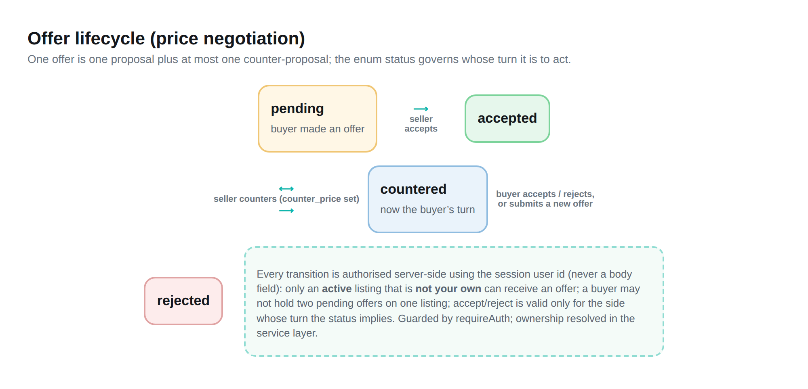
Figure 10: The offer lifecycle. The status enum governs whose turn it is to act; every transition is authorised server-side.

17. Database Design
All data lives in PostgreSQL. The schema is defined in one idempotent SQL file, and every index carries an in-place comment naming the query it exists for. The main tables are described below.
Table | Purpose / key points
users | One account system. Email is case-insensitive (citext) and unique; password_hash is nullable for Google-only accounts. Separate, masked phone/contact_email for the “Contact Seller” action.
oauth_identities | One row per linked social login, so a Google sign-in resolves to one user rather than a duplicate.
listing_categories | Sixteen top-level categories; a row with parent_slug set is a subcategory of another.
listings | The core table: title, description, category, audience, brand, size, colour, condition, price, city, status, view_count, dates, and a generated weighted search_vector.
listing_photos | Photo paths only (bytes live outside the DB); a generated 480px thumbnail path; one primary photo per listing enforced by a unique index.
saved_searches | A named search plus its filters, with seen_count and last_viewed_at for the “new since” badge.
saved_listings | A join row per (user, listing) — the wishlist; ownership is the primary key itself.
listing_offers | A buyer’s price offer and the seller’s response; seller_id copied at creation for a fast dashboard query.
user_sessions | Server-side session store used by connect-pg-simple.
The entity–relationship diagram below shows the tables, their key columns, and how they relate. Foreign keys use ON DELETE CASCADE so that, for example, deleting a listing automatically removes its photos and saved-listing references.
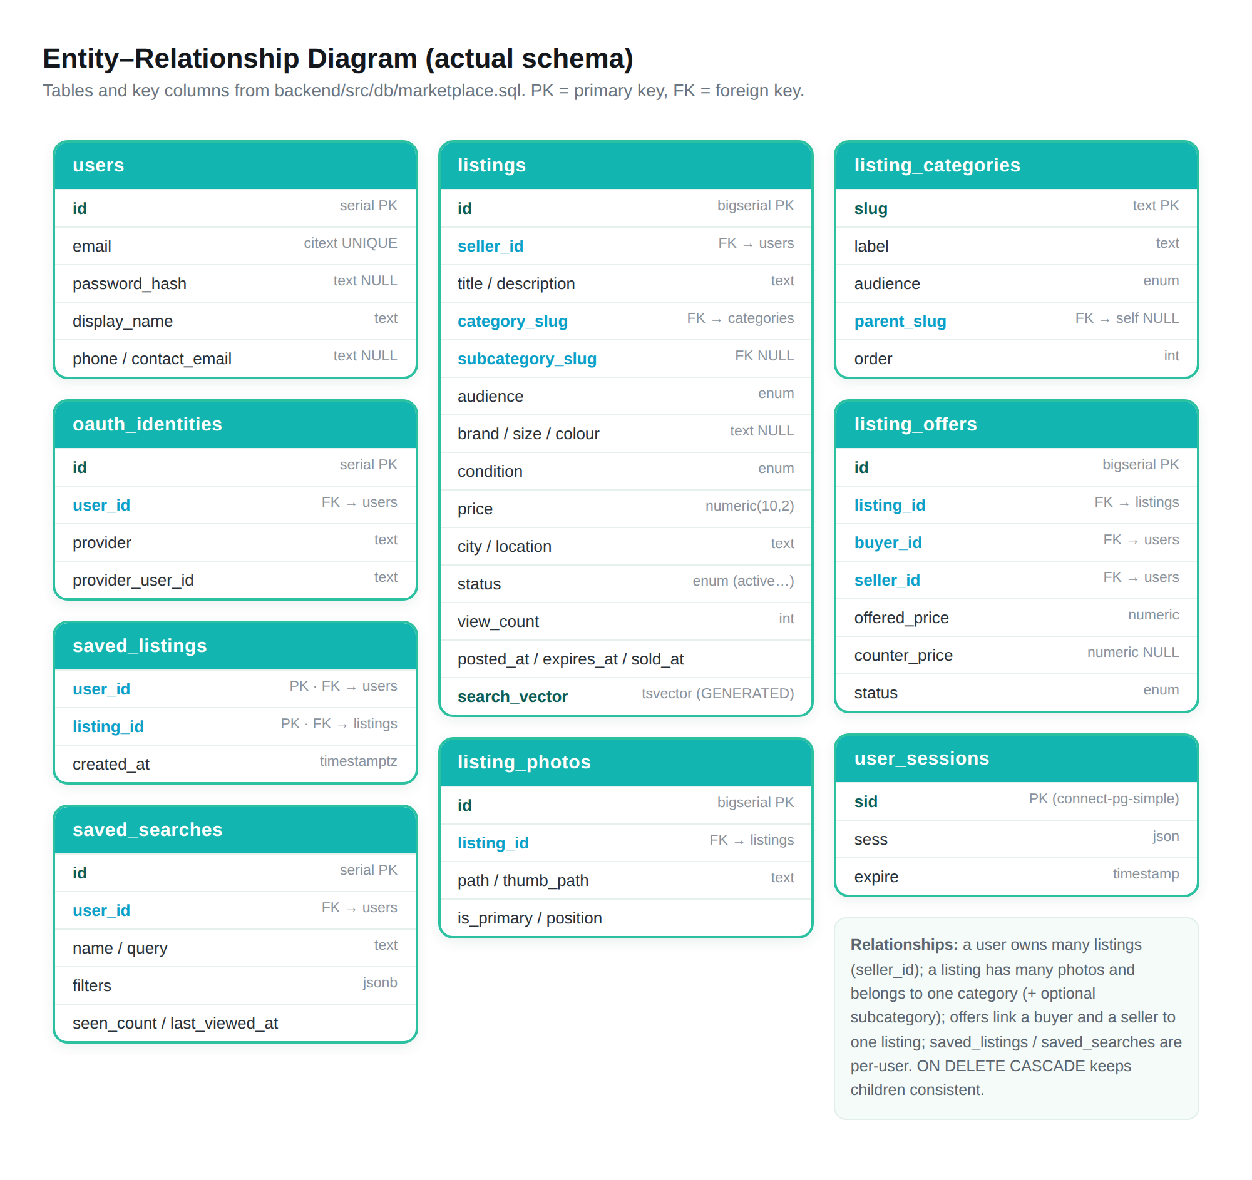
Figure 11: Entity–Relationship diagram of the actual Bazaar schema (from backend/src/db/marketplace.sql).

Indexes, and why each exists
Indexes are what make search fast at scale. Each one below backs a specific query pattern; single-column indexes that would only ever be used alongside a sequential scan were considered and deliberately rejected.
Index | Backs
GIN on search_vector | Full-text match (the @@ operator).
GIN trigram on title | Typo-tolerant fallback search and type-ahead.
(status, posted_at DESC, id DESC) | Default “newest” browse and its keyset cursor.
(status, price, id) | Price sorts and their cursor.
(status, category, posted_at, id) / (status, city, …) | Category and city browse without a full scan.
Partial facets index, INCLUDE (price) | Index-only scan for the six facet columns plus price, over active rows only.
Partial (expires_at) where active | The 5-minute expiry sweep.
(seller_id, posted_at DESC) | The seller dashboard.
(listing_id, position) on photos | Fetching a page’s photos in one round trip (avoids N+1).
Offers: buyer / seller / (listing, buyer) | “My Offers”, “Offers Received”, and the duplicate-offer check.

The 145,000-listing seed
A seed script generates 145,000 realistic listings so that performance is measured at genuine scale. It multiplies about 150 real product templates across 2,000 sellers and 18 Indian cities, varying price, condition, dates, status and view count per row using a seeded pseudo-random generator (Mulberry32) — so a given size always reproduces the same catalogue, keeping before/after query comparisons meaningful. About 70% of rows are active, 12% sold and 18% expired, which is why 145,000 total keeps the active, searchable count comfortably above the brief’s 100,000 floor. Rows are inserted in batches, and the table is analysed at the end so the query planner has real statistics.

18. API / Backend
The backend exposes a documented HTTP API under /api. Every response uses one consistent envelope: { success: true, data: … } on success, or { success: false, message: … } on error, with a meaningful HTTP status code (400, 401, 403, 404, 409, 500). Reading endpoints (browse, search, view a listing) are open; anything that writes, or that is per-user, sits behind the login guard.
The main endpoints are summarised below (a fuller reference lives in the project’s docs/API.md).
Method & path | Auth | Purpose
GET /api/dashboard | open | Home page data: active count, recent listings, categories.
GET /api/search/listings | open | Main search/filter/sort/paginate + facet counts.
GET /api/search/suggest | open | Type-ahead suggestions.
GET /api/listings | open | Browse active listings by category/audience.
GET /api/listings/:id | open | A single listing’s full detail.
GET /api/listings/mine | login | The signed-in user’s own listings (any status).
POST /api/listings | login | Create a listing (owner from session).
PATCH /api/listings/:id | owner | Edit a listing.
DELETE /api/listings/:id | owner | Delete a listing.
POST /api/listings/:id/sold | /renew | owner | Mark sold / renew for another term.
POST /api/listings/images | login | Upload up to 8 validated photos.
GET/POST/DELETE /api/saved-listings | login | Wishlist.
GET/POST/DELETE /api/saved-searches | login | Saved searches (+ /viewed).
POST /api/offers, /:id/accept|reject|counter | login | Price negotiation.
POST /api/auth/register | login | logout | open | Email/password auth.
GET /api/auth/google | /callback | open | Google OAuth 2.0 flow.

19. Implementation
The implementation follows the layered structure described in the architecture section, and a few implementation details are worth highlighting because they are what make the system both fast and safe.

Everything runs in one database round trip where possible
For a search, the page of results, the total count and the facet counts do not depend on each other, so they are dispatched to the database together rather than one after another. Over a network link to a hosted database, the round trip dominates the cost, so running the three queries in parallel roughly halves the time a search takes.

Keyset pagination
Previous/Next and any adjacent page number carry a small cursor — the sort values of the last row on the page, base64-encoded. The next page is then fetched with a condition like WHERE (posted_at, id) < (cursor), which seeks straight to the right place using the index instead of counting past every earlier row. This is what keeps a deep page as fast as an early one. Jumping to an arbitrary, hand-typed distant page number is the one case that still uses OFFSET — a deliberate, bounded trade-off.

Safety by construction
Every value that goes into a query is passed as a bound parameter — nothing the user types is ever concatenated into SQL — so SQL injection is structurally impossible, and this is backed by an automated test. A page of results fetches its photos through a single LATERAL join rather than one query per listing, avoiding the N+1 problem. The central error handler returns a generic message in production so that internal database details never leak to a client.

20. Testing & Test Cases
Both the frontend and backend use the Vitest test runner. The tests focus on the trickiest, most important behaviour — counts and pagination — rather than only the easy “happy path”. The backend’s count and ranking tests run as true integration tests against the real database, because facet counting and full-text ranking are genuinely PostgreSQL behaviour that a mock cannot honestly stand in for. Test rows are created under a reserved user and cleaned up before and after each run, so they never mix with the 100,000+ real listings.
# | Test case | What it proves
1 | Filter combinations | Several filters combine into the correct SQL clause; clearing one leaves the rest untouched; only the row matching all filters comes back.
2 | Facet counts | Counts match a hand-known fixture, including re-narrowing every other facet once one is applied.
3 | Pagination stability | A full keyset walk visits every row exactly once; a listing inserted mid-walk does not shift or duplicate an already-fetched page.
4 | Relevance ordering | A title match outranks the same word appearing only in the description.
5 | Search URL round trip | Every field of a search survives being written to the URL and read back.
6 | SQL-injection safety | A destructive payload leaves the table intact; a tautology payload does not widen the query to match everything.
7 | Expiry sweep | An expired listing flips to “expired”; one not yet due is left alone; a sold listing is never reverted.

21. Performance Testing
Performance was measured with PostgreSQL’s own EXPLAIN (ANALYZE) on the deployed database, at the current scale of roughly 145,000 rows (about 100,000+ active). The numbers below are warm-cache, server-side query times (they exclude the network trip between the client and the server).
Query | Measured time
Full-text search for “iphone”, ranked, limited | ~15–19 ms
Category browse, newest first | ~0.1 ms
Facet counts, narrowed by a different filter | ~7–24 ms
Deep pagination via OFFSET (page ~4000) | ~27–83 ms
The same depth via keyset cursor | ~1 ms
Facet counts, no filter at all (was ~2,180 ms) | ~215–450 ms
The headline result is pagination: at a depth of about 96,000 rows, a plain OFFSET query took ~35 ms while the keyset cursor took ~0.08 ms for the same page — and, crucially, the cursor’s time does not grow with depth. The facet-count query for a completely unfiltered browse was the slowest case; rewriting it to use a single GROUPING SETS statement (verified to produce byte-for-byte identical results) reduced it from about 2,180 ms to 215–450 ms.

An honest performance limitation
The brief also asks the deployed API (not just the database) to answer within 300 ms. This target is not currently met end-to-end: real requests to the live API measured roughly 500 ms to 2 seconds, even though the database queries themselves cost single-digit to tens of milliseconds once warm. Investigation (using a dedicated /health/latency endpoint that times a trivial query from inside the server) showed two stacked causes, neither of which is a code problem: the Render backend and the Supabase database appear to be in different regions, adding about 140 ms of network round trip per query; and both services run on their free tiers, whose shared/throttled CPU adds further variable delay. Closing this gap is a hosting decision (same-region deployment and/or a paid tier), not a code change, and this is disclosed rather than hidden.

22. Results / Screenshots
The finished system is live and fully functional. The figures throughout this report are captures of the actual deployed Bazaar interface at devnco-bazaar.vercel.app. The key results are:
- A working, public marketplace serving 145,000 listings (about 1,24,445 active at the time of writing), with no login needed to browse.
- Fast, correct search: “iphone” returns 2,805 ranked results with live per-city facet counts, in tens of milliseconds at the database.
- Full seller tooling: posting with validated photo upload, editing, marking sold, renewing and deleting — all ownership-checked on the server.
- Accounts: email/password and Google sign-in, both working on the live site.
- Extra features: saved searches with a “new since” badge, a saved-listings wishlist, and a buyer/seller price-negotiation flow.
For reference, the main screens are captured throughout this report: the home page with live counts and categories (Figure 1), the search results page (Figure 2), the listing detail page (Figure 5), the zero-result state (Figure 6), the search filter panel with facet counts (Figure 7), and the login screen (Figure 9).

23. Limitations
In keeping with the goal of an honest report, the known limitations of the current system are:
- End-to-end API latency on the deployed instance is 500 ms–2 s, above the 300 ms target, because of cross-region hosting and free-tier compute (a hosting decision, not a code fix).
- Facet counts for the single facet currently being filtered on (for example, the category list while a category is selected), and for a completely unfiltered browse, cost several hundred milliseconds, because that count must scan the whole active set by design.
- Jumping directly to an arbitrary, non-adjacent page number (for example, typing ?page=500) still uses OFFSET for that one request — a deliberate, bounded trade-off.
- The typo-tolerance threshold fix is present in the code but needs a backend redeploy to take effect on the live site, so “bycicle” currently returns no results on the deployed instance.
- Automated test coverage of the write endpoints (create/edit/delete/sold/renew) is by code review rather than automated tests; the six search-focused cases and the expiry sweep are automated.
- A full page-by-page mobile audit has not been done, though the main flows have been checked at phone, tablet and desktop widths.

24. Future Scope
The project has clear, realistic directions for future work, several of which are simply the “out of scope” items the brief set aside:
- Deploy the backend and database in the same region, and/or on a paid tier, to bring end-to-end API latency under the 300 ms target.
- Add automated tests for the write endpoints and their ownership checks.
- Introduce in-app messaging between buyer and seller, and real email/SMS notifications for offers and saved-search alerts.
- Add map/radius search using the neighbourhood/location field that already exists in the schema.
- Add seller ratings and reviews, and a moderation/reporting workflow.
- Explore a further architecture for the single-selected-facet count so that even that case stays under a few hundred milliseconds.

25. Conclusion
Bazaar meets the core challenge set by the brief: it is a complete, deployed classifieds marketplace in which all searching, filtering, sorting, counting and pagination are performed by PostgreSQL, correctly and quickly, over a database of more than one hundred thousand listings. Full-text search with relevance ranking, typo-tolerant fallback, live facet counts, keyset pagination and a carefully justified set of indexes together demonstrate how far PostgreSQL’s own capabilities can be pushed without any external search engine.
Beyond search, the project delivers a full working product — secure email/password and Google authentication, complete seller tooling with validated photo upload and automatic expiry, saved searches and listings, and a price-negotiation flow — all behind a clean, documented API with server-enforced ownership. Just as importantly, the project is honest about what it does not do and where its remaining limitations lie. Building it taught me, in a hands-on way, how databases, indexing, API design and front-end state management fit together to make an application that stays fast and correct at real scale.

26. References
[1] PostgreSQL 17 Documentation — Full Text Search. https://www.postgresql.org/docs/current/textsearch.html
[2] PostgreSQL Documentation — pg_trgm (trigram similarity). https://www.postgresql.org/docs/current/pgtrgm.html
[3] PostgreSQL Documentation — Indexes and EXPLAIN. https://www.postgresql.org/docs/current/using-explain.html
[4] React Documentation. https://react.dev
[5] Vite Documentation. https://vitejs.dev
[6] Tailwind CSS Documentation. https://tailwindcss.com
[7] React Router Documentation. https://reactrouter.com
[8] Express (v5) Documentation. https://expressjs.com
[9] node-postgres (pg) Documentation. https://node-postgres.com
[10] Google Identity — OAuth 2.0. https://developers.google.com/identity/protocols/oauth2
[11] Supabase Documentation (Postgres & Storage). https://supabase.com/docs
[12] Vercel Documentation. https://vercel.com/docs
[13] Render Documentation. https://render.com/docs
[14] Vitest Documentation. https://vitest.dev
[15] Bazaar — live site. https://devnco-bazaar.vercel.app
[16] Project source documentation: README.md, BRIEF.md and docs/API.md within the project repository.

