Aim : Build a Product API using Express.js and MongoDB, and fetch/display the product data in a React.js frontend using Axios.

ScreenShots :-

- Backend:-
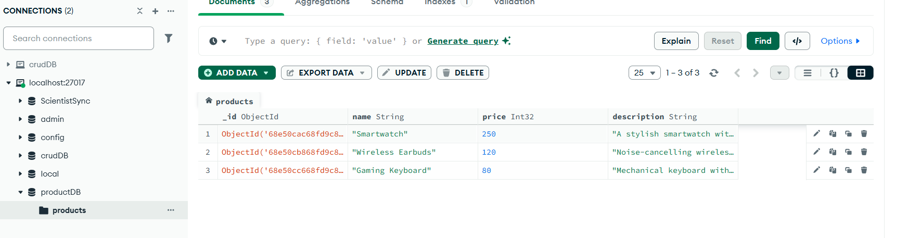

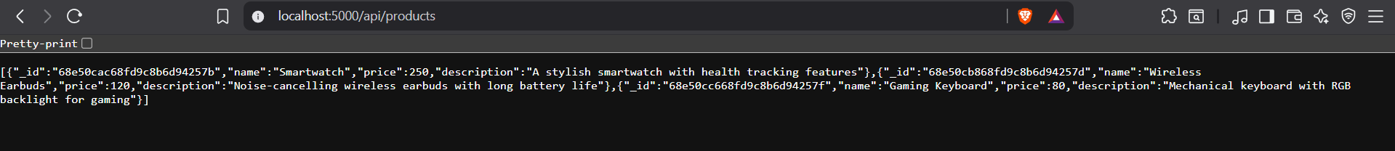

- Frontend:-
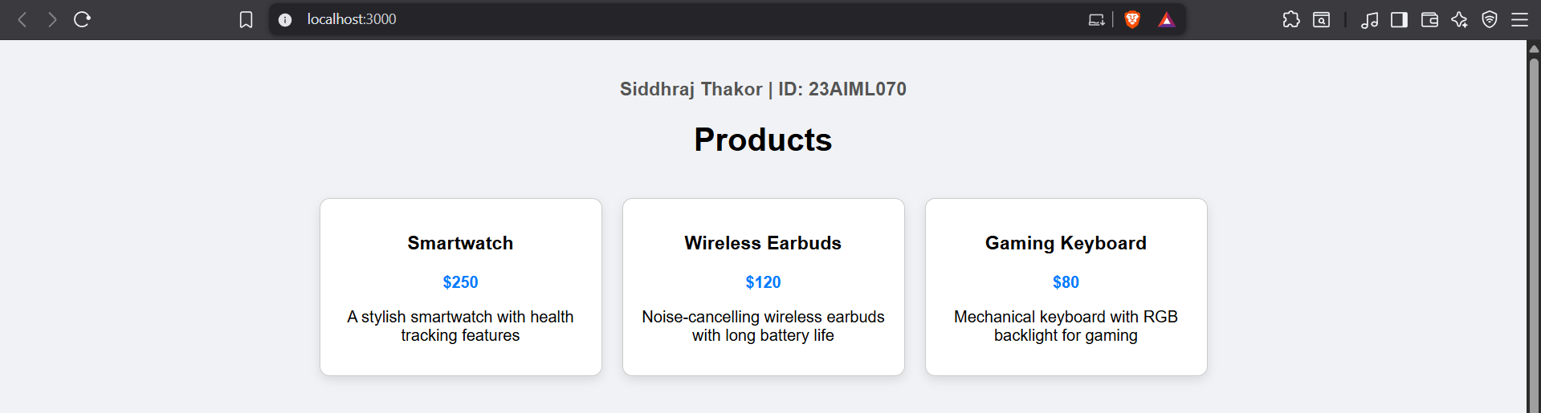

Code

