Aim : Take two numbers as input from the user and perform addition using the useState hook.

ScreenShots :-

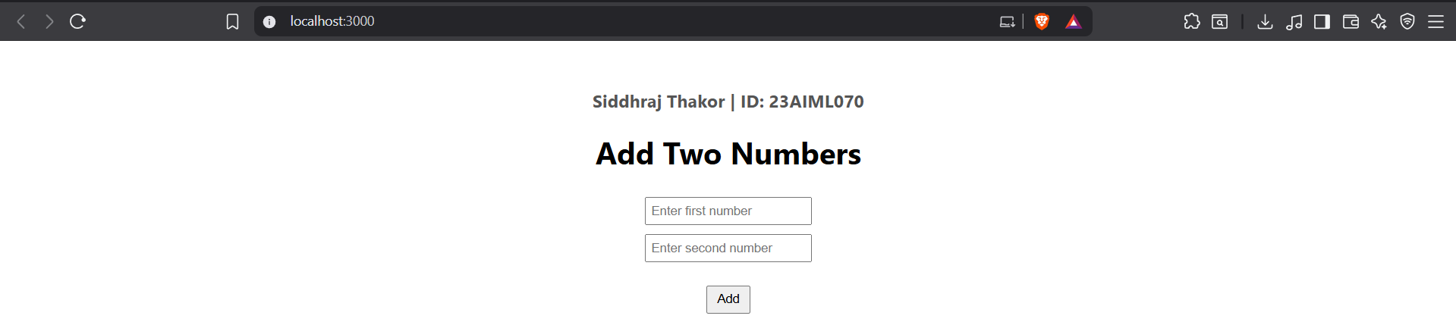

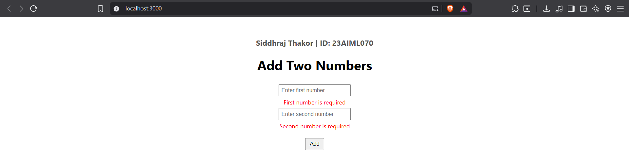

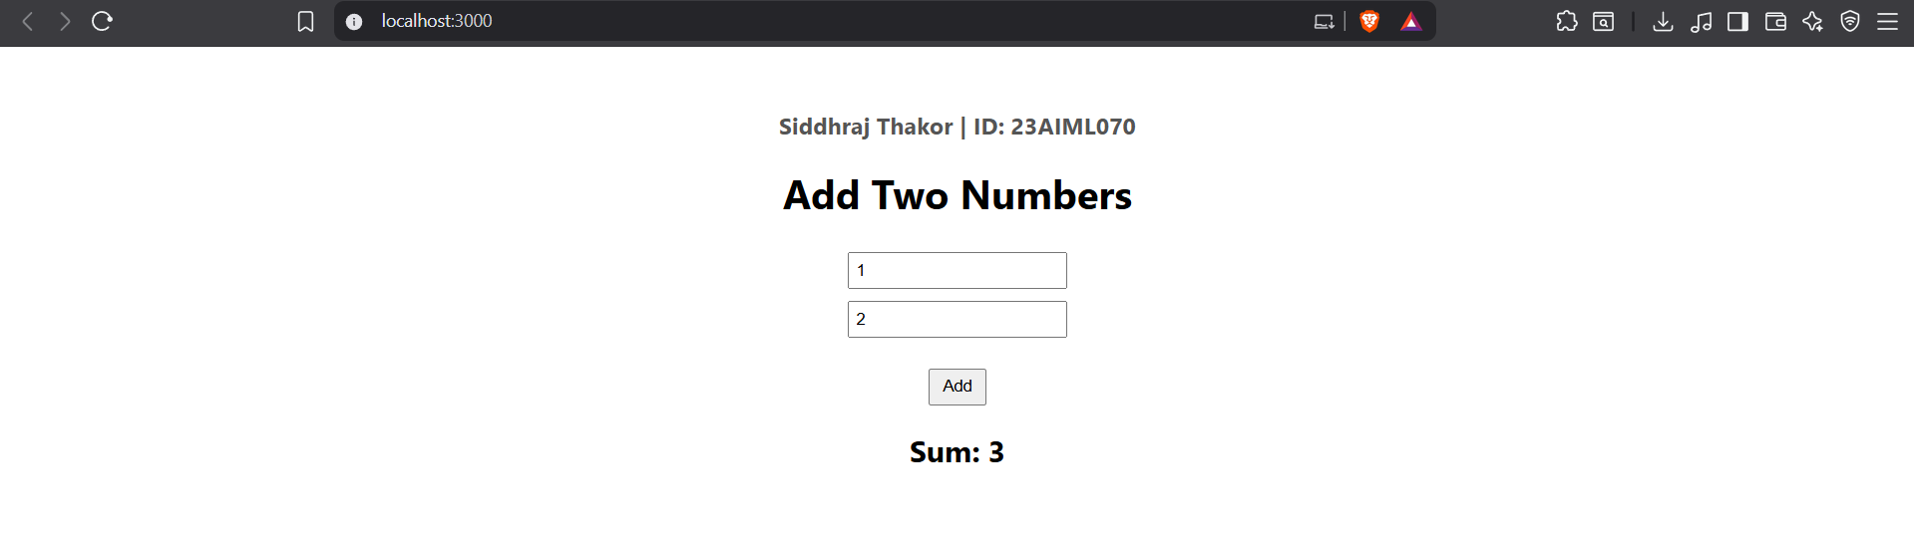

code

