Aim : Develop a Todo application using React JS

ScreenShots :-

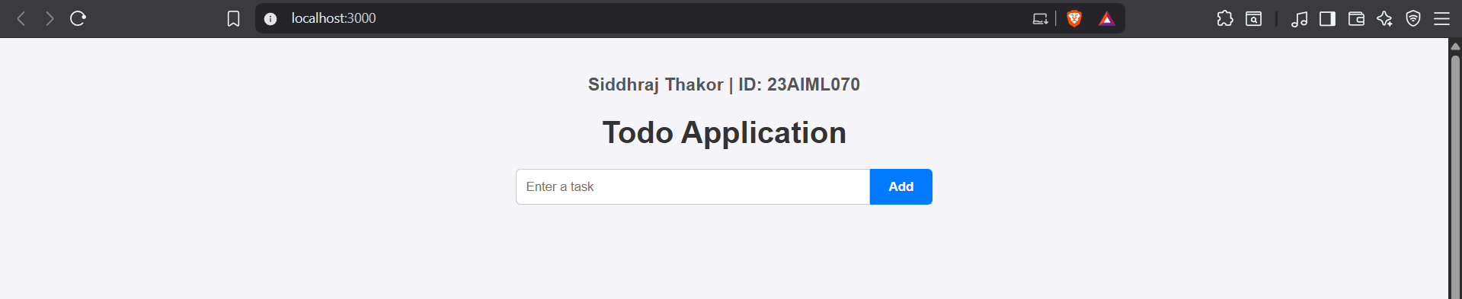

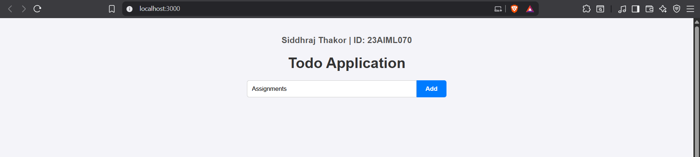

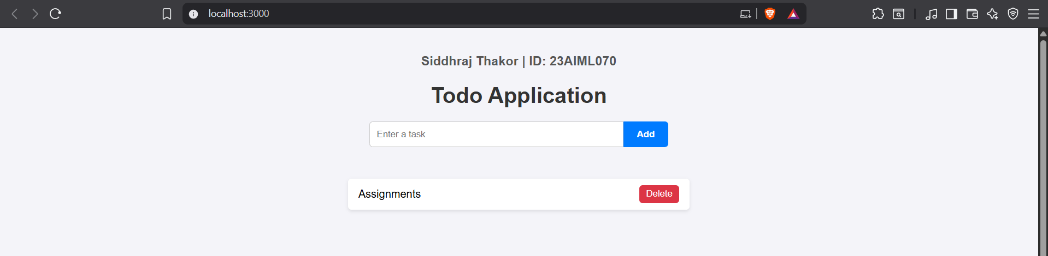

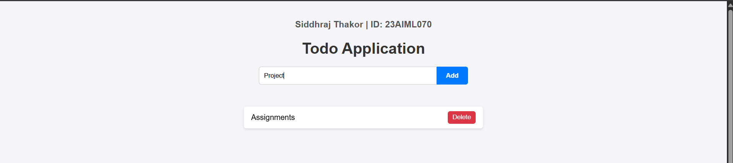

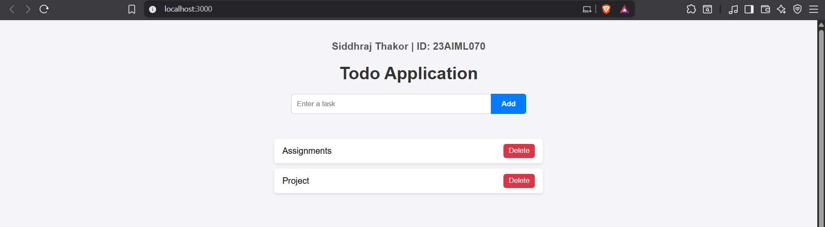
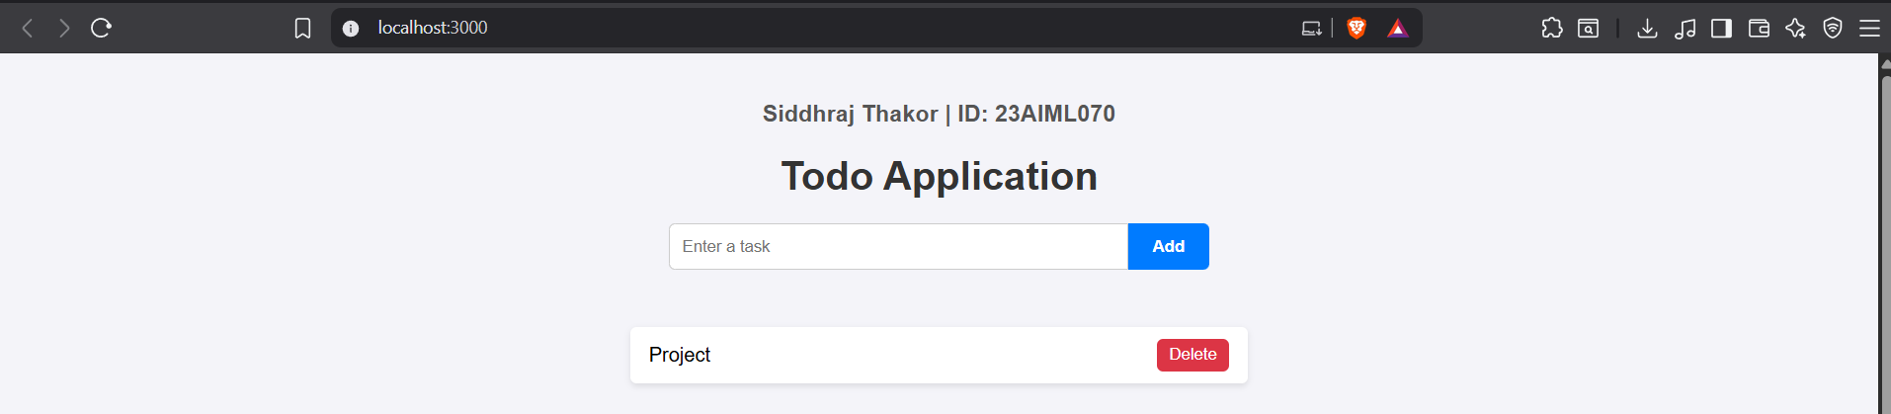

code

