Aim : Create a Product Card component and fetch product data from a free any online API.

ScreenShots :-

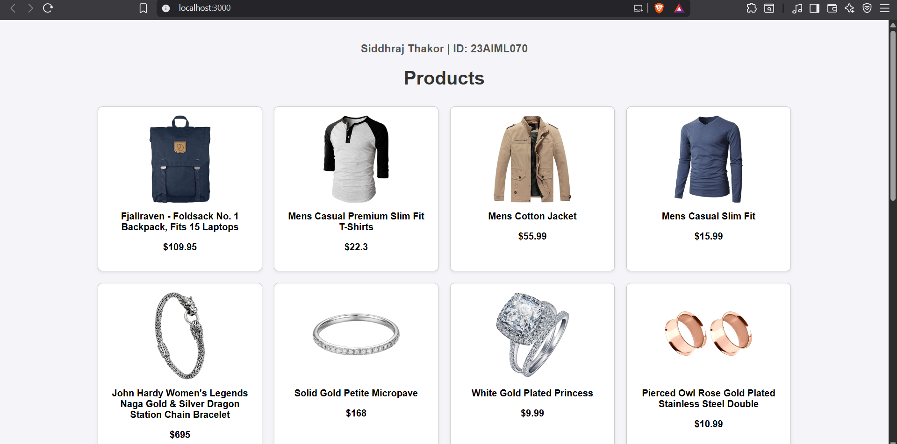

code

