Aim : Set up a basic Node.js and Express server with routing.

ScreenShots :-

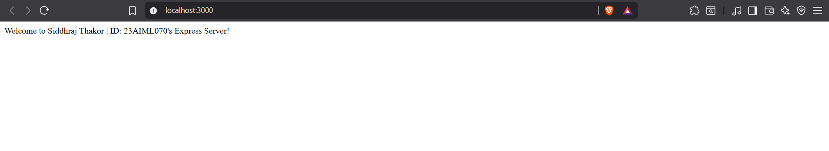

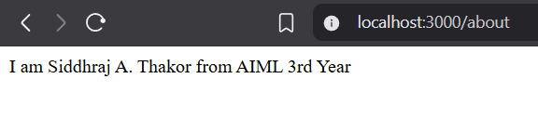

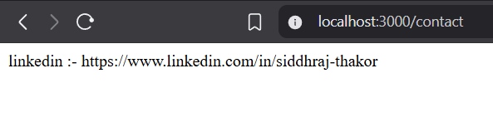

code

