Aim : Create an Express.js application that accepts two numbers via a POST request and displays the result using the EJS template engine.

ScreenShots :-

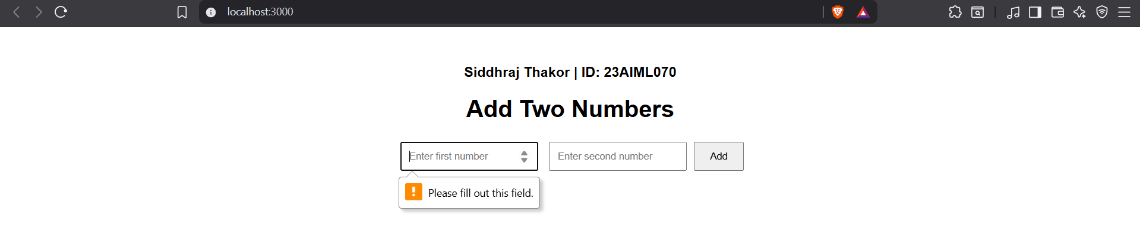

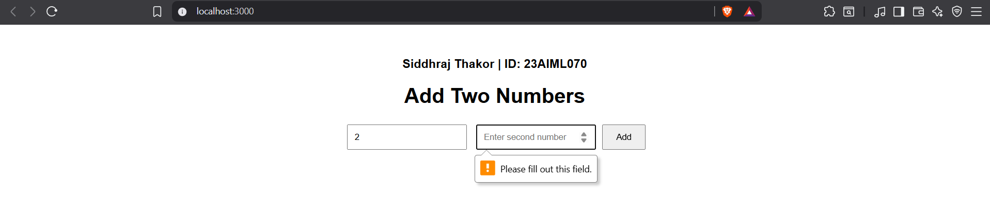

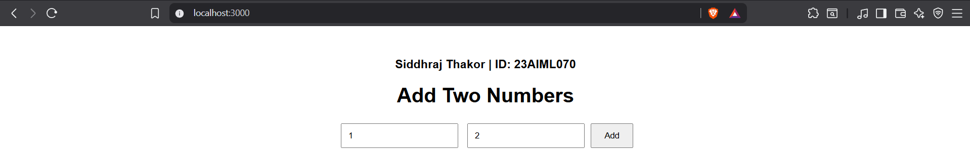

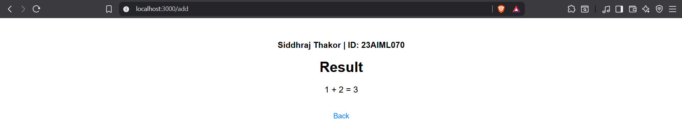
code

