Aim : Implement full CRUD (Create, Read, Update, Delete) operations using Express.js and MongoDB.

ScreenShots :-

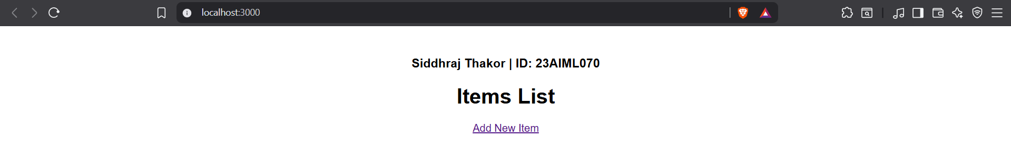

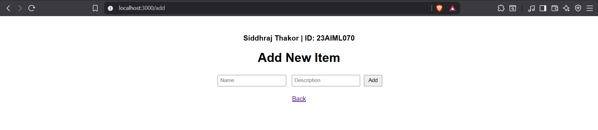

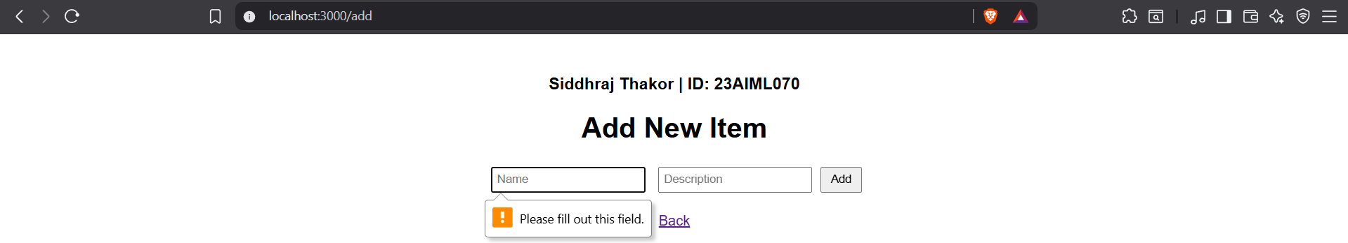

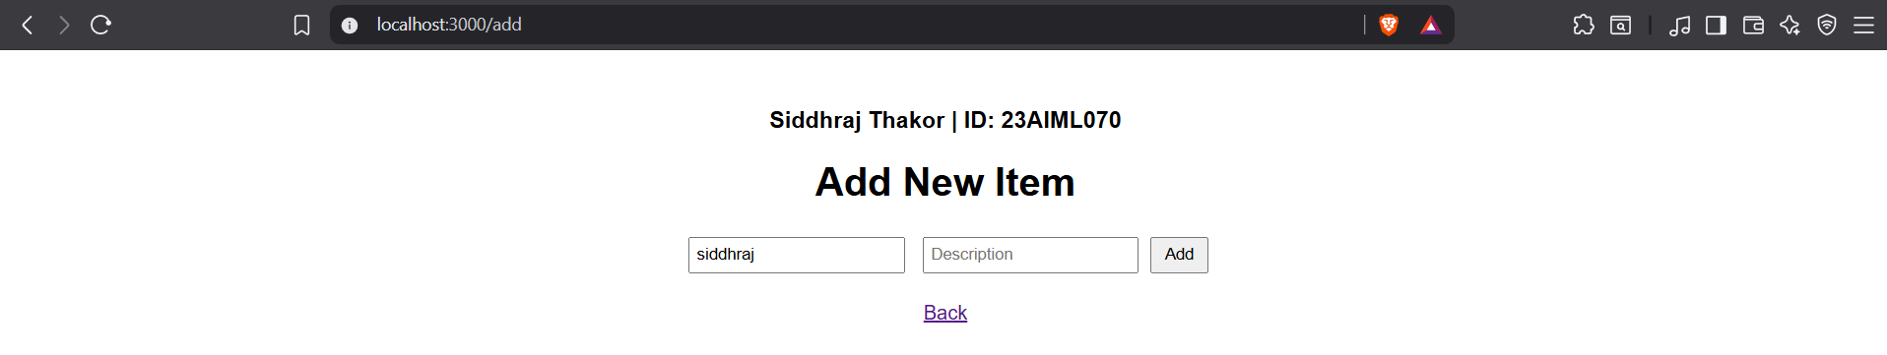

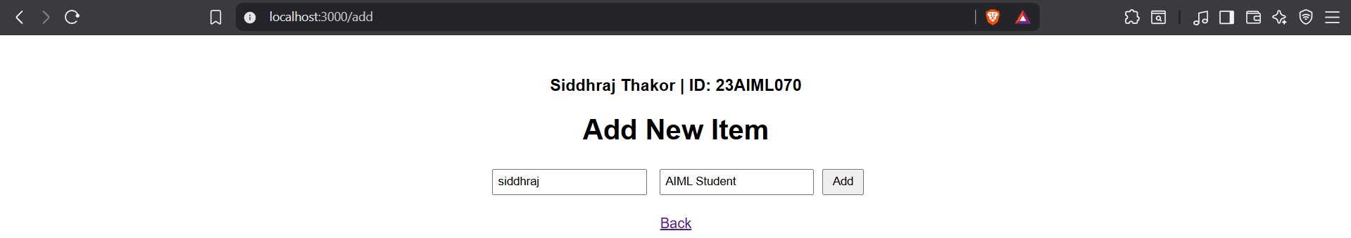

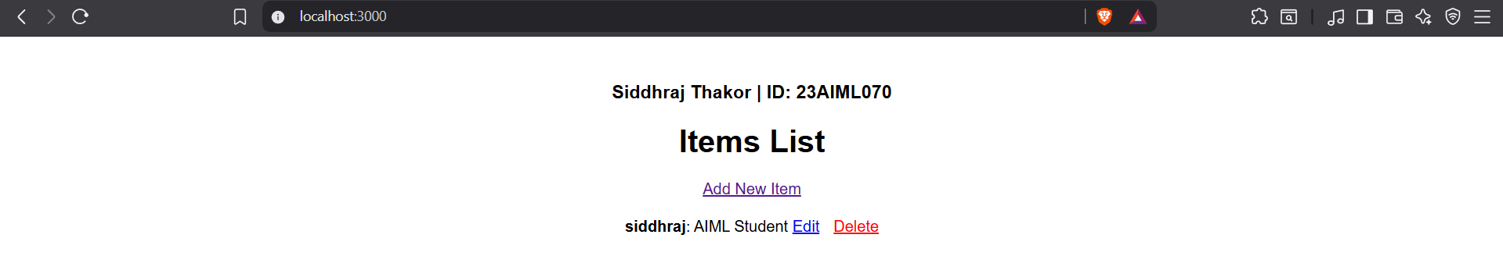

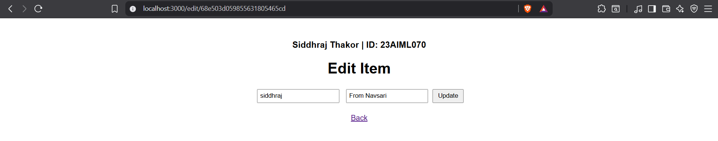

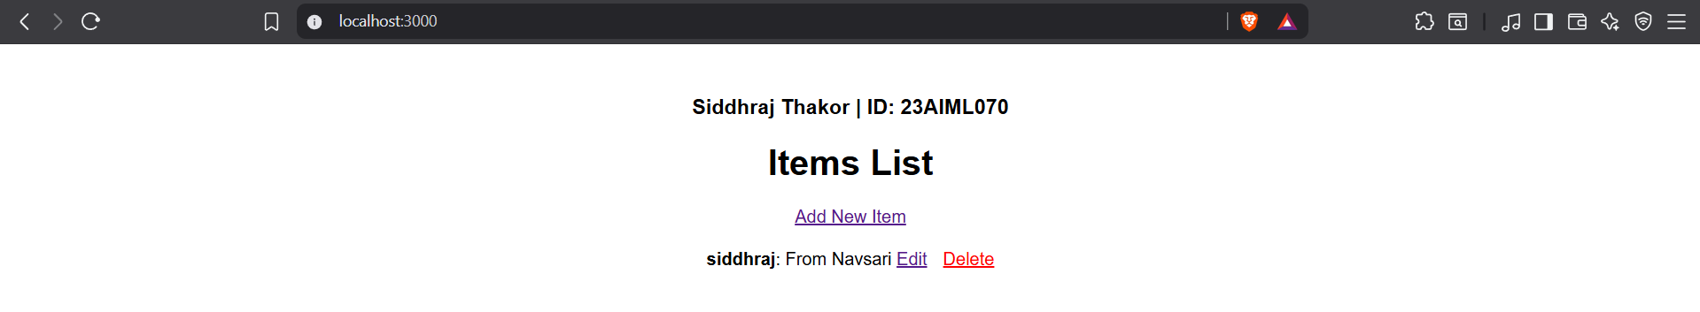

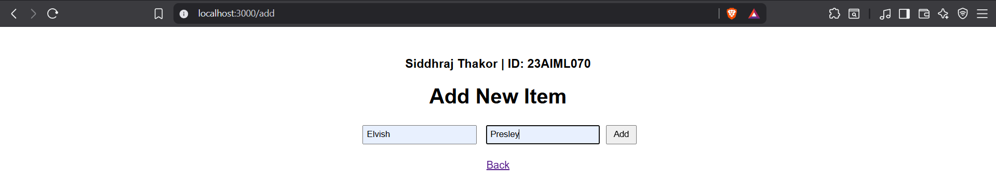

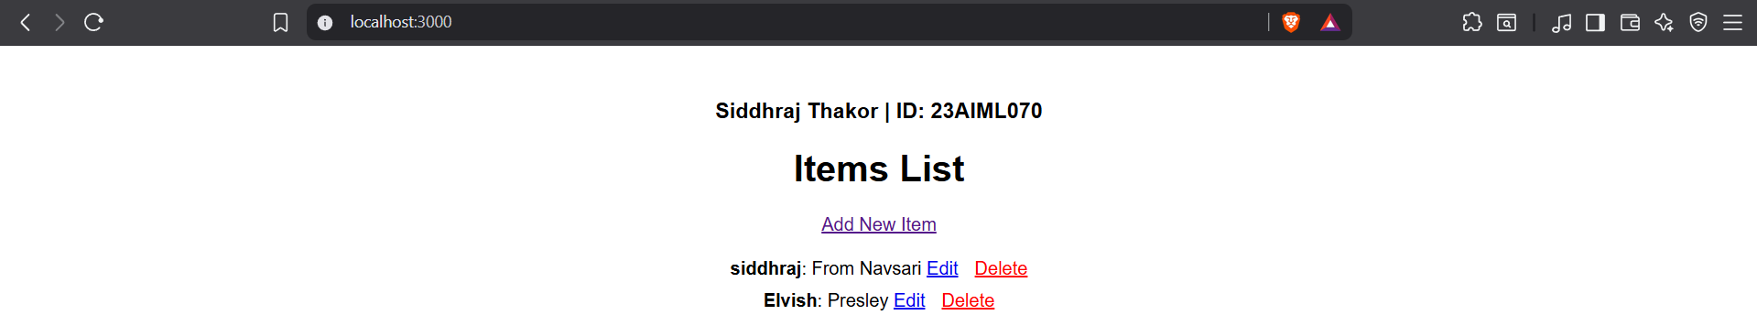

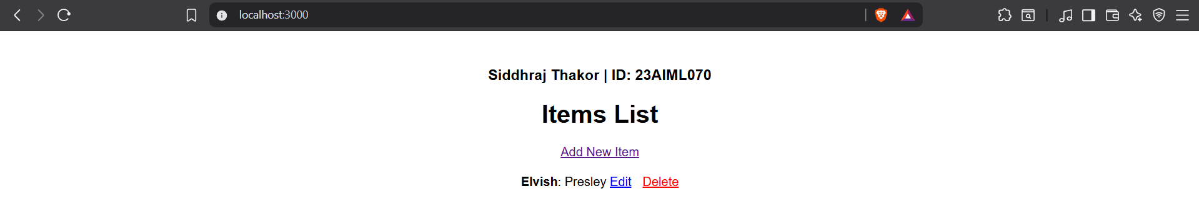

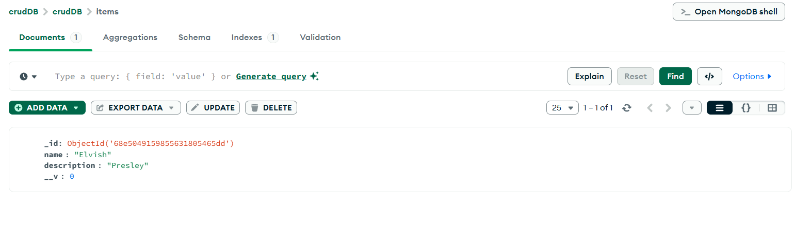
code

