ALL CODES

Aim : Create a React JS project and implement navigation between multiple components.

ScreenShots :-

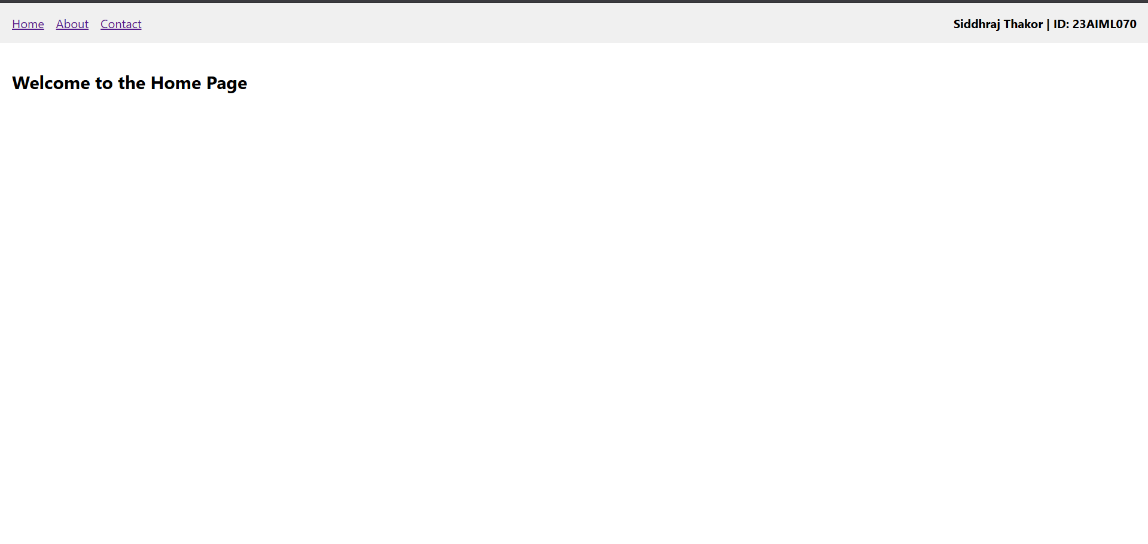

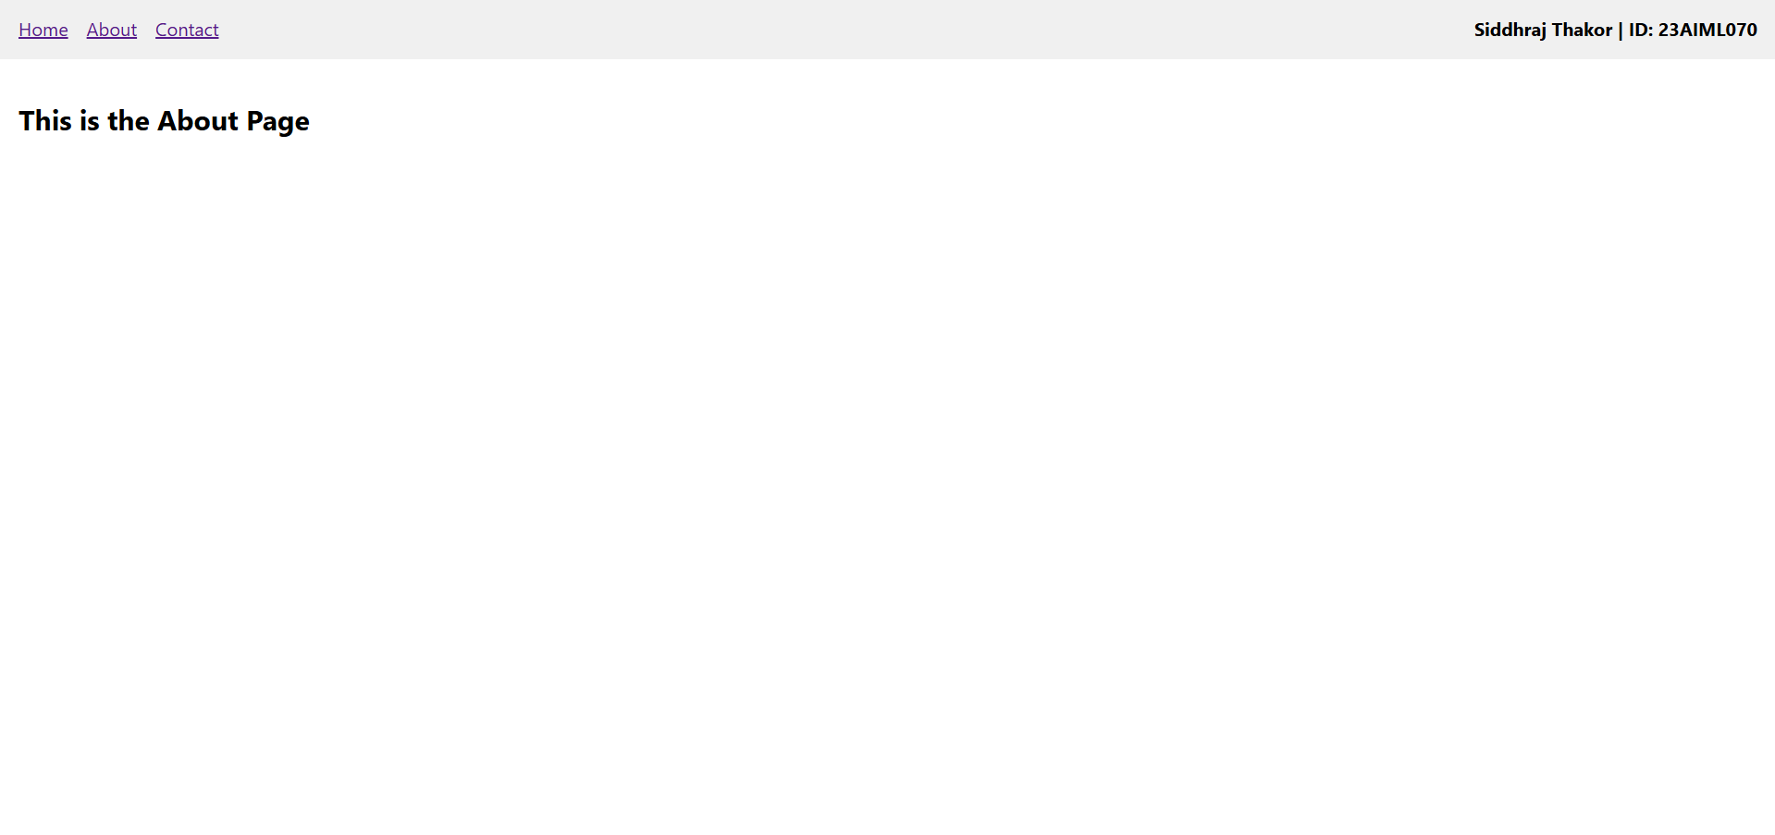
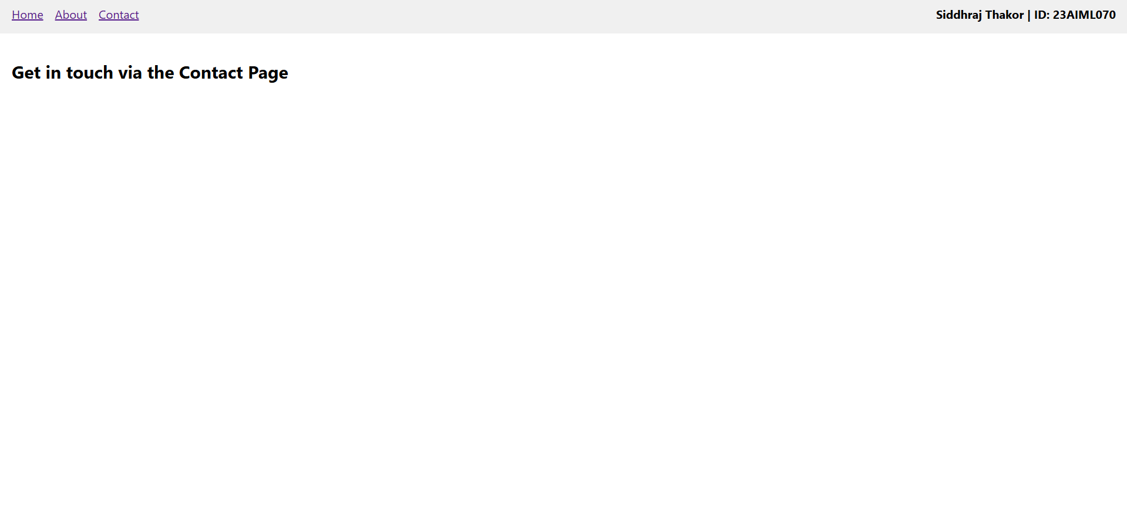

Aim : Build a Counter application using React JS with Increment, Decrement, and Reset functionality.

ScreenShots :-

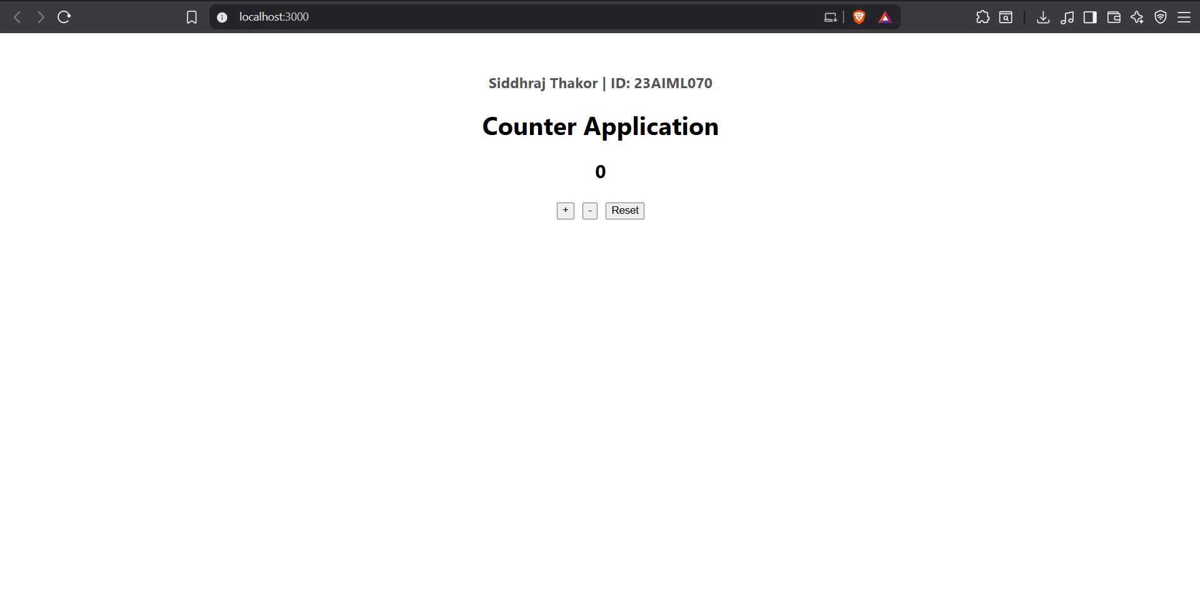

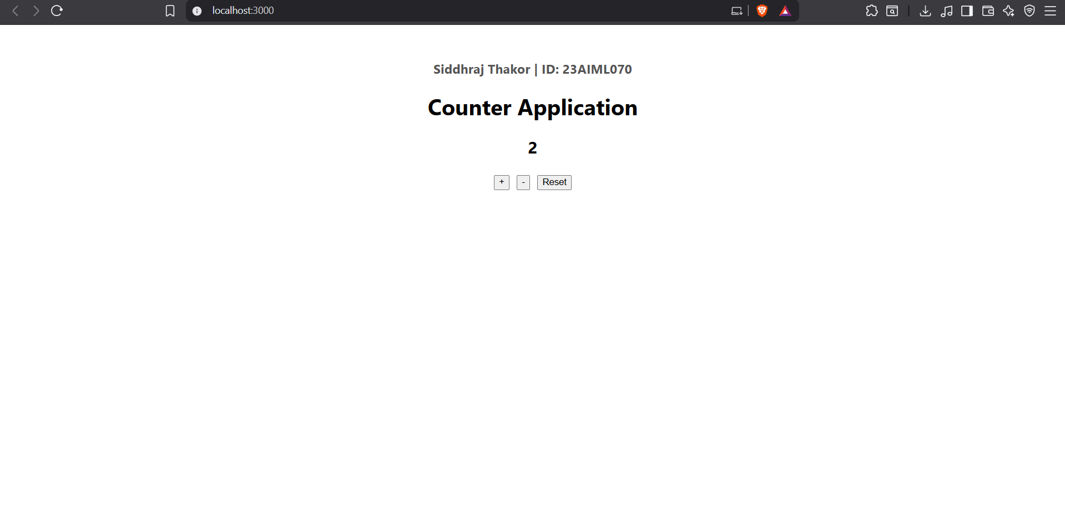

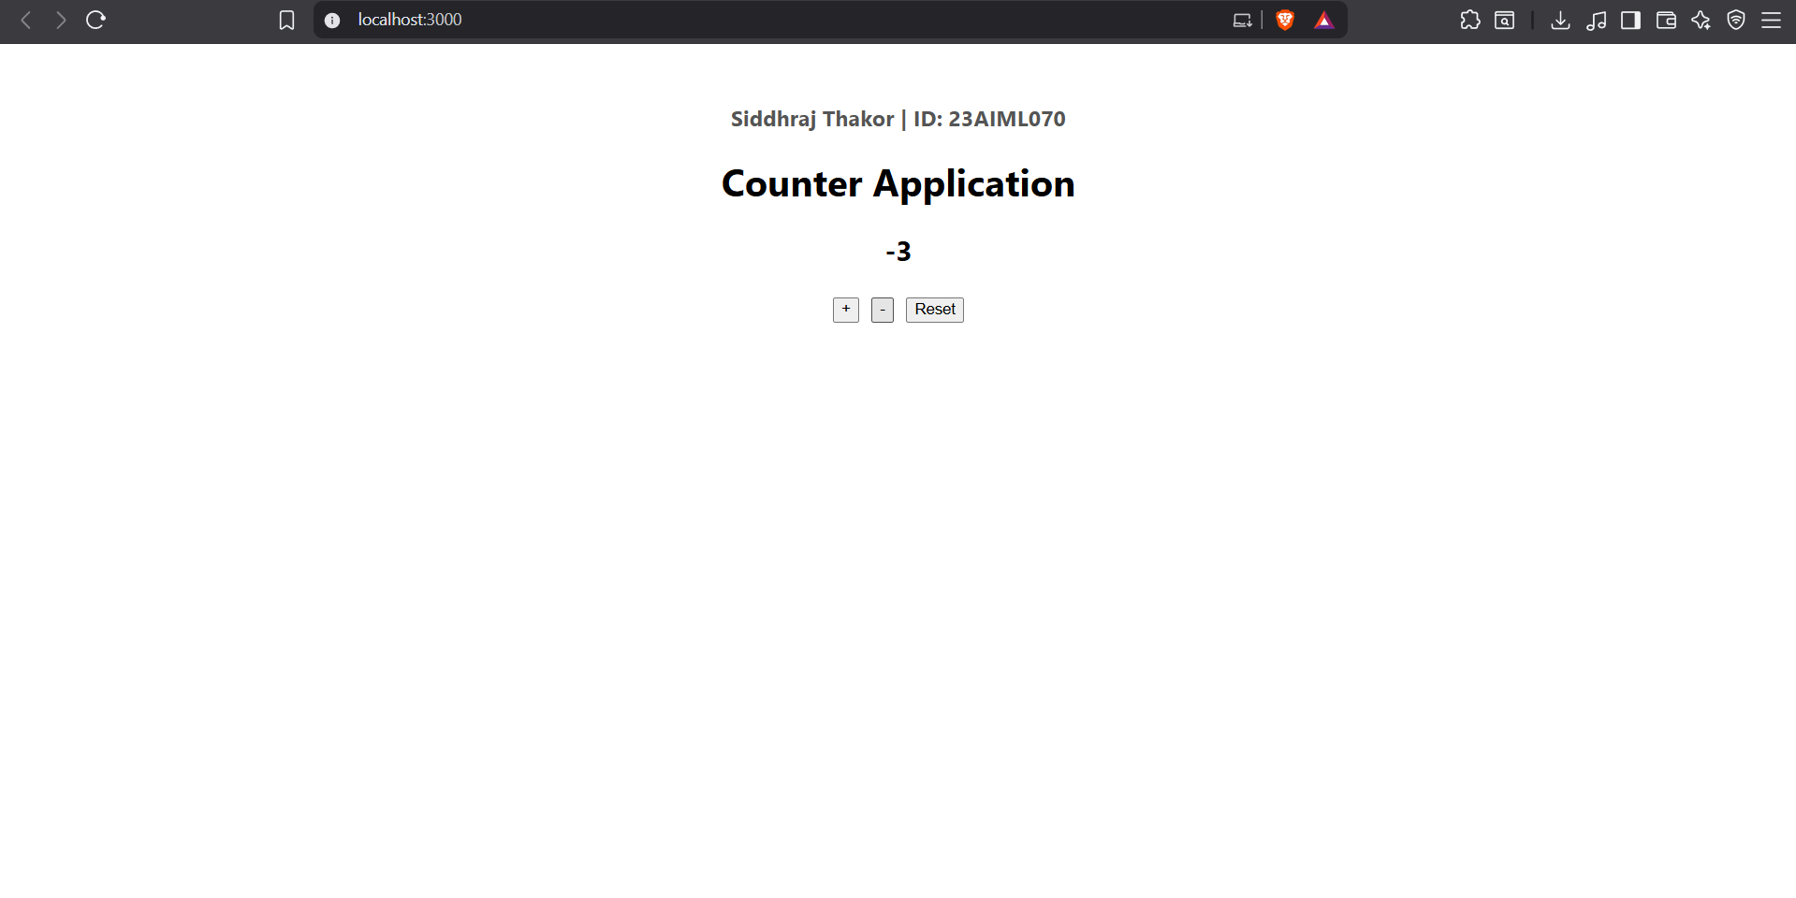

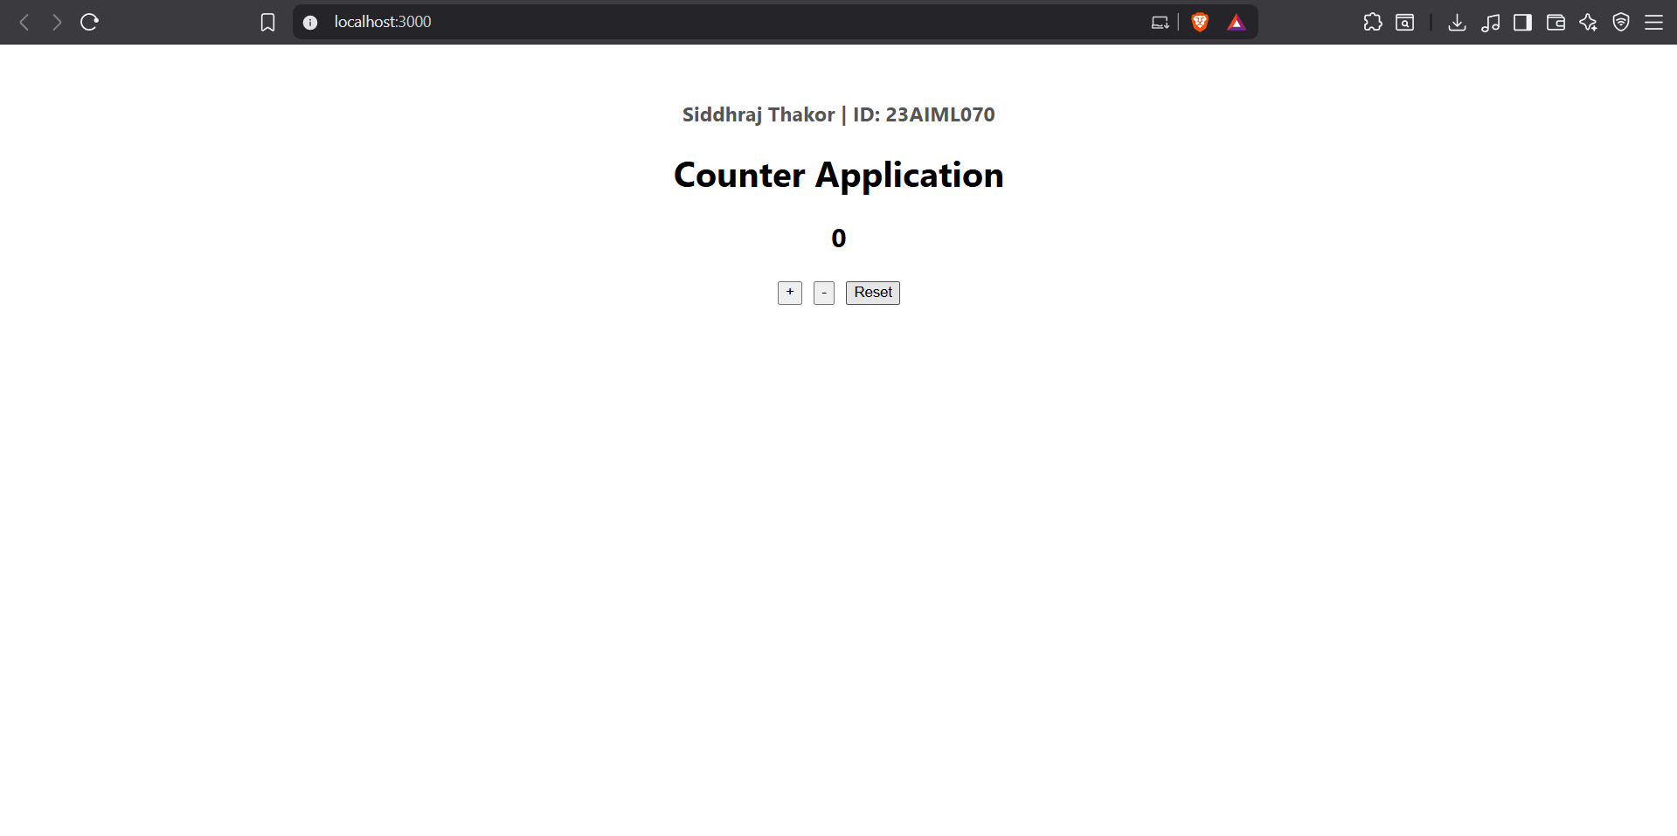

Aim : Take two numbers as input from the user and perform addition using the useState hook.

ScreenShots :-

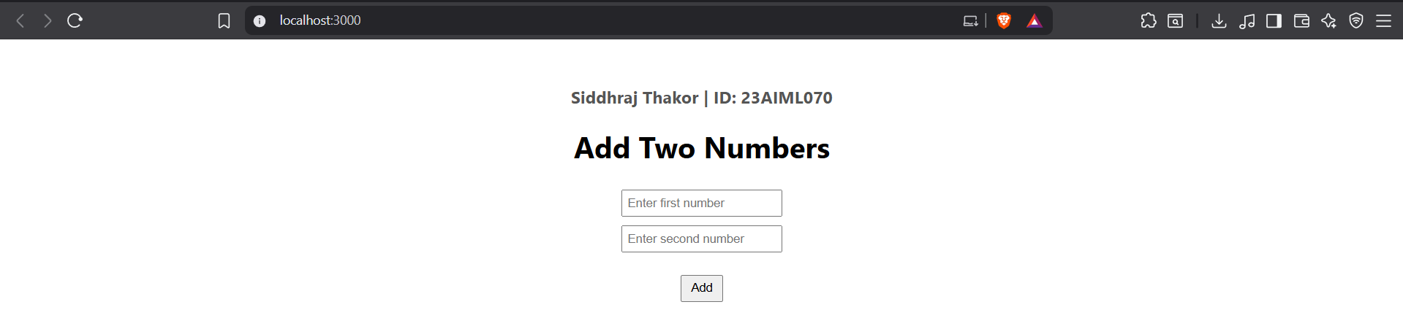

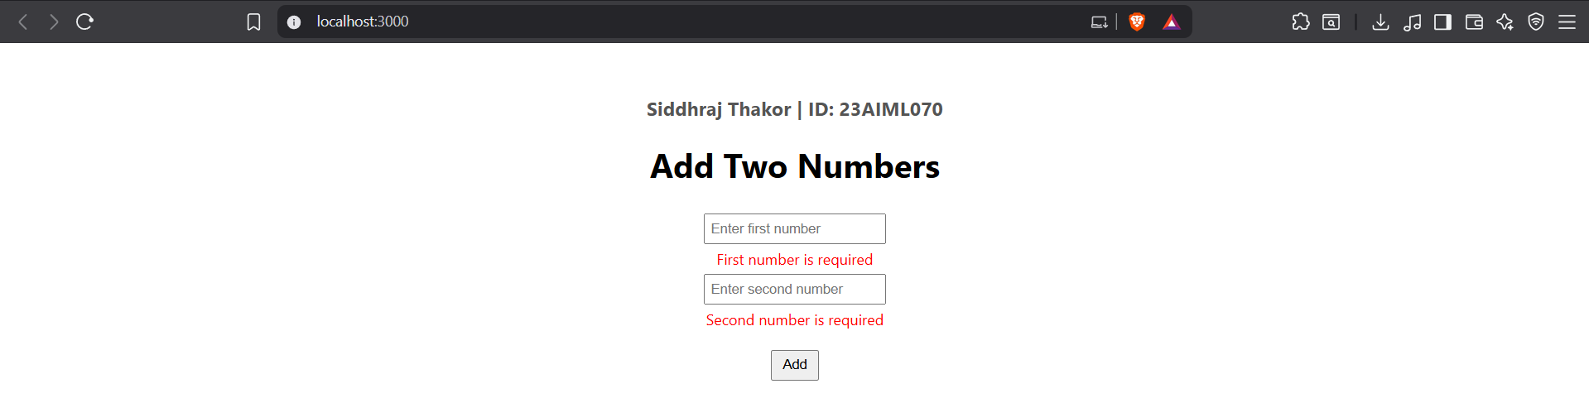

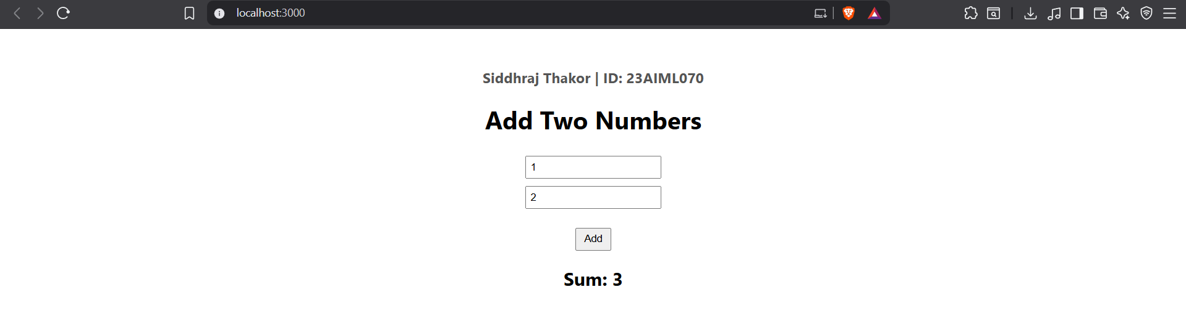

Aim : Develop a Todo application using React JS

ScreenShots :-

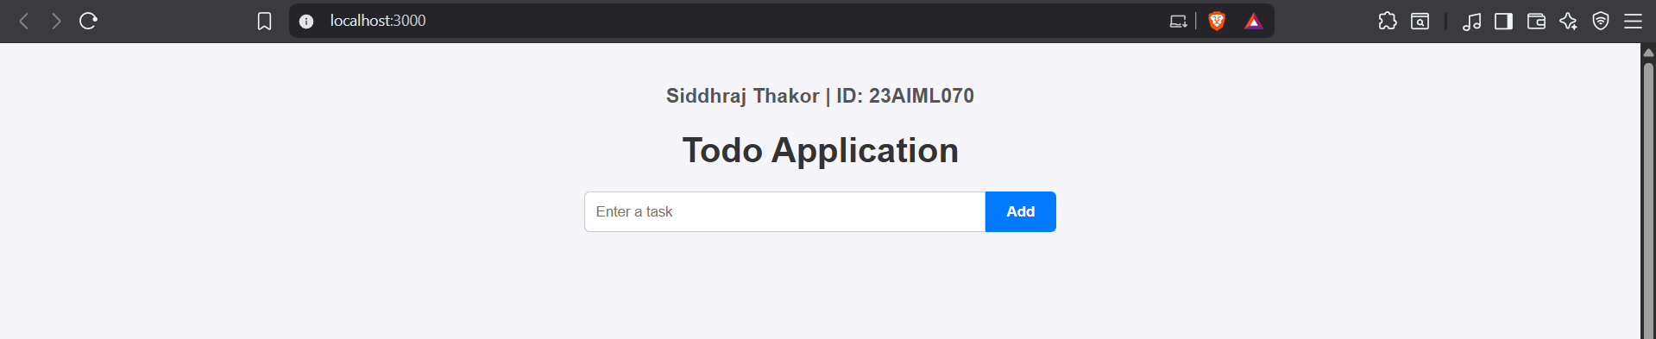

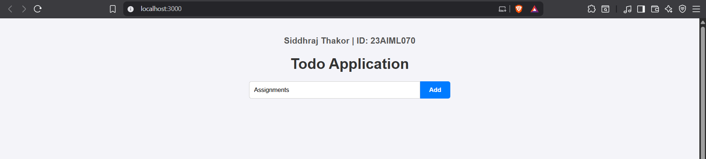

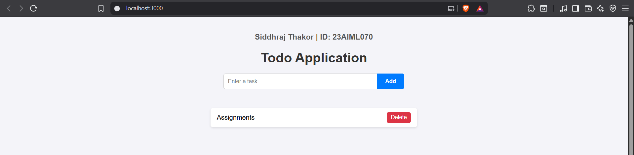

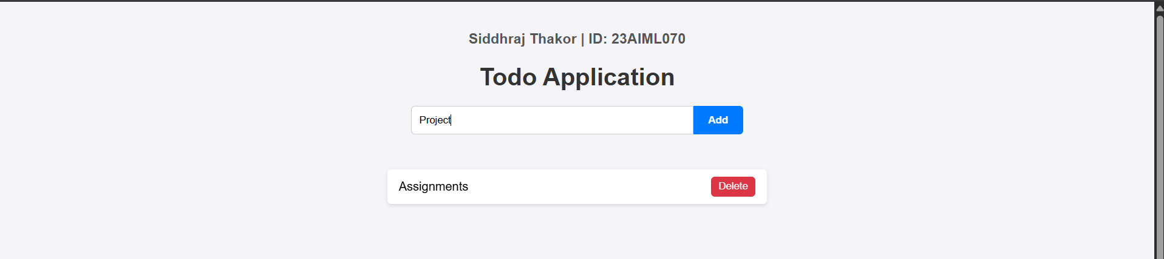

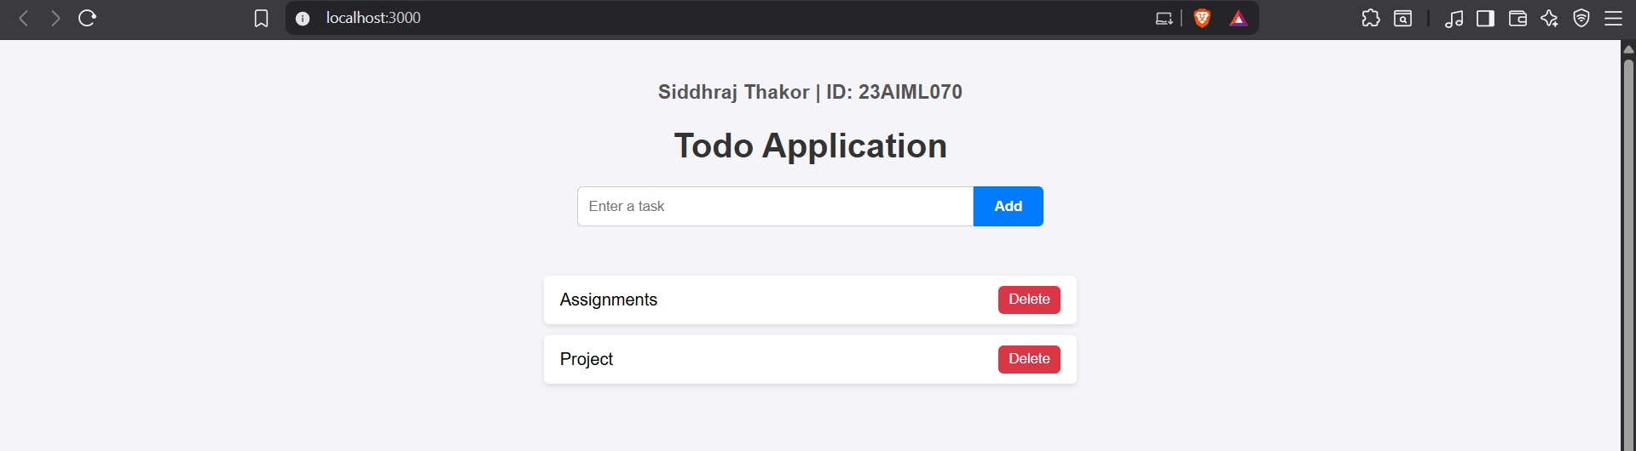

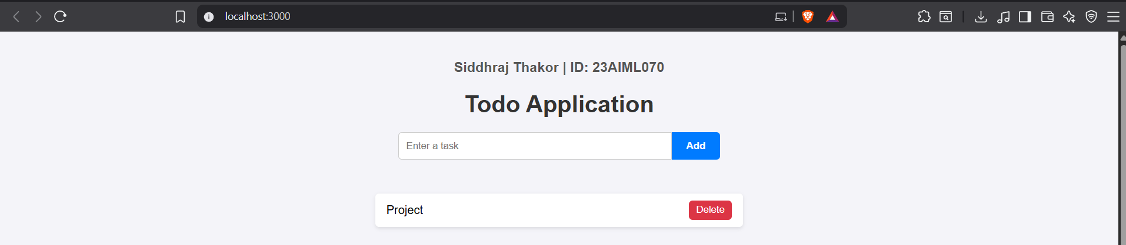

Aim : Create a Signup form with necessary validations and store the data in LocalStorage.

ScreenShots :-

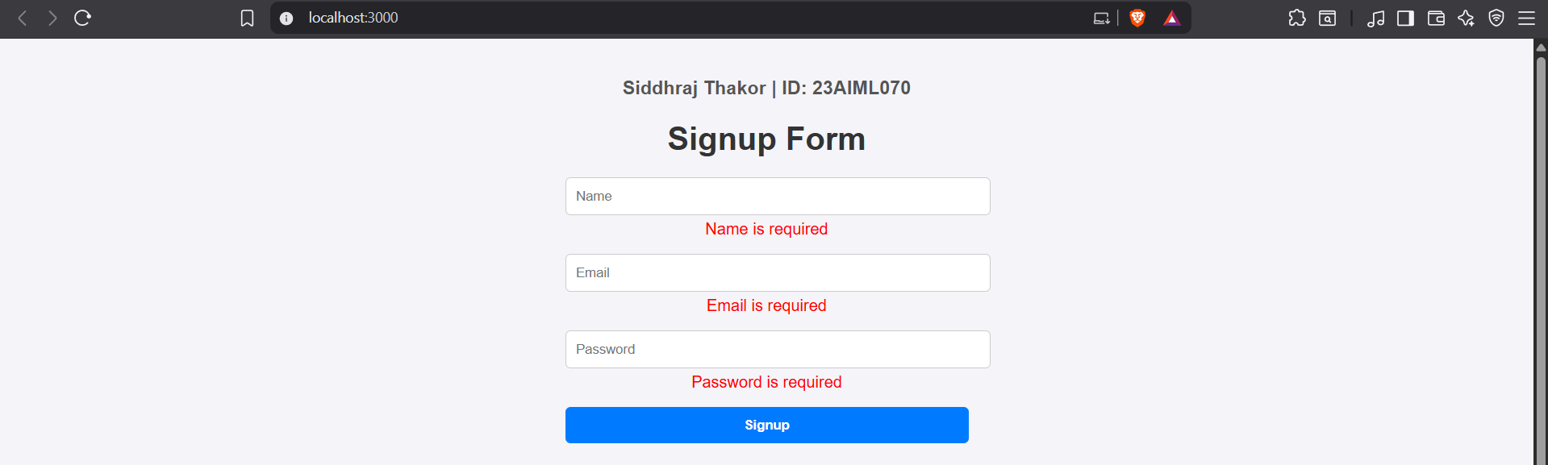

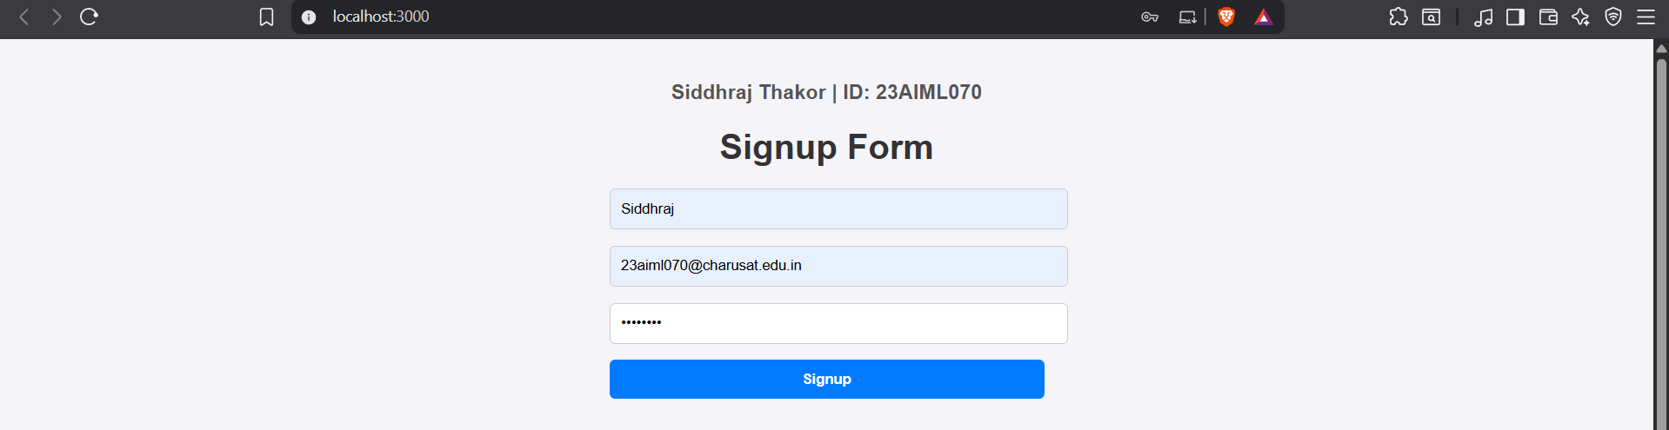
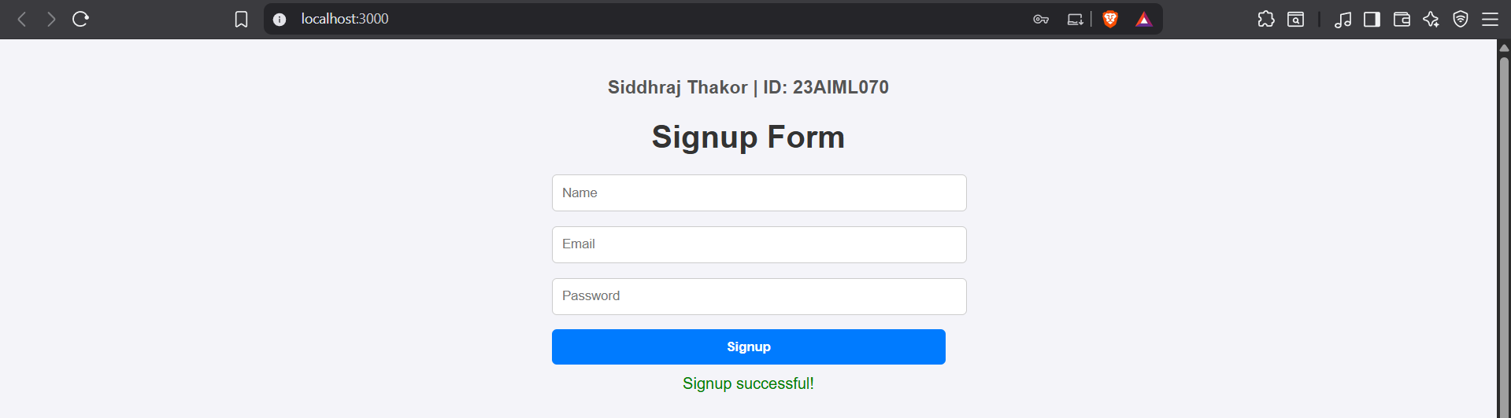
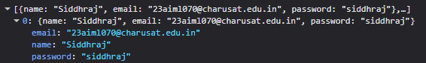

Aim : Create a Product Card component and fetch product data from a free any online API.

ScreenShots :-

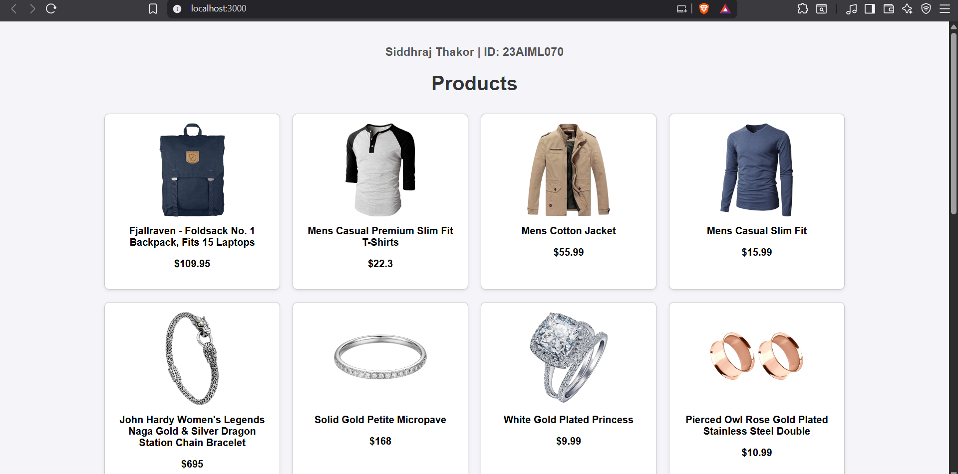

Aim : Set up a basic Node.js and Express server with routing.

ScreenShots :-

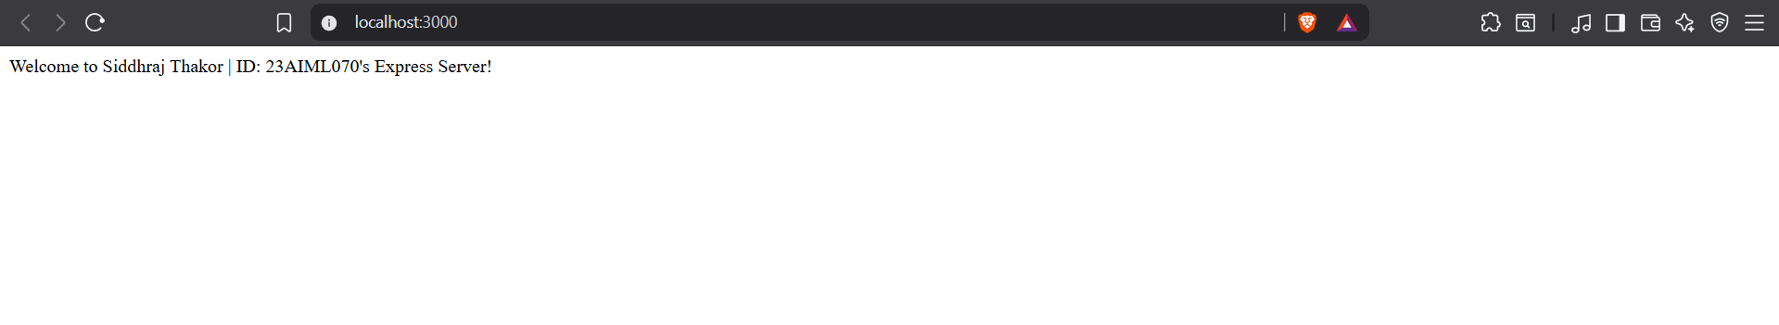

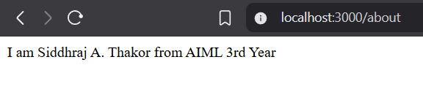

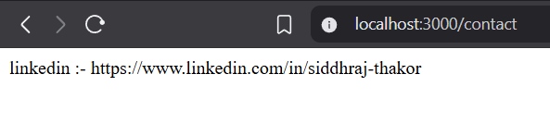

Aim : Create an Express.js application that accepts two numbers via a POST request and displays the result using the EJS template engine.

ScreenShots :-

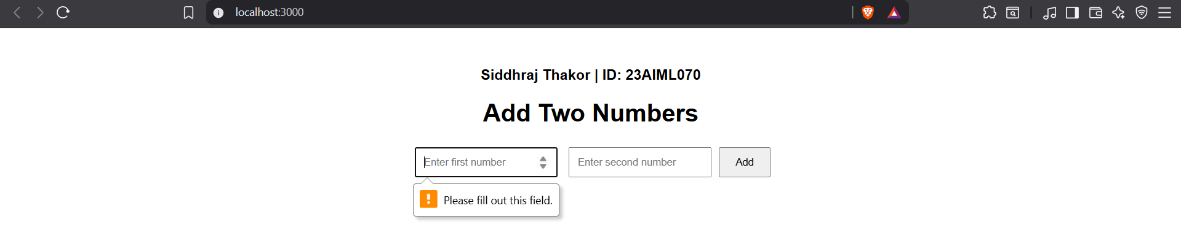

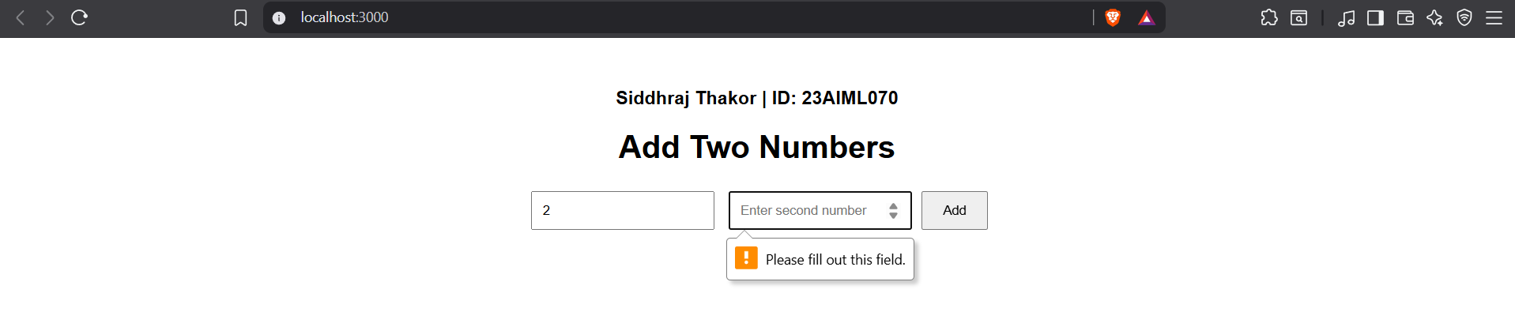

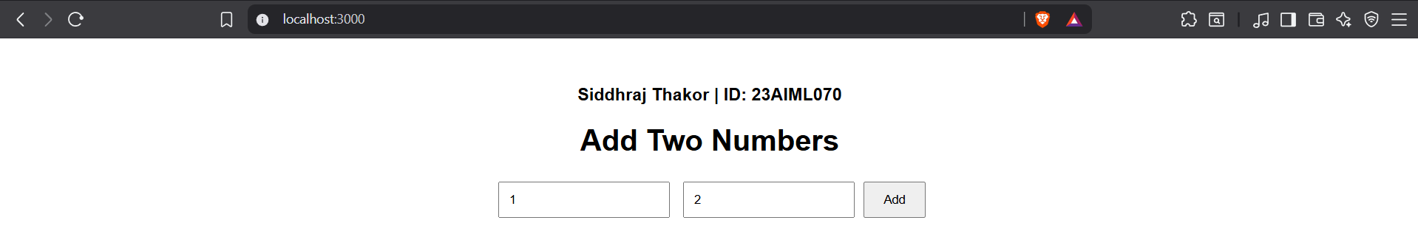

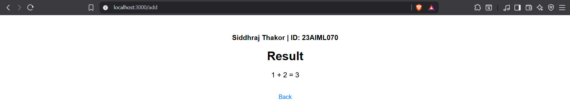

Aim : Implement full CRUD (Create, Read, Update, Delete) operations using Express.js and MongoDB.

ScreenShots :-

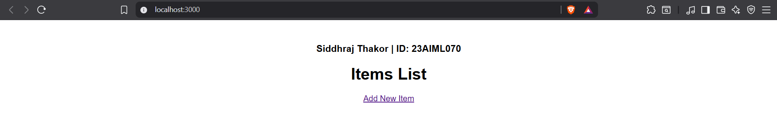

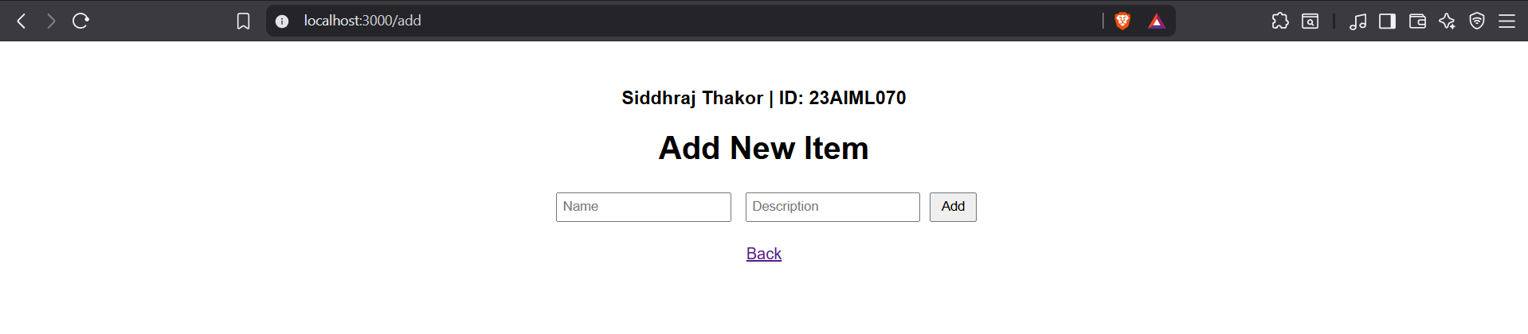

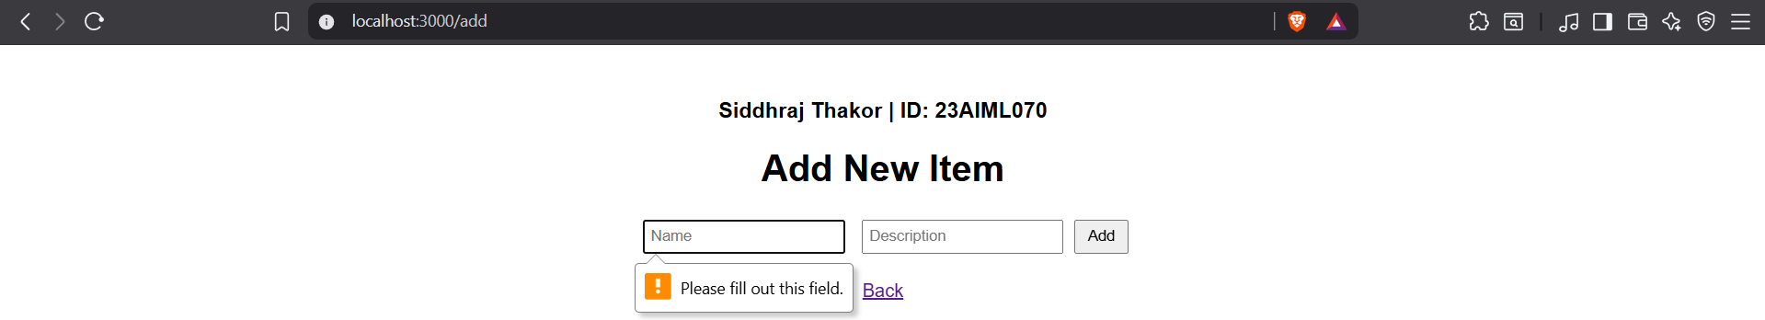

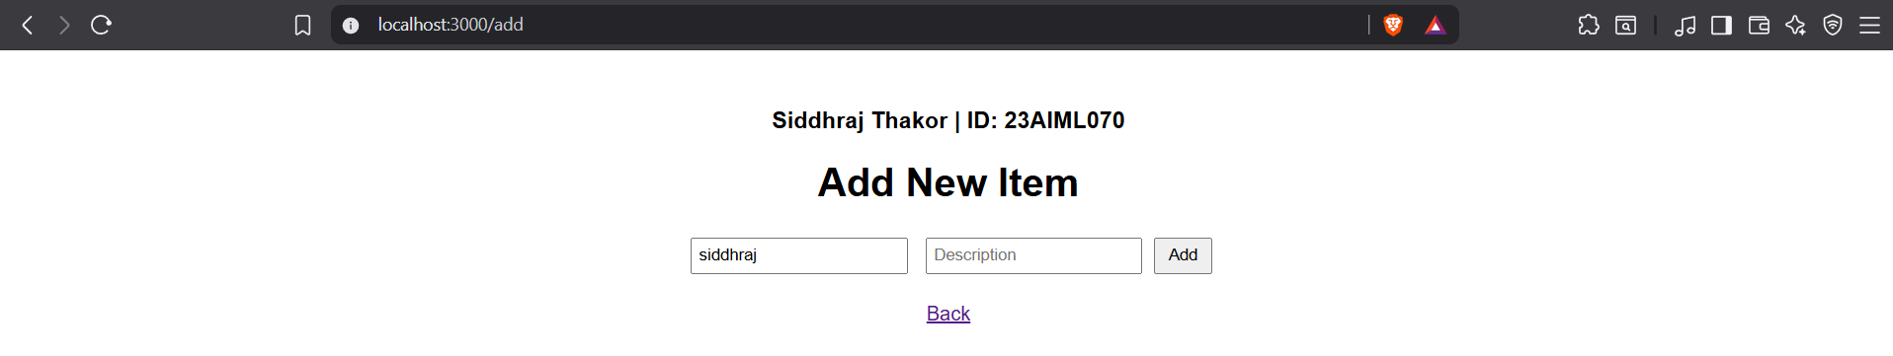

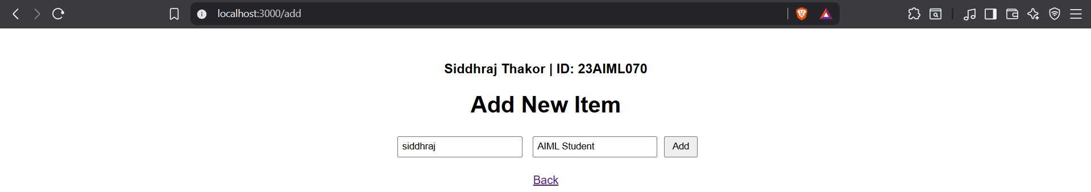

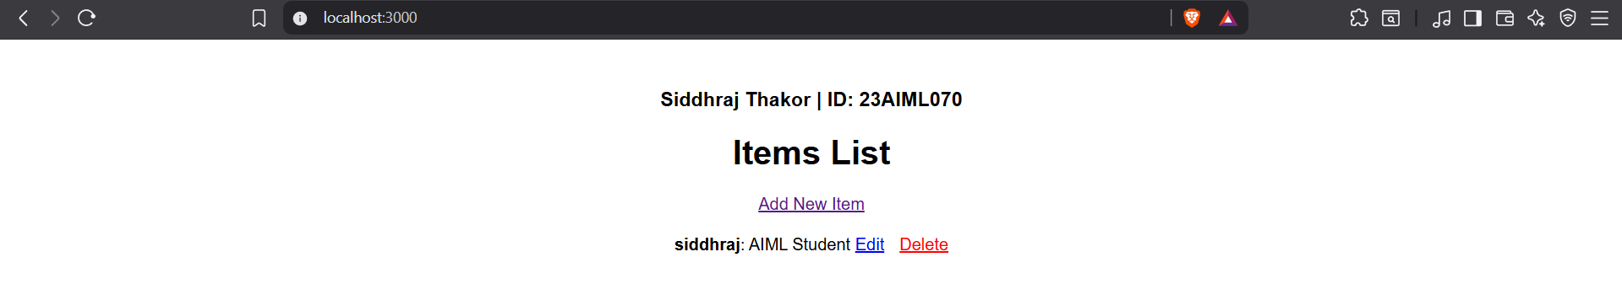

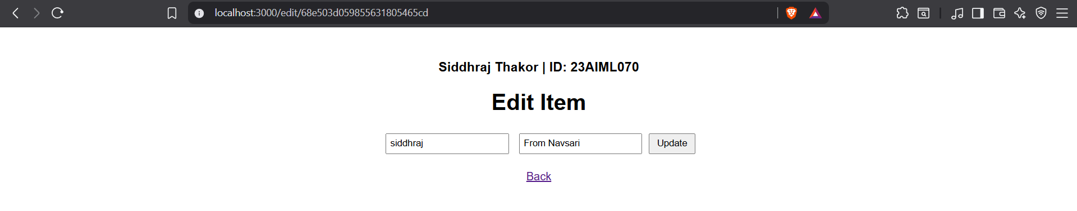

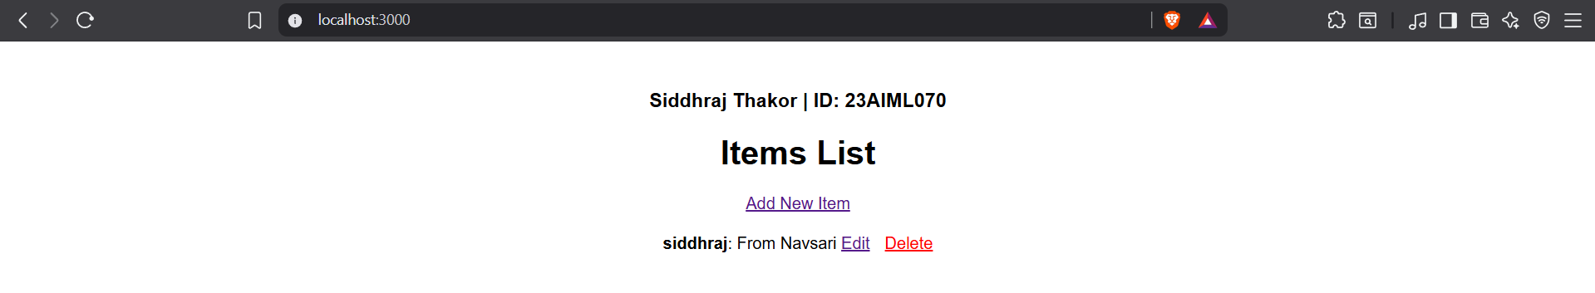

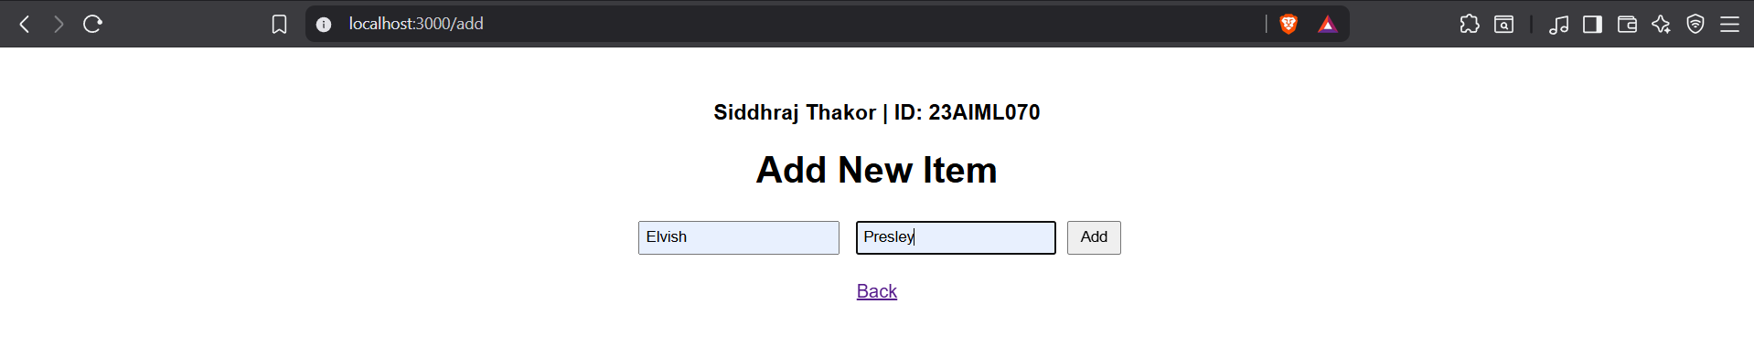

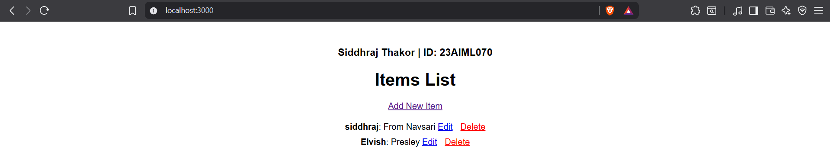

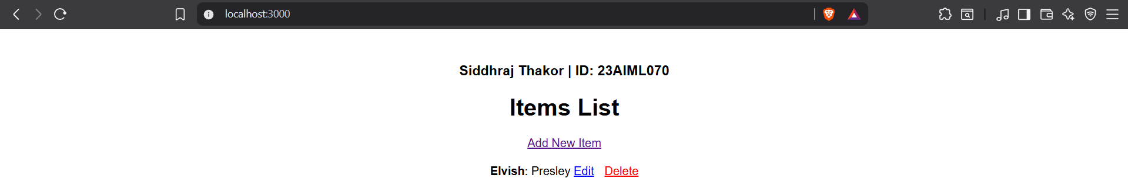

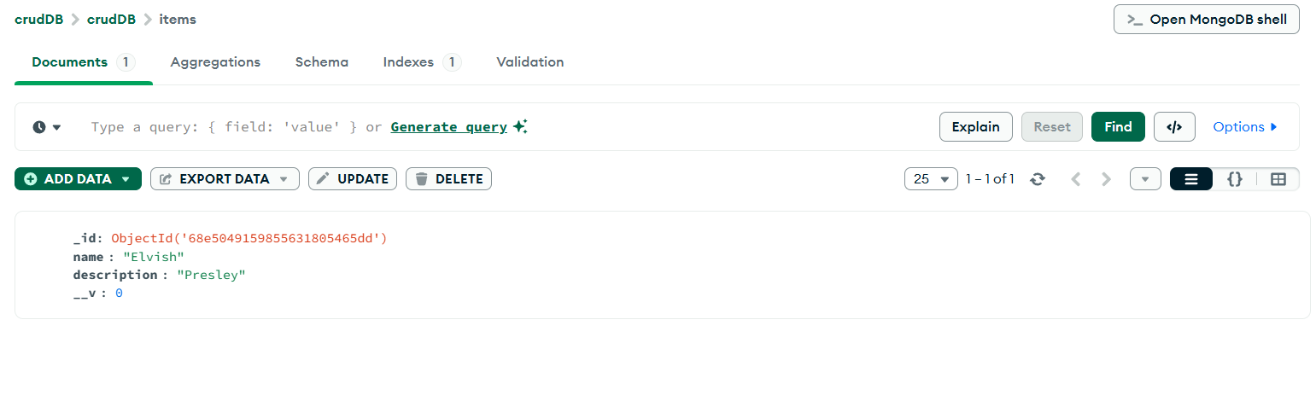

Aim : Build a Product API using Express.js and MongoDB, and fetch/display the product data in a React.js frontend using Axios.

ScreenShots :-

- Backend:-
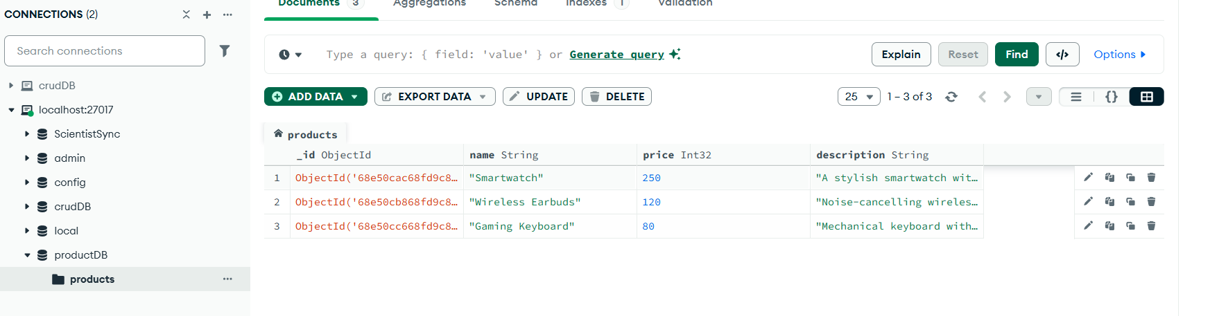

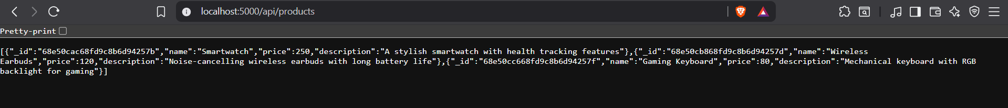

- Frontend:-
