# **PRACTICAL 10**

**AIM** - To create a PL/SQL procedure that performs the multiplication of two numbers.

**Theoretical Description :**

This PL/SQL procedure focuses on performing multiplication of two numeric input values while adhering to structured programming principles. It accepts two parameters of type NUMBER and provides the calculated result using an output parameter. The procedure also incorporates mechanisms to validate inputs and handle any errors effectively.

**Key Features and Constraints**

1. **Input Parameters**: The procedure takes two input parameters of data type NUMBER to ensure compatibility with numerical operations.
2. **Output Parameter**: The calculated product is returned via an output parameter for enhanced clarity in the code structure.
3. **Validation and Error Handling**: Comprehensive validation is implemented to address scenarios like incorrect data types or unexpected runtime issues, ensuring the procedure remains robust and reliable.

**Constraints**

1. Input Parameters: The procedure will accept two input parameters of type NUMBER.

2. Output Parameter: The procedure will have an output parameter to return the result of the

multiplication.

3. Error Handling: The procedure will handle potential errors such as invalid input types.

**Query:**

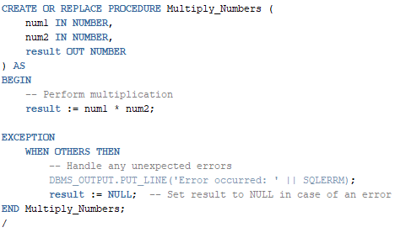

**Output:**



**Test Case 1**: Multiplying two positive numbers

**Input**: num1 = 10, num2 = 5

**Expected Output**: The result should be 50.

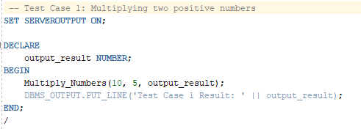

**Output** :

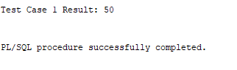

**Test Case 2**: Multiplying a positive number and zero

**Input**: num1 = 15, num2 = 0

**Expected Output**: The result should be 0.

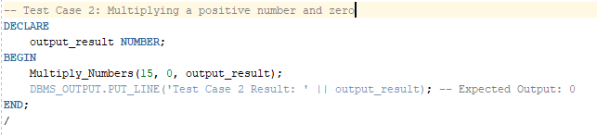

**Output** :

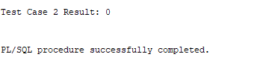

**Test Case 3**: Multiplying two negative numbers

**Input**: num1 = -4, num2 = -6

**Expected Output**: The result should be 24.

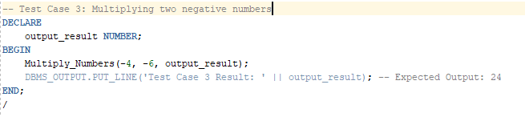

**Output** :

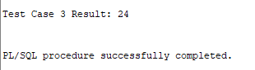

**Test Case 4**: Multiplying a positive number and a negative number

**Input**: num1 = 7, num2 = -3

**Expected Output**: The result should be -21.

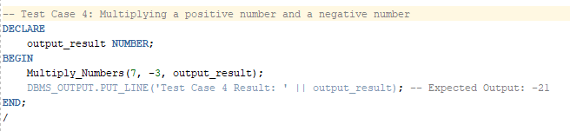

**Output** :

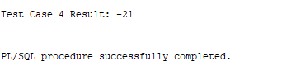

**Test Case 5**: Multiplying two floating-point numbers

**Input**: num1 = 2.5, num2 = 4.2

**Expected Output**: The result should be 10.5.

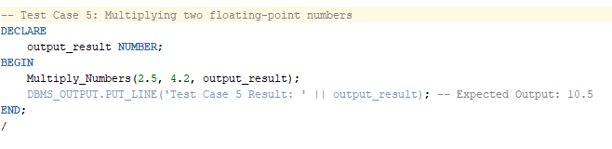

**Output** :

