**PRACTICAL - 3**

**Aim: To Perform Data Query Language (DQL) and Data Manipulation Language (DML) Commands.**

**Theoretical Description:**

* **DQL (Data Query Language) :**

**DQL is used to retrieve data from a database without modifying it. The main command in DQL is SELECT.**

* **SELECT: Retrieves data from a table.**
* **DML (Data Manipulation Language) :**

**DML is used to manipulate data in the database. It includes commands like INSERT, UPDATE, and DELETE.**

* **INSERT: Adds new data to a table.**
* **UPDATE: Modifies existing data in a table.**
* **DELETE: Removes data from a table.**

**Query-1: Retrieve all data from employee, jobs and deposit.**

**SQL Statement:**

**select * from Employee;**

**select * from Job;**

**select * from deposit;**

**Output:**

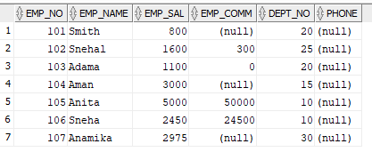

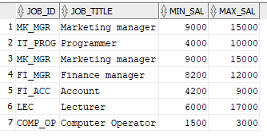

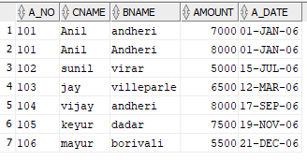

**Query-2: Display job title and maximum salary of all jobs.**

**SQL Statement: select job_title,max_sal from Job ;**

**Output:**

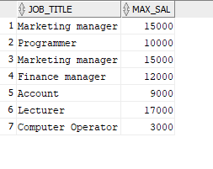

**Query-3: Write a query to find out to all the branches.**

**SQL Statement:**

**Output:**

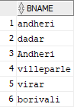

**Query-4: Display all the account no. into which rupees are between dates 01-01-06 and 25-07-06.**

**SQL Statement: select a_no from deposit where a_date between '01-JAN-2006' AND '25-JULY-2006';**

**Output:**

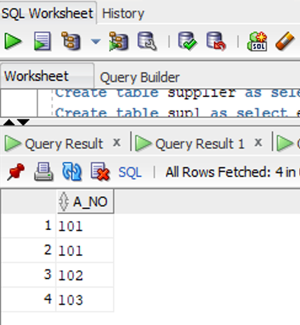

**Query-5: Display names of all customers whose account is deposited after 09-oct-06**

**SQL Statement: SELECT cname FROM deposit WHERE a_date > '09-OCT-2006';**

**Output:**

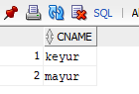

**Query-6: Display name and salary of employee whose department no is 20. Give alias name to name of employee.**

**SQL Statement: SELECT emp_name AS employee_name, emp_sal FROM Employee WHERE dept_no = 20;**

**Output:   
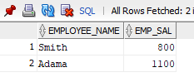**

**Query-7: Display employee no, name and department details of those employee whose department lies in(10,20).**

**SQL Statement: SELECT emp_no, emp_name, dept_no FROM Employee WHERE dept_no IN (10, 20);**

**Output:**

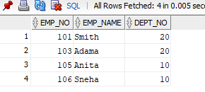

**Query-8: Display employee no, name and department details of those employee whose department not in(15,30).**

**SQL Statement: SELECT emp_no, emp_name, dept_no FROM employee WHERE dept_no NOT IN (15, 30);**

**Output:**

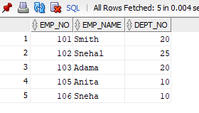

**Query-9: Display employee no, name and department details of those employee whose department no is between 15 and 25.**

**SQL Statement: SELECT emp_no, emp_name, dept_no FROM employee WHERE dept_no BETWEEN 15 AND 25;**

**Output:**

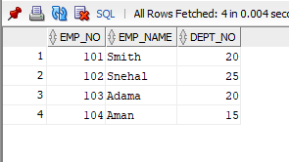

**Query-10: Display name of all employee whose emp_comm contains the non-null values.**

**SQL Statement: SELECT emp_name FROM employee WHERE emp_comm IS NOT NULL;**

**Output:**

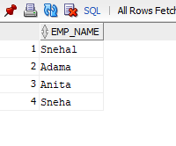

**Query-11: Combine two columns min_sal and max_sal and display it one column using common alias name.**

**SQL Statement:**

**Output:**

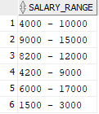

**Query-12: Insert the data into sup2 from employee.**

**SQL Statement: INSERT INTO sup2 SELECT * FROM Employee;**

**Output: 2 rows inserted**

**Query-13: Delete all the rows from sup1 as sup.**

**SQL Statement: DELETE FROM sup1;**

**Output: 7 rows deleted.**

**Query-14: Delete the detail of supplier whose emp_no is 103.**

**SQL Statement: DELETE FROM supplier WHERE emp_no = 103;**

**Output: 1 row deleted.**

**Query-15: Update the name of employee to ‘Aman’ name whose emp_name is ‘Anita’.**

**SQL Statement: UPDATE employee SET emp_name = 'Aman' WHERE emp_name = 'Anita';**

**Output: 1 row updated.**

**Query-16: Update the value of employee name whose employee number is 103.**

**SQL Statement: UPDATE employee SET emp_name = 'New Name' WHERE emp_no = 103;**

**Output: 1 row updated.**

**Query-17: Find out the maximum and minimum salary form job table.**

**SQL Statement: SELECT MAX(max_sal), MIN(min_sal) FROM jobs;**

**Output:**

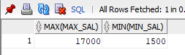

**Query-18: Find out the average salary of employee.**

**SQL Statement: SELECT AVG(emp_sal) FROM employee;**

**Output:**

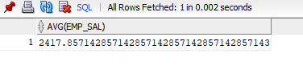

**Query-19: Count the total no as well as distinct rows in dept_no column with a condition of salary greater than 1000 of employee.**

**SQL Statement: SELECT COUNT(DISTINCT dept_no) FROM employee WHERE emp_sal > 1000;**

**Output:**

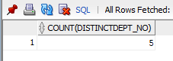

**Query-20: Display the detail of all employees in ascending order, descending order of their name and no.**

**SQL Statement: SELECT * FROM employee ORDER BY emp_name ASC, emp_no ASC;**

**Output:**

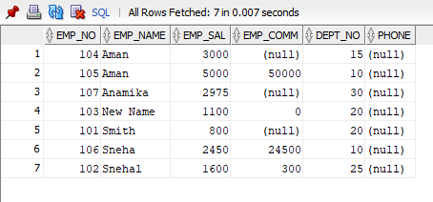

**Query-21:Display the dept_no in ascending order and accordingly display emp_comm in descending order.**

**SQL Statement: SELECT dept_no, emp_comm FROM employee ORDER BY dept_no ASC, emp_comm DESC;**

**Output:**

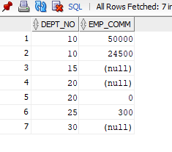

**Query-22: Update the value of emp_comm to 500 where dept_no is 20.**

**SQL Statement: UPDATE employee SET emp_comm = 500 WHERE dept_no = 20;**

**Output: 2 rows updated.**

**Query-23: Display the emp_comm in ascending order with null value first and accordingly sort employee salary in descending order.**

**SQL Statement: SELECT emp_comm, emp_sal FROM employee ORDER BY emp_comm ASC NULLS FIRST, emp_sal DESC;**

**Output:**

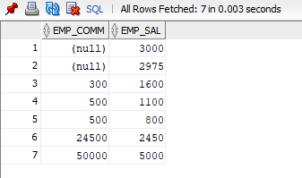

**Query-24: Display the emp_comm in ascending order with null value last and accordingly sort emp_no in descending order.**

**SQL Statement: SELECT emp_comm, emp_no FROM employee ORDER BY emp_comm ASC NULLS LAST, emp_no DESC;**

**Output:**

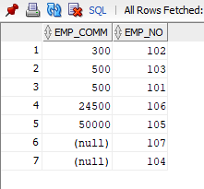

**// [IF any Questions are given to you]**

**Question-1:**

**Answer:**

**Question-2:**

**Answer:**