**PRACTICAL 8**

**AIM** - To apply the concept of integrity/data constraints while creating or altering tables in a database for managing sales-related data. FOR BELOW TASKS.

**1) Create Table Salespeople where Snum number(4) P.K, Sname varchar2(20)**

**Constraints**

1. **Primary Key Constraint**: Ensure Snum uniquely identifies each record. 2. **Not Null Constraint**: Ensure Sname is not null.

**Tasks:**

**Test Case 1: Insert a valid record.**

**Objective**: Verify that a valid record can be inserted into the Salespeople table. **Expected Result**: The record should be inserted successfully.

**Query:**



**Output:**

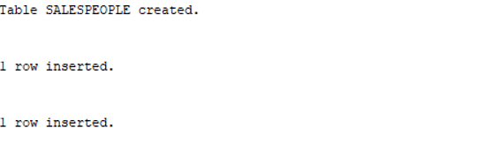

**Test Case 2: Insert a record with a duplicate Snum**

**Objective**: Verify that inserting a record with a duplicate Snum results in an error.

**Expected Result**: The insertion should fail with a primary key constraint violation error.

**Query:**



**Output:**

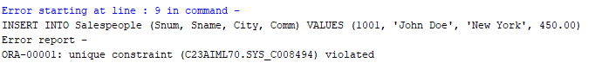

**Test Case 3: Insert a record with a null Sname**

**Objective**: Verify that inserting a record with a null Sname results in an error.

**Expected Result**: The insertion should fail with a not-null constraint violation error.

**Query:**



**Output:** 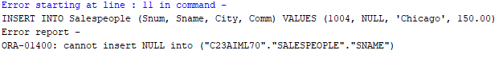

**Test Case 4: Insert a record with missing City and Comm**

**Objective**: Verify that a record can be inserted with City and Comm as null.

**Expected Result**: The record should be inserted successfully with City and Comm as null.

**Query:**



**Output:**



**Test Case 5: Retrieve all records from the Salespeople table.**

**Objective**: Verify that all records can be retrieved from the table.

**Query and output:**

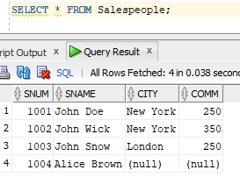

**2) Create Table customer where Cnum number (4) P.K, Cname varchar2(20)NOT NULL, City varchar2(20), Rating number(3) DEFAULT 10, Snum number(4) F.K.(where snum refer salespeople table).**

**Query:**

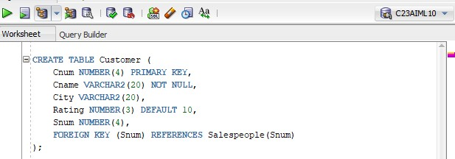

**Output:**



**Constraints**

1. **Primary Key Constraint**: Ensure Cnum uniquely identifies each record.
2. **Not Null Constraint**: Ensure Cname is not null.
3. **Foreign Key Constraint**: Ensure Snum references the Snum field in the Salespeople table. 4. **Default Constraint**: Ensure Rating defaults to 10 if no value is provided.

**Tasks:**

**Test Case 1**: Insert a valid record

**Objective**: Verify that a valid record can be inserted into the Customer table. **Expected Result**: The record should be inserted successfully. **Query:**



**Output:**



**Test Case 2**: Insert a record with a missing Rating

**Objective**: Verify that a record can be inserted with a Rating defaulting to 10.

**Expected Result**: The record should be inserted successfully with a Rating of 10.

**Query:**



**Output:**



**Test Case 3**: Insert a record with a null Cname

**Objective**: Verify that inserting a record with a null Cname results in an error.

**Expected Result**: The insertion should fail with a not null constraint violation error.

**Query:** 

**Output:**

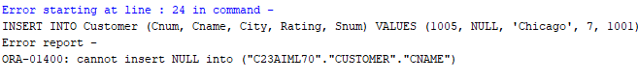

**Test Case 4**: Insert a record with a non-existent Snum

**Objective**: Verify that inserting a record with a non-existent Snum results in an error.

**Expected Result**: The insertion should fail with a foreign key constraint violation error. **Query:**

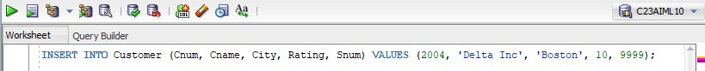

**Output:**

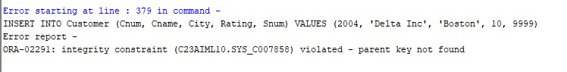

**Test Case 5**: Insert a record with missing City and Rating

**Objective**: Verify that a record can be inserted with City and Rating as null/default.

**Expected Result:** The record should be inserted successfully with City as null and Rating as 10.

**Query:**

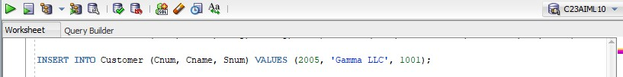

**Output:**



**Test Case 6**: Retrieve all records from the Customer table **Objective**: Verify that all records can be retrieved from the table.

**Expected Result:** The query should return all the inserted records.

**Query:**

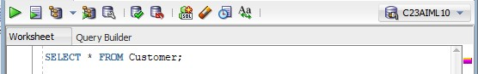

**Output:**

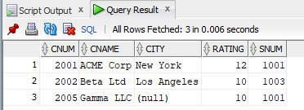

**3) Create table Order where Order_no number(4) P.K, Amount number(5), Odate varchar2(10), Cnum number(4) F.K, (where cnum refer customer table). Snum number(4) F.K (where snum refers salespeople table).**

**Query:**

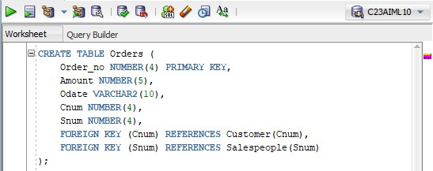

**Output:**



**Constraints**

1. **Primary Key Constraint**: Ensure Order_no uniquely identifies each record.
2. **Foreign Key Constraint**: Ensure Cnum references the Cnum field in the Customer table. 3. **Foreign Key Constraint**: Ensure Snum references the Snum field in the Salespeople table.

**Tasks:**

**Test Case 1**: Insert a valid record

**Objective**: Verify that a valid record can be inserted into the Orders table. **Expected Result**: The record should be inserted successfully.

**Query:**

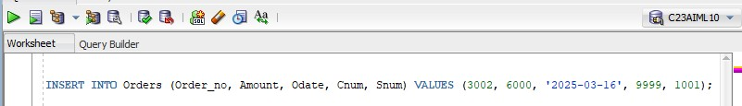

**Output:**



**Test Case 2**: Insert a record with a non-existent Cnum

**Objective**: Verify that inserting a record with a non-existent Cnum results in an error.

**Expected Result**: The insertion should fail with a foreign key constraint violation error for Cnum. **Query:**

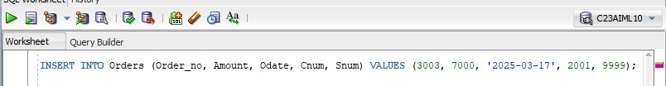

**Output:**

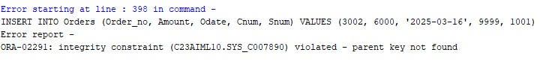

**Test Case 3**: Insert a record with a non-existent Snum

**Objective**: Verify that inserting a record with a non-existent Snum results in an error.

**Expected Result**: The insertion should fail with a foreign key constraint violation error for Snum. **Query:**

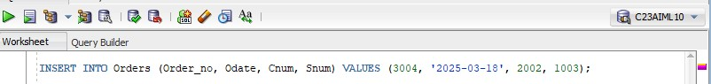

**Output:**

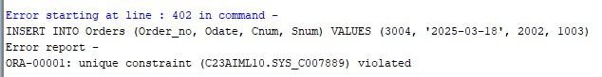

**Test Case 4**: Insert a record with a null Amount

**Objective**: Verify that a record can be inserted with Amount as null.

**Expected Result**: The record should be inserted successfully with Amount as null. **Query:**



**Output:**



**Test Case 5**: Insert a record with null Odate

**Objective**: Verify that a record can be inserted with Odate as null.

**Expected Result:** The record should be inserted successfully with Odate as null. **Query:**

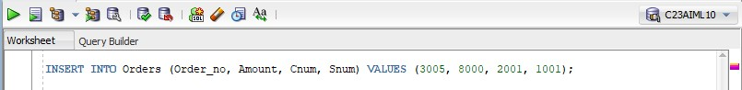

**Output:**



**Test Case 6:** Retrieve all records from the Orders table

**Objective**: Verify that all records can be retrieved from the table.

**Expected Result**: The query should return all the inserted records. **Query:**

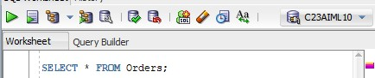

**Output:**

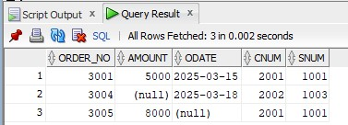

# Table: Sales_order

**Constraints**

∙ **Primary Key Constraints**: Ensure unique identification of records.

∙ **Foreign Key Constraints**: Maintain relationships between tables.

∙ **Not Null Constraints**: Ensure critical fields are not null.

∙ **Check Constraints**: Ensure data integrity by limiting column values.

∙ **Unique Constraints**: Ensure columns have unique values where required. ∙ **Default Constraints**: Assign default values to columns when no value is provided.

**Column Name Data Type Constraints :**

**Order_no** Varchar2(6) Primary key/First letter starting with ‘O’

**Order_date** Date

**Client_no** Varchar2(6) Foreign Key references client_no of client_master table

**Dely_addr** Varchar2(25)

**Salesman_no** Varchar2(6) Foreign Key references sales_no of

Salesman_master table

**Dely_type** char Delivery: part(P)/ full (f) Default ‘F’

**Order_status** Varchar2 in Process, Fulfilled, Backorder, Cancelled

**Test Case**: Verify that all constraints, including the primary key, foreign key, check constraints, and default values, are correctly applied.

**Query:**

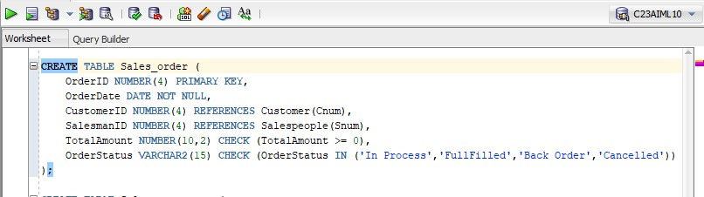

**Output:**



# Table: Salesman_master

**Constraints**

∙ **Primary Key Constraints**: Ensure unique identification of records.

∙ **Foreign Key Constraints**: Maintain relationships between tables.

∙ **Not Null Constraints**: Ensure critical fields are not null.

∙ **Check Constraints**: Ensure data integrity by limiting column values.

∙ **Unique Constraints**: Ensure columns have unique values where required. ∙ **Default Constraints**: Assign default values to columns when no value is provided.

**Column name Data type Constraints :**

Salesman_no Varchar2(6) The primary key/first letter must start with ‘S’

Salesman _name Varchar2(20) Not null

Address Varchar2(30) Not null

City Varchar2(20)

Pincode Varchar2(8)

State Varchar2(20)

Sal_amt Number(8,2) Not null, cannot be 0

Ytd_sales Number(6,2) Not null, cannot be 0

Tgt_sales Number(6,2) Not null

**Test Case**: Verify that all constraints, including the primary key, not null, and check constraints, are correctly applied.

**Query:**

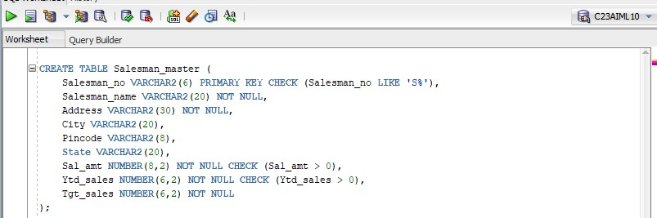

**Output:**



PAGE

**6. Table: Client_master**

**Constraints**

∙ **Primary Key Constraints**: Ensure unique identification of records.

∙ **Foreign Key Constraints**: Maintain relationships between tables.

∙ **Not Null Constraints**: Ensure critical fields are not null.

∙ **Check Constraints**: Ensure data integrity by limiting column values.

∙ **Unique Constraints**: Ensure columns have unique values where required.

∙ **Default Constraints**: Assign default values to columns when no value is provided.

**Column name Data type Constraints**

Client_no Varchar2(6) The primary key/first letter must start with ‘C’

Name Varchar2(20) Not null

Address Varchar2(30)

City Varchar2(15)

Pincode Number(8)

State Varchar2(15)

Bal_due Number(10,2)

**Test Case**: Verify that all constraints, including the primary key, not null, and check constraints, are correctly applied.

**Query:**

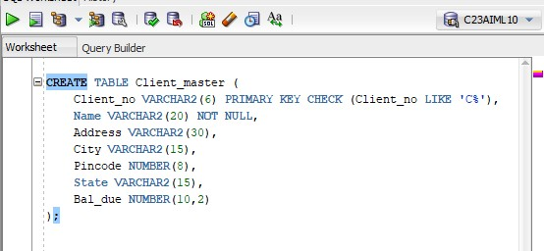

**Output:**

