**PRACTICAL -5**

**Aim:** To Study data communication using SQL functions

**Theoretical Description**:

* **AVG(n)** – Returns the average of numeric values.
* **MIN(expr)** – Returns the minimum value from a column.
* \**COUNT(expr / )* – Returns the number of rows.
* **MAX(expr)** – Returns the maximum value from a column.
* **SUM(n)** – Returns the total sum of numeric values.
* **ABS(n)** – Returns the absolute value of n.
* **POWER(m, n)** – Returns m raised to the power of n.
* **ROUND(n, m)** – Rounds n to m decimal places.
* **SQRT(n)** – Returns the square root of n.
* **LOWER(char)** – Converts text to lowercase.
* **INITCAP(char)** – Capitalizes the first letter of each word.
* **UPPER(char)** – Converts text to uppercase.
* **SUBSTR(char, m, n)** – Extracts a substring from position m of length n.
* **LENGTH(word)** – Returns the length of a string.
* **LTRIM(char, set)** – Removes leading characters from a string.
* **RTRIM(char, set)** – Removes trailing characters from a string.
* **LPAD(char1, n, char2)** – Pads char1 on the left with char2 to make it n characters long.
* **RPAD(char1, n, char2)** – Pads char1 on the right with char2 to make it n characters long.
* **TO_NUMBER(char)** – Converts a string to a number.
* **TO_CHAR(n, fmt)** – Converts a number to a formatted string.
* **TO_DATE(char, fmt)** – Converts a string into a date format.
* **ADD_MONTHS(d, n)** – Adds n months to a given date d.
* **LAST_DAY(d)** – Returns the last day of the month for a given date.
* **MONTHS_BETWEEN(d1, d2)** – Finds the number of months between two dates.
* **NEXT_DAY(date, char)** – Returns the next occurrence of a specified weekday.
* **UNION** – Combines unique results from two queries.
* **UNION ALL** – Combines results from two queries (including duplicates).
* **INTERSECT** – Returns common records from two queries.

**Aggregate Functions:**

**Query-1:** AVG (DISTINCT | ALL | n)

**SQL Statement:** SELECT AVG(emp_sal) AS average_salary FROM Employee1

**Output:**

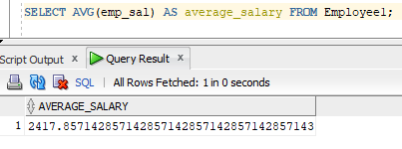

**Query-2:** MIN (DISTINCT | ALL | expr)

**SQL Statement:** SELECT MIN(emp_sal) AS min_salary FROM Employee1;

**Output:**

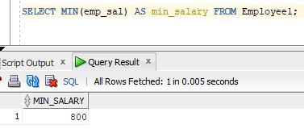

**Query-3:** COUNT (DISTINCT | ALL | expr)

**SQL Statement:**

SELECT COUNT(DISTINCT dept_no) AS distinct_departments FROM Employee1;

**Output:**

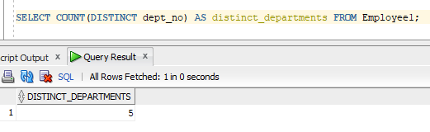

**Query-4:** COUNT (*)

**SQL Statement:**

SELECT COUNT(*) AS total_employees FROM Employee1;

**Output:**

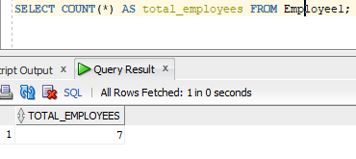

**Query-5:** MAX (DISTINCT | ALL | expr)

**SQL Statement:**

SELECT MAX(max_sal) AS highest_salary FROM Job;

**Output:**

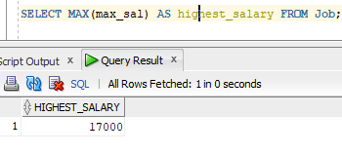

**Query-6:** SUM (DISTINCT | ALL | n)

**SQL Statement:**

SELECT SUM(amount) AS total_amount FROM Deposit;

**Output:**

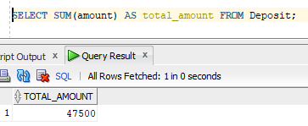

**Query-7:** Numeric Functions:ABS(n)

**SQL Statement:**

SELECT ABS(emp_sal) AS abs_salary FROM Employee1;

**Output:**

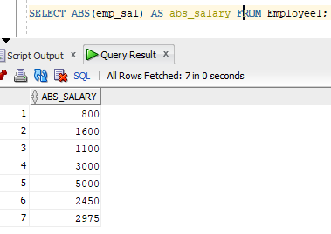

**Query-8:** POWER(m, n)

**SQL Statement:**

SELECT POWER(2, 3) AS result FROM dual;.

**Output:**

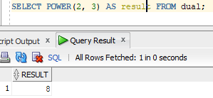

**Query-9:** ROUND(n, m)

**SQL Statement:**

SELECT ROUND(emp_sal, 2) AS rounded_salary FROM Employee1;

**Output:**

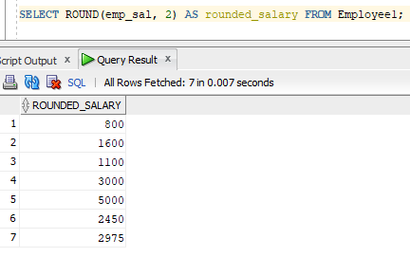

**Query-10:** SQRT(n)

**SQL Statement:**

SELECT SQRT(emp_sal) AS sqrt_salary FROM Employee1;

**Output:**

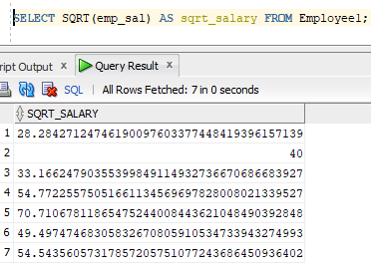

**Query-11:** String Functions: LOWER(char)

**SQL Statement:**

SELECT LOWER(emp_name) AS lower_name FROM Employee1;

**Output:**

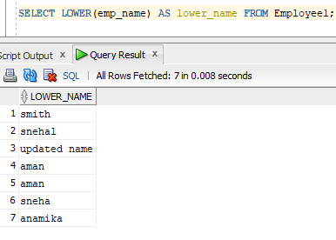

**Query-12:** INITCAP(char)

**SQL Statement:**

SELECT INITCAP(emp_name) AS capitalized_name FROM Employee1;

**Output:**

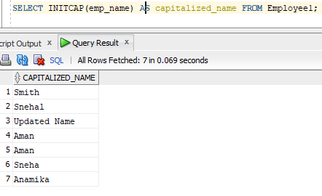

**Query-13:** UPPER(char)

**SQL Statement:**

SELECT UPPER(emp_name) AS upper_name FROM Employee1;

**Output:**

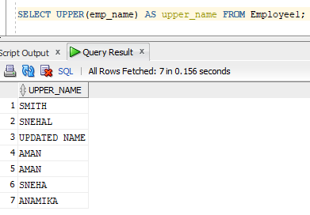

**Query-14:** SUBSTR(char, m [, n])

**SQL Statement:**

SELECT SUBSTR(emp_name, 1, 3) AS name_part FROM Employee1;

**Output:**

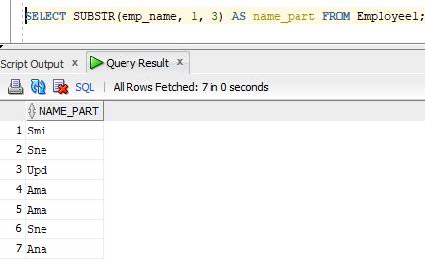

**Query-15:** LENGTH(word)

**SQL Statement:**

SELECT LENGTH(emp_name) AS name_length FROM Employee1;

**Output:**

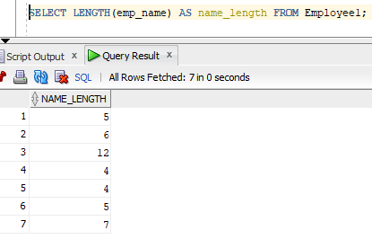

**Query-16:** LTRIM(char [, set])

**SQL Statement:**

SELECT LTRIM(emp_name, ' ') AS trimmed_name FROM Employee1;

**Output:**

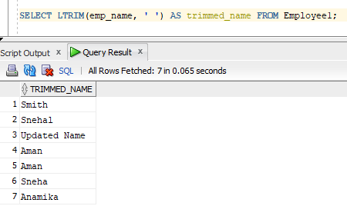

**Query-17:** RTRIM(char [, set])

**SQL Statement:**

SELECT RTRIM(emp_name, ' ') AS trimmed_name FROM Employee1;

**Output:**

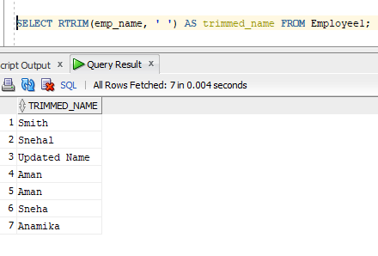

**Query-18:** LPAD(char1, n [, char2])

**SQL Statement:**

SELECT LPAD(emp_name, 10, '*') AS padded_name FROM Employee1;

**Output:**

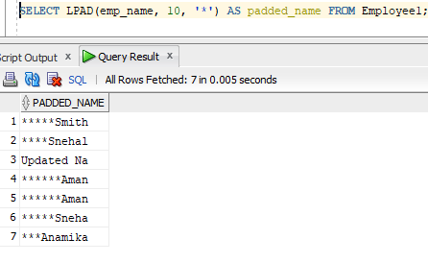

**Query-19:** RPAD(char1, n [, char2])

**SQL Statement:**

SELECT RPAD(emp_name, 10, '*') AS padded_name FROM Employee1;

**Output:**

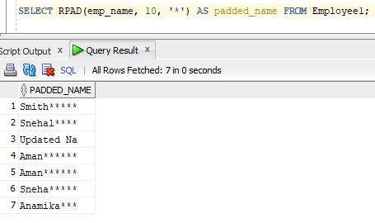

**Query-20: Conversion Functions:**TO_NUMBER(char)

**SQL Statement:**

SELECT TO_NUMBER('1000') AS num_value FROM dual;

**Output:**

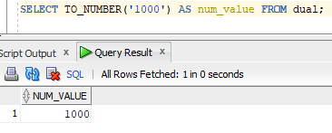

**Query-21:** TO_CHAR(n [, fmt])

**SQL Statement:**

SELECT TO_CHAR(emp_sal, '9999.99') AS salary_str FROM Employee1;

**Output:**

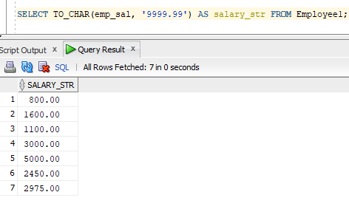

**Query-22:** Date Conversion Functions: TO_DATE (char [, fmt])

**SQL Statement:**

SELECT TO_DATE('2023-01-01', 'YYYY-MM-DD') AS date_value FROM dual;

**Output:**

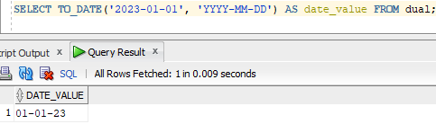

**Query-23:** DATE Functions: ADD_MONTHS(d, n)

**SQL Statement:**

SELECT ADD_MONTHS(SYSDATE, 3) AS new_date FROM dual;

**Output:**

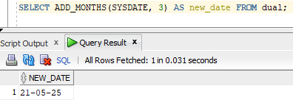

**Query-24:** LAST_DAY(d)

**SQL Statement:**

SELECT LAST_DAY(SYSDATE) AS last_day FROM dual;

**Output:**

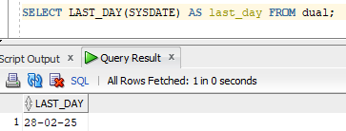

**Query-25:** MONTHS_BETWEEN(d1, d2)

**SQL Statement:**

SELECT MONTHS_BETWEEN(TO_DATE('2023-06-01', 'YYYY-MM-DD'), SYSDATE) AS months_diff FROM dual;

**Output:**

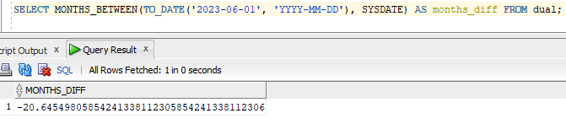

**Query-26:** NEXT_DAY(date, char)

**SQL Statement:**

SELECT NEXT_DAY(SYSDATE, 'SUNDAY') AS next_sunday FROM dual;

**Output:**

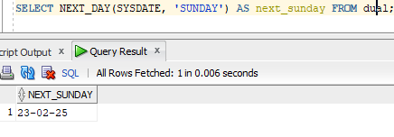

**Query-27:** UNION

**SQL Statement:**

SELECT emp_name FROM Employee1 UNION SELECT cname FROM Deposit;

**Output:**

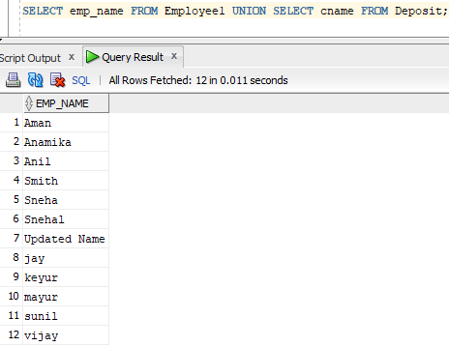

**Query-28:** UNION ALL

**SQL Statement:**

SELECT emp_name FROM Employee1 UNION ALL SELECT cname FROM Deposit;

**Output:**

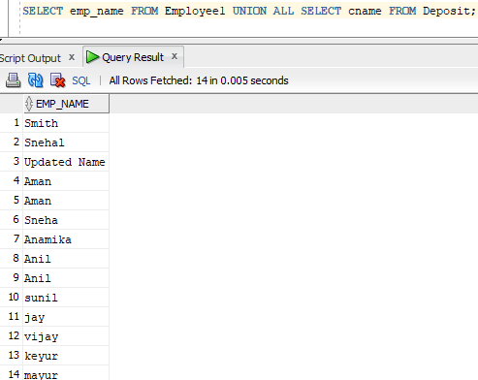

**Query-29:** INTERSECTION

**SQL Statement:**

SELECT FROM employeel where emp_sal>2500 INTERSECT SELECT FROM employeel WHERE emp_no='104';

**Output:**

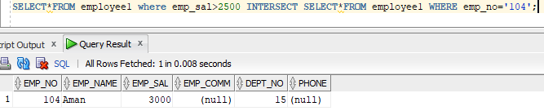

**Query-30:** MINUS

**SQL Statement:**

SELECT emp_name FROM Employee1 MINUS SELECT cname FROM Deposit;

**Output:**

