**Assignment 1**

1. Write a code in R to check whether a password is valid or not. Password should have a minimum of 8 characters. Must contain at least one special character from [/, *, @, _], must have a string and a numeric value in it.

ANS:-

check_string <- function(i_s) {

c1 <- nchar(i_s) > 8

c2 <- !grepl("[_@*/][0-9][A-Za-z]", i_s)

return(c1 && c2 )

}

input_string <- "abc@123*xyz"

if (check_string(input_string)) {

print("The string meets all conditions.")

} else {

print("The string does not meet all conditions.")

}

Output:-

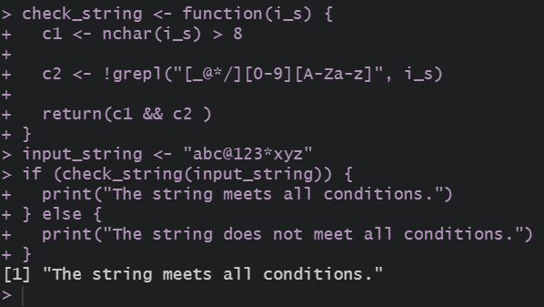

1. Differentiate between paste(), paste0(), print() and cat() functions in R that somewhat serves same purpose with minor differences.

ANS:-

#paste(): Concatenates strings with a specified separator (default is a space).

paste_example <- paste("Hello", "World", sep = "-")

# paste0(): Concatenates strings without any separator.

paste0_example <- paste0("Hello", "World")

# print(): Prints output with a newline, often used for debugging.

print_example <- print("Hello World")

# cat(): Concatenates and outputs strings without quotes and no newline by default.

cat_example <- cat("Hello", "World", "\n")

cat("paste() example:", paste_example, "\n")

cat("paste0() example:", paste0_example, "\n")

cat("print() example:\n")

print(print_example)

cat("cat() example:")

cat(cat_example)

output:-

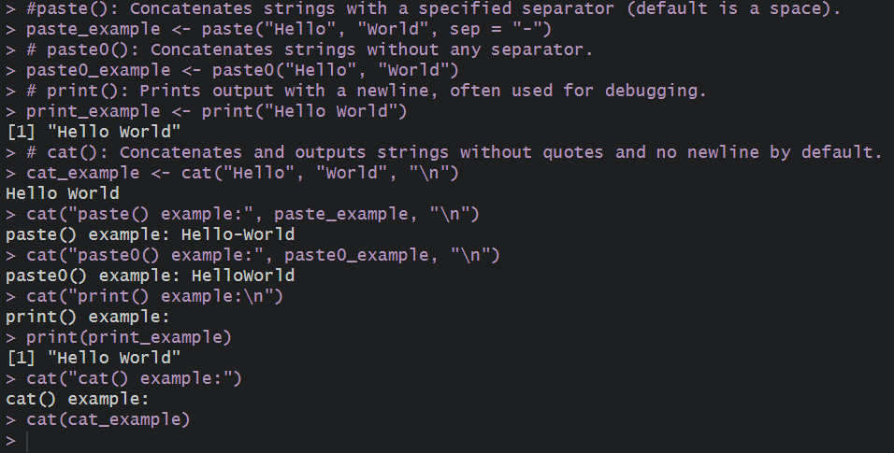

3. Use conditionals to to check if a character string contains a specific substring.

#using grepl

my_string <- "Hello, welcome to R programming!"

ANS:-

# Check if the string contains the substring "welcome"

if (grepl("welcome", my_string)) {

print("The substring 'welcome' is found!")

} else {

print("The substring 'welcome' is NOT found.")

}

Output:-

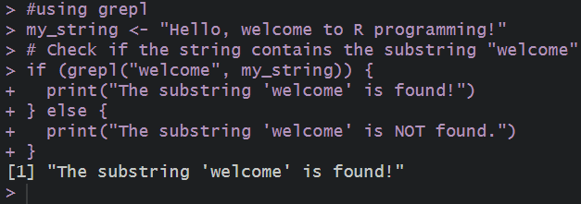

# using grep

my_string <- "Learning R is fun!"

# Check if the substring "R" exists

if (length(grep("R", my_string)) > 0) {

print("The substring 'R' is found!")

} else {

print("The substring 'R' is NOT found.")

}

Output:-

