PRACTICAL: 1

Objective:

To explore AWS CloudShell and Visual Studio Code IDE, understand their interfaces, and execute basic AWS CLI commands for managing cloud resources.

Theory:

Amazon Web Services (AWS) provides a cloud-based environment to develop, deploy, and manage applications efficiently. AWS CloudShell is a browser-based command-line interface that allows users to interact with AWS services without installing any software on their local system. It comes pre-installed with AWS CLI, SDKs, and essential development tools.

AWS Command Line Interface (AWS CLI) is a unified tool that enables users to manage AWS services using commands in a terminal. It helps automate cloud operations such as listing storage services, managing compute instances, and configuring resources.

Visual Studio Code (VS Code) is a lightweight and powerful Integrated Development Environment (IDE) that supports multiple programming languages and extensions. In this lab, VS Code IDE is used to explore cloud-based development and understand its integration with AWS services.

By using AWS CloudShell and VS Code IDE together, developers can efficiently perform cloud operations and develop applications in a secure and scalable environment.

Code:

NA

Output:

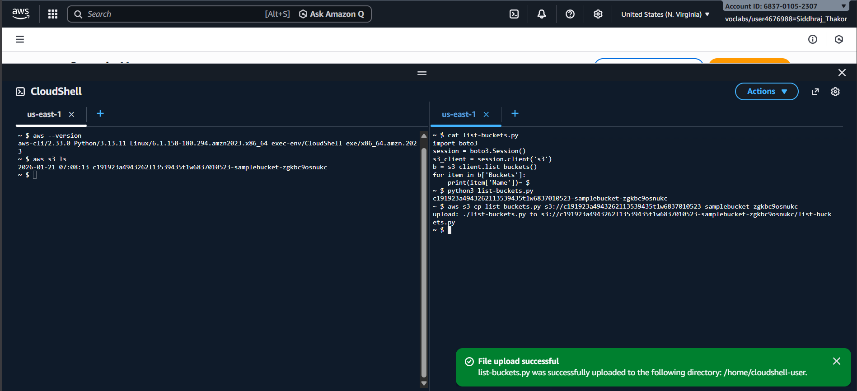
Figure 1: Verify that the AWS CLI is installed & Test the ability to run an AWS CLI command

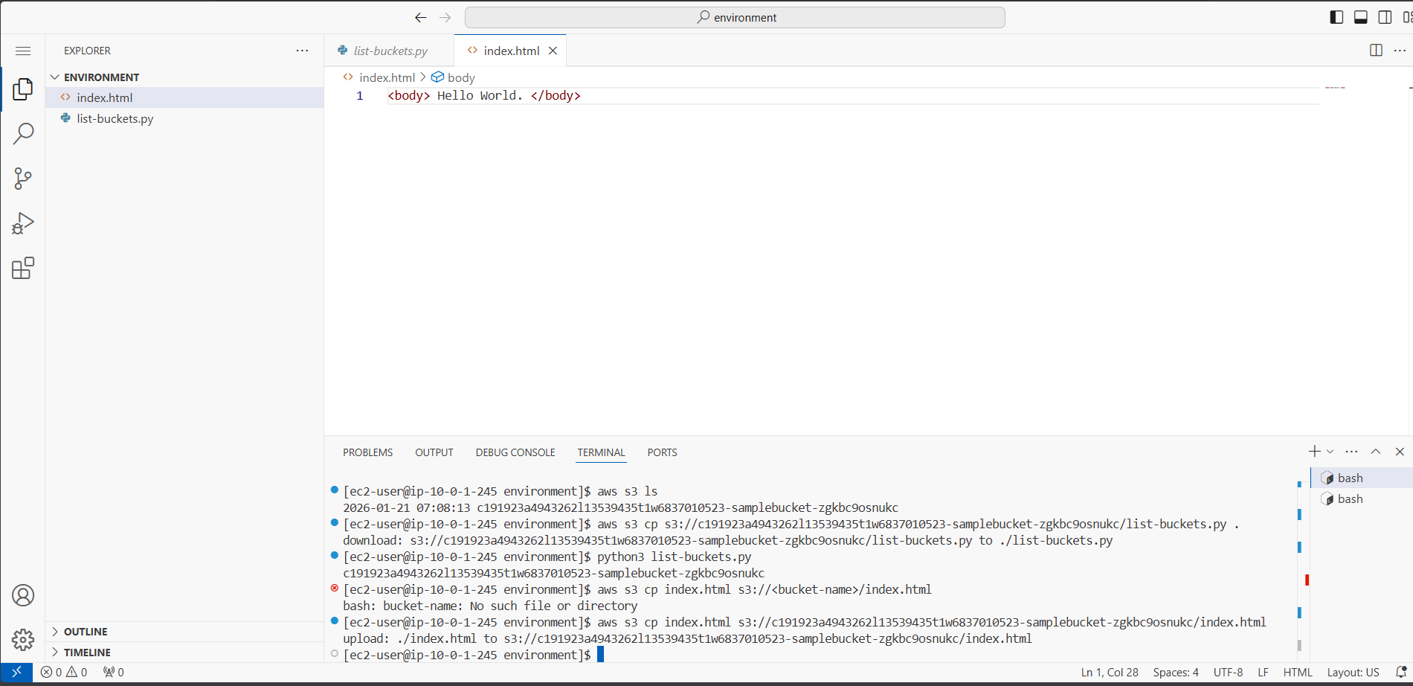
FIGURE 2: Running SDK for Python (Boto3) code to retrieve S3 bucket names

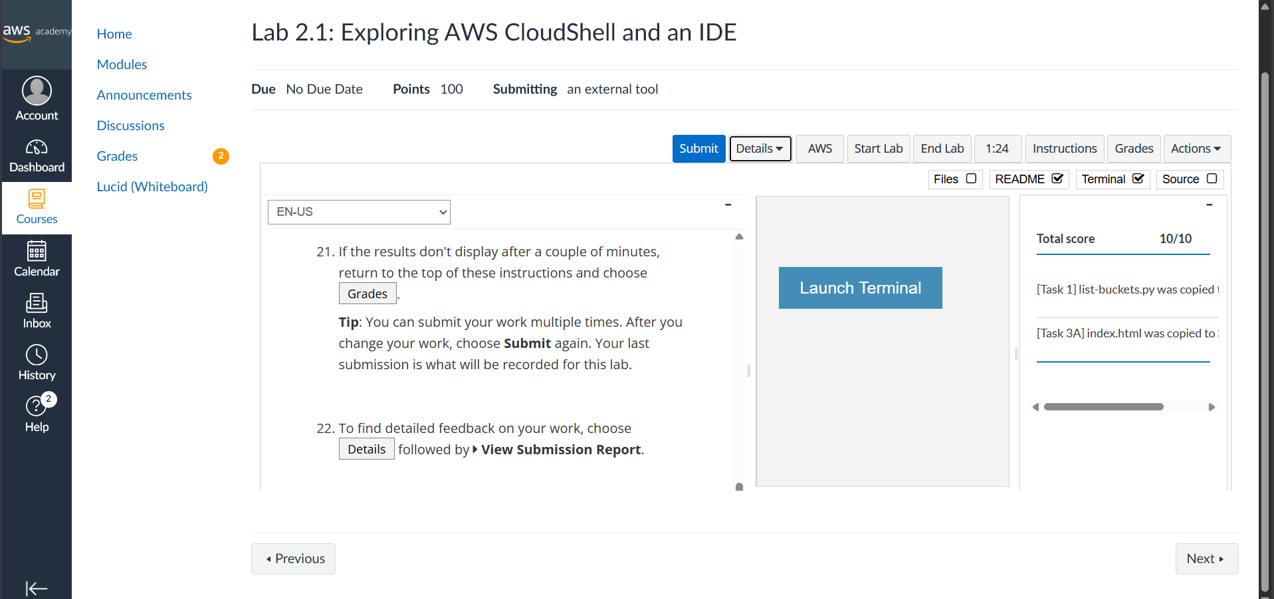

FIGURE 3: Grade of Lab

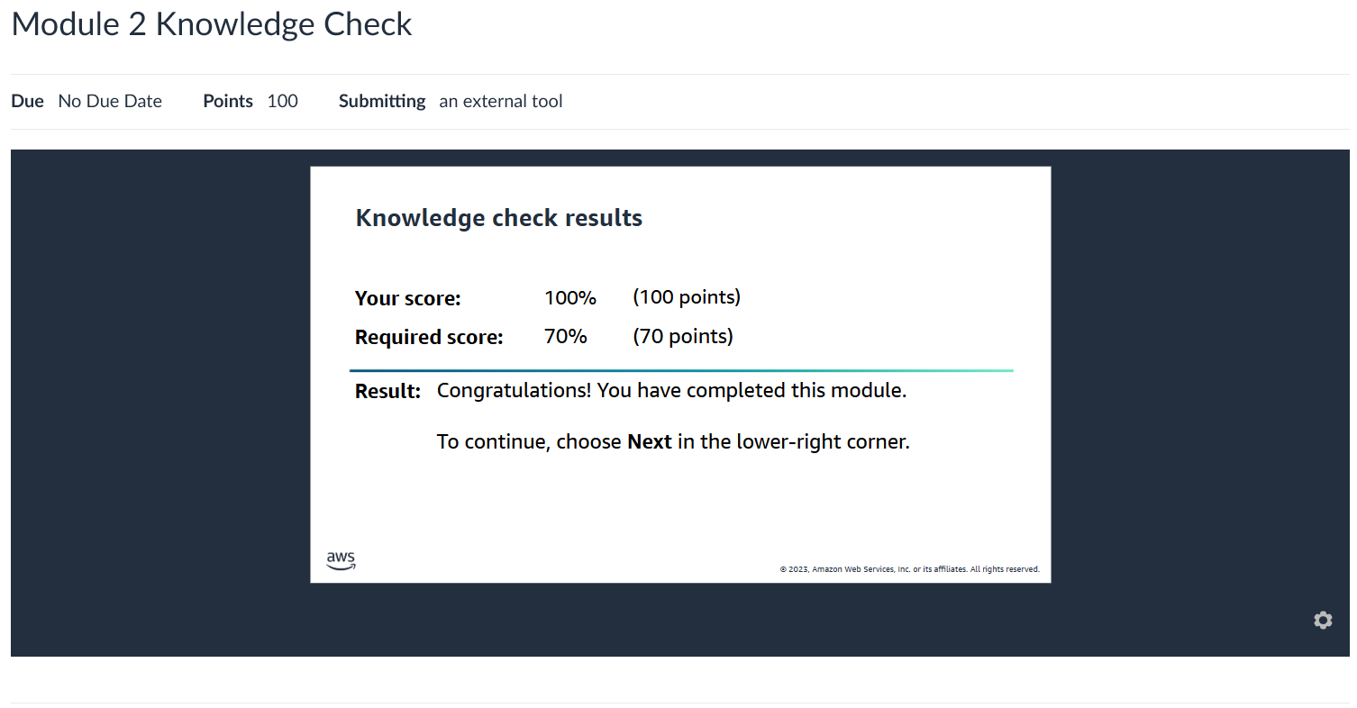
FIGURE 4: Grade of Knowledge Check
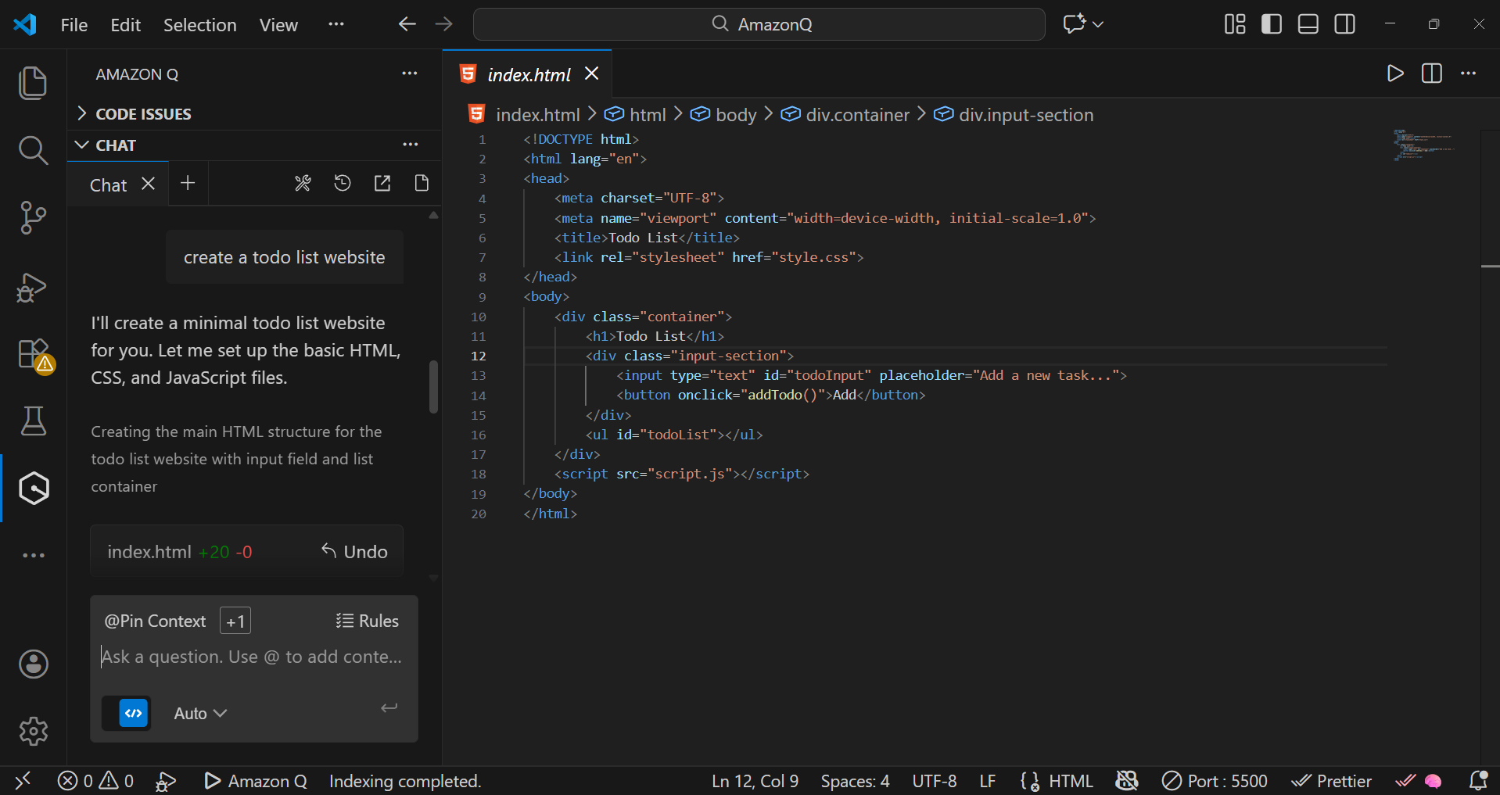

FIGURE 5: Amazon Q Installation
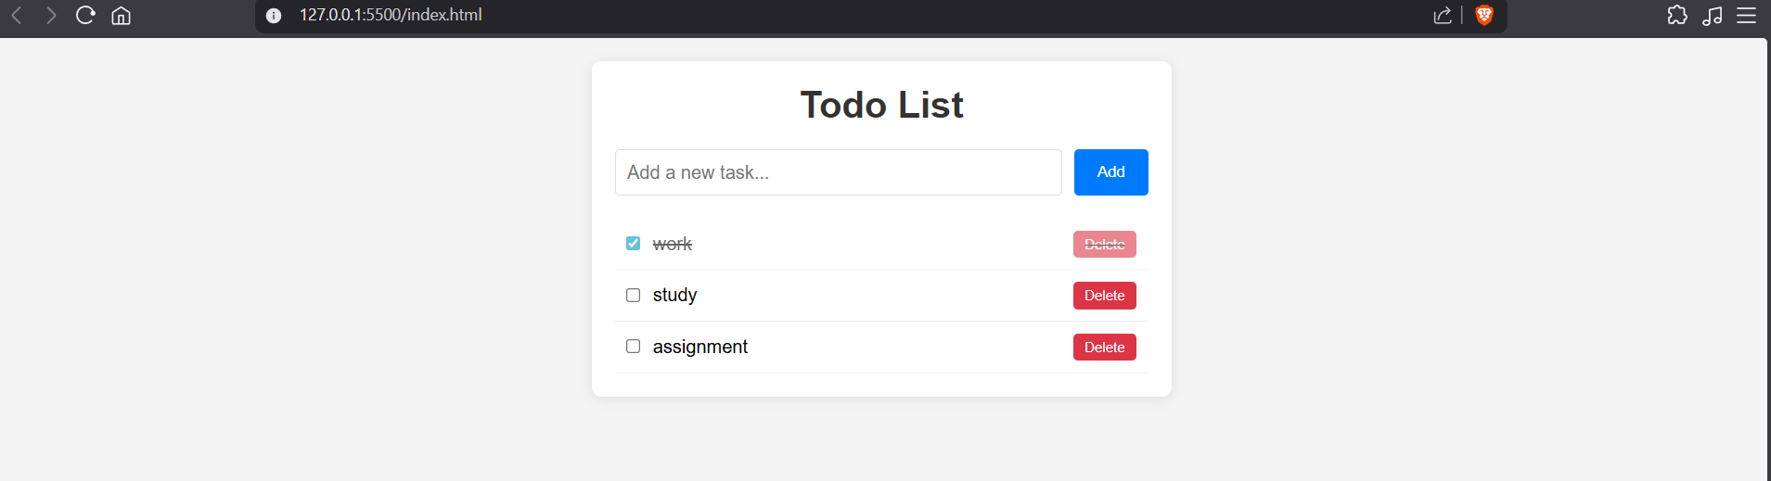
FIGURE 6: Website created by AmazonQ:

Learning Outcome :

- Understood how to access and use AWS CloudShell from the AWS Management Console.
- Learned to verify AWS CLI installation and execute basic AWS CLI commands.
- Gained hands-on experience with Amazon S3 operations using AWS CLI and Python Boto3 SDK.
- Explored the features and interface of Visual Studio Code (VS Code) IDE.
- Learned to run Python programs and install required libraries in a cloud-based IDE.
- Created and uploaded a simple HTML webpage to Amazon S3 using VS Code IDE.
- Understood the integration of AWS CloudShell, VS Code IDE, and Amazon S3 for cloud-based development.

References :

- AWS Academy Cloud Computing Lab Manual
- https://docs.aws.amazon.com/cloudshell
- https://aws.amazon.com/cli
- https://code.visualstudio.com/docs

