PRACTICAL: 2

Objective:
To create and host a static website using Amazon S3, apply bucket policies for controlled access, upload website files using AWS CLI and Python Boto3 SDK, and restrict website access to a specific IP address range following AWS security best practices.

Theory:
Amazon Simple Storage Service (Amazon S3) is a highly scalable, secure, and durable object storage service provided by Amazon Web Services (AWS). It is commonly used to store and retrieve any amount of data from anywhere on the web. One of the important features of Amazon S3 is its ability to host static websites efficiently.

In this practical, Amazon S3 is used to host a static website for a café. The website consists of HTML, CSS, JavaScript, and image files. AWS Command Line Interface (AWS CLI) is used to create and manage the S3 bucket, while the AWS SDK for Python (Boto3) is used to apply bucket policies programmatically.

Security is an essential aspect of cloud architecture. Therefore, a bucket policy is configured to restrict access to the website so that it is accessible only from a specific IPv4 address. This ensures that the website is protected during development and is not publicly exposed.

Visual Studio Code (VS Code) IDE is used as a cloud-based development environment to install dependencies, manage files, execute AWS CLI commands, and run Python scripts. By integrating Amazon S3, AWS CLI, and Boto3, this practical demonstrates secure cloud-based website hosting and data management.

Code:
N/A

Output:

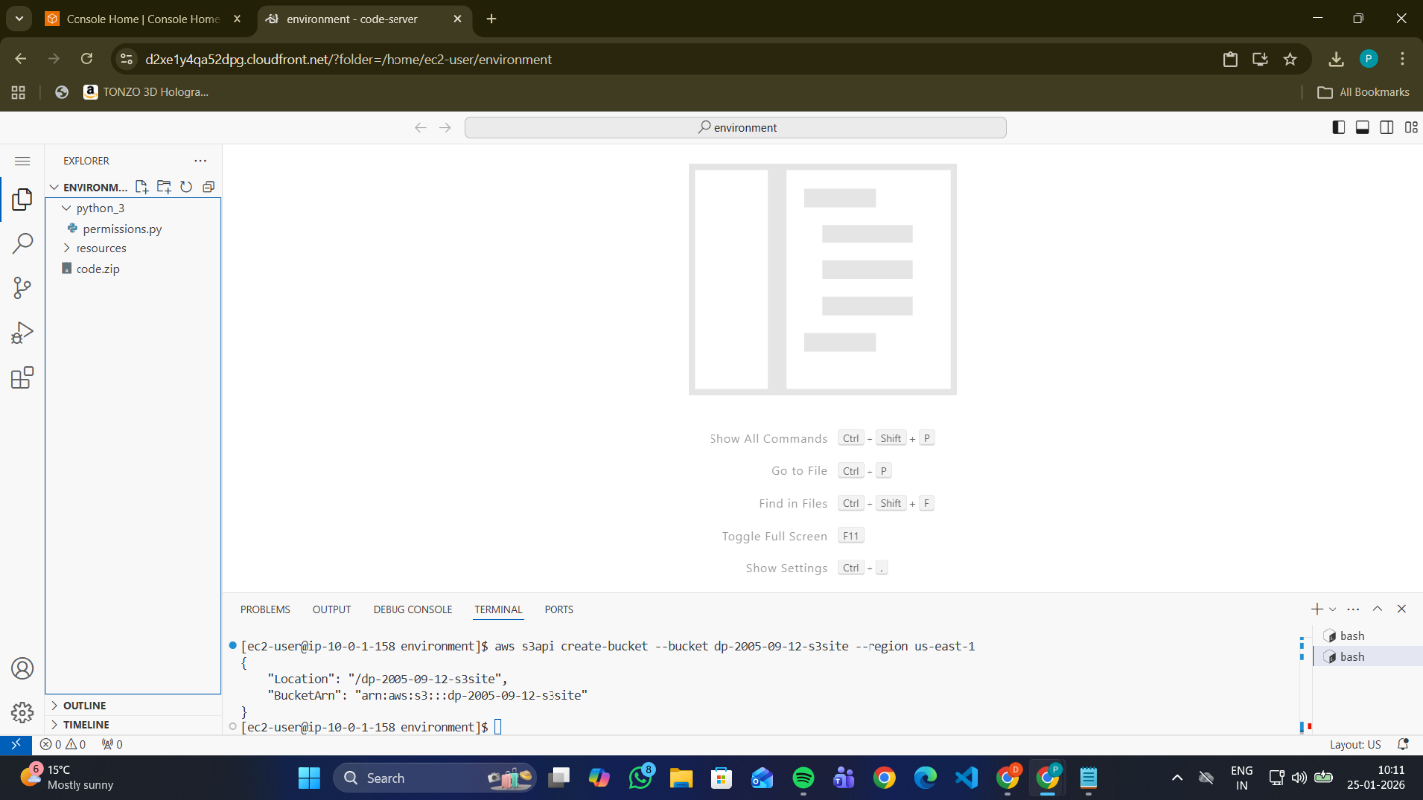
Figure 1: Creating an S3 bucket by using the AWS CLI

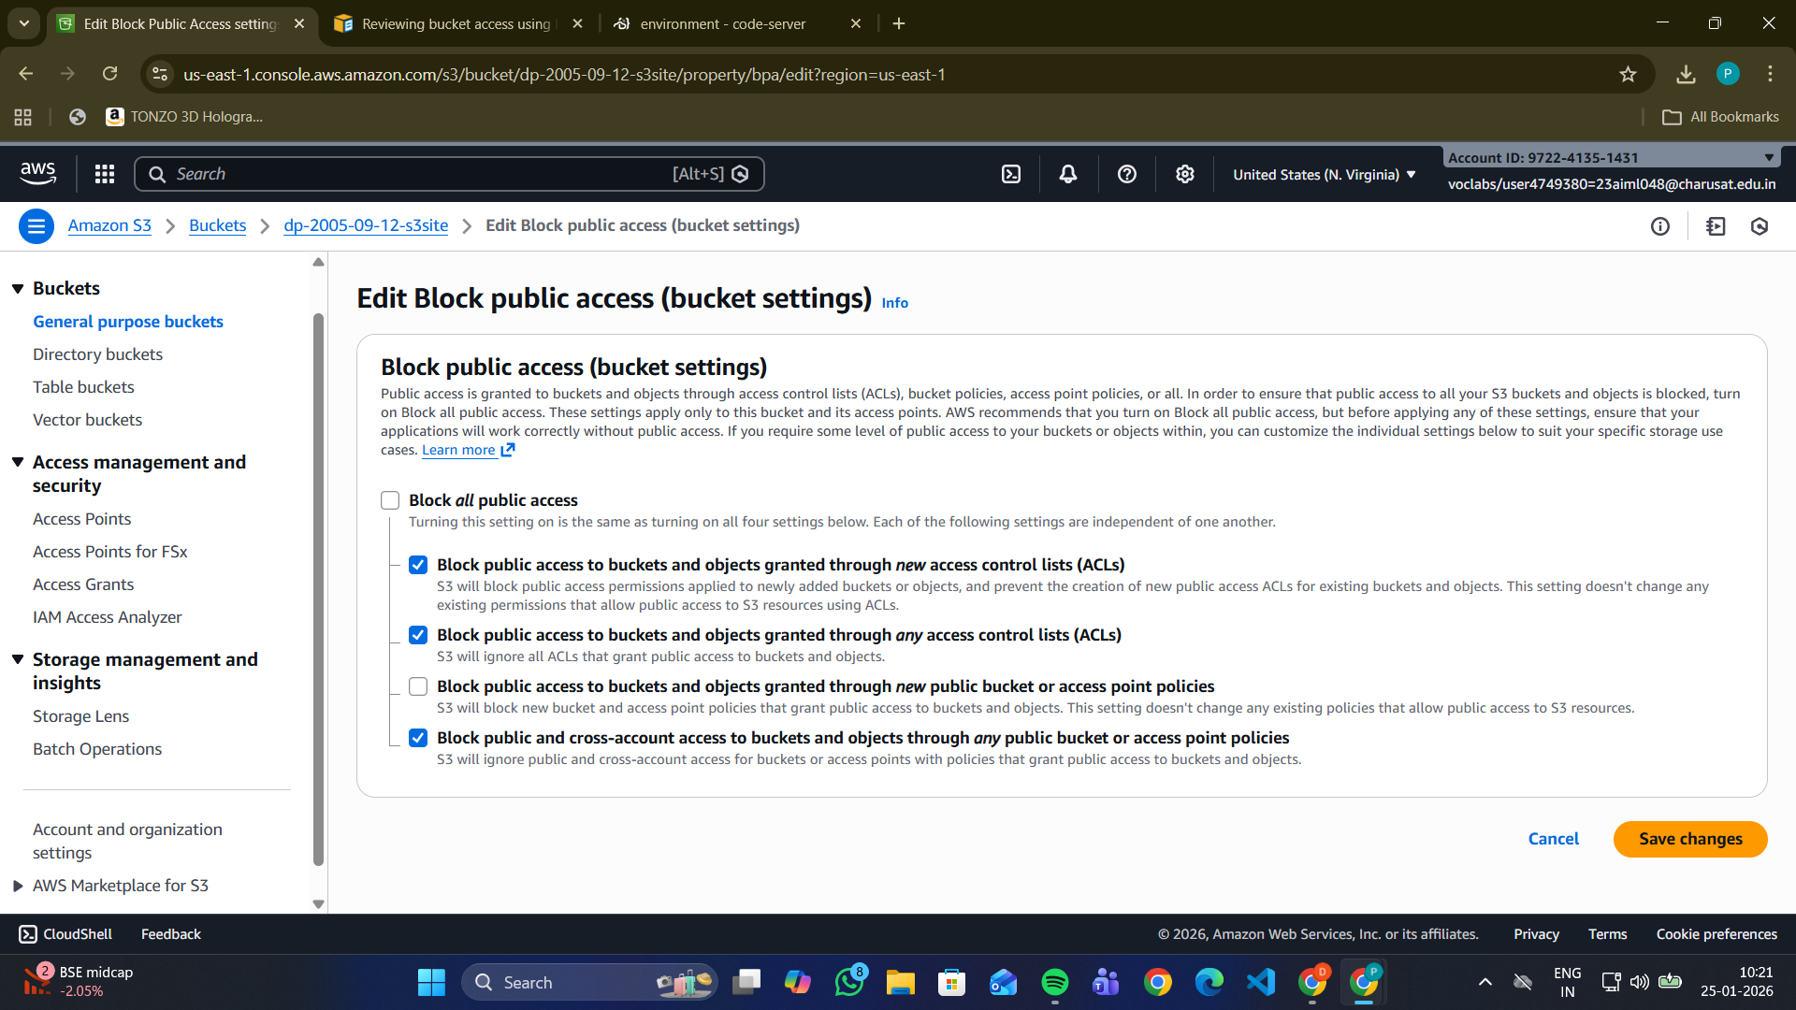
Figure 2: Modifying S3 bucket public access settings in AWS Management Console

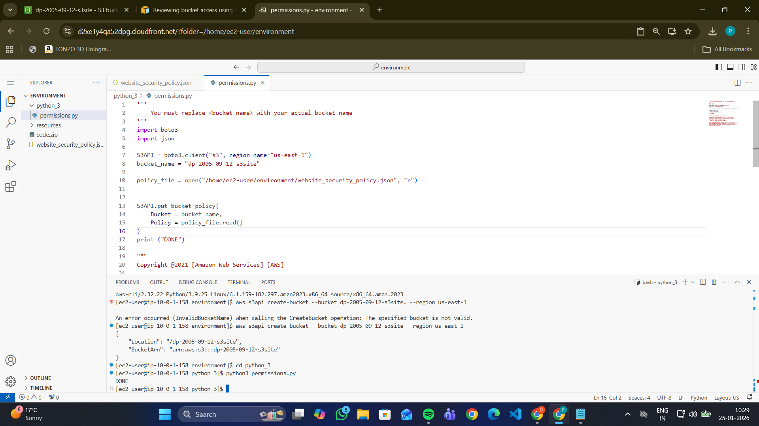

Figure 3: Creating and applying S3 bucket policy using Python (Boto3 SDK)

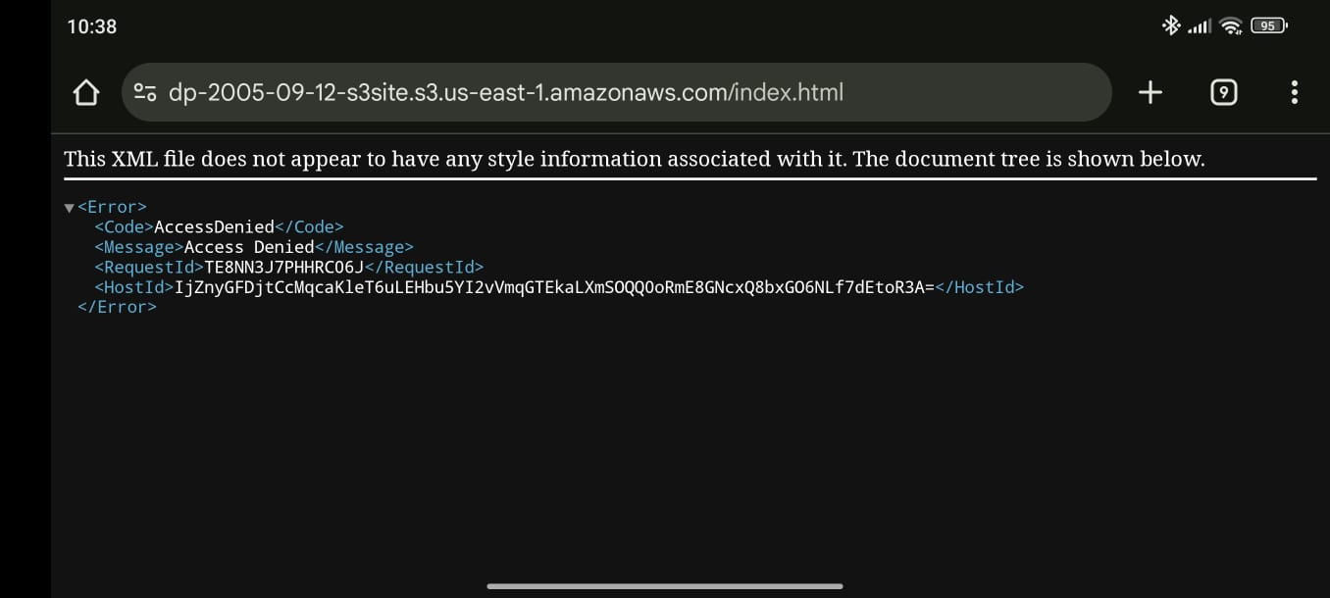
Figure 4: Access denied error when accessing website from a non-allowed IP address

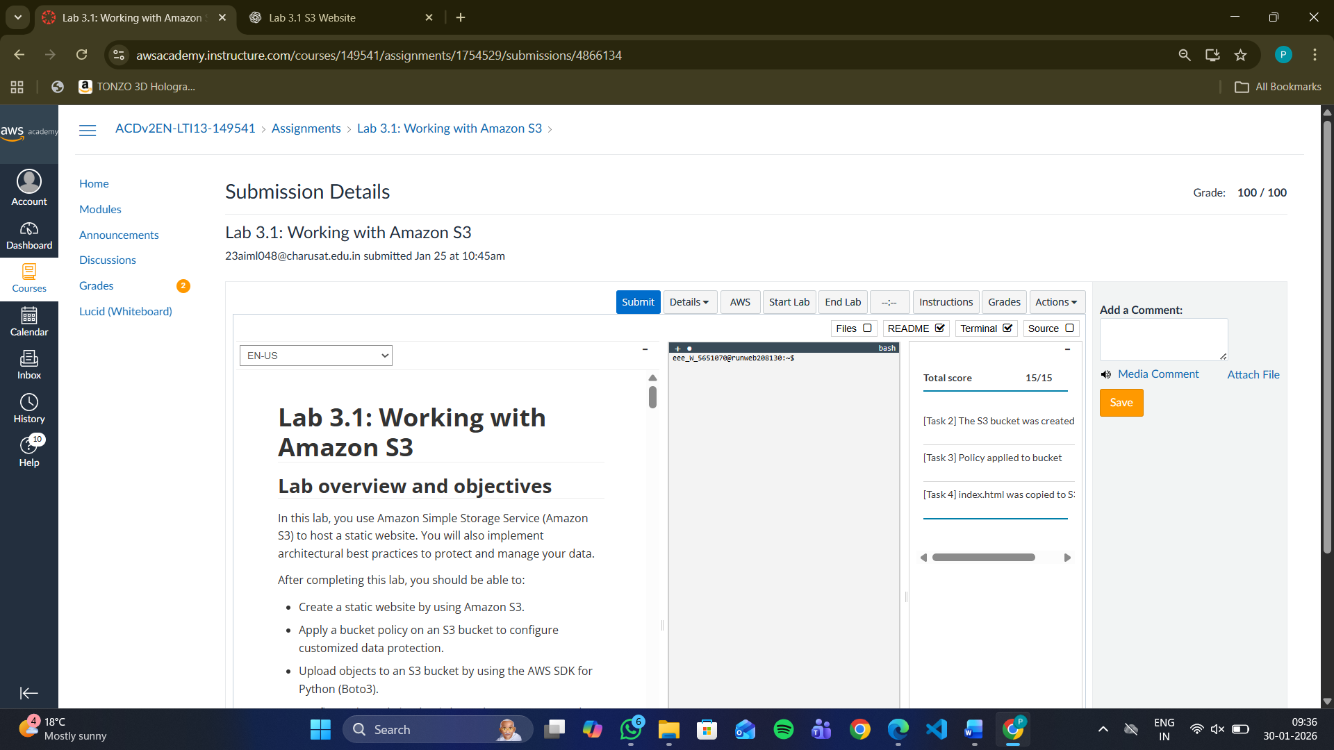
Figure 5: Grade of Lab

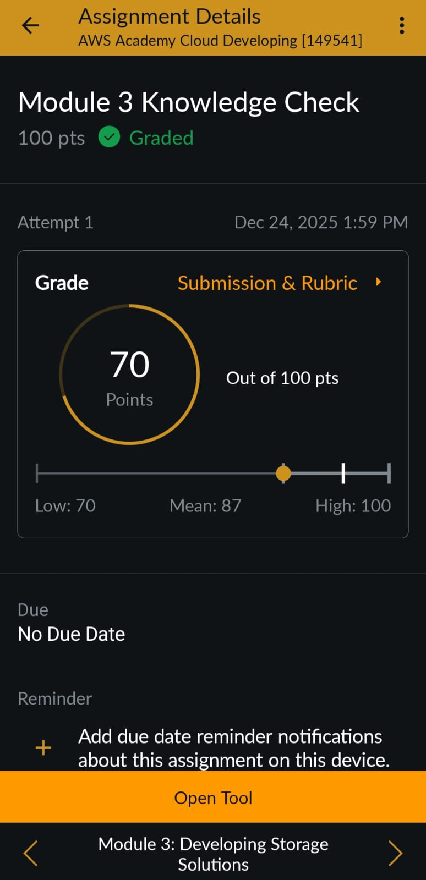

Figure 6: Grade of Knowledge Check

Learning Outcome :
- Understood the concept of static website hosting using Amazon S3.
- Learned to create and manage S3 buckets using AWS CLI.
- Gained hands-on experience with AWS SDK for Python (Boto3).
- Learned how to apply bucket policies for IP-based access restriction.
- Understood secure access management using IAM policies and conditions.
- Learned how to upload and manage website objects in Amazon S3.
- Explored the structure and working of a static web application hosted on AWS.
- Understood real-world cloud security best practices for controlled access.

References :
- AWS Academy Cloud Computing Lab Manual
- https://docs.aws.amazon.com/s3
- https://docs.aws.amazon.com/cli
- https://boto3.amazonaws.com/v1/documentation/api/latest/index.html
- https://docs.aws.amazon.com/AmazonS3/latest/userguide/WebsiteHosting.html

