PRACTICAL: 3

Objective:
To create and manage an Amazon DynamoDB table for storing café menu information, perform data insertion and modification using AWS CLI and Python Boto3 SDK, query table data efficiently, implement batch processing, and configure a Global Secondary Index (GSI) for optimized data retrieval.

Theory:
Amazon DynamoDB is a fully managed, serverless NoSQL key-value and document database provided by Amazon Web Services (AWS). It is designed to deliver fast and predictable performance with seamless scalability. DynamoDB is ideal for applications that require low-latency data access and flexible schema design.

In this practical, DynamoDB is used to store and manage the café’s menu data dynamically. Unlike traditional relational databases, DynamoDB allows records with varying attributes to be added without altering the table schema. Each DynamoDB table requires a primary key that uniquely identifies each record.

AWS Command Line Interface (AWS CLI) and AWS SDK for Python (Boto3) are used to create tables, insert records, apply condition expressions, perform batch operations, and query data. Conditional expressions help prevent unintended overwrites, while batch processing improves efficiency when inserting large datasets.

A Global Secondary Index (GSI) is introduced to enable querying on non-primary key attributes, such as identifying special menu items. This enhances application performance and allows efficient data filtering for dynamic website content.

Visual Studio Code (VS Code) IDE is used as the development environment to execute scripts, manage files, and interact with AWS services securely.

Code:
N/A

Output:

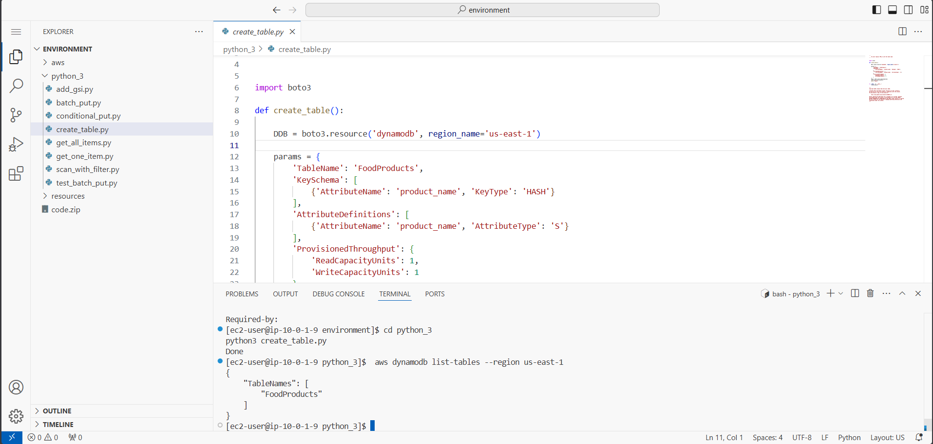
Figure 1: Creating DynamoDB table FoodProducts using Python Boto3

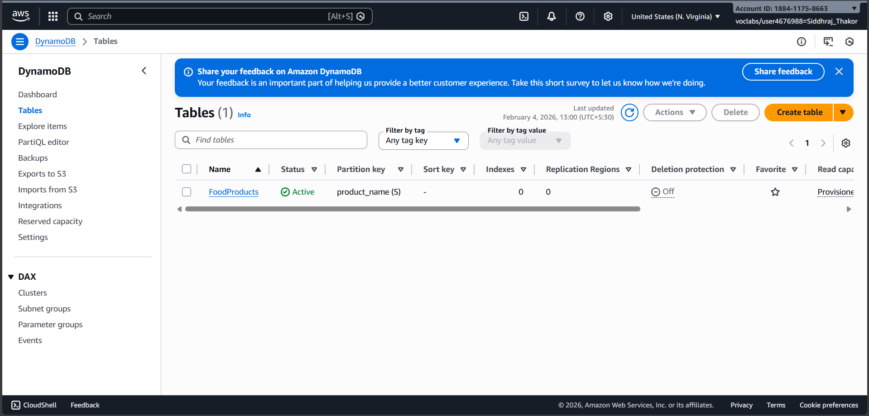
Figure 2: Verifying table creation using AWS CLI and DynamoDB Console

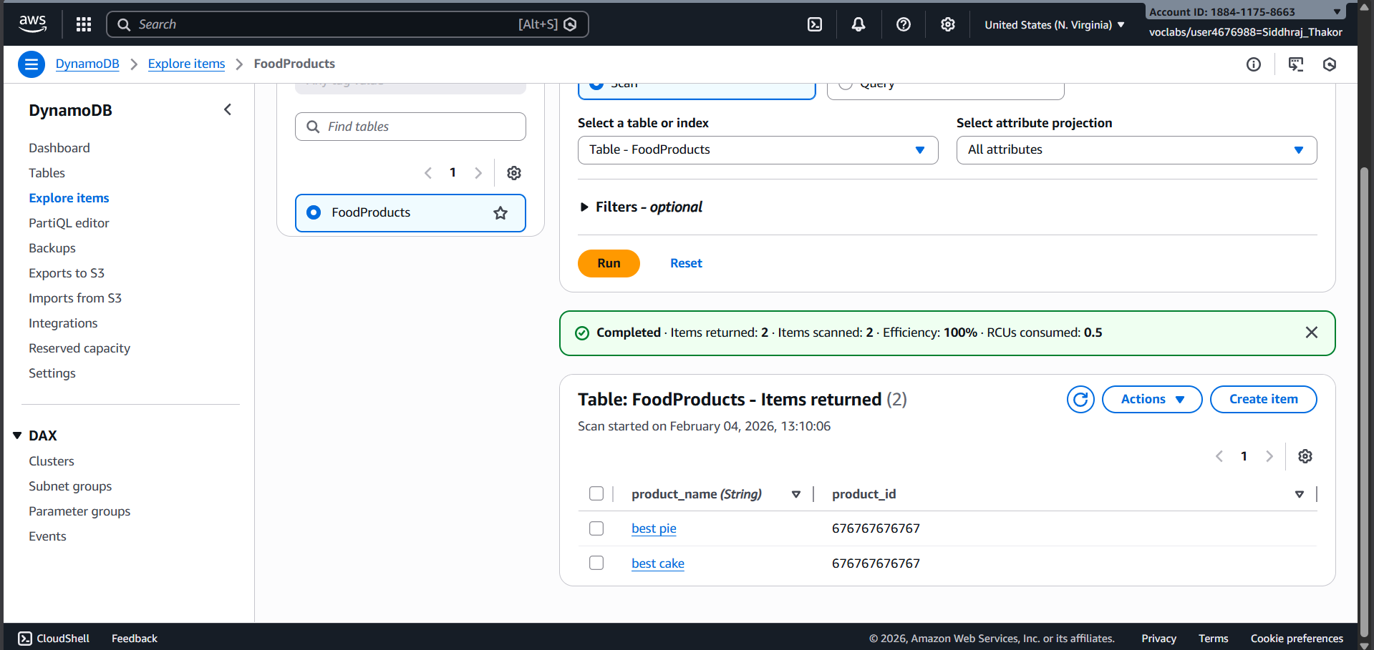
Figure 3: Demonstrating overwrite behavior with duplicate primary keys

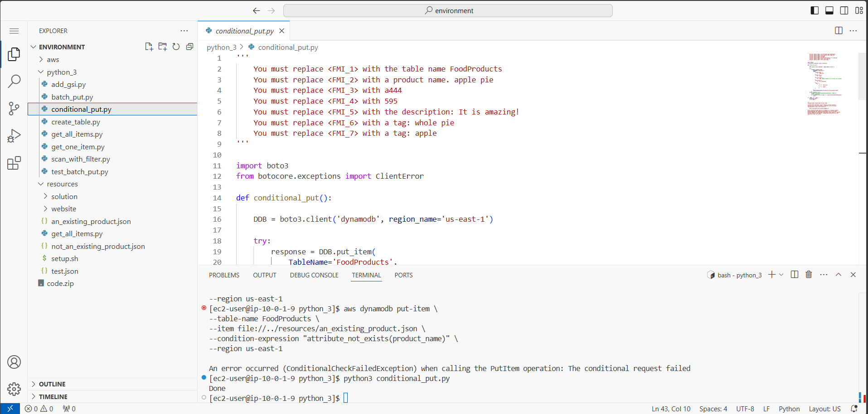
Figure 4: Inserting single items using Python SDK with conditional put

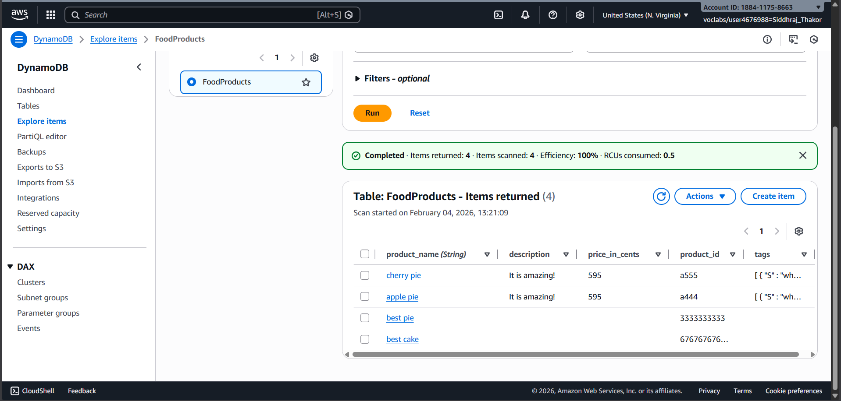
Figure 5: Successfully loading production menu data into DynamoDB

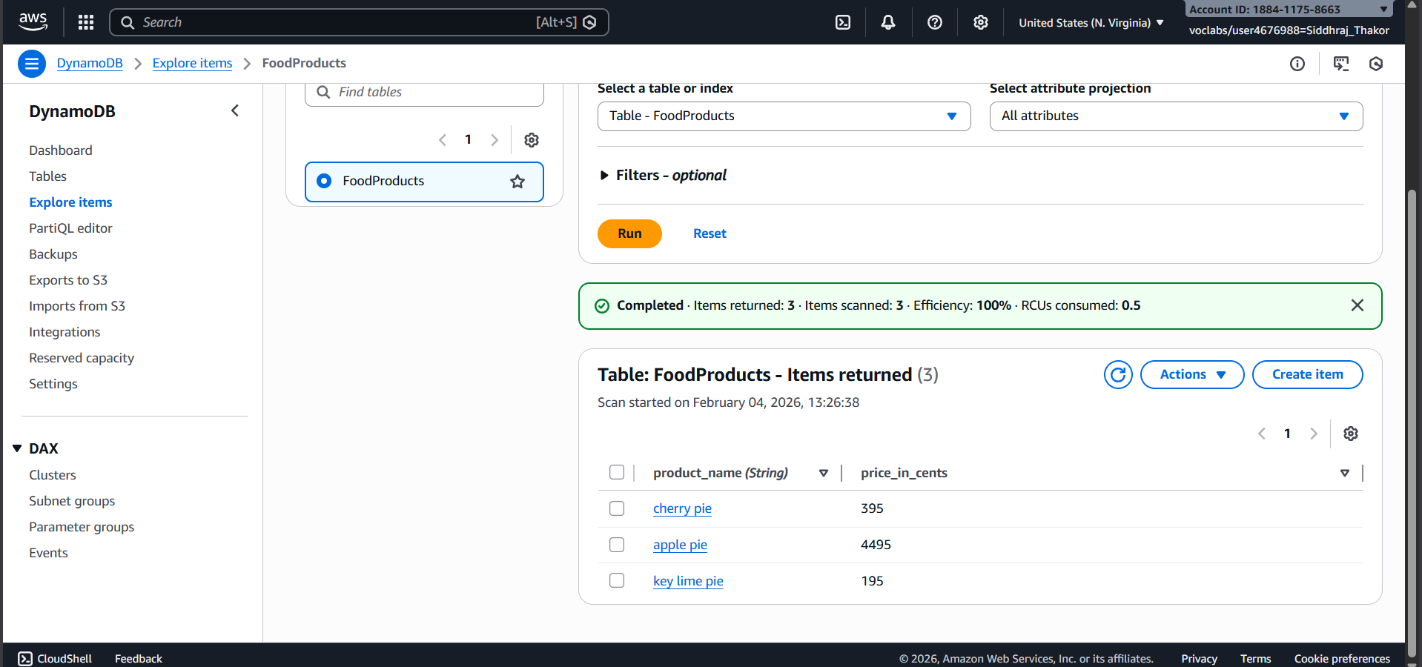
Figure 6: Retrieving all items using scan() operation

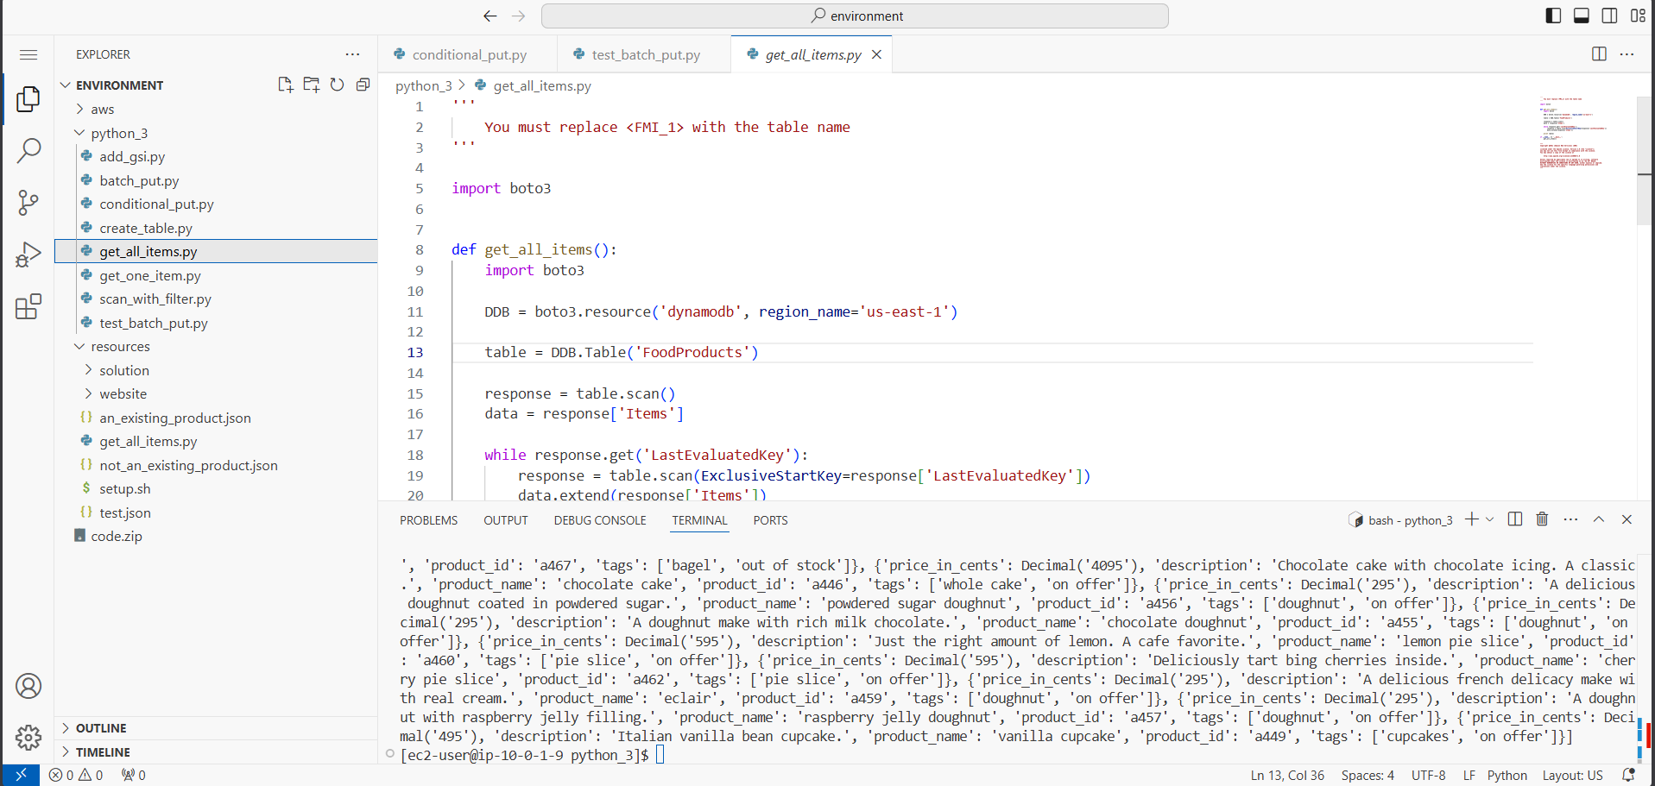
Figure 7: Retrieving a all item using get_all_item() operation

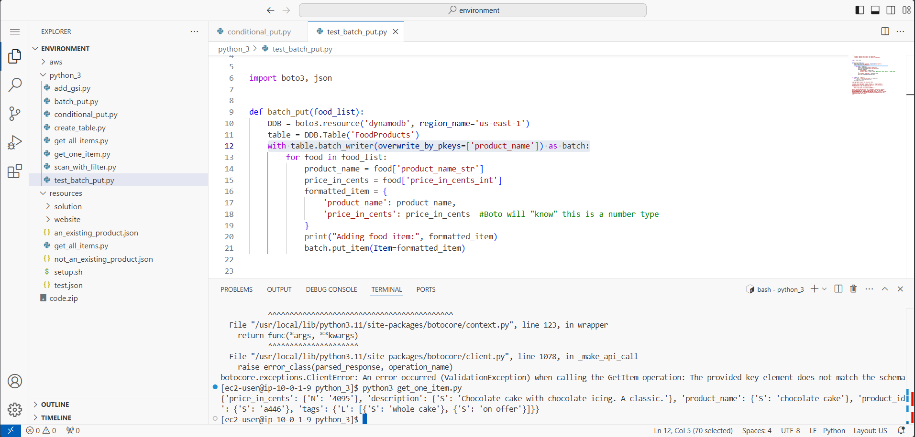
Figure 8: Retrieving a single item using get_item() operation

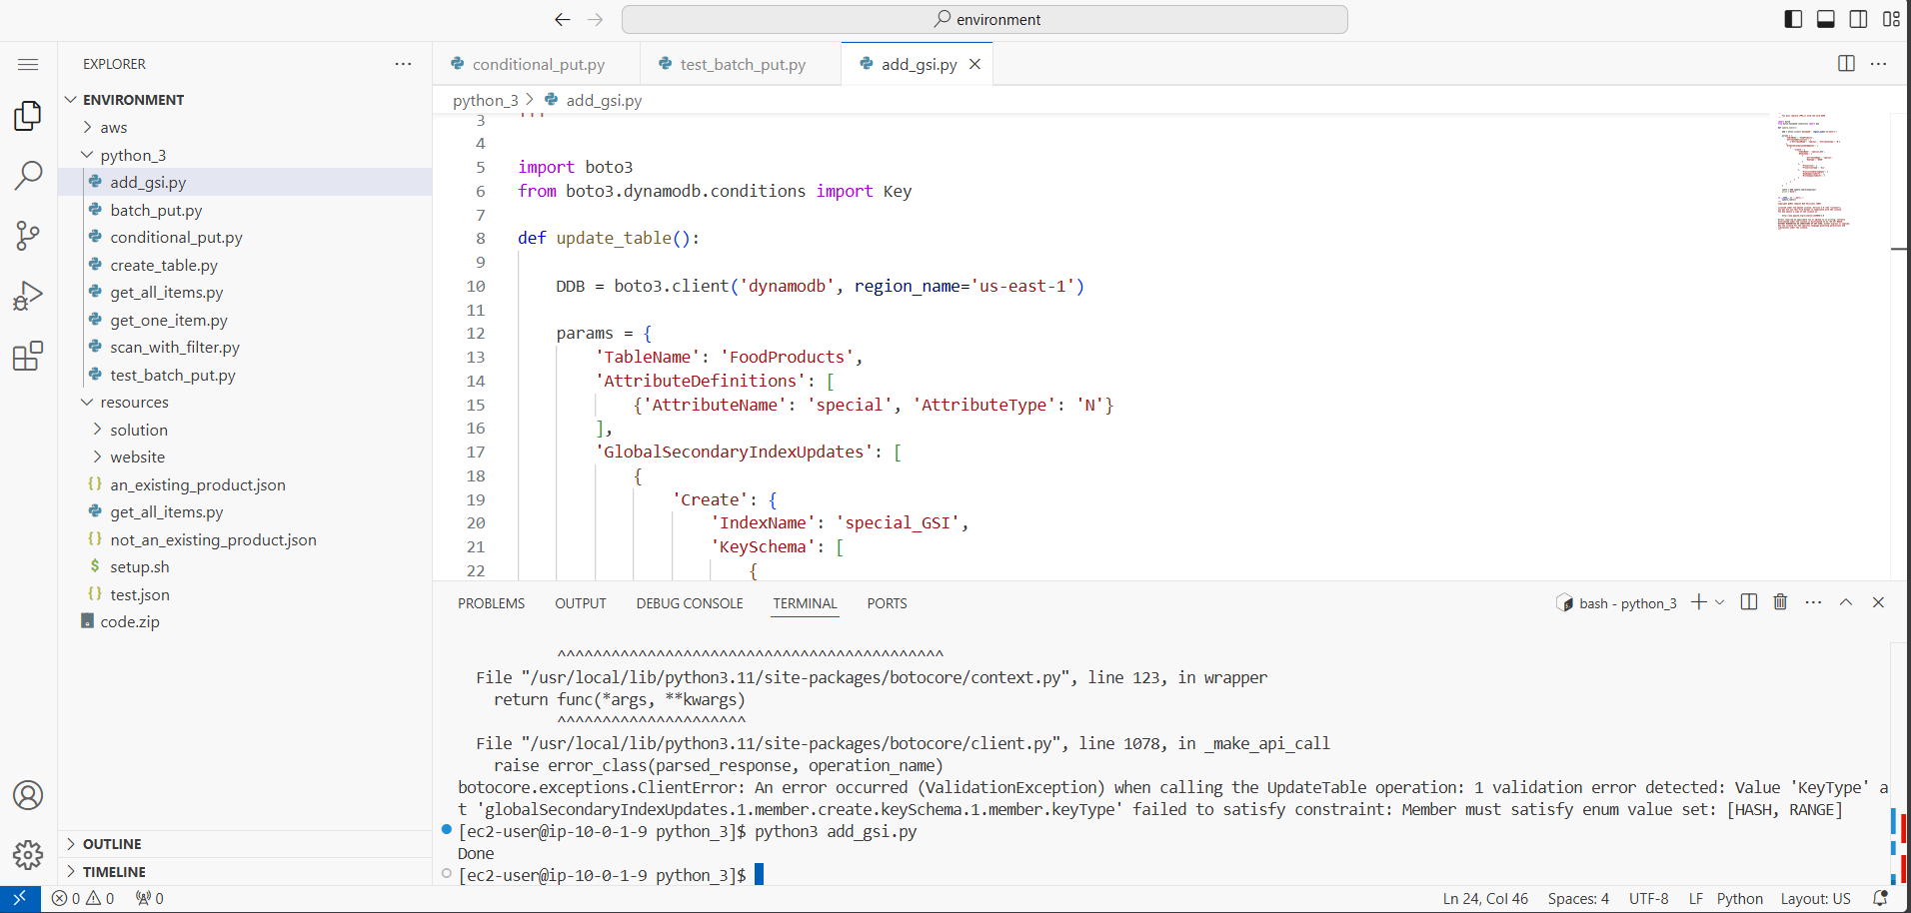
Figure 9: Creating a Global Secondary Index (special_GSI)

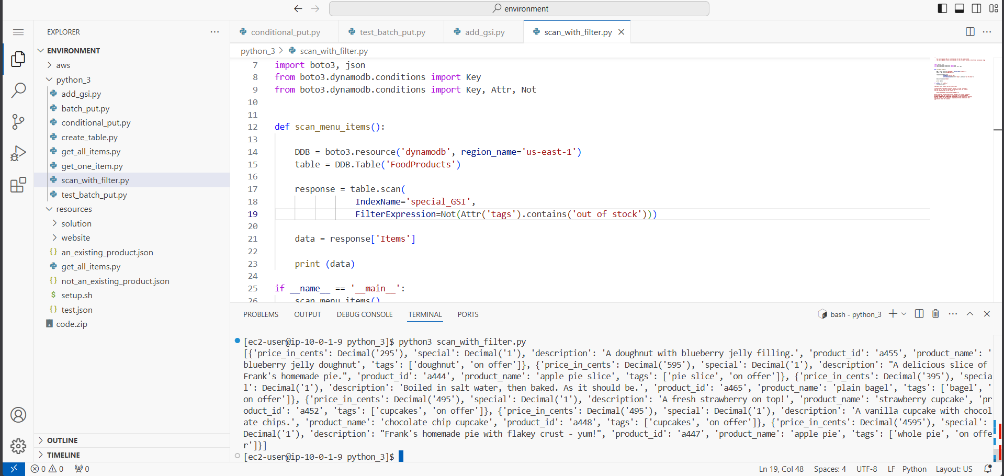
Figure 10: Querying DynamoDB using GSI with filter expressions

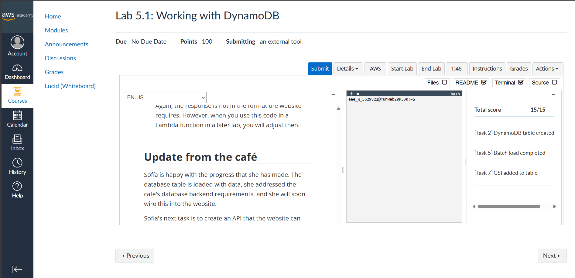
Figure 10: Grade of Lab

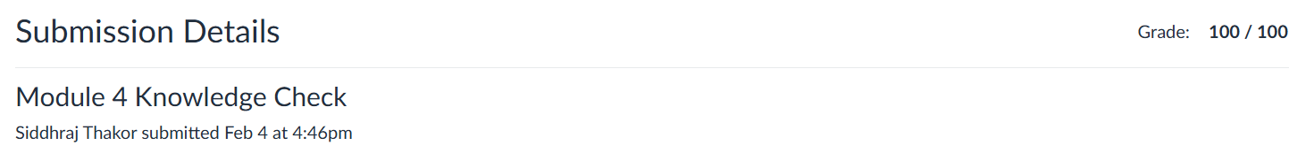

Figure 11: Grade of Knowledge Check Module 4

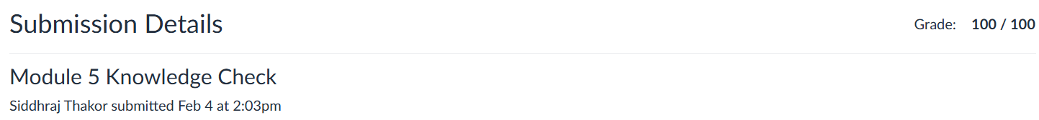
Figure 12: Grade of Knowledge Check Module 5

Learning Outcome :
- Understood the concept of static website hosting using Amazon S3.
- Learned to create and manage S3 buckets using AWS CLI.
- Gained hands-on experience with AWS SDK for Python (Boto3).
- Learned how to apply bucket policies for IP-based access restriction.
- Understood secure access management using IAM policies and conditions.
- Learned how to upload and manage website objects in Amazon S3.
- Explored the structure and working of a static web application hosted on AWS.
- Understood real-world cloud security best practices for controlled access.

References :
- AWS Academy Cloud Computing Lab Manual
- https://docs.aws.amazon.com/s3
- https://docs.aws.amazon.com/cli
- https://boto3.amazonaws.com/v1/documentation/api/latest/index.html
- https://docs.aws.amazon.com/AmazonS3/latest/userguide/WebsiteHosting.html

