

CHARUSAT Chandubhai S Patel Institute of Technology Department of Artificial Intelligence & Machine Learning AIML 301 – Cryptography & Network Security

23AIML070 Practical-2 Date: 01/06/2025

Aim : Implement classical cryptography techniques: Caesar Cipher, Playfair Cipher, and Rail-Fence Cipher to understand substitution and transposition encryption.

Ceaser cipher:

CODE

#include<iostream>
using namespace std;

string ceaser(string s1,int sf){
string ans;

for(int i=0; i<s1.length(); i++){
char ch = s1[i];
if(ch >= 'a' && ch <= 'z'){
ch = ((ch - 'a' + sf) % 26) + 'a';
}
else if(ch >= 'A' && ch <= 'Z'){
ch = ((ch - 'A' + sf) % 26) + 'A';
}
ans += ch;
}

return ans;

}

string ceaser_decrypt(string encrypted, int sf) {
return ceaser(encrypted, (26 - (sf % 26)) % 26);
}

int main(){

string s;
int shift;
cout<<"<<<<<<<<<<<<<<<<< ceaser cipher >>>>>>>>>>>>>>>>>"<<endl;
cout<<"Enter String : ";
cin>>s;

cout<<"Enter Shift value :";
cin>>shift;

string ans= ceaser(s,shift);
cout<<"ENCREYPTED TEXT : "<<ans;

cout<<endl<<"Decrypting TEXT ................."<<endl;
string dec = ceaser_decrypt(ans, shift);
cout<<"DECRYPTED TEXT : "<<dec;

return 0;
}

OUTPUT

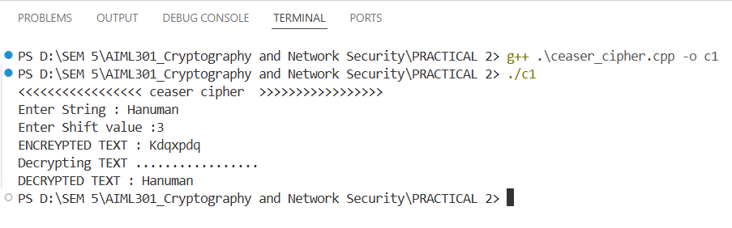

Playfair Cipher:

CODE

#include<iostream>
#include<string>
#include<vector>
using namespace std;

char matrix[5][5];

void createMatrix(string key) {
bool used[26] = {false};
used[9] = true;
int row = 0, col = 0;

for(char c : key) {
if(c >= 'A' && c <= 'Z') c = c - 'A' + 'a';
if(c >= 'a' && c <= 'z' && !used[c - 'a']) {
matrix[row][col] = c;
used[c - 'a'] = true;
col++;
if(col == 5) {
col = 0;
row++;
}
}
}

for(char c = 'a'; c <= 'z' && row < 5; c++) {
if(c == 'j') continue;
if(!used[c - 'a']) {
matrix[row][col] = c;
col++;
if(col == 5) {
col = 0;
row++;
}
}
}
}

pair<int,int> findPosition(char c) {
if(c == 'j') c = 'i';
for(int i = 0; i < 5; i++) {
for(int j = 0; j < 5; j++) {
if(matrix[i][j] == c) {
return {i, j};
}
}
}
return {-1, -1};
}

string preparePlaintext(string text) {
string result = "";
for(char c : text) {
if(c >= 'A' && c <= 'Z') c = c - 'A' + 'a';
if(c >= 'a' && c <= 'z') {
if(c == 'j') c = 'i';
result += c;
}
}

string finalText = "";
for(int i = 0; i < result.length(); i++) {
finalText += result[i];
if(i + 1 < result.length() && result[i] == result[i + 1]) {
finalText += 'x';
}
}

if(finalText.length() % 2 == 1) {
finalText += 'x';
}

return finalText;
}

string playfair(string plaintext, string key) {
createMatrix(key);
plaintext = preparePlaintext(plaintext);
string ciphertext = "";

for(int i = 0; i < plaintext.length(); i += 2) {
char a = plaintext[i];
char b = plaintext[i + 1];

pair<int,int> posA = findPosition(a);
pair<int,int> posB = findPosition(b);

if(posA.first == posB.first) {
ciphertext += matrix[posA.first][(posA.second + 1) % 5];
ciphertext += matrix[posB.first][(posB.second + 1) % 5];
}
else if(posA.second == posB.second) {
ciphertext += matrix[(posA.first + 1) % 5][posA.second];
ciphertext += matrix[(posB.first + 1) % 5][posB.second];
}
else {
ciphertext += matrix[posA.first][posB.second];
ciphertext += matrix[posB.first][posA.second];
}
}

return ciphertext;
}

string playfair_decrypt(string ciphertext, string key) {
createMatrix(key);
string plaintext = "";
for(int i = 0; i < ciphertext.length(); i += 2) {
char a = ciphertext[i];
char b = ciphertext[i + 1];
pair<int,int> posA = findPosition(a);
pair<int,int> posB = findPosition(b);

if(posA.first == posB.first) {
plaintext += matrix[posA.first][(posA.second + 4) % 5];
plaintext += matrix[posB.first][(posB.second + 4) % 5];
}
else if(posA.second == posB.second) {
plaintext += matrix[(posA.first + 4) % 5][posA.second];
plaintext += matrix[(posB.first + 4) % 5][posB.second];
}
else {
plaintext += matrix[posA.first][posB.second];
plaintext += matrix[posB.first][posA.second];
}
}
return plaintext;
}

int main(){
string s, key;
cout<<"//////////////////// playfair cipher ////////////////////"<<endl;
cout<<"Enter String : ";
cin>>s;

cout<<"Enter Key : ";
cin>>key;

string ans = playfair(s, key);
cout<<"ENCRYPTED TEXT : "<<ans<<endl;

string decrypted = playfair_decrypt(ans, key);
cout<<"DECRYPTED TEXT : "<<decrypted<<endl;

return 0;
}
OUTPUT

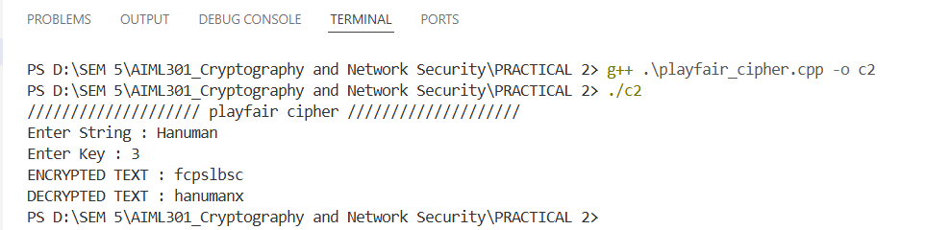

Railfense Cipher:

CODE

#include<iostream>
#include<string>
#include<vector>
using namespace std;

char matrix[5][5];

void createMatrix(string key) {
bool used[26] = {false};
used[9] = true;
int row = 0, col = 0;

for(char c : key) {
if(c >= 'A' && c <= 'Z') c = c - 'A' + 'a';
if(c >= 'a' && c <= 'z' && !used[c - 'a']) {
matrix[row][col] = c;
used[c - 'a'] = true;
col++;
if(col == 5) {
col = 0;
row++;
}
}
}

for(char c = 'a'; c <= 'z' && row < 5; c++) {
if(c == 'j') continue;
if(!used[c - 'a']) {
matrix[row][col] = c;
col++;
if(col == 5) {
col = 0;
row++;
}
}
}
}

pair<int,int> findPosition(char c) {
if(c == 'j') c = 'i';
for(int i = 0; i < 5; i++) {
for(int j = 0; j < 5; j++) {
if(matrix[i][j] == c) {
return {i, j};
}
}
}
return {-1, -1};
}

string preparePlaintext(string text) {
string result = "";
for(char c : text) {
if(c >= 'A' && c <= 'Z') c = c - 'A' + 'a';
if(c >= 'a' && c <= 'z') {
if(c == 'j') c = 'i';
result += c;
}
}

string finalText = "";
for(int i = 0; i < result.length(); i++) {
finalText += result[i];
if(i + 1 < result.length() && result[i] == result[i + 1]) {
finalText += 'x';
}
}

if(finalText.length() % 2 == 1) {
finalText += 'x';
}

return finalText;
}

string playfair(string plaintext, string key) {
createMatrix(key);
plaintext = preparePlaintext(plaintext);
string ciphertext = "";

for(int i = 0; i < plaintext.length(); i += 2) {
char a = plaintext[i];
char b = plaintext[i + 1];

pair<int,int> posA = findPosition(a);
pair<int,int> posB = findPosition(b);

if(posA.first == posB.first) {
ciphertext += matrix[posA.first][(posA.second + 1) % 5];
ciphertext += matrix[posB.first][(posB.second + 1) % 5];
}
else if(posA.second == posB.second) {
ciphertext += matrix[(posA.first + 1) % 5][posA.second];
ciphertext += matrix[(posB.first + 1) % 5][posB.second];
}
else {
ciphertext += matrix[posA.first][posB.second];
ciphertext += matrix[posB.first][posA.second];
}
}

return ciphertext;
}

string playfair_decrypt(string ciphertext, string key) {
createMatrix(key);
string plaintext = "";
for(int i = 0; i < ciphertext.length(); i += 2) {
char a = ciphertext[i];
char b = ciphertext[i + 1];
pair<int,int> posA = findPosition(a);
pair<int,int> posB = findPosition(b);

if(posA.first == posB.first) {
plaintext += matrix[posA.first][(posA.second + 4) % 5];
plaintext += matrix[posB.first][(posB.second + 4) % 5];
}
else if(posA.second == posB.second) {
plaintext += matrix[(posA.first + 4) % 5][posA.second];
plaintext += matrix[(posB.first + 4) % 5][posB.second];
}
else {
plaintext += matrix[posA.first][posB.second];
plaintext += matrix[posB.first][posA.second];
}
}

OUTPUT
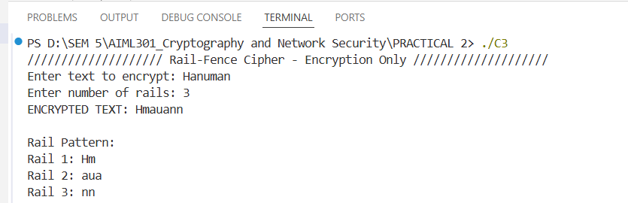

Key Questions:

1. How does the Caesar cipher perform character shifting?
Ans: The Caesar cipher shifts each letter in your message by a fixed number of places in the alphabet (e.g., a shift of 3 turns 'A' into 'D', 'B' into 'E', etc.). If the shift goes past 'Z', it wraps around to 'A' (like a circular alphabet). For example, with a shift of 3, "CAT" becomes "FDW". It’s a straightforward substitution method, but its simplicity makes it easy to break.

2. How does the Playfair cipher differ from monoalphabetic ciphers?
Ans: Unlike monoalphabetic ciphers (like Caesar), which replace each letter with another single letter consistently, the Playfair cipher encrypts pairs of letters (digraphs) using a 5x5 grid created from a keyword. It substitutes each pair based on their positions in the grid, following specific rules (e.g., same row, same column, or rectangle swap). This makes it a polygraphic cipher, disrupting single-letter patterns and increasing complexity.

3. What is the method to encode text using Rail-Fence cipher?
Ans: In the Rail-Fence cipher, you write your message in a zigzag pattern across a set number of rows (rails). For example, with 3 rails, the message "HELLO" is written as:
H L
E L
O
Then, you read the rows top to bottom (H L, E L, O) to get the encoded message "HLELO". The zigzag pattern scrambles the order, making it harder to read without knowing the number of rails.

Supplementary Problems:

1. What are the security weaknesses of Caesar cipher?
Ans: The Caesar cipher is weak because it only has 25 possible shifts, so an attacker can try every option (brute force). It also preserves letter frequency (e.g., 'E' stays the most common), making it vulnerable to frequency analysis. Since it’s a monoalphabetic cipher, the substitution pattern remains consistent, so once a few letters are guessed, the whole message can be decoded.

2. Why is the Playfair cipher more secure than Caesar cipher?
Ans: The Playfair cipher is more secure because it encrypts pairs of letters (digraphs) instead of single letters, breaking up common single-letter patterns (like 'E' or 'T'). By using a 5x5 grid and keyword-based rules, it creates a more complex substitution that resists frequency analysis better than the Caesar cipher’s simple shift, which is easily reversed.

Key Skills:
- Understanding and applying encryption algorithms logically
- Practicing cipher techniques to encode and decode messages
- Developing problem-solving skills for classical cryptography

Applications:
- Exploring the basics of secure communication systems

Learning Outcome: We will practice classic encryption methods, analyze their strengths and weaknesses, and build a foundational understanding of secure communication principles.

