

CHARUSAT Chandubhai S Patel Institute of Technology Department of Artificial Intelligence & Machine Learning AIML 301 – Cryptography & Network Security

23AIML070 Practical-3 Date: 29/07/2025

Aim: Implement the Diffie-Hellman key exchange algorithm for secure key sharing over an insecure channel.
The Diffie-Hellman algorithm is being used to establish a shared secret that can be used for secret communications while exchanging data over a public network using the elliptic curve to generate points and get the secret key using the parameters.

CODE:
#define ll long long
#include <iostream>
#include <cmath>

using namespace std;

ll power(ll a, ll b, ll p)
{
ll res = 1;
a = a % p;
while (b > 0)
{
if (b % 2 == 1)
res = (res * a) % p;
b = b >> 1;
a = (a * a) % p;
}
return res;
}

ll public_key_A(ll g, ll p, ll a)
{
ll ans;

ans = power(g, a, p);
return ans;
}

ll public_key_B(ll g, ll p, ll b)
{
ll ans;

ans = power(g, b, p);
return ans;
}

ll symmetric_key_k1(ll y, ll a, ll p)
{

return power(y, a, p);
}

ll symmetric_key_k2(ll y, ll b, ll p)
{

return power(y, b, p);
}

int main()
{
ll p = 23;
ll g = 9;
ll a;
ll b;

cout << "ENTER Private Key For A :";
cin >> a;

cout << "ENTER Private Key For B :";
cin >> b;

ll A_p = public_key_A(g, p, a);
ll B_p = public_key_B(g, p, b);

cout << "Public Key of A (A_p): " << A_p << endl;
cout << "Public Key of B (B_p): " << B_p << endl;

ll K1 = symmetric_key_k1(B_p, a, p);
ll K2 = symmetric_key_k2(A_p, b, p);

cout << "Shared Key computed by A (K1): " << K1 << endl;
cout << "Shared Key computed by B (K2): " << K2 << endl;

if (K1 == K2)
cout << "\nKey Exchange Successful! Shared Secret: " << K1 << endl;
else
cout << "\nKey Exchange Failed!" << endl;

return 0;
}

OUTPUT:
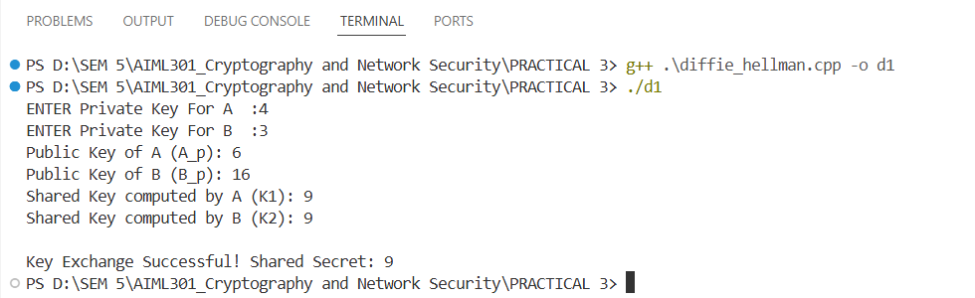

Key Questions:
1.What mathematical principle underlies Diffie-Hellman key exchange?
- The security of the Diffie-Hellman key exchange relies on the mathematical properties of modular exponentiation and the discrete logarithm problem.

- Modular exponentiation is the process of raising a number to a power and taking the remainder when divided by a modulus. In the Diffie-Hellman algorithm, modular exponentiation is used to compute A and B, which are then exchanged between the parties.

- The discrete logarithm problem, on the other hand, is the challenge of finding the exponent, given a base, a modulus, and the result of modular exponentiation. The security of the Diffie-Hellman key exchange is based on the assumption that the discrete logarithm problem is computationally infeasible to solve, making it difficult for an attacker to compute the shared secret key.

2.How is a shared secret derived without transmitting private keys?
- Each party computes the shared secret using their private key and the other party's public key, leveraging modular exponentiation.
kb = x^b mod p X=Public (A), a=Private(A),p=public number
ka = y^a mod p Y=public (B), b=Private(B),

3.What are the vulnerabilities of Diffie-Hellman?
- Vulnerable to man-in-the-middle attacks if authentication is not used; also susceptible to attacks if small primes or weak parameters are chosen.

A man-in-the-middle attack on the Diffie-Hellman key exchange occurs when an attacker, Malory, intercepts the public values exchanged between A and B. Malory replaces A's and B's public keys with her own,

tricking each party into establishing a separate shared secret with him instead of with each other. As a result, A and B unknowingly communicate through Malory,

who can decrypt, read, modify, and re-encrypt all messages between them. This attack highlights the importance of authentication in the Diffie-Hellman protocol to prevent such vulnerabilities.

Supplementary Problems:
1.Can Diffie-Hellman be used in group key sharing?
- Yes. Diffie–Hellman key agreement is not limited to negotiating a key shared by only two participants. Any number of users can take part in an agreement by performing iterations of the agreement protocol and exchanging intermediate data

2.What role does modular arithmetic play in this algorithm?
- Modular arithmetic do help in mathematical operations such as

1. Generating Public Keys:
2. Deriving the Shared Secret:
3. Security and the Discrete Logarithm Problem:

- It ensures that the computations remain within a finite field, making the discrete logarithm problem hard to solve and thus providing security.

Key Skills:
Key exchange, modular arithmetic, secure communication

Applications:
- Secure Shell (SSH):
- Transport Layer Security (TLS) / Secure Sockets Layer (SSL):
- Public Key Infrastructure (PKI):
- Internet Key Exchange (IKE): .
- Internet Protocol Security (IPSec):
- VPN
- Secret messaging apps.

Learning Outcome:
Students will securely exchange keys using the Diffie-Hellman protocol.

