

CHARUSAT Chandubhai S Patel Institute of Technology Department of Artificial Intelligence & Machine Learning AIML 301 – Cryptography & Network Security

23AIML070 Practical-4 Date: 15/07/2025

Aim: Implement the RSA cryptosystem for secure public-key encryption and decryption.

CODE

#include <iostream>
#include <vector>
using namespace std;
#define ll long long

// me - Modular Exponentiation
ll me(ll b, ll e, ll m)
{
ll r = 1;
b %= m;
while (e > 0)
{
if (e % 2 == 1)
r = (r * b) % m;
e >>= 1;
b = (b * b) % m;
}
return r;
}

// mi - Modular Inverse
int mi(int e, int phi)
{
int t = 0, nt = 1;
int r = phi, nr = e;
while (nr != 0)
{
int q = r / nr;
int tmp = nt;
nt = t - q * nt;
t = tmp;

tmp = nr;
nr = r - q * nr;
r = tmp;
}
if (r > 1)
return -1;
if (t < 0)
t += phi;
return t;
}

int main()
{
cout << "===== RSA IMPLEMENTATION =====\n";

int p, q;
cout << "Enter P (prime number 1): ";
cin >> p;
cout << "Enter Q (prime number 2): ";
cin >> q;

int n = p * q;
int phi = (p - 1) * (q - 1);
int e = 17;
int d = mi(e, phi);

if (d == -1)
{
cout << "Error: Invalid values. 'e' and 'phi' are not coprime.\n";
return 1;
}

cout << "\nPublic Key: (" << e << ", " << n << ")";
cout << "\nPrivate Key: (" << d << ", " << n << ")\n";

cin.ignore();
string msg;
cout << "\nEnter message to encrypt: ";
getline(cin, msg);

vector<int> encrypted;
cout << "\nEncrypted: ";
for (char ch : msg)
{
int m = (int)ch;
ll c = me(m, e, n);
encrypted.push_back(c);
cout << c << " ";
}

cout << "\n\nDecrypted: ";
for (int c : encrypted)
{
ll m = me(c, d, n);
cout << (char)m;
}

cout << "\n==============================\n";
cout<<"By 23AIML010 OM CHOKSI";

return 0;
}

OUTPUT

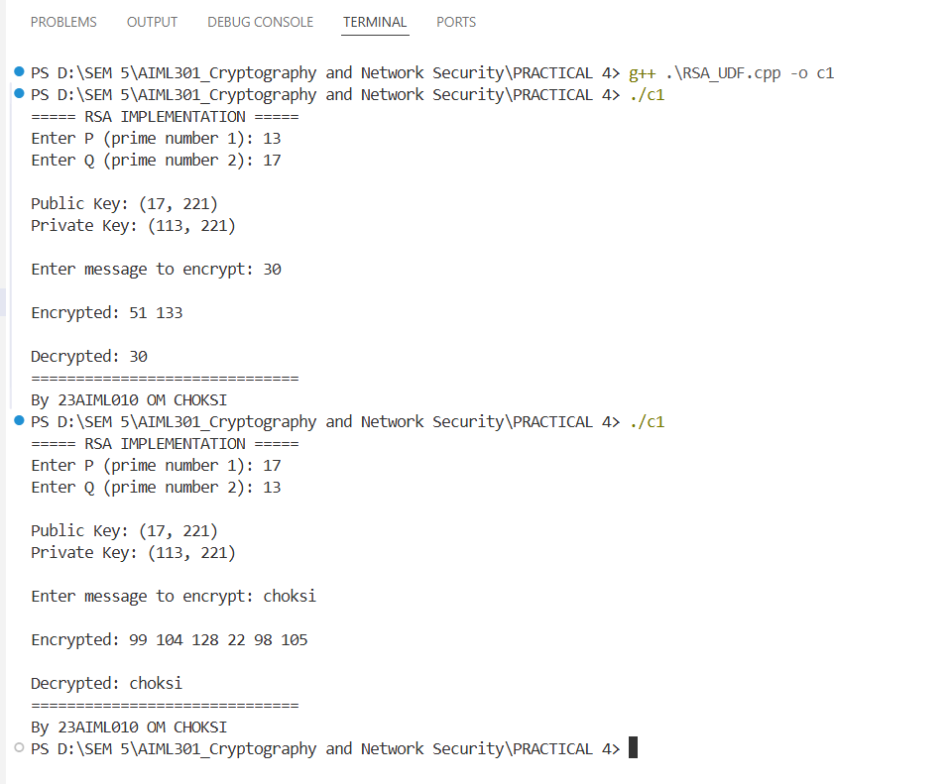
Key Questions:

1. How are RSA keys generated from prime numbers?
Ans:
- Select two prime numbers p and q.
- Compute n = p * q.
- Compute Euler’s totient: φ(n) = (p - 1) * (q - 1).
- Choose e such that 1 < e < φ(n) and gcd(e, φ(n)) = 1.
- Compute private key d such that (d * e) % φ(n) = 1.
This is done using the modular inverse of e mod φ(n).

2. What is the totient function and why is it used?
Ans: The totient function (written as φ(n)) tells us how many numbers are there less than n that do not share any common factors with n (except 1).
In RSA, we use φ(n) to:
- Help calculate the private key from the public key.
- Make sure the keys work correctly for encryption and decryption.
So, φ(n) is an important part of how RSA generates secure keys.

3. What is the difference between public and private keys in RSA?
Ans:
Public Keys | Private keys
Public Key (e, n): Used for encryption | Private Key (d, n): Used for decryption.
Shared openly. | Must be kept secret.

Supplementary Problems:

1. What is the risk of small key sizes in RSA?
Ans: If the RSA key size is too small, today’s powerful computers can quickly figure out the two secret prime numbers (p and q) used to generate the keys.
This means someone could break the encryption using brute-force or smart math tricks.
That’s why it's strongly recommended to use RSA keys of at least 2048 bits in real-life applications to stay secure.

2. Explain how RSA ensures data confidentiality and authentication.
Ans:
Confidentiality means keeping a message secret. In RSA, the sender encrypts the message using the receiver’s public key. Only the receiver can read it by decrypting with their private key.

Authentication means proving who sent the message. The sender can encrypt a small summary (called a hash) of the message using their own private key. This acts like a digital signature. The receiver can use the sender’s public key to check that the message really came from them and hasn’t been changed.

Key Skills:
- Public-key encryption, modular exponentiation, number theory
- Developing problem-solving skills for classical cryptography
Applications:
Digital signatures, secure emails, HTTPS
Learning Outcome:
Students will implement RSA and demonstrate secure message transfer.
- Learn key mathematical principles like totients and modular inverses.
- Demonstrate secure message transfer using public-key cryptography.

Dataset/Test Data:
Use simulated networks or test machines Small test messages and keys for validation.
foundational understanding of secure communication principles.

