

CHARUSAT
Chandubhai S Patel Institute of Technology
Department of Artificial Intelligence & Machine Learning
AIML 301 – Cryptography & Network Security

Practical – 6 Date : 22/07/2025

Aim: Demonstrate steganography using OpenStego by hiding and extracting secret messages in files.

Screenshots
Hiding the Data
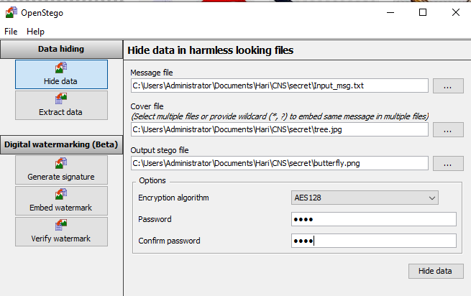
Confirmation
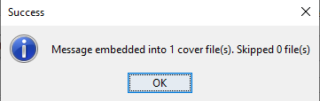

Extracting the msg
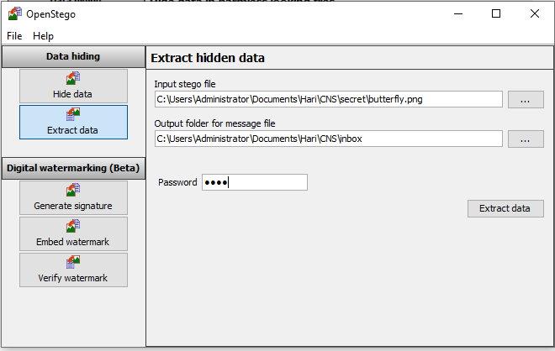

Message Extracted
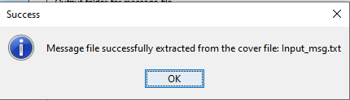

Message
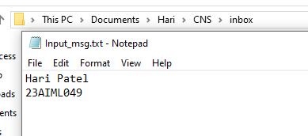

Key Questions:
- What is the purpose of steganography in cybersecurity?
Steganography is used to conceal the existence of data within another file to protect sensitive information and avoid detection by unauthorized parties.
- How does OpenStego protect the hidden message?
OpenStego uses two methods: data hiding (embedding the message in a cover file using a password) and watermarking (embedding a signature to prove authenticity). It also supports AES encryption for added security.
- What file formats are supported by OpenStego?
OpenStego primarily supports image files as cover files, especially the .png format. The hidden message can be any type of file.
Supplementary Problems:
- Compare steganography with cryptography:
  - Steganography hides the existence of the message.
  - Cryptography scrambles the content of the message.
Steganography is about concealment; cryptography is about encryption. They are often combined for enhanced security.
- What are common use cases of OpenStego?
  - Secure file sharing without drawing attention
  - Protecting intellectual property via watermarking
  - Covert communication in sensitive environments
  - Authenticating documents with invisible marks

