

CHARUSAT Chandubhai S Patel Institute of Technology Department of Artificial
Intelligence & Machine Learning AIML 301 –
Cryptography & Network Security

23AIML070 Practical-7 Date: 19/08/2025

Aim: Perform encryption and decryption using CrypTool to demonstrate symmetric and asymmetric algorithms.

Symmetric encryption (AES)
AES is a block cipher that encrypts data in fixed-size blocks (128 bits) using keys of 128, 192, or 256 bits. It performs multiple rounds of substitution, permutation, and key mixing, making it fast and secure for modern applications.

ENCRYPTION
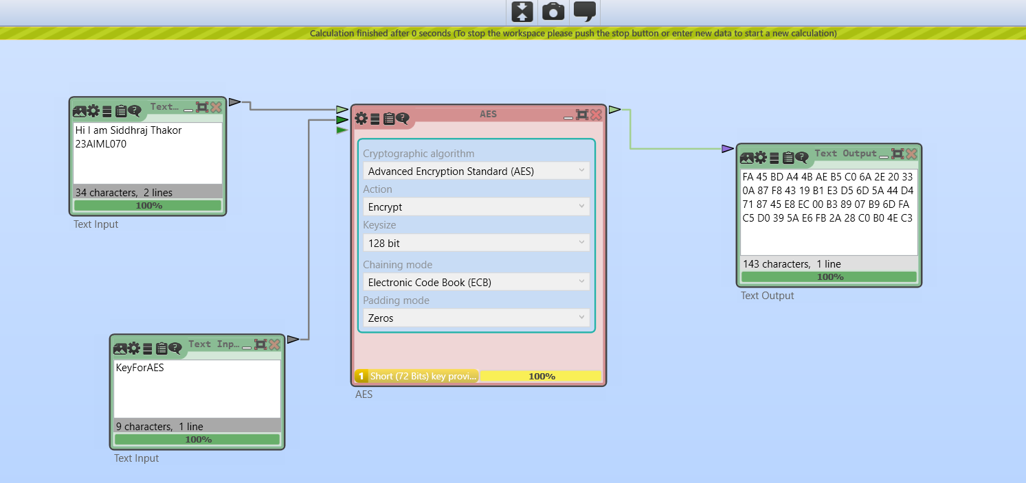
DECRYPTION:
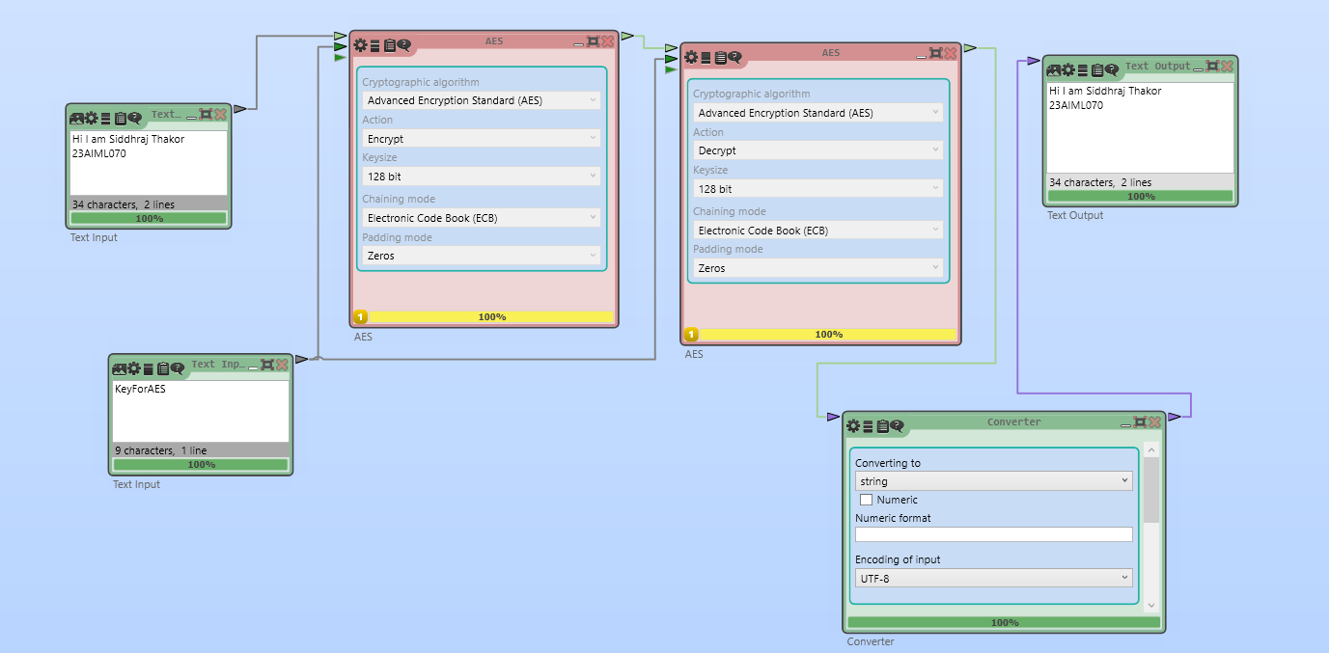

DES (Data Encryption Standard) – Symmetric
DES is an older block cipher that encrypts 64-bit blocks using a 56-bit key. It uses 16 rounds of permutation and substitution. While historically important, DES is now considered insecure due to its small key size.
ENCRYPTION
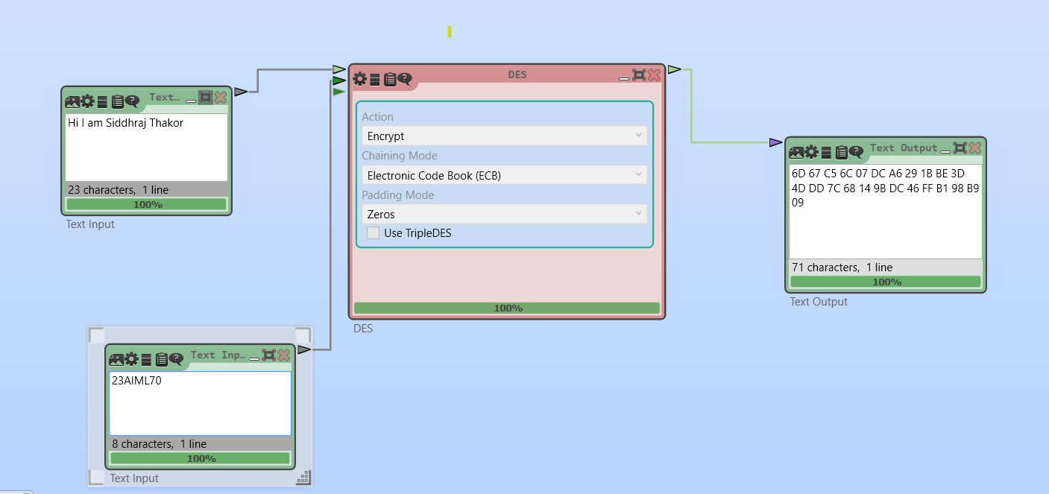

DECRYPTION
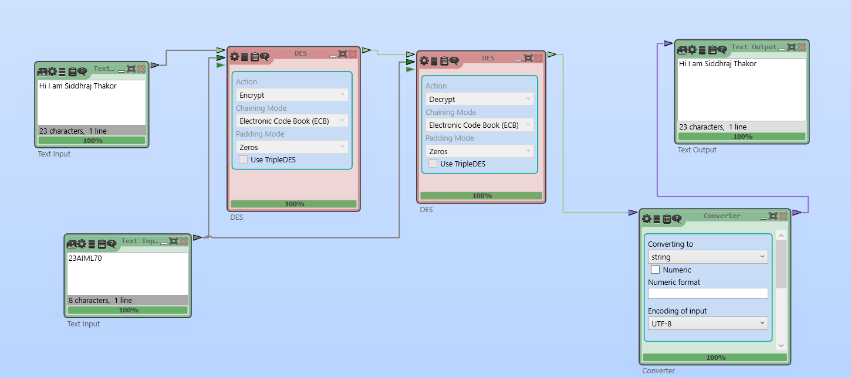

RSA ALGORITHM
RSA uses a pair of keys: a public key for encryption and a private key for decryption. It relies on the mathematical difficulty of factoring large prime numbers. RSA is widely used for secure key exchange and digital signatures.

ENCRYPTION
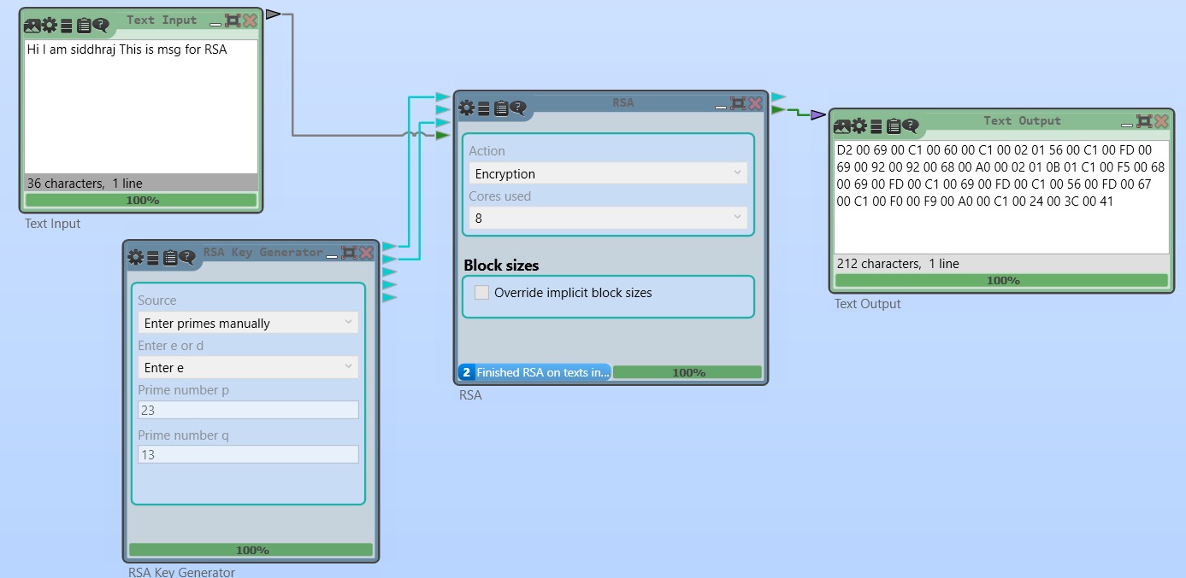

DECRYPTION

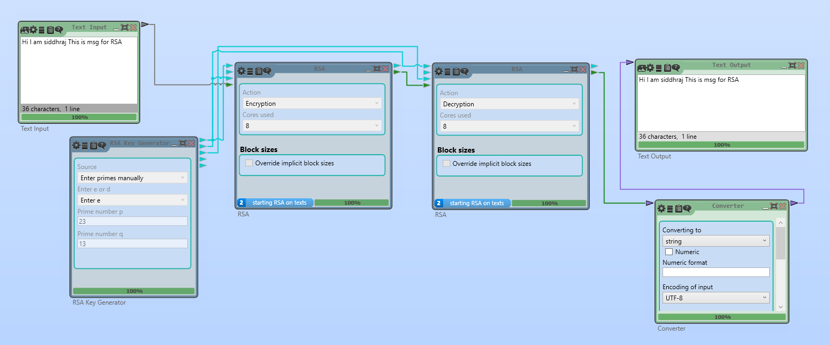

PLAYFAIR CIPHER ALGORITHM
Playfair is a digraph substitution cipher that encrypts pairs of letters using a 5×5 matrix of letters based on a keyword. It was historically used for manual encryption and provides more security than monoalphabetic ciphers.

ENCRYPTION
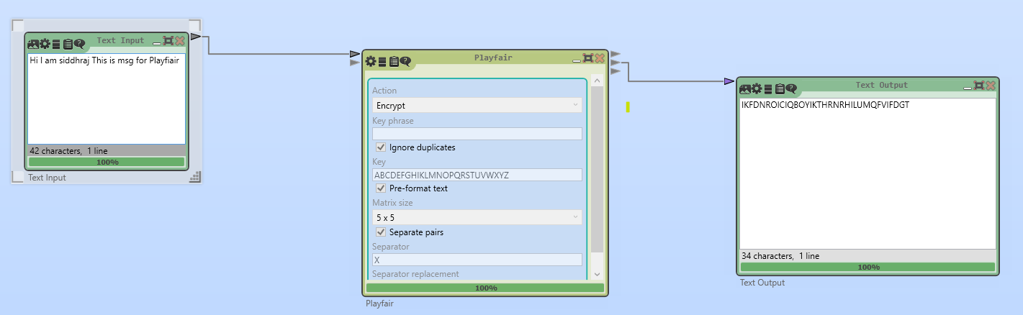

DECRYPTION
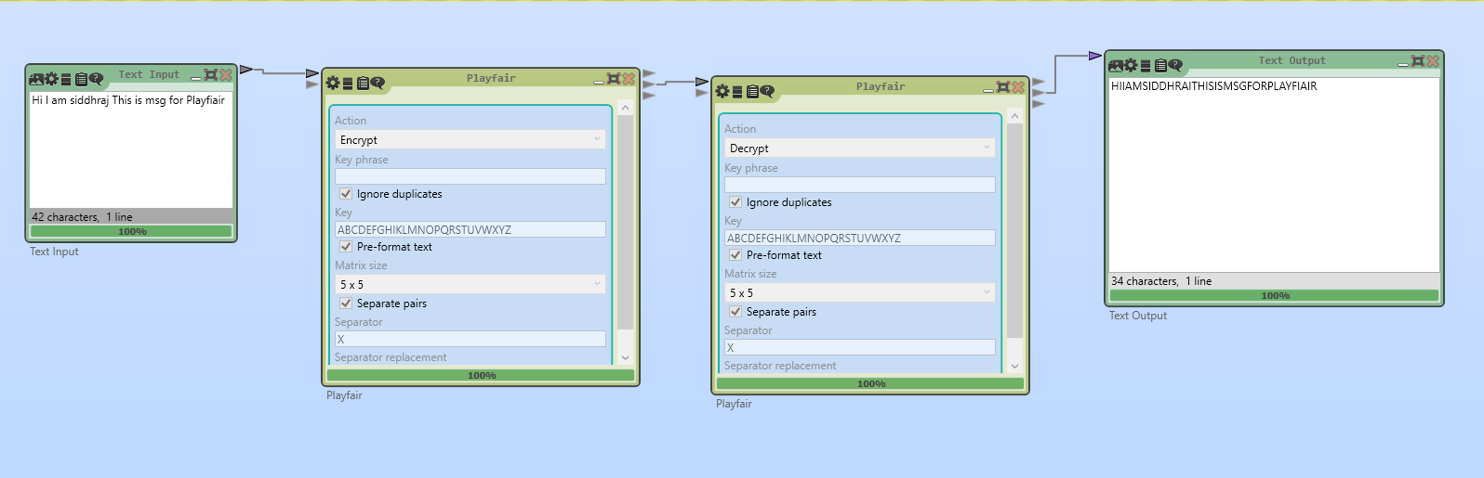

CAESER CIPHER ALGORITHM
The Caesar cipher is a simple substitution cipher that shifts each letter in the plaintext by a fixed number of positions in the alphabet. It is easy to implement but also easy to break.

ENCRYPTION
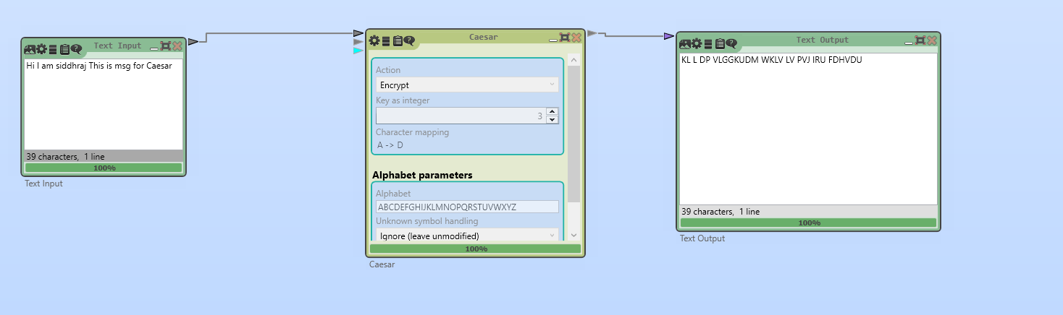

DECRYPTION
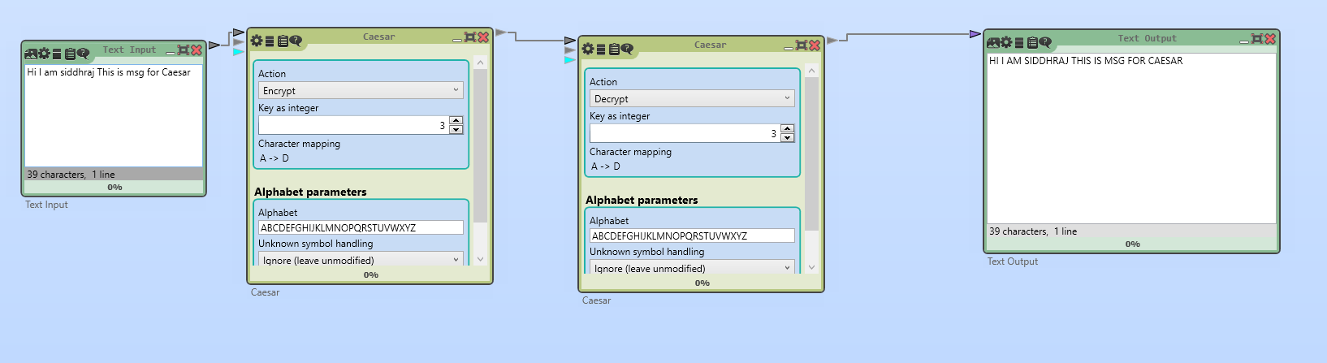

VIGENERE CIPHER ALGORITHM
Vigenère is a polyalphabetic substitution cipher that uses a keyword to determine letter shifts. It is stronger than the Caesar cipher but still vulnerable to frequency analysis if the keyword is short.

ENCRYPTION
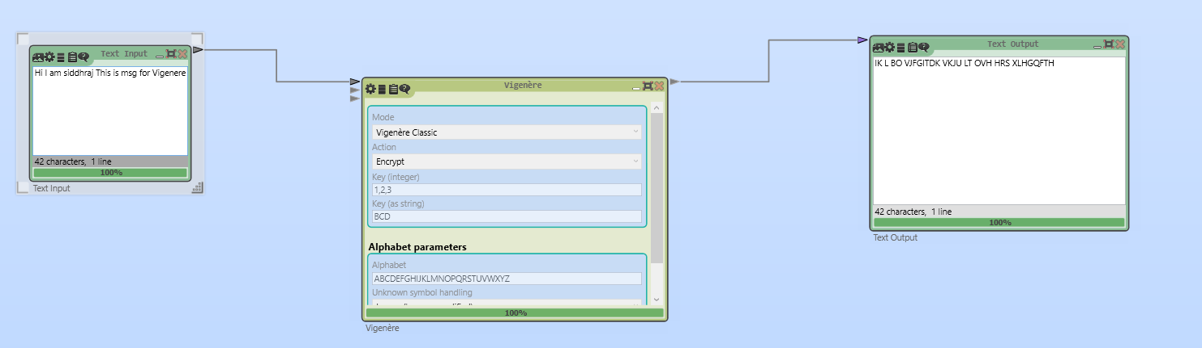

DECRYPTION
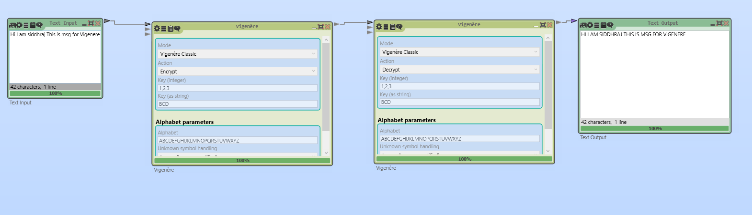

Key Questions:
- What are the differences between AES and RSA in CrypTool?
Ans: AES is a symmetric block cipher that uses the same secret key for both encryption and decryption, making it fast and efficient for large amounts of data. RSA is an asymmetric algorithm that uses a public key for encryption and a private key for decryption, making it slower but ideal for secure key exchange and digital signatures. In CrypTool, AES shows repeated rounds of substitution and permutation, while RSA demonstrates key-pair generation and mathematical exponentiation steps.
- How does CrypTool help visualize encryption steps?
Ans: CrypTool provides a step-by-step graphical view of encryption processes, showing transformations such as substitution, permutation, key scheduling, and mathematical operations. This helps learners understand how plaintext is transformed into ciphertext and vice versa.
- What insights can CrypTool provide to beginners?
Ans: CrypTool helps beginners see the internal working of cryptographic algorithms, compare different techniques, understand strengths and weaknesses, and experiment with various key sizes and parameters to observe their effect on encryption strength.

Supplementary Problems:
- List three cryptographic algorithms available in CrypTool.
Ans:
  - Advanced Encryption Standard (AES)
  - Rivest–Shamir–Adleman (RSA)
  - Data Encryption Standard (DES)

- What is the benefit of using a GUI-based cryptography simulator?
Ans: A GUI-based simulator like CrypTool makes cryptography more interactive and intuitive, allowing learners to visualize each step of encryption/decryption, experiment without coding, and understand concepts faster compared to purely theoretical study.

Key Skills:
Encryption/decryption, algorithm simulation
Applications:
Educational demonstrations, beginner cryptography labs
Learning Outcome:
Students will understand practical encryption using a visual tool.

