

CHARUSAT
Chandubhai S Patel Institute of Technology
Department of Artificial Intelligence & Machine
Learning
AIML 301 – Cryptography & Network Security

Practical – 8 Date: 02/09/2025

Aim: Implement Message Integrity using SHA-256 hashing algorithm
Message Integrity ensures that data is not altered during transmission or storage. One of the most common ways to achieve this is through cryptographic hashing.
- SHA-256 (Secure Hash Algorithm – 256 bit) is a one-way cryptographic hash function that generates a fixed 256-bit (32-byte) hash value from any input message.
- Even a small change in the input (like changing one character) produces a completely different hash output (known as the avalanche effect).
- Since SHA-256 is collision-resistant, it is very difficult for two different messages to produce the same hash.

Implementation Code
import hashlib
# Function to get the SHA-256 hash of a message def get_sha256_hash(input_string):
"""Returns the SHA-256 hash of the given input string.""" sha256_hash = hashlib.sha256() sha256_hash.update(input_string.encode('utf-8')) return sha256_hash.hexdigest()
# Original message
message = "Hello, I am Dev Patel" hashed_message = get_sha256_hash(message)
print(f"Original Message: {message}") print(f"SHA-256 Hash: {hashed_message}")
# Simulate Message Tampering tampered_message = "Hello, this is Dev"
tampered_hash = get_sha256_hash(tampered_message)
23AIML070 Page No. 2
print("\nTampered Message:", tampered_message) print("SHA-256 Hash (after tampering)", tampered_hash)

Output
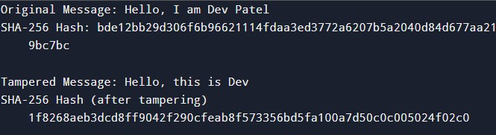
Key Questions:

1.Understanding Hashing in Message Integrity
Hashing ensures that data hasn't been altered during transmission or storage by producing a unique hash value for each piece of data. This hash value is like a digital fingerprint that can be easily compared to detect tampering.
Here's how hashing protects message integrity:
- Hashing detects tampering: A small change in the data results in a completely different hash value, making tampering easily detectable.
- Hash value changes drastically with tampering: When a message is altered, even by a single character, its hash value will change drastically, alerting that the integrity of the message has been compromised.

2. Components of a Simple Blockchain Block
A simple blockchain block consists of:
- Block Data (Transaction or Message): The data being stored in the block, such as a transaction or a message.
- Timestamp: The time at which the block was created.
- Hash of the block: A unique hash value for the block, generated based on its contents.
- Hash of the previous block: A reference to the previous block in the chain, linking blocks together.

3.SHA-256 Security and Blockchain Immutability
SHA-256 is considered secure because it produces a fixed-length hash (256 bits), is collisionresistant, and is computationally infeasible to reverse. This ensures that once data is written, it cannot be easily changed.
Blockchain ensures data immutability by linking blocks together using hash values. Any change to a block will change its hash, which in turn affects all subsequent blocks, making it computationally impractical to alter a single block without changing the entire chain.

