

CHARUSAT
Chandubhai S Patel Institute of Technology
Department of Artificial Intelligence & Machine
Learning
AIML 301 – Cryptography & Network Security

Practical – 9 Date: 16/09/2025

Aim: Write a program to generate a digital certificate and sign it with a private key.
A digital certificate serves to authenticate the identity of an entity and to facilitate secure communication by encrypting data. It typically contains:
- Subject: The entity the certificate is issued to.
- Issuer: The Certificate Authority (CA) that issued it.
- Public Key: Associated with the subject.
- Signature: Created by the CA using their private key to verify authenticity.
- Validity Period: The time frame when the certificate is valid.

Output
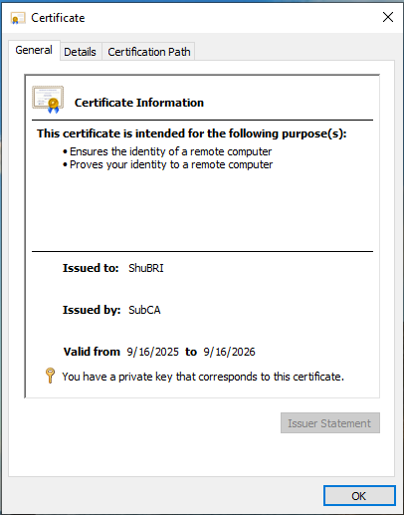

Key Questions:
- What are the components of a digital certificate?
A digital certificate typically consists of the following components:
  - Subject: The entity that the certificate is issued to (e.g., a website or individual).
  - Issuer: The certificate authority (CA) that issued the certificate.
  - Public Key: The public key corresponding to the private key held by the subject.
  - Signature Algorithm: The cryptographic algorithm used to sign the certificate.
  - Signature: A cryptographic signature from the certificate issuer (CA) confirming the certificate’s validity.
  - Validity Period: The dates between which the certificate is considered valid.
  - Serial Number: A unique identifier assigned by the certificate issuer.
  - Certificate Extensions: Optional additional information.
- How is a certificate signed and verified?
  - Signing: When a certificate is created, the certificate authority (CA) uses its private key to sign the certificate. This is typically done by creating a hash of the certificate content and encrypting that hash with the private key.
  - Verification: When someone receives a certificate, they can verify its authenticity by checking the signature using the CA's public key. If the signature matches, the certificate is considered valid.
- Why are public-key infrastructures (PKIs) important?
Public-Key Infrastructure (PKI) enables secure communication over insecure networks, such as the internet. PKIs:
  - Provide encryption and decryption of data using public-private key pairs.
  - Ensure authenticity and integrity of communication by verifying digital certificates.
  - Offer mechanisms for certificate management (e.g., revocation, expiration).
  - Support trust through trusted certificate authorities (CAs).

Supplementary Problems:
- Explain certificate revocation.
Certificate revocation is the process of invalidating a certificate before its expiration date. Reasons for revocation can include:
  - The private key corresponding to the certificate has been compromised.
  - The certificate was issued incorrectly (e.g., wrong information, fraud).
  - The certificate is no longer needed or in use.
Revocation can be checked through:
  - CRLs (Certificate Revocation Lists): A list maintained by the CA that contains revoked certificates.
  - OCSP (Online Certificate Status Protocol): A real-time protocol to check the revocation status of a certificate.
- What are certificate authorities and their responsibilities?
A Certificate Authority (CA) is an entity that issues digital certificates. Their responsibilities include:
  - Issuing Certificates: Verifying the identity of an entity and issuing digital certificates.
  - Managing Certificate Lifecycles: Handling the creation, renewal, and revocation of certificates.
  - Providing Public Key Infrastructure (PKI): Ensuring trust by managing and distributing public keys securely.

