AIM :- Study and compare different software process models and compare them based on cost, simplicity, risk, involvement of user, flexibility, maintenance, integrity, security, re-usability, and requirement.
Parameter | Waterfall | V-Model | Iterative | Spiral | Agile
Cost | Low initial cost as it follows a fixed, linear budget plan. | Moderate cost due to extensive and parallel testing resources. | Can become high because repeated cycles require continuous funding. | Highest cost due to constant risk assessment and prototyping. | Moderate; costs depend on the number of sprints and team size.
Simplicity | Very easy to understand as it follows a "one-step-at-a-time" flow. | Simple but disciplined, requiring strict mapping of tests to design. | Moderately complex; requires managing multiple versions of the product. | Most complex; requires highly skilled experts for risk analysis. | Moderate; easy to start but requires cultural shift and discipline.
Risk | High risk; errors are often discovered only during the final stages. | Moderate; early test planning reduces some risk but late changes are hard. | Reduced risk as each version provides a chance to fix major flaws. | Lowest risk; every cycle starts with identifying and fixing potential failures. | Low risk; frequent deliveries ensure the project stays on track.
User Involvement | Low; the user is usually only involved at the very start and very end. | Moderate; users help define requirements and perform acceptance testing. | High; users provide feedback on each successive version produced. | Moderate; users are involved during the evaluation phase of each loop. | Highest; the customer is a constant partner throughout the process.
Flexibility | Rigid; once a phase is finished, going back to change it is difficult. | Rigid; it follows a strict sequence that discourages mid-way changes. | Flexible; features can be adjusted or added in the next iteration. | Highly flexible; the model is designed to evolve as the project grows. | Most Flexible; welcomes changing requirements even late in development.
Maintenance | Difficult because the entire system is delivered at once as a "black box." | Easier than Waterfall because testing documentation is very thorough. | Manageable since the system is built and maintained in chunks. | Manageable; though complex, the history of risk cycles helps tracking. | Easiest; continuous integration makes ongoing updates part of the flow.
Requirement | Must be clear and fixed before any development starts. | Must be precise and stable to allow for early test design. | Can be partially known and refined as iterations progress. | Often complex, ambiguous, or highly innovative at the start. | Dynamic and expected to change frequently throughout the project.
Example | Static Website: Building a basic 5-page site for a local business with a fixed scope. | Medical Device: Software for a heart monitor where every code line must be verified. | Search Engine: Releasing a text search first, then adding image and video search later. | Defense Systems: Large-scale military projects like a fighter jet flight control system. | Mobile Apps: Developing a social media app where features change based on user trends.

1) Waterfall Model
- This model operates on a strictly sequential basis, requiring the total completion of one stage before the subsequent one can begin.  - The process initiates with a thorough analysis of requirements and concludes only after the final maintenance phase is reached.  - Due to its rigid structure, revisiting a previous stage to implement modifications is highly challenging and often costly.  - Its straightforward design makes the development lifecycle very simple to comprehend and oversee.  - It is most effective for minor projects where the objectives are fixed, well-documented, and unlikely to shift. | 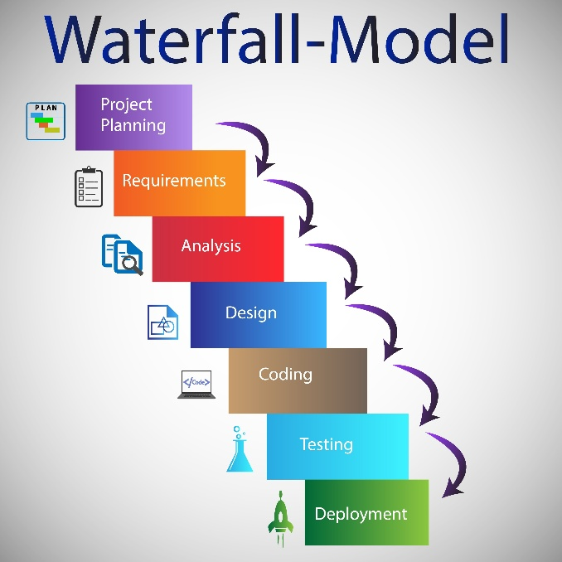

2) V-Model
- Functioning as an evolved version of the Waterfall approach, this model places a heavy emphasis on integrating quality checks throughout the entire lifecycle.  - It operates on a symmetrical structure where every single stage of development is directly paired with a specific, corresponding testing level.  - By organizing the testing strategy during the early design stages, the model significantly enhances the overall reliability and quality of the final product.  - Despite the parallel testing, the framework remains relatively inflexible, making it hard to incorporate new requirements once the build is underway.  - This model is exceptionally well-suited for safety-critical industries, such as medical technology or embedded aerospace systems, where precision is vital. | 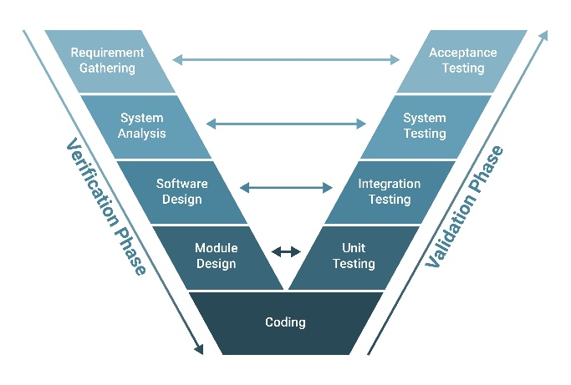

3) Iterative Model
- This framework focuses on building the software through a series of repeating, manageable cycles rather than attempting a single, full release.  - Every individual cycle concludes with the delivery of a functional, executable version of the software, allowing for incremental progress.  - The system is continuously refined and enhanced based on user evaluations and feedback gathered at the end of each iteration.  - Project security and stability are improved because potential flaws and technical risks are identified and addressed early in the process.  - This approach is highly effective for projects where the initial requirements are only partially understood and need to evolve over time. | 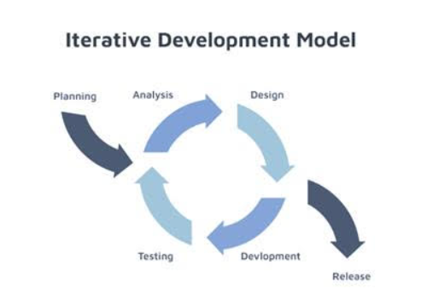

4) Spiral Model
- This framework integrates the repetitive nature of iterative development with a deep, systematic focus on risk management.  - The process advances through continuous loops, where each rotation involves four distinct stages: planning, evaluating risks, engineering, and assessing the results.  - Potential failures are proactively identified and mitigated at the start of every cycle, ensuring high project stability.  - Due to its intensive nature, this model is inherently complex to manage and requires a significant financial investment.  - It is the preferred choice for massive, high-stakes, or mission-critical initiatives where avoiding error is the top priority. | 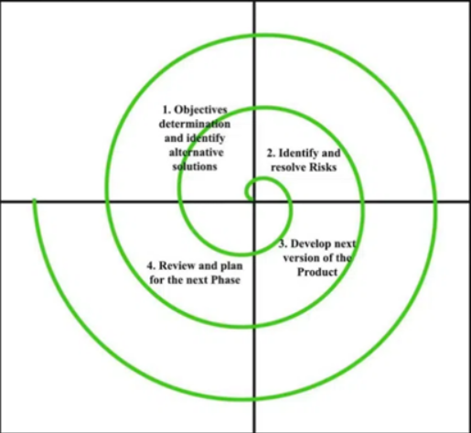

5) Agile Model
- This model utilizes an incremental and highly adaptive strategy, focusing on rapid delivery and flexibility.  - The entire development process is partitioned into brief, time-boxed units known as "sprints," typically lasting a few weeks each.  - Success is driven by constant collaboration, with the customer remaining actively involved and providing feedback throughout the lifecycle.  - The framework is designed to welcome modifications, allowing for requirement changes to be integrated seamlessly even during late stages of production.  - It is ideally suited for dynamic, fast-paced environments, such as the development of mobile applications and modern web platforms. | 