

CHARUSAT Chandubhai S Patel Institute of Technology Department of Artificial Intelligence & Machine Learning AIML 301 – Cryptography & Network Security
Practical – 1 Date :23/06/ 2025
Aim : Study various phishing attacks and their countermeasures. Understand different forms like spear phishing, email phishing, and whaling, and evaluate practical countermeasures such as spam filters, MFA, and employee education.
Keys Questions/Analysis/Interpretation:
- What are the common types of phishing attacks?
  - Email Phishing – The most widespread form, where attackers send fraudulent emails posing as reputable sources to steal sensitive data.

  - Spear Phishing – A targeted version of email phishing that uses personalized information to trick specific individuals or organizations.

  - Whaling – A type of spear phishing aimed at high-level executives or important targets to gain access to sensitive corporate information.

  - Smishing – Phishing attacks carried out via SMS or text messages, urging recipients to click malicious links or provide private data.

  - Vishing – Voice phishing through phone calls, where attackers impersonate legitimate entities to manipulate victims into revealing information.

  - Clone Phishing – An attacker copies a legitimate email and replaces links or attachments with malicious ones before sending it again.

  - Pharming – Redirecting users from legitimate websites to fake ones without their knowledge, often by exploiting DNS vulnerabilities.

- How can multi-factor authentication help prevent phishing?
  - Multi-factor authentication (MFA) helps prevent phishing by adding an extra layer of security beyond just a password. Here's how:
  - Extra Verification Step: Even if a hacker steals your password through phishing, they still need a second factor (like an OTP or fingerprint) to access your account.
  - Reduces Password Reliance: MFA limits the damage caused by compromised passwords, making it harder for attackers to succeed with just login credentials.
  - Real-Time Alerts: Many MFA systems notify users when someone tries to log in, helping detect unauthorized access attempts quickly.
  - Blocks Automated Attacks: Bots and automated scripts used in phishing can’t bypass MFA easily, adding a strong barrier.
  - Secures High-Risk Accounts: For sensitive systems (like banking or work platforms), MFA protects critical data even if the user is tricked by a phishing email.
- Why is user education crucial in phishing prevention?
  - User education is crucial in phishing prevention because informed users are the first line of defense. Here's why:
  - Recognizing Red Flags: Educated users can identify suspicious emails, links, and messages that often go unnoticed.
  - Avoiding Costly Mistakes: Training helps users avoid clicking malicious links or sharing sensitive information, which could lead to data breaches.
  - Reducing Human Error: Most phishing attacks exploit human mistakes—education minimizes these vulnerabilities.
  - Encouraging Safe Practices: Users learn to follow best practices like checking URLs, using strong passwords, and enabling MFA.
  - Creating a Security-Aware Culture: Regular awareness training fosters a mindset where users actively protect organizational and personal data.
Supplementary Problems:
- How can phishing be detected using automated tools?
  - Phishing can be detected using automated tools through various techniques and technologies that analyze emails, websites, and user behavior. Here’s how:
  - URL and Domain Analysis: Tools scan links for suspicious patterns, like misspelled domain names, IP-based URLs, or known blacklisted domains.
  - Machine Learning Algorithms: AI-based tools learn from past phishing attacks to detect and flag new, similar threats based on patterns and anomalies.
  - Email Filtering Systems: Spam filters and secure email gateways automatically identify phishing emails by scanning for malicious attachments, links, and unusual sender behavior.
  - Website Reputation Services: Browsers and security tools check websites against databases of known phishing or malicious sites before users access them.
  - Behavioral Monitoring: Some tools track user actions for unusual behavior (e.g., sudden login attempts from different locations), triggering alerts or blocks if phishing is suspected.

- Explain how attackers create convincing phishing emails.
  - Attackers create convincing phishing emails by carefully mimicking legitimate communication to trick recipients. Here’s how they do it:
  - Spoofing Trusted Senders: They fake the sender’s email address or display name to make it appear as if it's from a known contact, company, or authority (like a bank or boss).
  - Using Legitimate-Looking Design: They copy logos, formatting, and language styles from real organizations to make the email appear professional and authentic.
  - Personalizing Content: Attackers often include the victim’s name, job title, or other personal details (from data leaks or social media) to build trust.
  - Creating Urgency or Fear: Phishing emails often contain urgent messages like “Your account will be locked!” or “Action needed now” to pressure users into reacting quickly without thinking.
  - Embedding Malicious Links or Attachments: They include links that look legitimate but lead to fake login pages, or attachments that install malware when opened.



CHARUSAT Chandubhai S Patel Institute of Technology Department of Artificial Intelligence & Machine Learning AIML 301 – Cryptography & Network Security

23AIML070 Practical-2 Date: 01/06/2025

Aim : Implement classical cryptography techniques: Caesar Cipher, Playfair Cipher, and Rail-Fence Cipher to understand substitution and transposition encryption.

Ceaser cipher:

CODE

#include<iostream>
using namespace std;

string ceaser(string s1,int sf){
string ans;

for(int i=0; i<s1.length(); i++){
char ch = s1[i];
if(ch >= 'a' && ch <= 'z'){
ch = ((ch - 'a' + sf) % 26) + 'a';
}
else if(ch >= 'A' && ch <= 'Z'){
ch = ((ch - 'A' + sf) % 26) + 'A';
}
ans += ch;
}

return ans;

}

string ceaser_decrypt(string encrypted, int sf) {
return ceaser(encrypted, (26 - (sf % 26)) % 26);
}

int main(){

string s;
int shift;
cout<<"<<<<<<<<<<<<<<<<< ceaser cipher >>>>>>>>>>>>>>>>>"<<endl;
cout<<"Enter String : ";
cin>>s;

cout<<"Enter Shift value :";
cin>>shift;

string ans= ceaser(s,shift);
cout<<"ENCREYPTED TEXT : "<<ans;

cout<<endl<<"Decrypting TEXT ................."<<endl;
string dec = ceaser_decrypt(ans, shift);
cout<<"DECRYPTED TEXT : "<<dec;

return 0;
}

OUTPUT

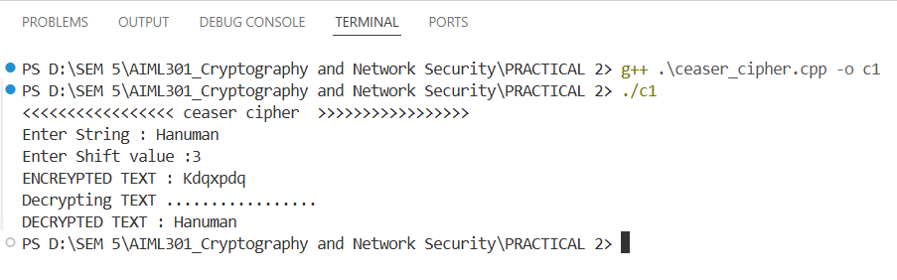

Playfair Cipher:

CODE

#include<iostream>
#include<string>
#include<vector>
using namespace std;

char matrix[5][5];

void createMatrix(string key) {
bool used[26] = {false};
used[9] = true;
int row = 0, col = 0;

for(char c : key) {
if(c >= 'A' && c <= 'Z') c = c - 'A' + 'a';
if(c >= 'a' && c <= 'z' && !used[c - 'a']) {
matrix[row][col] = c;
used[c - 'a'] = true;
col++;
if(col == 5) {
col = 0;
row++;
}
}
}

for(char c = 'a'; c <= 'z' && row < 5; c++) {
if(c == 'j') continue;
if(!used[c - 'a']) {
matrix[row][col] = c;
col++;
if(col == 5) {
col = 0;
row++;
}
}
}
}

pair<int,int> findPosition(char c) {
if(c == 'j') c = 'i';
for(int i = 0; i < 5; i++) {
for(int j = 0; j < 5; j++) {
if(matrix[i][j] == c) {
return {i, j};
}
}
}
return {-1, -1};
}

string preparePlaintext(string text) {
string result = "";
for(char c : text) {
if(c >= 'A' && c <= 'Z') c = c - 'A' + 'a';
if(c >= 'a' && c <= 'z') {
if(c == 'j') c = 'i';
result += c;
}
}

string finalText = "";
for(int i = 0; i < result.length(); i++) {
finalText += result[i];
if(i + 1 < result.length() && result[i] == result[i + 1]) {
finalText += 'x';
}
}

if(finalText.length() % 2 == 1) {
finalText += 'x';
}

return finalText;
}

string playfair(string plaintext, string key) {
createMatrix(key);
plaintext = preparePlaintext(plaintext);
string ciphertext = "";

for(int i = 0; i < plaintext.length(); i += 2) {
char a = plaintext[i];
char b = plaintext[i + 1];

pair<int,int> posA = findPosition(a);
pair<int,int> posB = findPosition(b);

if(posA.first == posB.first) {
ciphertext += matrix[posA.first][(posA.second + 1) % 5];
ciphertext += matrix[posB.first][(posB.second + 1) % 5];
}
else if(posA.second == posB.second) {
ciphertext += matrix[(posA.first + 1) % 5][posA.second];
ciphertext += matrix[(posB.first + 1) % 5][posB.second];
}
else {
ciphertext += matrix[posA.first][posB.second];
ciphertext += matrix[posB.first][posA.second];
}
}

return ciphertext;
}

string playfair_decrypt(string ciphertext, string key) {
createMatrix(key);
string plaintext = "";
for(int i = 0; i < ciphertext.length(); i += 2) {
char a = ciphertext[i];
char b = ciphertext[i + 1];
pair<int,int> posA = findPosition(a);
pair<int,int> posB = findPosition(b);

if(posA.first == posB.first) {
plaintext += matrix[posA.first][(posA.second + 4) % 5];
plaintext += matrix[posB.first][(posB.second + 4) % 5];
}
else if(posA.second == posB.second) {
plaintext += matrix[(posA.first + 4) % 5][posA.second];
plaintext += matrix[(posB.first + 4) % 5][posB.second];
}
else {
plaintext += matrix[posA.first][posB.second];
plaintext += matrix[posB.first][posA.second];
}
}
return plaintext;
}

int main(){
string s, key;
cout<<"//////////////////// playfair cipher ////////////////////"<<endl;
cout<<"Enter String : ";
cin>>s;

cout<<"Enter Key : ";
cin>>key;

string ans = playfair(s, key);
cout<<"ENCRYPTED TEXT : "<<ans<<endl;

string decrypted = playfair_decrypt(ans, key);
cout<<"DECRYPTED TEXT : "<<decrypted<<endl;

return 0;
}
OUTPUT

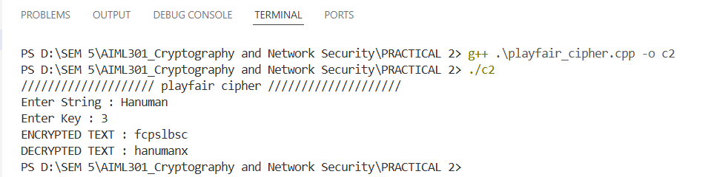

Railfense Cipher:

CODE

#include<iostream>
#include<string>
#include<vector>
using namespace std;

char matrix[5][5];

void createMatrix(string key) {
bool used[26] = {false};
used[9] = true;
int row = 0, col = 0;

for(char c : key) {
if(c >= 'A' && c <= 'Z') c = c - 'A' + 'a';
if(c >= 'a' && c <= 'z' && !used[c - 'a']) {
matrix[row][col] = c;
used[c - 'a'] = true;
col++;
if(col == 5) {
col = 0;
row++;
}
}
}

for(char c = 'a'; c <= 'z' && row < 5; c++) {
if(c == 'j') continue;
if(!used[c - 'a']) {
matrix[row][col] = c;
col++;
if(col == 5) {
col = 0;
row++;
}
}
}
}

pair<int,int> findPosition(char c) {
if(c == 'j') c = 'i';
for(int i = 0; i < 5; i++) {
for(int j = 0; j < 5; j++) {
if(matrix[i][j] == c) {
return {i, j};
}
}
}
return {-1, -1};
}

string preparePlaintext(string text) {
string result = "";
for(char c : text) {
if(c >= 'A' && c <= 'Z') c = c - 'A' + 'a';
if(c >= 'a' && c <= 'z') {
if(c == 'j') c = 'i';
result += c;
}
}

string finalText = "";
for(int i = 0; i < result.length(); i++) {
finalText += result[i];
if(i + 1 < result.length() && result[i] == result[i + 1]) {
finalText += 'x';
}
}

if(finalText.length() % 2 == 1) {
finalText += 'x';
}

return finalText;
}

string playfair(string plaintext, string key) {
createMatrix(key);
plaintext = preparePlaintext(plaintext);
string ciphertext = "";

for(int i = 0; i < plaintext.length(); i += 2) {
char a = plaintext[i];
char b = plaintext[i + 1];

pair<int,int> posA = findPosition(a);
pair<int,int> posB = findPosition(b);

if(posA.first == posB.first) {
ciphertext += matrix[posA.first][(posA.second + 1) % 5];
ciphertext += matrix[posB.first][(posB.second + 1) % 5];
}
else if(posA.second == posB.second) {
ciphertext += matrix[(posA.first + 1) % 5][posA.second];
ciphertext += matrix[(posB.first + 1) % 5][posB.second];
}
else {
ciphertext += matrix[posA.first][posB.second];
ciphertext += matrix[posB.first][posA.second];
}
}

return ciphertext;
}

string playfair_decrypt(string ciphertext, string key) {
createMatrix(key);
string plaintext = "";
for(int i = 0; i < ciphertext.length(); i += 2) {
char a = ciphertext[i];
char b = ciphertext[i + 1];
pair<int,int> posA = findPosition(a);
pair<int,int> posB = findPosition(b);

if(posA.first == posB.first) {
plaintext += matrix[posA.first][(posA.second + 4) % 5];
plaintext += matrix[posB.first][(posB.second + 4) % 5];
}
else if(posA.second == posB.second) {
plaintext += matrix[(posA.first + 4) % 5][posA.second];
plaintext += matrix[(posB.first + 4) % 5][posB.second];
}
else {
plaintext += matrix[posA.first][posB.second];
plaintext += matrix[posB.first][posA.second];
}
}

OUTPUT
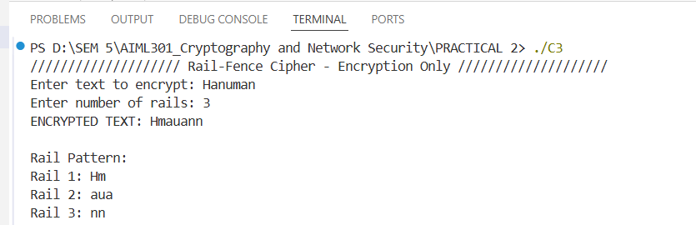

Key Questions:

1. How does the Caesar cipher perform character shifting?
Ans: The Caesar cipher shifts each letter in your message by a fixed number of places in the alphabet (e.g., a shift of 3 turns 'A' into 'D', 'B' into 'E', etc.). If the shift goes past 'Z', it wraps around to 'A' (like a circular alphabet). For example, with a shift of 3, "CAT" becomes "FDW". It’s a straightforward substitution method, but its simplicity makes it easy to break.

2. How does the Playfair cipher differ from monoalphabetic ciphers?
Ans: Unlike monoalphabetic ciphers (like Caesar), which replace each letter with another single letter consistently, the Playfair cipher encrypts pairs of letters (digraphs) using a 5x5 grid created from a keyword. It substitutes each pair based on their positions in the grid, following specific rules (e.g., same row, same column, or rectangle swap). This makes it a polygraphic cipher, disrupting single-letter patterns and increasing complexity.

3. What is the method to encode text using Rail-Fence cipher?
Ans: In the Rail-Fence cipher, you write your message in a zigzag pattern across a set number of rows (rails). For example, with 3 rails, the message "HELLO" is written as:
H L
E L
O
Then, you read the rows top to bottom (H L, E L, O) to get the encoded message "HLELO". The zigzag pattern scrambles the order, making it harder to read without knowing the number of rails.

Supplementary Problems:

1. What are the security weaknesses of Caesar cipher?
Ans: The Caesar cipher is weak because it only has 25 possible shifts, so an attacker can try every option (brute force). It also preserves letter frequency (e.g., 'E' stays the most common), making it vulnerable to frequency analysis. Since it’s a monoalphabetic cipher, the substitution pattern remains consistent, so once a few letters are guessed, the whole message can be decoded.

2. Why is the Playfair cipher more secure than Caesar cipher?
Ans: The Playfair cipher is more secure because it encrypts pairs of letters (digraphs) instead of single letters, breaking up common single-letter patterns (like 'E' or 'T'). By using a 5x5 grid and keyword-based rules, it creates a more complex substitution that resists frequency analysis better than the Caesar cipher’s simple shift, which is easily reversed.

Key Skills:
- Understanding and applying encryption algorithms logically
- Practicing cipher techniques to encode and decode messages
- Developing problem-solving skills for classical cryptography

Applications:
- Exploring the basics of secure communication systems

Learning Outcome: We will practice classic encryption methods, analyze their strengths and weaknesses, and build a foundational understanding of secure communication principles.



CHARUSAT Chandubhai S Patel Institute of Technology Department of Artificial Intelligence & Machine Learning AIML 301 – Cryptography & Network Security

23AIML070 Practical-3 Date: 29/07/2025

Aim: Implement the Diffie-Hellman key exchange algorithm for secure key sharing over an insecure channel.
The Diffie-Hellman algorithm is being used to establish a shared secret that can be used for secret communications while exchanging data over a public network using the elliptic curve to generate points and get the secret key using the parameters.

CODE:
#define ll long long
#include <iostream>
#include <cmath>

using namespace std;

ll power(ll a, ll b, ll p)
{
ll res = 1;
a = a % p;
while (b > 0)
{
if (b % 2 == 1)
res = (res * a) % p;
b = b >> 1;
a = (a * a) % p;
}
return res;
}

ll public_key_A(ll g, ll p, ll a)
{
ll ans;

ans = power(g, a, p);
return ans;
}

ll public_key_B(ll g, ll p, ll b)
{
ll ans;

ans = power(g, b, p);
return ans;
}

ll symmetric_key_k1(ll y, ll a, ll p)
{

return power(y, a, p);
}

ll symmetric_key_k2(ll y, ll b, ll p)
{

return power(y, b, p);
}

int main()
{
ll p = 23;
ll g = 9;
ll a;
ll b;

cout << "ENTER Private Key For A :";
cin >> a;

cout << "ENTER Private Key For B :";
cin >> b;

ll A_p = public_key_A(g, p, a);
ll B_p = public_key_B(g, p, b);

cout << "Public Key of A (A_p): " << A_p << endl;
cout << "Public Key of B (B_p): " << B_p << endl;

ll K1 = symmetric_key_k1(B_p, a, p);
ll K2 = symmetric_key_k2(A_p, b, p);

cout << "Shared Key computed by A (K1): " << K1 << endl;
cout << "Shared Key computed by B (K2): " << K2 << endl;

if (K1 == K2)
cout << "\nKey Exchange Successful! Shared Secret: " << K1 << endl;
else
cout << "\nKey Exchange Failed!" << endl;

return 0;
}

OUTPUT:
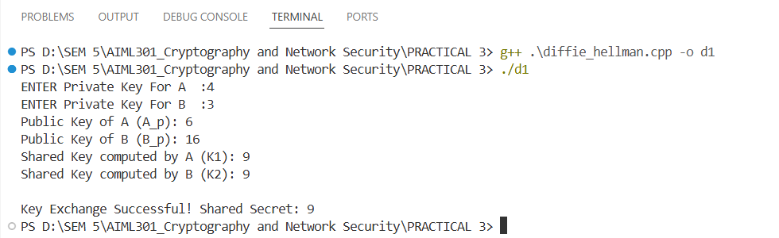

Key Questions:
1.What mathematical principle underlies Diffie-Hellman key exchange?
- The security of the Diffie-Hellman key exchange relies on the mathematical properties of modular exponentiation and the discrete logarithm problem.

- Modular exponentiation is the process of raising a number to a power and taking the remainder when divided by a modulus. In the Diffie-Hellman algorithm, modular exponentiation is used to compute A and B, which are then exchanged between the parties.

- The discrete logarithm problem, on the other hand, is the challenge of finding the exponent, given a base, a modulus, and the result of modular exponentiation. The security of the Diffie-Hellman key exchange is based on the assumption that the discrete logarithm problem is computationally infeasible to solve, making it difficult for an attacker to compute the shared secret key.

2.How is a shared secret derived without transmitting private keys?
- Each party computes the shared secret using their private key and the other party's public key, leveraging modular exponentiation.
kb = x^b mod p X=Public (A), a=Private(A),p=public number
ka = y^a mod p Y=public (B), b=Private(B),

3.What are the vulnerabilities of Diffie-Hellman?
- Vulnerable to man-in-the-middle attacks if authentication is not used; also susceptible to attacks if small primes or weak parameters are chosen.

A man-in-the-middle attack on the Diffie-Hellman key exchange occurs when an attacker, Malory, intercepts the public values exchanged between A and B. Malory replaces A's and B's public keys with her own,

tricking each party into establishing a separate shared secret with him instead of with each other. As a result, A and B unknowingly communicate through Malory,

who can decrypt, read, modify, and re-encrypt all messages between them. This attack highlights the importance of authentication in the Diffie-Hellman protocol to prevent such vulnerabilities.

Supplementary Problems:
1.Can Diffie-Hellman be used in group key sharing?
- Yes. Diffie–Hellman key agreement is not limited to negotiating a key shared by only two participants. Any number of users can take part in an agreement by performing iterations of the agreement protocol and exchanging intermediate data

2.What role does modular arithmetic play in this algorithm?
- Modular arithmetic do help in mathematical operations such as

1. Generating Public Keys:
2. Deriving the Shared Secret:
3. Security and the Discrete Logarithm Problem:

- It ensures that the computations remain within a finite field, making the discrete logarithm problem hard to solve and thus providing security.

Key Skills:
Key exchange, modular arithmetic, secure communication

Applications:
- Secure Shell (SSH):
- Transport Layer Security (TLS) / Secure Sockets Layer (SSL):
- Public Key Infrastructure (PKI):
- Internet Key Exchange (IKE): .
- Internet Protocol Security (IPSec):
- VPN
- Secret messaging apps.

Learning Outcome:
Students will securely exchange keys using the Diffie-Hellman protocol.



CHARUSAT Chandubhai S Patel Institute of Technology Department of Artificial Intelligence & Machine Learning AIML 301 – Cryptography & Network Security

23AIML070 Practical-4 Date: 15/07/2025

Aim: Implement the RSA cryptosystem for secure public-key encryption and decryption.

CODE

#include <iostream>
#include <vector>
using namespace std;
#define ll long long

// me - Modular Exponentiation
ll me(ll b, ll e, ll m)
{
ll r = 1;
b %= m;
while (e > 0)
{
if (e % 2 == 1)
r = (r * b) % m;
e >>= 1;
b = (b * b) % m;
}
return r;
}

// mi - Modular Inverse
int mi(int e, int phi)
{
int t = 0, nt = 1;
int r = phi, nr = e;
while (nr != 0)
{
int q = r / nr;
int tmp = nt;
nt = t - q * nt;
t = tmp;

tmp = nr;
nr = r - q * nr;
r = tmp;
}
if (r > 1)
return -1;
if (t < 0)
t += phi;
return t;
}

int main()
{
cout << "===== RSA IMPLEMENTATION =====\n";

int p, q;
cout << "Enter P (prime number 1): ";
cin >> p;
cout << "Enter Q (prime number 2): ";
cin >> q;

int n = p * q;
int phi = (p - 1) * (q - 1);
int e = 17;
int d = mi(e, phi);

if (d == -1)
{
cout << "Error: Invalid values. 'e' and 'phi' are not coprime.\n";
return 1;
}

cout << "\nPublic Key: (" << e << ", " << n << ")";
cout << "\nPrivate Key: (" << d << ", " << n << ")\n";

cin.ignore();
string msg;
cout << "\nEnter message to encrypt: ";
getline(cin, msg);

vector<int> encrypted;
cout << "\nEncrypted: ";
for (char ch : msg)
{
int m = (int)ch;
ll c = me(m, e, n);
encrypted.push_back(c);
cout << c << " ";
}

cout << "\n\nDecrypted: ";
for (int c : encrypted)
{
ll m = me(c, d, n);
cout << (char)m;
}

cout << "\n==============================\n";
cout<<"By 23AIML010 OM CHOKSI";

return 0;
}

OUTPUT
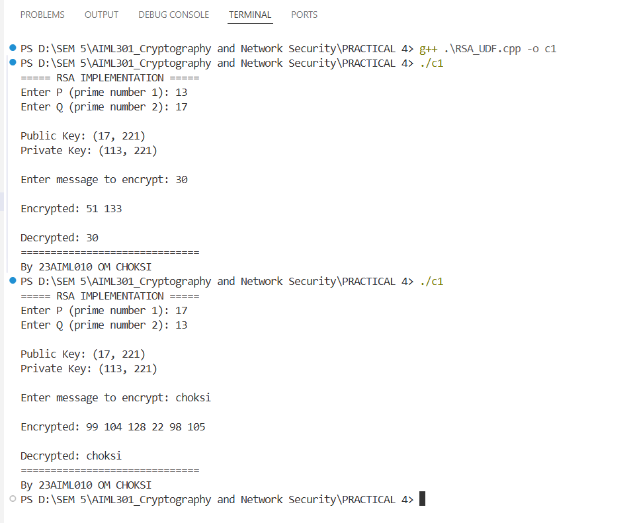

Key Questions:

1. How are RSA keys generated from prime numbers?
Ans:
- Select two prime numbers p and q.
- Compute n = p * q.
- Compute Euler’s totient: φ(n) = (p - 1) * (q - 1).
- Choose e such that 1 < e < φ(n) and gcd(e, φ(n)) = 1.
- Compute private key d such that (d * e) % φ(n) = 1.
This is done using the modular inverse of e mod φ(n).

2. What is the totient function and why is it used?
Ans: The totient function (written as φ(n)) tells us how many numbers are there less than n that do not share any common factors with n (except 1).
In RSA, we use φ(n) to:
- Help calculate the private key from the public key.
- Make sure the keys work correctly for encryption and decryption.
So, φ(n) is an important part of how RSA generates secure keys.

3. What is the difference between public and private keys in RSA?
Ans:
Public Keys | Private keys
Public Key (e, n): Used for encryption | Private Key (d, n): Used for decryption.
Shared openly. | Must be kept secret.

Supplementary Problems:

1. What is the risk of small key sizes in RSA?
Ans: If the RSA key size is too small, today’s powerful computers can quickly figure out the two secret prime numbers (p and q) used to generate the keys.
This means someone could break the encryption using brute-force or smart math tricks.
That’s why it's strongly recommended to use RSA keys of at least 2048 bits in real-life applications to stay secure.

2. Explain how RSA ensures data confidentiality and authentication.
Ans:
Confidentiality means keeping a message secret. In RSA, the sender encrypts the message using the receiver’s public key. Only the receiver can read it by decrypting with their private key.

Authentication means proving who sent the message. The sender can encrypt a small summary (called a hash) of the message using their own private key. This acts like a digital signature. The receiver can use the sender’s public key to check that the message really came from them and hasn’t been changed.

Key Skills:
- Public-key encryption, modular exponentiation, number theory
- Developing problem-solving skills for classical cryptography
Applications:
Digital signatures, secure emails, HTTPS
Learning Outcome:
Students will implement RSA and demonstrate secure message transfer.
- Learn key mathematical principles like totients and modular inverses.
- Demonstrate secure message transfer using public-key cryptography.

Dataset/Test Data:
Use simulated networks or test machines Small test messages and keys for validation.
foundational understanding of secure communication principles.



CHARUSAT Chandubhai S Patel Institute of Technology Department of Artificial Intelligence & Machine Learning AIML 301 – Cryptography & Network Security

Practical – 5 Date:29/07/2025
Problem Definition:
Implement the S-DES symmetric encryption algorithm to understand simplified block cipher operations.
Code:
#include <iostream>
#include <vector>
#include <algorithm>
#include <bitset>
using namespace std;

int P10[] = {3, 5, 2, 7, 4, 10, 1, 9, 8, 6};
int P8[] = {6, 3, 7, 4, 8, 5, 10, 9};
int IP[] = {2, 6, 3, 1, 4, 8, 5, 7};
int IP_INV[] = {4, 1, 3, 5, 7, 2, 8, 6};
int EP[] = {4, 1, 2, 3, 2, 3, 4, 1};
int P4[] = {2, 4, 3, 1};
int S0[4][4] = {
{1, 0, 3, 2},
{3, 2, 1, 0},
{0, 2, 1, 3},
{3, 1, 3, 2}};

int S1[4][4] = {
{0, 1, 2, 3},
{2, 0, 1, 3},
{3, 0, 1, 0},
{2, 1, 0, 3}};
vector<int> permute(const vector<int> &input, const int *order, int size)
{
vector<int> output;
for (int i = 0; i < size; i++)
{
output.push_back(input[order[i] - 1]);
}
return output;
}
void leftShift(vector<int> &bits, int shifts)
{
rotate(bits.begin(), bits.begin() + shifts, bits.begin() + 5);
rotate(bits.begin() + 5, bits.begin() + 5 + shifts, bits.end());
}
vector<int> xorVec(const vector<int> &a, const vector<int> &b)
{
vector<int> result;
for (size_t i = 0; i < a.size(); i++)
result.push_back(a[i] ^ b[i]);
return result;
}

vector<int> sboxLookup(const vector<int> &input, int box[4][4])
{
int row = input[0] * 2 + input[3];
int col = input[1] * 2 + input[2];
int val = box[row][col];
return {val / 2, val % 2};
}
vector<int> fFunction(vector<int> right, vector<int> key)
{
vector<int> expanded = permute(right, EP, 8);
vector<int> xored = xorVec(expanded, key);
vector<int> left(xored.begin(), xored.begin() + 4);
vector<int> right_half(xored.begin() + 4, xored.end());
vector<int> s0_out = sboxLookup(left, S0);
vector<int> s1_out = sboxLookup(right_half, S1);
vector<int> combined = {s0_out[0], s0_out[1], s1_out[0], s1_out[1]};
return permute(combined, P4, 4);
}
vector<int> fk(vector<int> bits, vector<int> key)
{
vector<int> left(bits.begin(), bits.begin() + 4);
vector<int> right(bits.begin() + 4, bits.end());
vector<int> f_out = fFunction(right, key);
vector<int> left_xor = xorVec(left, f_out);
left_xor.insert(left_xor.end(), right.begin(), right.end());
return left_xor;
}
vector<int> switchHalves(vector<int> bits)
{
vector<int> result(bits.begin() + 4, bits.end());
result.insert(result.end(), bits.begin(), bits.begin() + 4);
return result;
}
pair<vector<int>, vector<int>> generateKeys(vector<int> key10)
{
vector<int> p10 = permute(key10, P10, 10);
leftShift(p10, 1);
vector<int> k1 = permute(p10, P8, 8);
leftShift(p10, 2);
vector<int> k2 = permute(p10, P8, 8);
return {k1, k2};
}
vector<int> encrypt(vector<int> plaintext, vector<int> k1, vector<int> k2)
{
vector<int> ip = permute(plaintext, IP, 8);
vector<int> round1 = fk(ip, k1);
vector<int> swapped = switchHalves(round1);
vector<int> round2 = fk(swapped, k2);
return permute(round2, IP_INV, 8);
}
vector<int> decrypt(vector<int> ciphertext, vector<int> k1, vector<int> k2)
{
vector<int> ip = permute(ciphertext, IP, 8);
vector<int> round1 = fk(ip, k2);
vector<int> swapped = switchHalves(round1);
vector<int> round2 = fk(swapped, k1);
return permute(round2, IP_INV, 8);
}
int main()
{
vector<int> key10 = {1, 1, 0, 1, 0, 0, 1, 0, 1, 0};
vector<int> plaintext = {0, 1, 1, 0, 1, 0, 0, 1};
auto [k1, k2] = generateKeys(key10);
vector<int> cipher = encrypt(plaintext, k1, k2);
vector<int> decrypted = decrypt(cipher, k1, k2);
cout << "Plaintext: ";
for (int b : plaintext)
cout << b;
cout << "\nEncrypted: ";
for (int b : cipher)
cout << b;
cout << "\nDecrypted: ";
for (int b : decrypted)
cout << b;

return 0;
}

Output:
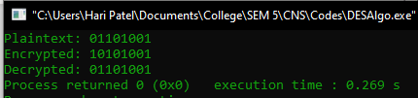
Key Questions:
- What are the steps in S-DES key generation?
Ans: Apply P10 permutation to 10-bit key, split into two halves, perform LS-1 shift, apply P8 to get K1. Then again LS-2 shift and apply P8 to get K2.
- How are permutations used in S-DES?
Ans: Permutations like P10, P8, IP, IP⁻¹, EP, and P4 are used for key generation and encryption to mix bits and add diffusion.
- What is the role of the Feistel structure?
Ans: It splits data into two halves and processes them through multiple rounds with keys, providing both confusion and diffusion for security.
Supplementary Problems:
1. How does S-DES differ from DES?
Ans: S-DES uses smaller key and block sizes (10-bit key, 8-bit block) and is simpler, while DES uses 56-bit key and 64-bit blocks and more rounds.
2. What are the advantages of learning S-DES for beginners?
Ans: It helps understand the fundamentals of encryption like key scheduling, Feistel rounds, permutations and S-boxes in a simplified way.



CHARUSAT Chandubhai S Patel Institute of Technology Department of Artificial Intelligence & Machine Learning AIML 301 – Cryptography & Network Security

Practical :– 6 Date:- 22/07/2025

Aim: Demonstrate steganography using OpenStego by hiding and extracting secret messages in files.

Screenshots
Hiding the Data
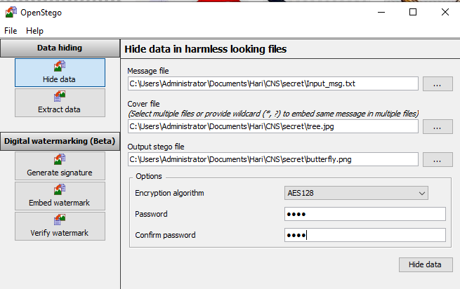
Confirmation
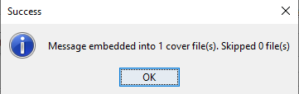

Extracting the msg
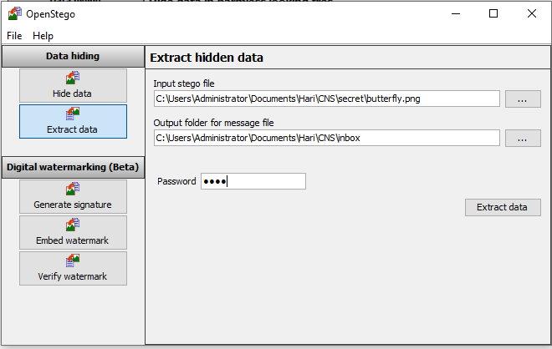

Message Extracted
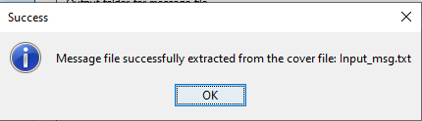

Message
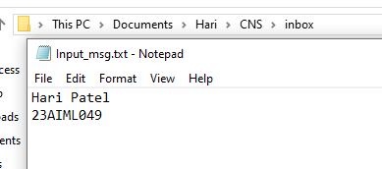

Key Questions:
- What is the purpose of steganography in cybersecurity?
Steganography is used to conceal the existence of data within another file to protect sensitive information and avoid detection by unauthorized parties.
- How does OpenStego protect the hidden message?
OpenStego uses two methods: data hiding (embedding the message in a cover file using a password) and watermarking (embedding a signature to prove authenticity). It also supports AES encryption for added security.
- What file formats are supported by OpenStego?
OpenStego primarily supports image files as cover files, especially the .png format. The hidden message can be any type of file.
Supplementary Problems:
- Compare steganography with cryptography:
  - Steganography hides the existence of the message.
  - Cryptography scrambles the content of the message.
Steganography is about concealment; cryptography is about encryption. They are often combined for enhanced security.
- What are common use cases of OpenStego?
  - Secure file sharing without drawing attention
  - Protecting intellectual property via watermarking
  - Covert communication in sensitive environments
  - Authenticating documents with invisible marks



CHARUSAT Chandubhai S Patel Institute of Technology Department of Artificial
Intelligence & Machine Learning AIML 301 –
Cryptography & Network Security

23AIML070 Practical-7 Date: 19/08/2025

Aim: Perform encryption and decryption using CrypTool to demonstrate symmetric and asymmetric algorithms.

Symmetric encryption (AES)
AES is a block cipher that encrypts data in fixed-size blocks (128 bits) using keys of 128, 192, or 256 bits. It performs multiple rounds of substitution, permutation, and key mixing, making it fast and secure for modern applications.

ENCRYPTION
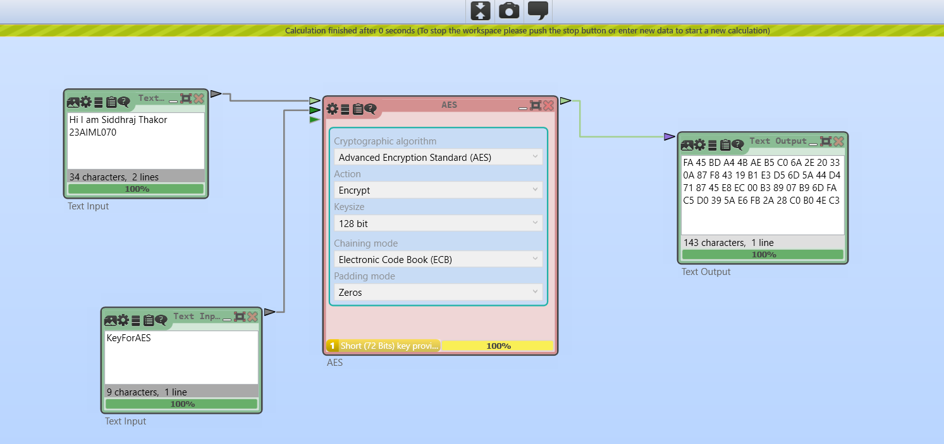
DECRYPTION:
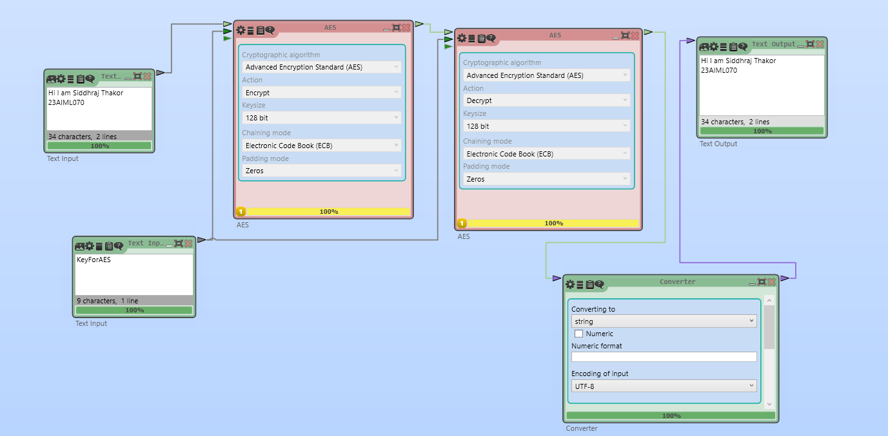

DES (Data Encryption Standard) – Symmetric
DES is an older block cipher that encrypts 64-bit blocks using a 56-bit key. It uses 16 rounds of permutation and substitution. While historically important, DES is now considered insecure due to its small key size.
ENCRYPTION
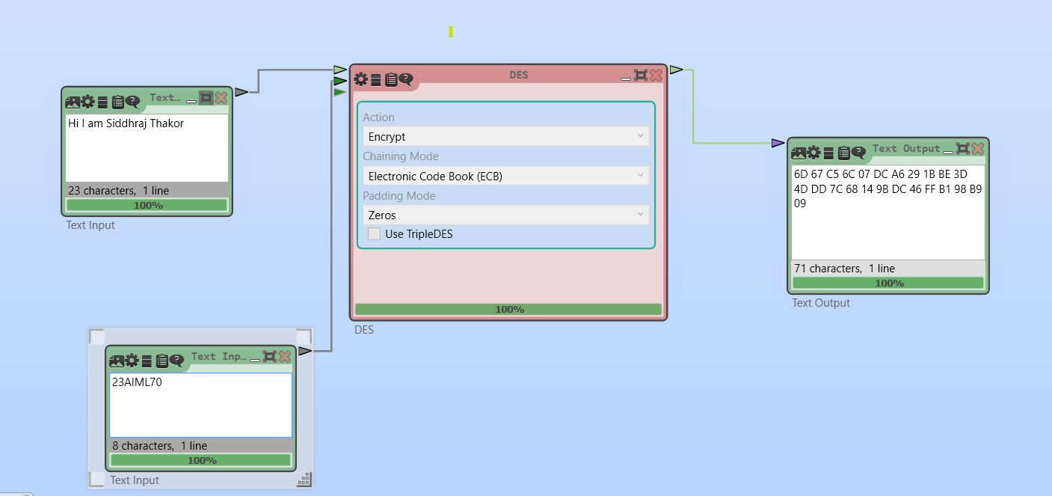

DECRYPTION
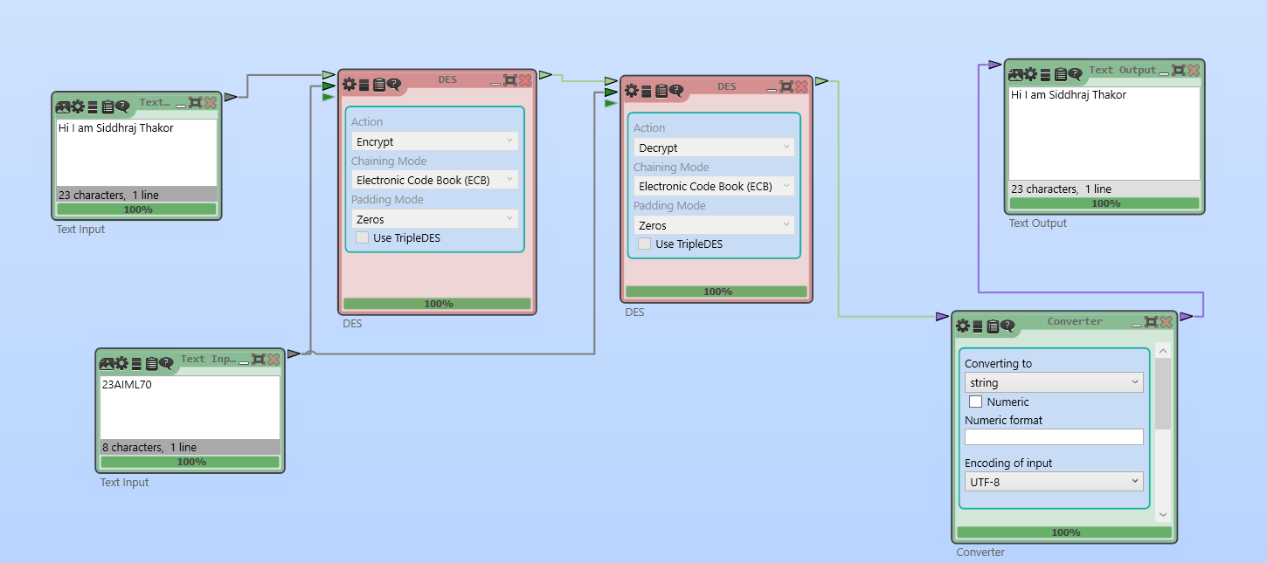

RSA ALGORITHM
RSA uses a pair of keys: a public key for encryption and a private key for decryption. It relies on the mathematical difficulty of factoring large prime numbers. RSA is widely used for secure key exchange and digital signatures.

ENCRYPTION
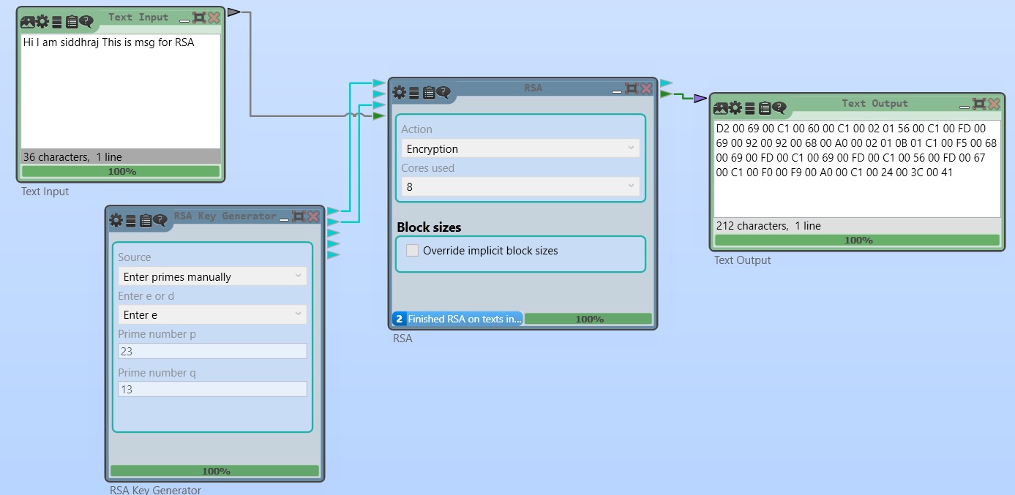

DECRYPTION

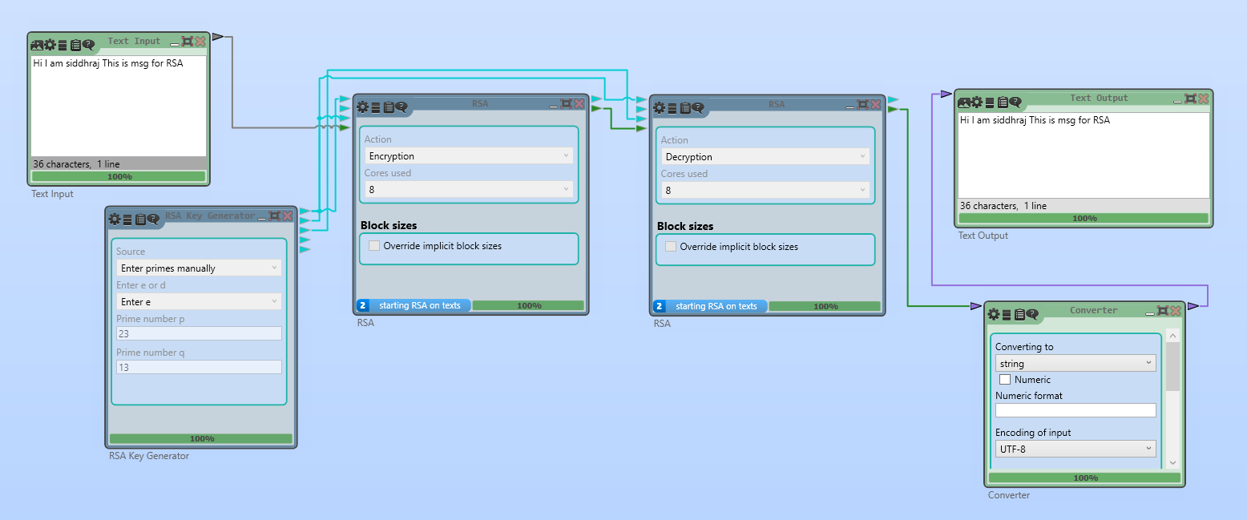

PLAYFAIR CIPHER ALGORITHM
Playfair is a digraph substitution cipher that encrypts pairs of letters using a 5×5 matrix of letters based on a keyword. It was historically used for manual encryption and provides more security than monoalphabetic ciphers.

ENCRYPTION
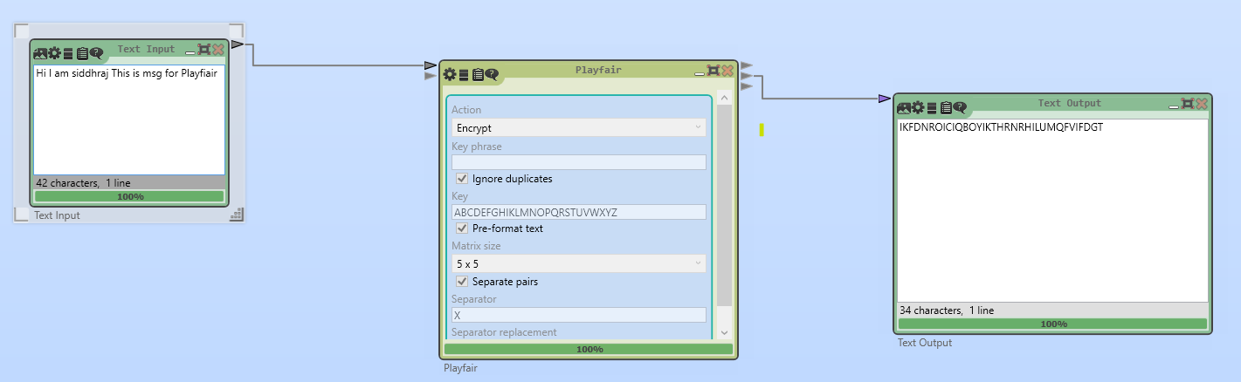

DECRYPTION
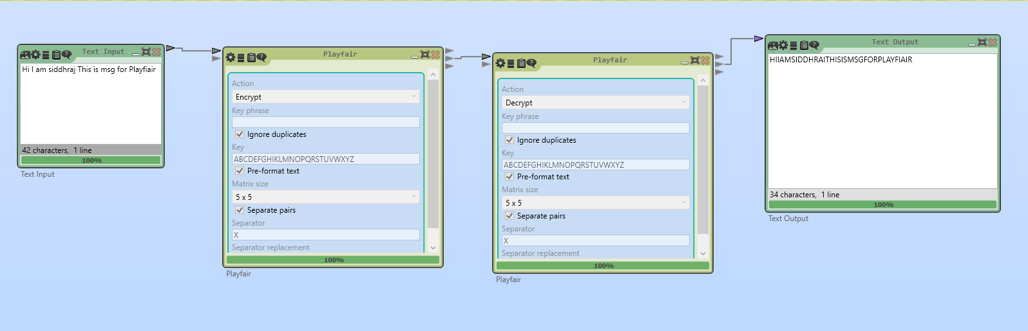

CAESER CIPHER ALGORITHM
The Caesar cipher is a simple substitution cipher that shifts each letter in the plaintext by a fixed number of positions in the alphabet. It is easy to implement but also easy to break.

ENCRYPTION
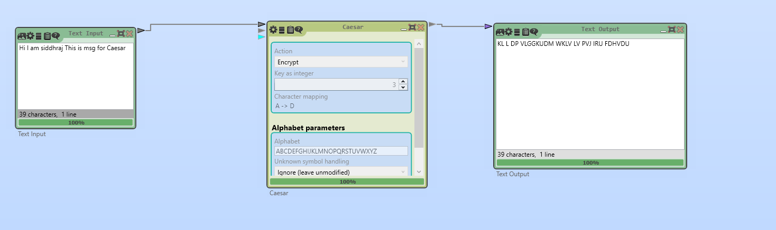

DECRYPTION
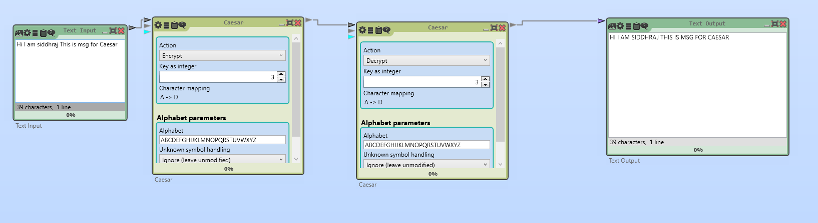

VIGENERE CIPHER ALGORITHM
Vigenère is a polyalphabetic substitution cipher that uses a keyword to determine letter shifts. It is stronger than the Caesar cipher but still vulnerable to frequency analysis if the keyword is short.

ENCRYPTION
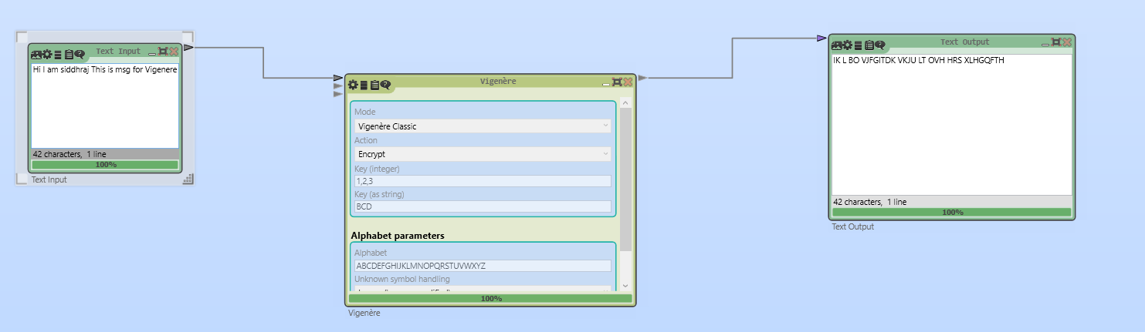

DECRYPTION
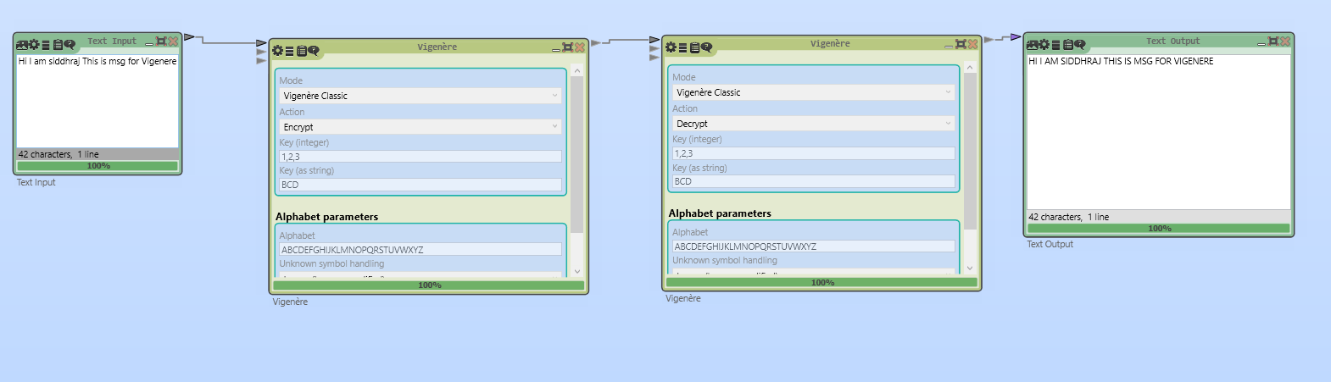

Key Questions:
- What are the differences between AES and RSA in CrypTool?
Ans: AES is a symmetric block cipher that uses the same secret key for both encryption and decryption, making it fast and efficient for large amounts of data. RSA is an asymmetric algorithm that uses a public key for encryption and a private key for decryption, making it slower but ideal for secure key exchange and digital signatures. In CrypTool, AES shows repeated rounds of substitution and permutation, while RSA demonstrates key-pair generation and mathematical exponentiation steps.
- How does CrypTool help visualize encryption steps?
Ans: CrypTool provides a step-by-step graphical view of encryption processes, showing transformations such as substitution, permutation, key scheduling, and mathematical operations. This helps learners understand how plaintext is transformed into ciphertext and vice versa.
- What insights can CrypTool provide to beginners?
Ans: CrypTool helps beginners see the internal working of cryptographic algorithms, compare different techniques, understand strengths and weaknesses, and experiment with various key sizes and parameters to observe their effect on encryption strength.

Supplementary Problems:
- List three cryptographic algorithms available in CrypTool.
Ans:
  - Advanced Encryption Standard (AES)
  - Rivest–Shamir–Adleman (RSA)
  - Data Encryption Standard (DES)

- What is the benefit of using a GUI-based cryptography simulator?
Ans: A GUI-based simulator like CrypTool makes cryptography more interactive and intuitive, allowing learners to visualize each step of encryption/decryption, experiment without coding, and understand concepts faster compared to purely theoretical study.

Key Skills:
Encryption/decryption, algorithm simulation
Applications:
Educational demonstrations, beginner cryptography labs
Learning Outcome:
Students will understand practical encryption using a visual tool.


CHARUSAT
Chandubhai S Patel Institute of Technology
Department of Artificial Intelligence & Machine
Learning
AIML 301 – Cryptography & Network Security

Practical – 8 Date: 02/09/2025

Aim: Implement Message Integrity using SHA-256 hashing algorithm
Message Integrity ensures that data is not altered during transmission or storage. One of the most common ways to achieve this is through cryptographic hashing.
- SHA-256 (Secure Hash Algorithm – 256 bit) is a one-way cryptographic hash function that generates a fixed 256-bit (32-byte) hash value from any input message.
- Even a small change in the input (like changing one character) produces a completely different hash output (known as the avalanche effect).
- Since SHA-256 is collision-resistant, it is very difficult for two different messages to produce the same hash.

Implementation Code
import hashlib
# Function to get the SHA-256 hash of a message def get_sha256_hash(input_string):
"""Returns the SHA-256 hash of the given input string.""" sha256_hash = hashlib.sha256() sha256_hash.update(input_string.encode('utf-8')) return sha256_hash.hexdigest()
# Original message
message = "Hello, I am Dev Patel" hashed_message = get_sha256_hash(message)
print(f"Original Message: {message}") print(f"SHA-256 Hash: {hashed_message}")
# Simulate Message Tampering tampered_message = "Hello, this is Dev"
tampered_hash = get_sha256_hash(tampered_message)
print("\nTampered Message:", tampered_message) print("SHA-256 Hash (after tampering)", tampered_hash)

Output
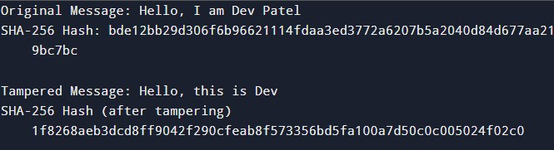
Key Questions:

1.Understanding Hashing in Message Integrity
Hashing ensures that data hasn't been altered during transmission or storage by producing a unique hash value for each piece of data. This hash value is like a digital fingerprint that can be easily compared to detect tampering.
Here's how hashing protects message integrity:
- Hashing detects tampering: A small change in the data results in a completely different hash value, making tampering easily detectable.
- Hash value changes drastically with tampering: When a message is altered, even by a single character, its hash value will change drastically, alerting that the integrity of the message has been compromised.

2. Components of a Simple Blockchain Block
A simple blockchain block consists of:
- Block Data (Transaction or Message): The data being stored in the block, such as a transaction or a message.
- Timestamp: The time at which the block was created.
- Hash of the block: A unique hash value for the block, generated based on its contents.
- Hash of the previous block: A reference to the previous block in the chain, linking blocks together.

3.SHA-256 Security and Blockchain Immutability
SHA-256 is considered secure because it produces a fixed-length hash (256 bits), is collisionresistant, and is computationally infeasible to reverse. This ensures that once data is written, it cannot be easily changed.
Blockchain ensures data immutability by linking blocks together using hash values. Any change to a block will change its hash, which in turn affects all subsequent blocks, making it computationally impractical to alter a single block without changing the entire chain


CHARUSAT
Chandubhai S Patel Institute of Technology
Department of Artificial Intelligence & Machine
Learning
AIML 301 – Cryptography & Network Security

Practical – 9 Date: 16/09/2025

Aim: Write a program to generate a digital certificate and sign it with a private key.
A digital certificate serves to authenticate the identity of an entity and to facilitate secure communication by encrypting data. It typically contains:
- Subject: The entity the certificate is issued to.
- Issuer: The Certificate Authority (CA) that issued it.
- Public Key: Associated with the subject.
- Signature: Created by the CA using their private key to verify authenticity.
- Validity Period: The time frame when the certificate is valid.

Output
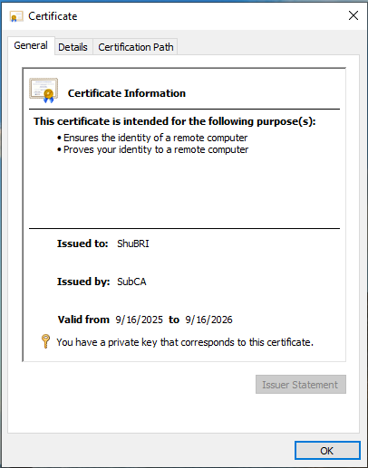

Key Questions:
- What are the components of a digital certificate?
A digital certificate typically consists of the following components:
  - Subject: The entity that the certificate is issued to (e.g., a website or individual).
  - Issuer: The certificate authority (CA) that issued the certificate.
  - Public Key: The public key corresponding to the private key held by the subject.
  - Signature Algorithm: The cryptographic algorithm used to sign the certificate.
  - Signature: A cryptographic signature from the certificate issuer (CA) confirming the certificate’s validity.
  - Validity Period: The dates between which the certificate is considered valid.
  - Serial Number: A unique identifier assigned by the certificate issuer.
  - Certificate Extensions: Optional additional information.
- How is a certificate signed and verified?
  - Signing: When a certificate is created, the certificate authority (CA) uses its private key to sign the certificate. This is typically done by creating a hash of the certificate content and encrypting that hash with the private key.
  - Verification: When someone receives a certificate, they can verify its authenticity by checking the signature using the CA's public key. If the signature matches, the certificate is considered valid.
- Why are public-key infrastructures (PKIs) important?
Public-Key Infrastructure (PKI) enables secure communication over insecure networks, such as the internet. PKIs:
  - Provide encryption and decryption of data using public-private key pairs.
  - Ensure authenticity and integrity of communication by verifying digital certificates.
  - Offer mechanisms for certificate management (e.g., revocation, expiration).
  - Support trust through trusted certificate authorities (CAs).

Supplementary Problems:
- Explain certificate revocation.
Certificate revocation is the process of invalidating a certificate before its expiration date. Reasons for revocation can include:
  - The private key corresponding to the certificate has been compromised.
  - The certificate was issued incorrectly (e.g., wrong information, fraud).
  - The certificate is no longer needed or in use.
Revocation can be checked through:
  - CRLs (Certificate Revocation Lists): A list maintained by the CA that contains revoked certificates.
  - OCSP (Online Certificate Status Protocol): A real-time protocol to check the revocation status of a certificate.
- What are certificate authorities and their responsibilities?
A Certificate Authority (CA) is an entity that issues digital certificates. Their responsibilities include:
  - Issuing Certificates: Verifying the identity of an entity and issuing digital certificates.
  - Managing Certificate Lifecycles: Handling the creation, renewal, and revocation of certificates.
  - Providing Public Key Infrastructure (PKI): Ensuring trust by managing and distributing public keys securely.

Practical – 10 Date : 05 / 10/ 2025
Aim: Evaluate and compare different firewall software solutions for enterprise network protection based on functionality and performance
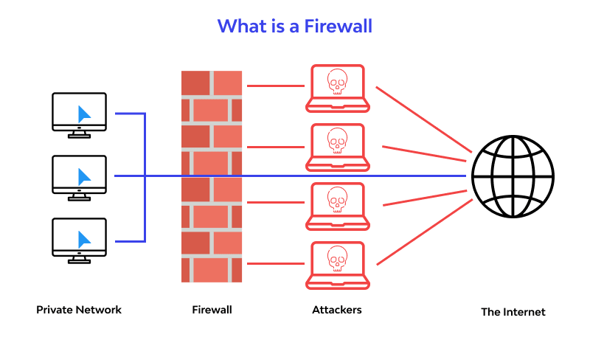
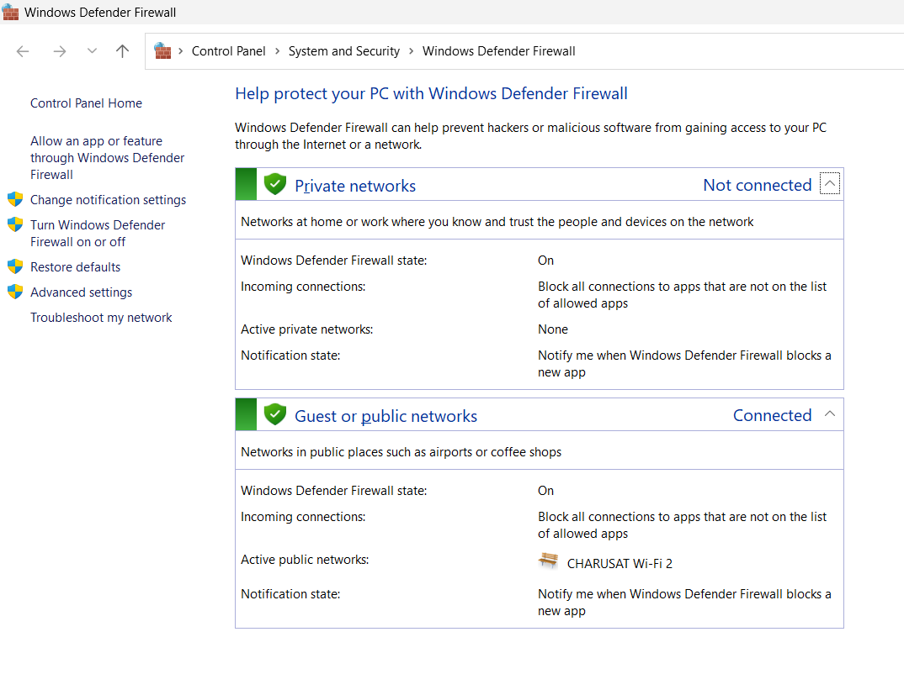
Firewall providers worldwide:

Category | Providers
Global Firewall Vendors (Hardware & Software) | Palo Alto Networks (NGFWs)  Fortinet (FortiGate)  Cisco (Firepower, ASA)  Check Point Sophos XG Firewall  Juniper Networks (SRX series)  SonicWall
Cloud Service Providers with Firewall Services | AWS  WAF & Network Firewall  Microsoft Azure Firewall  Google Cloud Firewall Oracle Cloud Infrastructure Firewall
Managed Security Service Providers (MSSPs) | IBM Security Services  AT&T Cybersecurity  Verizon Enterprise Security  NTT Security  HCLTech Cybersecurity Services  TCS (Tata Consultancy Services)

SELECTED:
Provider | Description
Palo Alto Networks | Known for Next-Gen Firewalls (NGFWs) with strong threat prevention, application awareness, and cloud integration.
Cisco Firewall | Offers Firepower and ASA series, widely used for enterprise networks with deep integration into Cisco’s ecosystem.
Fortinet (FortiGate) | Provides high-performance firewalls with built-in SD-WAN, VPN, and unified threat management at competitive pricing.
NGFWs (Next-Generation Firewalls) | Advanced firewalls that combine packet filtering, IDS/IPS, app control, and threat intelligence in one system.
SonicWall | Delivers cost-effective firewalls mainly for SMBs, with solid VPN, intrusion prevention, and easy management.

- Cisco Link
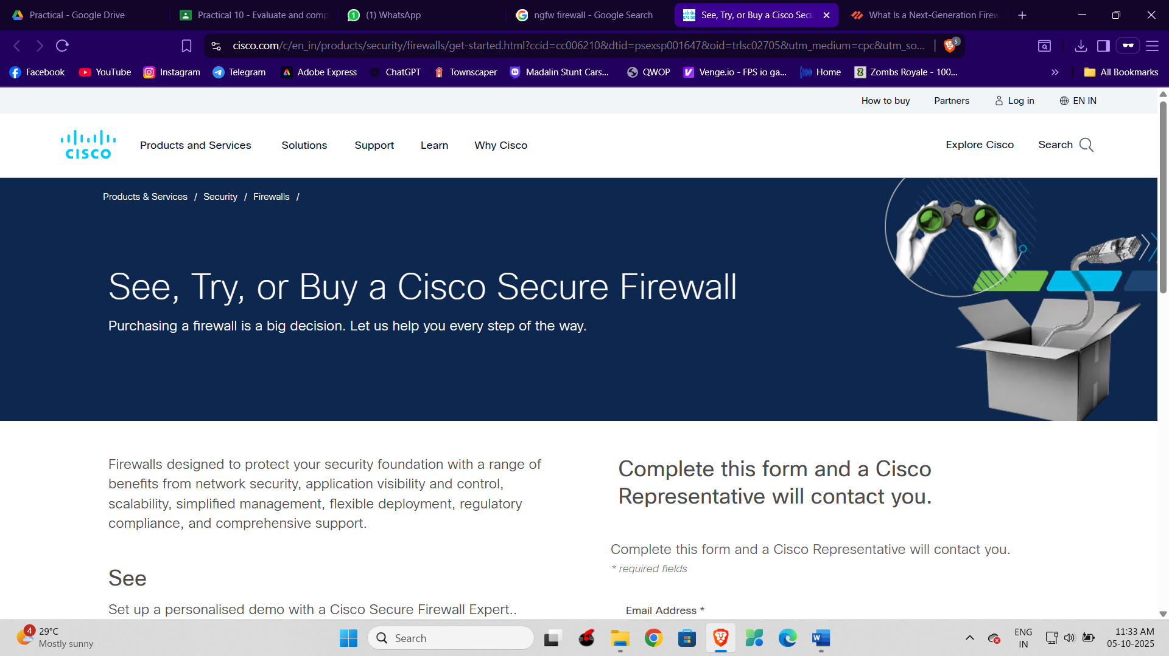

- Palo Alto Networks

- Fortinet
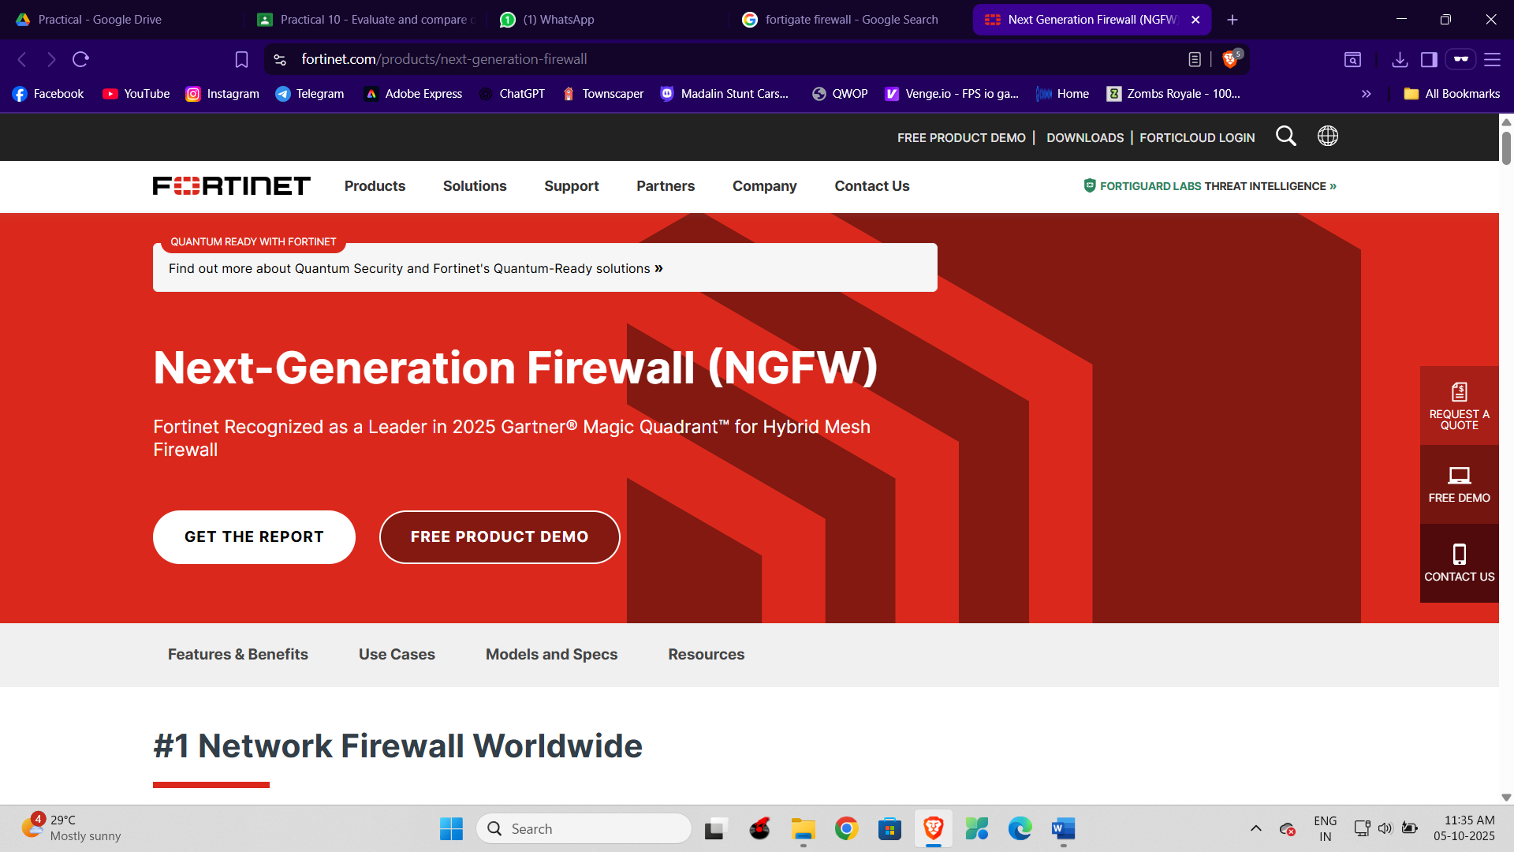

- NGFWs
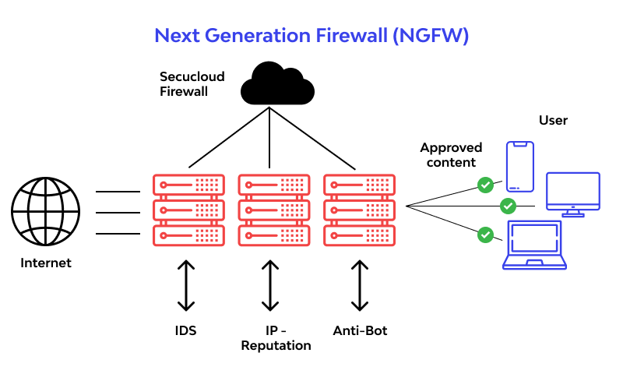
- SonicWall


Key Questions:
1. What are the key features of a good firewall?
Ans: : A good firewall inspects traffic, blocks unauthorized access, and allows trusted communication. Key features include deep packet inspection, intrusion prevention, VPN support, application control, centralized management, scalability, and strong logging.
2. How is firewall performance tested?
Ans. Performance is tested by simulating different traffic loads to measure throughput, latency, and connection handling. Independent labs also run real-world attack scenarios to check stability and effectiveness.
3. What is the role of packet filtering?
Ans. Packet filtering checks IP addresses, ports, and protocols of data packets to allow or block traffic. It acts as the firewall’s first line of defense against unauthorized access.

Supplementary Problems:

1. Compare hardware and software firewalls.
Feature | Hardware Firewall | Software Firewall
Definition | A dedicated physical device that filters traffic between networks (usually LAN ↔ Internet). | A program/application installed on a computer/server to filter traffic in/out of that system.
Deployment | Placed at the network perimeter (between internal network & external Internet). | Installed directly on end-user devices (PC, laptop, server) or sometimes as part of the OS.
Performance | Typically faster; has dedicated hardware (ASIC/CPU/RAM) for packet filtering, intrusion prevention, VPN, etc. | Depends on host system resources (CPU, RAM); may slow down the device if under heavy load.
Management | Centralized; controls traffic for entire organization/network. | Decentralized; must be configured on each device separately.
Security Scope | Protects entire network and connected devices. | Protects only the local device where it is installed.
Cost | Higher upfront cost (buying appliance, licensing, maintenance). | Usually cheaper or free (e.g., Windows Defender Firewall).
Examples | Palo Alto NGFW • Fortinet FortiGate Cisco Firepower • Check Point firewall appliances | Windows Defender Firewall (built-in) iptables on Linux Sophos Endpoint Firewall ZoneAlarm
Best For | Enterprises, data centers, ISPs – when you need high-performance network-wide security. | Individuals, small businesses – when  you need basic protection per device.



2. What are intrusion prevention systems (IPS)?
Ans: An Intrusion Prevention System (IPS) is a network security tool that monitors traffic in real time and blocks malicious activity before it can cause harm.
It’s like a security guard at the gate – not only watching for suspicious behavior but also stopping it instantly.
KeyFunctions of IPS:
- Traffic Monitroring
- Threat Detection
- Policy Enforcement
- Logging and Reporting
- Blocking Attacks

