PRACTICAL: 4

Objective:
To develop and deploy REST APIs using Amazon API Gateway by creating mock endpoints for a café web application, enabling HTTP methods such as GET and POST, configuring Cross-Origin Resource Sharing (CORS), deploying the API to a production stage, and integrating the API with a static website hosted on Amazon S3.

Theory:
Amazon API Gateway is a fully managed AWS service that enables developers to create, publish, maintain, monitor, and secure APIs at any scale. It acts as the front door for applications to access data, business logic, or functionality from backend services such as AWS Lambda, Amazon DynamoDB, or any web application.

In this practical, API Gateway is used to define REST API endpoints that the café web application will call. Three resources are configured: a GET /products endpoint to retrieve all menu items, a GET /products/on_offer endpoint to return only items currently on offer, and a POST /create_report endpoint to request an inventory report. During this lab phase, mock integration is used so that the API returns hardcoded JSON responses, allowing the frontend and API structure to be validated before connecting to the actual DynamoDB backend.

Cross-Origin Resource Sharing (CORS) is configured on the GET endpoints so that the browser-based café website, served from Amazon S3, can make AJAX requests to API Gateway without being blocked by the browser’s same-origin policy.

The AWS SDK for Python (Boto3) is used to programmatically create the API, define resources, HTTP methods, integrations, and responses. Once all three endpoints are created, the API is deployed to a stage named prod to generate an invokable URL. The café website’s config.js file is then updated with this URL so that the website dynamically retrieves menu data from API Gateway instead of static local JSON files.

Code:
N/A

Output:
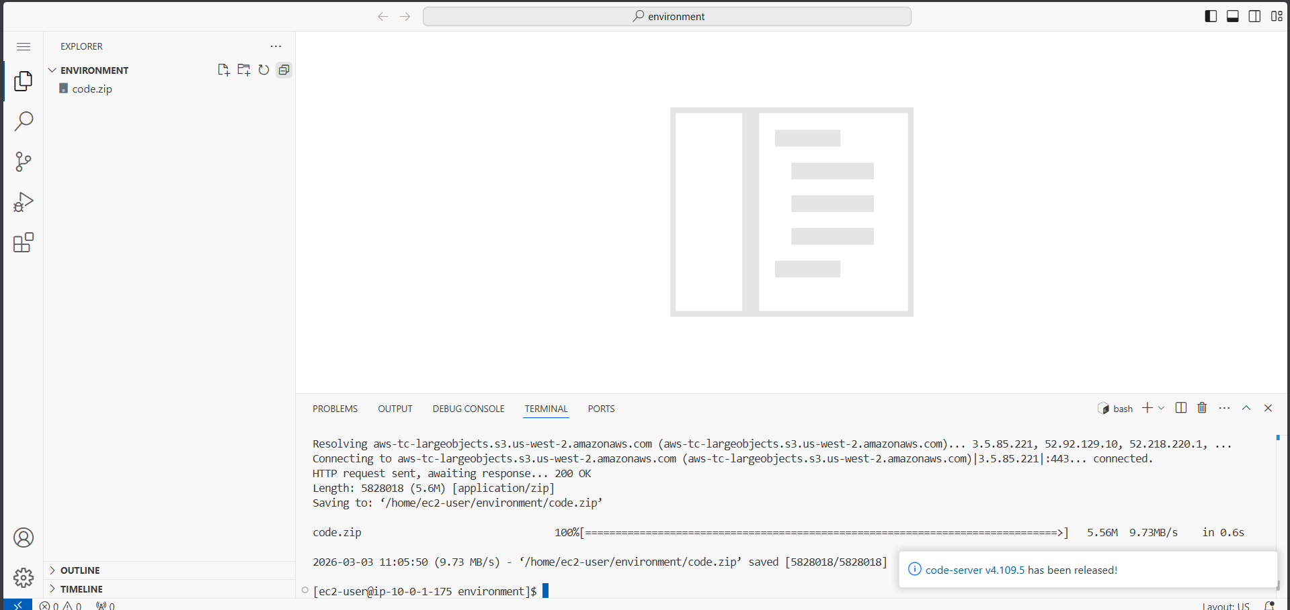
Figure 1: Downloading lab code.zip and running setup.sh to configure the VS Code IDE environment

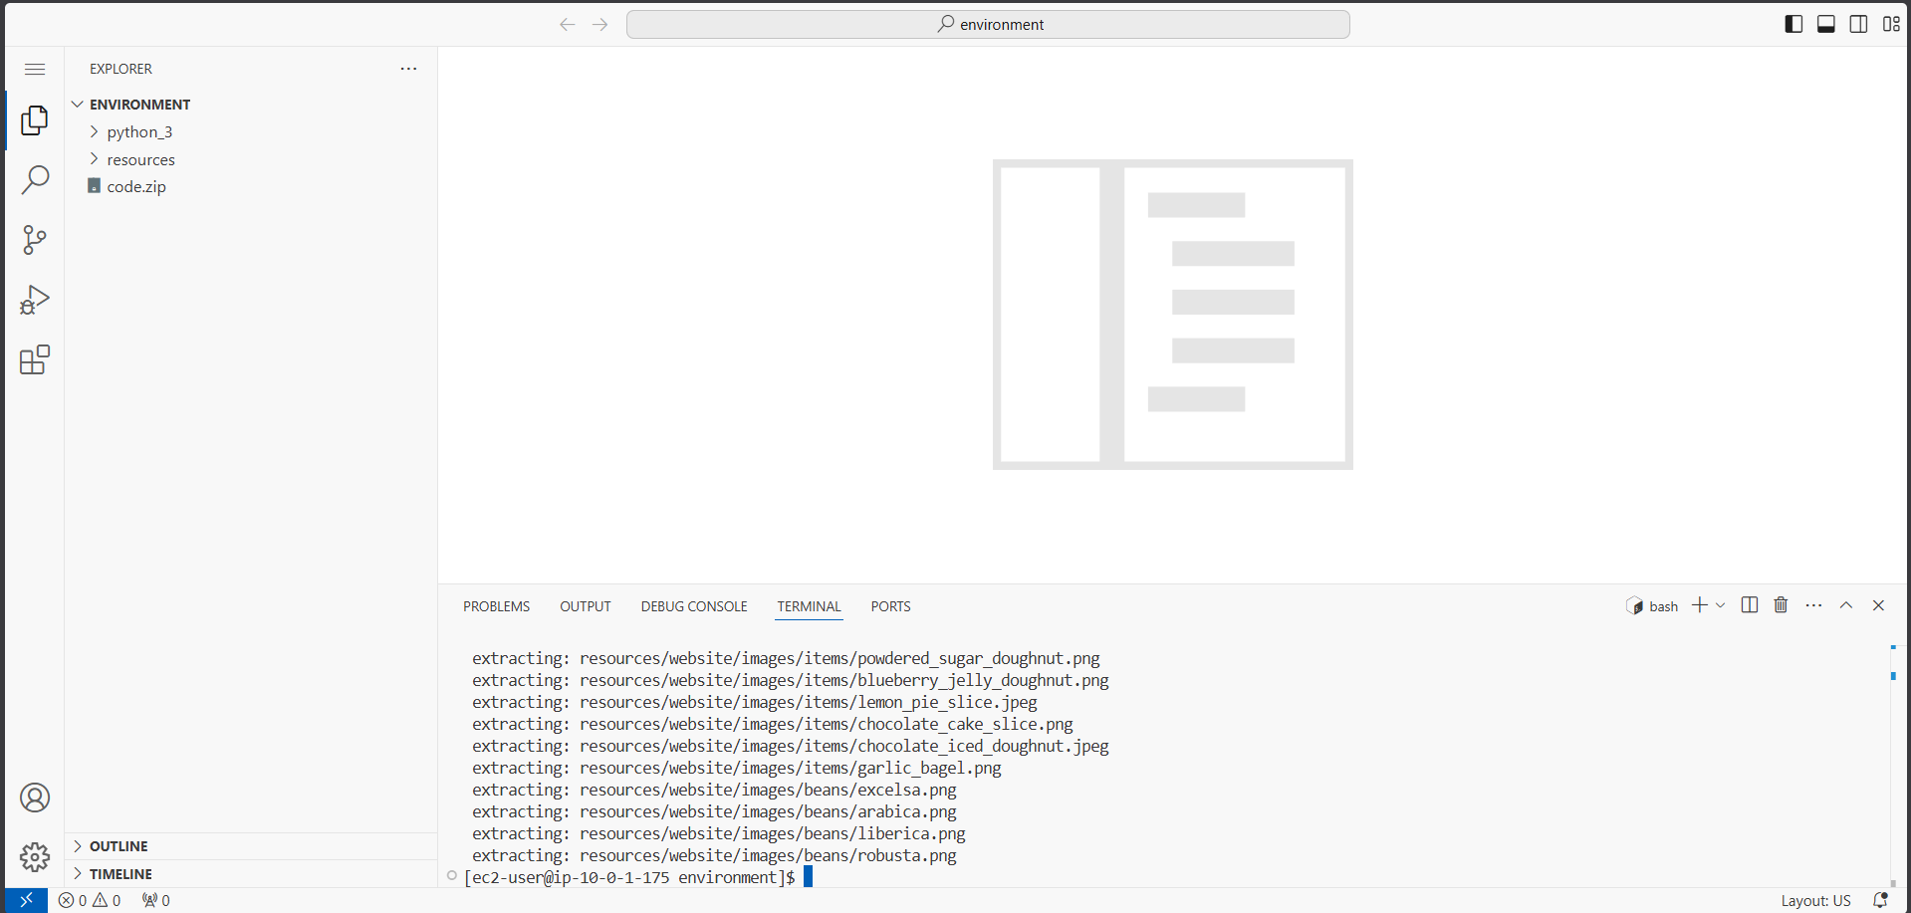
Figure 2: setup.sh extracting website files and uploading resources to Amazon S3

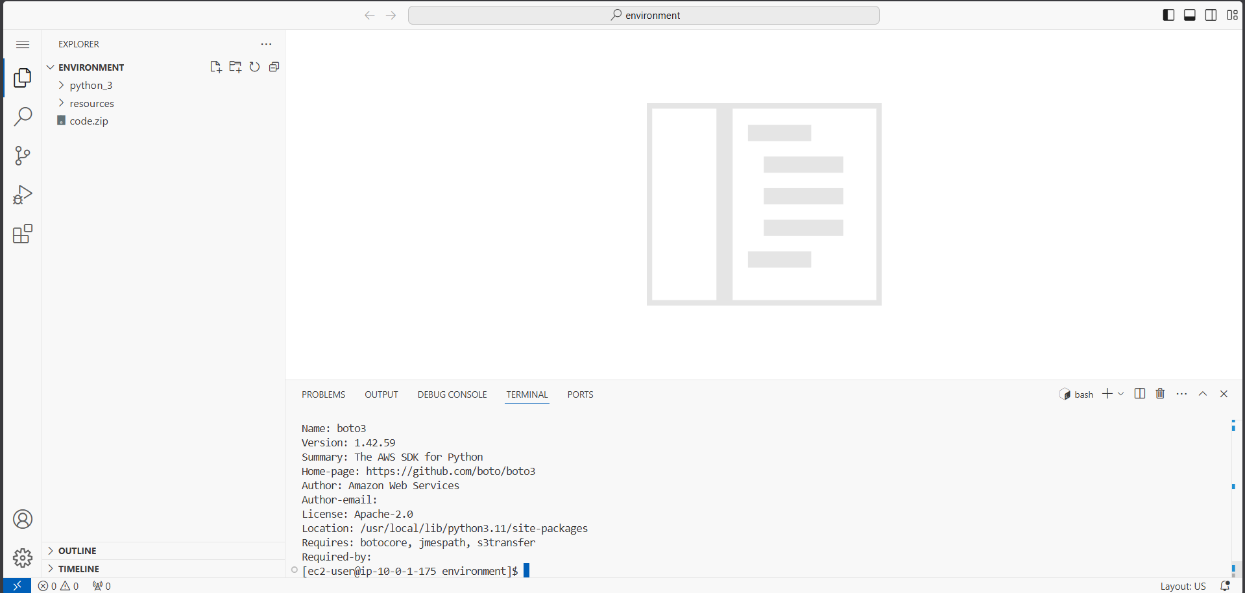
Figure 3: Verifying AWS CLI version and boto3 SDK installation in the VS Code terminal

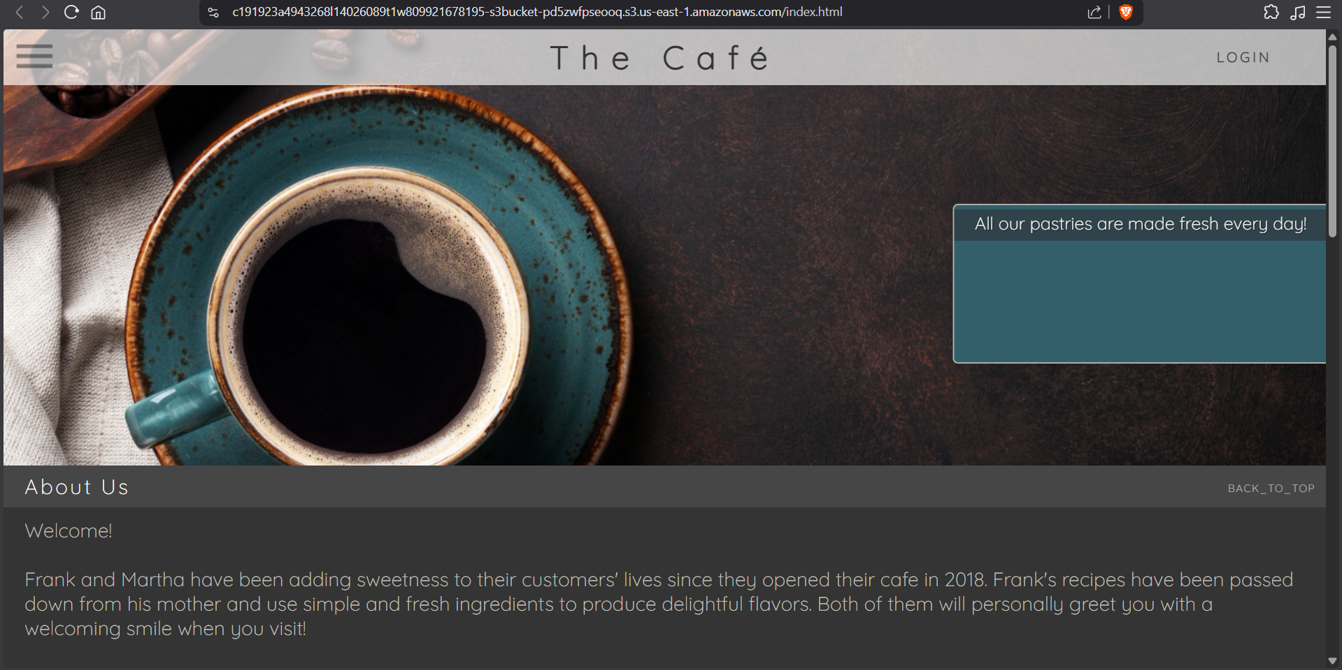
Figure 4: Café website loaded from S3 bucket — static site before API integration

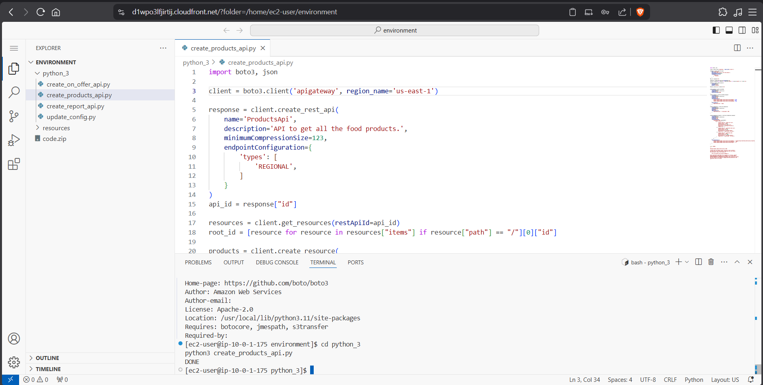
Figure 5: create_products_api.py open in VS Code — creating ProductsApi with GET /products endpoint

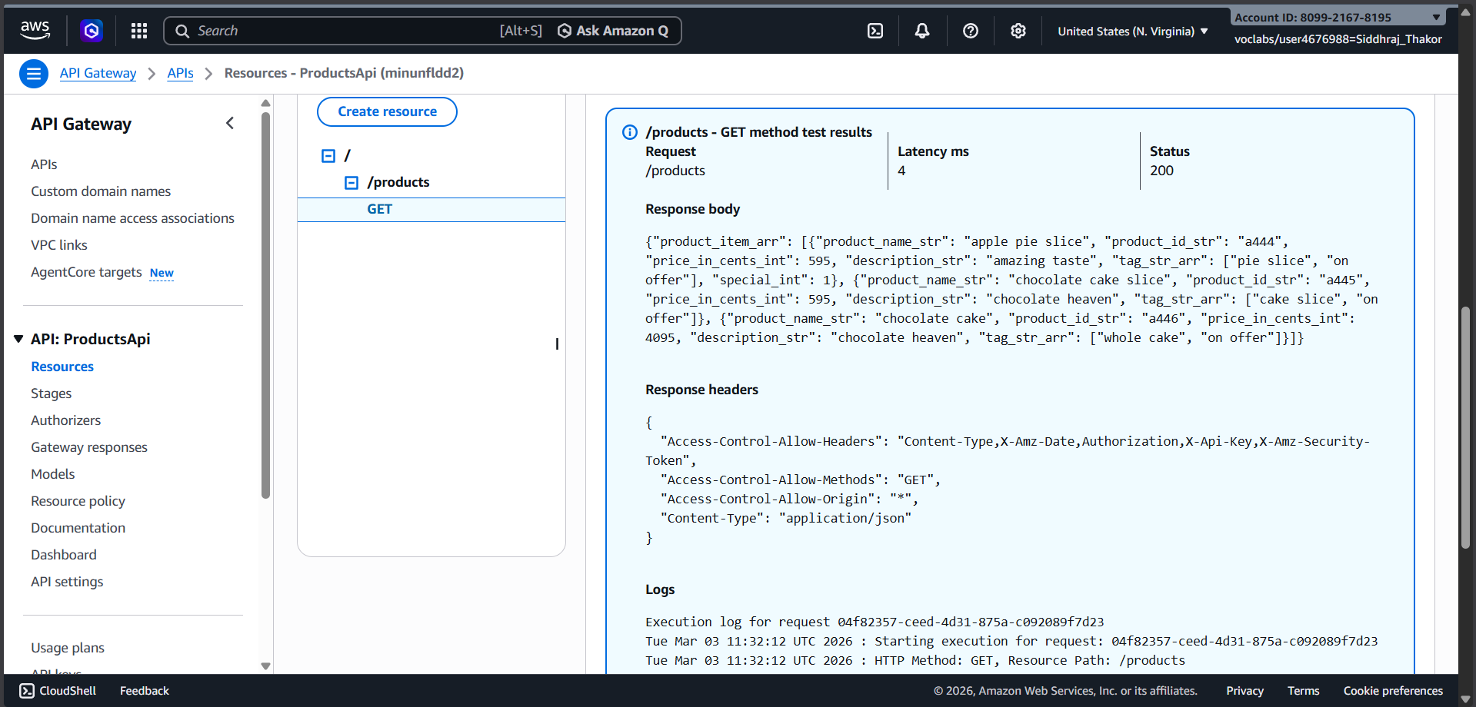
Figure 6: Testing GET /products mock endpoint in API Gateway — response showing three café menu items

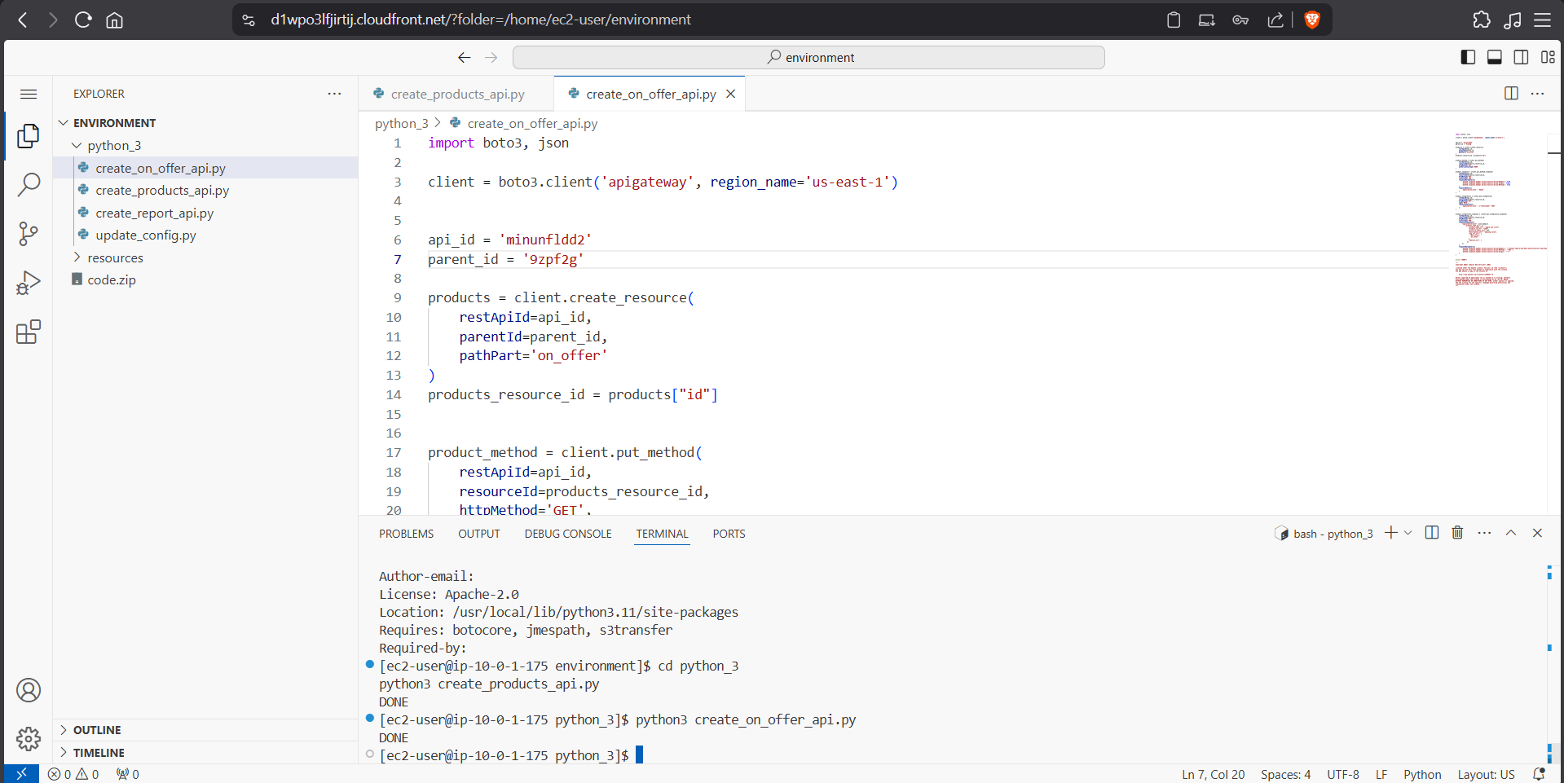
Figure 7: create_on_offer_api.py open in VS Code — adding GET /products/on_offer nested resource

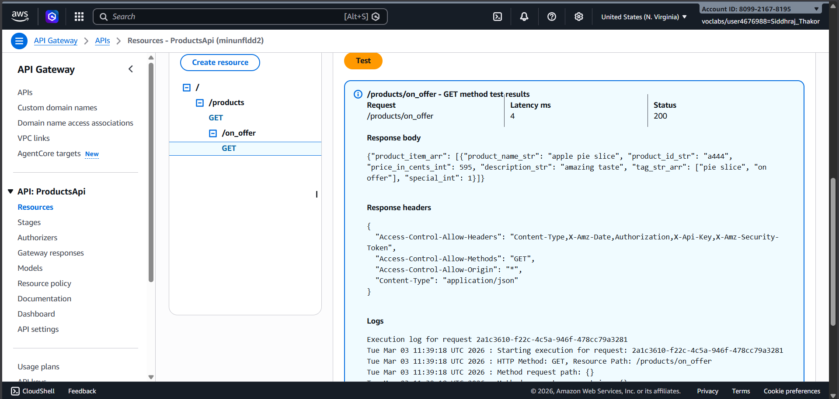
Figure 8: Testing GET /products/on_offer mock endpoint — response showing one on-offer item

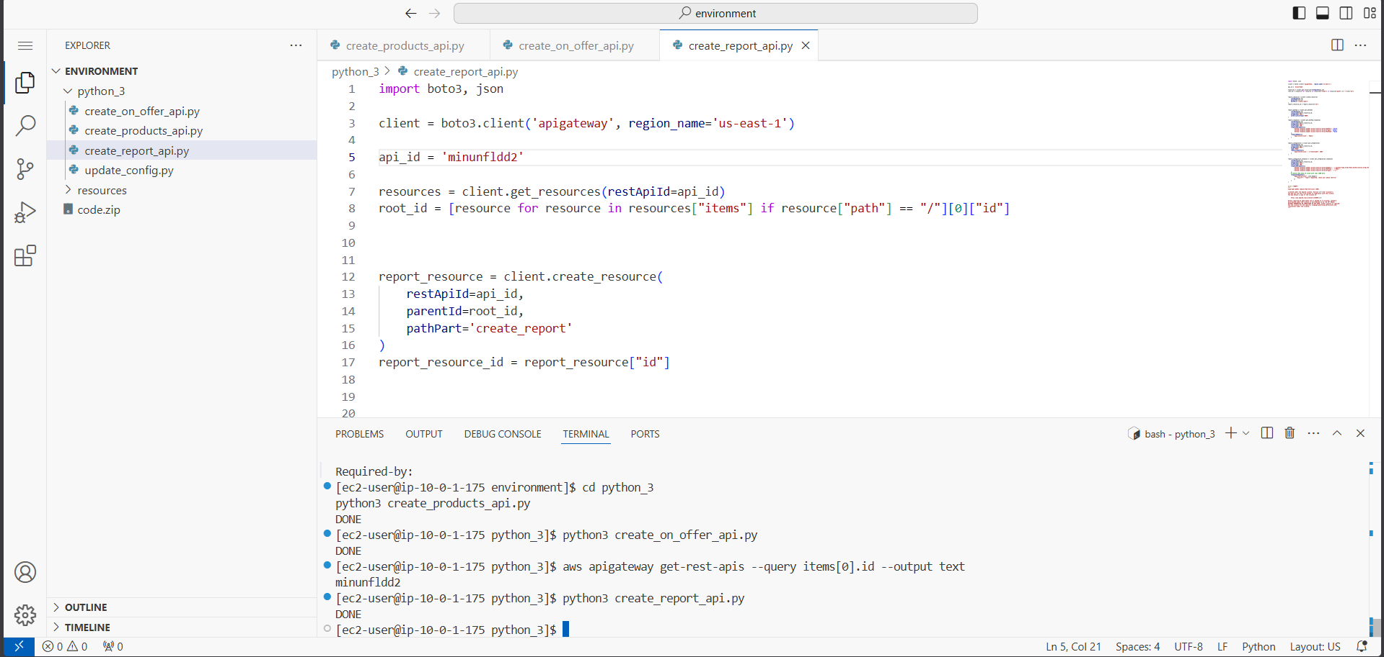
Figure 9: create_report_api.py open in VS Code — creating the POST /create_report endpoint

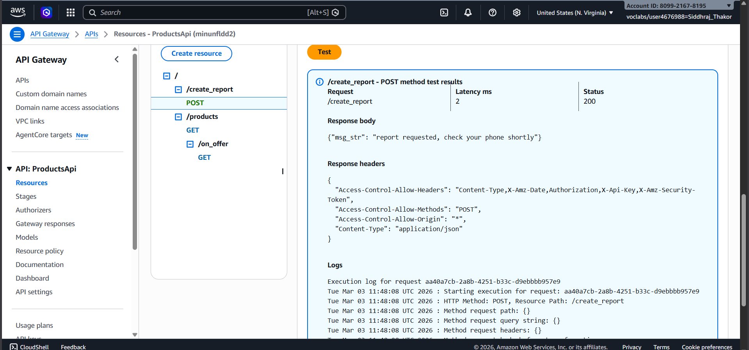
Figure 10: Testing POST /create_report mock endpoint — response confirming report request received

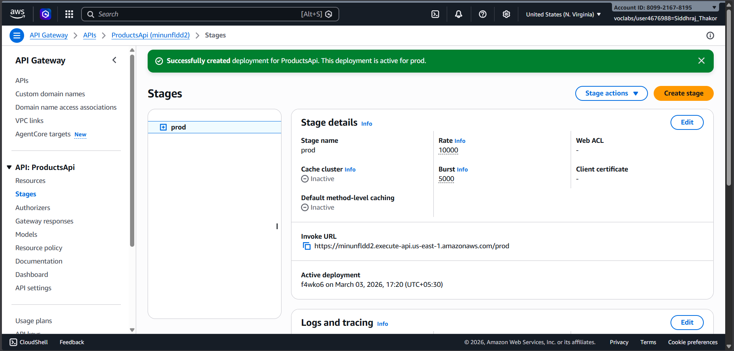
Figure 11: API Gateway prod stage deployed — Invoke URL generated for ProductsApi

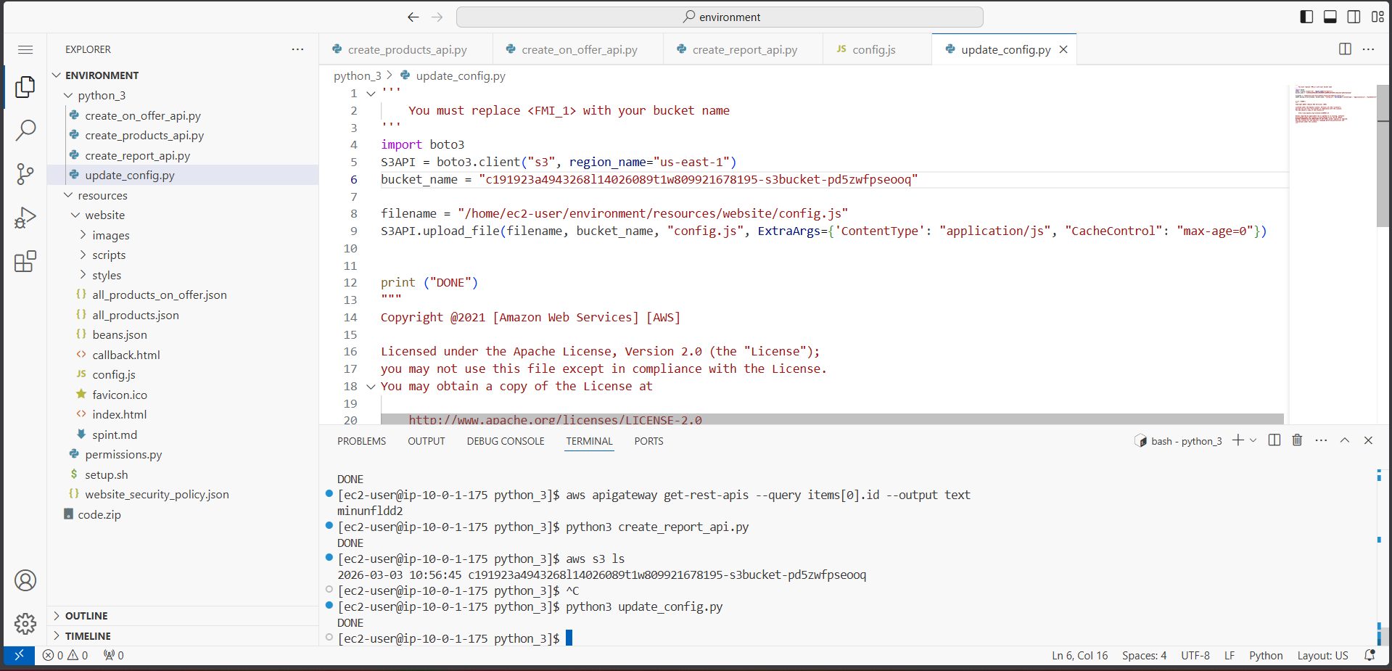
Figure 12: update_config.py uploading updated config.js with Invoke URL to S3 bucket

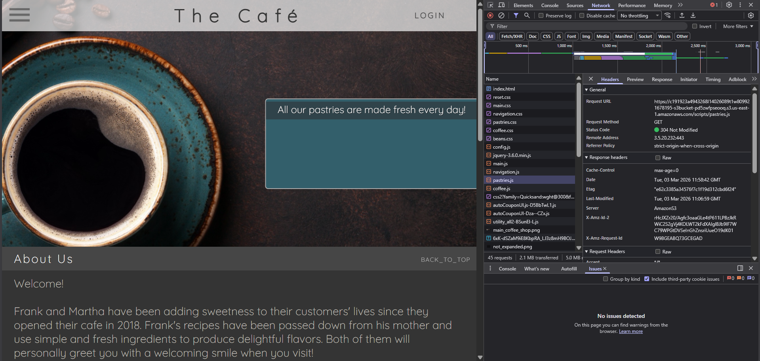
Figure 13: Café website with browser developer console — API Gateway requests confirmed in network tab

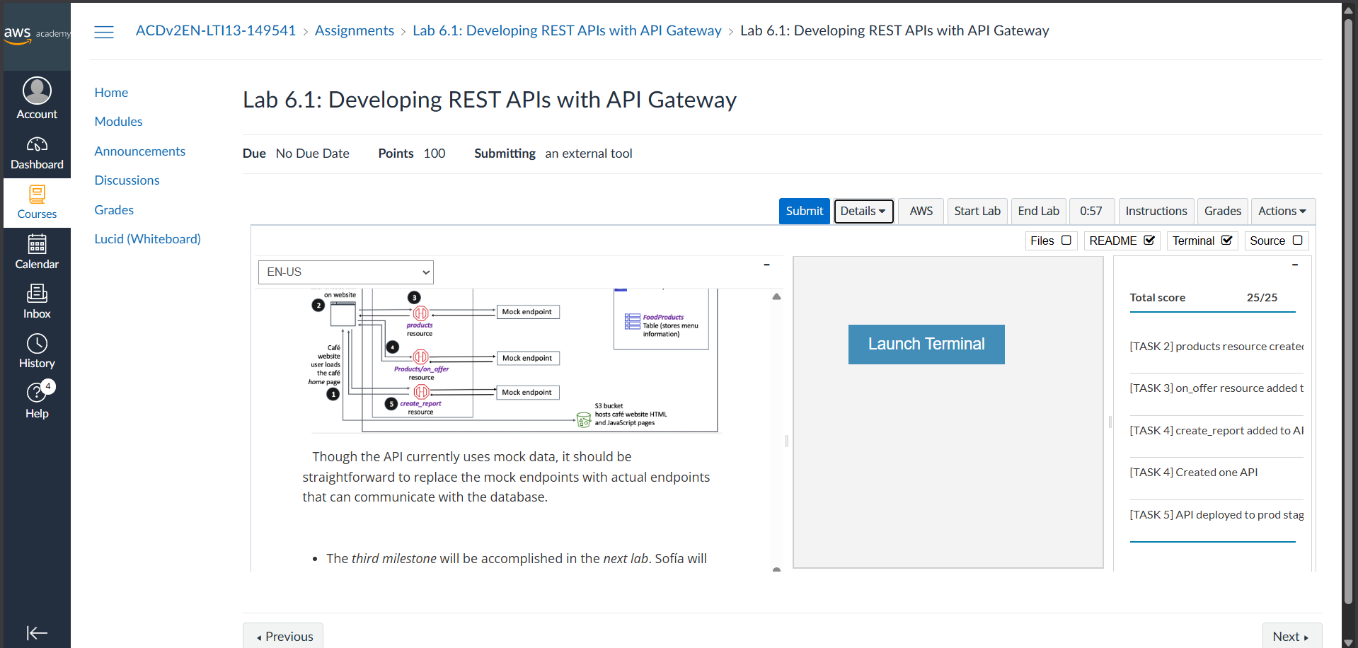
Figure 14: Lab 6.1 submission showing full score of 25/25 for all tasks

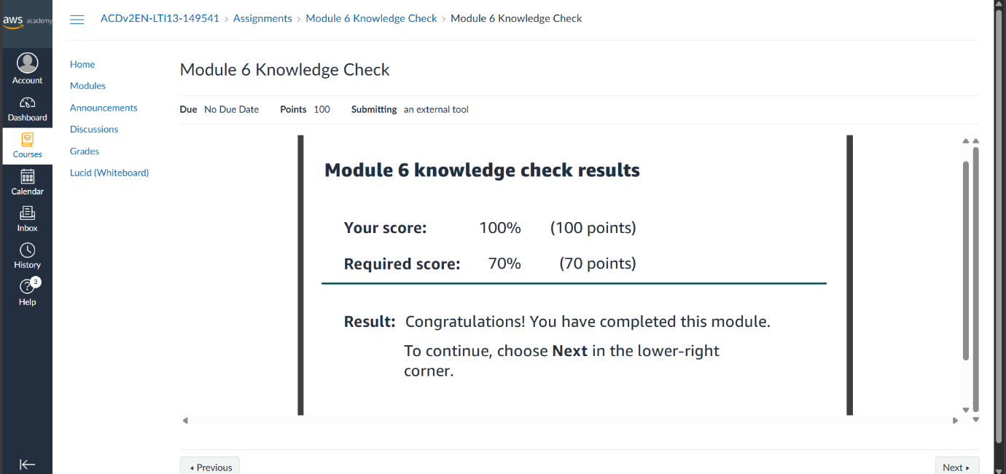
Figure 15: Module 6 Knowledge Check result — 100% score (100/100 points)

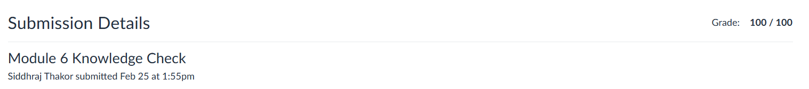
Figure 16: Knowledge Check submission details — Grade 100/100

Learning Outcome :
- Understood how Amazon API Gateway is used to create and manage REST APIs on AWS.
- Learned to define API resources, HTTP methods (GET, POST), and mock integrations using Boto3 SDK.
- Gained hands-on experience creating nested API resources and configuring method requests and responses.
- Understood how CORS is enabled in API Gateway to allow browser-based AJAX requests from S3-hosted websites.
- Learned how to deploy an API to a named stage (prod) and use the generated Invoke URL.
- Explored the integration between a static website hosted on Amazon S3 and a REST API on API Gateway.
- Understood mock integration as a development strategy for testing API structure before connecting real backends.
- Gained familiarity with the overall serverless architecture: S3 → API Gateway → Lambda → DynamoDB.

References :
- AWS Academy Cloud Computing Lab Manual
- https://docs.aws.amazon.com/apigateway
- https://docs.aws.amazon.com/cli
- https://boto3.amazonaws.com/v1/documentation/api/latest/index.html
- https://docs.aws.amazon.com/apigateway/latest/developerguide/how-to-cors.html

