PRACTICAL: 5

Objective:
To use the AWS SDK for Python (boto3) to create AWS Lambda functions that retrieve data from Amazon DynamoDB and return report acknowledgement messages. The Lambda functions are integrated with Amazon API Gateway REST endpoints (/products, /products/on_offer, and /create_report) to power a dynamic cafe website, replacing the mock data used in the previous lab with real DynamoDB queries.

Theory:
AWS Lambda is a serverless compute service that automatically runs code in response to events without requiring server provisioning or management. In this lab, Lambda is used to bridge the connection between API Gateway and DynamoDB. The get_all_products Lambda function performs a full table scan on the FoodProducts DynamoDB table when called from the GET /products endpoint, and performs an index scan on the special_GSI when called from GET /products/on_offer.

The AWS SDK for Python (boto3) is used to programmatically create both Lambda functions by packaging the Python code into .zip files, storing them in an S3 bucket, and invoking the boto3 Lambda client to register each function with the LambdaAccessToDynamoDB IAM role. A mapping template is added to the /on_offer integration request so that the path variable is passed to the Lambda event object, enabling the function to switch between a table scan and index scan using a single conditional.

Cross-Origin Resource Sharing (CORS) is re-enabled on the GET endpoints after switching from mock to Lambda integration, ensuring the browser-based S3-hosted cafe website can successfully invoke the API Gateway endpoints. The API is deployed to the prod stage after all changes, and the live cafe website is tested to confirm that product data from DynamoDB renders correctly and that price changes in DynamoDB are reflected in real time.

Code:
N/A (Lab uses AWS Console and boto3 wrapper scripts provided in code.zip)

Output:
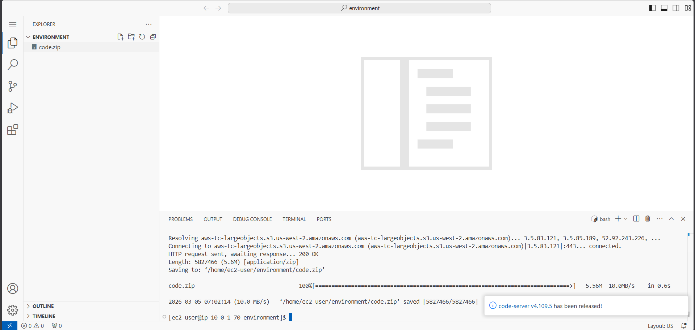
Figure 1: Launching the lab and accessing the VS Code IDE via LabIDEURL

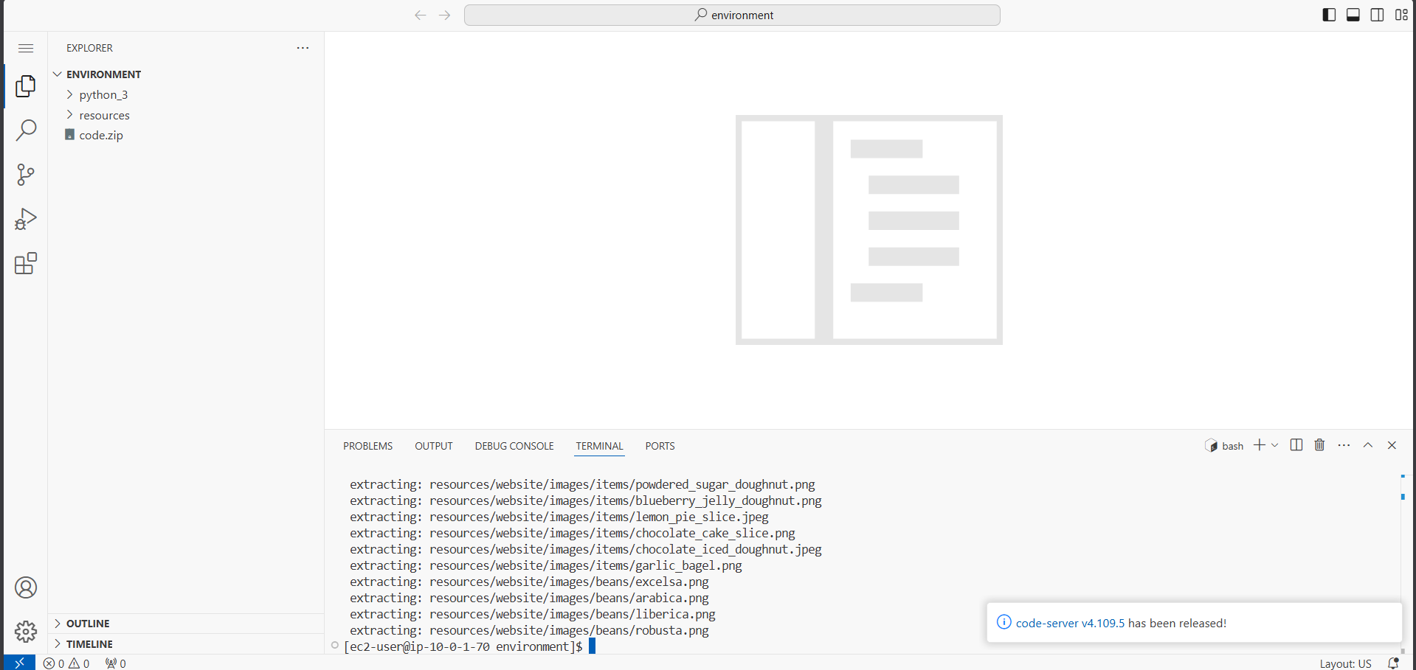
Figure 2: Downloading code.zip and extracting lab files in VS Code terminal

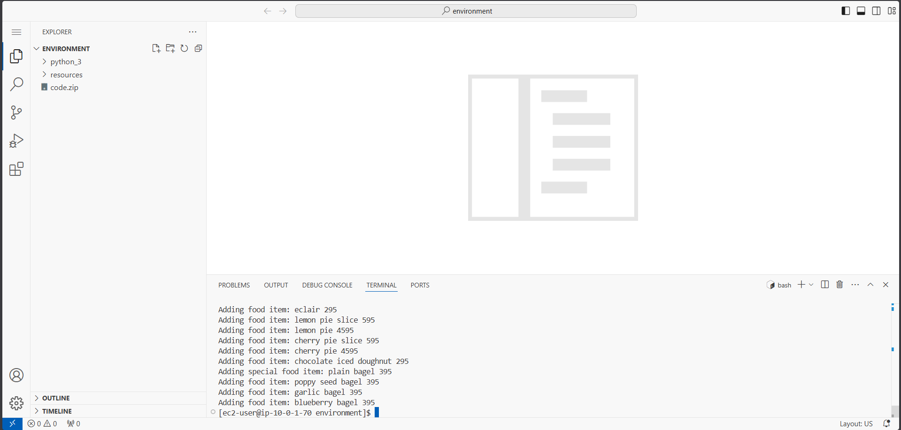
Figure 3: Running setup.sh to restore S3, DynamoDB, and API Gateway resources from earlier labs

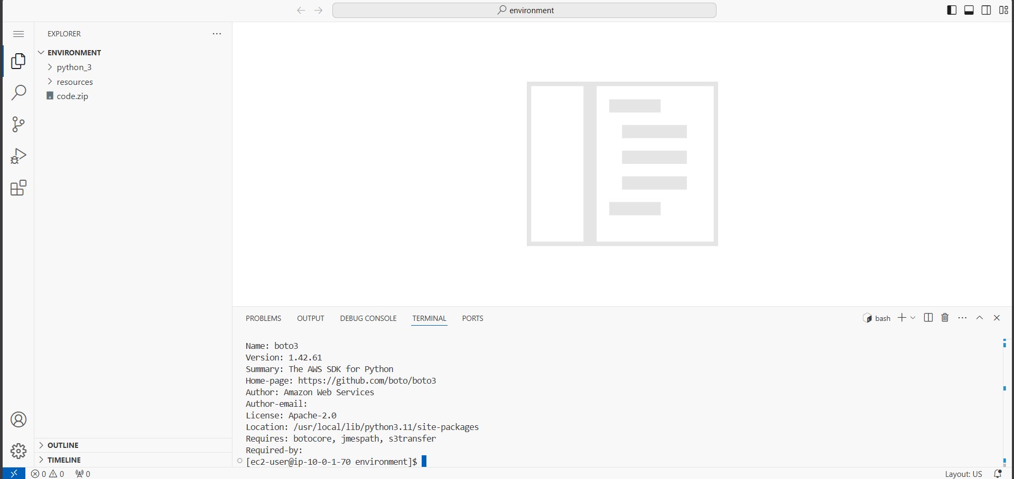
Figure 4: Verifying boto3 SDK installation using pip3 show boto3 in VS Code terminal

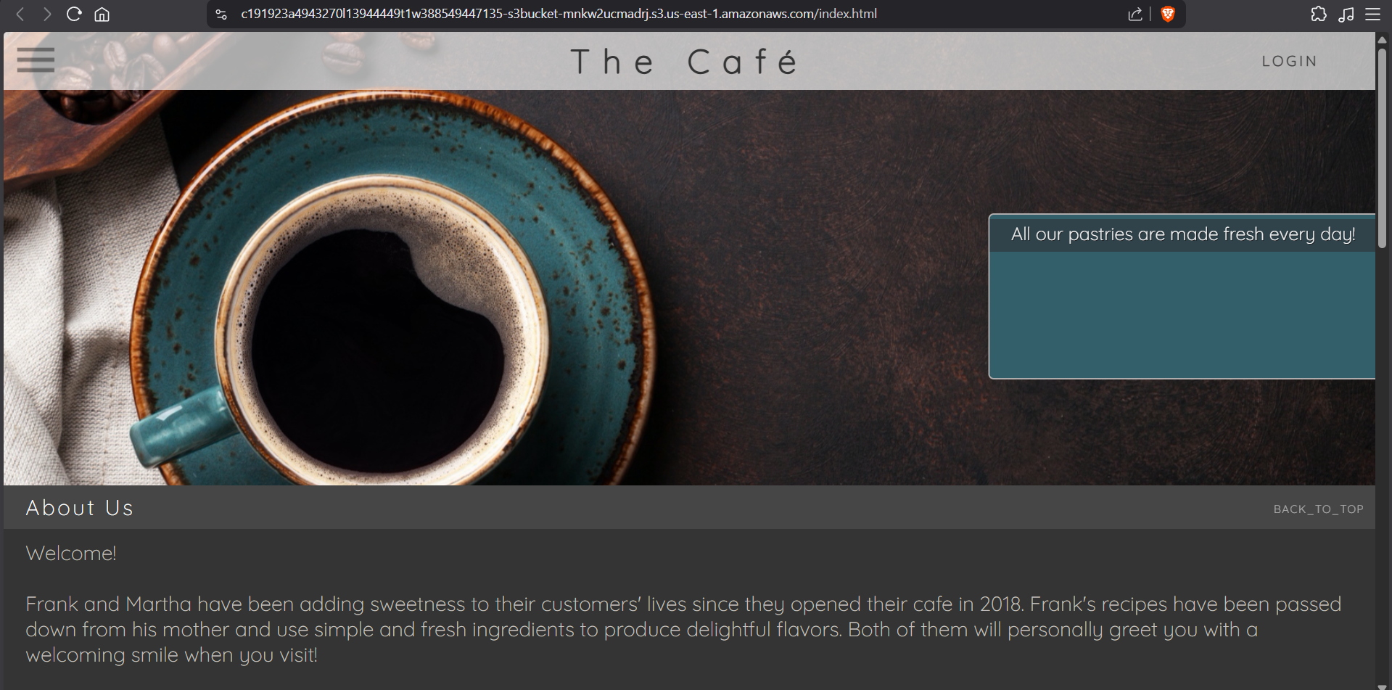
Figure 5: Confirming S3 bucket hosting — cafe website loaded showing hard-coded menu data

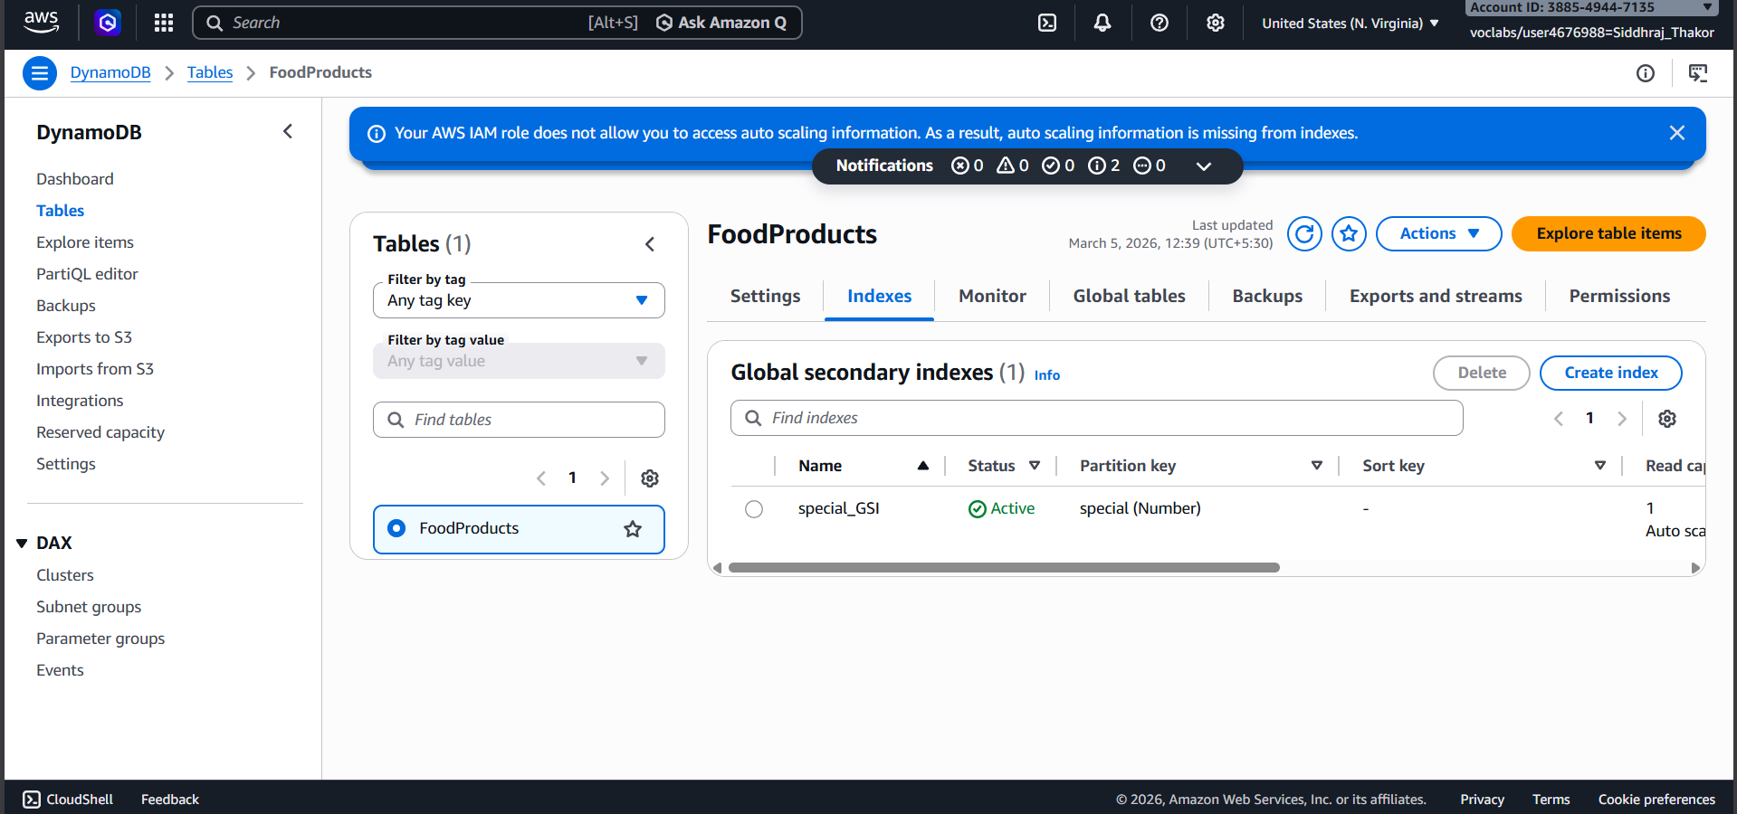
Figure 6: DynamoDB FoodProducts table populated with cafe menu items

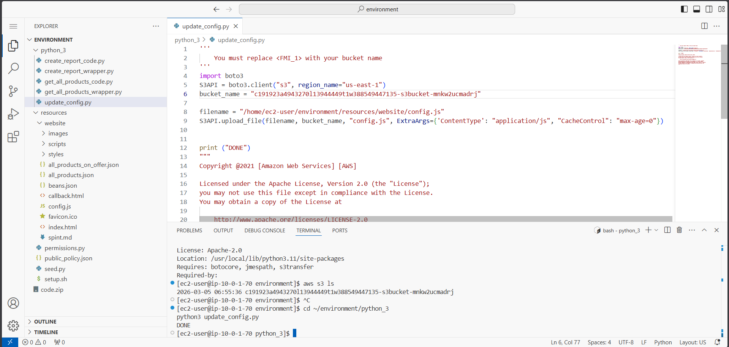
Figure 7: DynamoDB Indexes tab confirming special_GSI index was created

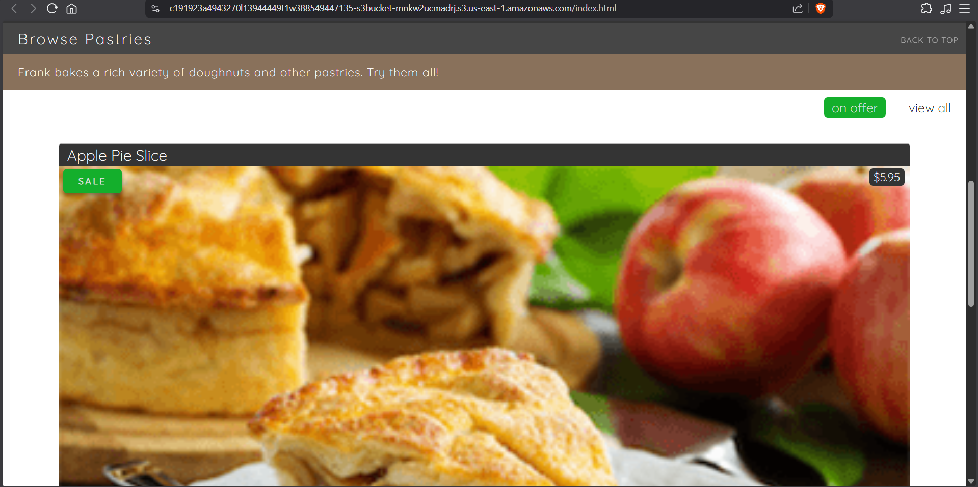
Figure 8: API Gateway ProductsApi showing GET /products, GET /on_offer, POST /create_report methods

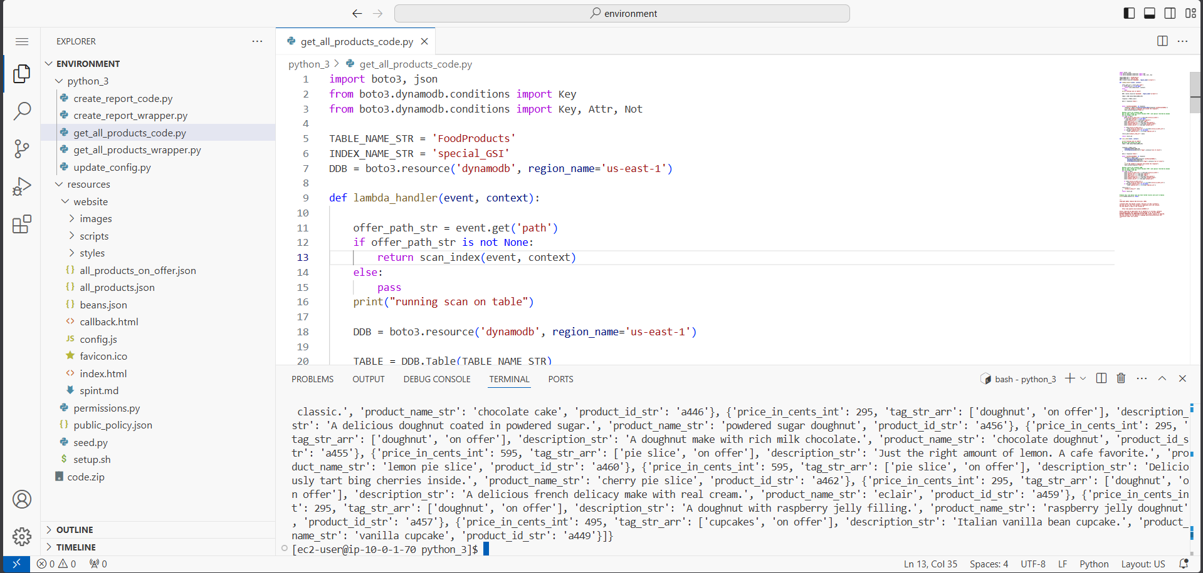
Figure 9: Copying the prod stage Invoke URL from API Gateway Stages panel

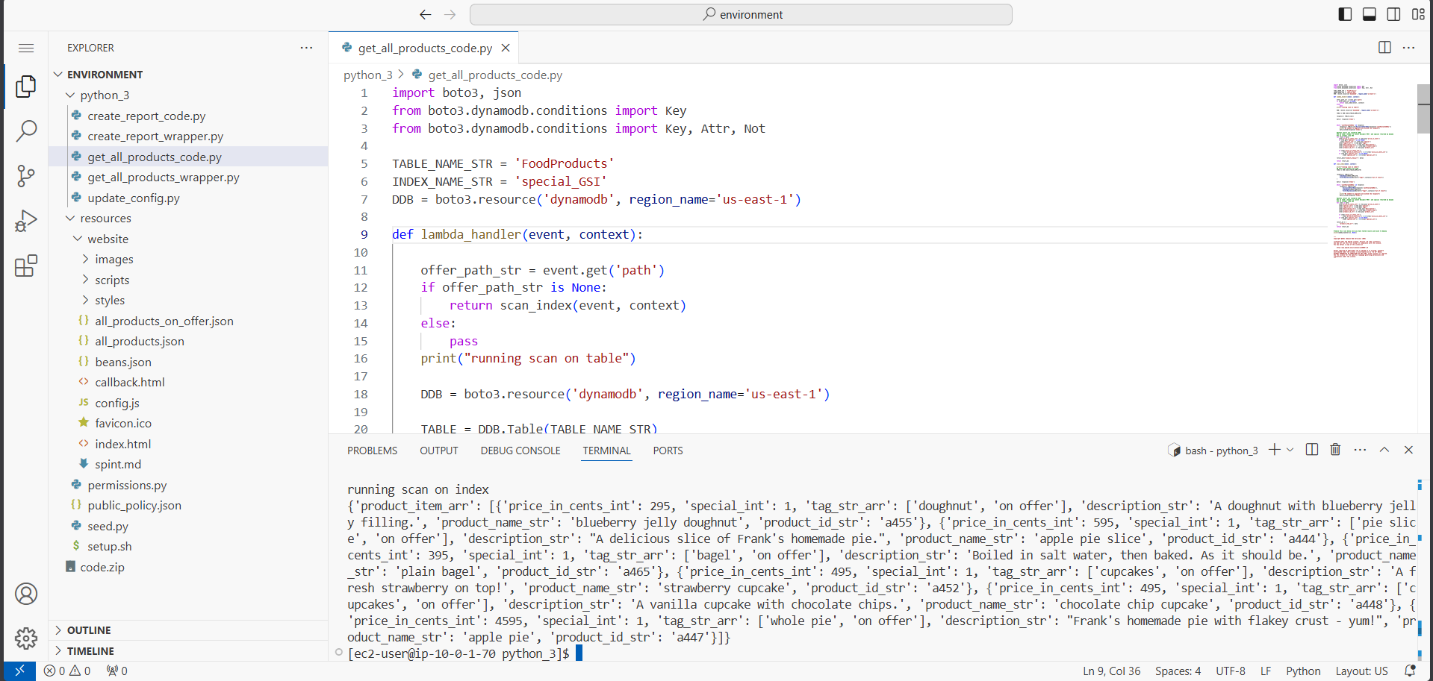
Figure 10: Updating config.js with the API Gateway Invoke URL in VS Code IDE

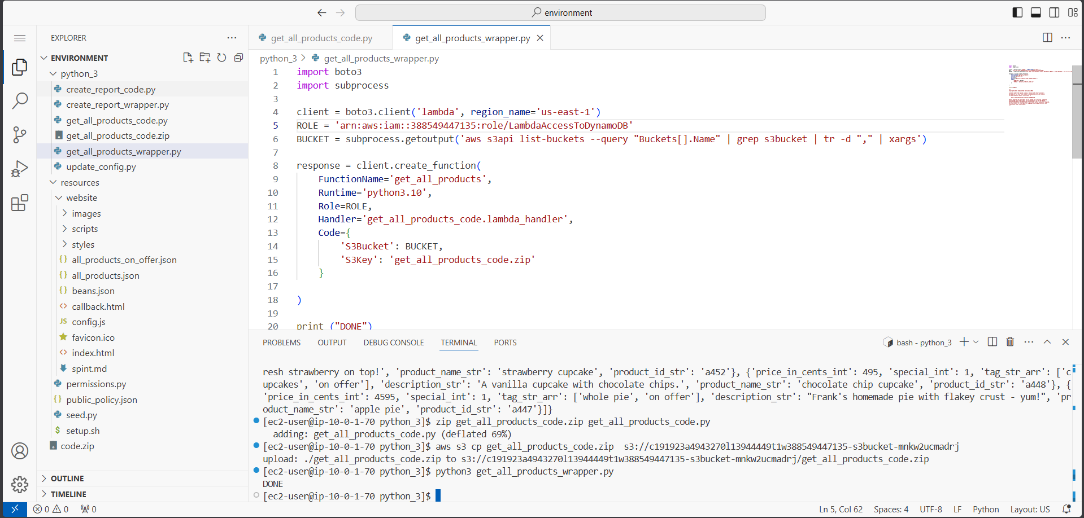
Figure 11: Running update_config.py to upload updated config.js to S3 bucket

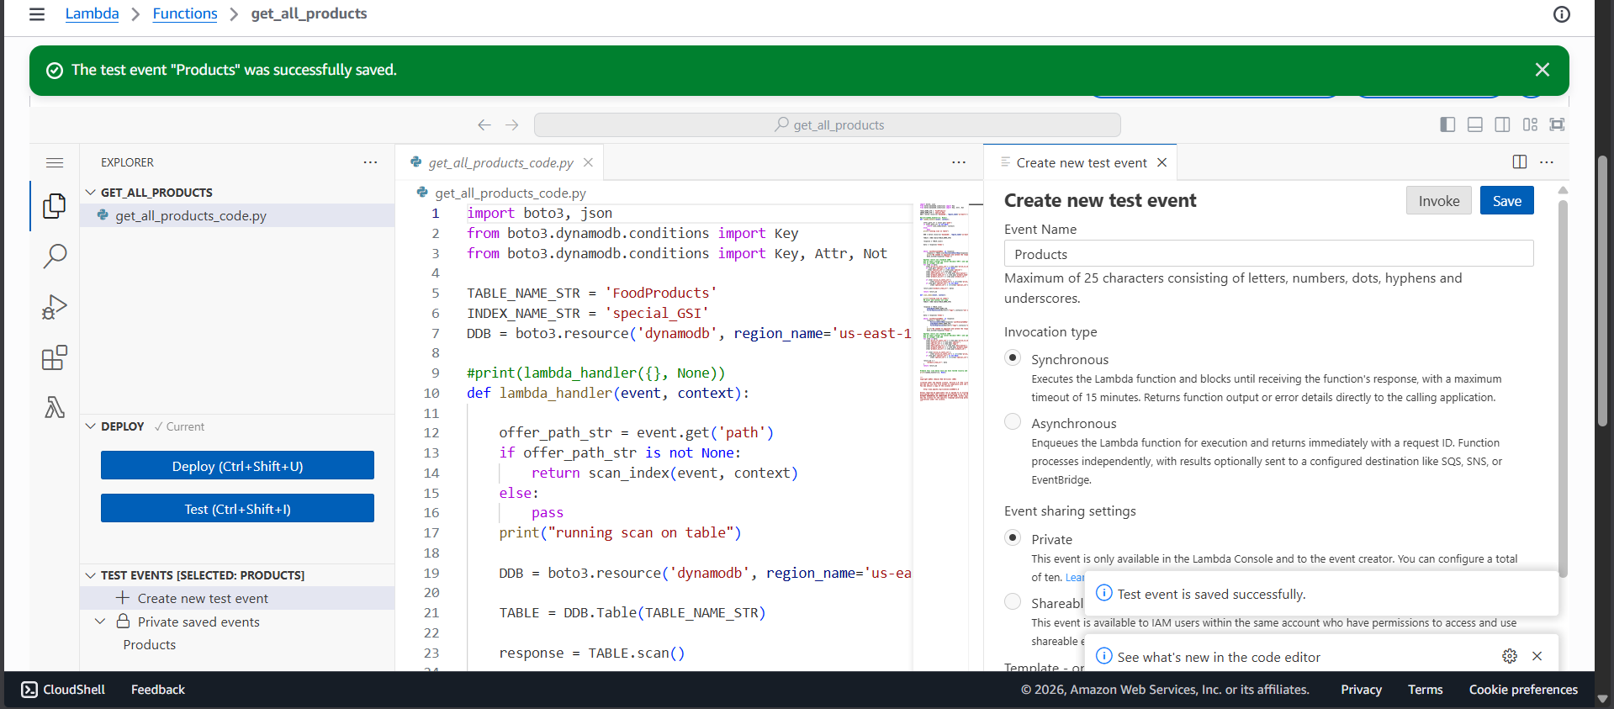
Figure 12: Cafe website refreshed -- showing mock API data (one item) confirming config update

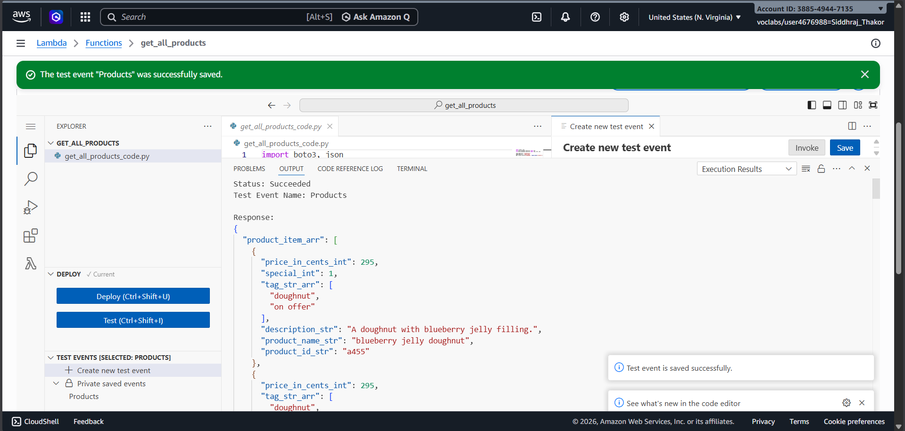
Figure 13: Opening get_all_products_code.py and replacing FMI placeholders with DynamoDB values

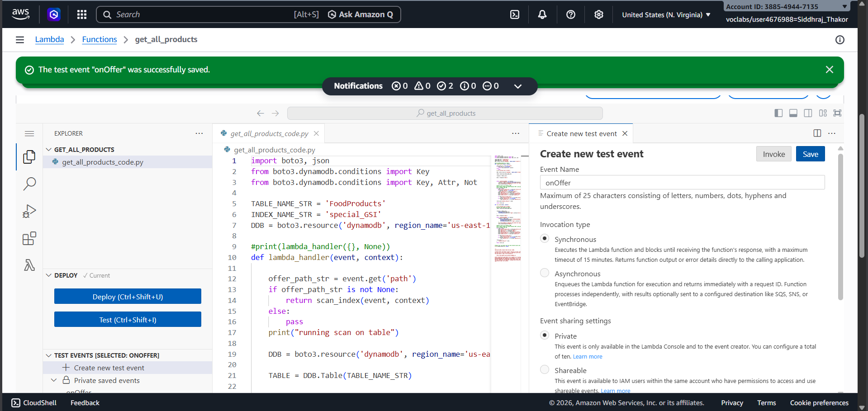
Figure 14: Testing get_all_products_code.py locally -- running scan on table, JSON output returned

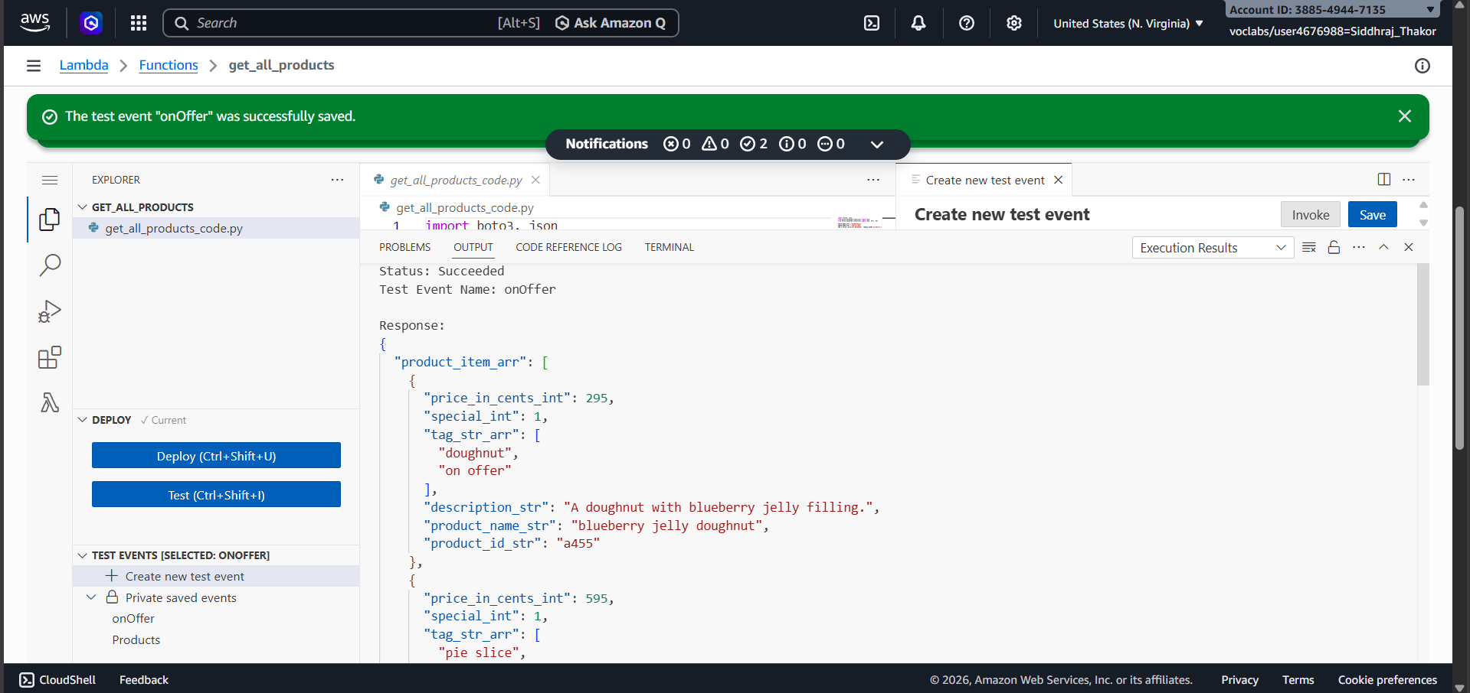
Figure 15: Modifying condition to is None and re-running to test scan on index filter

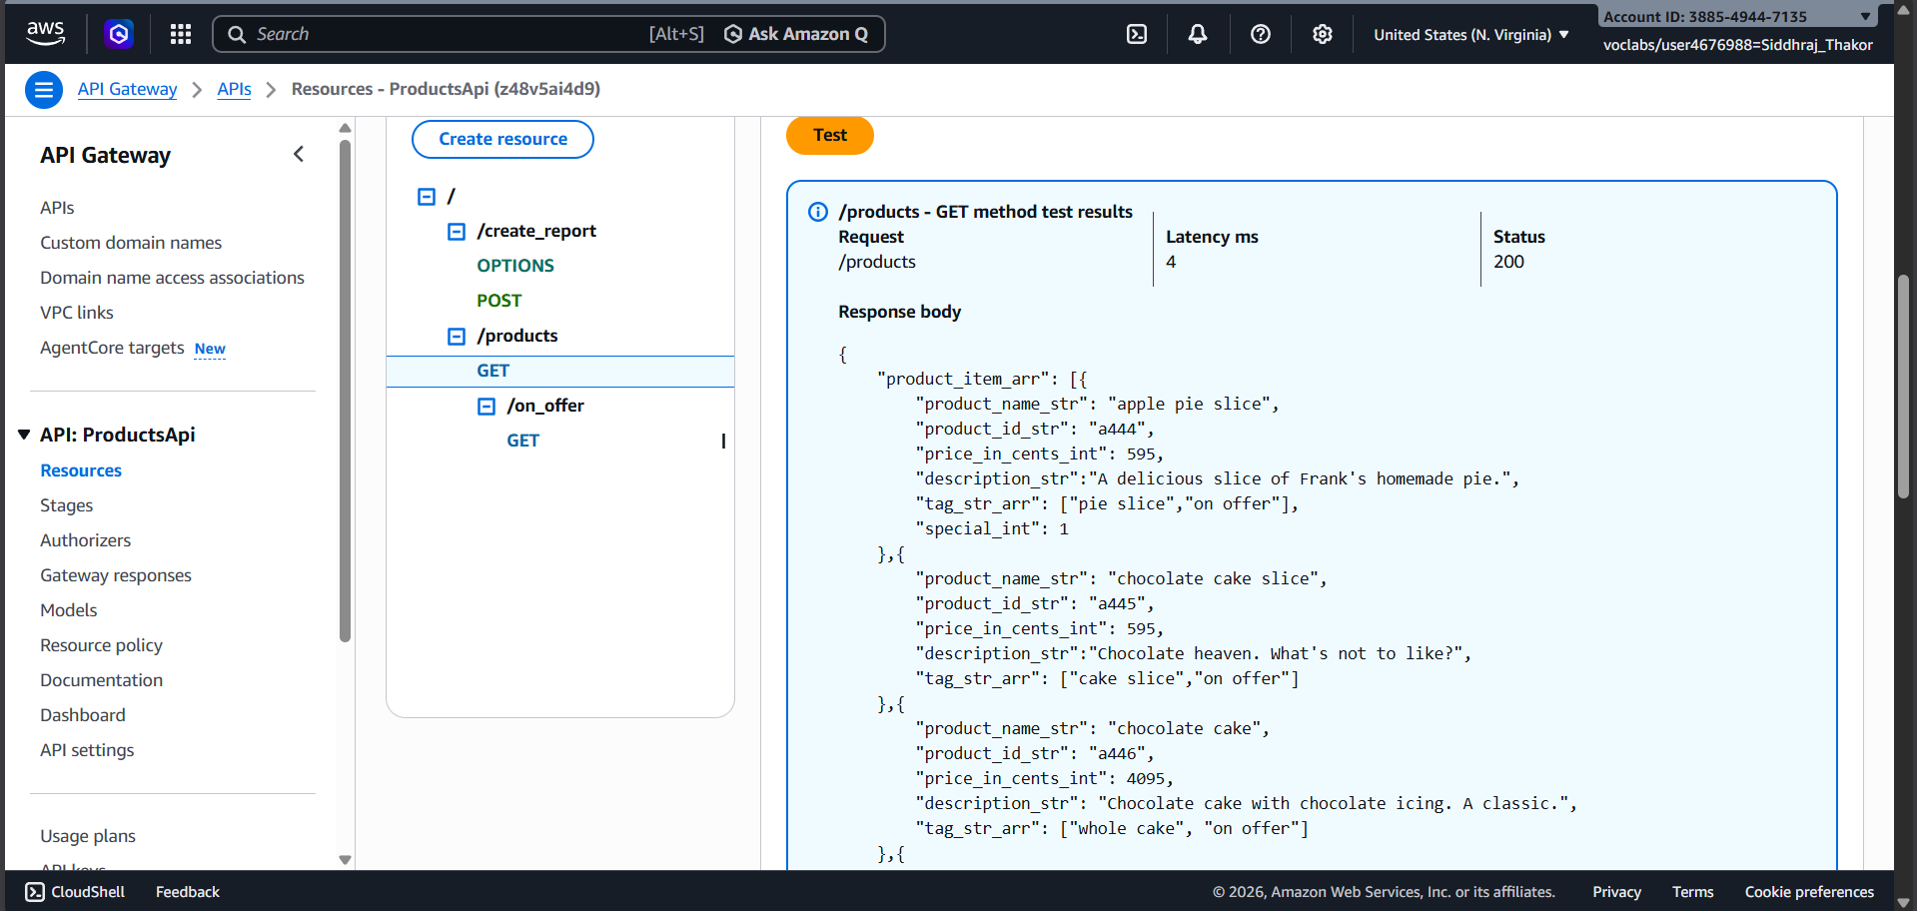
Figure 16: Reverting condition back to is not None and commenting out print statement

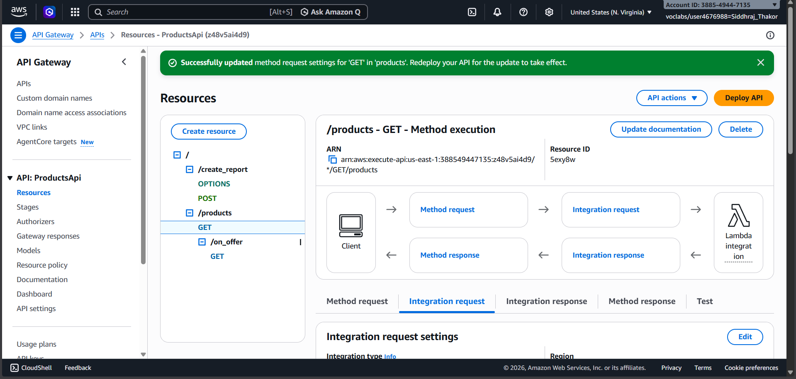
Figure 17: Locating LambdaAccessToDynamoDB IAM role and copying Role ARN value

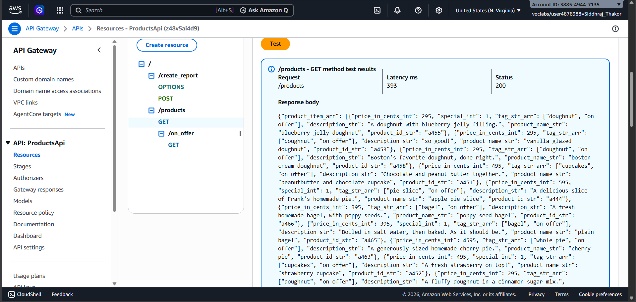
Figure 18: Editing get_all_products_wrapper.py -- replacing FMI_1 with IAM Role ARN

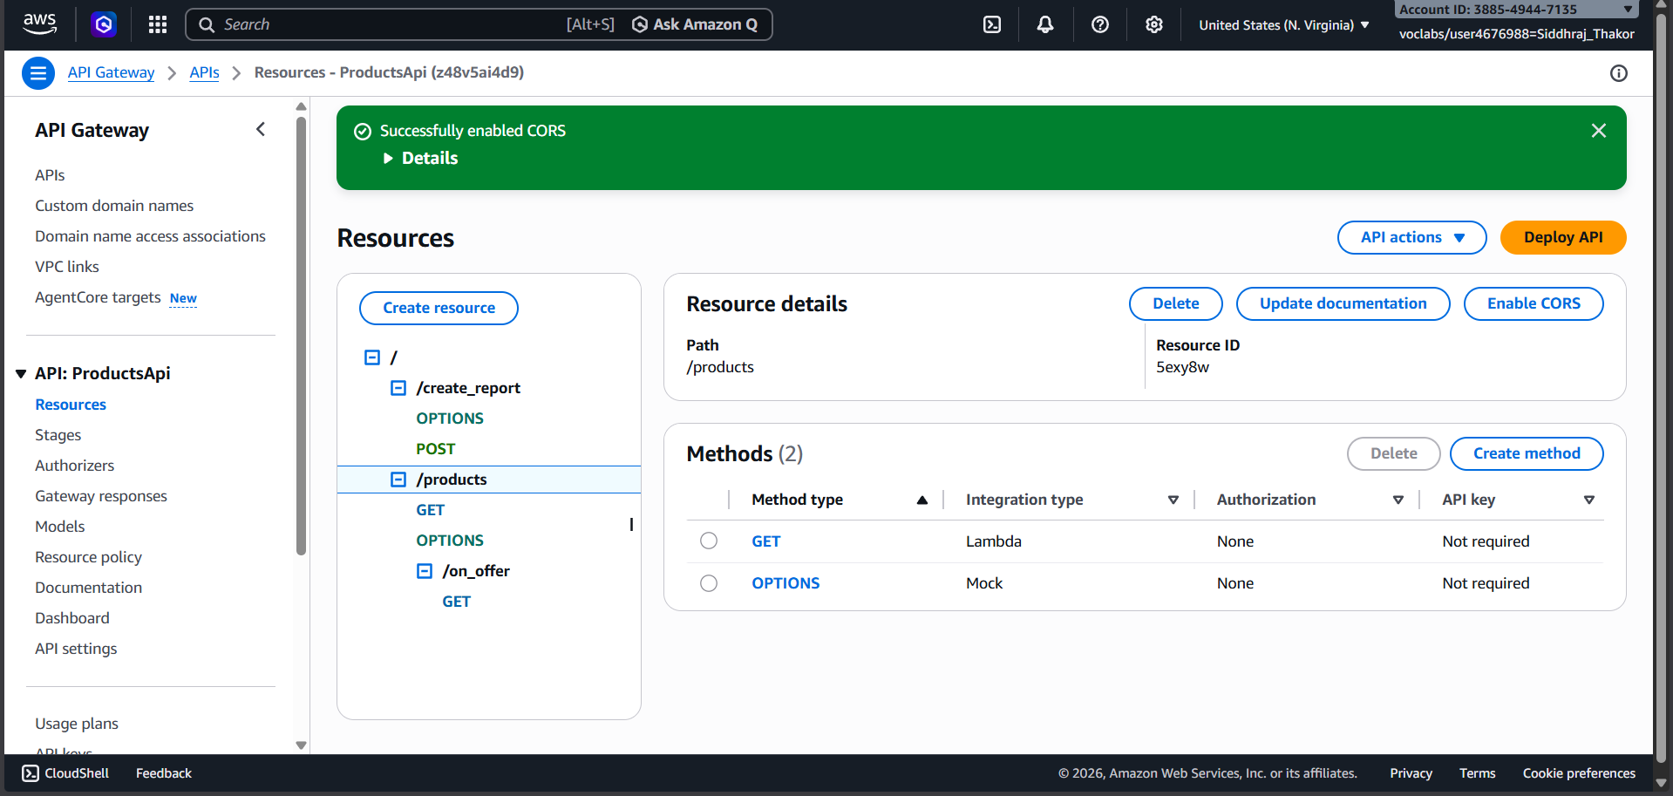
Figure 19: Packaging code.zip and uploading to S3 bucket via AWS CLI

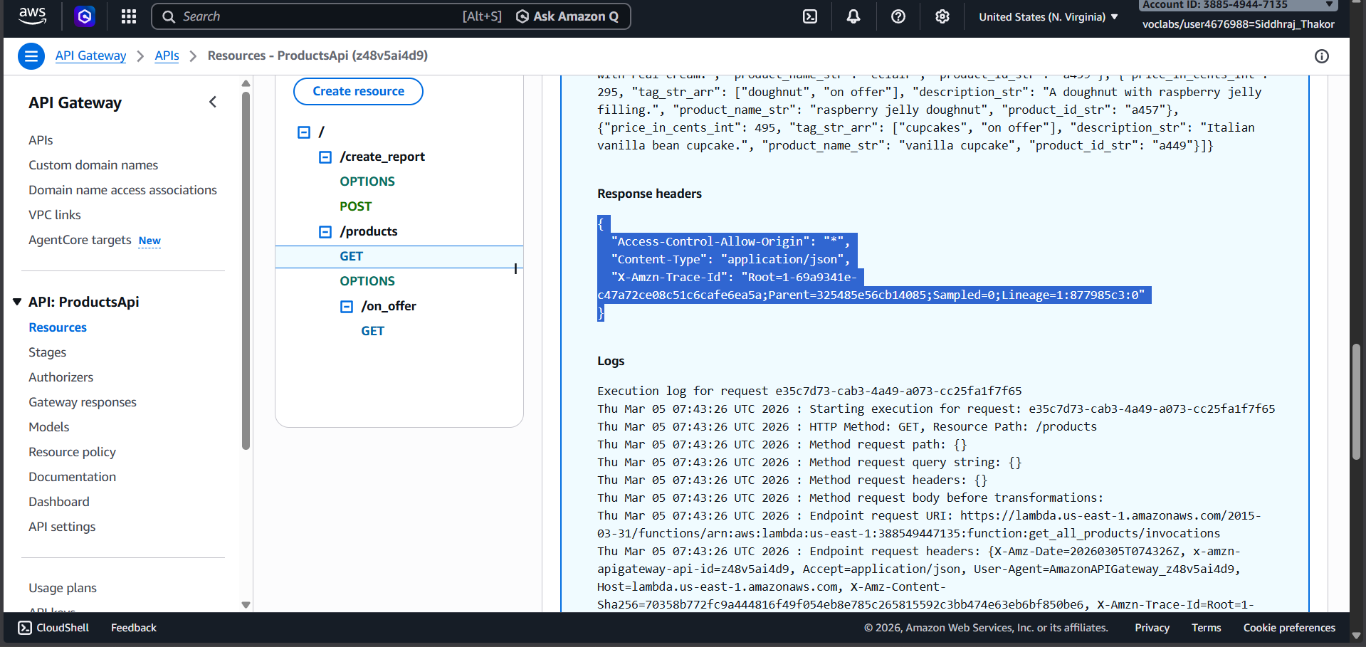
Figure 20: Running get_all_products_wrapper.py -- DONE confirming Lambda function created

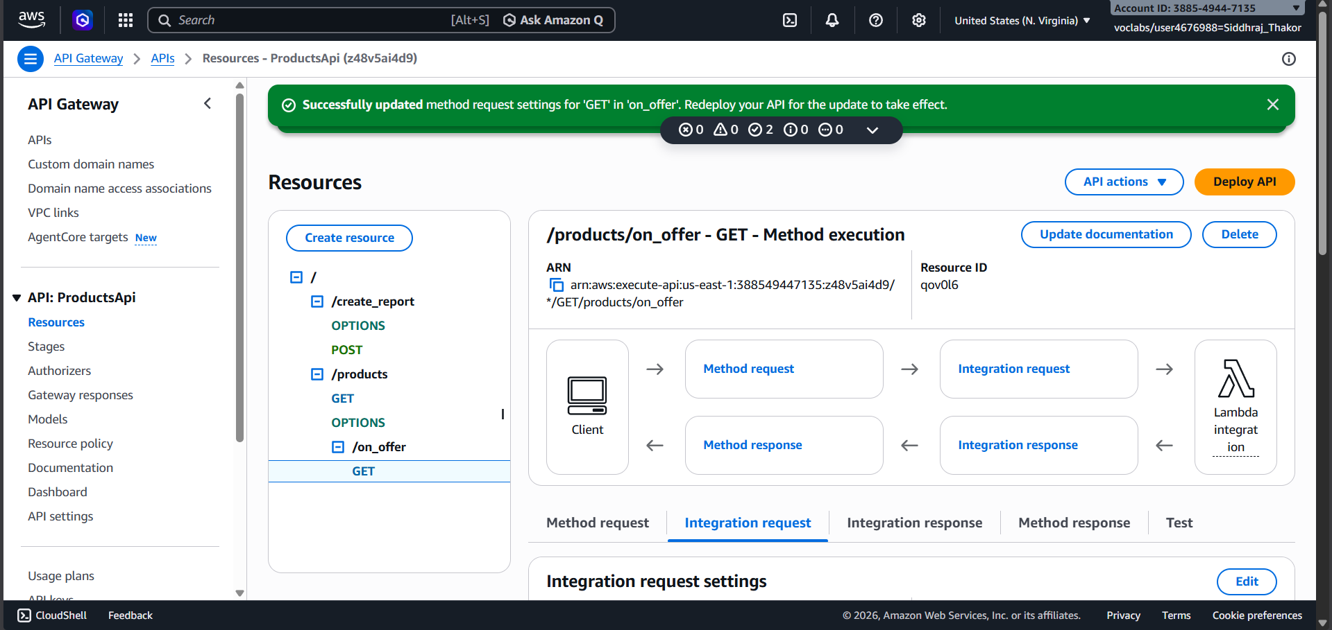
Figure 21: Lambda console -- get_all_products function created, code visible in Code source panel

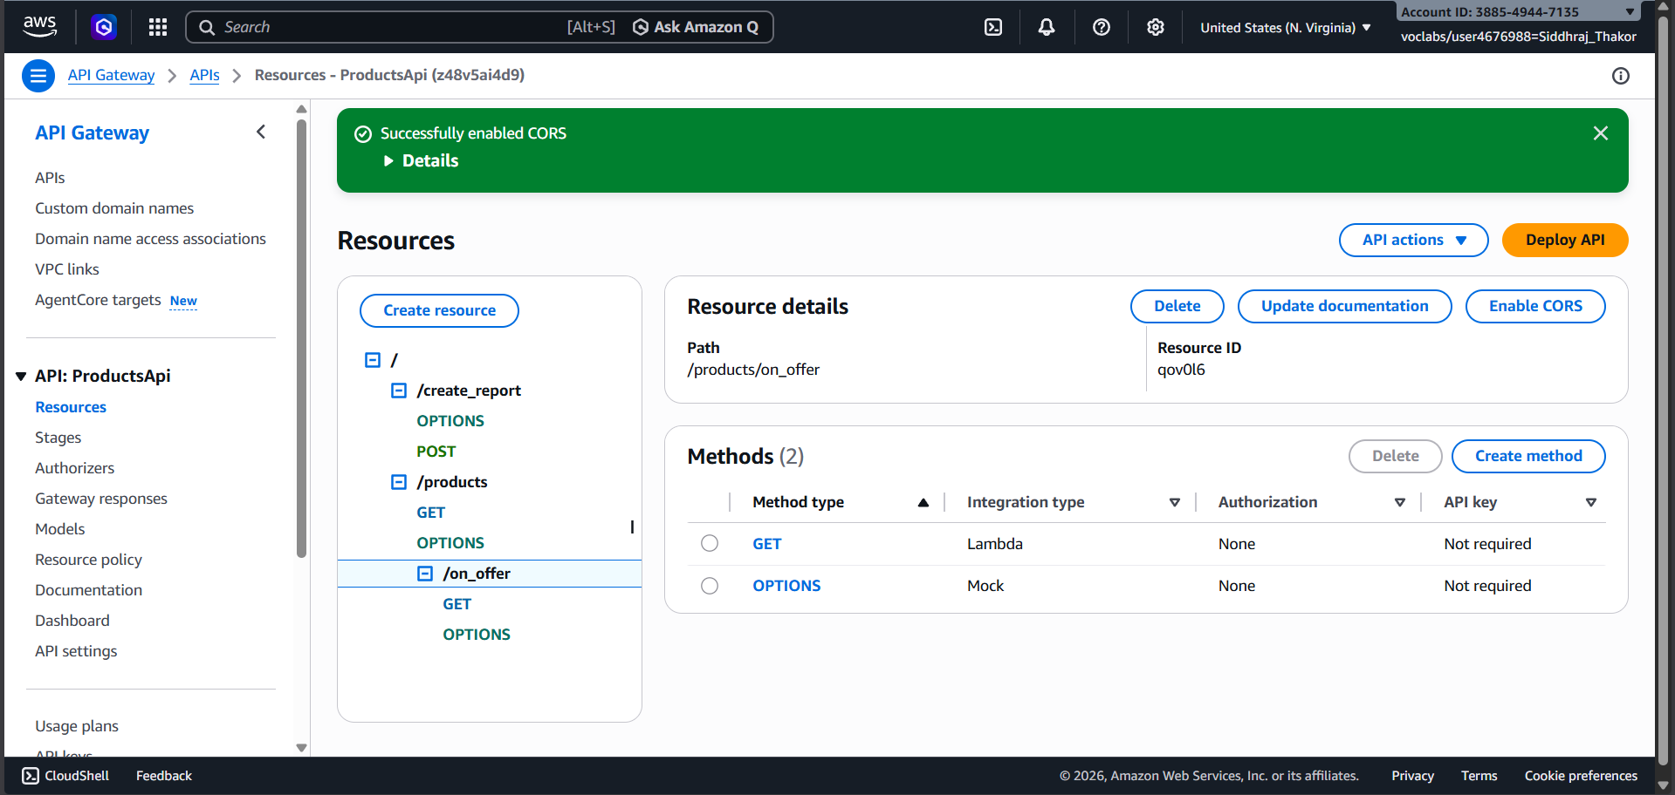
Figure 22: Testing Lambda with Products event -- DynamoDB table scan results returned

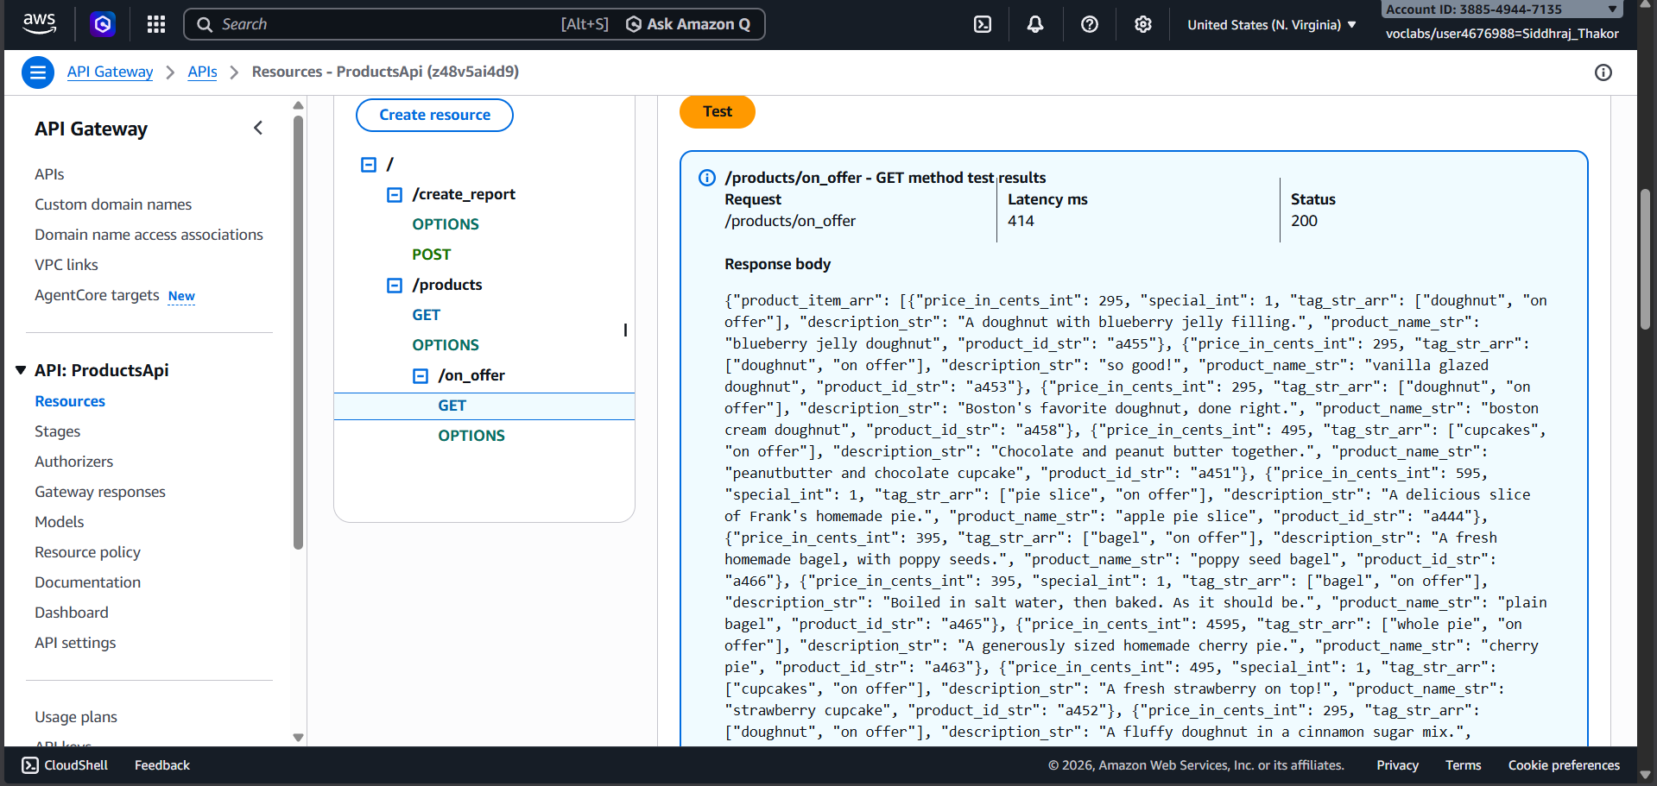
Figure 23: Creating onOffer test event with path on_offer -- only on-offer items returned

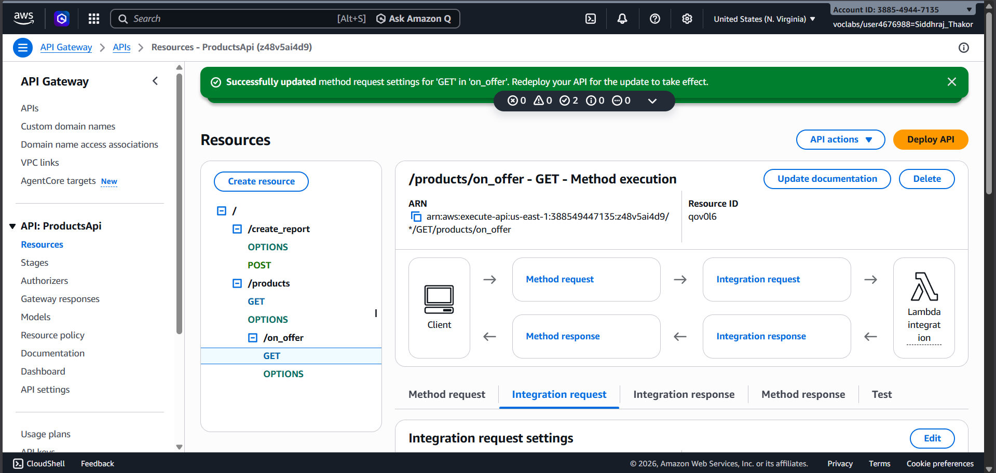
Figure 24: API Gateway GET /products -- replacing mock endpoint with get_all_products Lambda

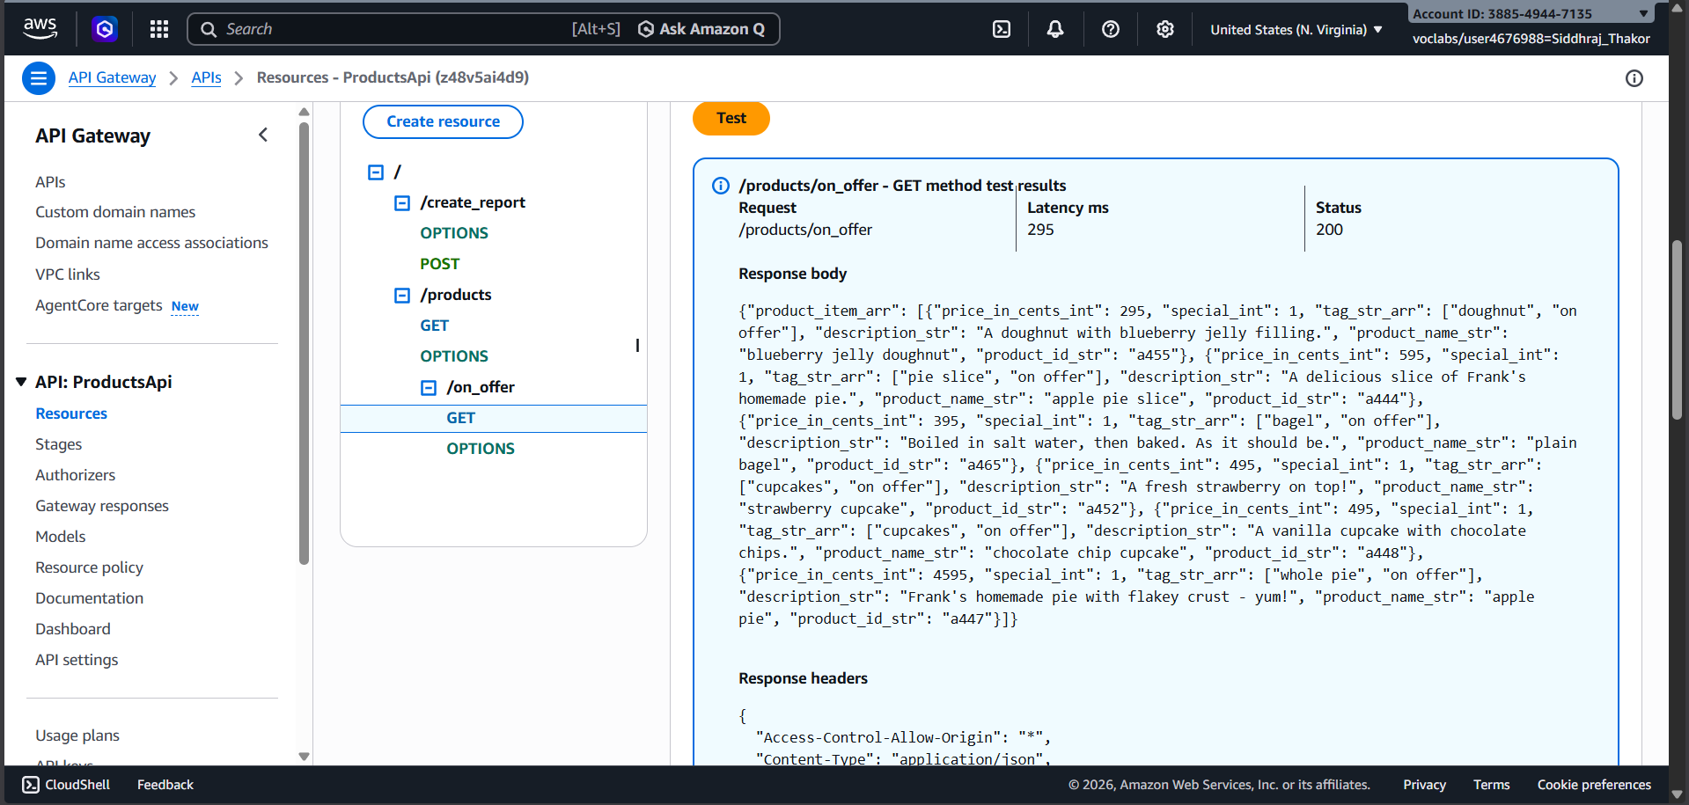
Figure 25: Testing GET /products after Lambda integration -- full product list returned

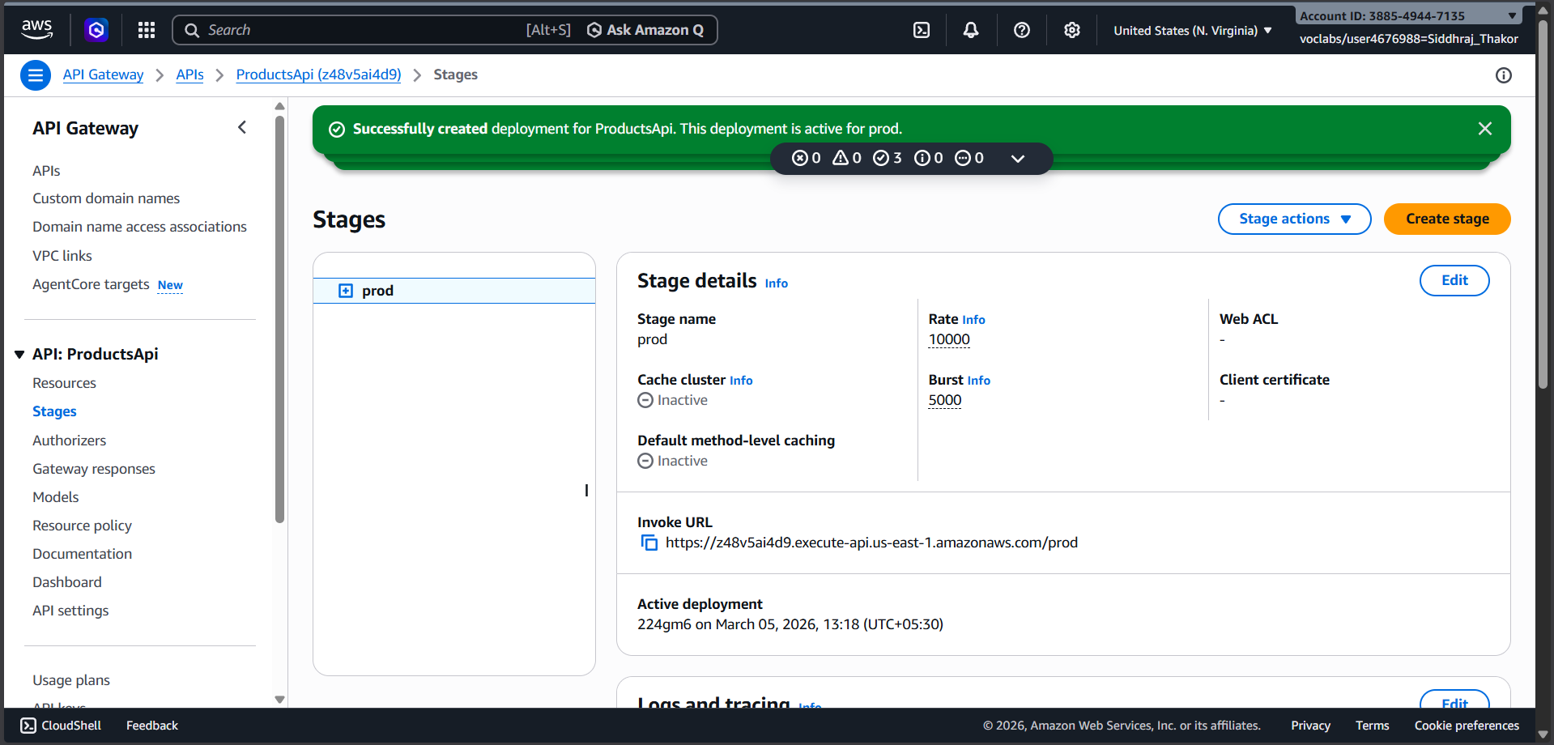
Figure 26: Enabling CORS on /products -- selecting Default 4XX, 5XX and GET method

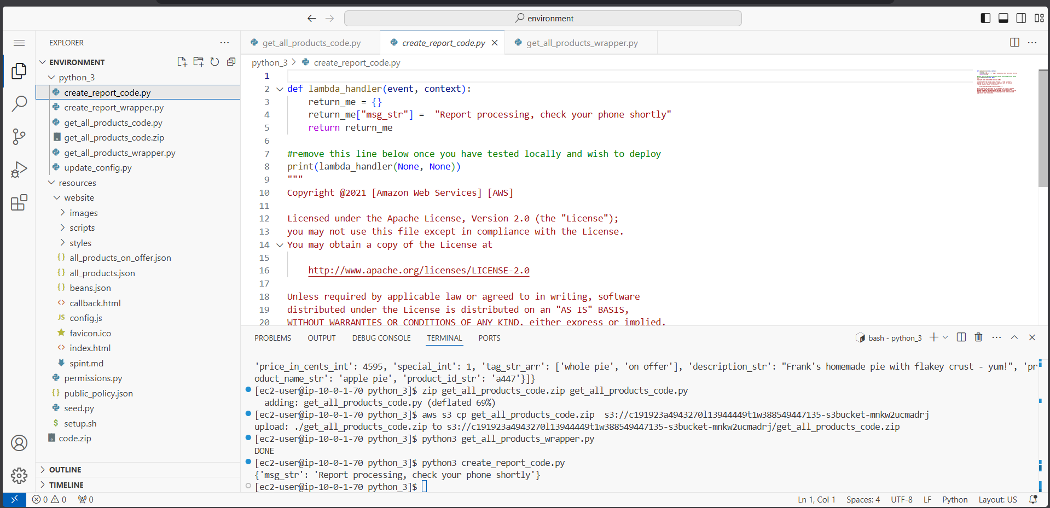
Figure 27: Testing GET /products again -- Access-Control-Allow-Origin header now present

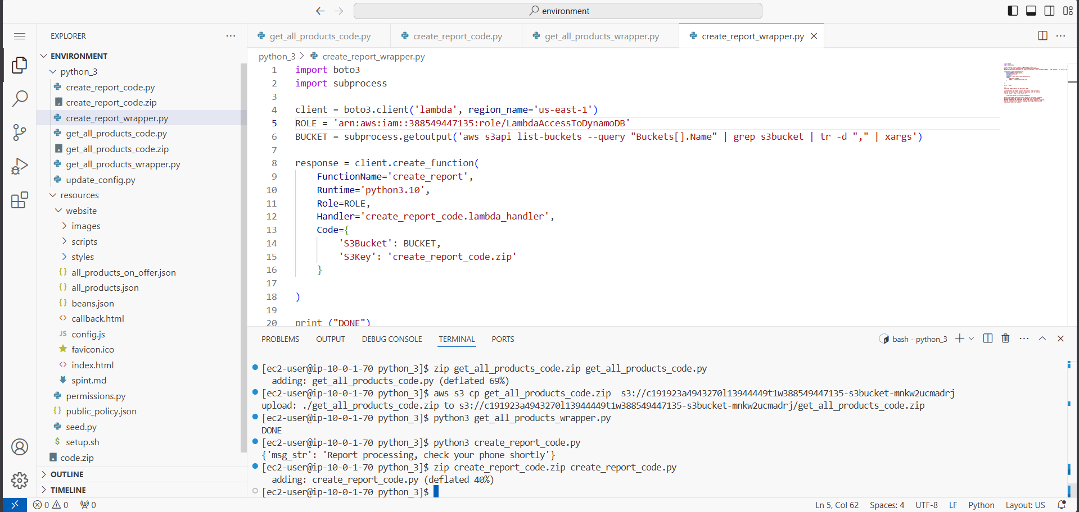
Figure 28: Configuring GET /on_offer Integration Request with get_all_products Lambda

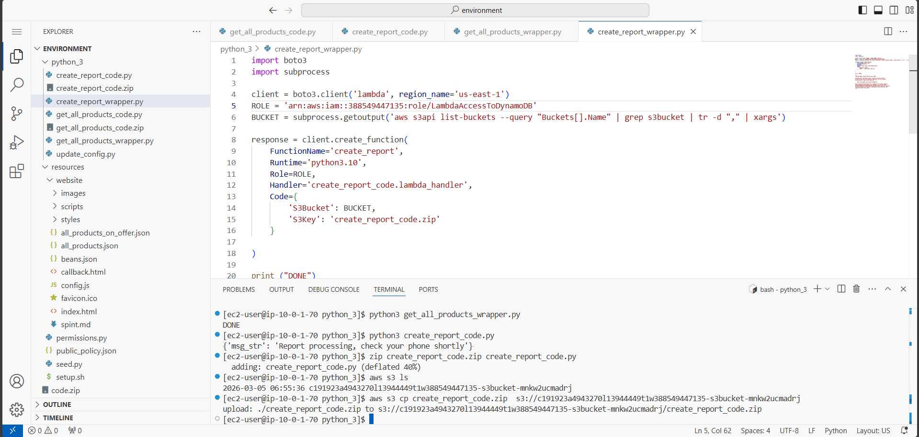
Figure 29: Enabling CORS on /on_offer and verifying CORS headers in response

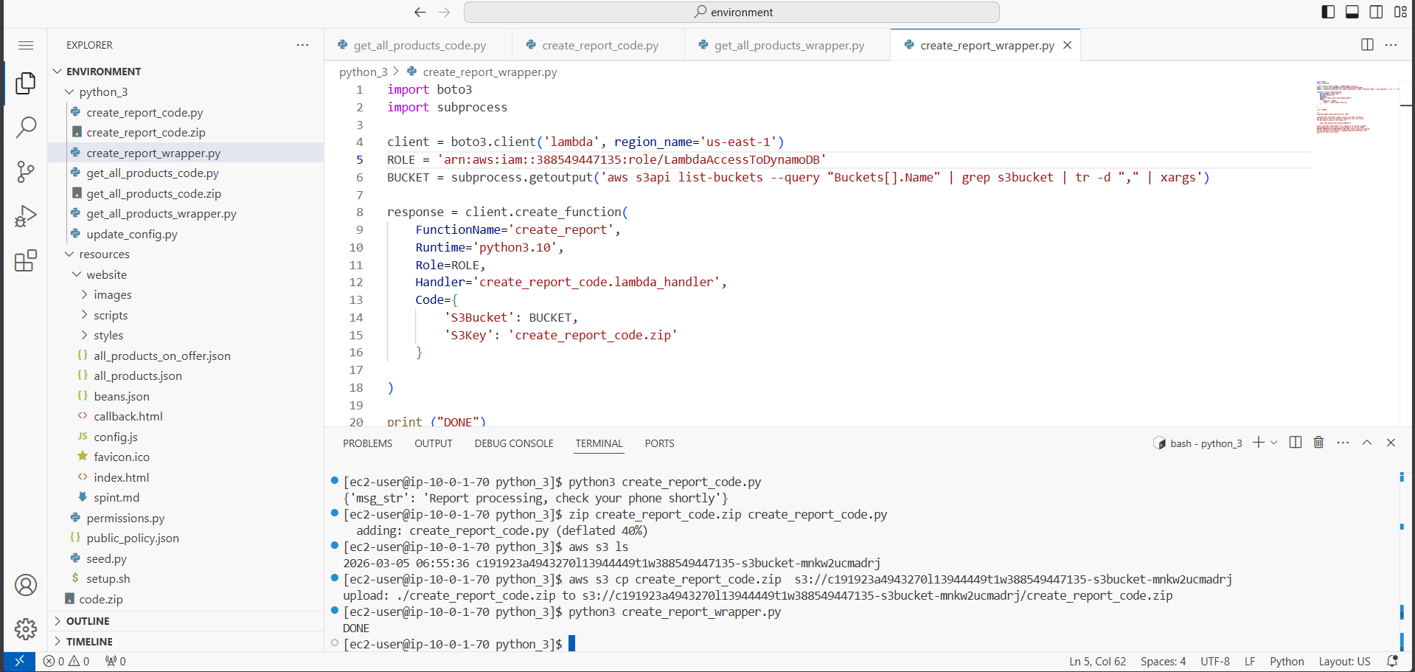
Figure 30: Adding mapping template to /on_offer -- passing context.resourcePath as path

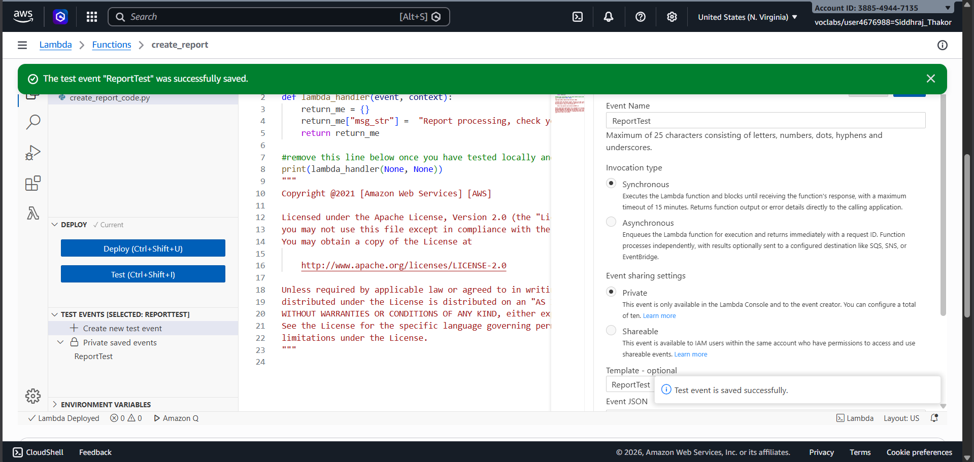
Figure 31: Testing GET /on_offer after mapping template -- only six on-offer items returned

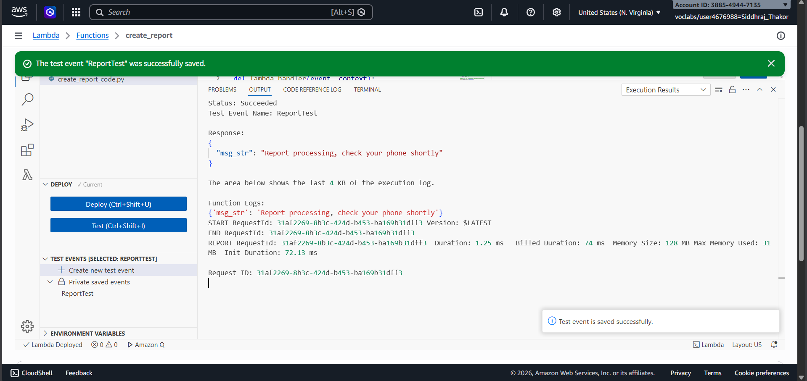
Figure 32: Deploying ProductsApi to prod stage after configuring all GET endpoints

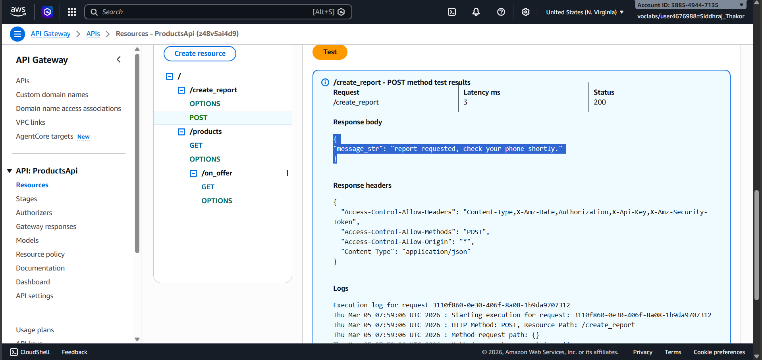
Figure 33: Testing create_report_code.py locally -- Report processing message with capital R

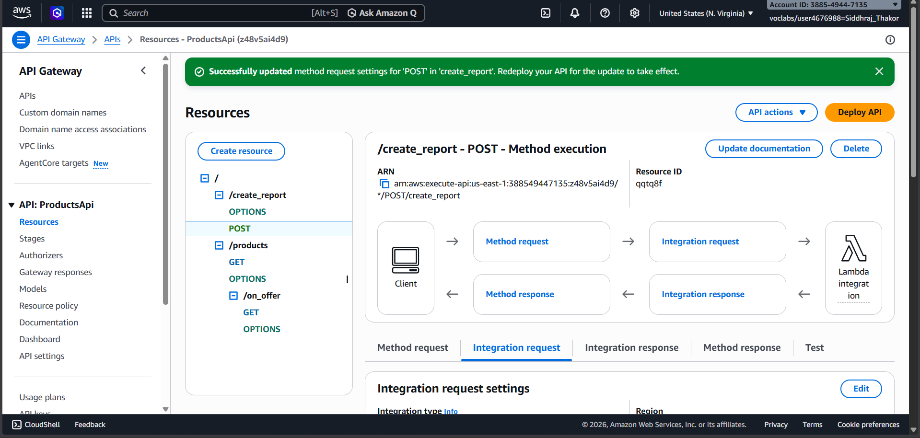
Figure 34: Editing create_report_wrapper.py with IAM Role ARN and packaging create_report_code.zip

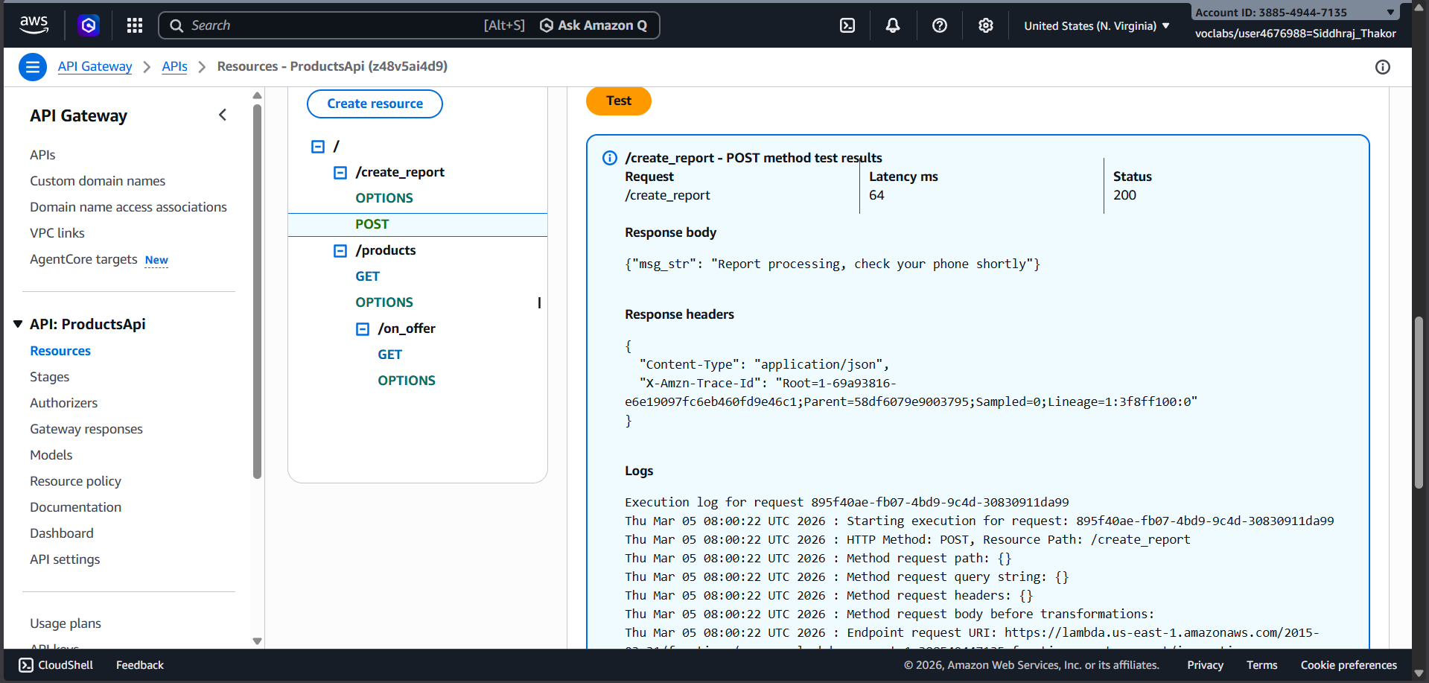
Figure 35: Running create_report_wrapper.py -- DONE confirming create_report Lambda created

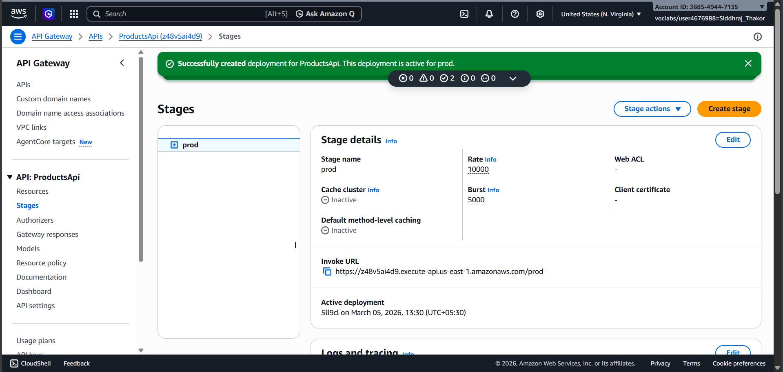
Figure 36: Testing create_report Lambda with ReportTest event -- confirmation message returned

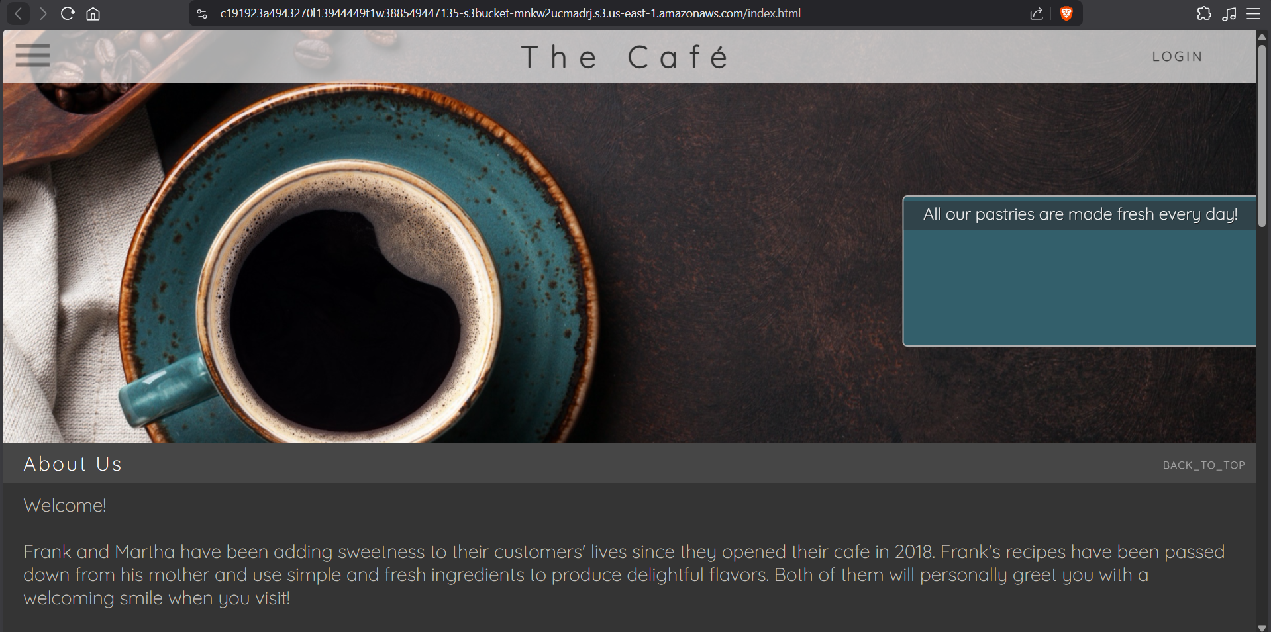
Figure 37: API Gateway POST /create_report -- replacing mock endpoint with create_report Lambda

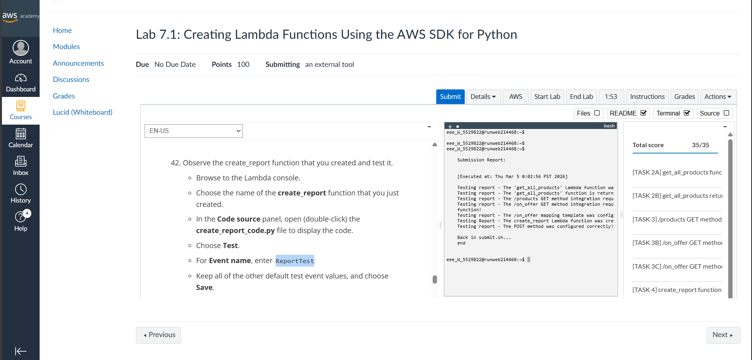
Figure 38: Testing POST /create_report -- capitalized R confirms Lambda (not mock) is responding

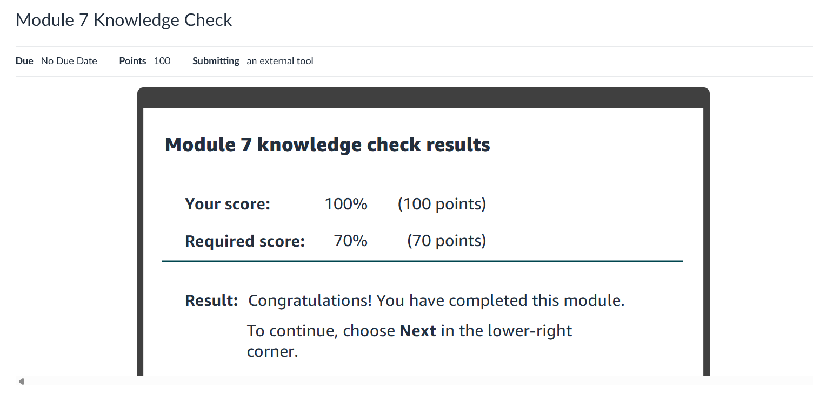
Figure 39: Cafe website -- Browse Pastries showing on-offer items, view all loads full menu

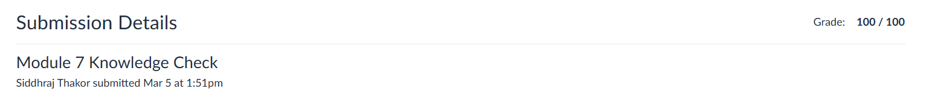
Figure 40: Lab submission result -- full score confirming all tasks completed successfully

