PRACTICAL: 8.1
Migrating a Web Application to Docker Containers

Student Name | 23AIML070
Branch / Programme | B.Tech – Artificial Intelligence & Machine Learning
Subject | Cloud Computing Lab
Lab Module | Module 8 – Containerization with Docker & AWS ECR

Objective
To migrate a web application and its MySQL database to run as Docker containers on AWS infrastructure. This lab covers creating Dockerfiles, building Docker images, running and managing containers, resolving environment variable-based database connectivity, and pushing images to Amazon Elastic Container Registry (Amazon ECR).

Theory

Docker and Containerization
Docker is an open-source platform that enables developers to build, ship, and run applications inside lightweight, portable containers. A container is an isolated execution environment that packages an application along with all its dependencies, libraries, and configuration files. Unlike virtual machines, containers share the host OS kernel and consume far fewer resources, making them efficient for both development and production environments.
A Dockerfile is a text file that contains a set of instructions for Docker to build an image. An image acts as a template from which one or more containers can be instantiated. Key Dockerfile instructions include FROM (specifying the base image), RUN (executing commands during build), COPY (copying files into the image), EXPOSE (declaring network ports), and CMD (defining the default startup command). Images are built layer-by-layer, and each instruction in the Dockerfile creates a new read-only layer, enabling efficient caching and re-use.

Environment Variables and Container Networking
Containers are isolated by default, so configuring how they communicate with external services is essential. Environment variables (passed using the -e flag with docker run) allow runtime configuration without modifying the application code or image. In this lab, the APP_DB_HOST variable is used to dynamically specify the MySQL database host, allowing the same image to point to either an EC2-hosted database or a containerized one without rebuilding.
When multiple containers run on the same Docker host, Docker assigns each container a private IP address on an internal bridge network. Containers can communicate with each other using these internal IPs. The docker inspect command is used to retrieve a container's IP address, which can then be passed to another container as an environment variable.

Amazon Elastic Container Registry (Amazon ECR)
Amazon ECR is a fully managed Docker container registry provided by AWS. It allows developers to store, manage, and deploy Docker container images securely. ECR integrates with IAM for access control, and images stored in ECR can be pulled directly by services such as Amazon ECS, Amazon EKS, and AWS Elastic Beanstalk. In this lab, the node_app Docker image is pushed to an ECR repository so that it is available for future deployments.
The workflow to push an image to ECR involves: (1) authenticating the Docker client using aws ecr get-login-password, (2) creating an ECR repository with aws ecr create-repository, (3) tagging the local image with the ECR repository URI, and (4) pushing the image using docker push. Once uploaded, images can be listed and verified using aws ecr list-images.

Database Migration with mysqldump
To containerize the MySQL database, a SQL dump of the existing database is created using the mysqldump utility. This produces a .sql file containing the DDL (CREATE DATABASE, CREATE TABLE) and DML (INSERT) statements needed to recreate the database schema and seed it with existing data. The dump file is then included in the MySQL Docker image's Dockerfile using a COPY instruction, and imported into the running container using docker exec.

Code
N/A – This lab uses Docker CLI commands and AWS CLI commands executed in the VS Code IDE terminal. No custom application code was written.

Output / Screenshots
The following screenshots document each step of the lab, from environment setup through Docker containerization and ECR image registration.
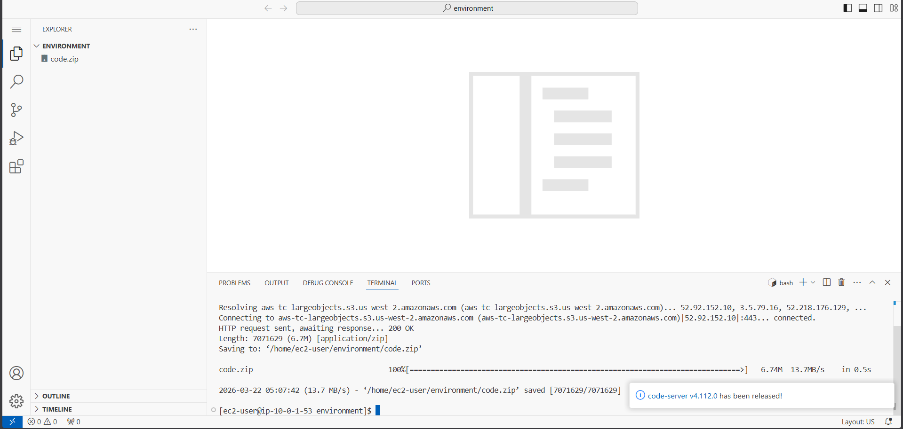
Figure 1: Accessing the VS Code IDE environment using LabIDEURL and LabIDEPassword
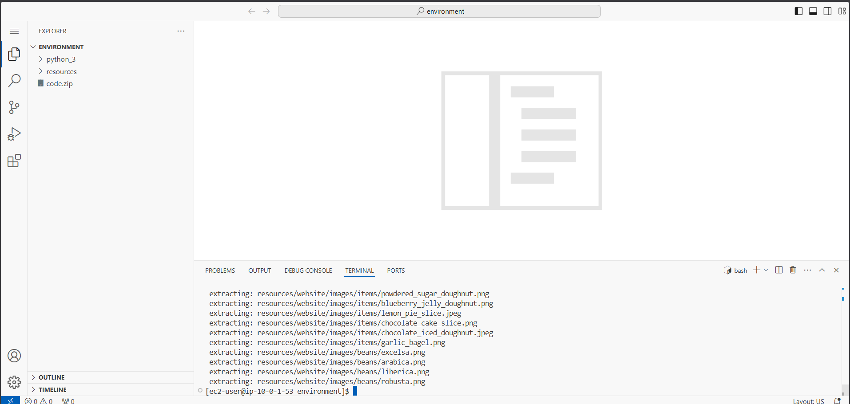
Figure 2: Downloading code.zip using wget in the VS Code IDE terminal
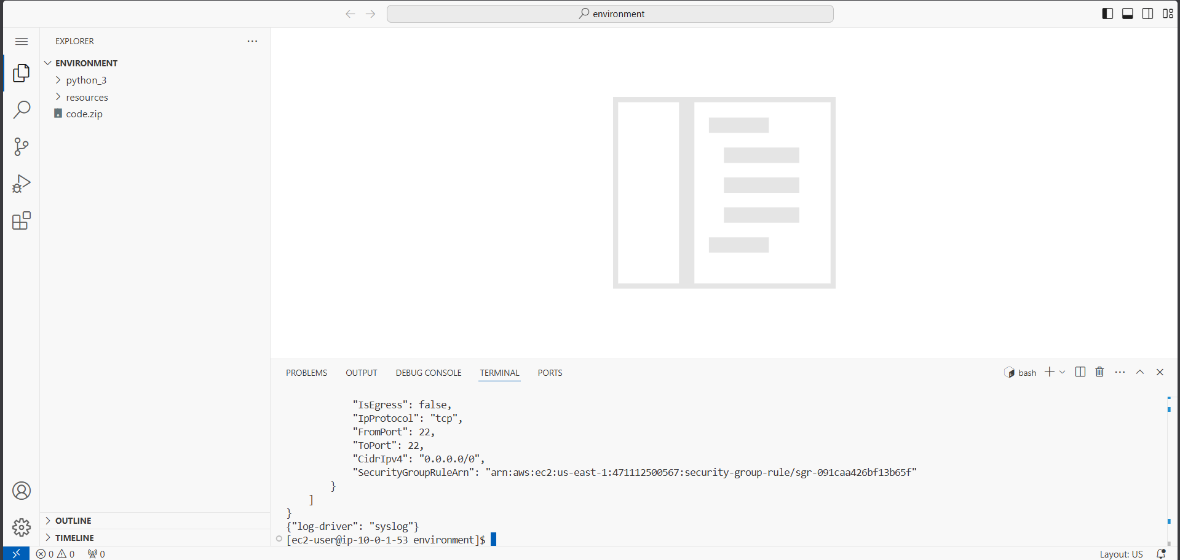
Figure 3: Extracting code.zip and running setup.sh script to configure the environment
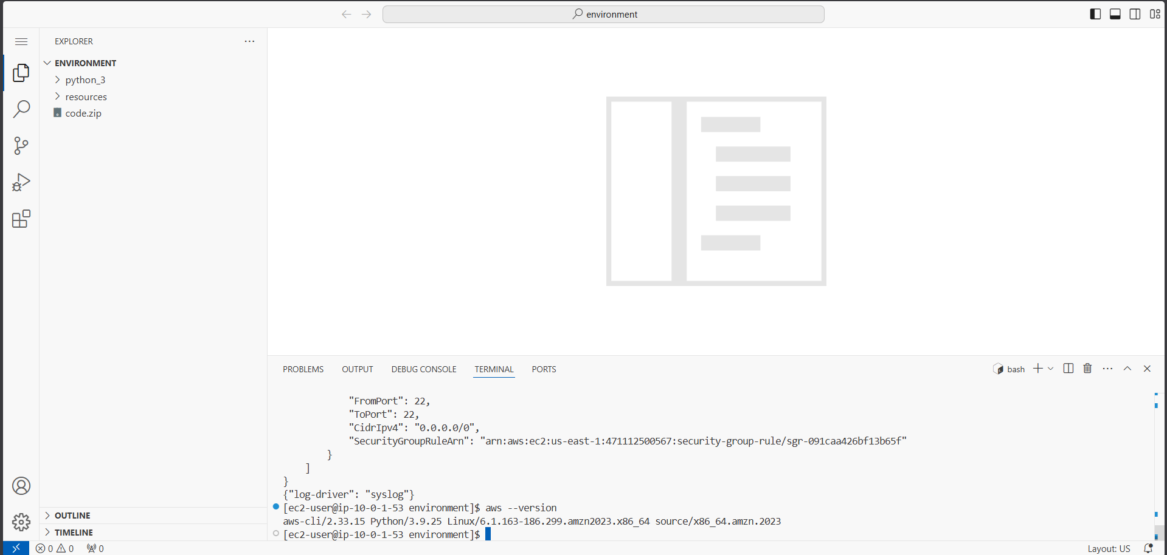
Figure 4: Verifying AWS CLI version 2 installation in the VS Code IDE terminal
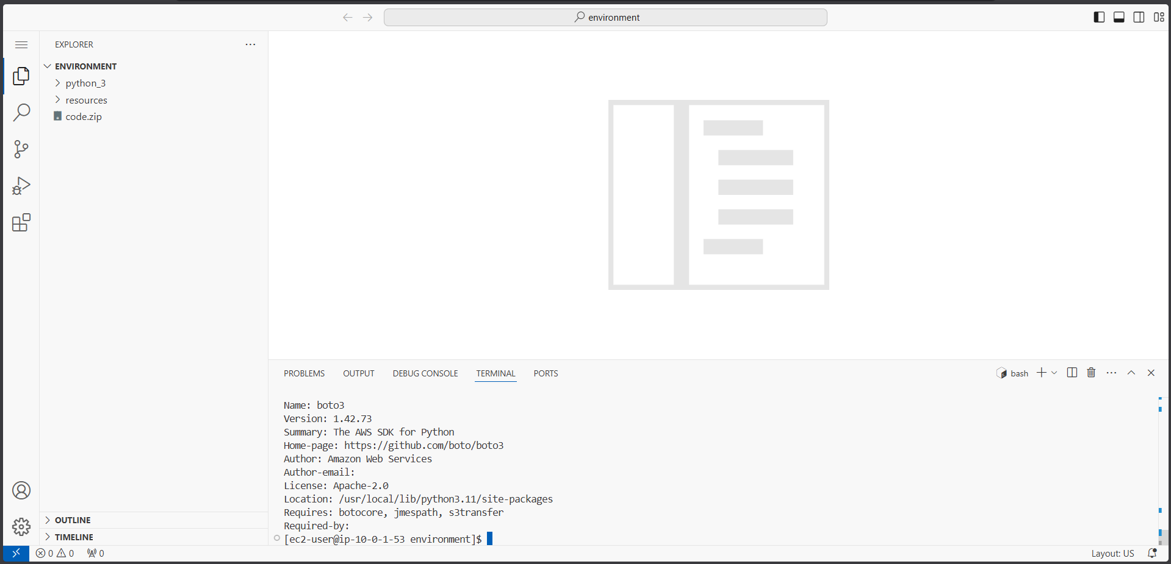
Figure 5: Verifying boto3 (AWS SDK for Python) installation using pip3
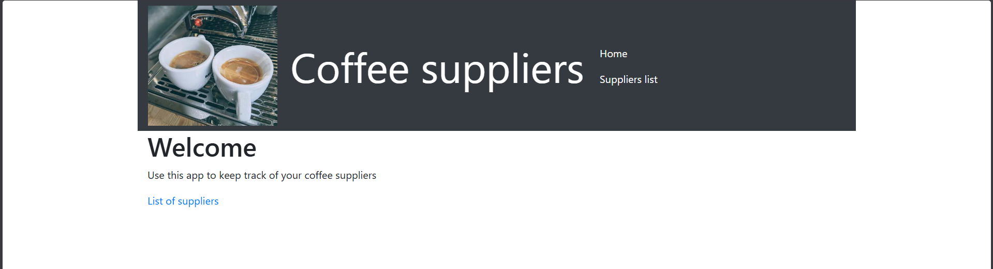
Figure 6: EC2 console showing three running instances: Lab IDE, MysqlServerNode, and AppServerNode
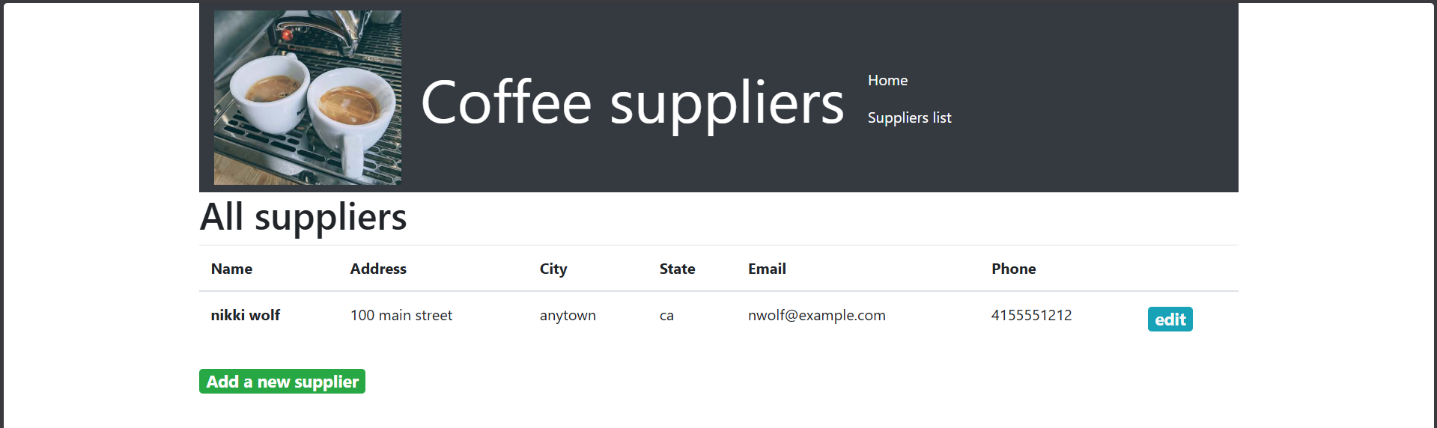
Figure 7: Coffee suppliers web application running on AppServerNode EC2 instance
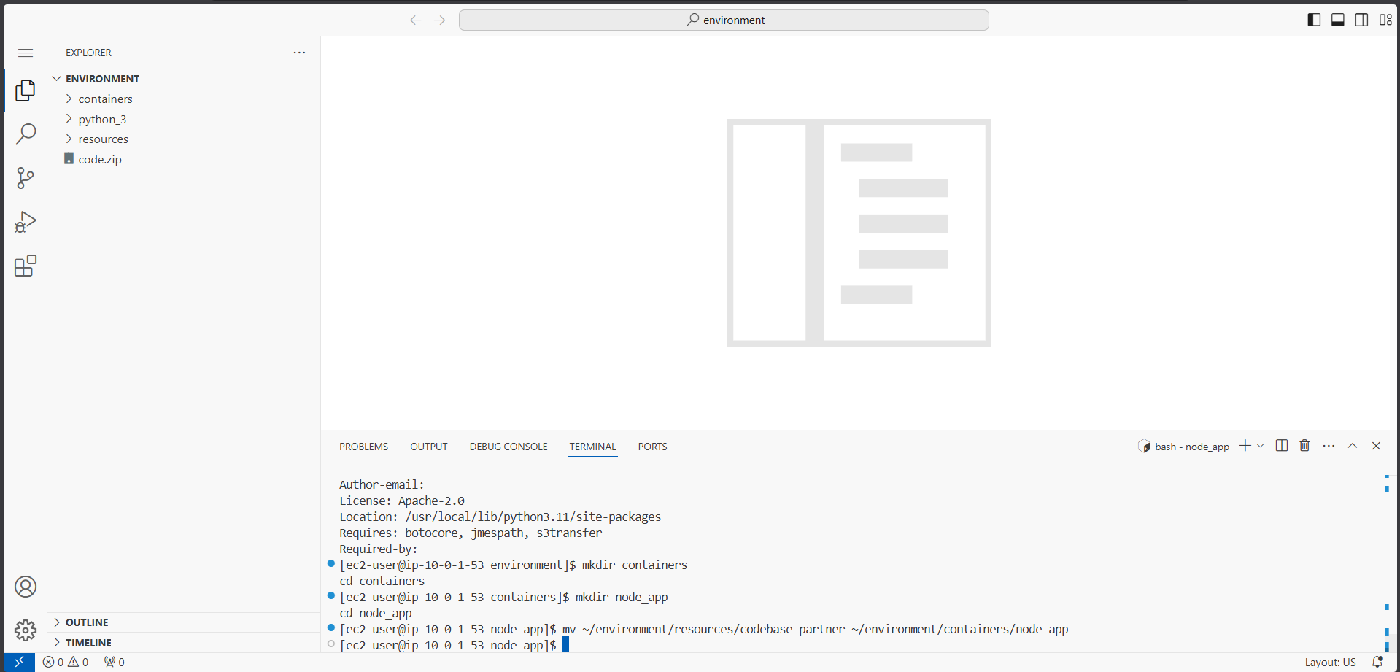
Figure 8: Adding a new supplier record using the web application interface
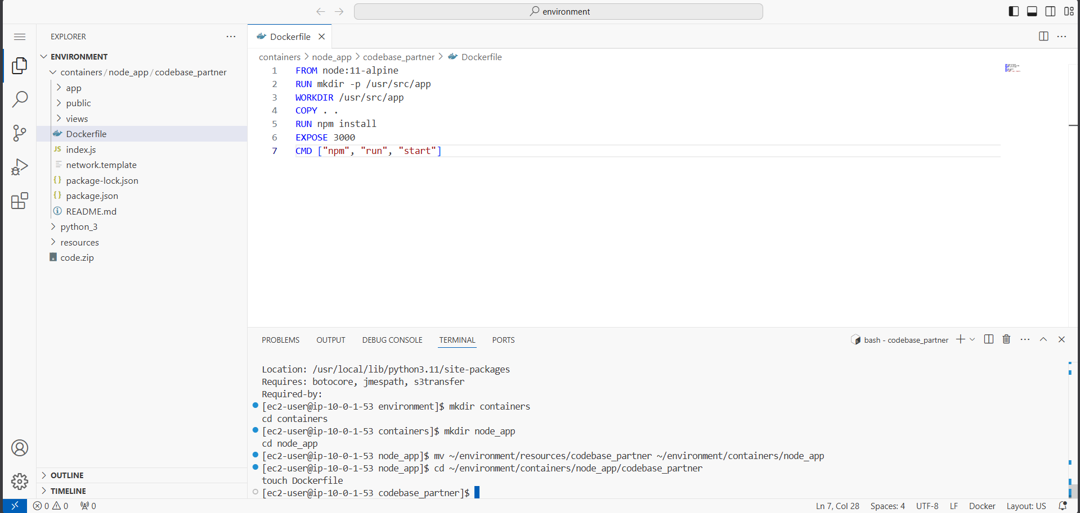
Figure 9: Supplier record successfully submitted and visible in the All Suppliers page
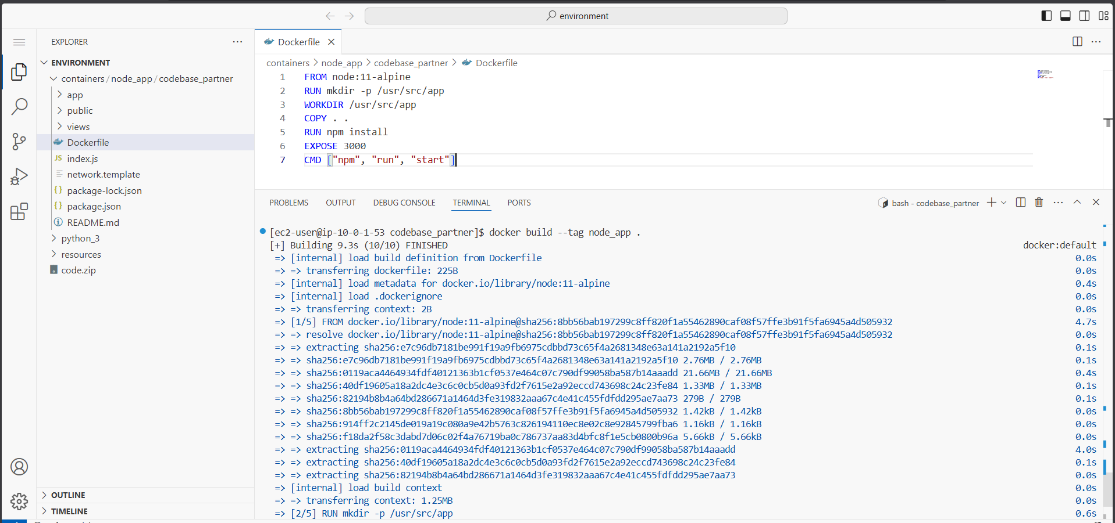
Figure 10: Exploring application codebase in VS Code IDE – codebase_partner directory
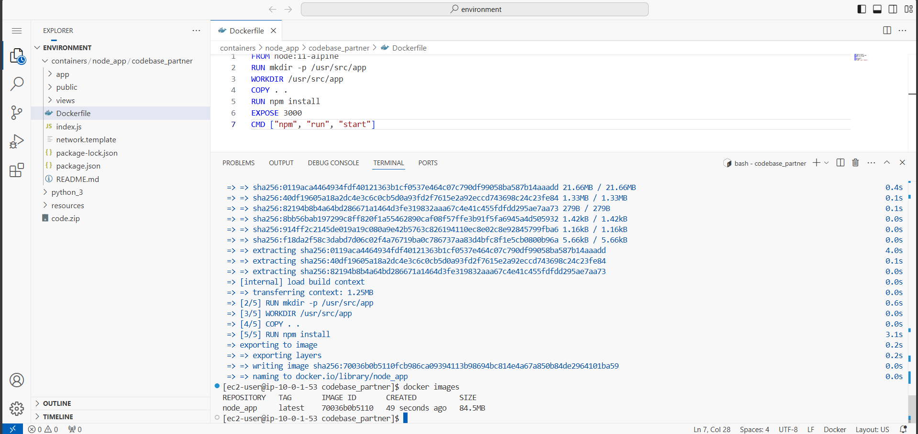
Figure 11: Creating containers directory and node_app subdirectory structure
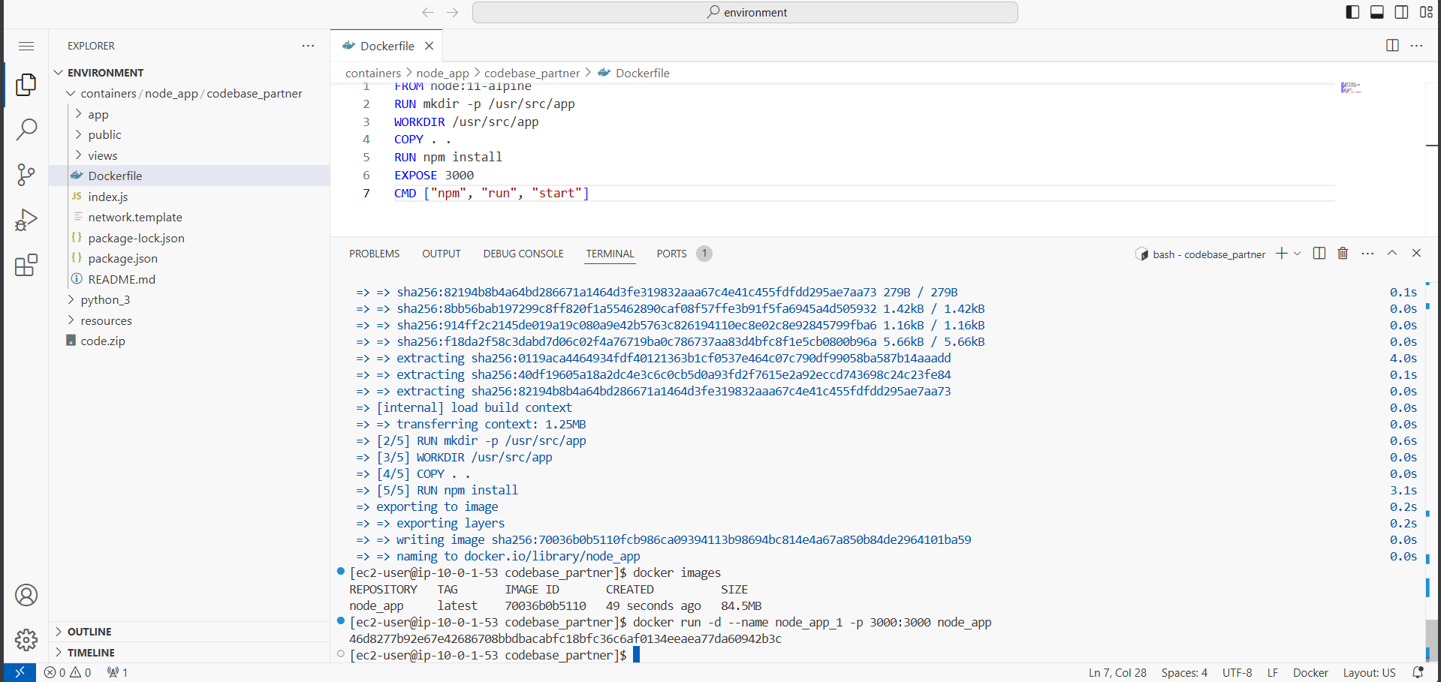
Figure 12: Creating and editing the Dockerfile in node_app/codebase_partner directory
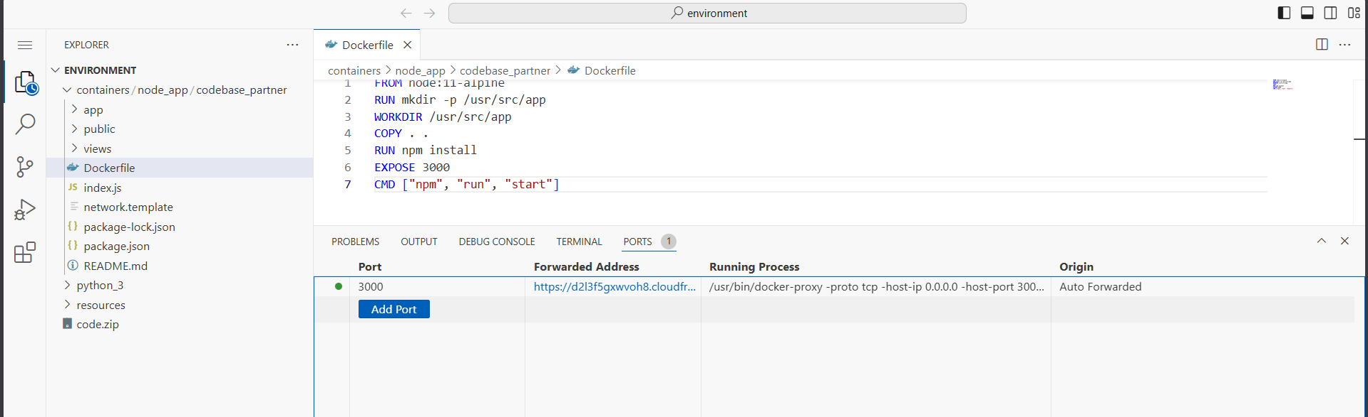
Figure 13: Dockerfile content – specifying node:11-alpine base image, port 3000, and start command
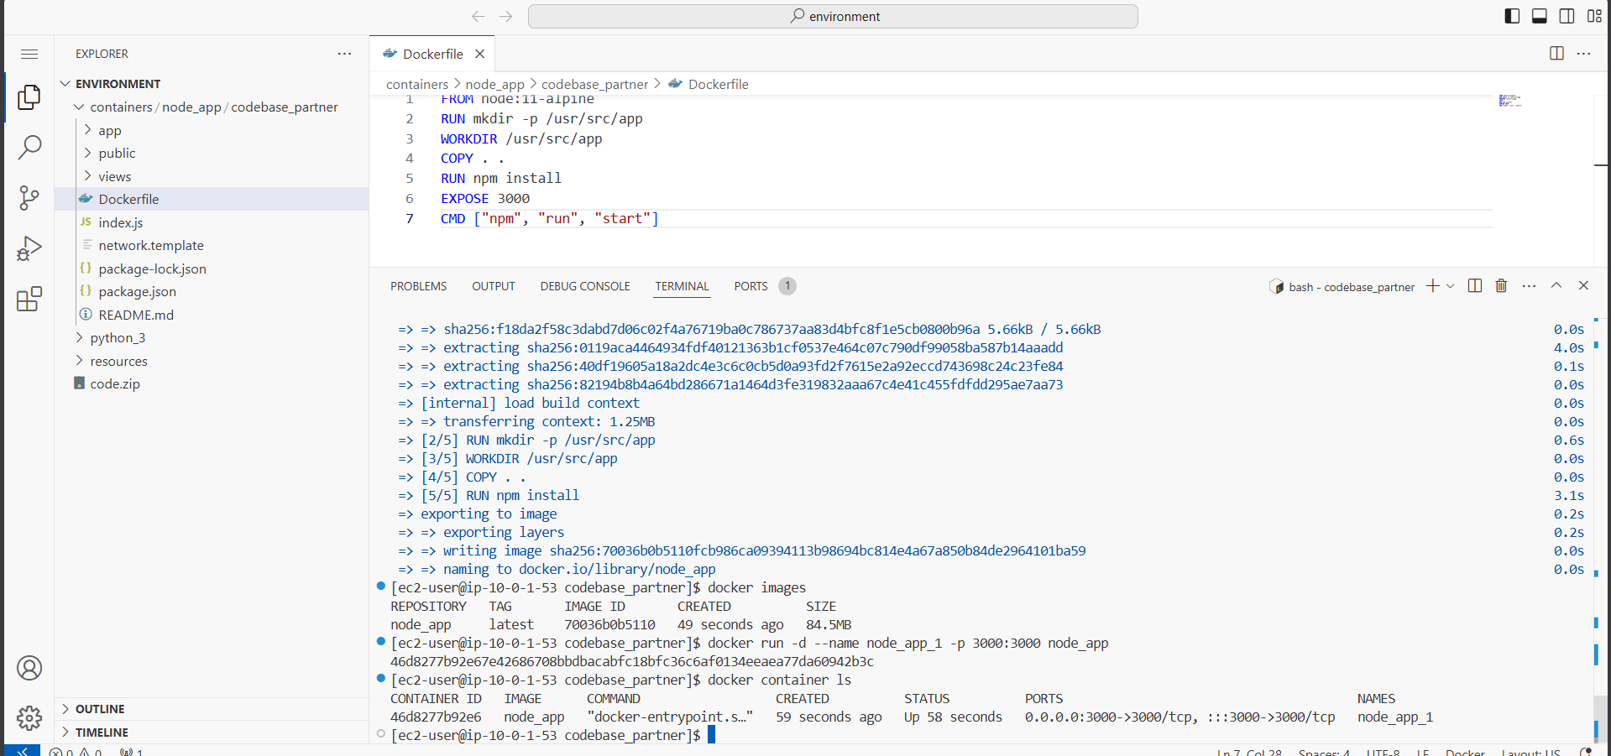
Figure 14: Building the Docker image using 'docker build --tag node_app .'
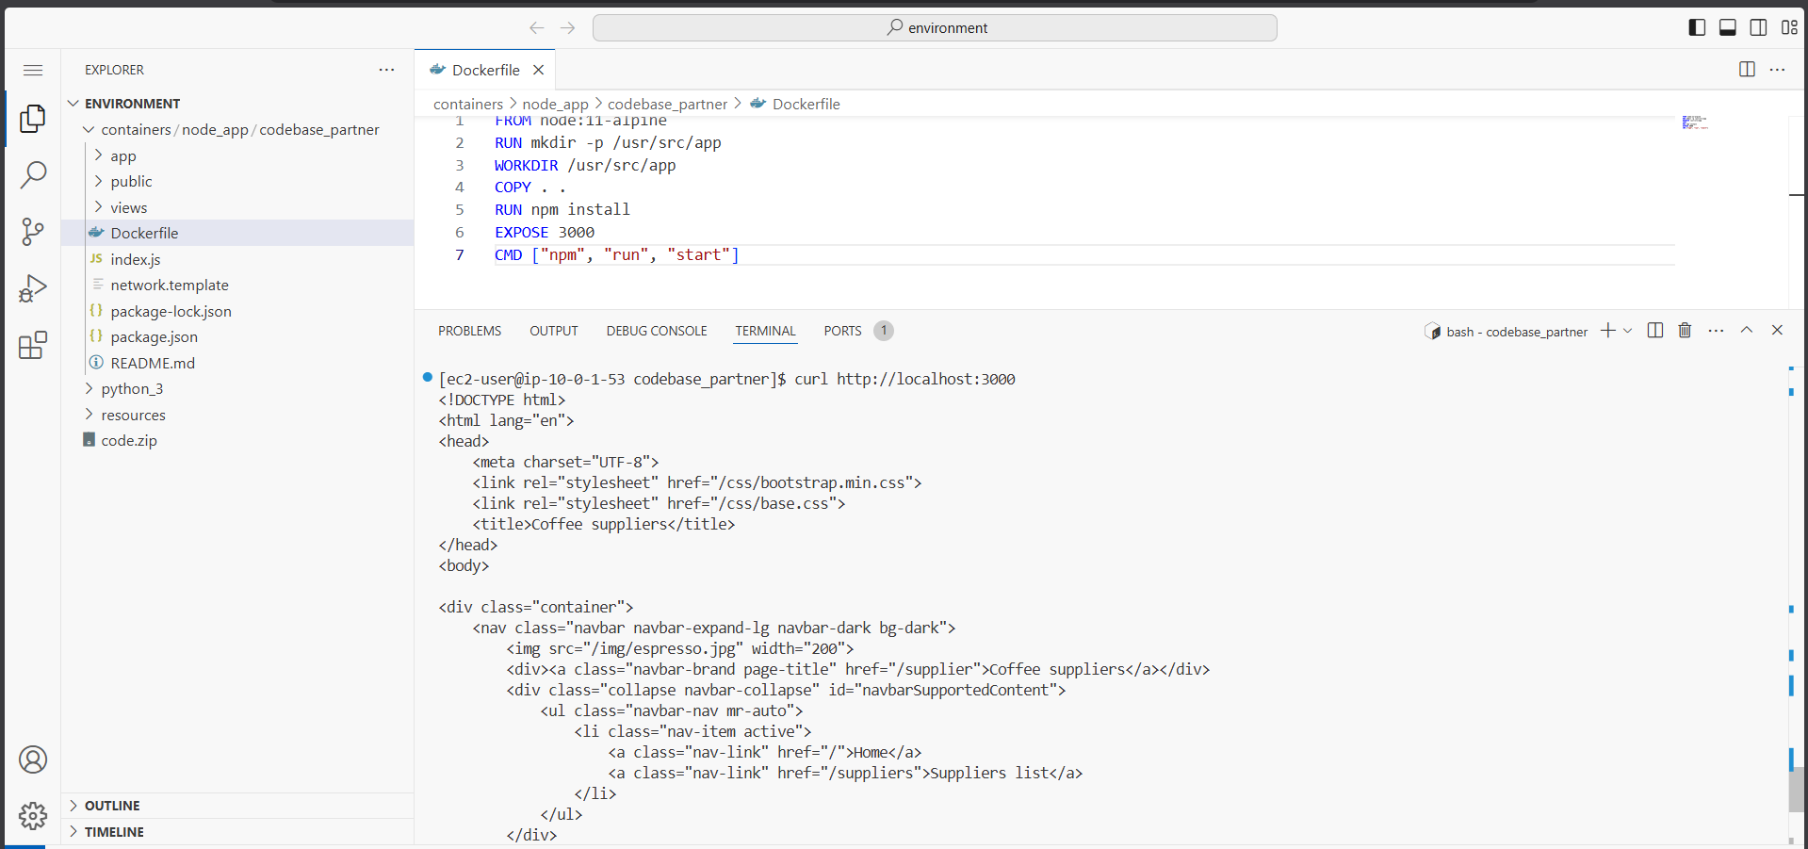
Figure 15: Docker build output – successfully built and tagged node_app:latest
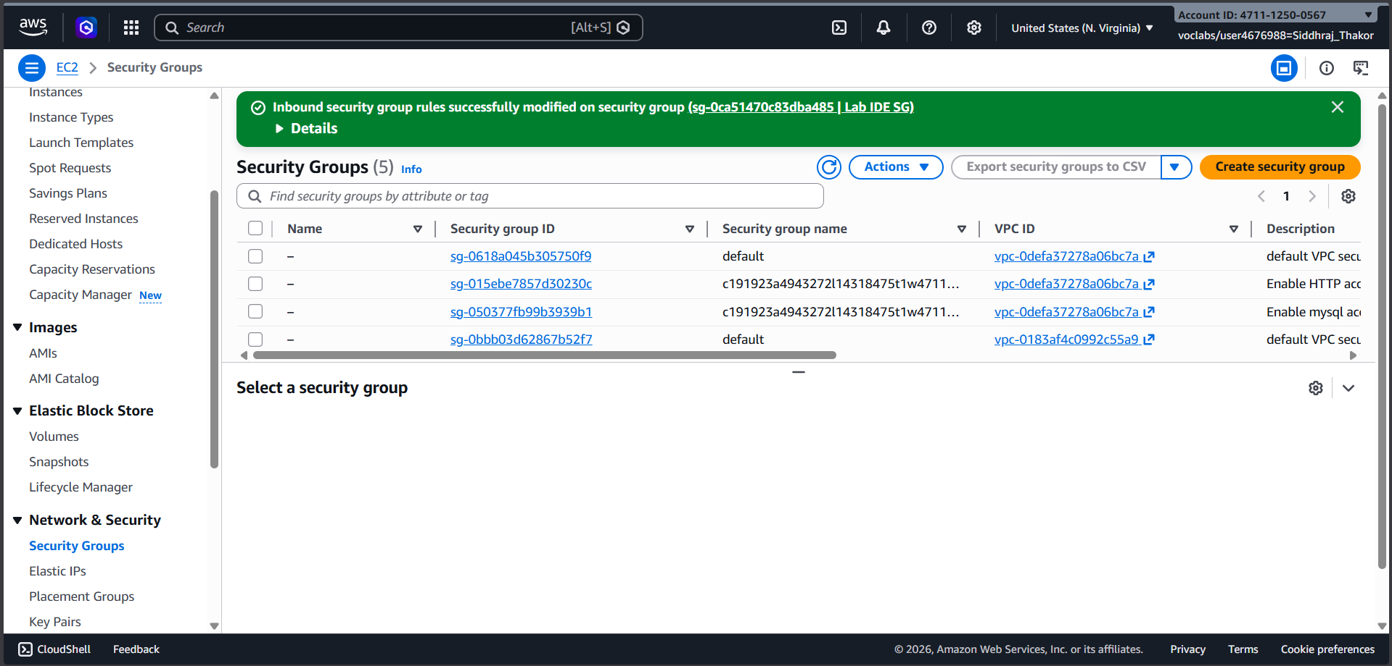
Figure 16: Verifying Docker image creation using 'docker images' command
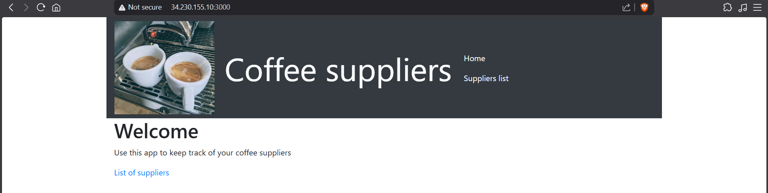
Figure 17: Running the Docker container with 'docker run -d --name node_app_1 -p 3000:3000 node_app'
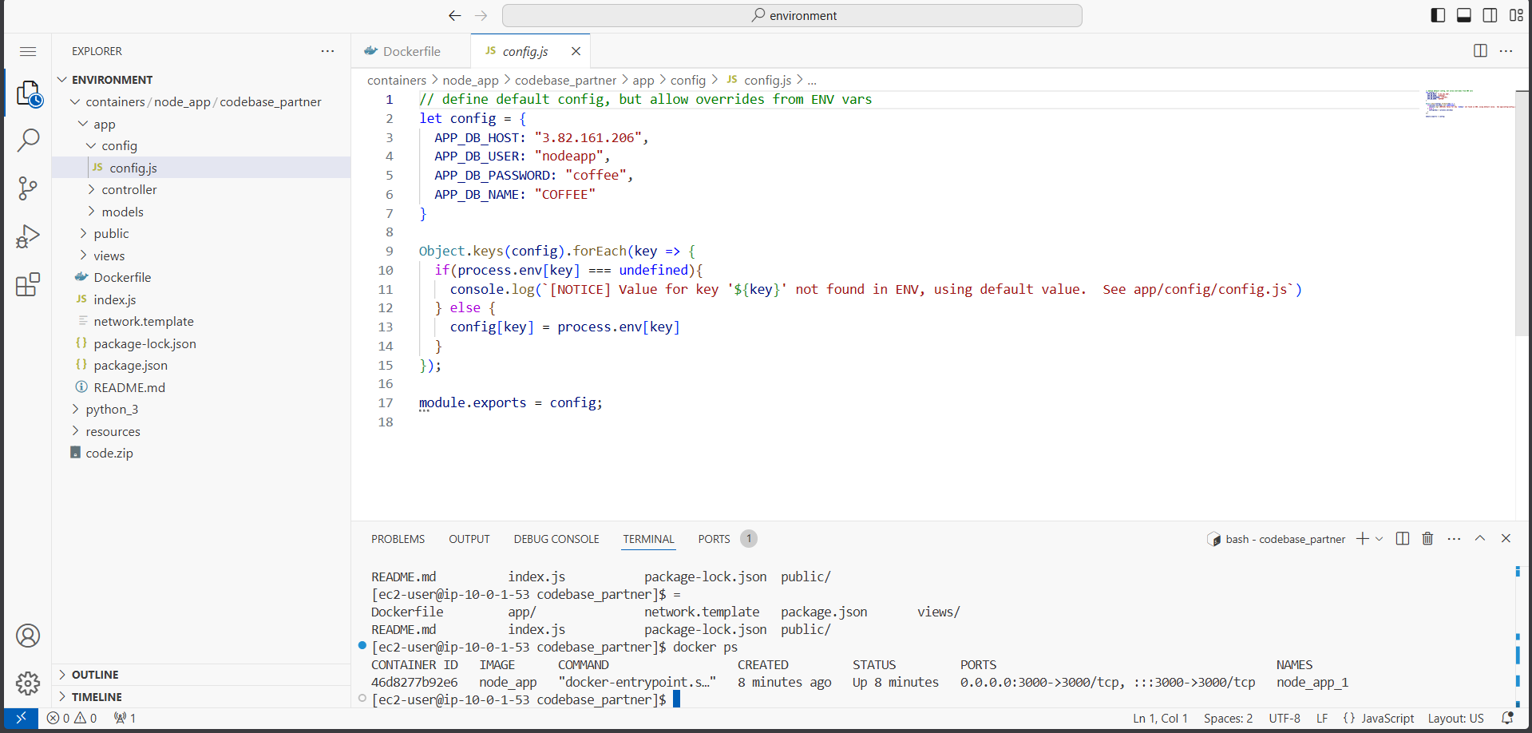
Figure 18: Testing the container with curl http://localhost:3000 – HTML response returned
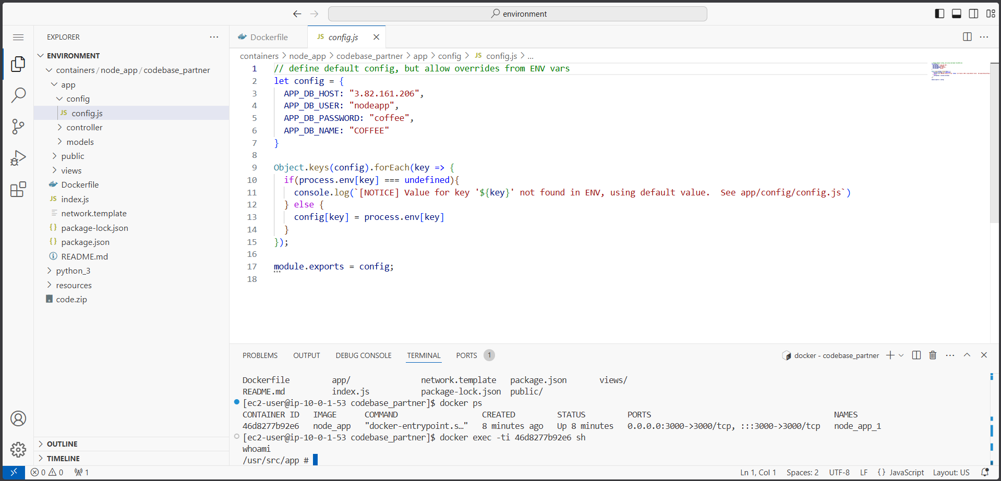
Figure 19: Configuring EC2 security group inbound rule to allow TCP port 3000 from My IP
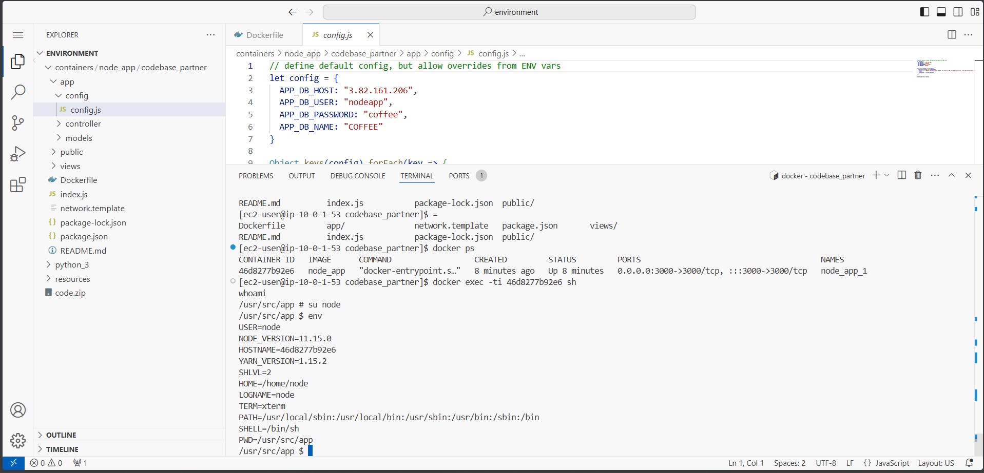
Figure 20: Coffee suppliers web application running from Docker container on VS Code IDE instance
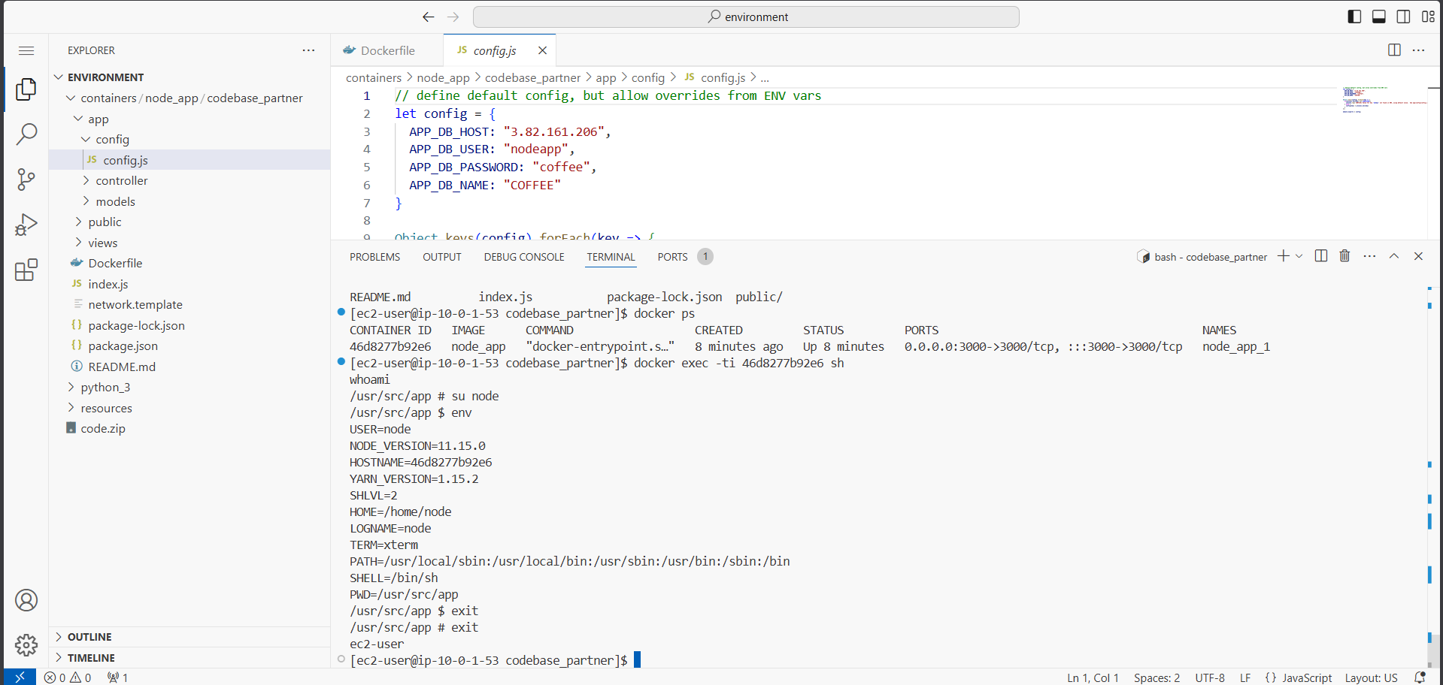
Figure 21: Database connection error – suppliers list fails due to incorrect APP_DB_HOST
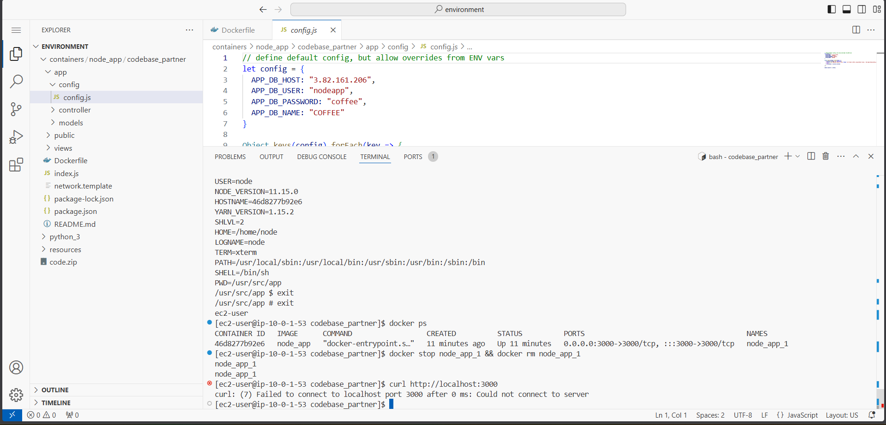
Figure 22: Inspecting config.js – hardcoded APP_DB_HOST and environment variable override logic
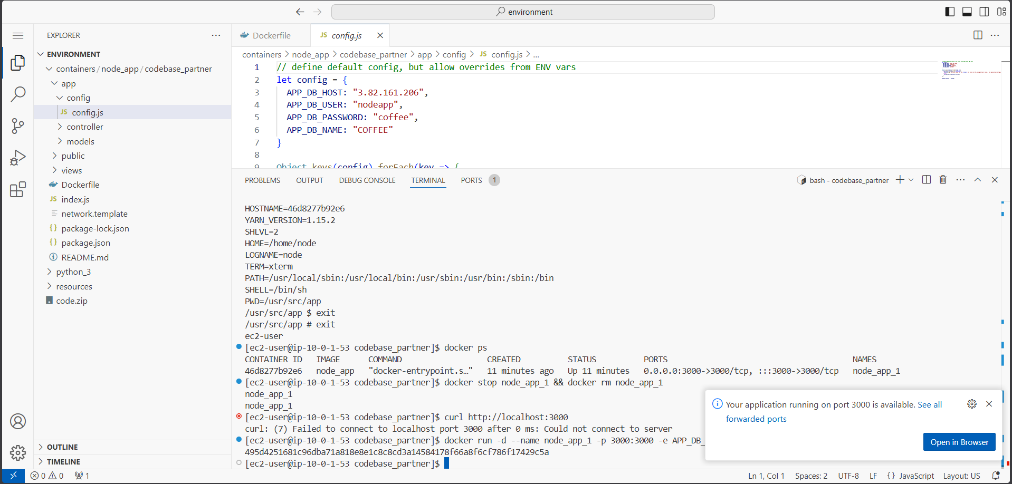
Figure 23: Connecting to the container using docker exec and checking env variables – APP_DB_HOST missing
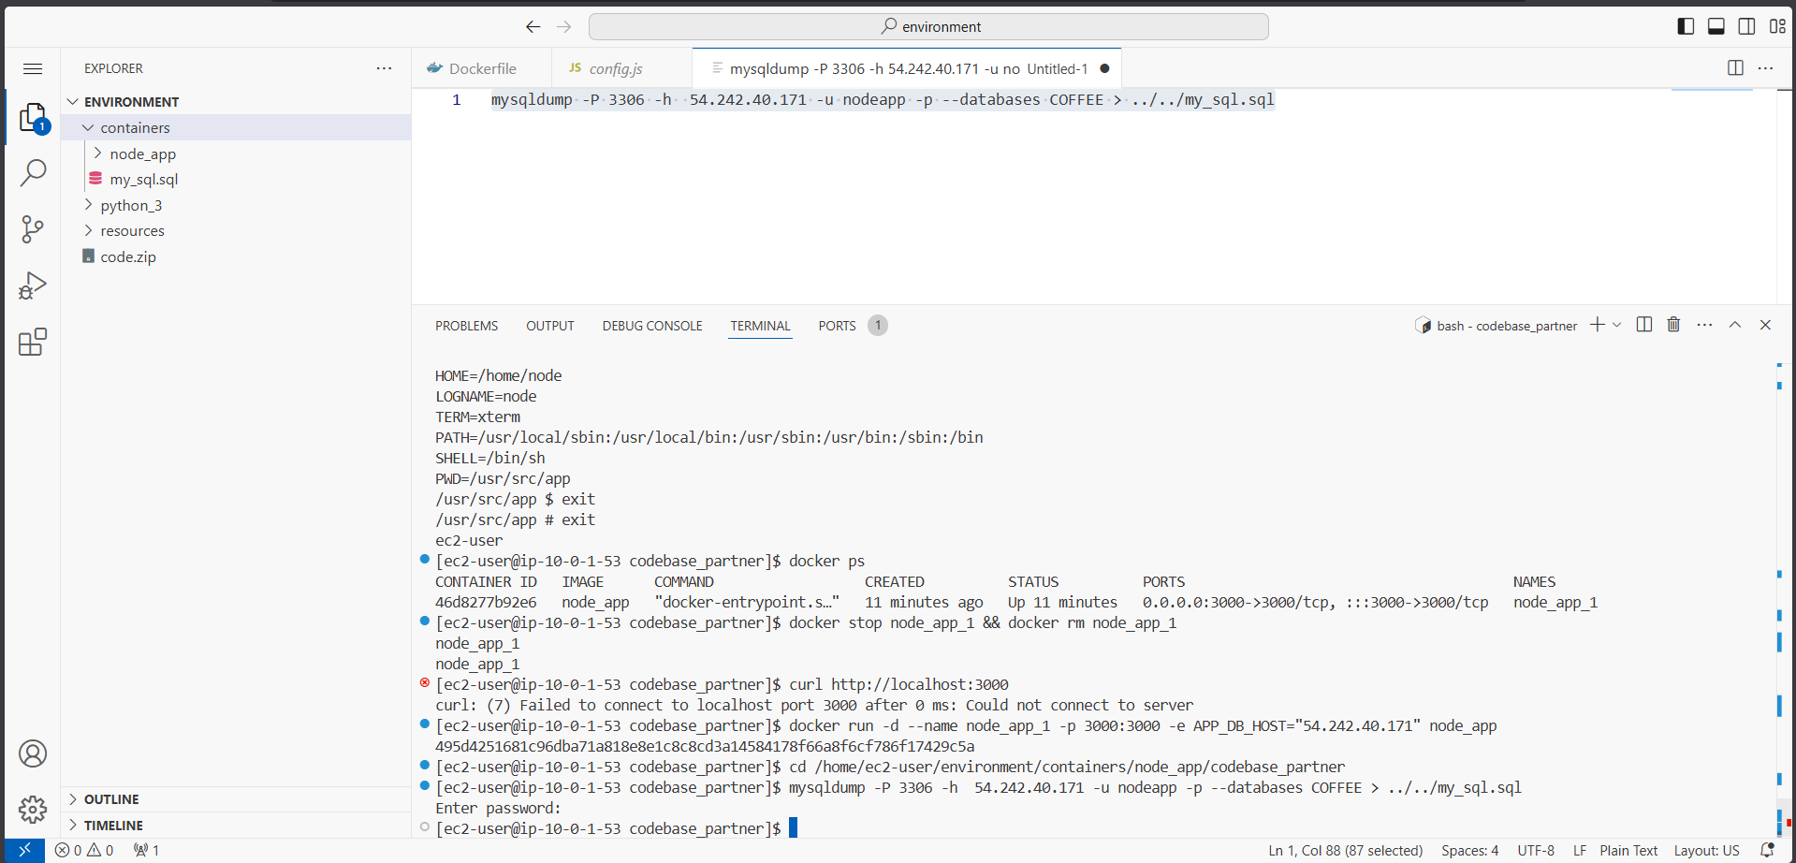
Figure 24: Stopping and removing node_app_1 container with docker stop and docker rm commands
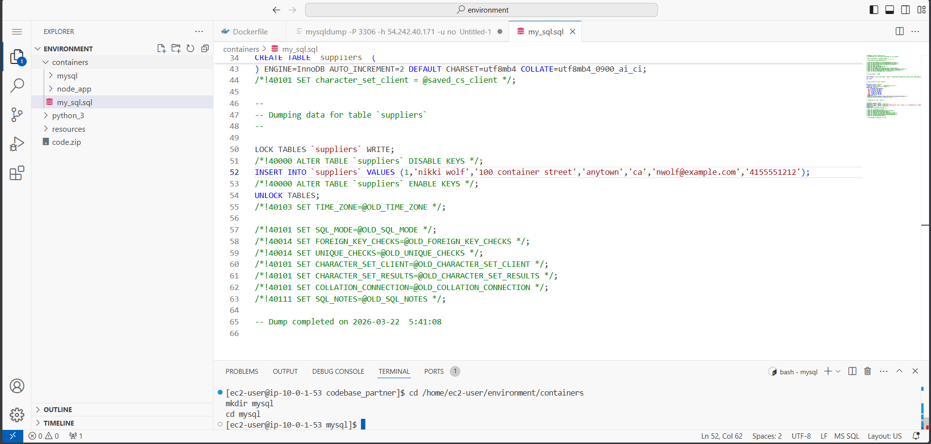
Figure 25: Re-launching container with APP_DB_HOST environment variable pointing to MysqlServerNode
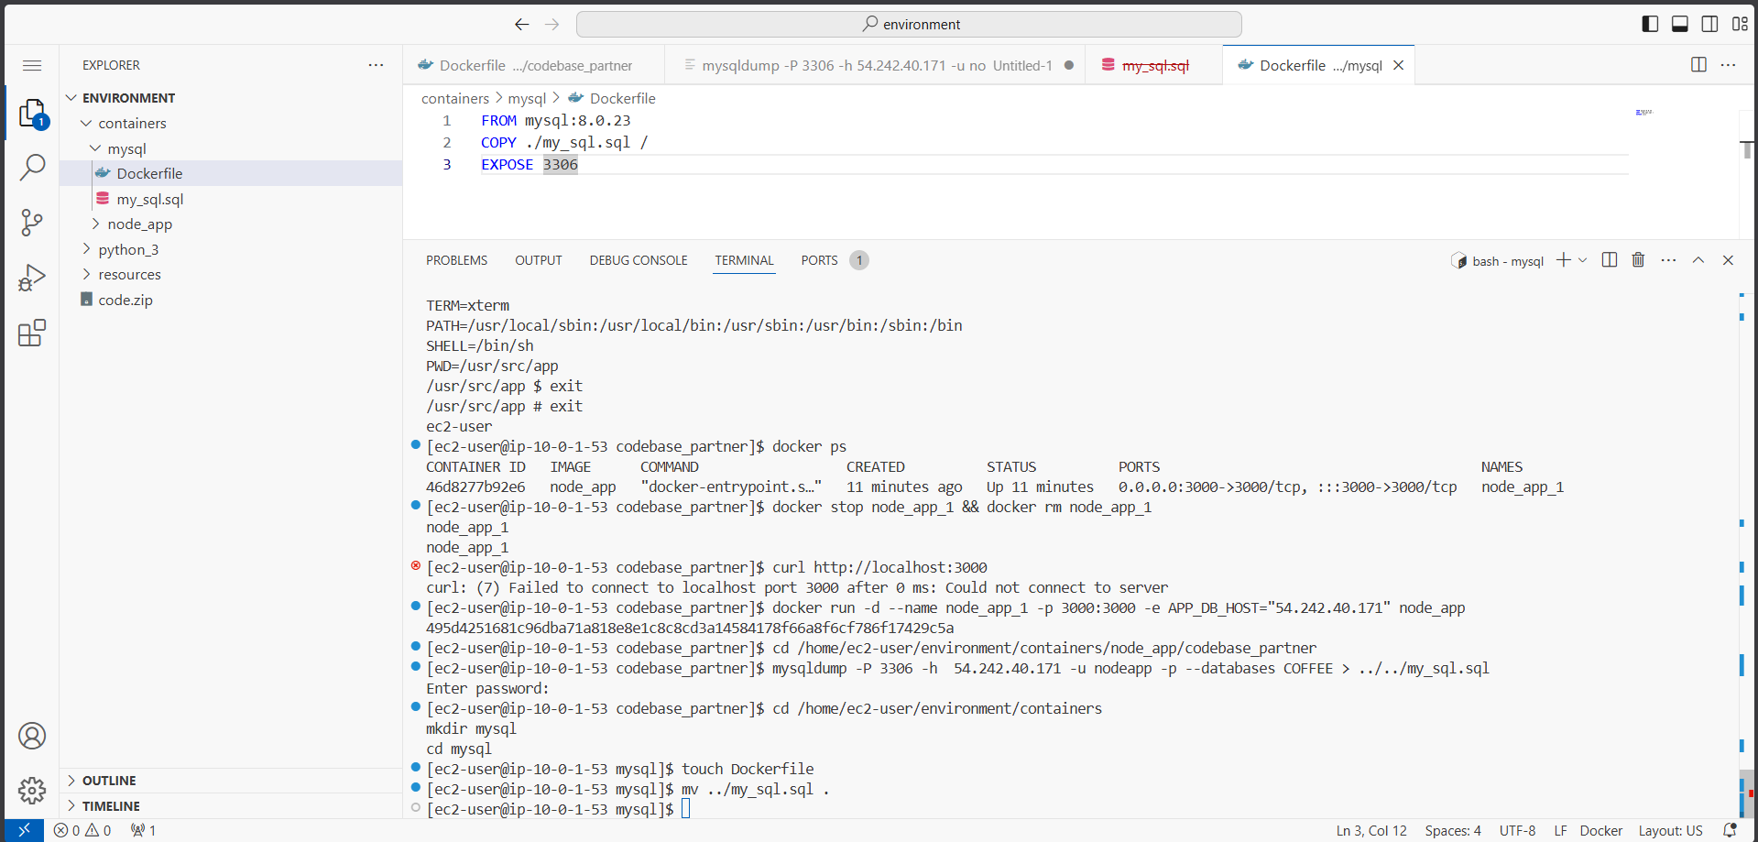
Figure 26: Coffee suppliers application now connected to database – supplier list loads successfully
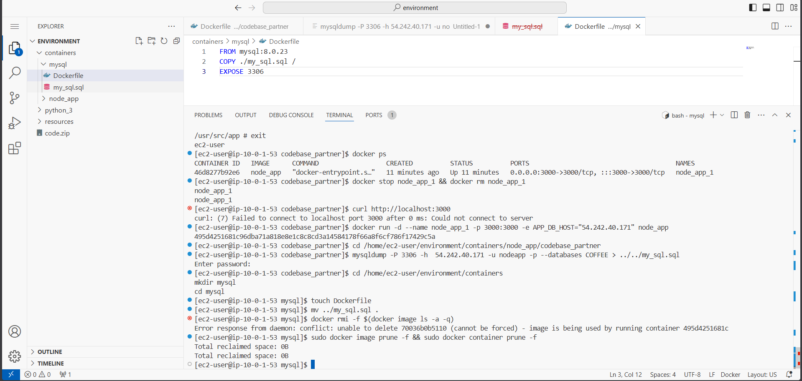
Figure 27: Creating mysqldump of COFFEE database from MysqlServerNode EC2 instance
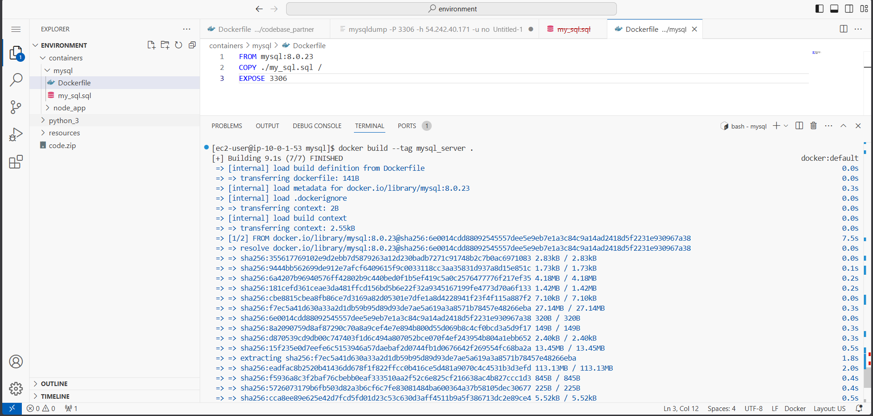
Figure 28: Viewing my_sql.sql – CREATE DATABASE, CREATE TABLE, and INSERT statements visible
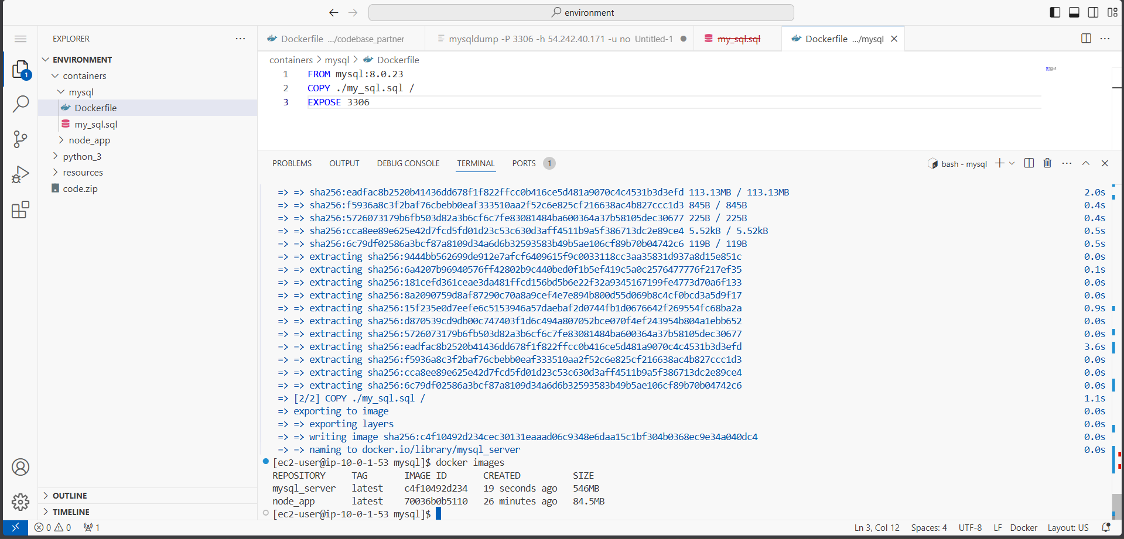
Figure 29: Modifying street address in my_sql.sql to 'Container' to verify new DB connection later
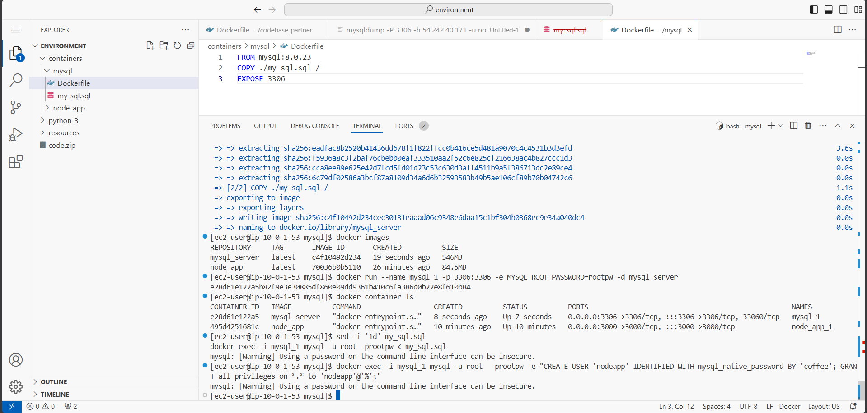
Figure 30: Creating containers/mysql directory and moving my_sql.sql into it
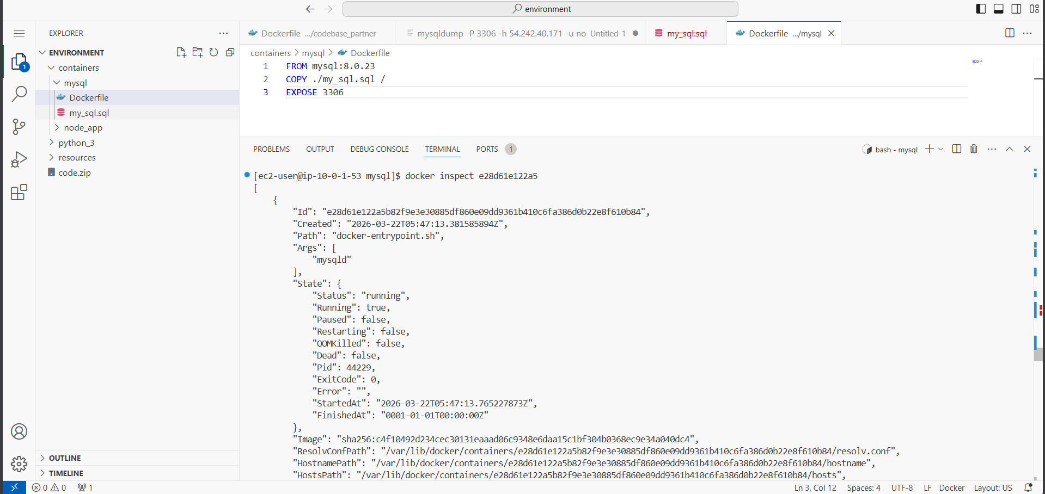
Figure 31: Dockerfile for MySQL container – FROM mysql:8.0.23, COPY sql file, EXPOSE 3306
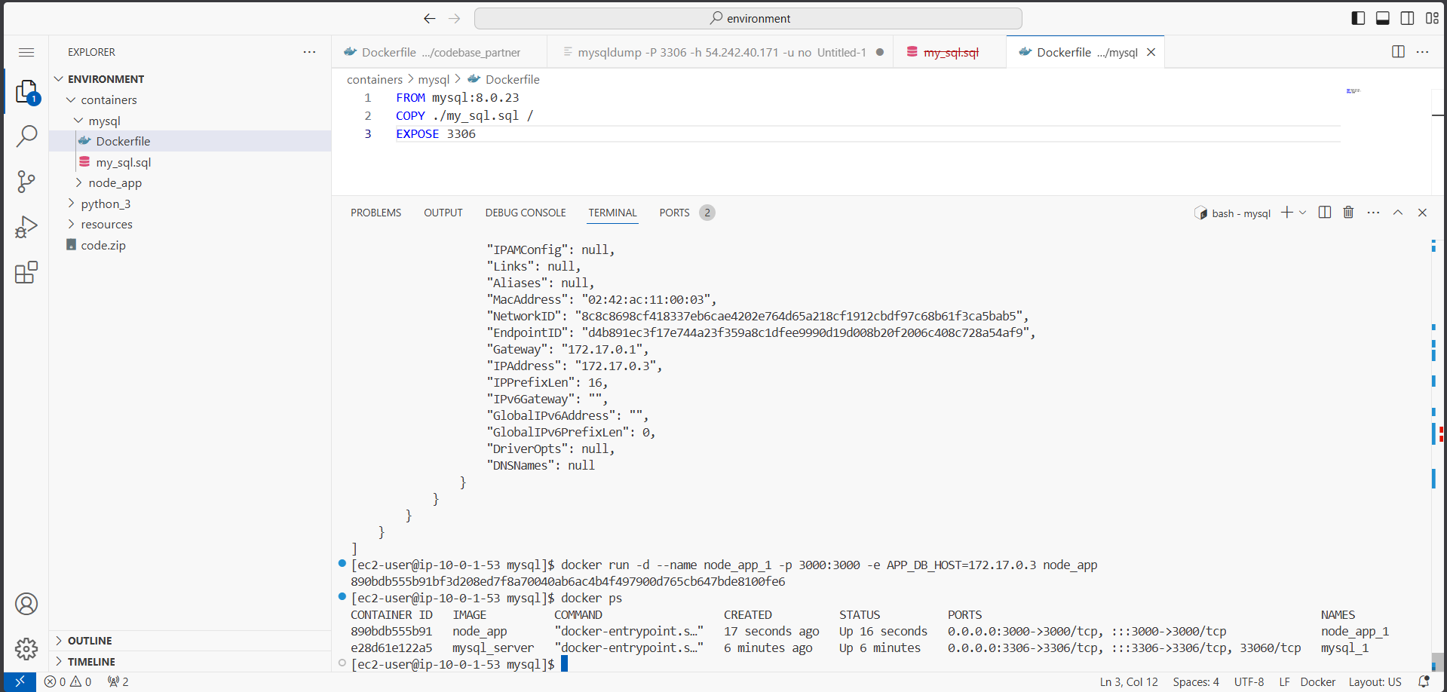
Figure 32: Removing unused Docker images to free disk space before building MySQL image
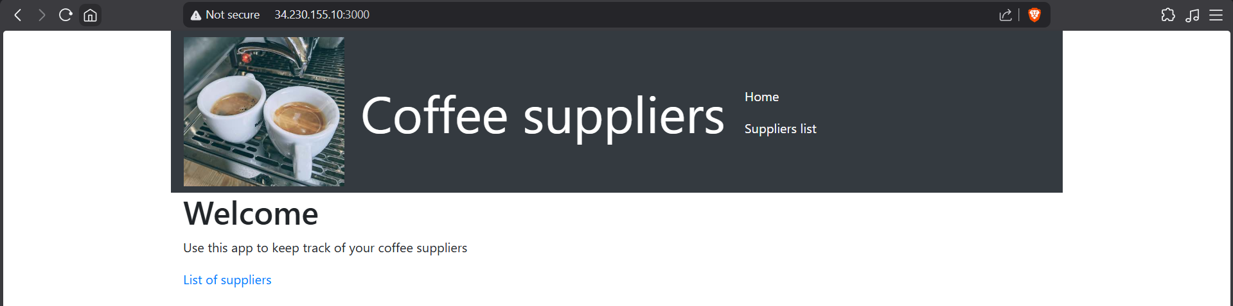
Figure 33: Building MySQL Docker image using 'docker build --tag mysql_server .'
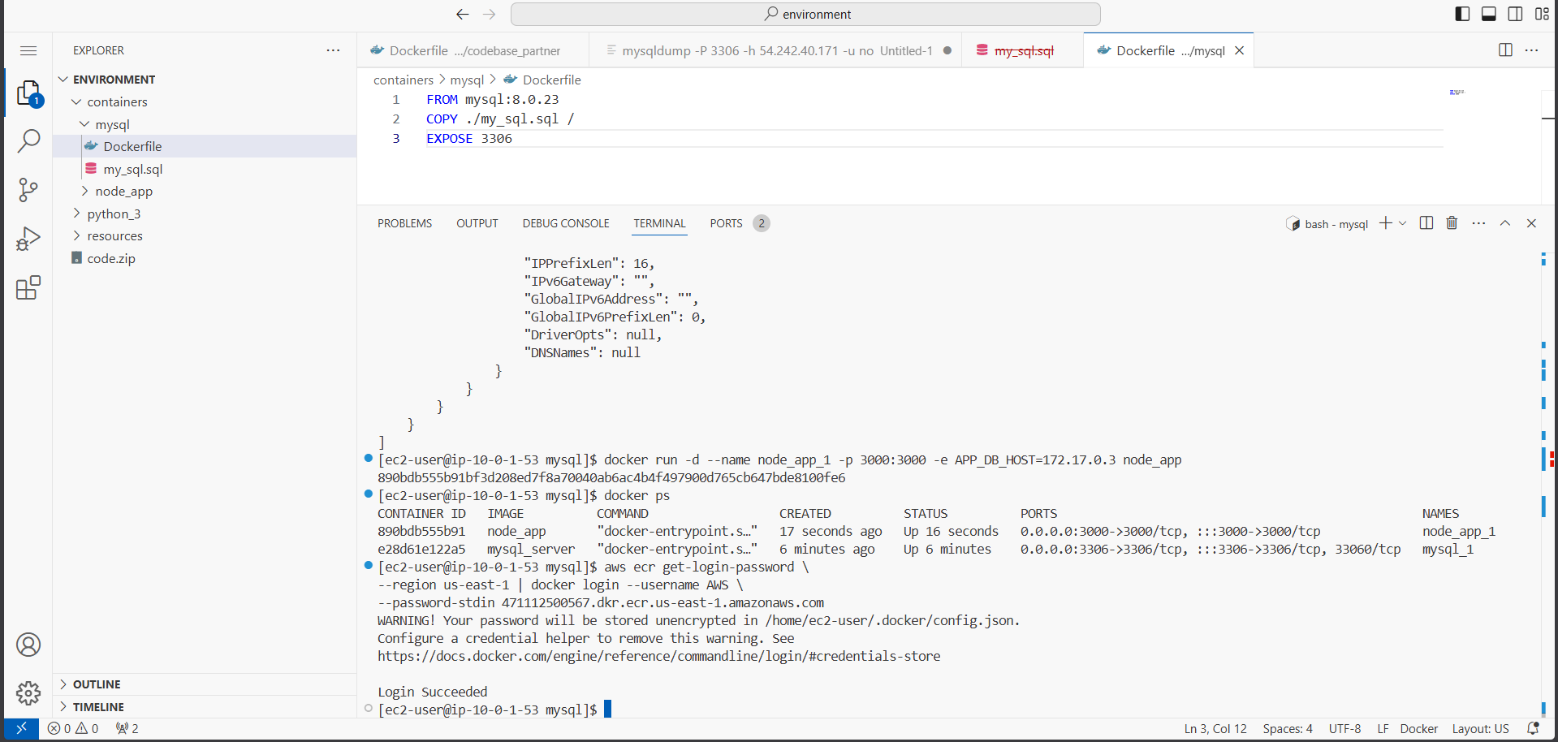
Figure 34: Verifying MySQL Docker image creation – mysql_server:latest listed in docker images
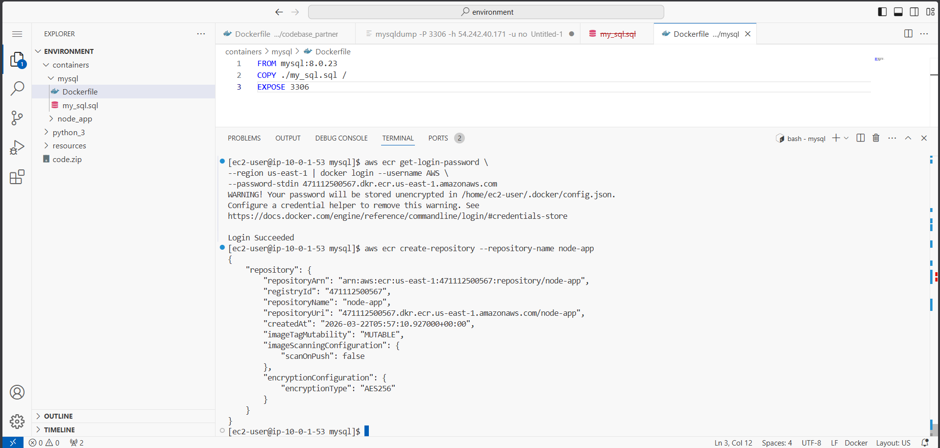
Figure 35: Running MySQL container with 'docker run --name mysql_1 -p 3306:3306 -e MYSQL_ROOT_PASSWORD=rootpw'
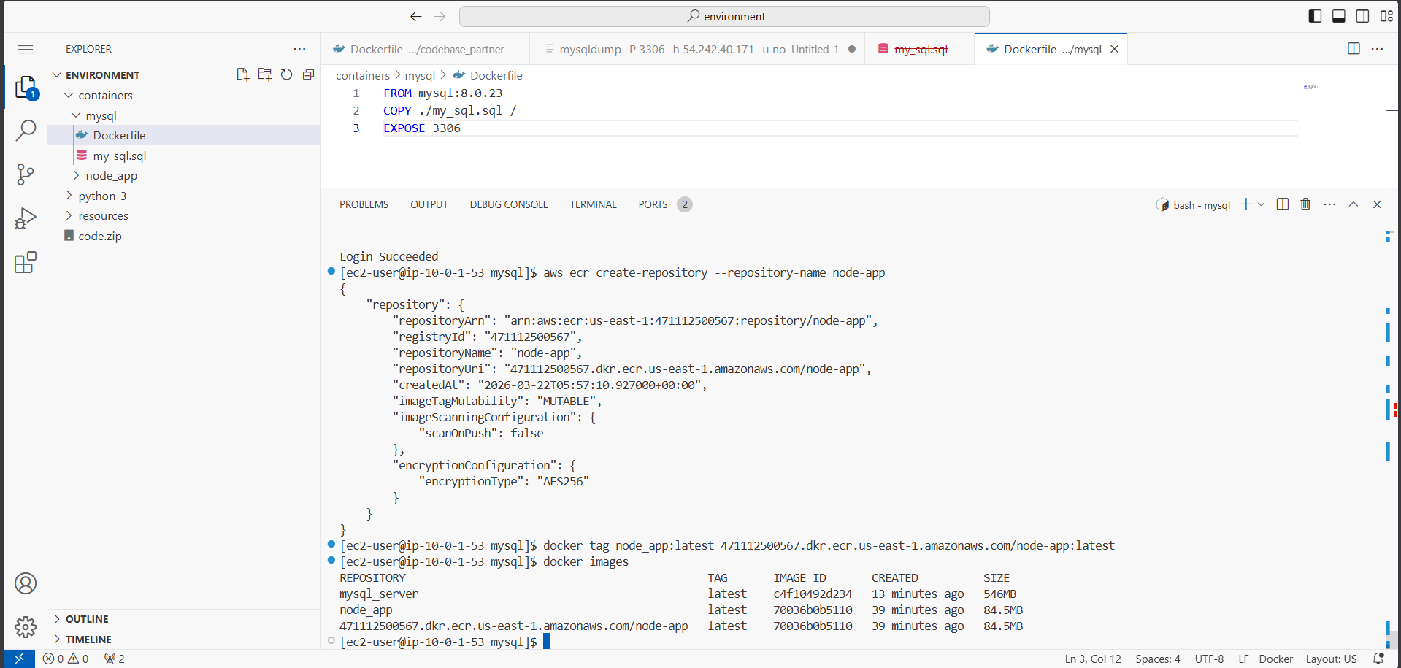
Figure 36: Importing SQL data and creating nodeapp database user inside the MySQL container
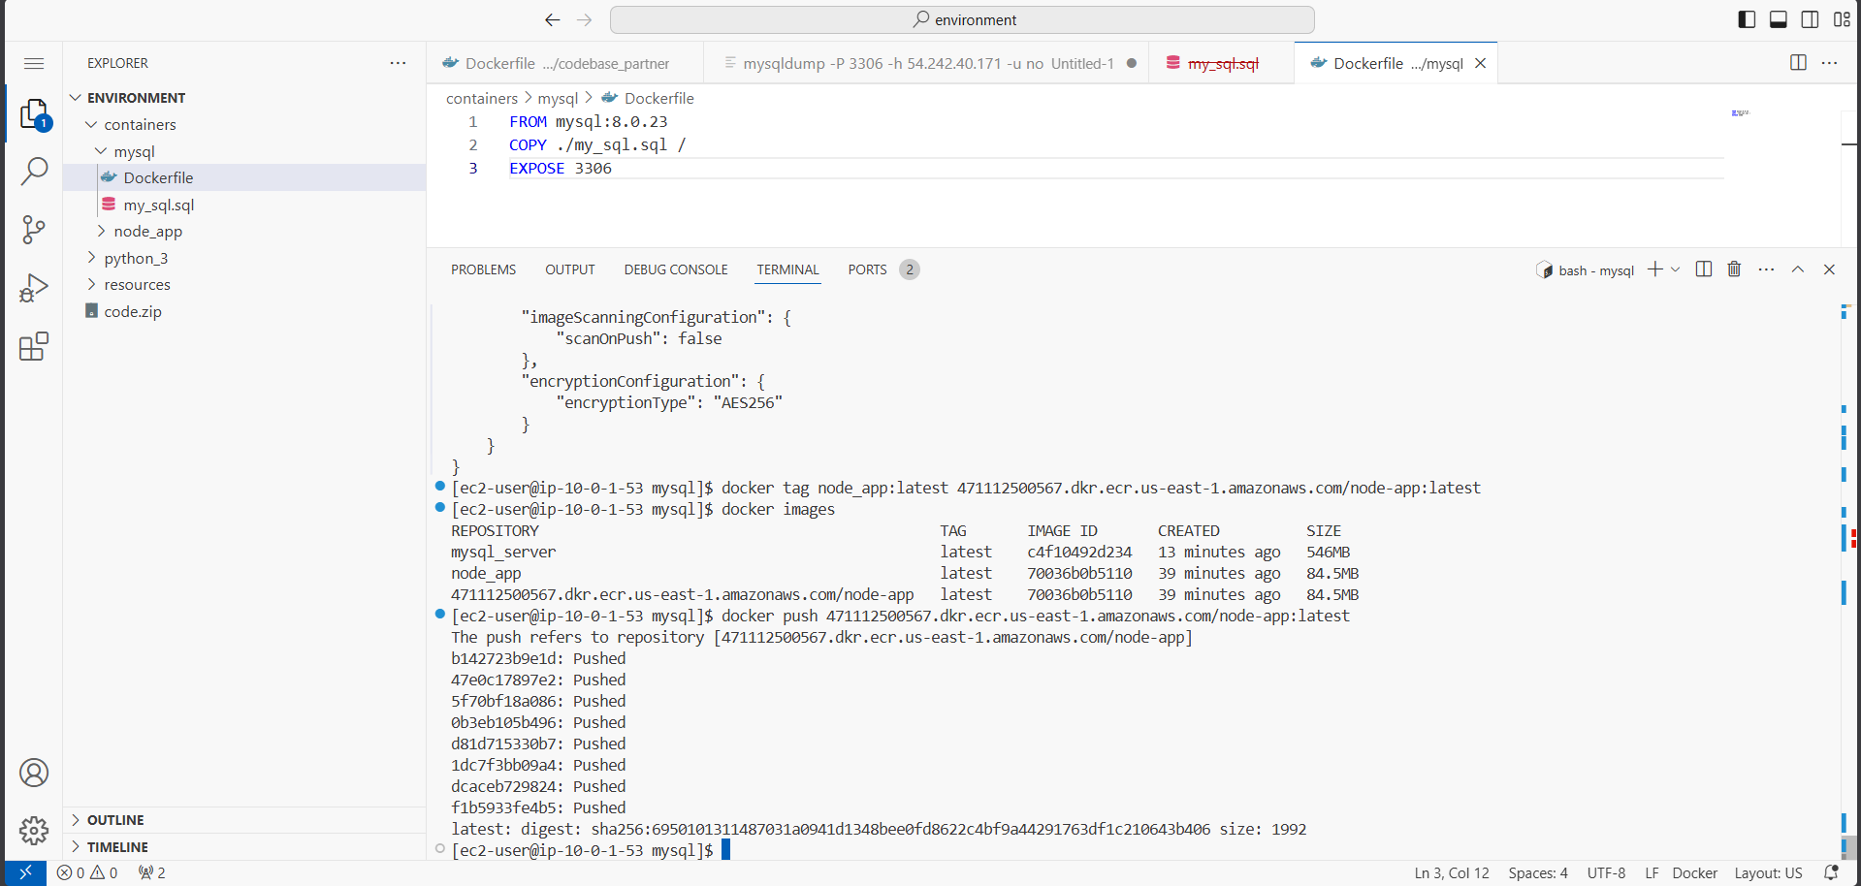
Figure 37: Inspecting mysql_1 container to find its IPAddress for node app connectivity
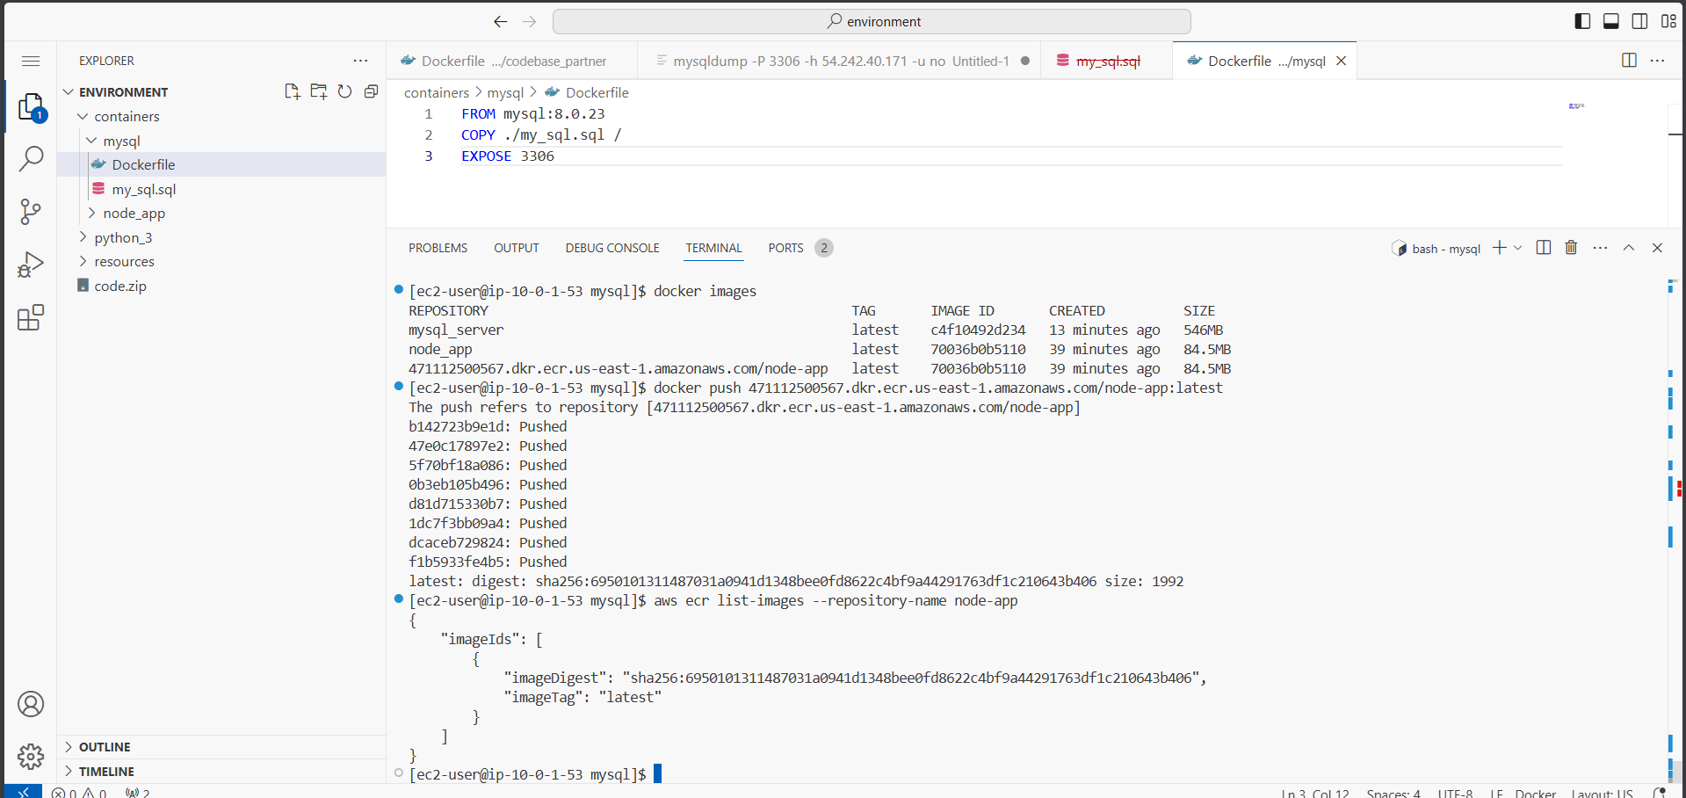
Figure 38: Starting node_app_1 container with APP_DB_HOST set to mysql_1 container IP address
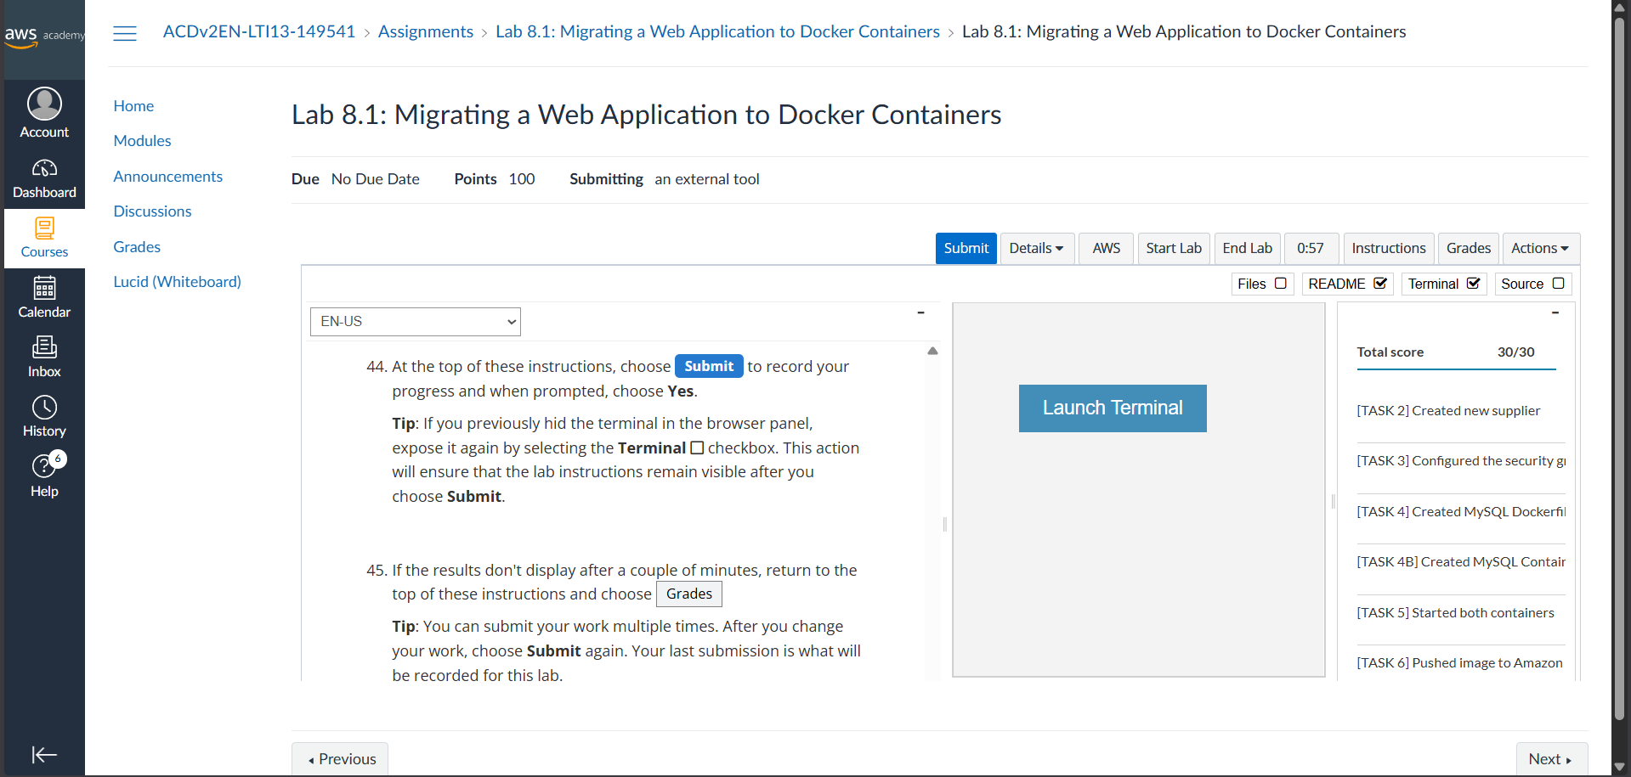
Figure 39: Lab 8.1 submission showing full score – both containers running and ECR image pushed

Learning Outcomes
- Understood how Docker containers provide a portable, isolated environment for running applications without directly installing software on the host OS.
- Learned to write a Dockerfile with instructions such as FROM, RUN, WORKDIR, COPY, EXPOSE, and CMD to build custom Docker images.
- Gained hands-on experience building Docker images using docker build and running containers using docker run with port mapping and environment variable flags.
- Understood how the -e flag is used to pass runtime environment variables (e.g., APP_DB_HOST) to containers, enabling dynamic configuration without modifying application code.
- Learned to use docker exec to connect a terminal session to a running container and inspect its internal environment.
- Gained experience using mysqldump to export a live MySQL database and import it into a containerized MySQL instance.
- Understood how containers on the same Docker host communicate over an internal bridge network using private IP addresses discovered via docker inspect.
- Learned to authenticate the Docker client to Amazon ECR using aws ecr get-login-password, create an ECR repository, tag images, and push them for cloud-accessible storage.
- Understood the overall migration path from EC2-hosted applications to a fully containerized architecture using Docker and AWS ECR.

References
- AWS Academy Cloud Computing Lab Manual – Module 8
- Docker Documentation: https://docs.docker.com
- Amazon ECR Developer Guide: https://docs.aws.amazon.com/ecr
- AWS CLI Reference: https://docs.aws.amazon.com/cli
- Docker Hub – Official MySQL Image: https://hub.docker.com/_/mysql
- Node.js Alpine Docker Image: https://hub.docker.com/_/node

