PRACTICAL: 8.2
Running Containers on a Managed Service

Student Name | 23AIML070
Branch / Programme | B.Tech – Artificial Intelligence & Machine Learning
Subject | Cloud Computing Lab
Lab Module | Module 8 – Managed Container Deployment with Elastic Beanstalk & Aurora

Objective
To deploy a containerized web application and its database using AWS managed services. The lab covers creating an Aurora Serverless (MySQL-compatible) database instance, configuring subnets and security groups for RDS and Elastic Beanstalk, loading data using the RDS Query Editor, deploying the Node.js Docker container using AWS Elastic Beanstalk, and integrating the coffee bean inventory with the main café website via Amazon API Gateway.

Theory

Amazon Aurora Serverless
Amazon Aurora Serverless is an on-demand, auto-scaling configuration for Amazon Aurora (MySQL and PostgreSQL-compatible). Unlike a standard provisioned database, Aurora Serverless automatically starts up, shuts down, and scales capacity up or down based on application needs. This makes it ideal for infrequent, intermittent, or unpredictable workloads. Aurora Serverless v2 uses Aurora Capacity Units (ACUs) to scale smoothly and near-instantly, without disrupting database connections.
Scaling relational databases using containers is not recommended because relational databases are stateful — they require reliable, persistent communication between the database host and its storage. This is difficult to achieve with dynamic, ephemeral containers. Aurora Serverless provides a managed, scalable alternative that eliminates the need to manually manage database containers.

AWS Elastic Beanstalk
AWS Elastic Beanstalk is a fully managed Platform-as-a-Service (PaaS) that simplifies the deployment and management of web applications and services. Developers upload their application code or a Docker configuration file, and Elastic Beanstalk automatically handles the deployment, load balancing, auto-scaling, and health monitoring of the underlying infrastructure. For Docker-based deployments, Elastic Beanstalk uses a Dockerrun.aws.json file to define the container image and port mappings.
When deploying a single Docker container, Elastic Beanstalk provisions an EC2 instance, a Classic Load Balancer (which proxies port 80 to the container port), and an Auto Scaling group. The EC2 instance pulls the Docker image from Amazon ECR at deploy time, using an IAM role with appropriate ECR permissions. This architecture adds resilience: if the EC2 instance fails, Auto Scaling replaces it automatically.

Amazon ECR and IAM Integration
Amazon Elastic Container Registry (ECR) stores the Docker images that Elastic Beanstalk uses. For the EC2 instances launched by Elastic Beanstalk to pull images from ECR, an IAM instance profile must be attached with policies that allow ecr:GetAuthorizationToken, ecr:GetDownloadUrlForLayer, ecr:BatchGetImage, and ecr:BatchCheckLayerAvailability. The role aws-elasticbeanstalk-ec2-role with the policy aws-elasticbeanstalk-ec2-instance-policy fulfills this requirement.

Amazon API Gateway HTTP Integration
In this lab, API Gateway is extended to include a new resource (/bean_products) that uses HTTP proxy integration to forward GET requests to the Elastic Beanstalk-hosted application's /beans.json endpoint. CORS is enabled on this resource to allow the browser-based café website (hosted on S3) to make cross-origin AJAX requests. This completes the full serverless-to-managed architecture: S3 → API Gateway → Elastic Beanstalk → Aurora Serverless.

VPC Networking for RDS and Elastic Beanstalk
Amazon RDS and load-balanced Elastic Beanstalk deployments require at least two subnets, each in a different Availability Zone. This requirement enables cross-zone redundancy. The extra subnet (extraSubnetForRds) is created with a CIDR block of 10.0.2.0/24 and is associated with a route table that includes a route to the internet gateway (0.0.0.0/0), which is required for Elastic Beanstalk EC2 instances to reach external services including ECR.

Code
N/A – This lab uses AWS CLI commands, Docker CLI commands, SQL statements in the RDS Query Editor, and a Dockerrun.aws.json configuration file. No custom application code was written.

Output / Screenshots
The following screenshots document each step of the lab from environment setup, Aurora Serverless database configuration, container testing, Elastic Beanstalk deployment, to API Gateway integration.
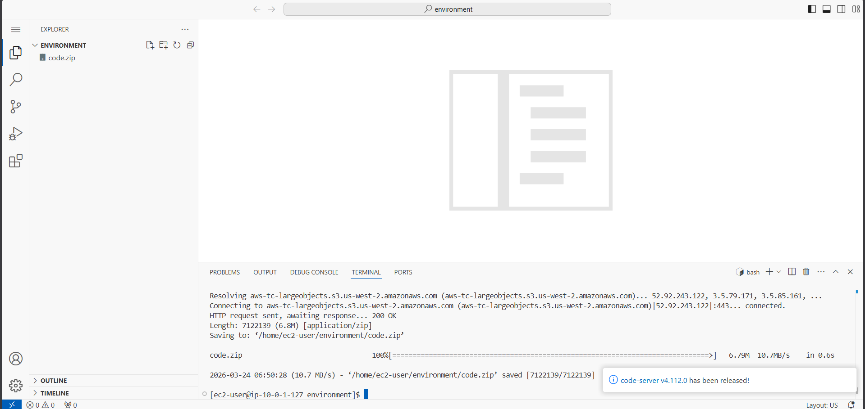
Figure 1: Connecting to VS Code IDE using LabIDEURL and LabIDEPassword credentials
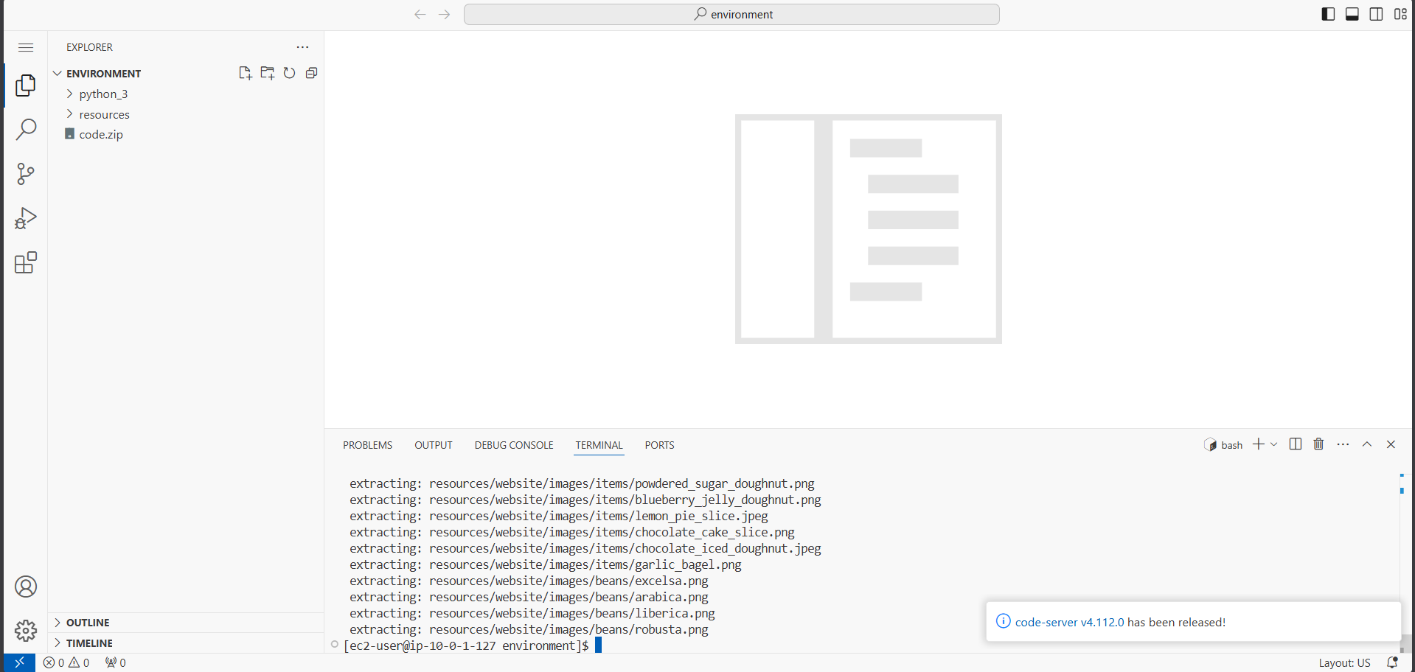
Figure 2: Downloading code.zip using wget and extracting files in the VS Code IDE terminal
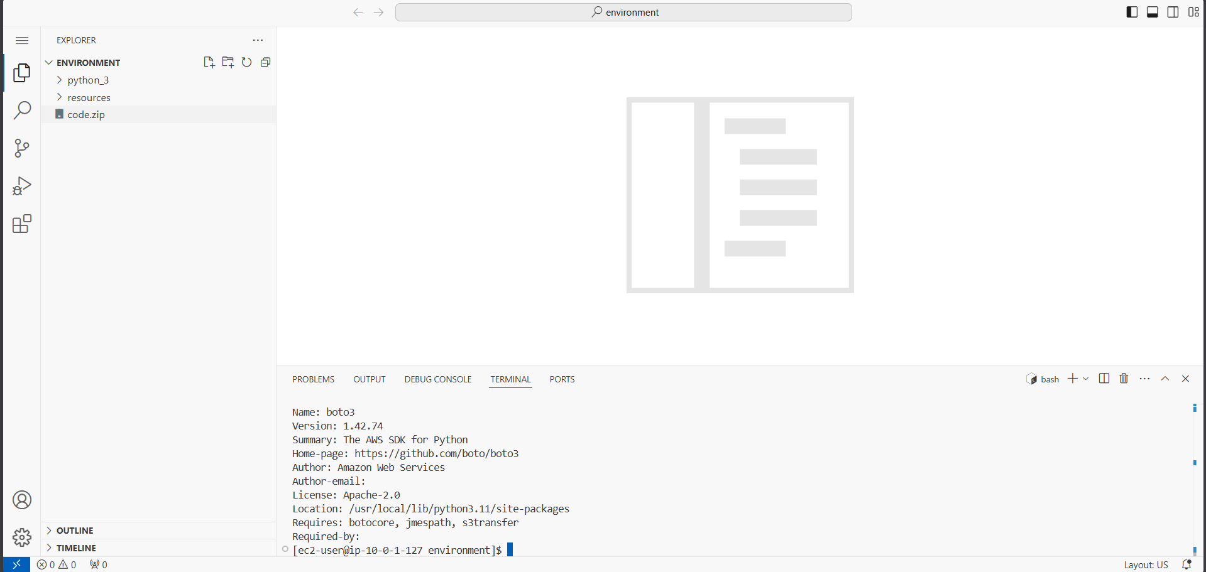
Figure 3: Running setup.sh script to install dependencies and configure the AWS environment
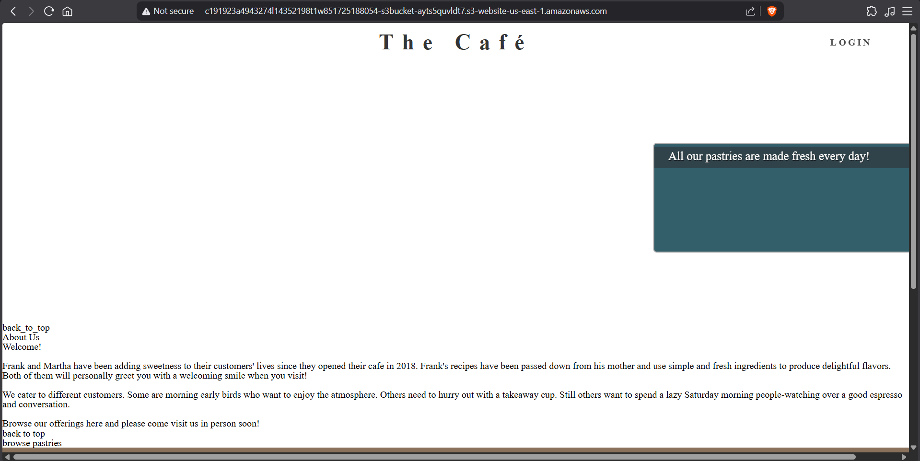
Figure 4: Verifying AWS CLI version 2 and boto3 SDK installation in the VS Code terminal
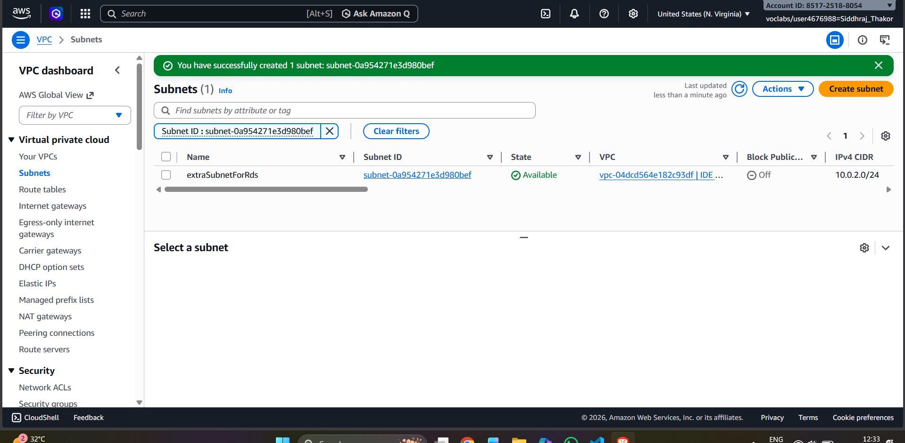
Figure 5: Café website loaded from Amazon S3 static website endpoint
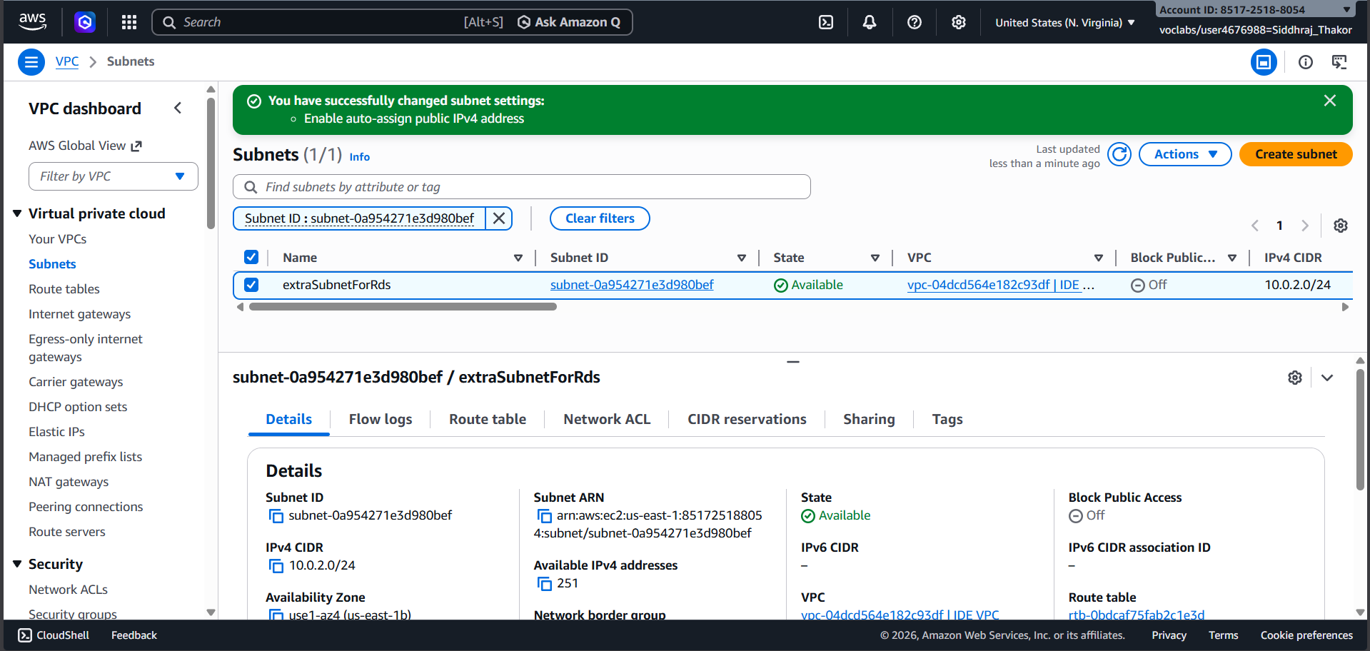
Figure 6: Amazon VPC console – selecting IDE VPC and copying VPC ID to text editor
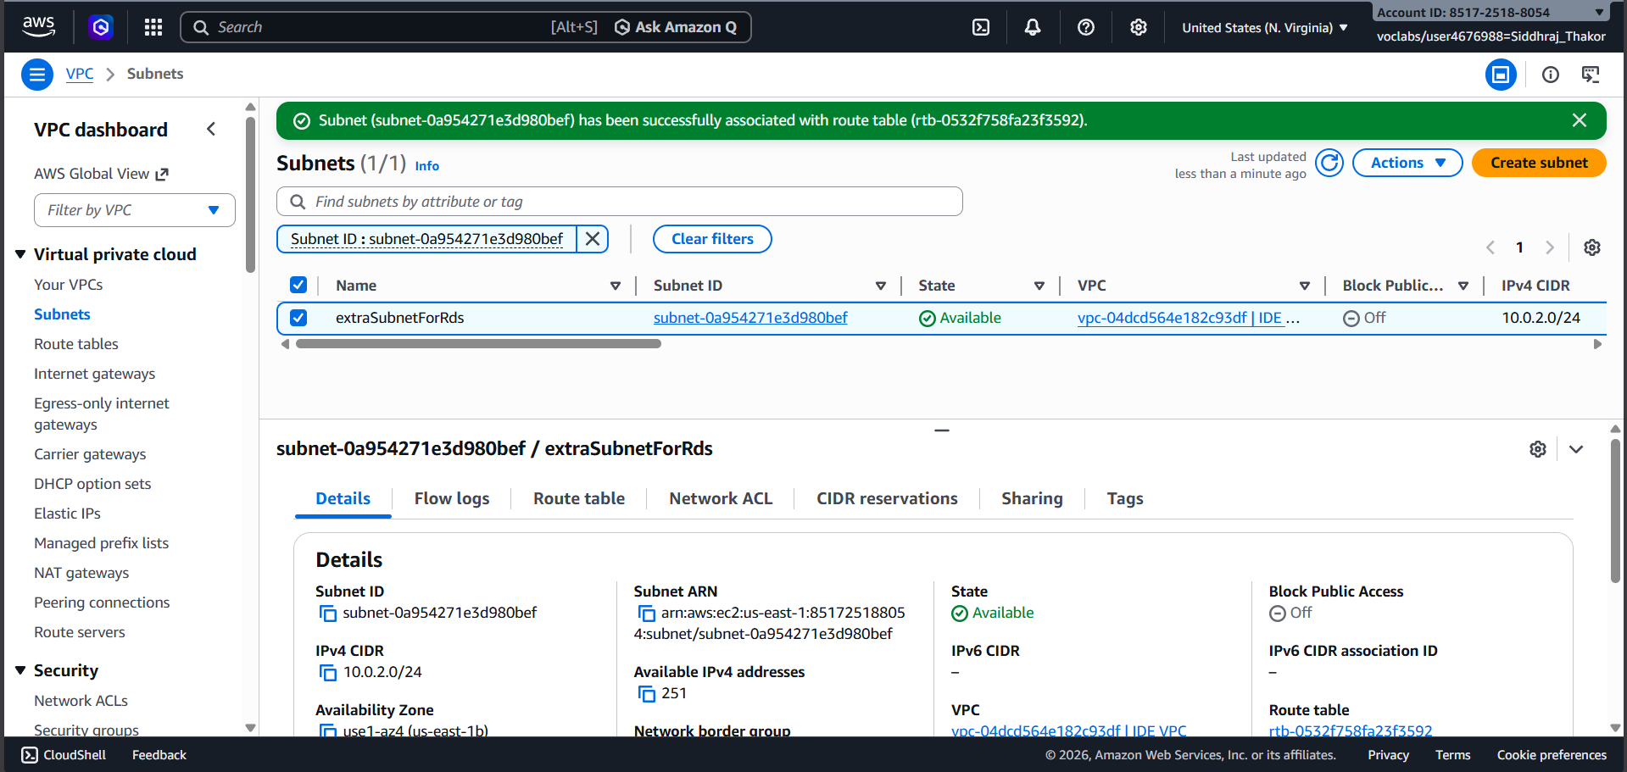
Figure 7: Subnet details – noting Availability Zone and Subnet ID of IDE Public Subnet One
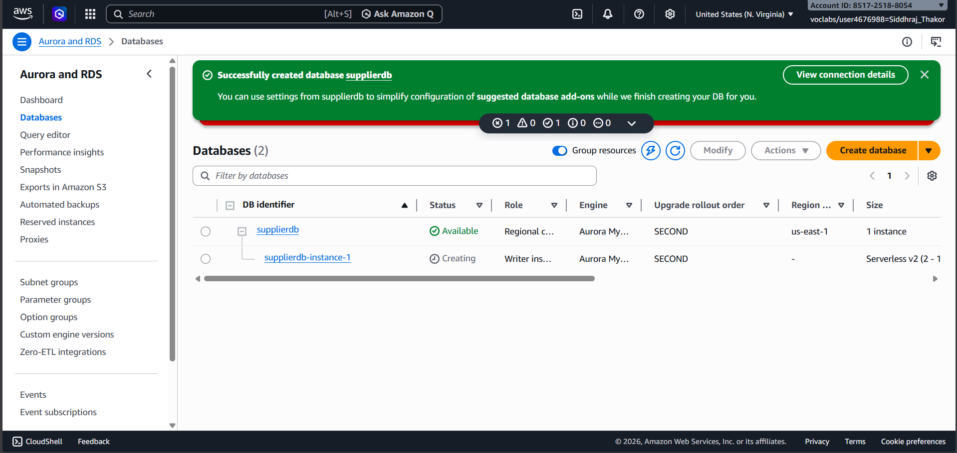
Figure 8: Creating extraSubnetForRds subnet in a different Availability Zone with CIDR 10.0.2.0/24
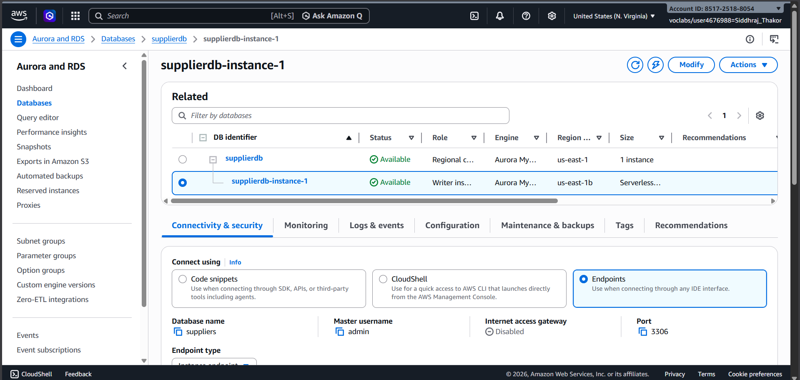
Figure 9: Enabling auto-assign public IPv4 address for extraSubnetForRds subnet
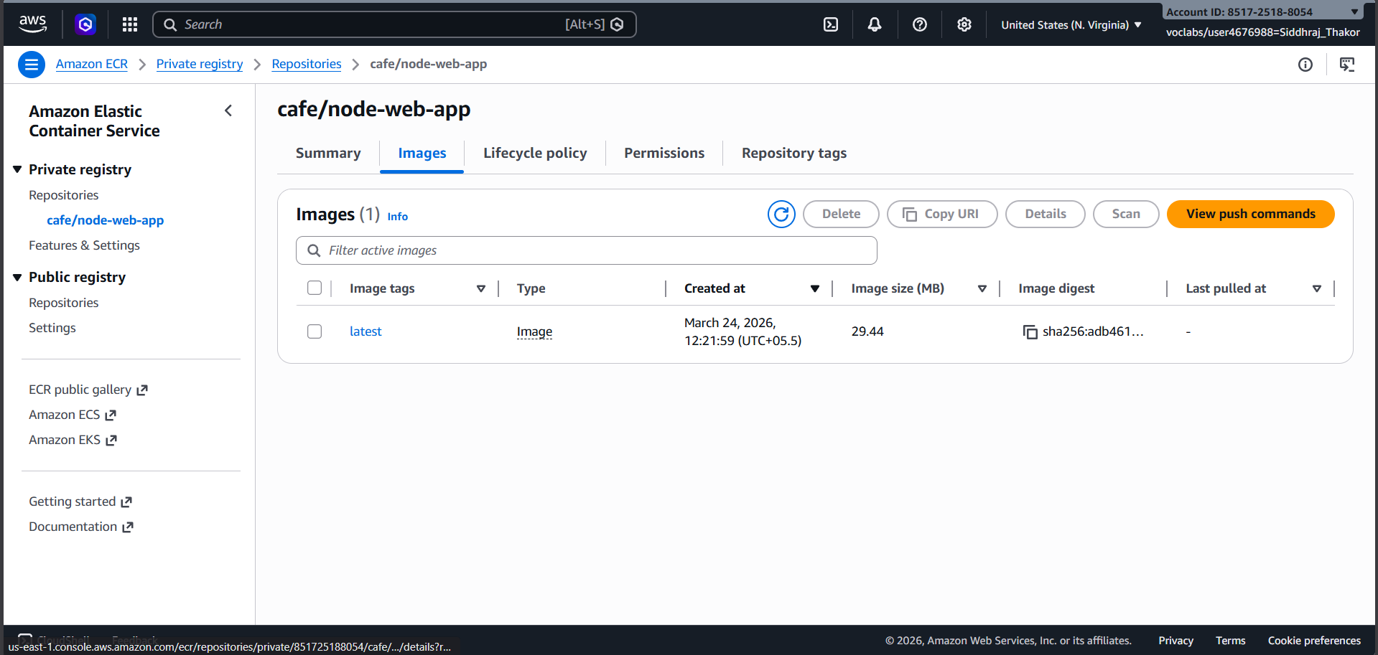
Figure 10: Editing route table association for extraSubnetForRds to add internet gateway route (0.0.0.0/0)
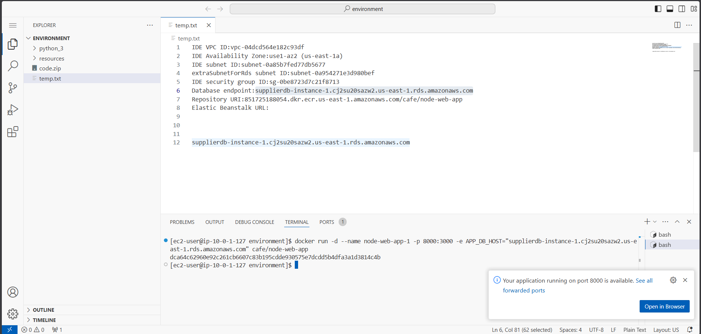
Figure 11: Amazon RDS console – configuring Aurora (MySQL-Compatible) Serverless v2 engine options
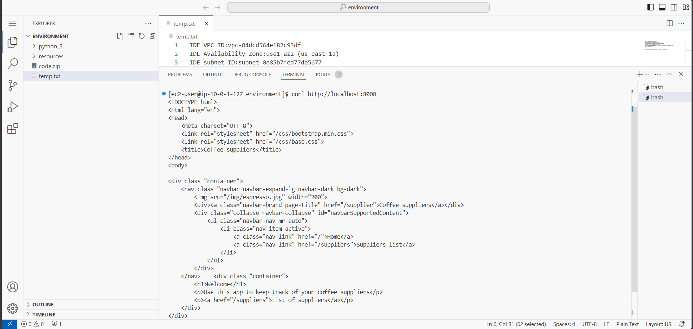
Figure 12: RDS database settings – entering cluster identifier 'supplierdb' and master password
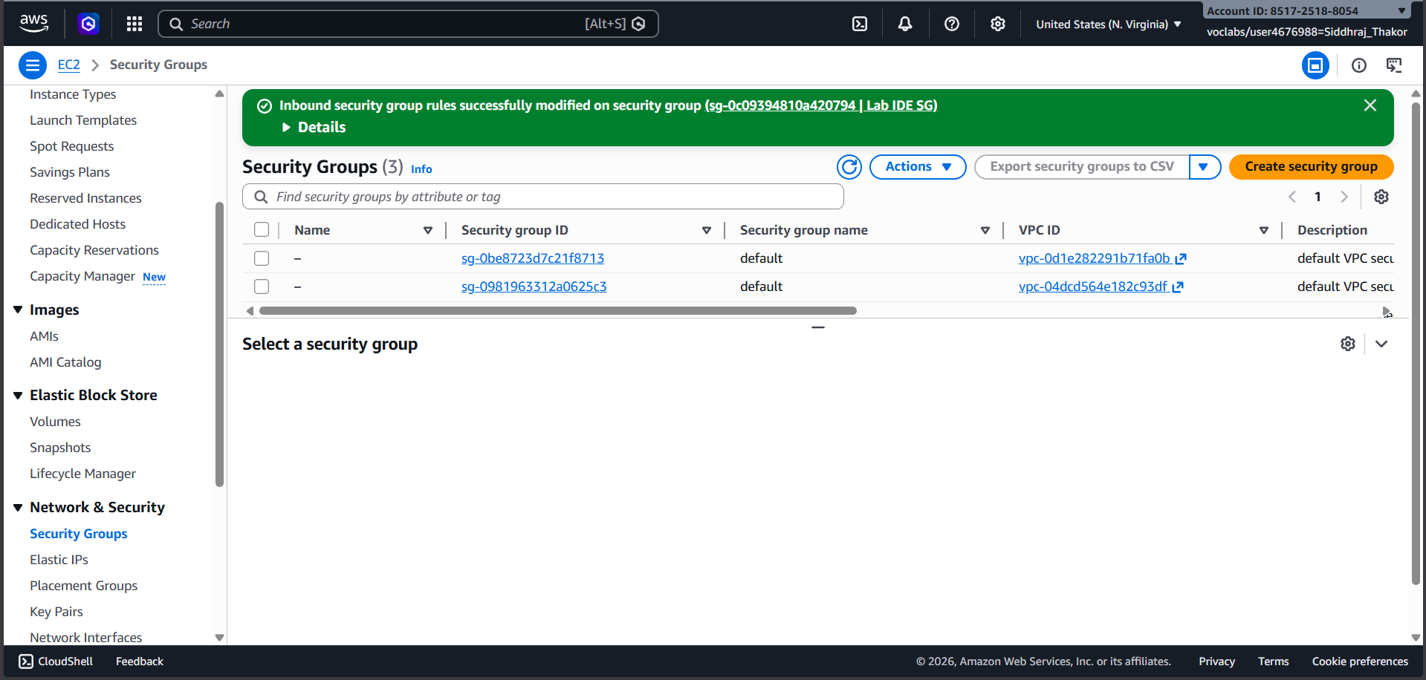
Figure 13: RDS connectivity settings – selecting IDE VPC, security group, enabling RDS Data API
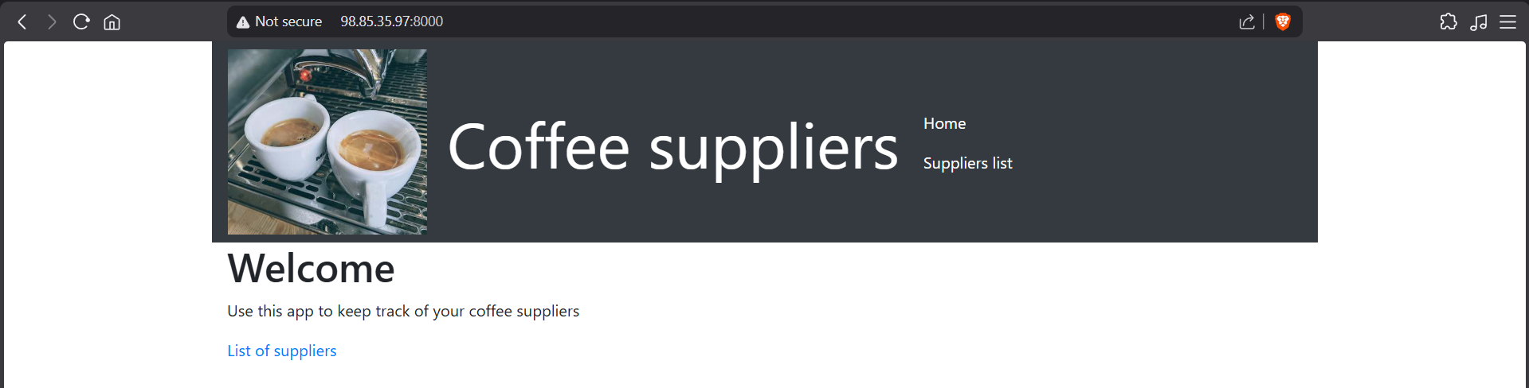
Figure 14: Aurora Serverless supplierdb cluster created – waiting for Available status
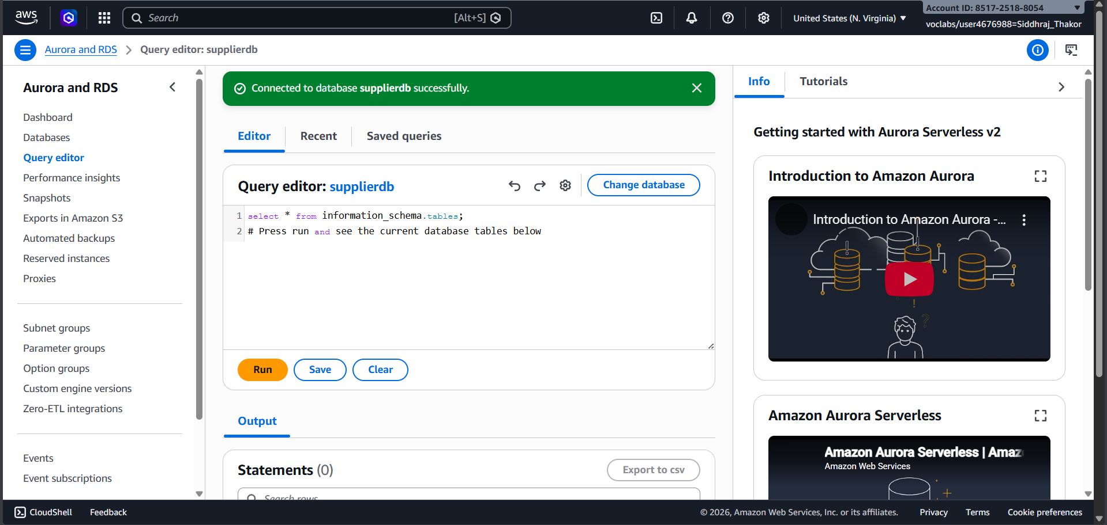
Figure 15: Copying database endpoint from supplierdb-instance-1 Connectivity & Security section
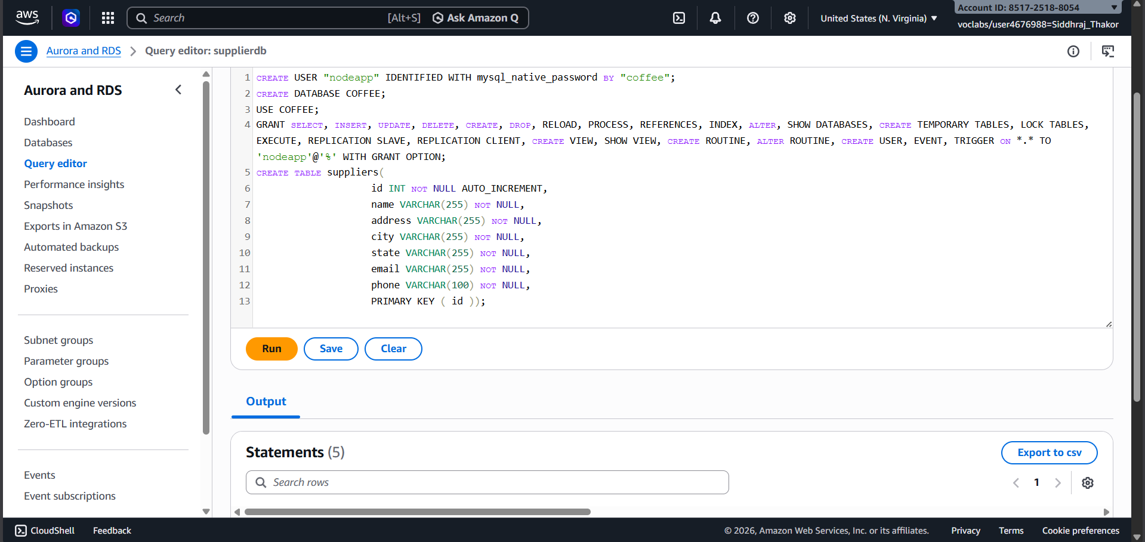
Figure 16: Locating security group ID from the VPC security groups linked to supplierdb
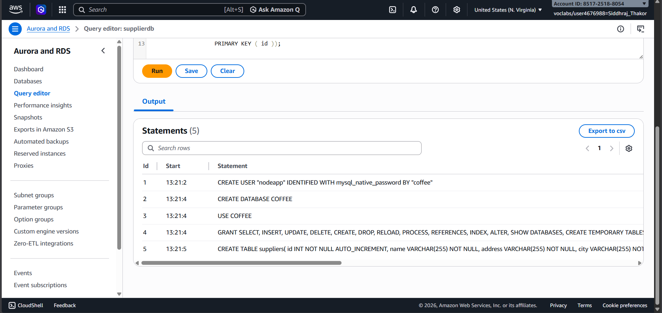
Figure 17: Amazon ECR console – reviewing cafe/node-web-app repository URI
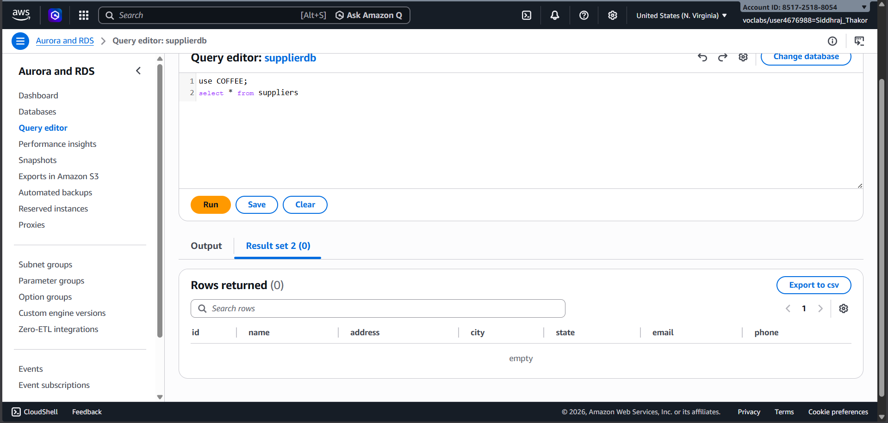
Figure 18: Running 'aws ecr describe-repositories' to verify ECR repository details in VS Code terminal
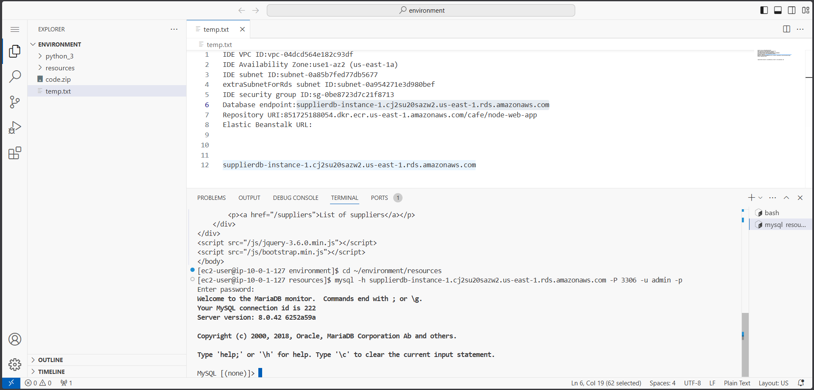
Figure 19: Running 'aws ecr describe-images' to inspect the cafe/node-web-app Docker image metadata
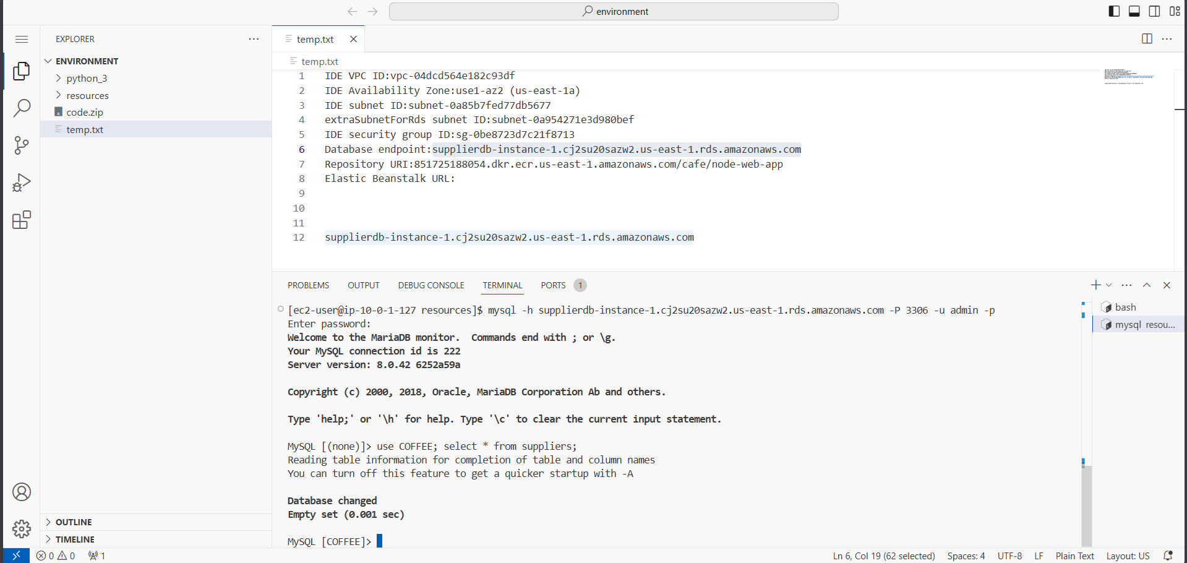
Figure 20: Starting node-web-app-1 container with APP_DB_HOST set to Aurora Serverless endpoint on port 8000
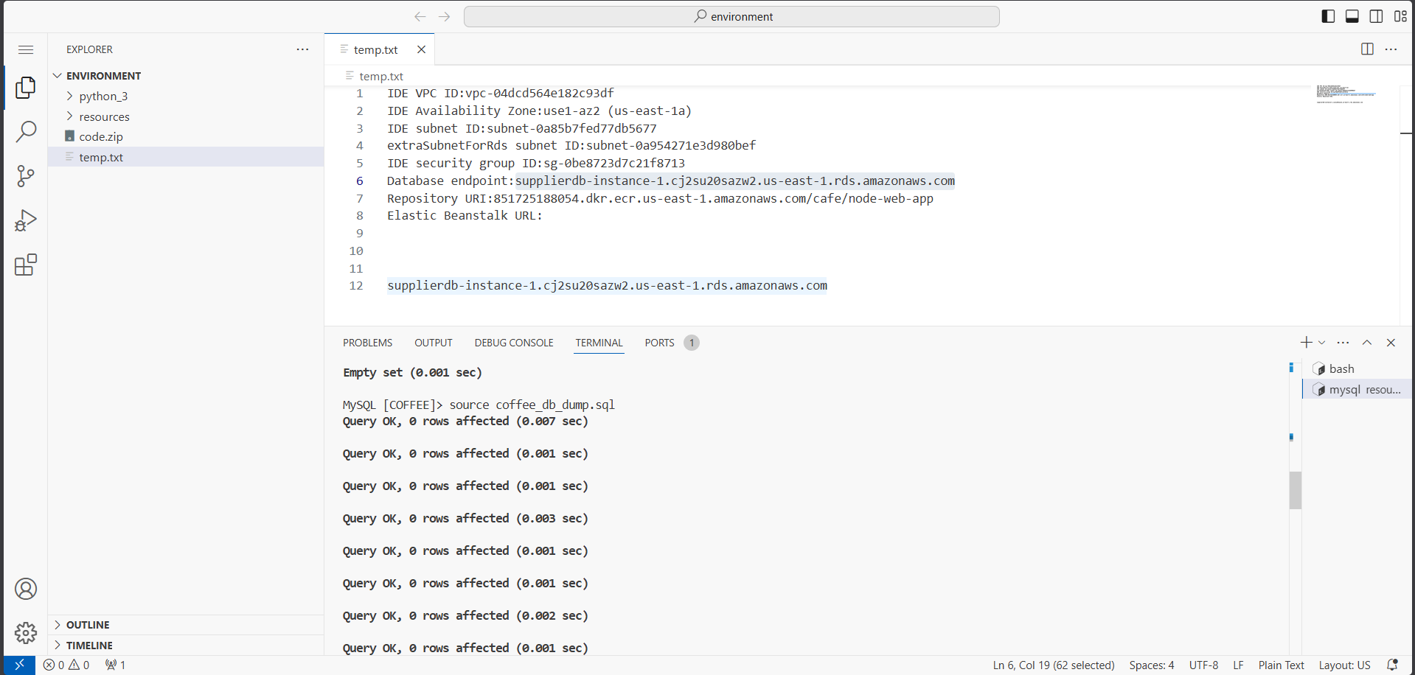
Figure 21: Testing container with curl http://localhost:8000 – HTML response confirming app is running
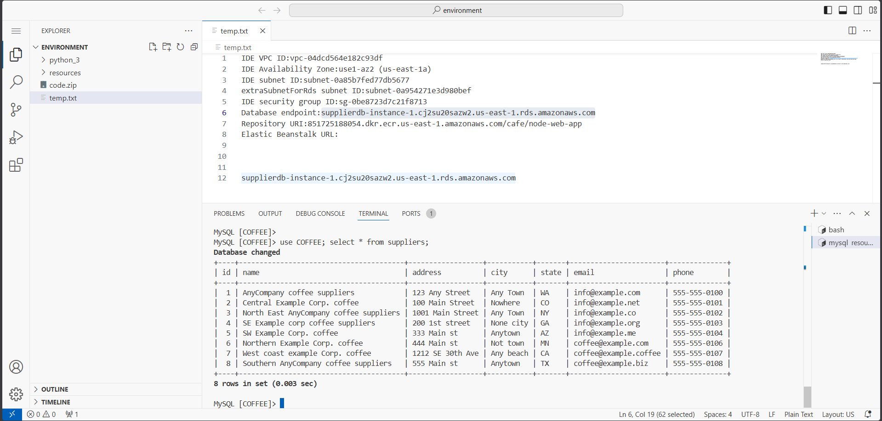
Figure 22: EC2 Security Groups – adding inbound rules for TCP port 8000 (My IP) and MySQL port 3306 (self-referencing)
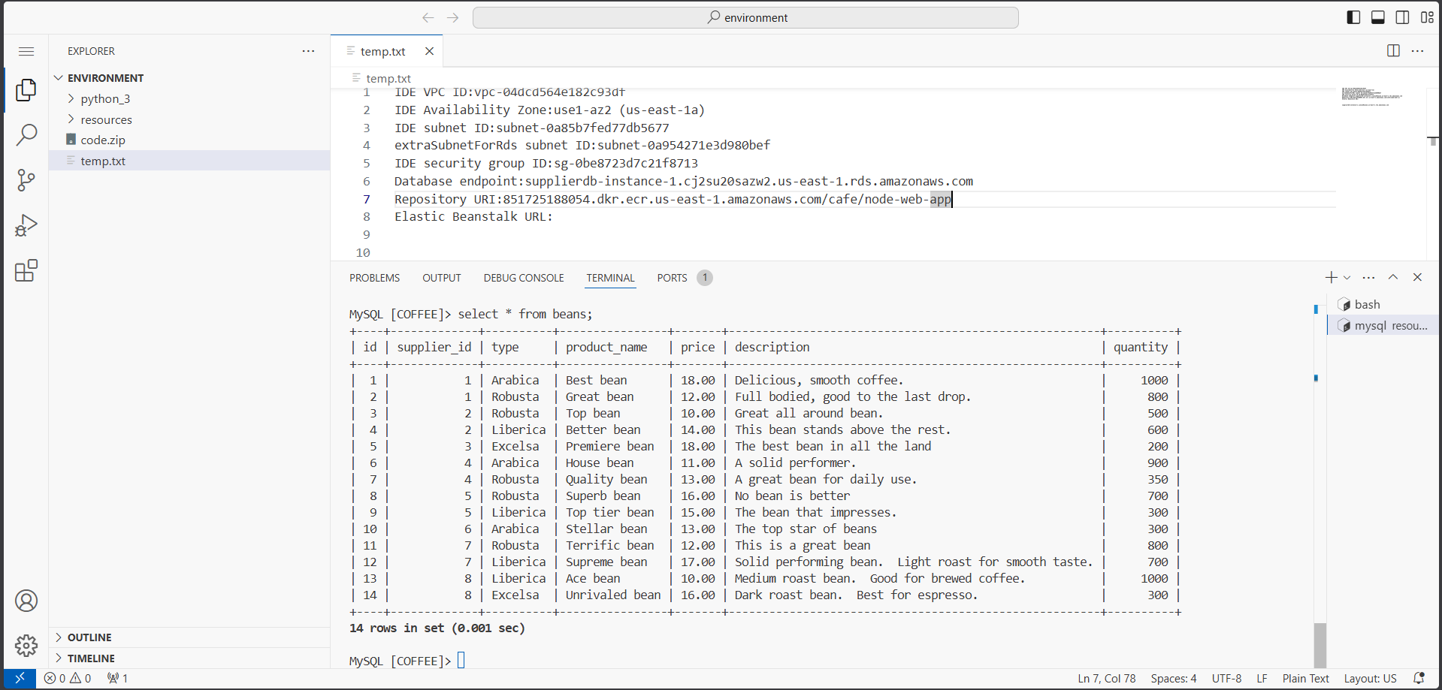
Figure 23: Coffee suppliers web application accessible at http://LabIDE-IP:8000 – confirming container connectivity
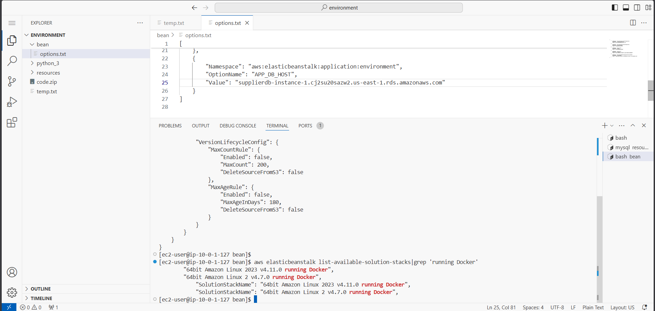
Figure 24: Suppliers page showing database error – COFFEE database objects not yet created in Aurora
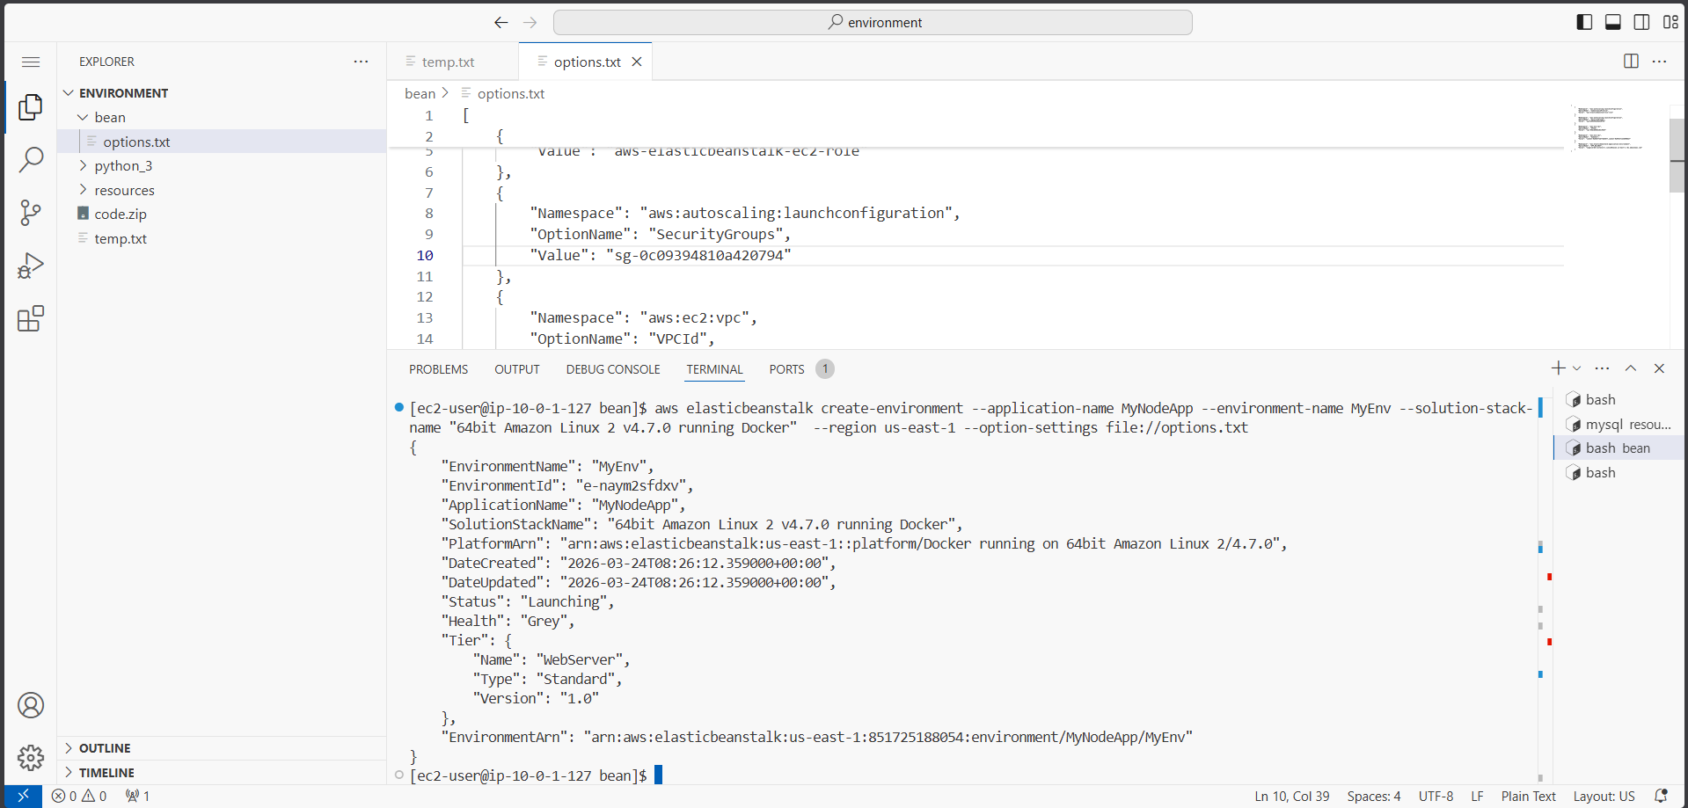
Figure 25: RDS Query Editor – connecting to supplierdb cluster with admin credentials
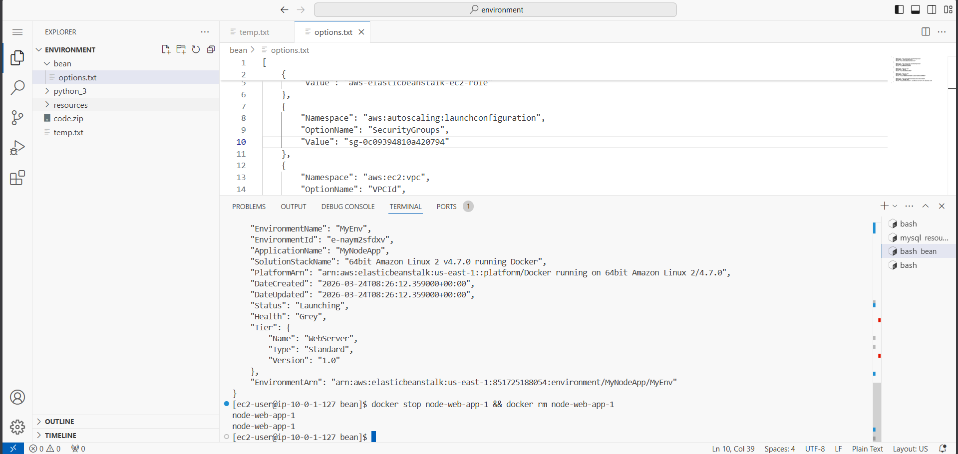
Figure 26: Running SQL script to CREATE USER nodeapp, CREATE DATABASE COFFEE, CREATE TABLE suppliers
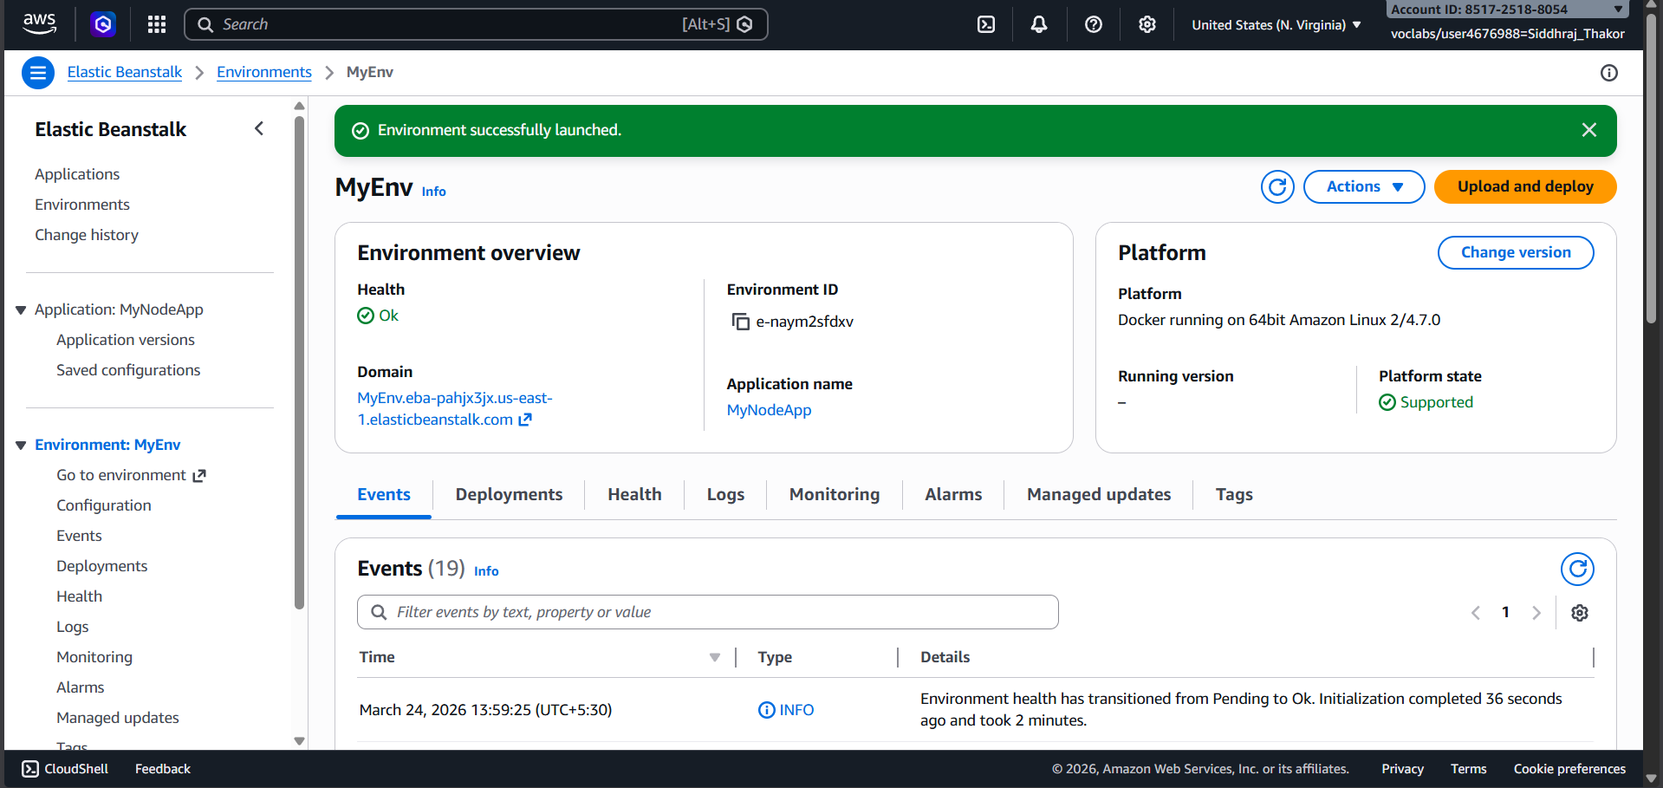
Figure 27: Query Editor output confirming successful creation of database objects
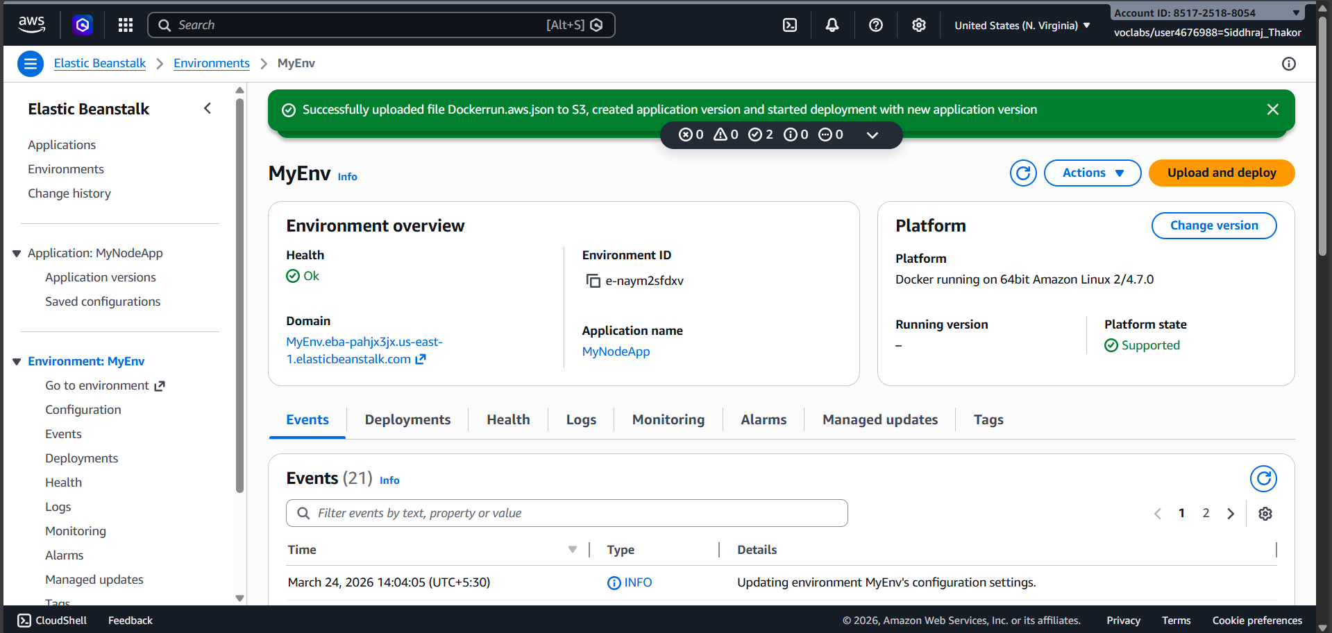
Figure 28: Verifying empty suppliers table with 'SELECT * FROM suppliers' query – no rows returned
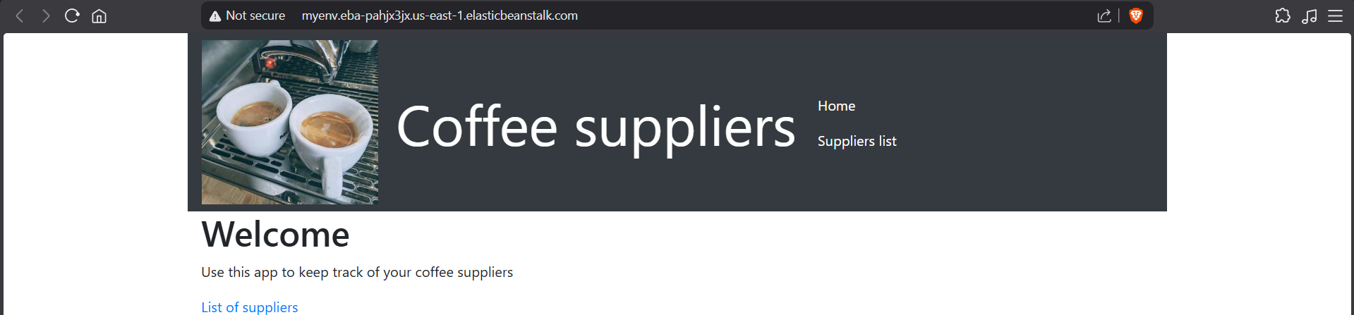
Figure 29: Suppliers page refreshed – shows empty table with Add a new supplier button (DB connected)
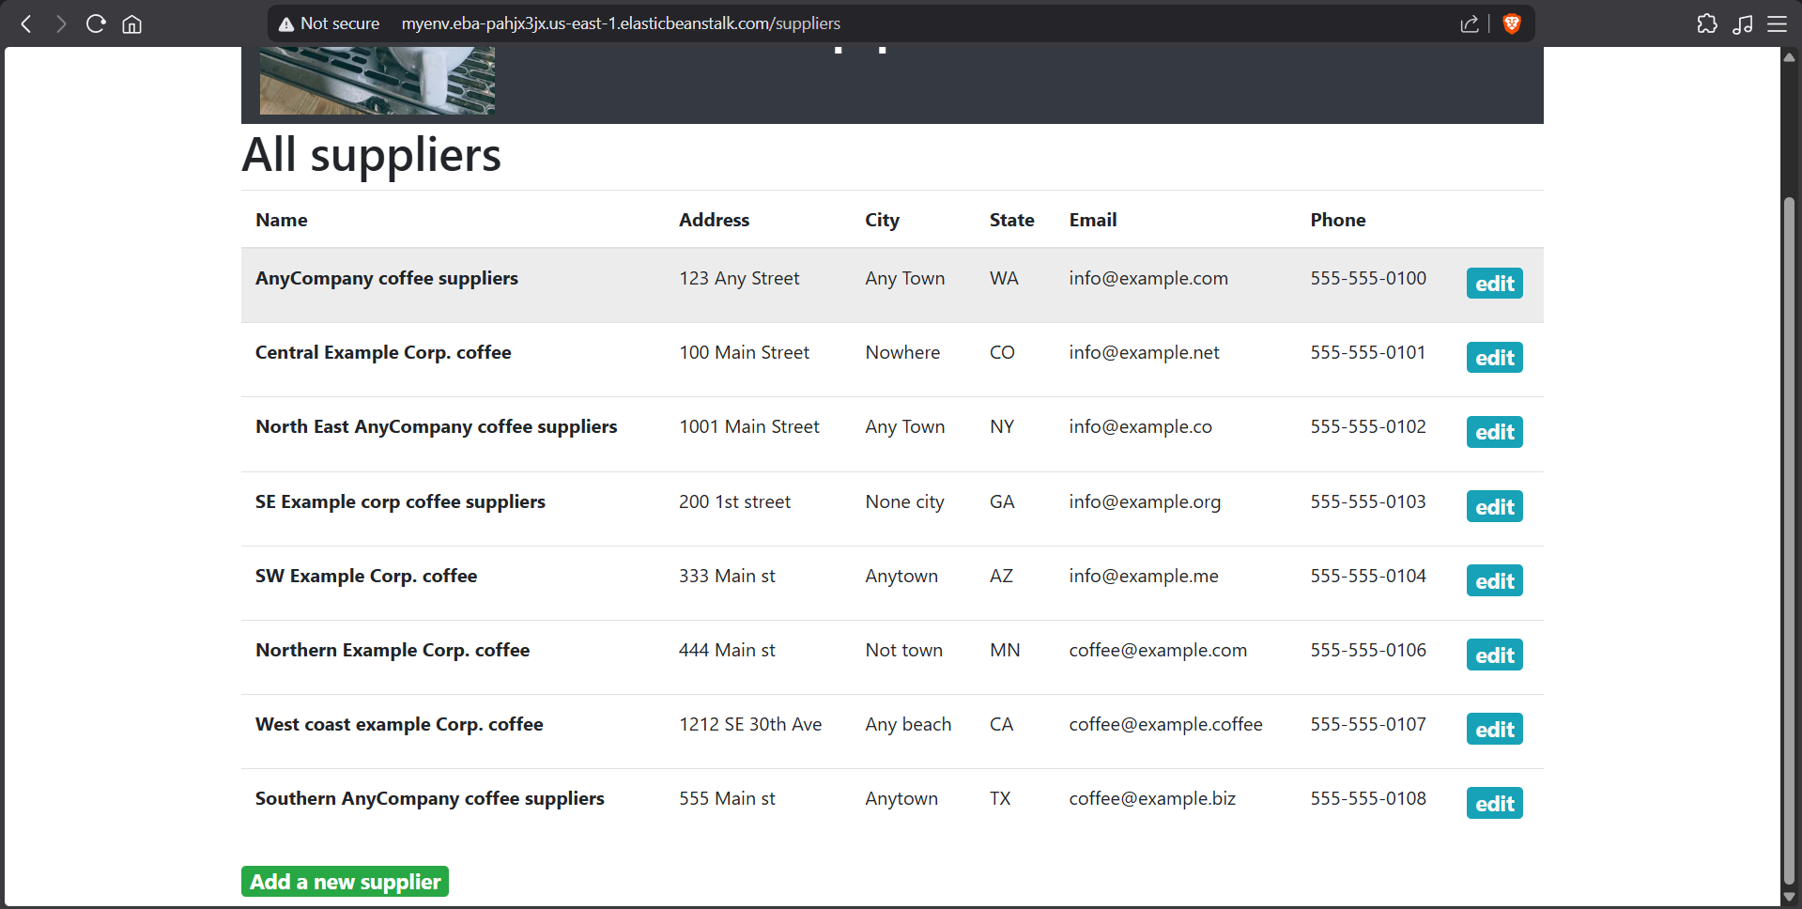
Figure 30: Adding a new supplier record through the web application form
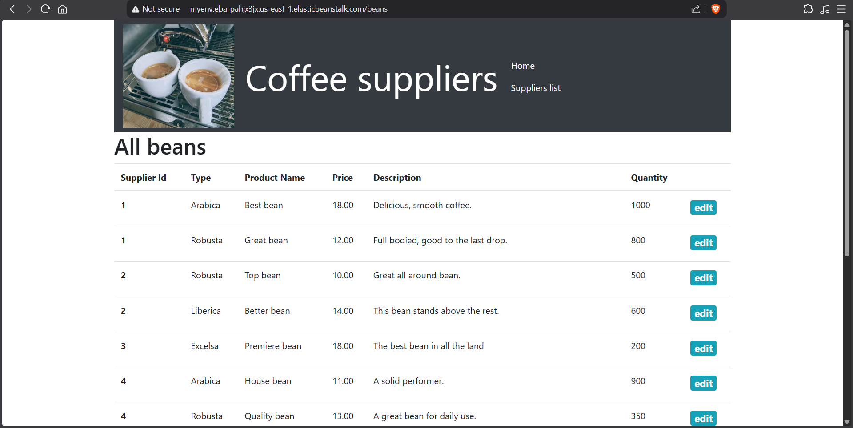
Figure 31: Running coffee_db_dump.sql using 'source' command to load supplier and beans data into Aurora
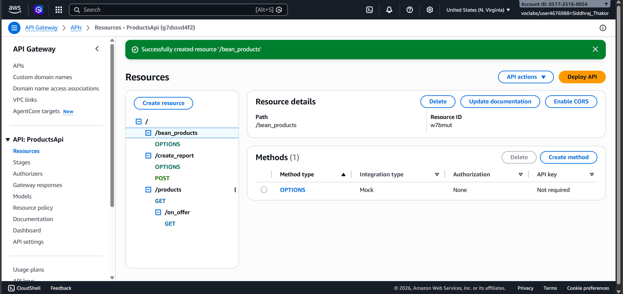
Figure 32: Querying suppliers table – 8 supplier records loaded from the SQL dump
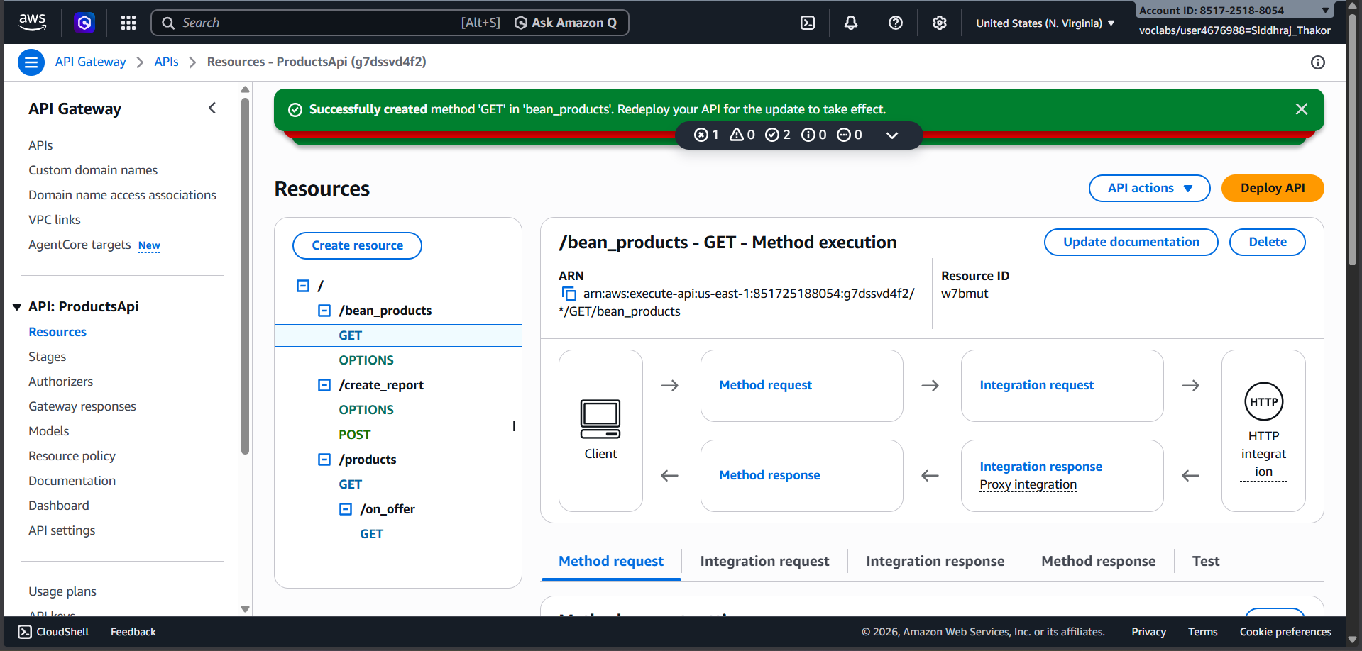
Figure 33: Querying beans table – 14 coffee bean inventory records loaded successfully
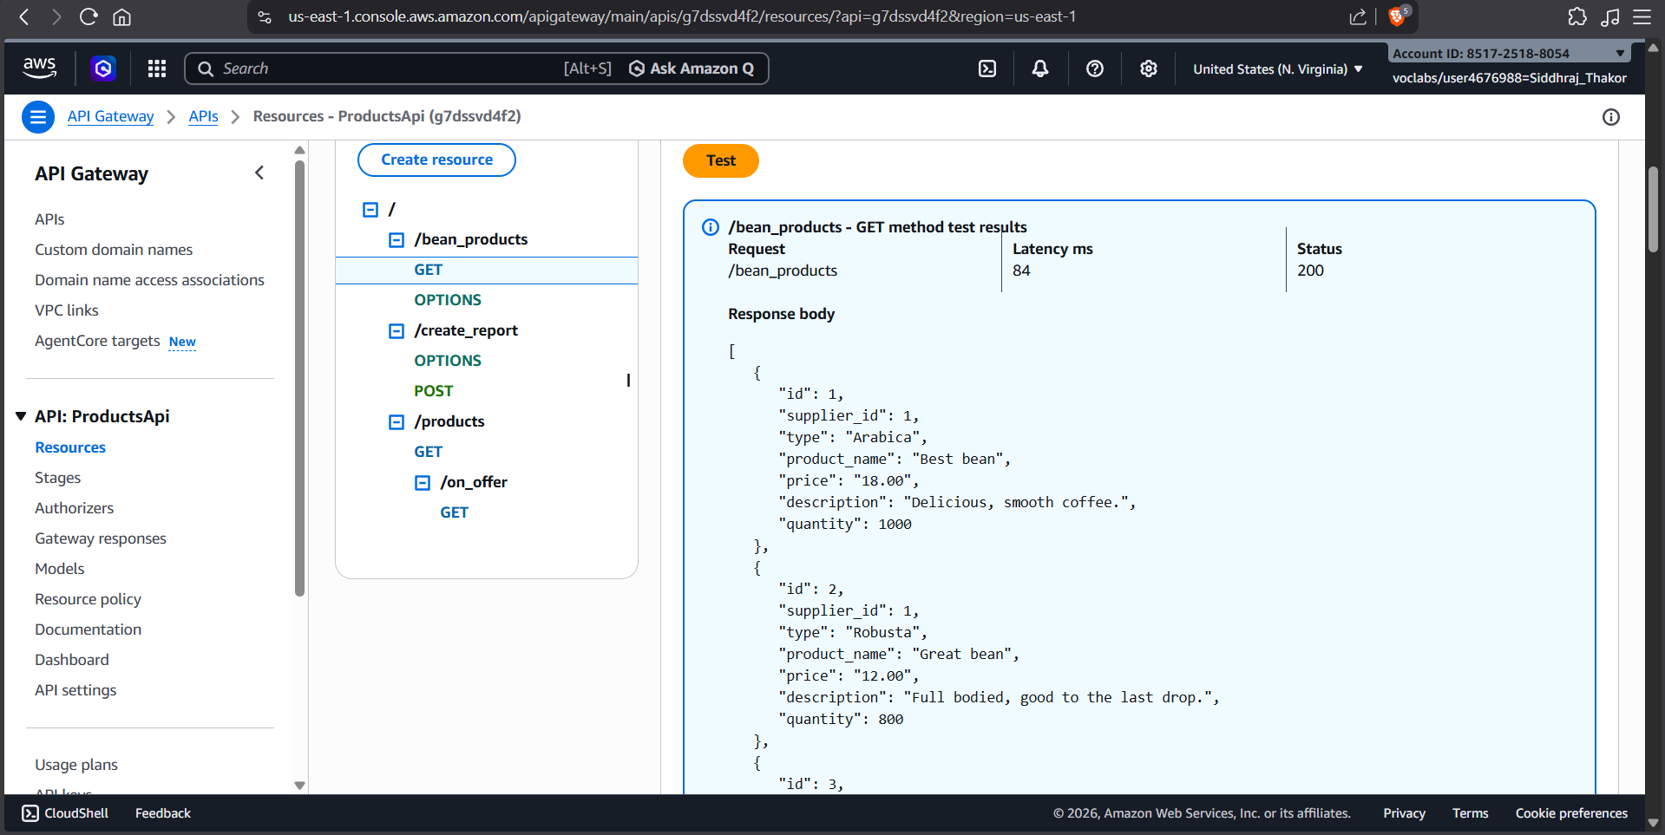
Figure 34: Coffee suppliers web application showing full supplier list after database seeding
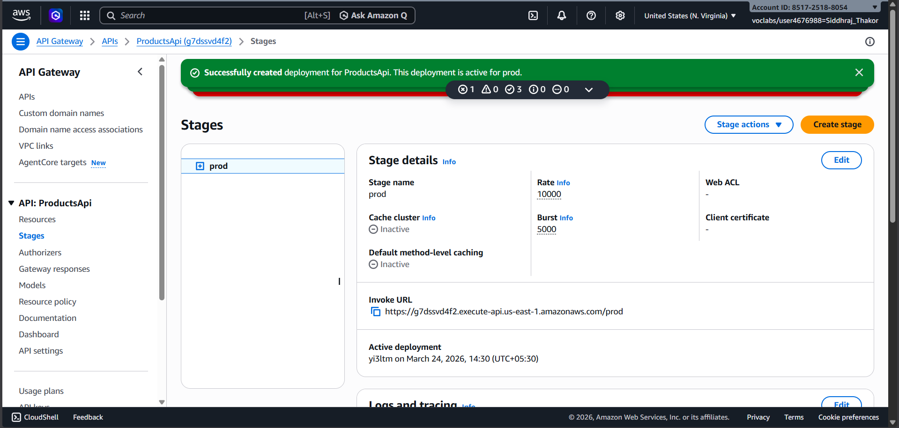
Figure 35: Elastic Beanstalk console – MyEnv environment Health showing OK after deployment
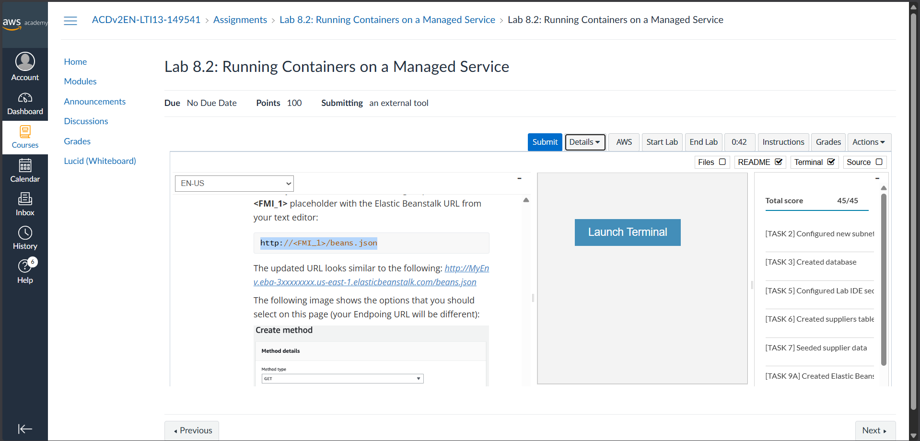
Figure 36: Deploying Dockerrun.aws.json to Elastic Beanstalk – uploading image URI from ECR
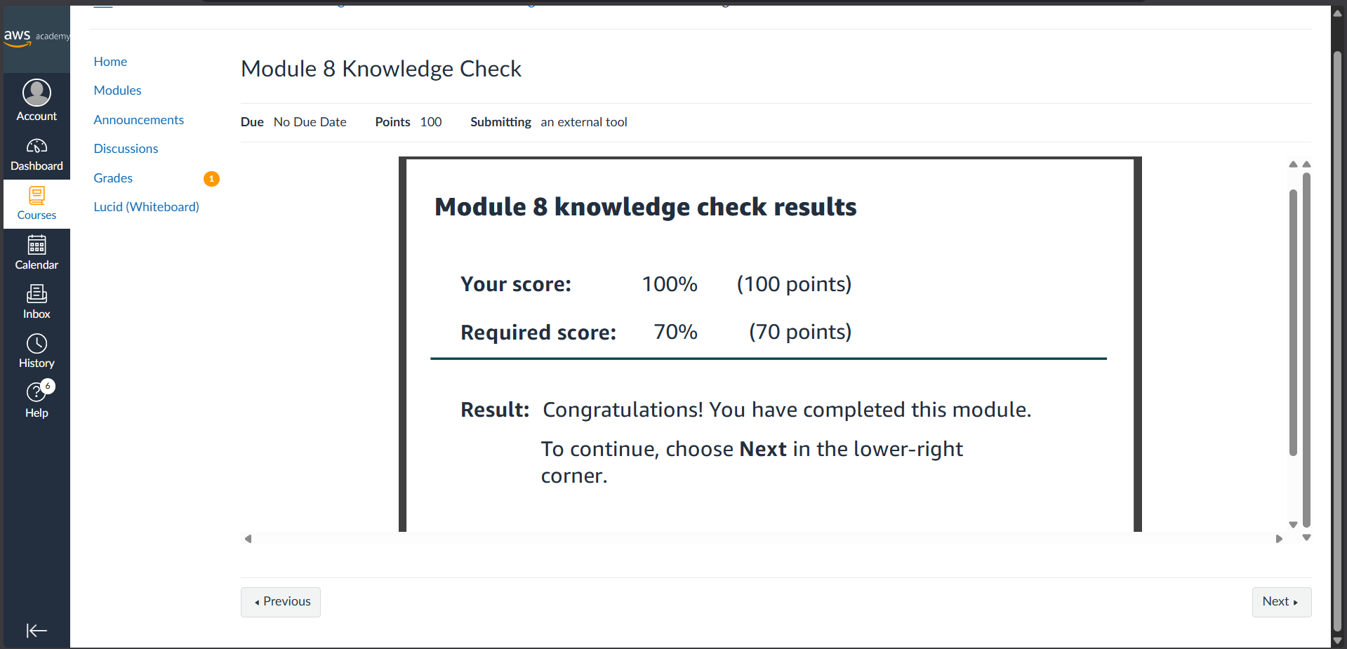
Figure 37: Lab 8.2 submission showing full score – Elastic Beanstalk, Aurora, and API Gateway all configured

Learning Outcomes
- Understood the limitations of running stateful relational databases in containers and the advantages of using Amazon Aurora Serverless as a managed, auto-scaling data platform.
- Learned to create and configure an Aurora Serverless v2 (MySQL-compatible) database instance including VPC, security groups, and enabling the RDS Data API.
- Gained hands-on experience using the Amazon RDS Query Editor to create database users, databases, tables, and to load data using a SQL script.
- Learned to configure VPC subnets across multiple Availability Zones to meet the networking prerequisites for Amazon RDS and load-balanced Elastic Beanstalk deployments.
- Understood how AWS Elastic Beanstalk simplifies Docker container deployment by managing the underlying EC2 instance, load balancer, and Auto Scaling group automatically.
- Learned to create a Dockerrun.aws.json file specifying the ECR image URI and container port, and deploy it to an Elastic Beanstalk environment.
- Gained experience reviewing and applying IAM policies and roles (aws-elasticbeanstalk-ec2-instance-policy) that grant EC2 instances the permissions needed to pull images from Amazon ECR.
- Learned to pass runtime configuration (APP_DB_HOST) as environment variables to Elastic Beanstalk-hosted containers, enabling dynamic database connectivity.
- Understood how to extend an Amazon API Gateway REST API with a new HTTP proxy integration resource (/bean_products) that forwards requests to an Elastic Beanstalk application endpoint.
- Gained practical experience integrating a static S3-hosted café website with a containerized backend application through API Gateway, completing a full serverless-to-managed cloud architecture.

References
- AWS Academy Cloud Computing Lab Manual – Module 8
- Amazon Aurora Serverless v2 Documentation: https://docs.aws.amazon.com/AmazonRDS/latest/AuroraUserGuide/aurora-serverless-v2.html
- AWS Elastic Beanstalk Developer Guide: https://docs.aws.amazon.com/elasticbeanstalk
- Amazon ECR Documentation: https://docs.aws.amazon.com/ecr
- Amazon API Gateway Developer Guide: https://docs.aws.amazon.com/apigateway
- AWS CLI Reference: https://docs.aws.amazon.com/cli
- Dockerrun.aws.json Reference: https://docs.aws.amazon.com/elasticbeanstalk/latest/dg/single-container-docker-configuration.html

