Practical – 10 Date : 05 / 10/ 2025
Aim: Evaluate and compare different firewall software solutions for enterprise network protection based on functionality and performance
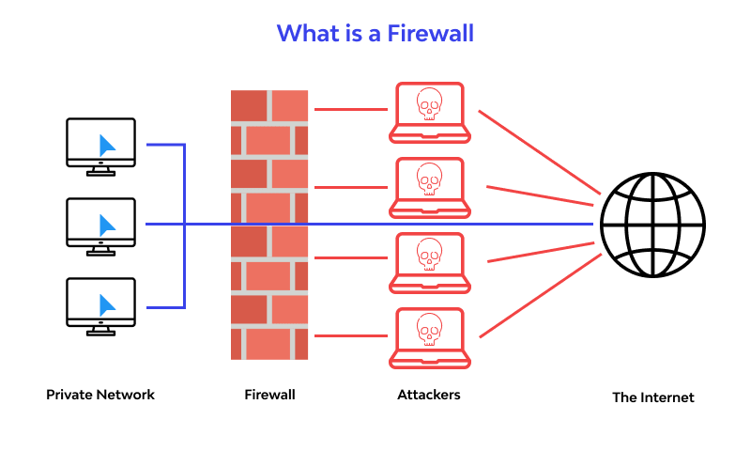
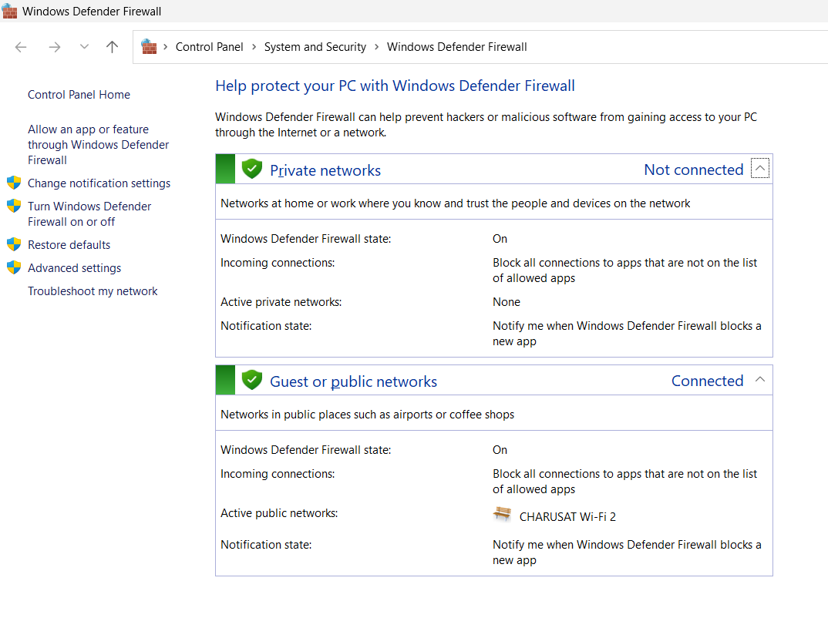
Firewall providers worldwide:

Category | Providers
Global Firewall Vendors (Hardware & Software) | Palo Alto Networks (NGFWs)  Fortinet (FortiGate)  Cisco (Firepower, ASA)  Check Point Sophos XG Firewall  Juniper Networks (SRX series)  SonicWall
Cloud Service Providers with Firewall Services | AWS  WAF & Network Firewall  Microsoft Azure Firewall  Google Cloud Firewall Oracle Cloud Infrastructure Firewall
Managed Security Service Providers (MSSPs) | IBM Security Services  AT&T Cybersecurity  Verizon Enterprise Security  NTT Security  HCLTech Cybersecurity Services  TCS (Tata Consultancy Services)

SELECTED:
Provider | Description
Palo Alto Networks | Known for Next-Gen Firewalls (NGFWs) with strong threat prevention, application awareness, and cloud integration.
Cisco Firewall | Offers Firepower and ASA series, widely used for enterprise networks with deep integration into Cisco’s ecosystem.
Fortinet (FortiGate) | Provides high-performance firewalls with built-in SD-WAN, VPN, and unified threat management at competitive pricing.
NGFWs (Next-Generation Firewalls) | Advanced firewalls that combine packet filtering, IDS/IPS, app control, and threat intelligence in one system.
SonicWall | Delivers cost-effective firewalls mainly for SMBs, with solid VPN, intrusion prevention, and easy management.

- Cisco Link
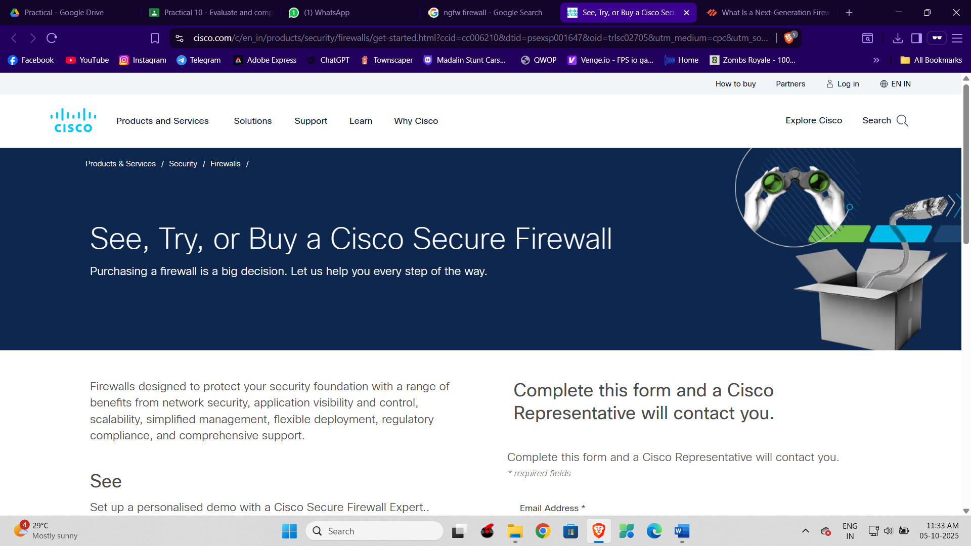

- Palo Alto Networks
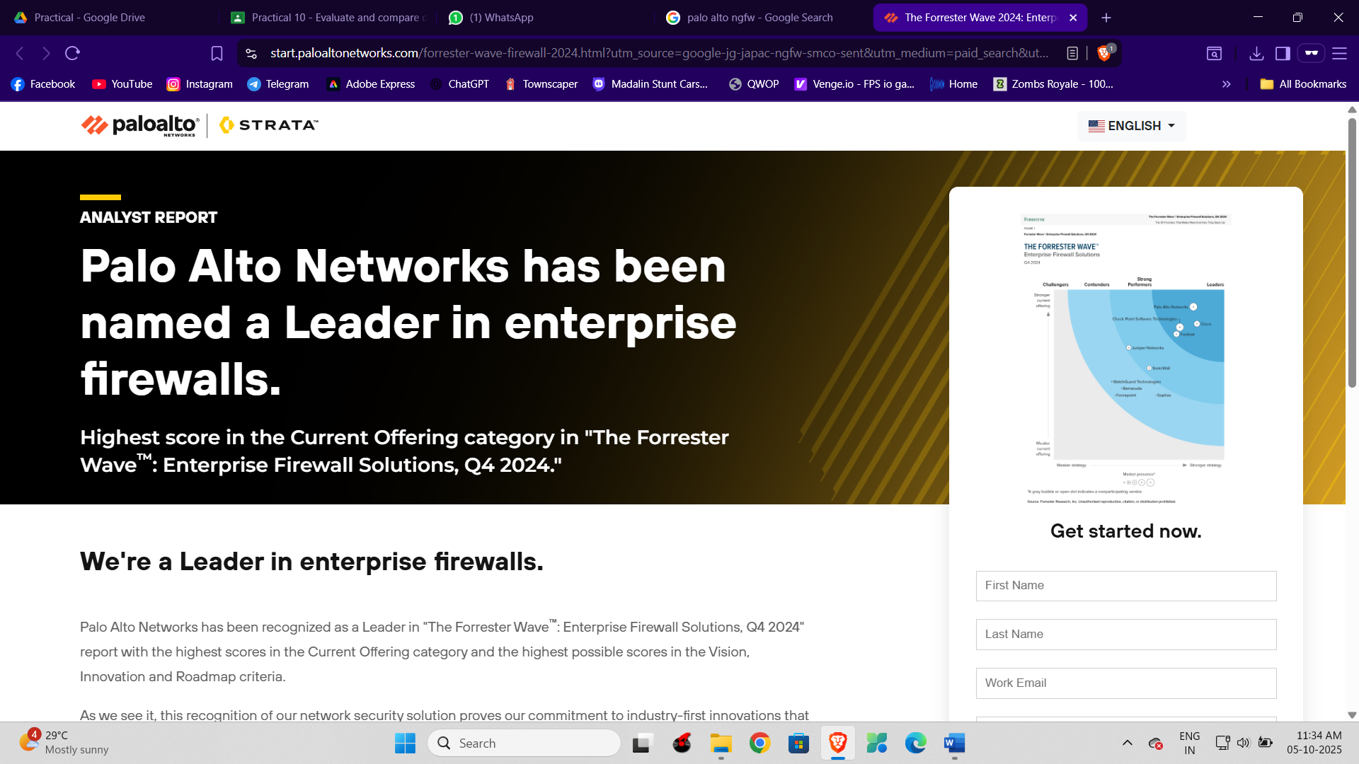
- Fortinet
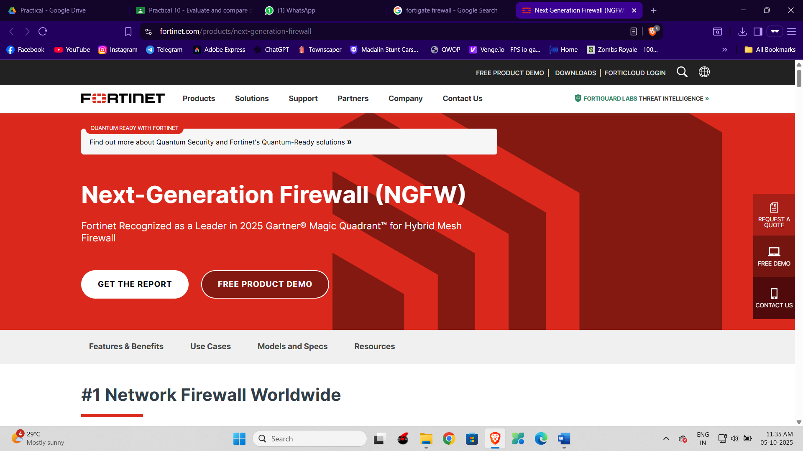
- NGFWs
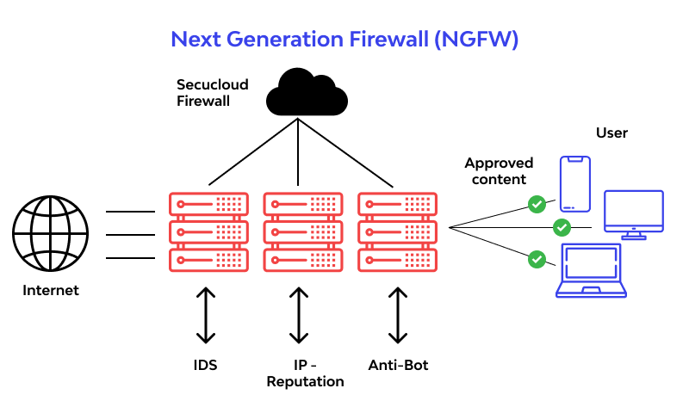
- SonicWall


Key Questions:
1. What are the key features of a good firewall?
Ans: : A good firewall inspects traffic, blocks unauthorized access, and allows trusted communication. Key features include deep packet inspection, intrusion prevention, VPN support, application control, centralized management, scalability, and strong logging.
2. How is firewall performance tested?
Ans. Performance is tested by simulating different traffic loads to measure throughput, latency, and connection handling. Independent labs also run real-world attack scenarios to check stability and effectiveness.
3. What is the role of packet filtering?
Ans. Packet filtering checks IP addresses, ports, and protocols of data packets to allow or block traffic. It acts as the firewall’s first line of defense against unauthorized access.

Supplementary Problems:

1. Compare hardware and software firewalls.
Feature | Hardware Firewall | Software Firewall
Definition | A dedicated physical device that filters traffic between networks (usually LAN ↔ Internet). | A program/application installed on a computer/server to filter traffic in/out of that system.
Deployment | Placed at the network perimeter (between internal network & external Internet). | Installed directly on end-user devices (PC, laptop, server) or sometimes as part of the OS.
Performance | Typically faster; has dedicated hardware (ASIC/CPU/RAM) for packet filtering, intrusion prevention, VPN, etc. | Depends on host system resources (CPU, RAM); may slow down the device if under heavy load.
Management | Centralized; controls traffic for entire organization/network. | Decentralized; must be configured on each device separately.
Security Scope | Protects entire network and connected devices. | Protects only the local device where it is installed.
Cost | Higher upfront cost (buying appliance, licensing, maintenance). | Usually cheaper or free (e.g., Windows Defender Firewall).
Examples | Palo Alto NGFW • Fortinet FortiGate Cisco Firepower • Check Point firewall appliances | Windows Defender Firewall (built-in) iptables on Linux Sophos Endpoint Firewall ZoneAlarm
Best For | Enterprises, data centers, ISPs – when you need high-performance network-wide security. | Individuals, small businesses – when  you need basic protection per device.

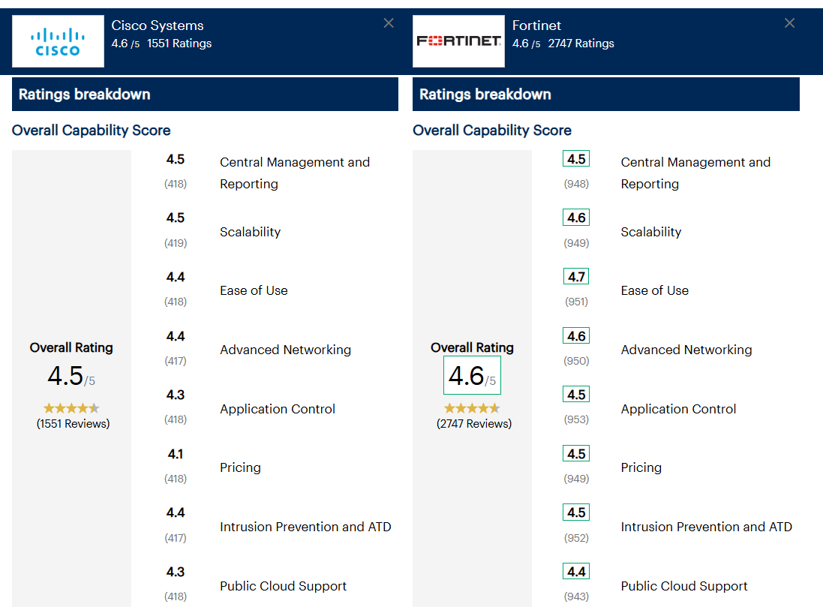

2. What are intrusion prevention systems (IPS)?
Ans: An Intrusion Prevention System (IPS) is a network security tool that monitors traffic in real time and blocks malicious activity before it can cause harm.
It’s like a security guard at the gate – not only watching for suspicious behavior but also stopping it instantly.
KeyFunctions of IPS:
- Traffic Monitroring
- Threat Detection
- Policy Enforcement
- Logging and Reporting
- Blocking Attacks

