Module Name: Boundary Value Analysis & Equivalence Partitioning
Test Case ID: st_07
Tester Name: sakhareliya sidhdh (Enrollment No: 2504030100105)
Webpage URL: https://www.selenium.dev/selenium/web/web-form.html

Scenario ID: BVA 01:- Enter Age = 17 in field
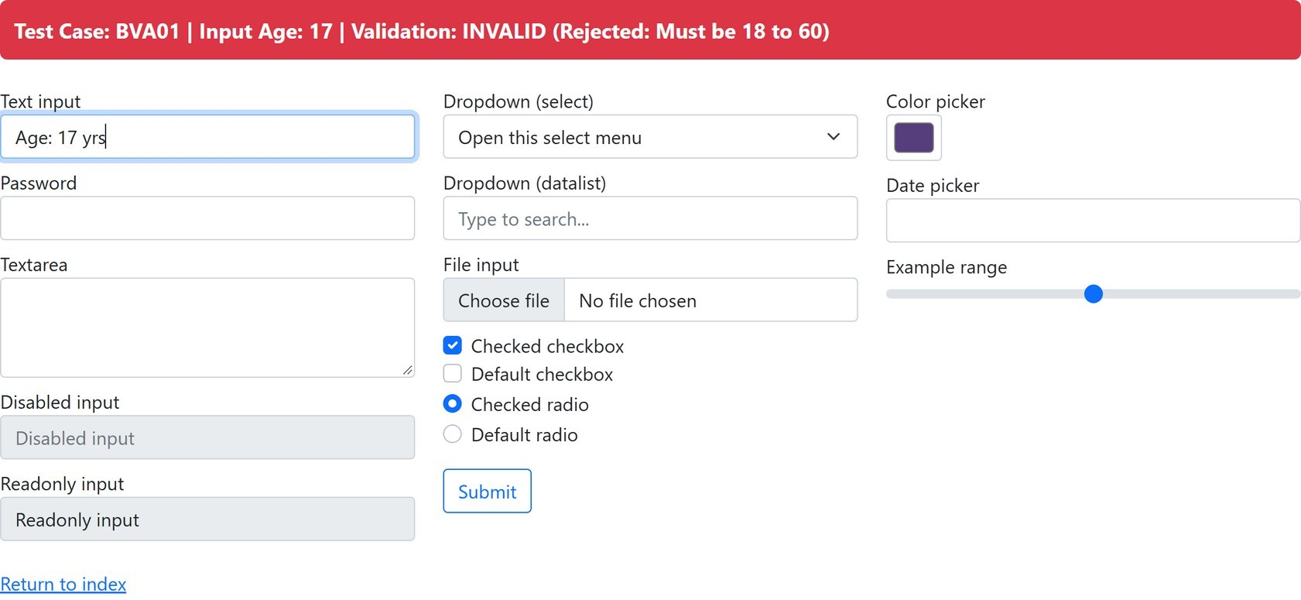

Scenario ID: BVA 02:- Enter Age = 18 in field
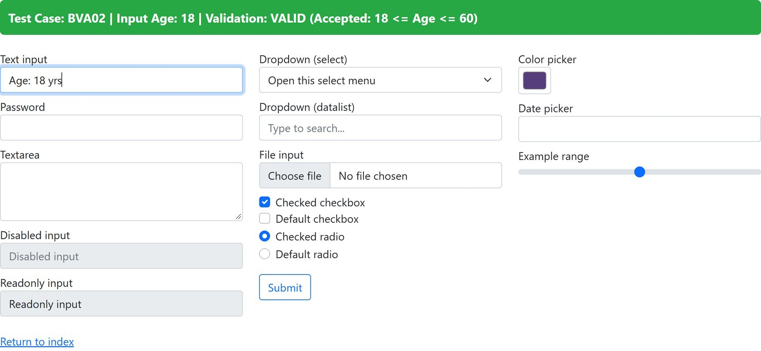

  - Scenario ID: BVA 03:- Enter Age = 19 in field

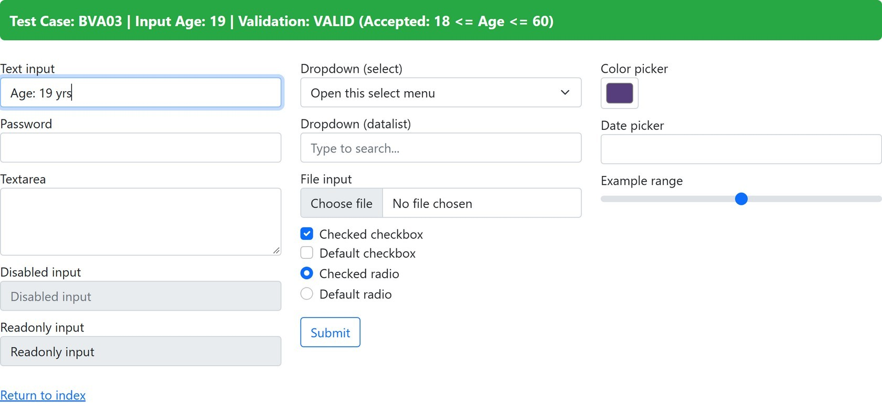

Scenario ID: BVA 04:- Enter Age = 59 in field
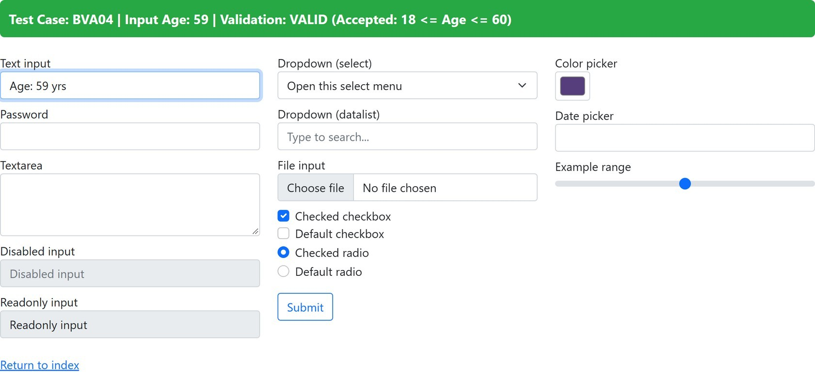

Scenario ID: BVA 05:- Enter Age = 60 in field

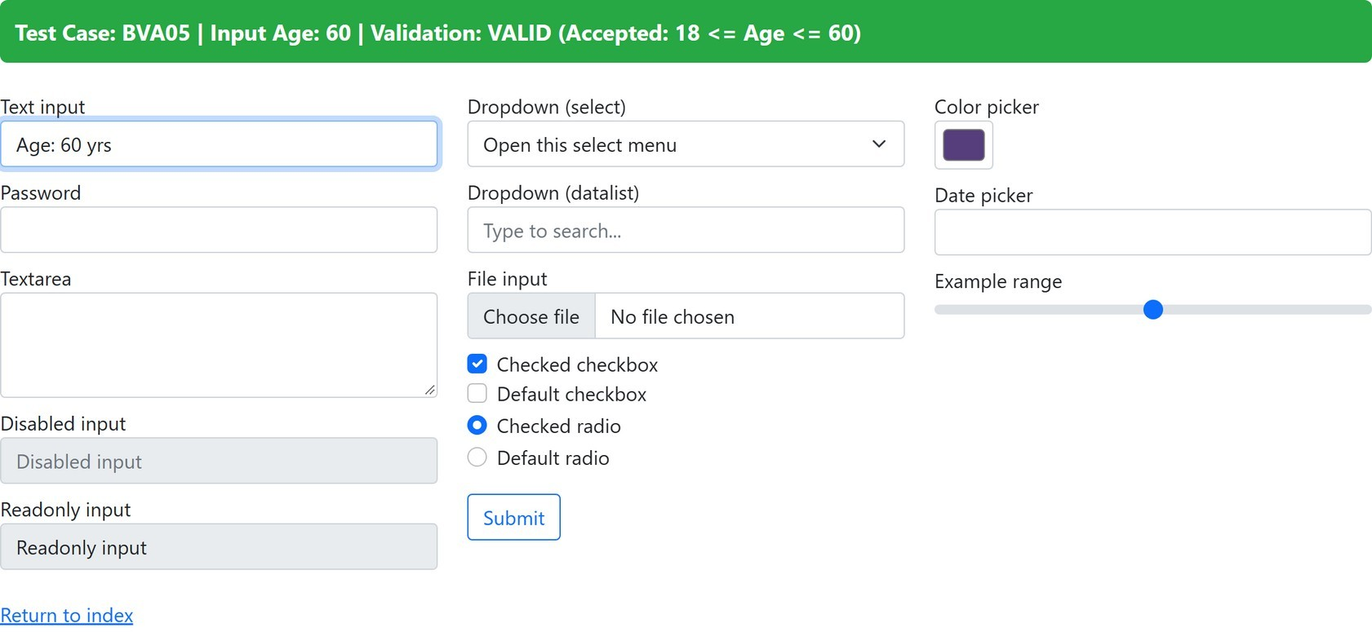

Scenario ID: BVA 06:- Enter Age = 61 in field

