Module Name: Bugzilla & TestLink
Test Case ID: st_8
Tester Name: Sakhareliya Sidhdh (Enrollment No: 2504030100105)
Webpage URL: https://www.instagram.com/

TC 01:- login page 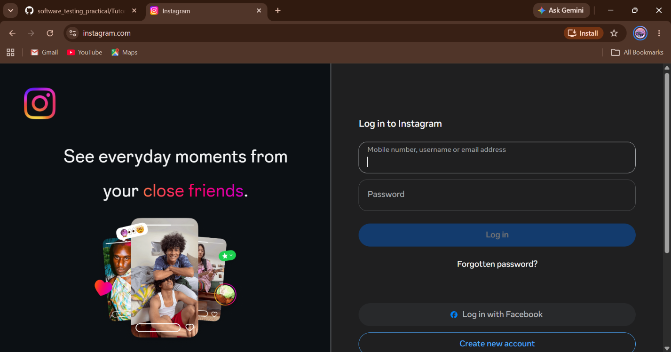
TC 02:-Login with valid credentials 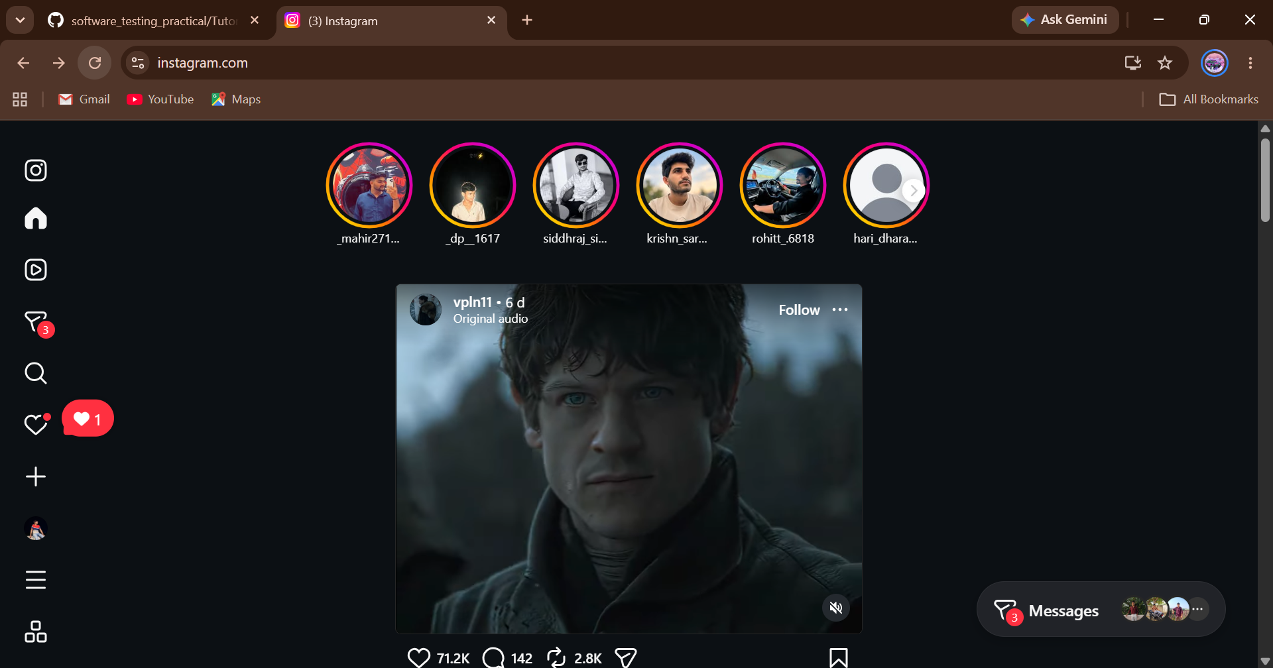
TC 03:-Login with invalid credentials 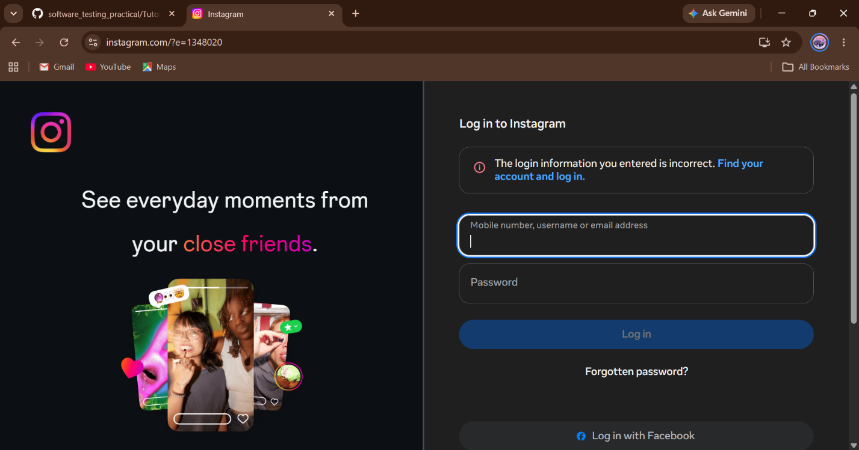
TC 04:-Blank username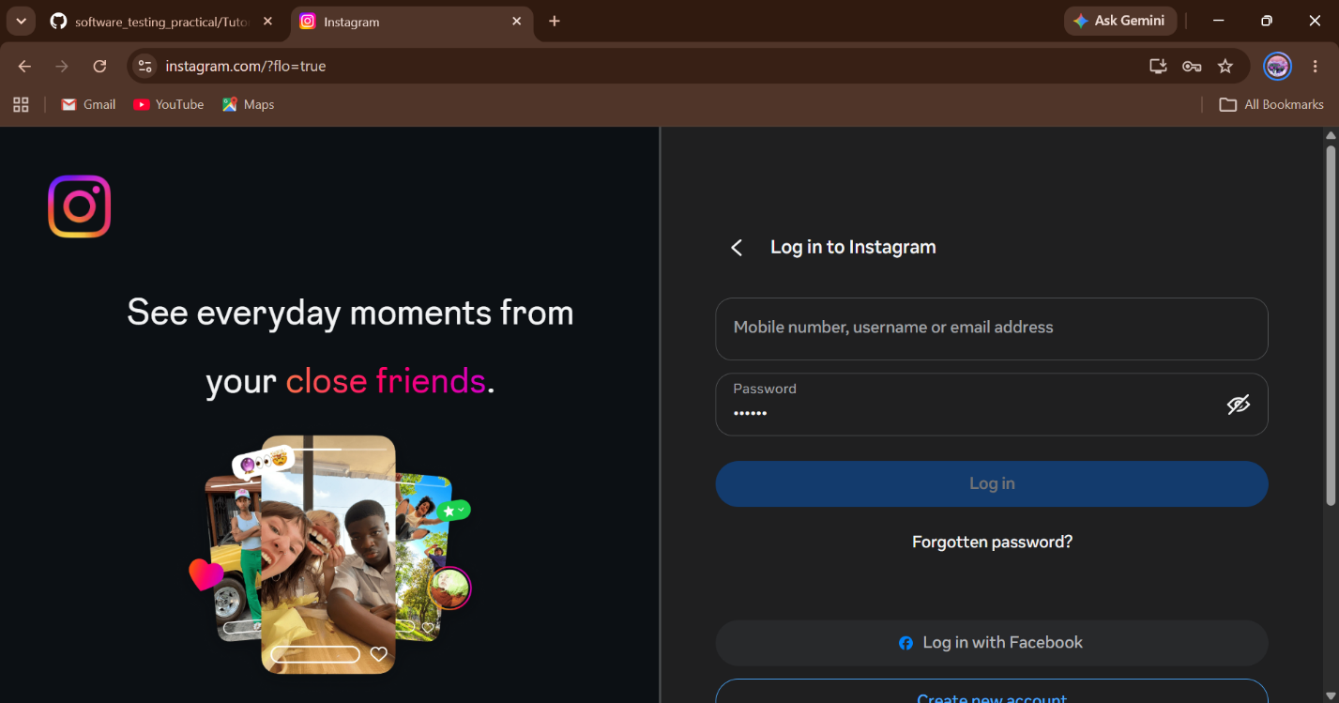
TC 05:-Blank password 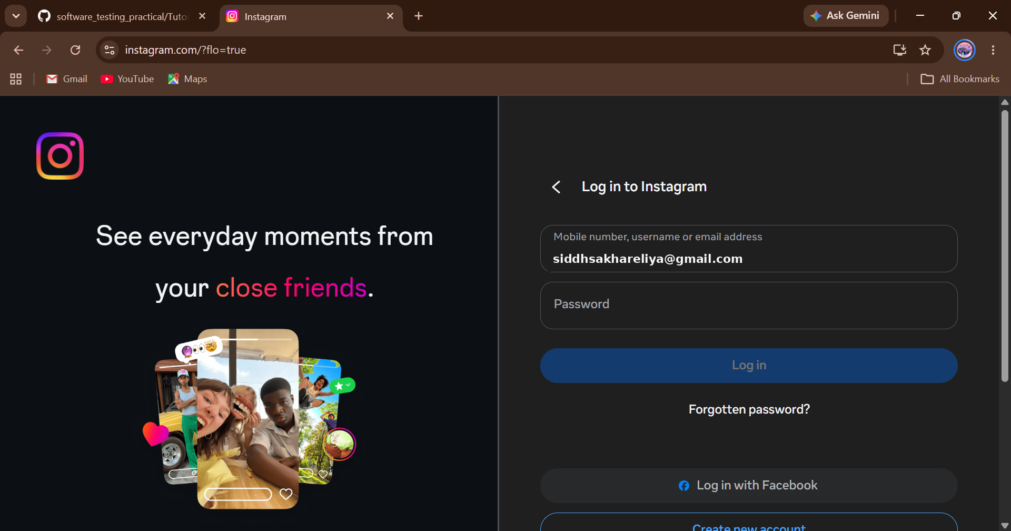
TC 06:-Both blank 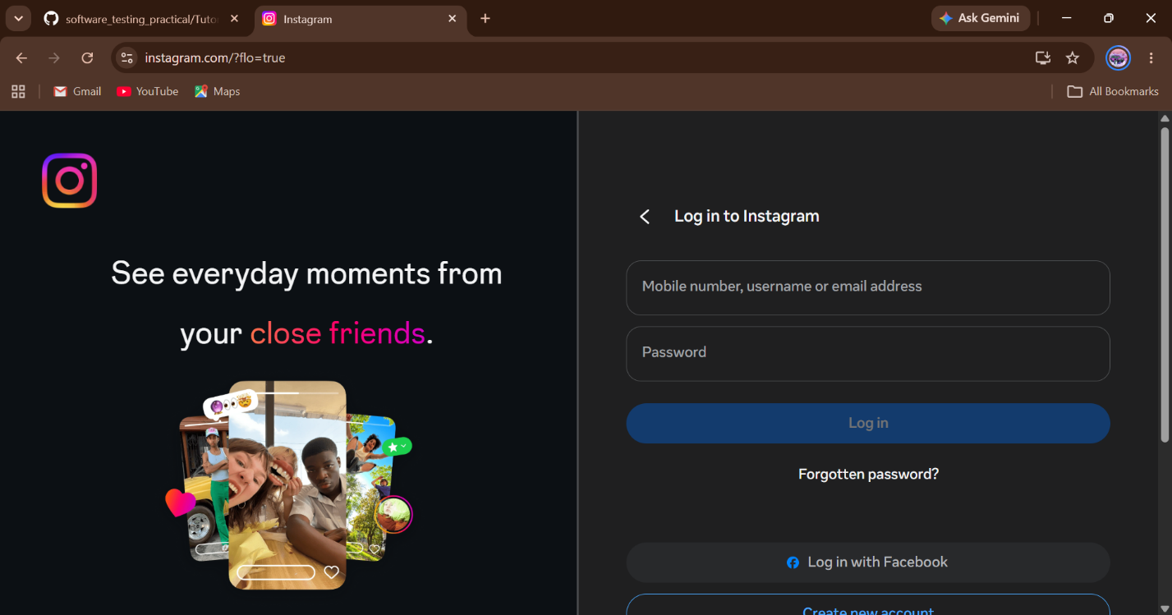
TC 07:-Logout successfully

