Module Name: Black-Box & White-Box Testing
Test Case ID: st_09
Tester Name: Sakhareliya Sidhdh (Enrollment No: 2504030100105)
Webpage URL: https://opensource-demo.orangehrmlive.com/

- Scenario ID: TC 001:- Valid login
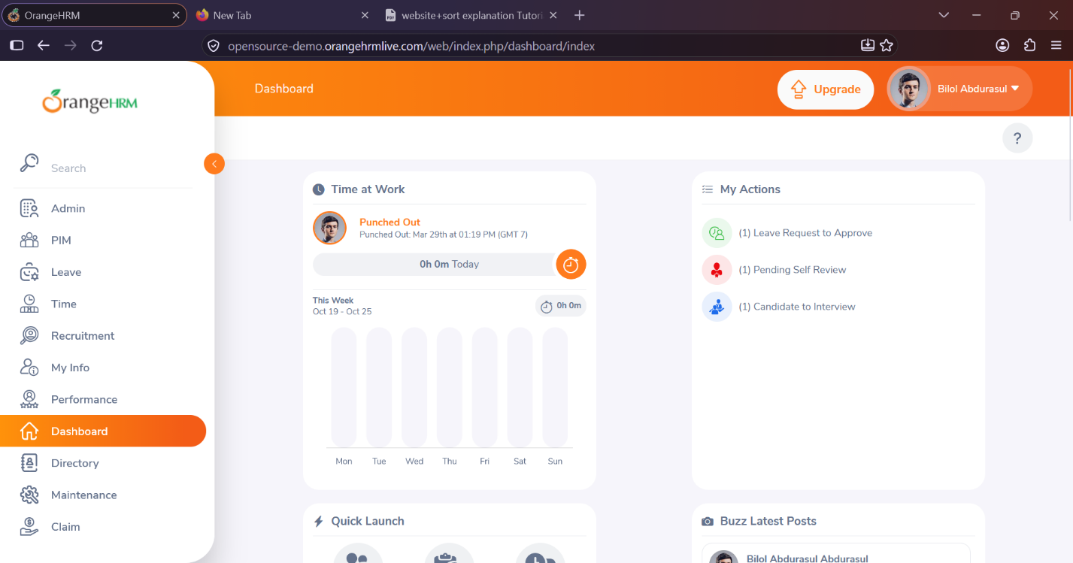
- Scenario ID: TC 002:- Invalid login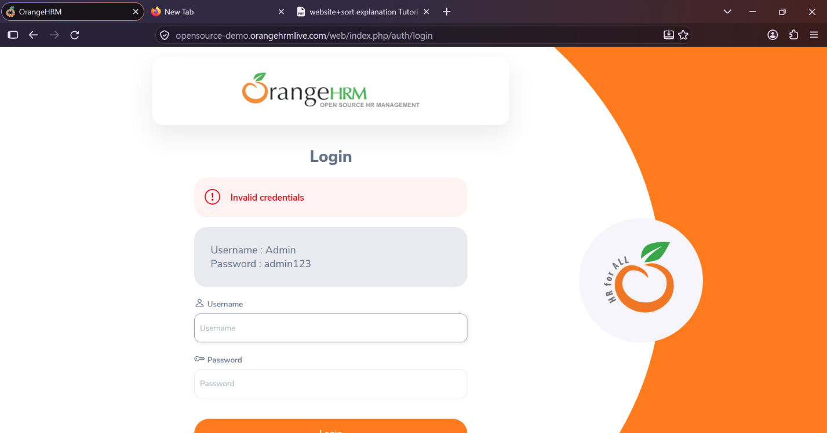

- Scenario ID: TC 003:- Blank login field
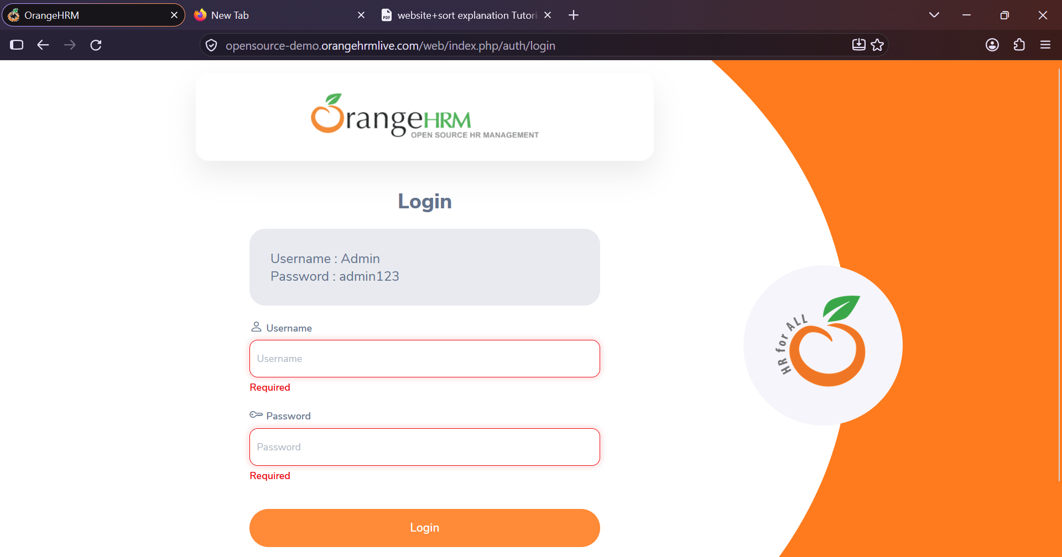
- Scenario ID: WB 001:- Dashboard
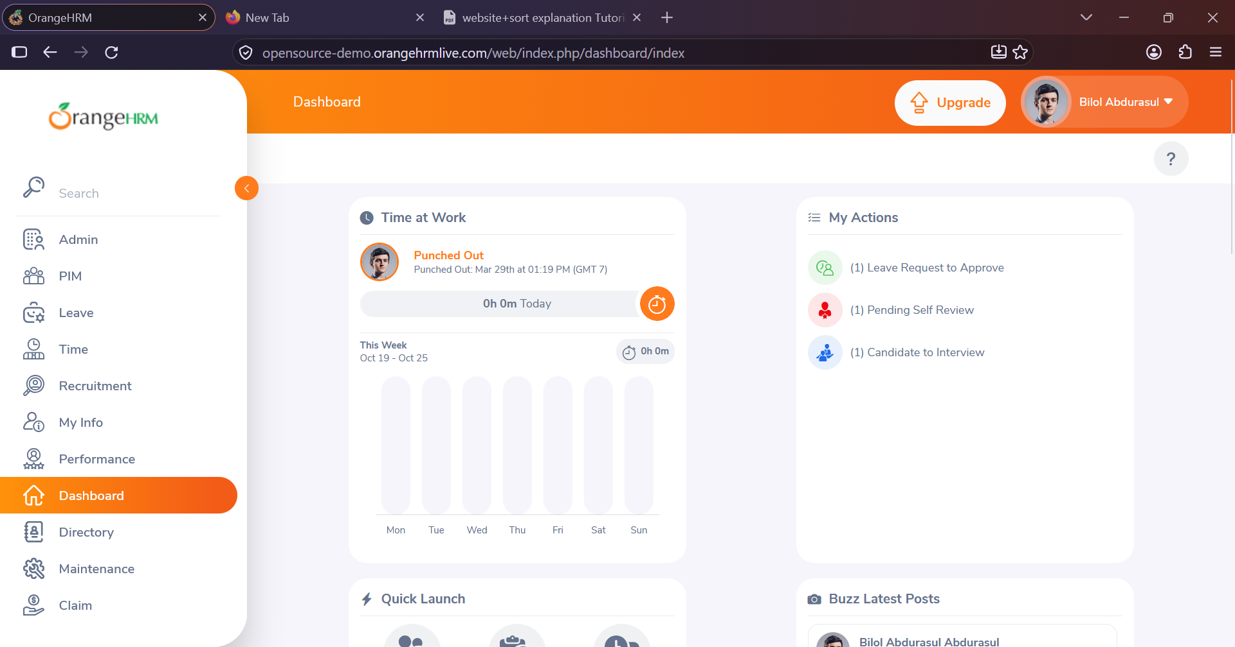

- Scenario ID: WB 002:- Employee management
