Module Name: Selenium Web Elements
Test Case ID: st_14
Tester Name: Sakhareliya Sidhdh (Enrollment No: 2504030100105)
Webpage URL: https://www.selenium.dev/selenium/web/web-form.html

SEL01:- Text box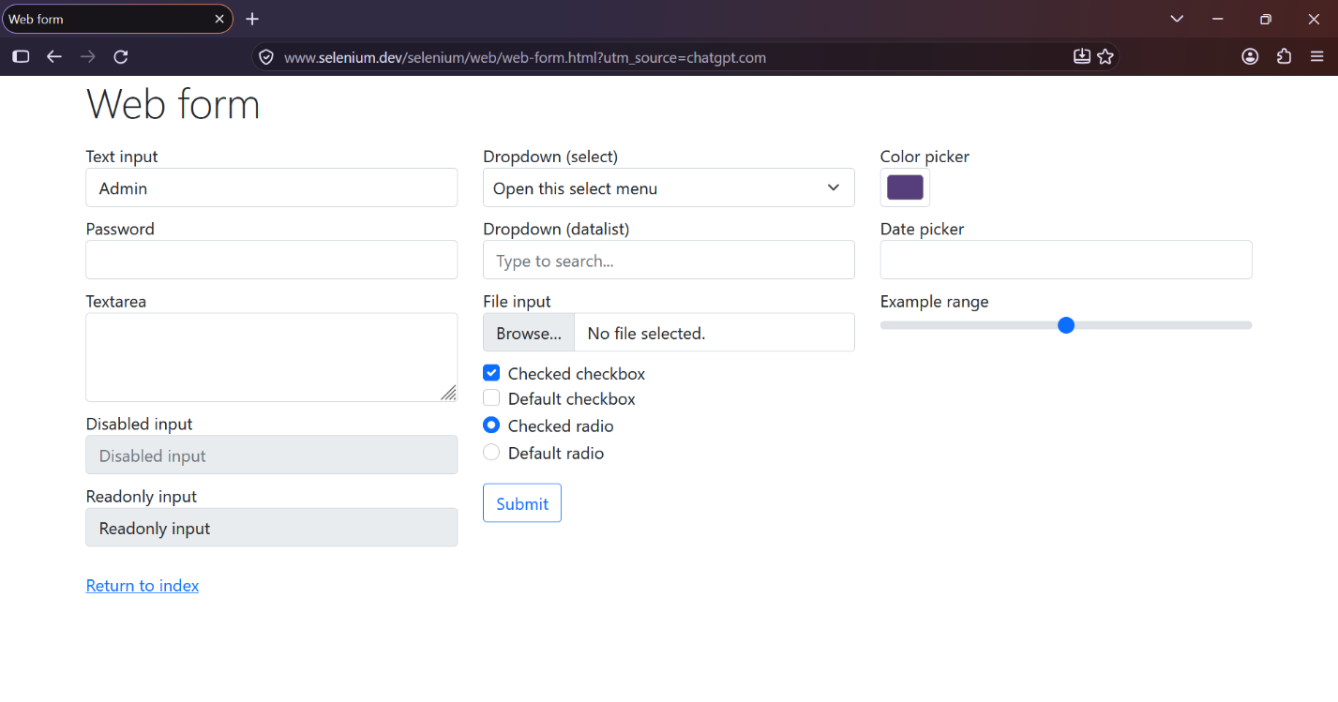
SEL02:- Password 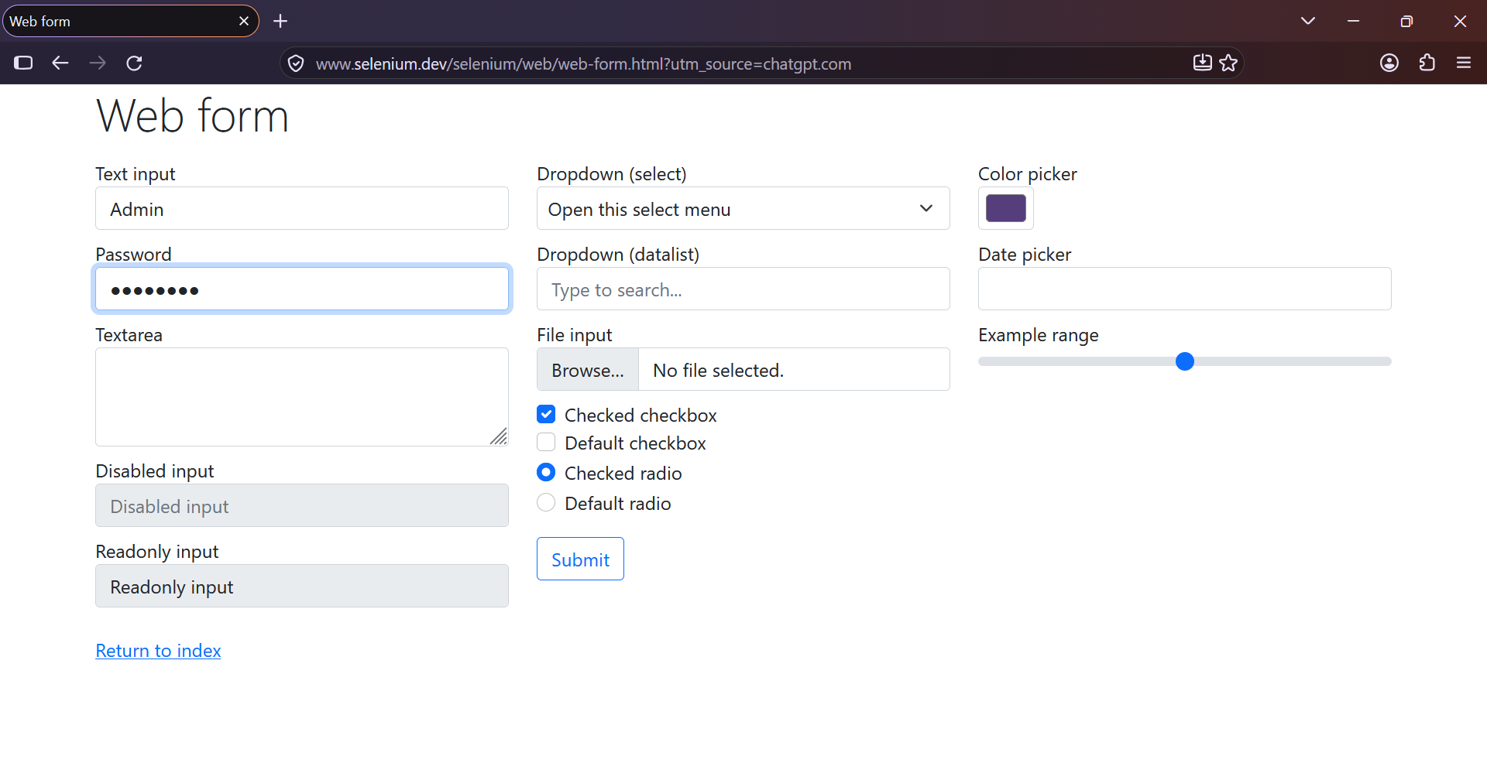
SEL03:- Text area 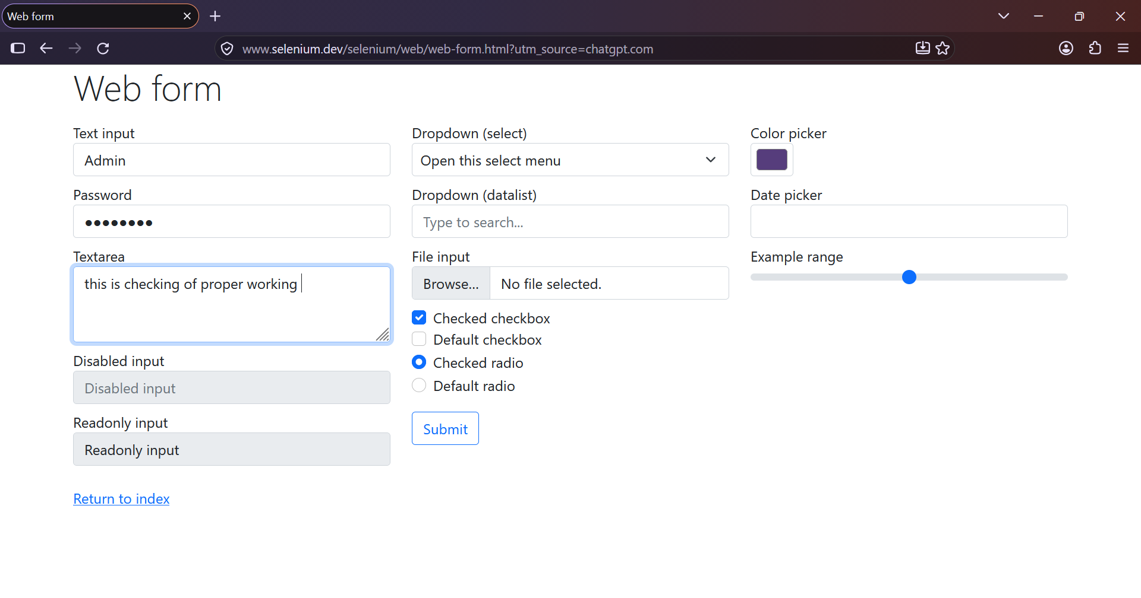
SEL04:- Dropdown 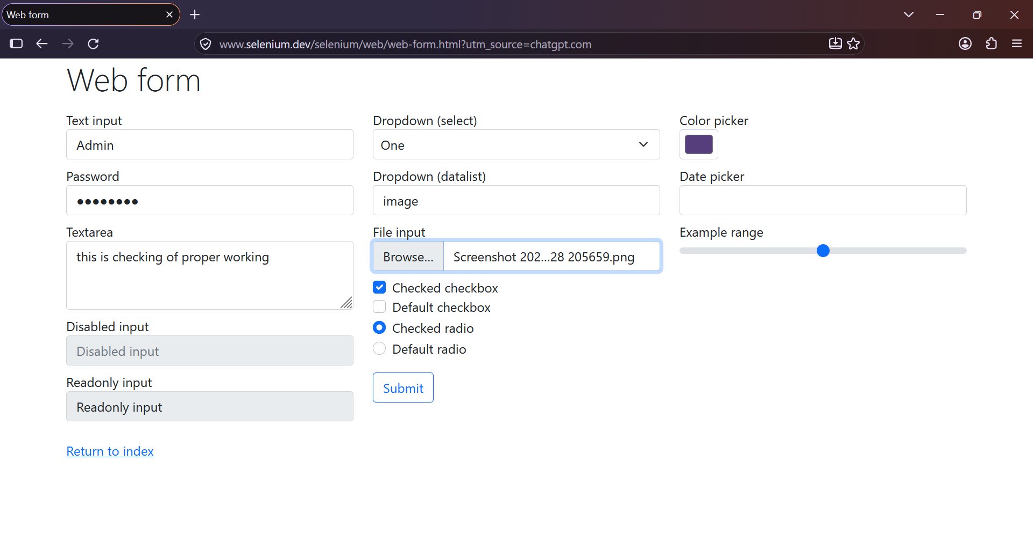
SEL05:- Checkbox 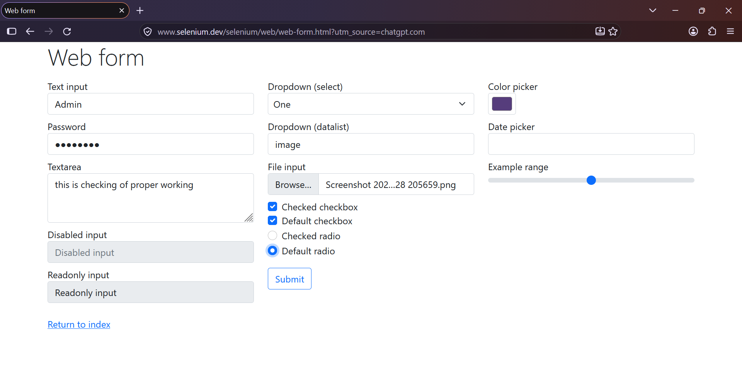
SEL06:- Radio button 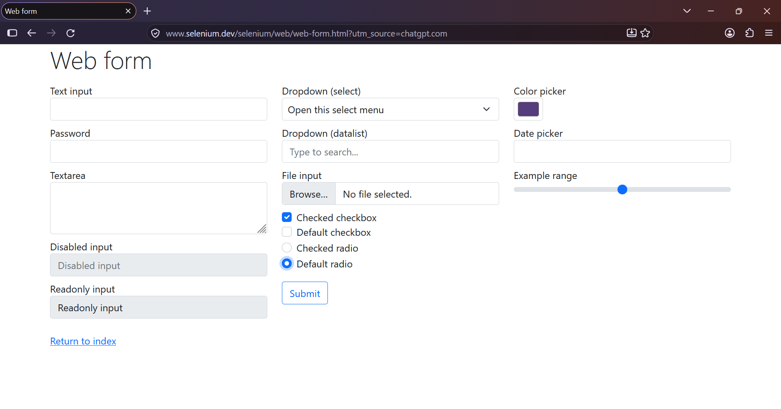
SEL07:- Date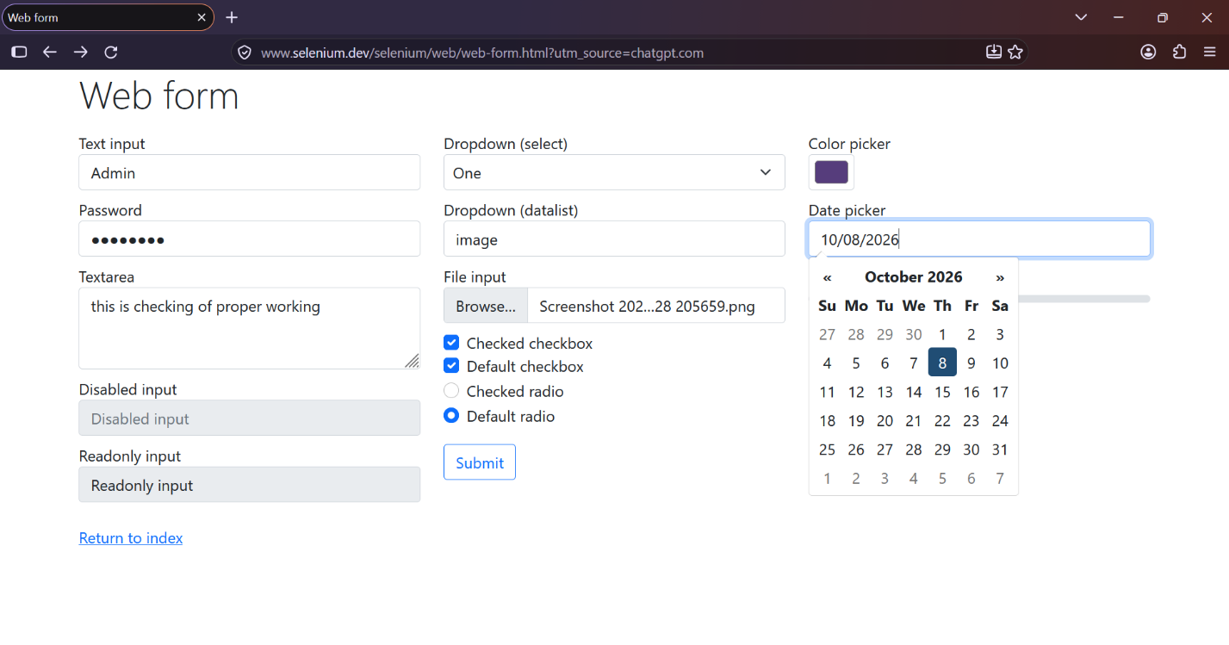
SEL08:- Submit 