VITyarthi | Open Source Software

The Open Source Audit

A Capstone Project for OSS NGMC Course

Course: Open Source Software | Unit Coverage: 1 – 5 Max Marks: 100

Student Name | Registration Number
SIDDHANT KUMAR | 24BAI10299
Slot | Date of Submission
A11 | 31-03-2026

Introduction

Open source software has become a very important part of the modern technology world. Open source software allows all users to access its complete source code.
The software is available for anyone to read and use and they can also make modifications.
The system allows only the originating company to access and modify the software code which differs from open source software. Open source software enables developers from different countries to work together on software development projects.

The developers can report issues and propose solutions while they introduce new capabilities to the system.The combined efforts of the team create software which becomes more dependable through time.

Numerous widely used tools in present times operate as open source software.
The Linux operating system and Python programming language and Firefox web browser serve as examples of open source software projects. The open source tools maintain their user base because they provide free access and their active user base constantly enhances their functionality.

I selected Git as my software auditing tool for this project. Developers use Git to track all modifications which they make to their code throughout different times.
Git enables multiple developers to work on the same project by preventing their code modifications from causing conflicts.

Developers can access any previous software version because the system maintains a complete record of all modifications.
Git has become one of the most popular tools which developers use throughout the globe.

All software projects which developers create use Git for version control purposes.
This report examines the origins of Git its licensing details and its operational functionality on Linux systems while comparing it to other software solutions.

Chosen Software

Software Name: Git
Category: Version Control System
License: GPL v2
Creator: Linus Torvalds

Approved software options

Software | Category | License | Why it's interesting
Linux Kernel | Operating System | GPL v2 | The foundation everything else runs on
Apache HTTP Server | Web Server | Apache 2.0 | Powers ~30% of all websites globally
MySQL | Database | GPL v2 / Commercial | A license with a  dual-model story to tell
Firefox | Web Browser | MPL 2.0 | A nonprofit fighting for an open web
VLC Media Player | Multimedia | LGPL / GPL | Plays anything — built by students in Paris
LibreOffice | Office Suite | MPL 2.0 | Born from a community fork — a real lesson
Python | Programming Language | PSF License | A language shaped entirely by community
Git | Version Control | GPL v2 | The tool Linus built when proprietary failed him

Project Report Structure

Part A — Origin and Philosophy (Units 1 & 2)

A1.The Problem Git Was Created to Solve

The creation of Git happened through the efforts of Linus Torvalds during the year 2005. The Linux operating system exists because Linus Torvalds created it. He did not build Git because he wanted to. He built it because he had no other choice. The Linux development team used BitKeeper before they created Git.

BitKeeper existed as a proprietary version control system which BitMover developed. BitMover provided free access to Linux developers under a special arrangement. The special arrangement between BitMover and Linux developers ended during 2005. A Linux developer attempted to examine BitKeeper's internal operations. BitMover considered this action to be a breach of their contract.

The company decided to remove Linux developers' access to their free license. The Linux project lost its code management tool without warning. Linus examined all the available free tools which included CVS and Subversion. He found all of the tools to be unsatisfactory. The tools worked too slowly to meet the demands of Linux which required faster performance. He needed a system which could deliver fast performance while operating through multiple locations. He decided to create the system because no existing solution could fulfill his requirements.

The first working version of Git was developed by Linus Torvalds during April 2005 after ten days of work. He named it Git which is a British slang word meaning a silly or unpleasant person. He later joked that he always names his projects after himself.
The biggest difference Git brought was the concept of distributed version control. CVS used a system where developers needed to access a central server which held all project files.

The developers needed to connect to that server in order to perform their tasks. The complete shutdown of work occurred when the server experienced downtime. Git completely transformed this system.

Every developer keeps a complete project duplicate which they store in their personal computer. The user can perform save operations and branch creation and history checking without any need for online access.

The system requires connection only during times when you need to present your work to other people. This method established a collaborative system which enabled teams to work together with increased speed and better adaptability.
The Linux Kernel project switched to Git very quickly after it was released.
Other open source projects also started using it soon after.

In 2008 GitHub established itself as a platform which operated through Git. Git became widely adopted across all software development fields because of its initial success in open source projects. Git has become the primary tool used by almost all software developers worldwide.

The process of software development requires Git to function properly. Git exists because proprietary software failed to meet the needs of the open source community. The situation demonstrates how important it is to have complete control over your equipment.

A2.License Analysis — GPL v2
The software Git operates under the GNU General Public License version 2 which people commonly refer to as GPL v2.
Richard Stallman together with the Free Software Foundation created this licensing agreement.This license rank as one of the most recognized open source licenses throughout the globe.
The Four Freedoms of Free Software:
- Freedom 0 — The freedom to run the program for any purpose
- Freedom 1 — The freedom to study how the program works and change
- Freedom 2 — The freedom to share copies of the program with other
- Freedom 3 — The freedom to share your modified versions with others
Git grants all four of its freedoms to everyone who uses its software.
Can a company modify Git and sell it without sharing changes?
No they cannot.
The GPL v2 license includes a copyleft rule that requires licensees to follow particular restrictions.
The requirement states that if you make software modifications which you distribute then you must provide the modified source code using the same GPL v2 license.
You cannot take Git change it and sell it as a closed product.
All modifications need to be accessible to all people.
GPL vs MIT License:
The GPL license requires that any modified version must also be shared openly.The MIT license permits users to change software but they must keep their modified versions secret.A company can take MIT licensed code change it and sell it without sharing anything back.
I would choose GPL v2 for my project because I need users to share their improvements with the entire community.The license requires all future developments based on my work to be shared with the community.
MIT license permits companies to take your work without needing to return anything to you.
Free as in Free Beer vs Free as in Freedom:
The phrase free as in free beer indicates that software can be used without any cost to the user.Free as in freedom means you have the right to use study change and share the software.
Git provides both.
Users can access Git without any payment while they have complete permission to examine its source code and make modifications and redistribute their changes.
The software achieves its status as free software through this specific feature.

A3.Ethics of open source

Open source software is built on the idea that knowledge should be shared freely. This is a very strong and positive idea. But there are also some complicated questions around it.

Should all software be open source?

There are good arguments on both sides of this question.
On one side open source software is better for society because anyone can check it fix it and improve it. It does not belong to one company so no single company can control it or take it away. It also allows people in poorer countries to access powerful tools without paying.

On the other side some companies need to keep their code private to survive. If a small startup spends years building a product and anyone can copy it for free that company might not be able to pay its employees. So forcing all software to be open source could actually reduce innovation in some cases.

My personal opinion is that software built with public money like government tools and educational software should always be open source. But private companies should have the choice.

Is it ethical for companies to profit from free community labor?

This is a tricky question. Companies like Google and Meta use Linux every day to run their businesses and make billions of dollars. Linux was built by thousands of volunteer developers. Some people feel this is not fair.

But many of these companies also contribute back to open source. Google has released many open source tools. Red Hat built its entire business on Linux and contributes a lot of code back. So it is not always a one way relationship.
The problem is when companies only take and never give back. That is where the ethical line gets crossed.

Standing on the shoulders of giants:

This phrase means that every new thing we build is built on top of what others built before us. In software this is very true. Every app every website every tool uses open source libraries and systems underneath. Git itself is built using the C programming language which is also open source. Open source does not stop innovation. It actually enables it by giving everyone a strong foundation to build on.

Part B — Linux Footprint (Unit 2)

Git can be easily installed on any Linux system using the package manager.

Installation Command: sudo apt install git

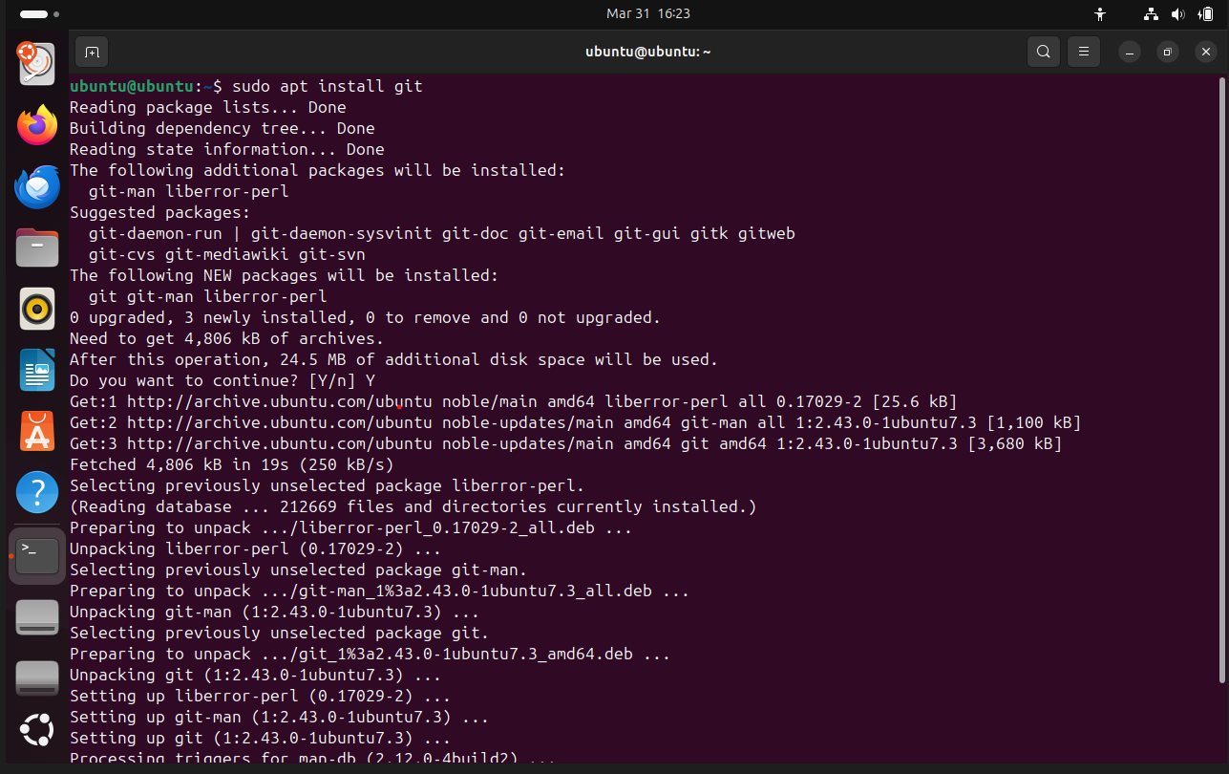
Important Directories:

- Binary location: /usr/bin/git
- Global config file: /etc/gitconfig
- User config file: ~/.gitconfig
- Repository data: .git/ folder inside each project

User and Permissions:

Git runs as the normal logged in user.
It does not need root or administrator access to work.
This is good for security because it means Git cannot accidentally change important system files. Each user manages their own repositories independently.

Service Management:
Git is not a background service.
It does not run continuously like a web server.
It only runs when you type a Git command in the terminal.
So there is no need to start or stop it as a service.
Update Model:
Git updates are handled by the package manager just like any other software.

sudo apt update
sudo apt upgrade git

When the Git community releases a security patch or new version it goes into the package repositories. The next time you run apt upgrade your system will automatically get the latest version. This is one of the advantages of open source software. Security fixes come from the whole community and reach users quickly.

Part C — The FOSS Ecosystem (Units 3 & 4)

Git does not work alone.
It is part of a much larger open source ecosystem.

Dependencies:

- GCC — the GNU C compiler used to compile Git from source
- OpenSSL — used for secure connections
- libcurl — used for transferring data over the internet
- Standard C libraries — the basic building blocks Git is written with

Platforms and Tools Built on Git:

- GitHub — the most popular platform for hosting Git repositories online
- GitLab — an open source alternative to GitHub that you can host yourself
- Bitbucket — another Git hosting platform used mostly in companies
- Gitea — a lightweight self hosted Git service

What Git has inspired:

Git changed how the entire software industry thinks about version control.
Before Git most companies used centralized tools.
After Git the distributed model became the standard.
Git also made open source collaboration much easier which helped projects like Linux Firefox and Python grow faster.

Community and Governance:

Git has a large and active global community.
The main development happens through a public mailing list called git@vger.kernel.org.
Contributions are submitted as patches and reviewed by maintainers.
Junio C Hamano has been the main maintainer of Git since 2005 when Linus handed it over to him. There are also regular Git developer meetings and the project is discussed at conferences like Linux Foundation events.

Relation to the LAMP Stack:
LAMP stands for Linux Apache MySQL and PHP.
Git is not directly part of the LAMP stack but it is used to manage and deploy the code that runs on LAMP servers.
Almost every web developer uses Git to push their code to a server.
So while Git is not inside the stack it sits right above it in every real world project.

Part D — Open Source vs Proprietary (Critical Analysis)
The closest proprietary alternative to Git is a tool called Perforce also known as Helix Core. It is used by large companies especially in the gaming and enterprise software industry.
Dimension | Open Source | Proprietary Alternative
Cost | Completely free | Expensive paid licenses
Security (who can audit the code?) | Anyone can audit the code | Only the company can check it
Support and reliability | Community forums Stack Overflow documentation | Paid official support
Freedom to modify | Full freedom under GPL v2 | Full freedom under GPL v2

Overall Verdict:
Git is a much better choice for most developers and teams. It is free powerful and supported by a massive community. The only area where Perforce has an advantage is in handling very large binary files which Git does not do as well. For large game studios that work with huge asset files Perforce can sometimes be a better fit.
But for the vast majority of software projects Git is the right choice. It is fast reliable and available to everyone for free.
I would definitely recommend Git for any real world deployment. I would also like to contribute to Git in the future. Even small contributions like improving documentation or reporting bugs are valuable. Open source projects like Git survive because people participate. And I think that is something worth being part of.

Shell Script Tasks

Script 1 — System Identity Report (Unit 1 & 2)

What this script does: This script displays basic information about the Linux system. It shows the kernel version the current user the home directory system uptime and the current date and time. It also displays the license that covers the operating system.

Concepts used: variables echo command substitution $() if-else for time based greeting

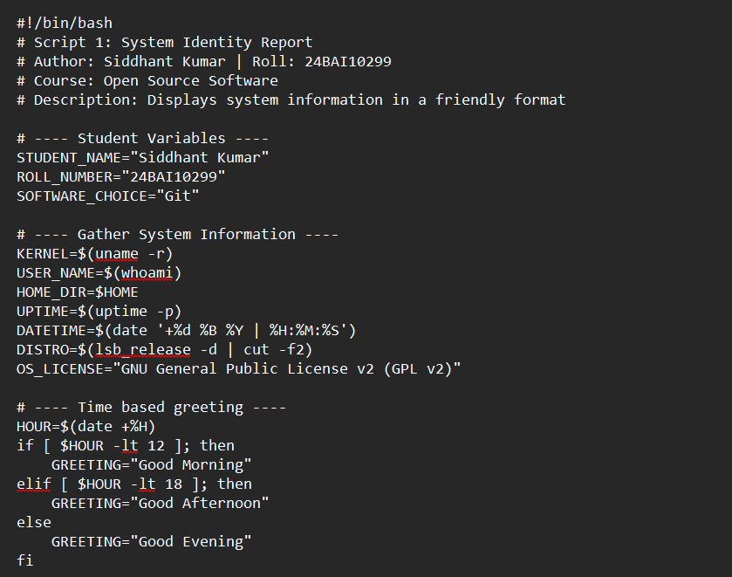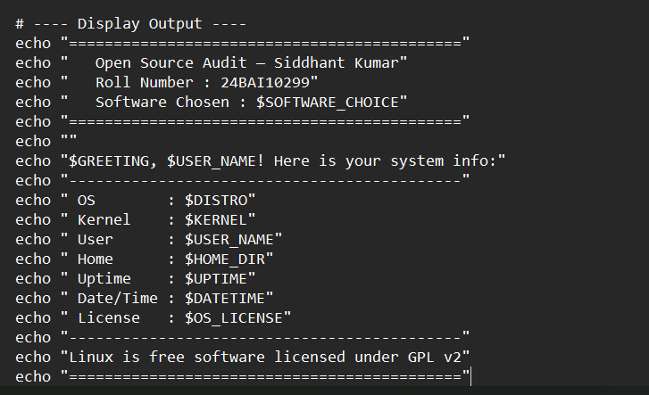

Script 2 — FOSS Package Inspector (Unit 2)

What this script does: This script checks whether Git is installed on the system. It shows the version and location of Git. It also uses a case statement to print a short philosophy note about different open source packages.

Concepts used: if-then-else case statement command substitution grep pipe

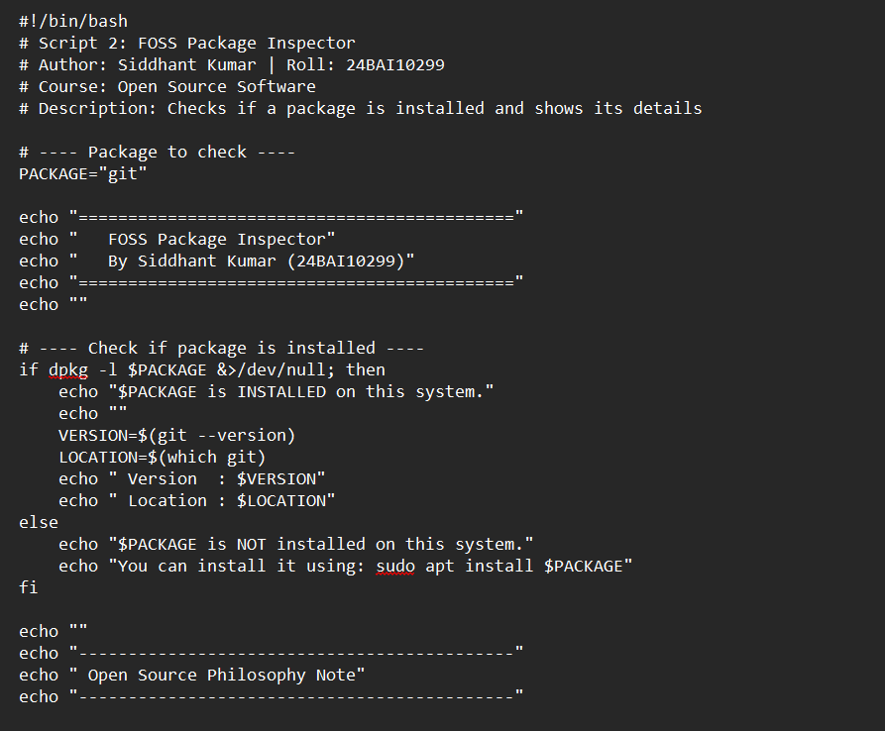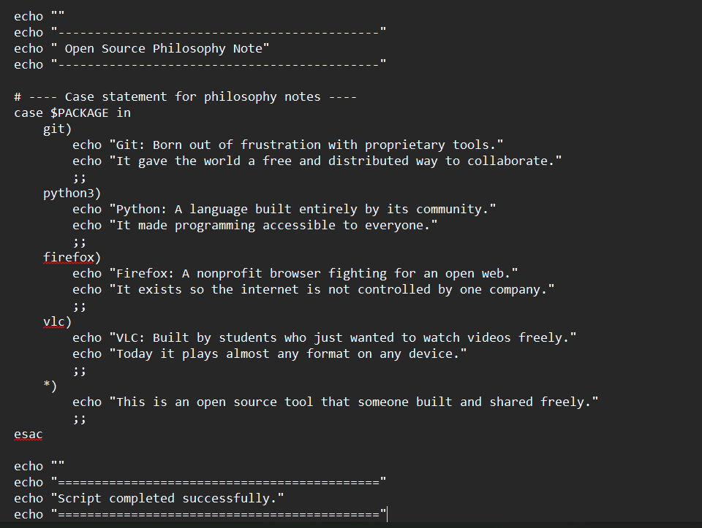

Script 3 — Disk and Permission Auditor (Unit 2)

What this script does: This script loops through important system directories. For each directory it shows the size permissions and owner. It also checks if the Git config file exists and shows its permissions.

Concepts used: for loop if-else du ls awk arrays

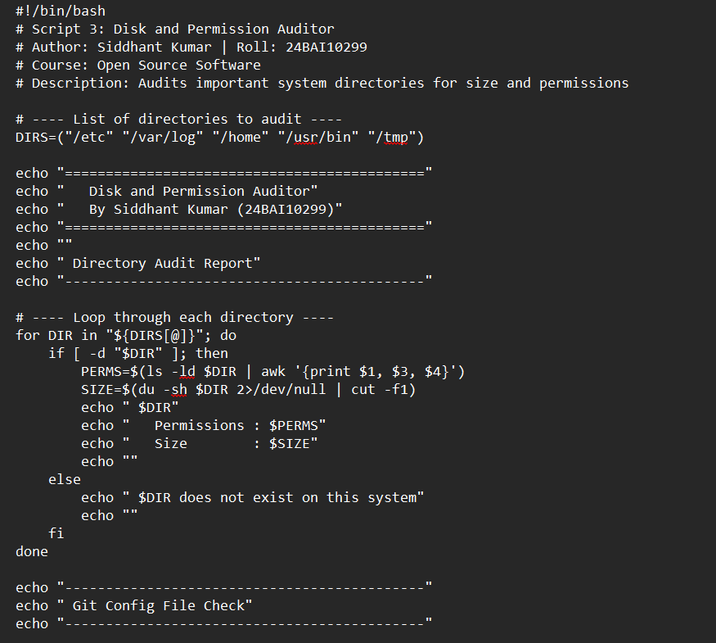

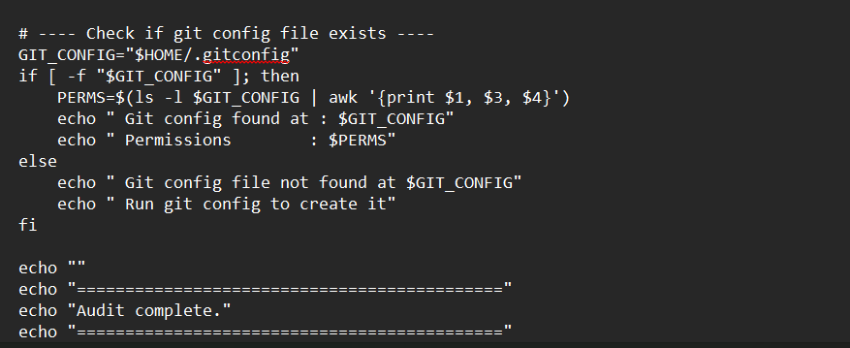

Script 4 — Log File Analyzer (Units 2 & 5)

What this script does: This script reads a log file line by line. It counts how many lines contain a given keyword like error or warning. It then prints a summary and shows the last 5 matching lines.

Concepts used: while read loop if-then counter variables command line arguments tail grep

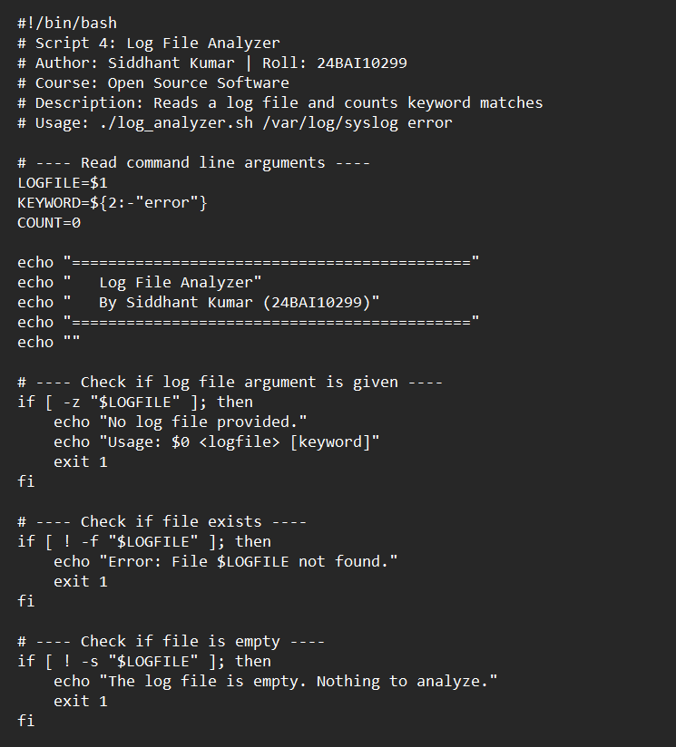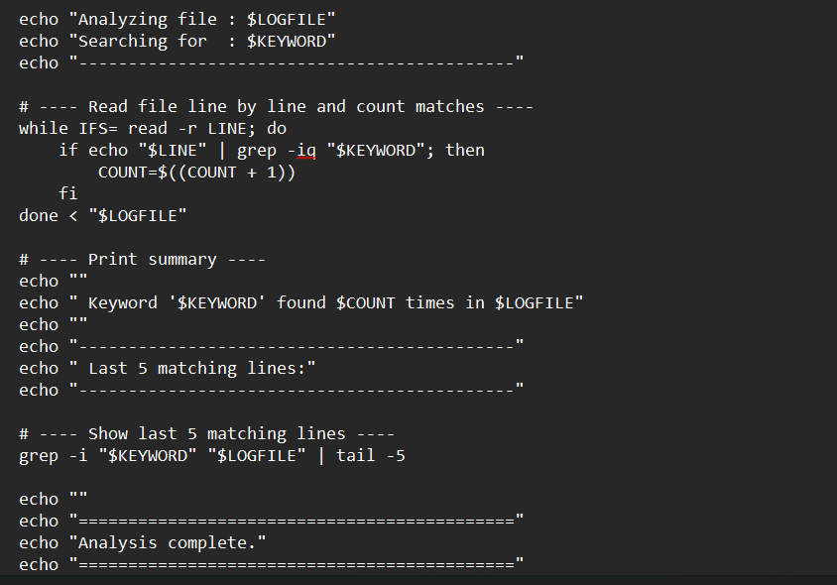

Script 5 — The Open Source Manifesto Generator (Unit 5)

What this script does: This script asks the user three simple questions. It then uses the answers to create a personal open source philosophy statement. The statement is saved to a text file and displayed on the screen.
Concepts used: read for user input string concatenation writing to file with > and >> date command

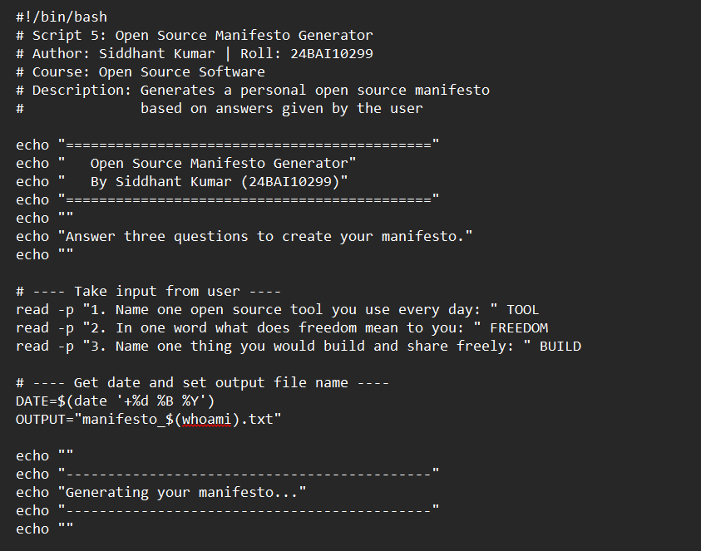

Conclusion

After doing this project I understand open source software much better than before. Git is not just a version control tool. It is a perfect example of what open source is all about. It was built because proprietary software failed the community. And what was built in its place became something much more powerful and free.

Git is completely free to use modify and share. It has a massive community behind it. It is trusted by millions of developers all over the world. And it keeps getting better because people contribute to it every day.

I would recommend Git for any real world project without any hesitation. I would also like to contribute to open source projects in the future. Even small contributions matter in the open source world. This project helped me see that open source is not just a licensing model. It is a way of thinking about knowledge collaboration and freedom.

Reference Resources

On open source philosophy:
- GNU Project — The Free Software Definition: gnu.org/philosophy/free-sw.html
- Open Source Initiative — The Open Source Definition: opensource.org/osd
- Eric S. Raymond — The Cathedral and the Bazaar: catb.org/~esr/writings/cathedral-bazaar
- Linus Torvalds — Just for Fun (autobiography)

On Linux and shell scripting:
- The Linux Command Line by William Shotts: linuxcommand.org
- GNU Bash Manual: gnu.org/software/bash/manual
- Linux man pages: man.cx

For finding license texts:
- SPDX License List: spdx.org/licenses
- Choose a License: choosealicense.com
- Git official repository on GitHub — LICENSE file

