1. Write a program to find the largest of two numbers using if-else statements.

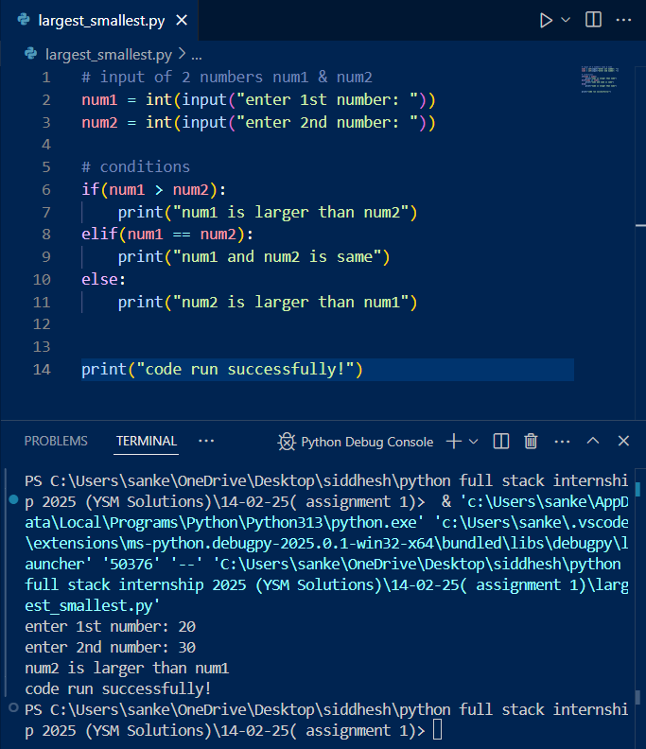

1. Write a program that uses if-else statements to print whether a number is positive, negative, or zero.

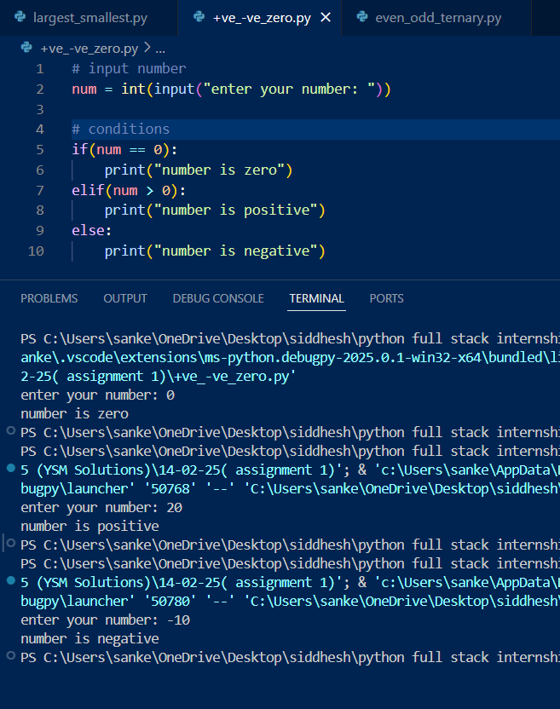

1. Write a program that checks whether a given number is even or odd using the ternary operator.

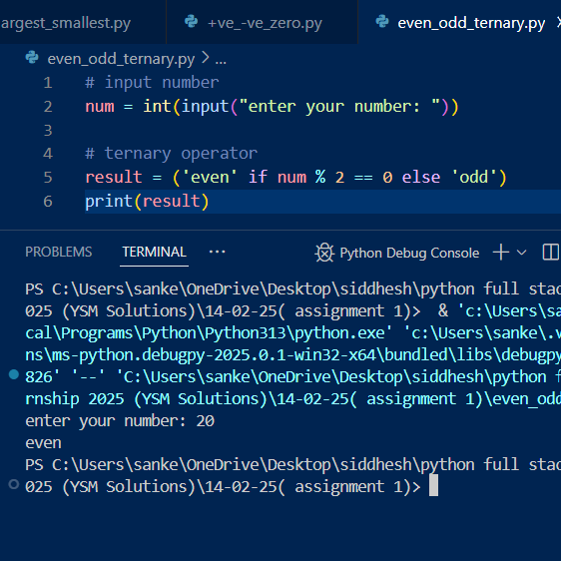

1. What is the output of the following expression? result = 25 // 4 \* 3 + 18 % 7 - 5 \* 2 / 2

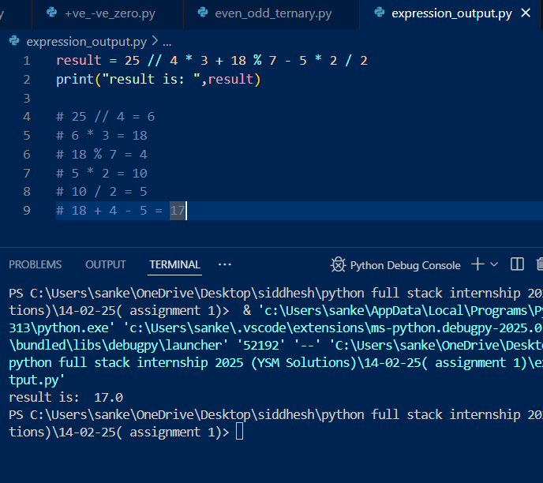

1. Write a program to calculate the area of a triangle given its base and height using the formula Area = (base \* height) / 2.

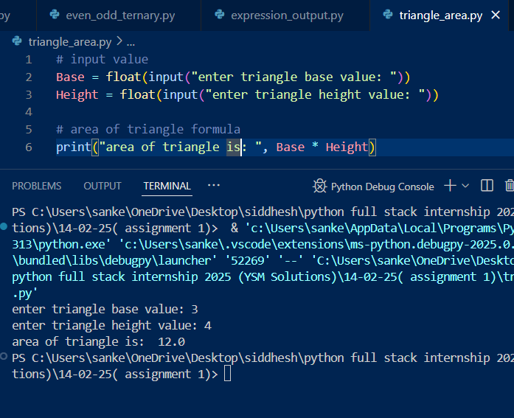

1. Write a program to calculate the perimeter of a rectangle using length and width variables.

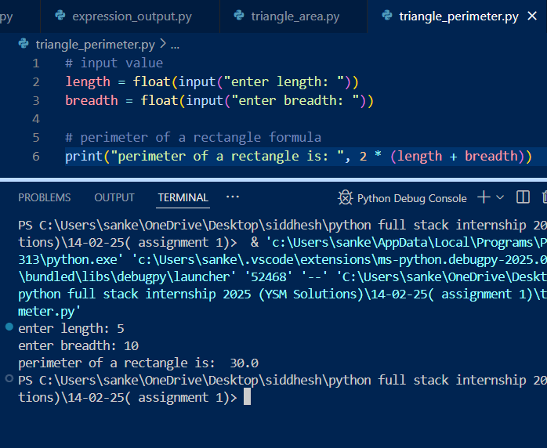

1. Write a program that uses the modulus operator (%) to find the remainder when dividing two numbers.

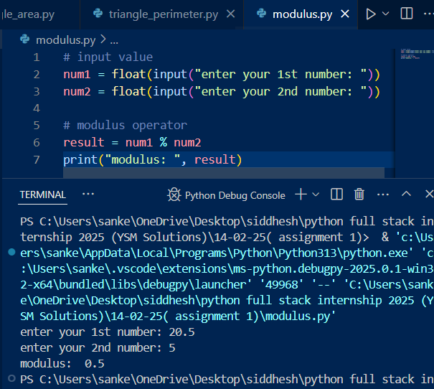

1. Write a program to compare two numbers and print whether the first is greater, smaller, or equal to the second using relational operators.

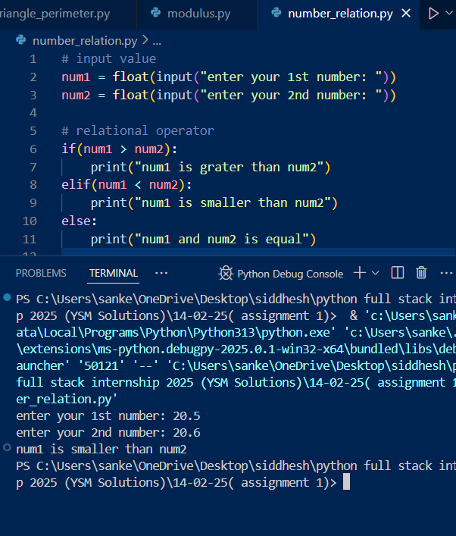

1. Write a program that takes two integers and performs both floor division (//) and modulo (%) operations. Print the results

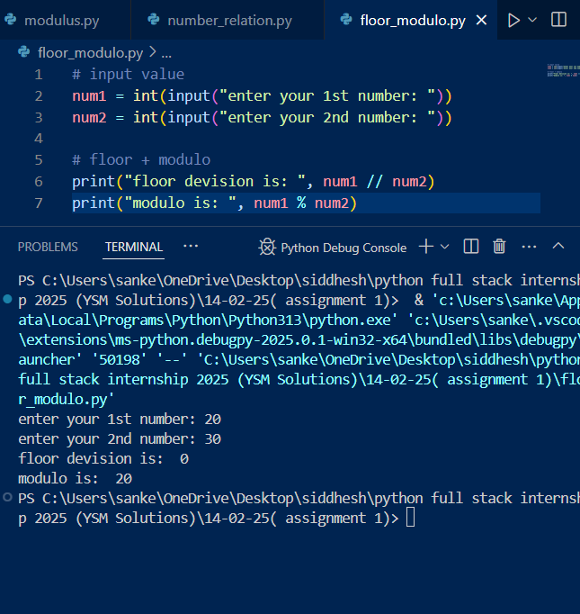

1. Write a program that prints the grade based on the score input using if-else statements (A for 90-100, B for 80-89, etc.).

