Name: Siddhesh Santosh Shinde
College: DBJ college
(Assignment no.4) python full stack internship

Q1) Create a database and a table named Employees with the following columns:
EmpID (Primary Key, Integer)
Name (VARCHAR, Not Null)
Age (Integer)
Department (VARCHAR)
Salary (Decimal)
JoiningDate (DATE)
City (VARCHAR)

Hint: Use the CREATE TABLE statement with appropriate data types and constraints.
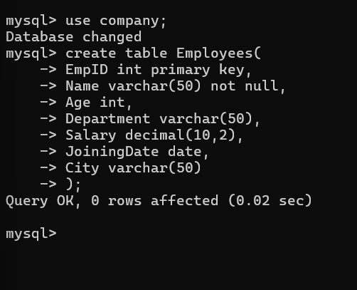
Q2) Insert at least 10 records into the Employees table with sample data.
Hint: Use the INSERT INTO statement.
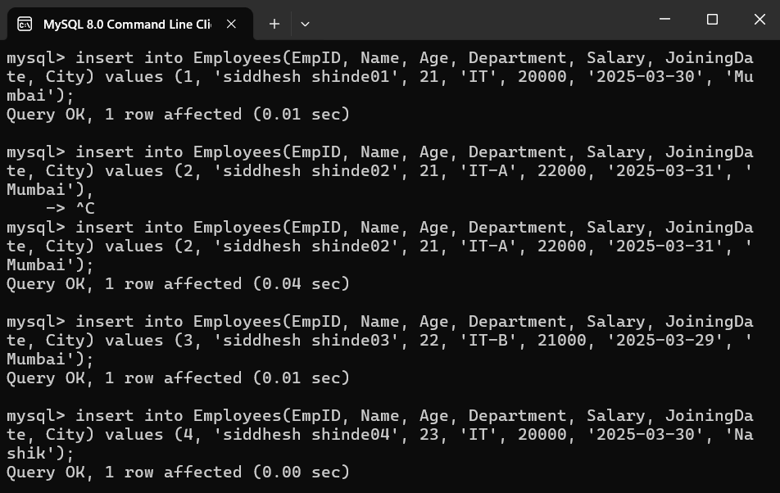

Q3) Write an SQL query to display all the records from the Employees table.
Hint: Use the SELECT * statement.
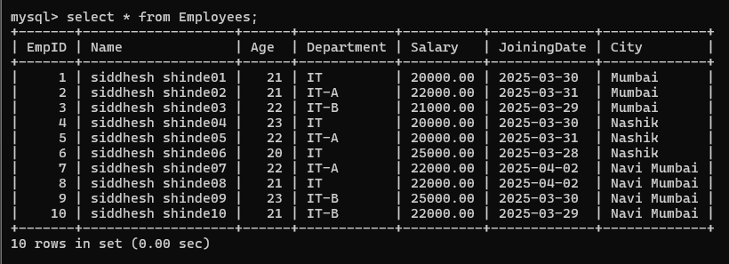
Q4) Display only the Name, Department, and Salary of all employees.
Hint: Select specific columns using SELECT followed by column names.
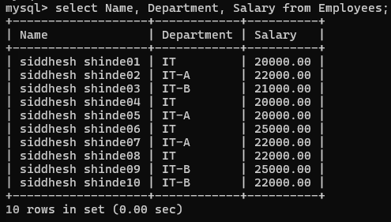
Q5) Display the records of employees who earn a salary greater than ₹50,000.
Hint: Use the WHERE clause with the > operator.
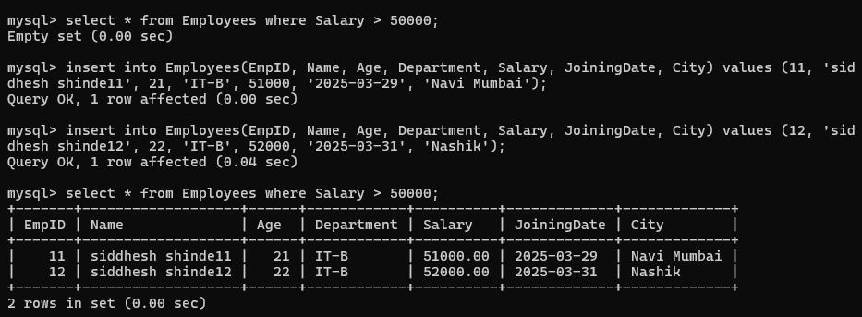
Q6) Display the employees who belong to the IT department.
Hint: Use the WHERE clause with string comparison.
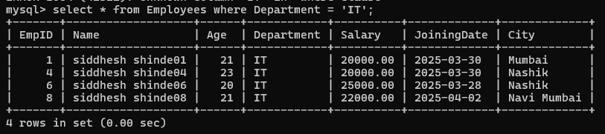
Q7) Display employees whose age is between 25 and 35.
Hint: Use the BETWEEN keyword.
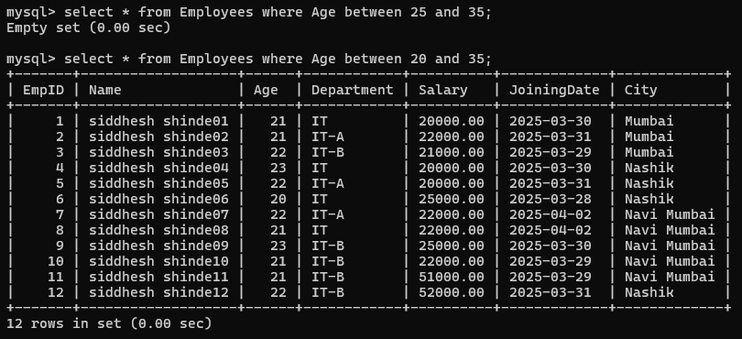
Q8) Display the employees who joined the company after 1st January 2022.
Hint: Use the WHERE clause with the > operator and DATE format.
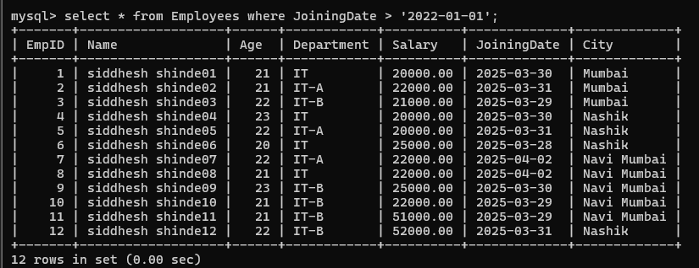
Q9) Display the employees from the Mumbai or Pune city.
Hint: Use the IN operator.
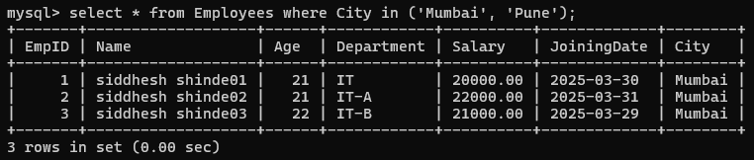
Q10) Display the total number of employees in each Department.
Hint: Use GROUP BY with COUNT().
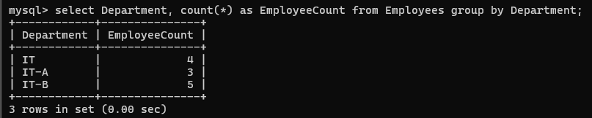

Q11) Display the average salary of employees in each Department.
Hint: Use AVG() with GROUP BY.
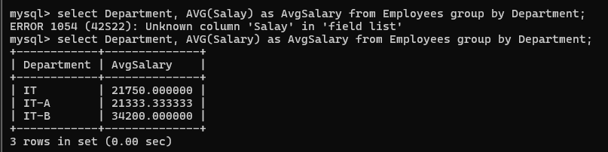
Q12) Display the employee with the highest salary.
Hint: Use the MAX() function.
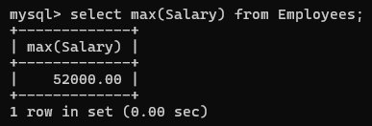
Q13) Display the top 3 highest-paid employees.
Hint: Use ORDER BY with LIMIT.
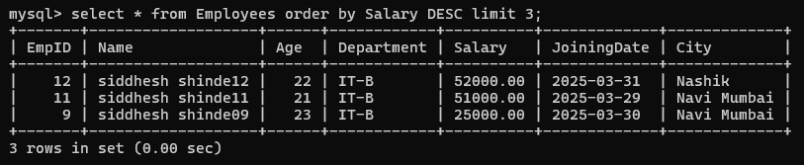
Q14) Display employees sorted in ascending order by Name and descending order by Salary.
Hint: Use ORDER BY with multiple conditions.
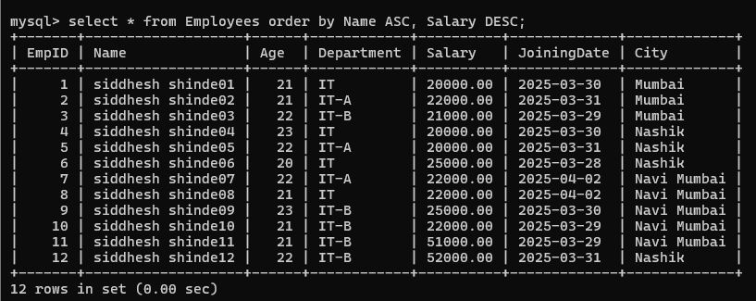

Q15) Update the salary of employees in the IT department by increasing it by 10%.
Hint: Use the UPDATE statement with the WHERE clause and salary calculation.
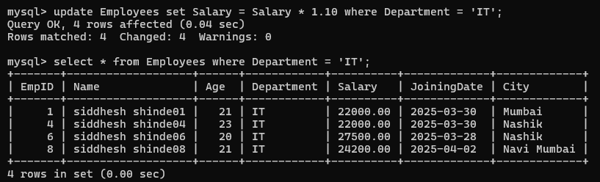
Q16) Delete employees who belong to the HR department.
Hint: Use the DELETE statement with the WHERE clause.
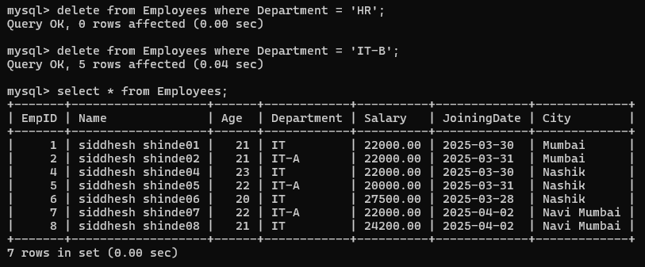
Q17) Create a new table called Projects with the following columns:
ProjectID (Primary Key)
ProjectName (VARCHAR)
EmpID (Foreign Key linked to the Employees table)
StartDate (DATE)
EndDate (DATE)

Hint: Use CREATE TABLE with FOREIGN KEY.
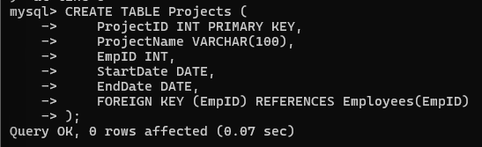

Q18) Insert sample data into the Projects table and display all projects assigned to employees.
Hint: Use INSERT INTO and SELECT statements.
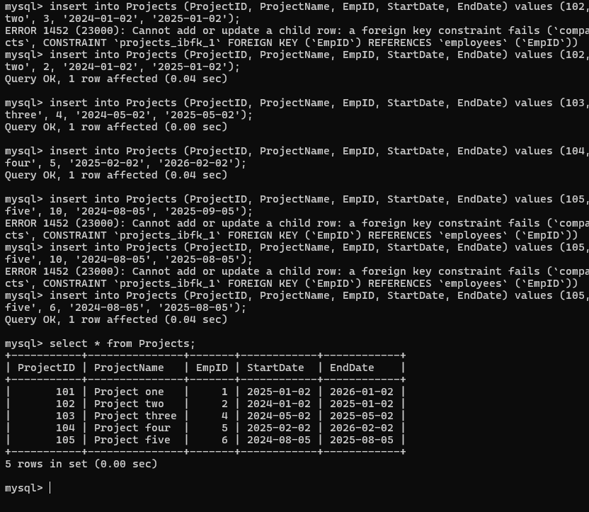
Q19) Display the list of employees who are working on a project that started after 1st January 2023.
Hint: Use INNER JOIN between Employees and Projects tables.
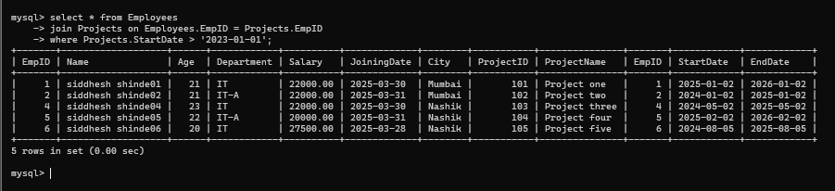
Q20) Display employees who are not assigned to any project.
Hint: Use LEFT JOIN with NULL condition.
