NLP Assignment 5 : HMM POS tagger

Intent
As a part of this assignment , I implemented the following tasks
- The required task to implemented , the viterbi algorithm and use laplace smoothing for the transition and the emission probabilities .
- Changed the amount of training data and looked at the change in accuracy
- Reduced the number of POS tags and measured accuracy
- Sorted the test sentence based on their confidence and interpreted trends

HMM POS Tagger
As a part of this task , I first computed the transition and the emission probabilities from the word counts. I used laplace smoothing to obtain the probabilities . I experimented with different smoothing parameters and obtained interesting results
After obtaining the transition and the emission probabilities , I implemented the viterbi algorithm and predicted the POS tags for the different sentences using the “wsj15-18.pos” file.
Accuracy estimation :
In order to measure the accuracy of the POS tagger , I counted the number of correctly predicted tags and the total number of tags across all the test sentences and used these values to find the accuracy . I also estimated the precision , recall and the fscore for each tag as a part of the accuracy estimation

Experiment 1 :
For the test case where 200 sentences were used for testing and the rest of the sentences from the wsf15-18.pos file was used for training , the results were as follows
Results :
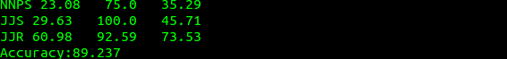
For this case , we got an accuracy of around 90% and we also get to see the F1 score of the tags . On
the analysis of the results , we see most of the tags have a Fscore of more than 80 . However a few tags like NNPS , PDT have an Fscore below 50 . In both the cases , we see that the precision is too low. The predeterminers like what,such,rather,quite can occur as other tags as well and hence there is a chance that from the training data they might have been tagged as other more probable types
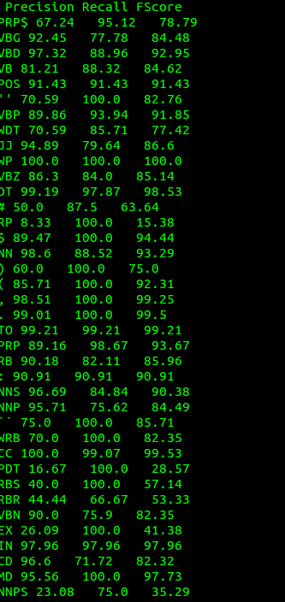

Experiment 2 :
I tried varying the smoothing parameter for laplace smoothing and got interesting results for it
Laplace Smoothing constant | Accuracy
1 | 58.96
0.1 | 76.565
0.01 | 89.237

Analysis :
This goes to show that adding to much weight to the unknowns can affect the probabilities drastically. It is very nice to see that as the laplace smoothing constant becomes smaller , the accuracies increase drastically.

Task 2 : Changing the input size :

Size of test and train case | Accuracy
Train : 200 , Test : 200 | 60.488
Train : 1000 , Test : 200 | 77.156
Train :2000 , Test : 200 | 86.49
Train:8736 , Test:200 | 89.237

Analysis :
With the increase in the input size , we see that the accuracy increase . We can also notice that however after a point , the increase in the input size does not affect the accuracy so much . Hence the increase in training size , increases accuracies but after a point , the accuracies become almost constant

Task 3 : Reduced the POS tags and measure accuracy :
On Composition | Accuracy
No Composition | 89.237
Composing All Vbs(VBD/G/N/P/Z) | 81.003
Composing Vbs,NNs | 67.621
Composing Vbs,NNs,JJs,RBs | 66.77
Composing Jjs,RBs | 88.415
Analysis :
The above table has a number of interesting results. The first notable fact is that tag composition
reduces the accuracy in most of the cases . When tags like verb are composed (past tense verb, gerund verb , past participle , 3rd person singular present and non-3rd person singular present) , the accuracy drops quite a bit . This is because , there exists pattern in the text such that a given type of word is mostly followed by a given tag and hence if the tags are composed it affects the accuracy severly . When both the nouns and the verb are composed , we see that the accuracy drops very badly and the composition of adjectives and adverbs makes the situation worse.
Another interesting point to note is when the tags like the adjectives and the adverbs are composed , the accuracy does not drop so much . This goes to show that these words do not affect their successor so much .

Sorting sentences based on confidence and interpreting trends
As a part of this task , I decided to find the confidence of the tasks , sort them based on their confidence and look at the most confident and the least confident results. For confidence I adopted the same method as the one given in the hint . I took the most likely path and took the Nth root of it , where N is the length of the sentence
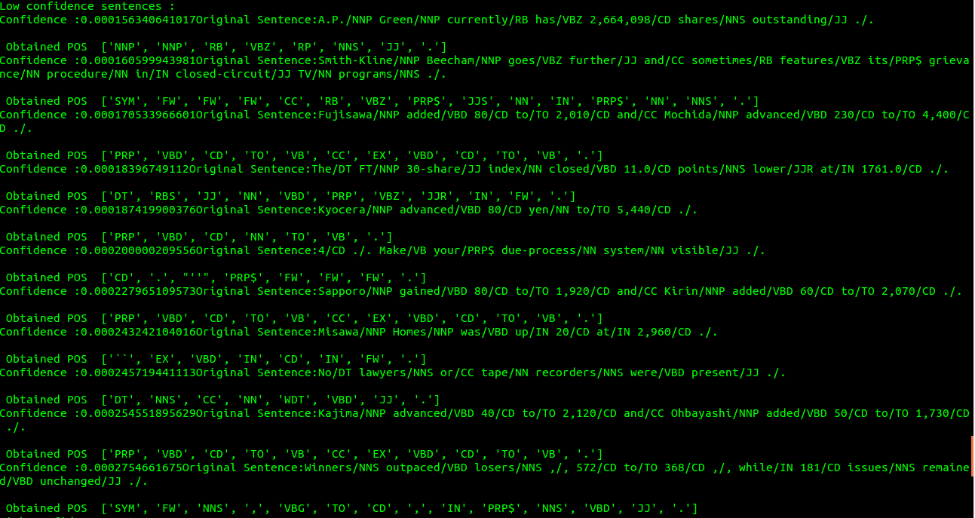

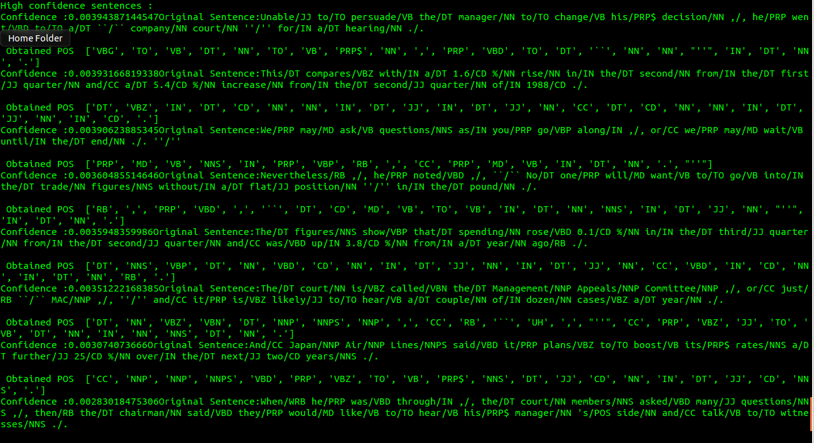
Analysis :
In general it looks like the sentence with high confidence are far more accurate than the sentences with lesser confidence. The high confidence sentence seem to have almost all the tags in place . The low seem to be shorter in general and they seem have misunderstood a number of tags . For example in case of sentence 1 in low confidence , the number has been choosen as a particle. This could because they are more probable after a verb when compared to a number . We also see in that in a number of sentences , just one tag is misplaced like in case the of high confidence sentences and we cannot come to a clear conclusion that the low confidence sentences have a large number of misplaced tags

