# Examples of Bad Design

## 1) A Cup with a Very Thin or Sharp Rim

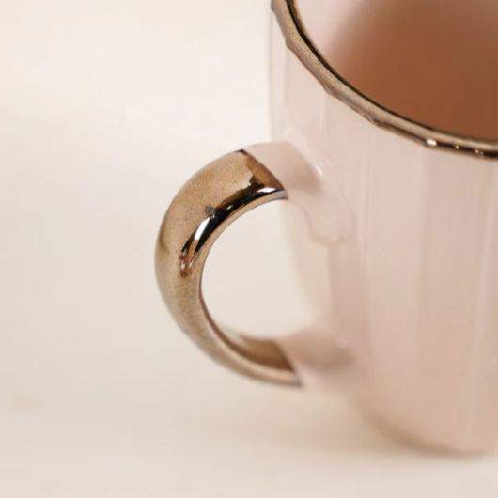

**Why it’s bad design:**

1. **Uncomfortable to Drink From** — A thin or sharp rim can hurt your lips or feel awkward when drinking.
2. **Poor Heat Insulation** — If the rim is too thin, hot drinks might feel hotter on your lips, increasing the risk of burns.
3. **Fragility** — Thin rims are more prone to chipping or breaking.
4. **Difficult to Clean** — If the shape or rim is too delicate, scrubbing can be tricky without causing damage.
5. **Aesthetic vs. Function Trade-off** — Sometimes, a design that looks sleek isn’t practical for everyday use, leading to user dissatisfaction.

## 2) Doors That You Can’t Tell Whether to Push or Pull

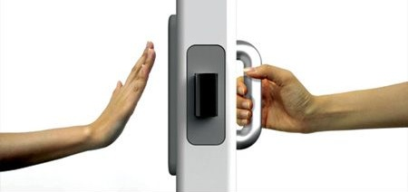

**Why it’s bad design:**

1.**Lack of Clear Visual Cues —** No signs, symbols, or obvious handles to indicate the correct action (push or pull).

2. **User Confusion and Hesitation—** People often stop to figure out how to open the door, causing delays and awkward interactions.

3.**Increased Wear and Tear —** Repeated pushing or pulling the wrong way stresses hinges and handles, leading to faster damage.

4.**Safety Risks —** In emergencies or crowded places, unclear door operation can cause jams or accidents.

5.**Poor User Experience —** It frustrates users and reflects a lack of intuitive, user-centered design.

## 3) Poorly Placed Light Switches

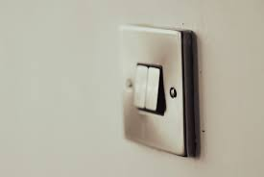

**Why it’s bad design:**

1. **Inconvenient Access:** Switches located too far from the entrance make it hard to turn on lights when entering a room.
2. **Hidden or Obstructed:** Sometimes switches are behind doors or furniture, causing awkward reaching or

fumbling in the dark.

1. **Lack of Standardization:** Different placement styles confuse users who rely on habit or muscle memory.
2. **Safety Concerns:** Difficulty finding switches in dark can lead to trips, falls, or accidents.
3. **Frustration and Reduced Usability:** Poor placement disrupts flow and reduces overall user satisfaction with the space.

## 4) Shampoo Bottles That Are Difficult to Open or Use

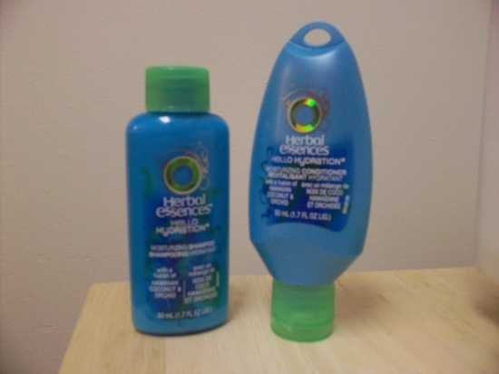

**Why it’s bad design:**

1. **Slippery or Tight Caps:** Hard to open with wet or soapy hands, causing frustration in the shower.

2. Complex Opening

**Mechanisms:** Flip tops or twist caps that require multiple steps slow down use and annoy users.

1. **Poor Dispensing Control:** Small or poorly designed openings can lead to spills, waste, or uneven product flow.
2. **Lack of One-Handed Operation:** Many bottles aren’t designed for easy one-handed use, which is inconvenient when multitasking.
3. **Not Ergonomic:** Shapes that are hard to grip or hold increase the chance of dropping the bottle.

## 5) Uncomfortable Public Seating

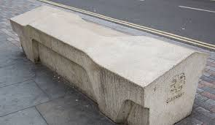

**Why it’s bad design:**

1. **Hard Materials:** Seating made from unforgiving materials like metal or concrete causes discomfort quickly.
2. **Poor Ergonomics:** Lack of proper back support or awkward angles leads to bad posture and physical strain.
3. **No Armrests or Padding:** Absence of armrests and cushioning reduces comfort and accessibility, especially for older adults.
4. **Discourages Use:** Uncomfortable seating discourages people from resting or spending t ime in public spaces.
5. **Excludes Some Users:** Poor design can make seating unusable for people with disabilities or mobility issues.

# Examples of Good Design

## 1) Ergonomic Office Chair

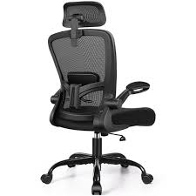

**Why it’s Good design:**

1. **Supports Natural Posture**: Designed to maintain the spine's natural curve, reducing back strain.
2. **Adjustable Features:** Includes height, armrest, and lumbar support adjustments for personalized comfort.
3. **Breathable Materials:** Mesh backrests promote airflow, keeping you cool during extended use.
4. **Durable Construction:** Built with highquality materials to withstand daily use.
5. **Enhanced Productivity:** Promotes comfort, leading to improved focus and efficiency.

## 2) Smartphone Touchscreen

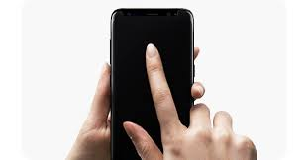

**Why it’s Good design:**

1. **Intuitive Interface:** Responsive touch capabilities allow for easy navigation.
2. **High-Resolution Display:** Crisp visuals enhance user experience.
3. **Multi-Touch Support:** Enables gestures like pinch-to-zoom and swipe.
4. **Durable Glass:** Scratch-resistant surfaces ensure longevity.
5. **User-Friendly Design:** Sleek and ergonomic design fits comfortably in hand.

## 3) Zipper Closures

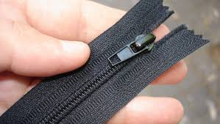

**Why it’s Good design:**

1. **Secure Fastening:** Provides a reliable closurefor various items.
2. **Easy Operation:** Smooth gliding mechanism for quick use.
3. **Versatile Application:** Used in clothing, bags, and accessories.
4. **Durable Material:** Resistant to wear and tear over time.
5. **Compact Design:** Lightweight and unobtrusive fastening solution.

## 4) Reusable Water Bottle with Easy-to-Open Cap

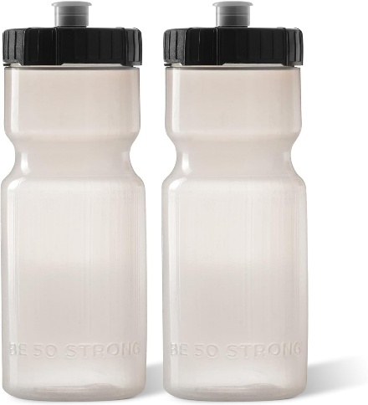

**Why it’s Good design:**

1. **Leak-Proof Design:** Ensures no spills duringtransport.
2. **One-Handed Operation:** Flip-top lid allows for easy opening while on the move.
3. **Insulated Construction:** Keeps beverages hot or cold for extended periods.
4. **Durable Build:** Made from high-quality materials for long-lasting use.
5. **Eco-Friendly:** Reduces the need for disposable plastic bottles.

## 5) Traffic Light with Countdown Timer

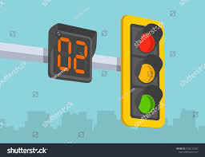

**Why it’s Good design:**

1. **Clear Visibility:** Bright displays ensure readability from a distance.
2. **Time Indicators:** Countdown timers inform pedestrians and drivers of remaining wait times.
3. **Safety Enhancement:** Reduces uncertainty, promoting safer crossings.
4. **Energy Efficient:** LED lights consume less power and have a longer lifespan.
5. **Weather Resistant:** Designed to withstand various environmental conditions.