# Examples of Jugad

## Using a Knife as a Screwdriver

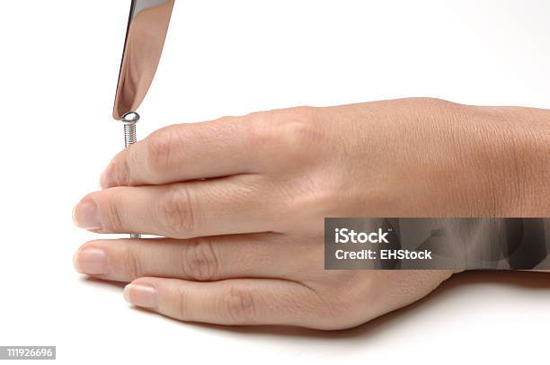

Jugaad: When a screwdriver isn’t available, people use a knife or other tools to tighten screws.

Problem: This can damage the screw or injure the user.

Better Solution: Keep a basic toolkit with essential tools like screwdrivers, or use multi-tools designed for various jobs safely.

## 2) Using Plastic Bags as Temporary Rain Covers



Jugaad: Covering backpacks or valuables with plastic bags during unexpected rain.

Problem: Not durable, tears easily, and creates waste.

Better Solution: Invest in waterproof covers or rainproof backpacks made from water-resistant materials.

## 3) Fixing a Loose Table Leg with Cardboard or Paper

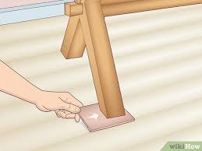

Jugaad: Stuffing cardboard or paper under a wobbly table leg to stabilize it.

Problem: Temporary fix that often slips or compresses, causing more instability.

Better Solution: Use furniture pads or adjustable leg levelers for a secure and lasting solution.

## 4) Using a Plastic Bottle as a Funnel

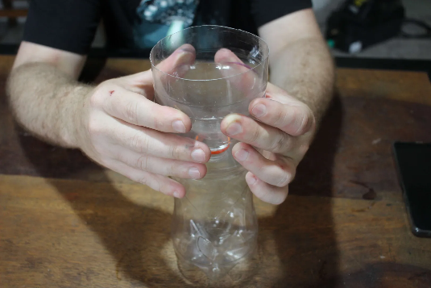

Jugaad: Cutting a plastic bottle to make a funnel for pouring liquids.

Problem: Edges can be sharp and uneven, posing a safety risk.

Better Solution: Buy inexpensive plastic funnels that are smooth and safe to use.

## 5) Using Newspaper to Clean Windows

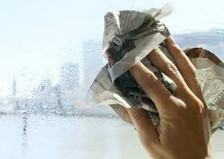

Jugaad: Wiping windows with crumpled newspaper instead of paper towels or cloth.

Problem: Ink can smudge and leave marks; not environmentally ideal.

Better Solution: Use microfiber cloths and ecofriendly glass cleaners.