**Assignment – 3**

1 ) Fan Regulator

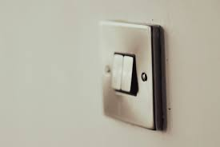

Feedback:-

The Regulator helps to change the RPM of the fan, leading to change in Speed.

Constraint:-

The Speed of fan cant go above 5

2 ) Desk Lamp

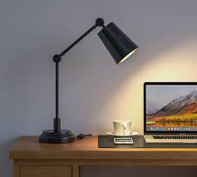

Feedback:-

Offers focused lighting for tasks.

Constraint:-

Limited lighting area compared to room lights

3 ) Running Shoes

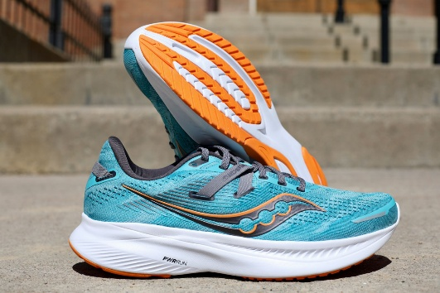

Feedback:

Provides support to reduce injury during runs.

Constraint:

Requires proper fit to avoid discomfort

4 ) Electric Kettle

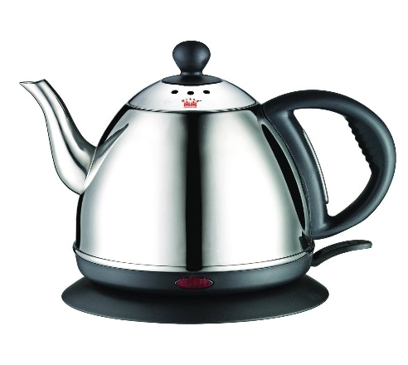

Feedback:-

Quickly boils water for convenience.

Constraint:

Needs to be plugged in to work and cant boil above a certain tempreture.

5 ) Water Bottle



Feedback:-

Keeps you hydrated on the go.

Constraint:

Needs regular cleaning to avoid bacteria buildup.