question:

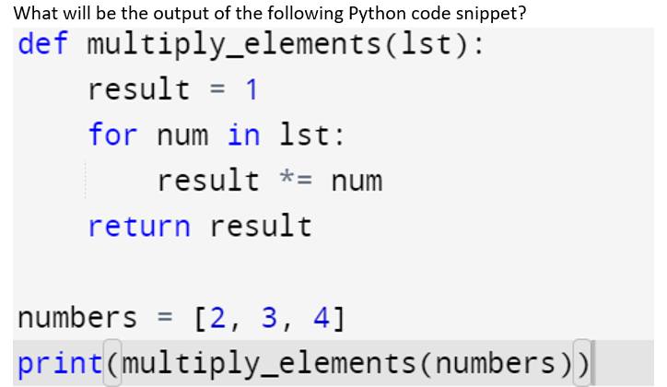

c_ans: 24

e_ans: The function multiply_elements multiplies all elements in the list numbers. The calculation is 2 * 3 * 4, which equals 24. Hence, the output is 24.

mark: 5

input_format: Here is a sample line of code that can be executed in Python:print("Hello, World!"),You can just as easily store a string as a variable and then print it to stdout:my_string = "Hello, World!",print(my_string)

question: Multiply two float numbers and print the result.

c_ans: Product of 1.20 and 3.40 is 4.08

e_ans: printf("product of " ,a*b);

mark: 10

input_format: Here is a sample line of code that can be executed in Python: print("Hello, World!"),You can just as easily store a string as a variable and then print it to stdout:  
my_string = "Hello, World!" print(my_string)