1)find the Circle ?

a)

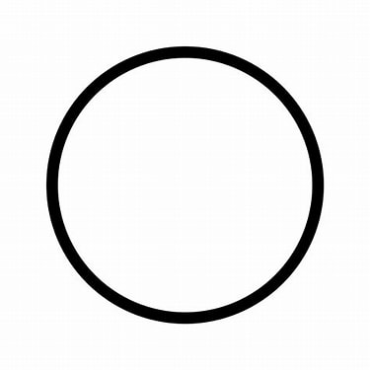

b)

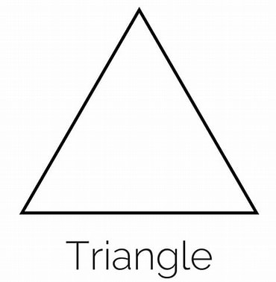

c)



d)

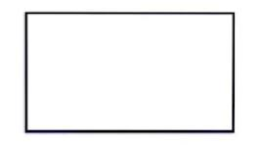

c_ans: A

e_ans: bowbow

mark:1

n_m:1

2)

a)M

b)F

c)D

d)S

c_ans: B

e_ans: testing

mark:1

n_m:1

3)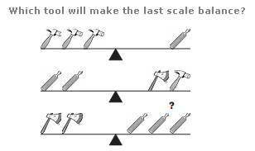

a)30

b)50

c)34

d)28

c_ans: B

e_ans: testing

mark:1

n_m:1

4) 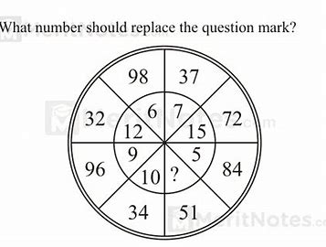

a)30

b)50

c)34

d)28

c_ans: B

e_ans: testing

mark:1

n_m:1

5) 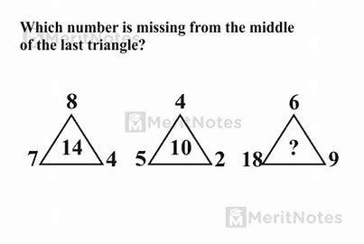

a)3

b)5

c)4

d)2

c_ans: A

e_ans: testing

mark:1

n_m:1

6) **Who is known as the father of the C programming language?**

a) Bjarne Stroustrup

b) James Gosling

c) Dennis Ritchie

d) Guido van Rossum

c_ans: A

e_ans:test

mark:1

n_m:0

**7) Which of the following is the correct file extension for C programs?**

**a).cp**

**b)cpp**

**c)class**

**d)cl**

**c_ans:C**

**e_ans:anser**

**mark:1**

**n_m:0**