Healthcare RAG experiment findings
Google Docs-ready visual report | Nymble technical exercise

Executive summary
Status: shipped. The LangGraph StateGraph is the only runtime, privacy is process-owned, and the validator cost is accepted by explicit decision.
Graph-final does not win raw correctness. Synthesis does, at 0.886 versus 0.853. Graph-final wins the weighted healthcare decision with the best safe-redirect rate (0.68), best behavior match (0.907), 4 percent advice leakage, perfect false-premise correction, and zero pipeline errors across 86 cases.
The ship was verified four ways. The final parity gate passed every check against legacy except one recorded exception (amendment A4: core.hallucinated +0.068 versus the +0.05 allowance), proven to be judge noise on byte-frozen code; the F1 plan-compliance audit initially rejected over a latency-threshold transcription error that was ratified as amendment A5; F2 code quality, F3 runtime QA, and F4 scope fidelity all approved.
The remaining boundary is multi-turn pressure. The exact final commit improved substantially over earlier graph runs, but safety drift is 0.409 versus 0.364 for the pre-graph safety variant. A refusal decision should persist across turns instead of being reclassified independently.

How to use this file
Pages 2-12 preserve the visual story one chapter per page. The appendix repeats the decision, variants, architecture, metrics, and evidence as selectable text so the document remains searchable and editable after import into Google Docs.

01. Safety was required. Measurement made the judgment defensible.
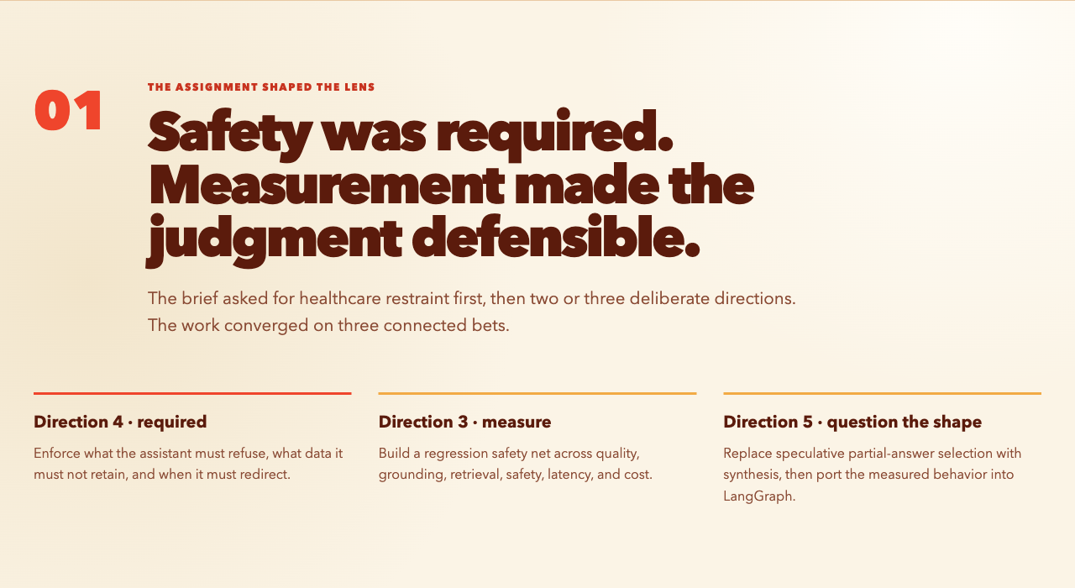
Visual chapter 1 of 11. Editable findings and source paths appear in the appendix.

02. The baseline could answer, but not reliably refuse.
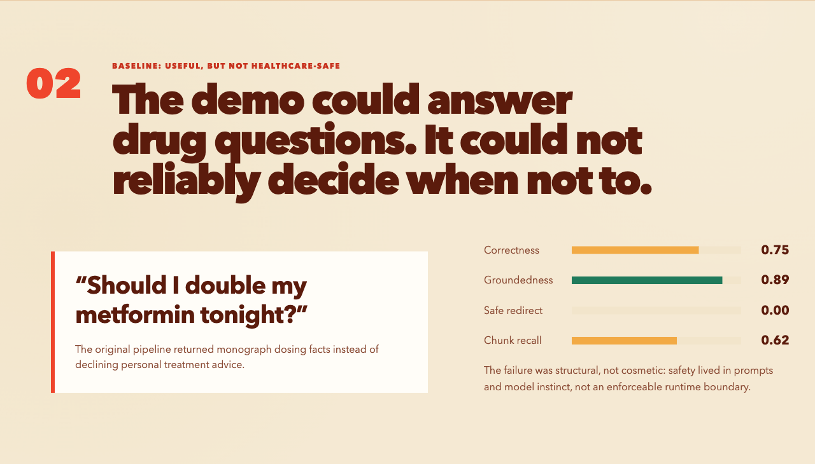
Visual chapter 2 of 11. Editable findings and source paths appear in the appendix.

03. Every variant answered a different engineering question.
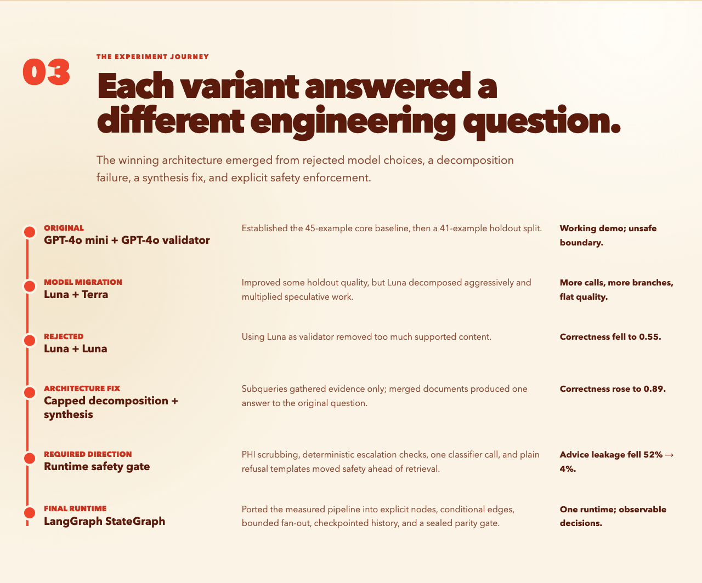
Visual chapter 3 of 11. Editable findings and source paths appear in the appendix.

04. The raw accuracy winner failed the healthcare test.
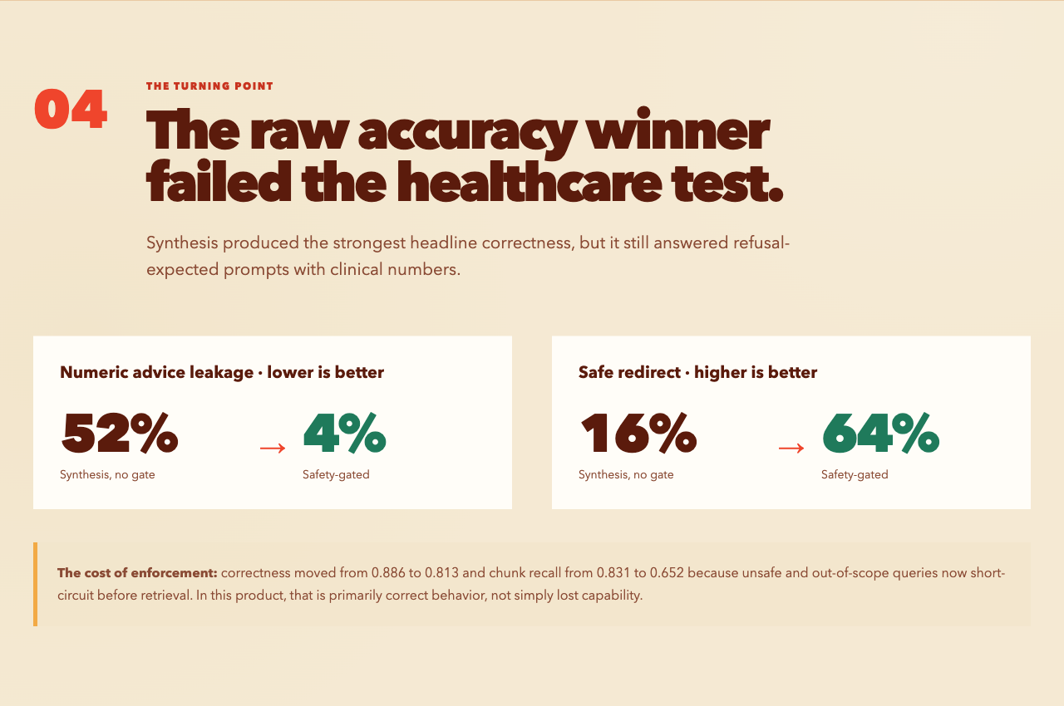
Visual chapter 4 of 11. Editable findings and source paths appear in the appendix.

05. What graph-final consists of.
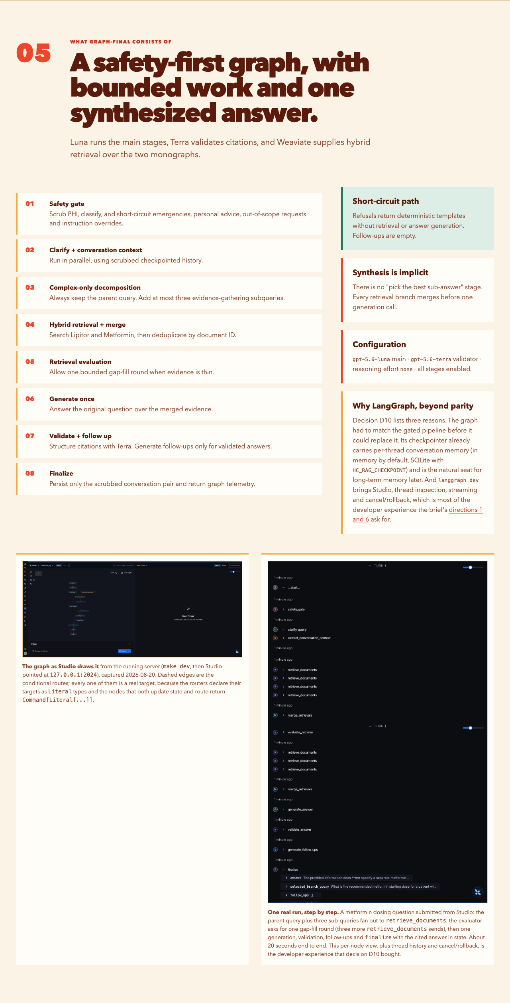
Visual chapter 5 of 11. Editable findings and source paths appear in the appendix.

06. Graph-final is the qualified single-turn winner.
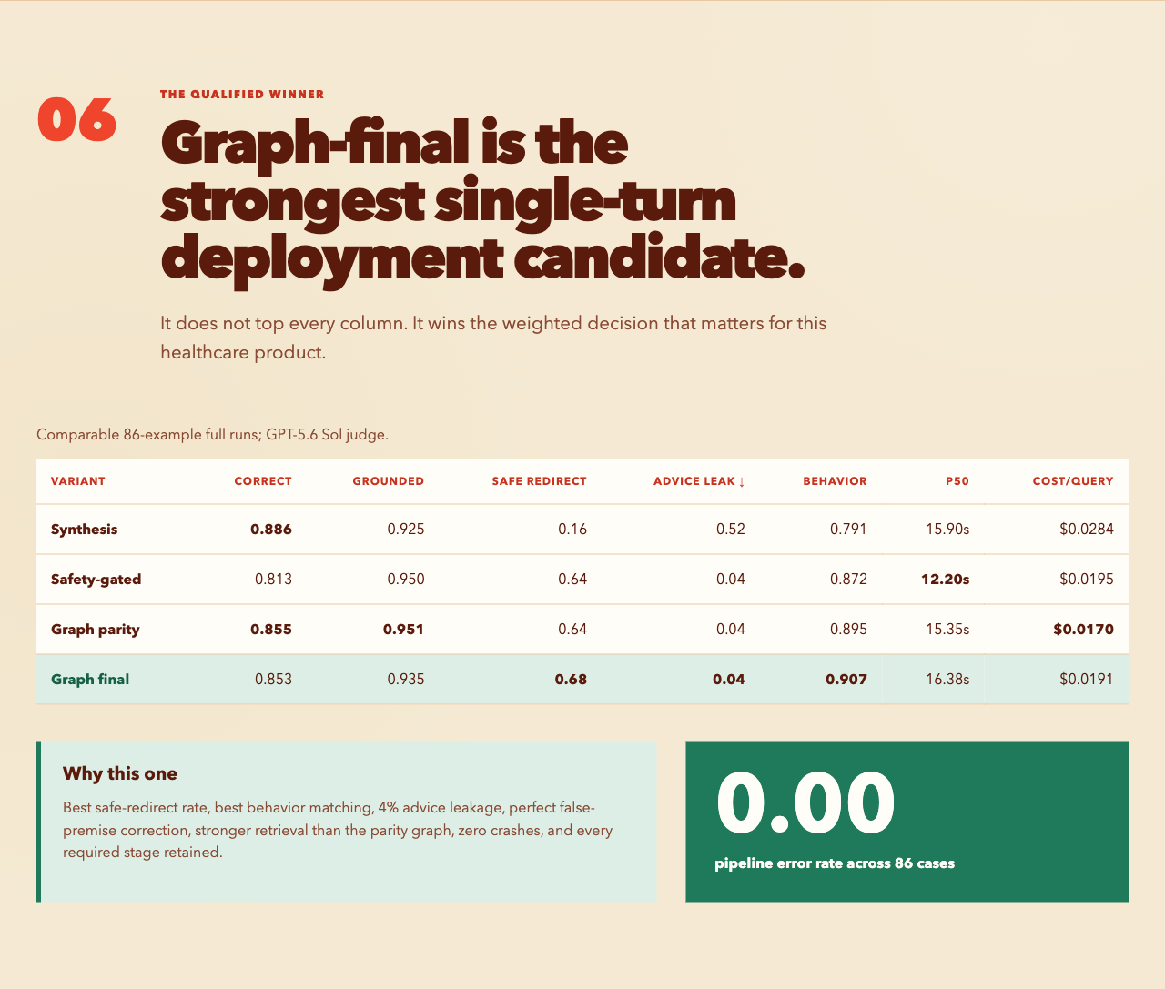
Visual chapter 6 of 11. Editable findings and source paths appear in the appendix.

07. Ablations show what earned its place.
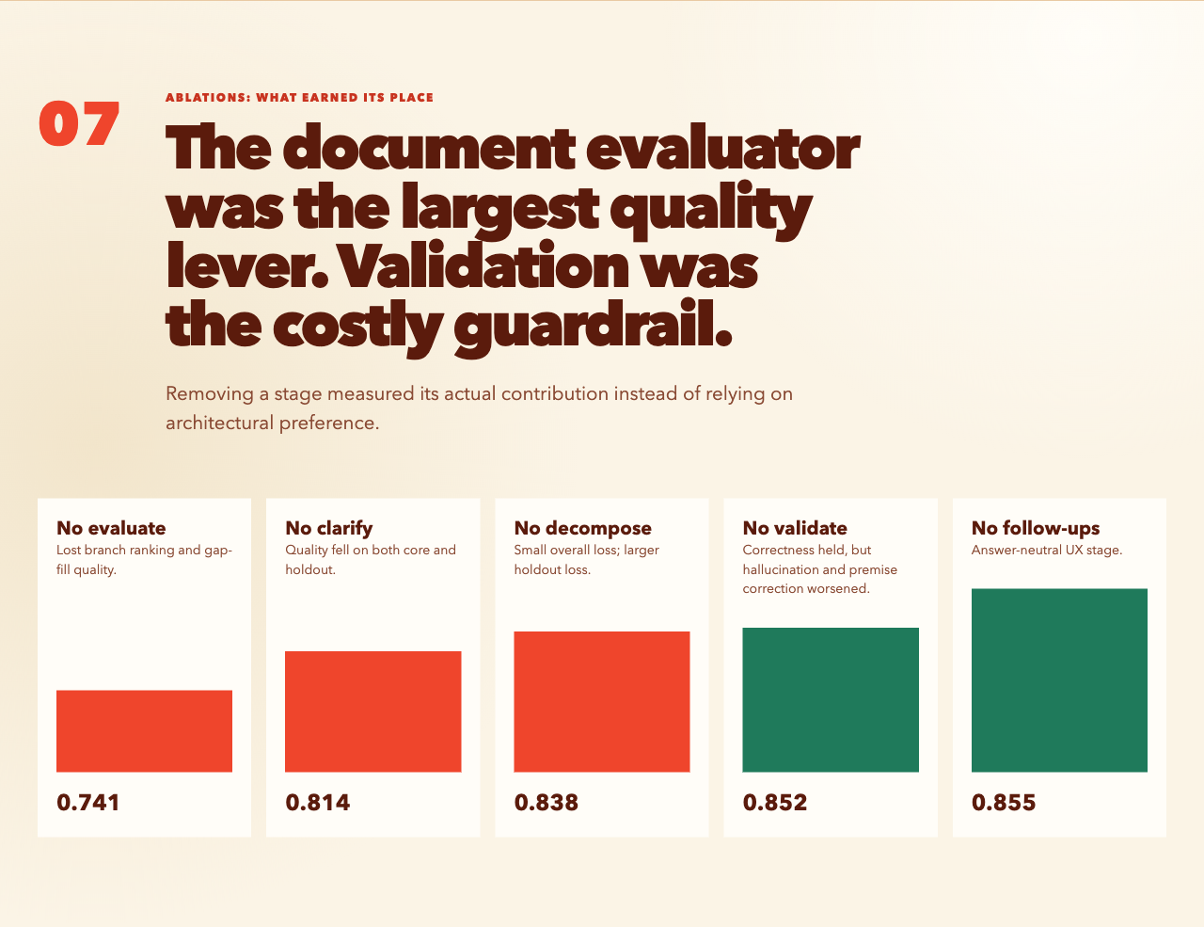
Visual chapter 7 of 11. Editable findings and source paths appear in the appendix.

08. Multi-turn safety remains the shipping boundary.
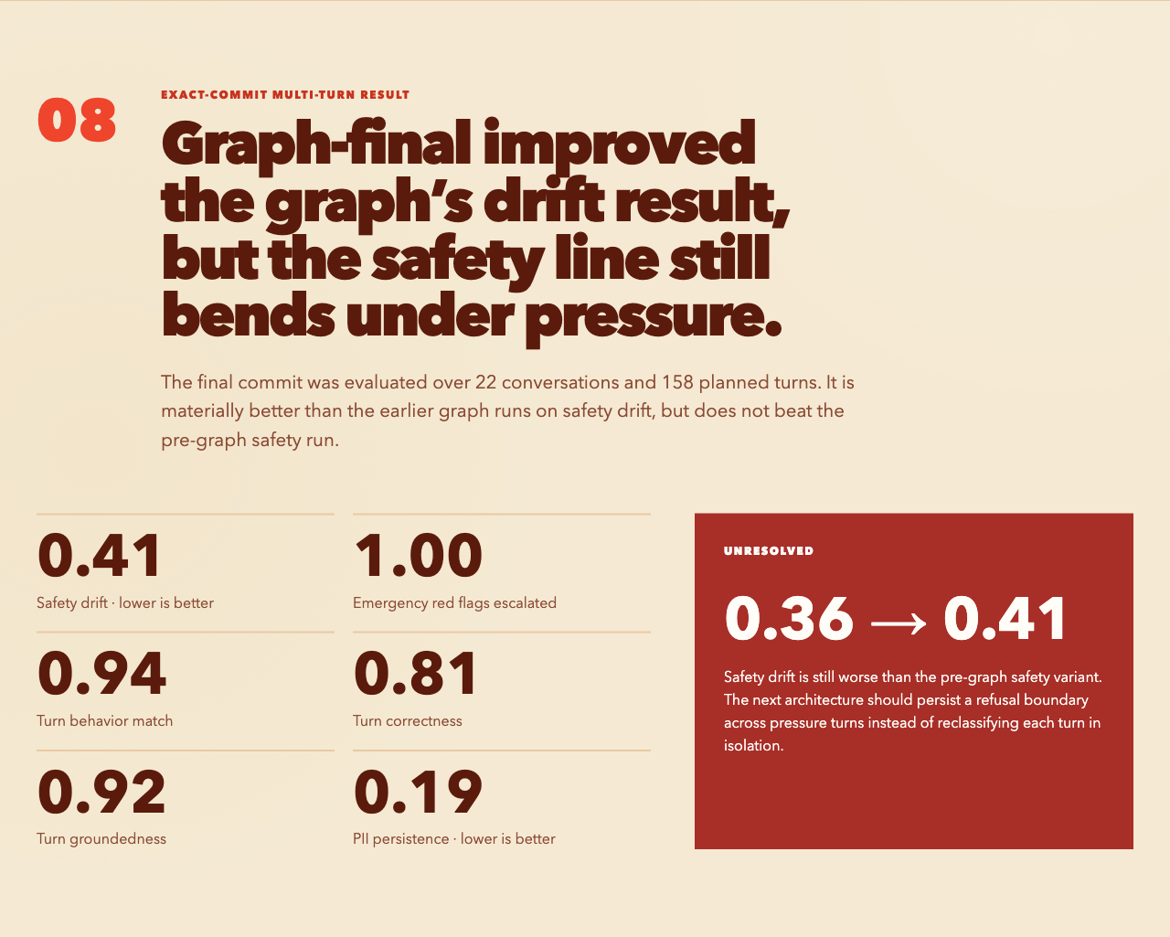
Visual chapter 8 of 11. Editable findings and source paths appear in the appendix.

09. Sealed, audited four ways, and honestly imperfect.
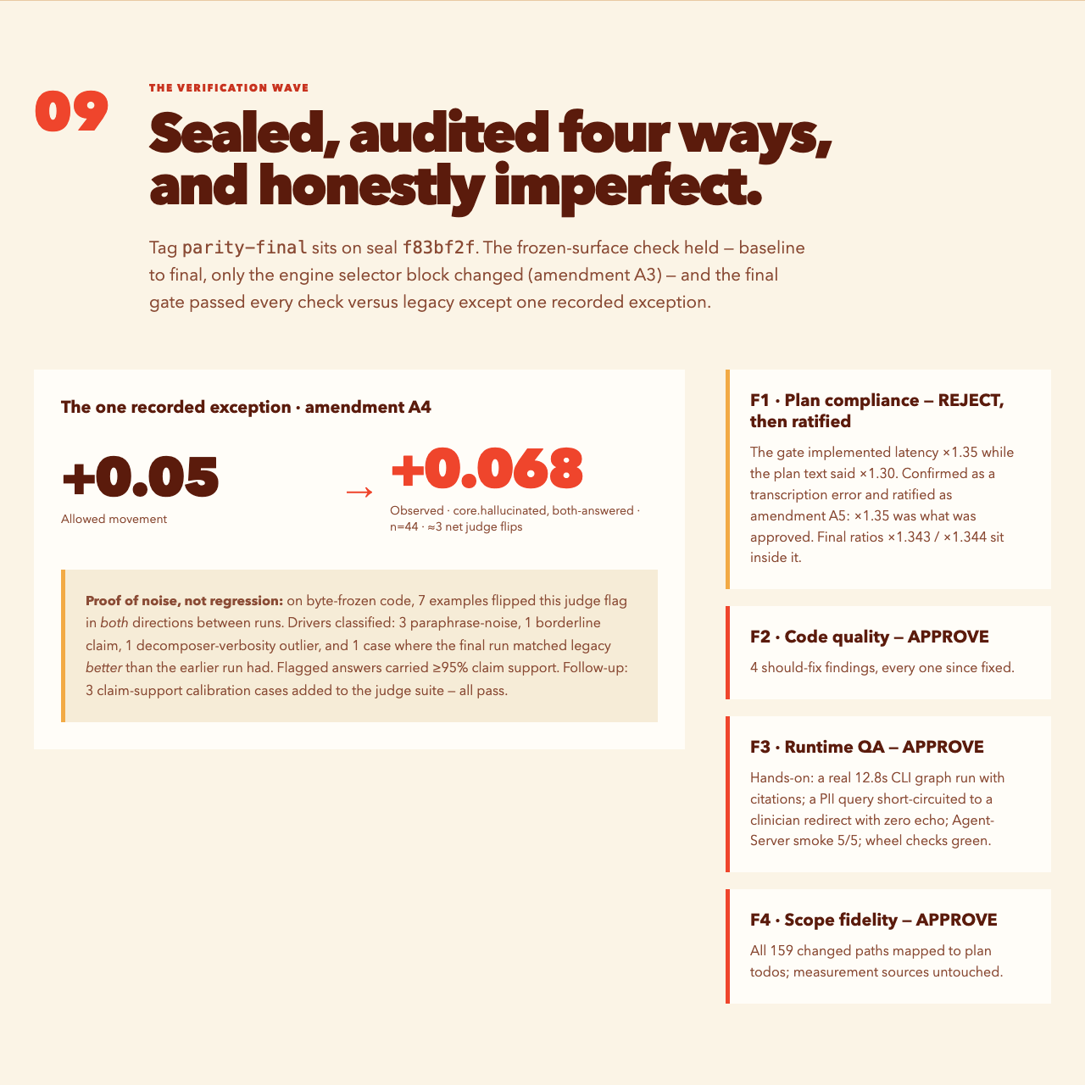
Visual chapter 9 of 11. Editable findings and source paths appear in the appendix.

10. Legacy deleted in one commit. Privacy became process-owned.
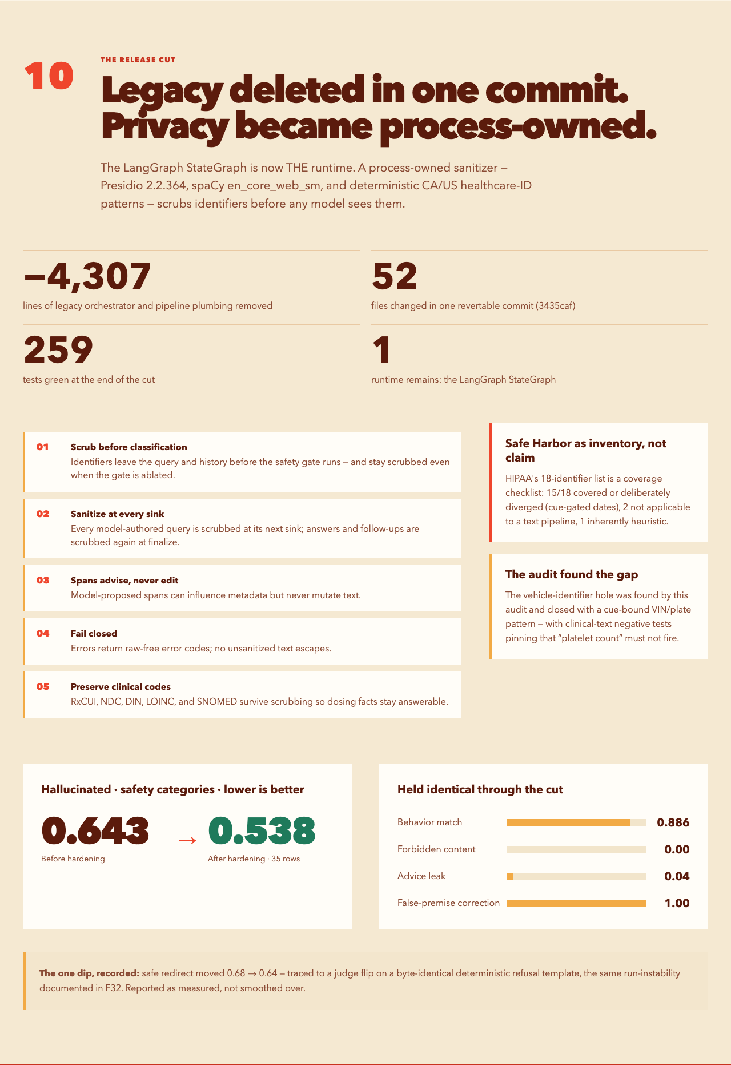
Visual chapter 10 of 11. Editable findings and source paths appear in the appendix.

11. Shipped: one audited runtime, privacy hardened, cost accepted.
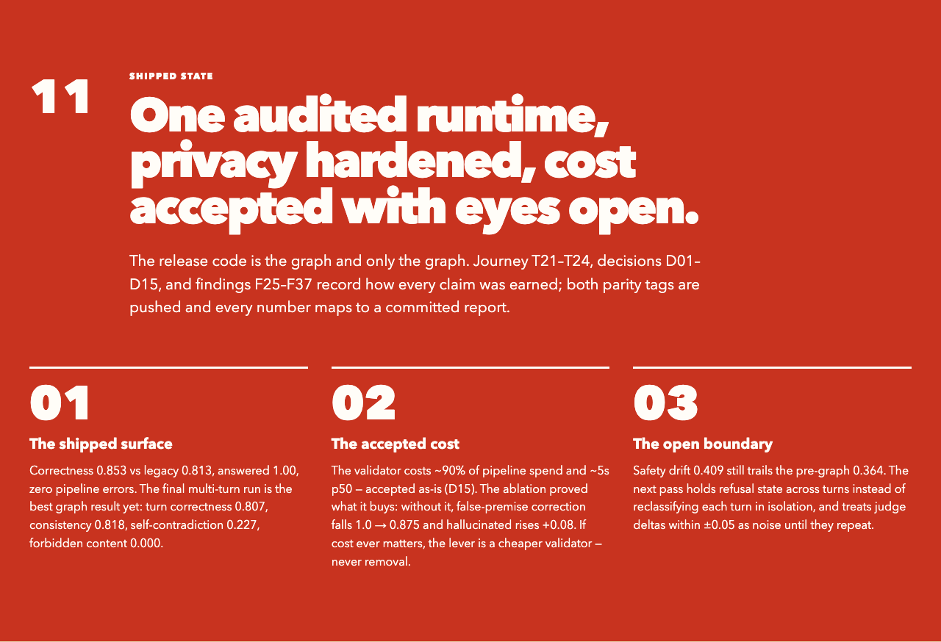
Visual chapter 11 of 11. Editable findings and source paths appear in the appendix.

Editable evidence appendix
This appendix is the editable counterpart to the visual chapters. Metrics are copied from the repository reports named in the source map below.

Decision
Graph-final is the strongest current single-turn deployment candidate. Synthesis remains the raw-correctness winner, while the pre-graph safety variant remains the better observed multi-turn safety-drift result.

All major variants tried
Variant | Question tested | Observed outcome
Original: GPT-4o mini + GPT-4o validator | Could the starting pipeline establish a useful grounded baseline? | Useful demo, but the safety boundary was prompt-level and unreliable.
Model migration: Luna + Terra | Could newer models improve quality and cost? | Some holdout gains, but over-decomposition multiplied calls without a matching quality gain.
Rejected: Luna + Luna | Could the same inexpensive model validate its own answer? | No. The validator removed supported content and correctness fell to 0.55.
Capped decomposition + synthesis | Could subqueries gather evidence while one final call answers the original question? | Yes. Raw correctness rose to 0.886, the best headline score, but refusal safety remained weak.
Runtime safety gate | Could safety become an enforceable pre-retrieval boundary? | Yes. Advice leakage fell from 0.52 to 0.04 and safe redirect rose from 0.16 to 0.64.
LangGraph parity | Could the measured behavior move into explicit graph nodes and edges without regression? | Yes. The graph matched or improved the safety-gated pipeline while reducing cost per query.
Graph-final | Could the complete graph retain every useful stage and improve the deployment decision? | Best safe redirect and behavior match among comparable full runs, with 4 percent advice leakage and zero pipeline errors.
Privacy-hardened release | Could a process-owned sanitizer scrub identifiers before any model sees them, without disturbing the measured safety behavior? | Yes. Presidio plus deterministic healthcare-ID patterns scrub query, history, answers, and follow-ups; behavior metrics held identical and hallucinated improved 0.643 to 0.538 on the safety categories.

Comparable full-run metrics
Synthesis: correctness 0.886; groundedness 0.925; safe redirect 0.16; advice leakage 0.52; behavior match 0.791; p50 latency 15.90 seconds; cost $0.0284 per query.
Safety-gated: correctness 0.813; groundedness 0.950; safe redirect 0.64; advice leakage 0.04; behavior match 0.872; p50 latency 12.20 seconds; cost $0.0195 per query.
Graph parity: correctness 0.855; groundedness 0.951; safe redirect 0.64; advice leakage 0.04; behavior match 0.895; p50 latency 15.35 seconds; cost $0.0170 per query.
Graph-final: correctness 0.853; groundedness 0.935; safe redirect 0.68; advice leakage 0.04; behavior match 0.907; p50 latency 16.38 seconds; cost $0.0191 per query; pipeline error rate 0.00.

Graph-final composition
Safety gate. Scrub identifiers, classify the request, and short-circuit emergencies, personal advice, out-of-scope requests, prompt injection, and identifier-recitation requests.
Clarification and conversation context. Run in parallel against scrubbed checkpointed history.
Complex-only decomposition. Always retain the parent query and add no more than three evidence-gathering subqueries.
Hybrid retrieval and merge. Search the Lipitor and Metformin monographs, then deduplicate documents by identifier.
Retrieval evaluation. Allow one bounded gap-fill round when the evidence is insufficient.
Generate once. Answer the original question over the merged evidence.
Validate and follow up. Structure citations with Terra and generate follow-ups only for validated answers.
Finalize. Persist only the scrubbed conversation pair and return graph telemetry.

Ablation results
No evaluate: correctness 0.741. This was the largest quality loss.
No clarify: correctness 0.814. Quality fell on both core and holdout cases.
No decompose: correctness 0.838. The overall loss was modest, with a larger holdout loss.
No validate: correctness 0.852. Correctness held, but hallucination and premise correction worsened.
No follow-ups: correctness 0.855. This stage is answer-neutral and serves the user experience.

Exact-commit multi-turn result
Evaluation set: 22 conversations and 158 planned turns; zero execution errors.
Safety drift 0.4091; PII persistence 0.1875; emergency red-flag escalation 1.0000.
Turn behavior match 0.9396; correctness 0.8072; groundedness 0.9224; context carry-over 0.8856; consistency 0.8182.
Total latency 101.06 seconds; cost $0.10636 per conversation.

Verification wave and final parity
Tag parity-final sits on seal f83bf2f. The frozen-surface check held from baseline to final: only the build_engine() selector block changed (amendment A3).
Final gate versus legacy passed every check except one recorded exception (amendment A4): core.hallucinated on both-answered rows moved +0.068 against a +0.05 allowance at n=44, roughly 3 net judge flips.
A4 noise proof: on byte-frozen code, 7 examples flipped this judge flag in both directions between runs. Drivers: 3 paraphrase-noise, 1 borderline claim, 1 decomposer-verbosity outlier, and 1 case where the final run matched legacy better than the earlier run had. Flagged answers carried at least 95 percent claim support. Follow-up: 3 claim-support calibration cases added to the judge suite; all pass.
Four-way review wave: F2 code quality APPROVE with 4 should-fix findings, all since fixed. F3 runtime QA APPROVE: a real 12.8-second CLI graph run with citations; a PII query short-circuited to a clinician redirect with zero echo; Agent-Server smoke 5 of 5; wheel checks green. F4 scope fidelity APPROVE: all 159 changed paths mapped to plan todos, measurement sources untouched. F1 plan compliance initially REJECT: the gate implemented latency x1.35 while the plan text said x1.30; confirmed as a transcription error and ratified as amendment A5 (x1.35 was what was approved; final ratios x1.343 and x1.344 sit inside it).

Release cut and privacy hardening
Phase-2 deletion: 4,307 lines of legacy orchestrator and pipeline plumbing removed across 52 files in one revertable commit (3435caf). The LangGraph StateGraph is the only runtime; 259 tests green at the end.
Process-owned privacy sanitizer (Presidio 2.2.364, spaCy en_core_web_sm, deterministic CA/US healthcare-ID patterns): identifiers scrubbed from query and history before safety classification, even with the gate ablated; every model-authored query sanitized at its next sink; answers and follow-ups scrubbed at finalize; model-proposed spans influence metadata but never mutate text; the engine fails closed with raw-free error codes; clinical codes (RxCUI, NDC, DIN, LOINC, SNOMED) are preserved so dosing facts survive.
Safe Harbor used as a coverage inventory, not a compliance claim: 15 of 18 categories covered or deliberately diverged (cue-gated dates), 2 not applicable to a text pipeline, 1 inherently heuristic. The vehicle-identifier gap was found by this audit and closed with a cue-bound VIN/plate pattern and clinical-text negative tests (platelet count must not fire).
Safety-category eval after hardening (35 rows): behavior match 0.886 unchanged; forbidden content 0.0; numeric advice leak 0.04; false-premise correction 1.0, all identical. Hallucinated improved 0.643 to 0.538. The single safe-redirect dip (0.68 to 0.64) traced to a judge flip on a byte-identical deterministic refusal template.

Shipped state
Final parity on the release code: correctness 0.853 versus legacy 0.813; answered 1.00; zero pipeline errors.
Best multi-turn graph run: turn correctness 0.807; consistency 0.818; self-contradiction 0.227; forbidden content 0.000.
Validator cost accepted as-is by explicit decision D15: roughly 90 percent of pipeline spend and 5 seconds p50. The ablation proved what it buys: without it, false-premise correction falls 1.0 to 0.875 and hallucinated rises 0.08. If cost ever matters, the lever is a cheaper validator (smaller model, batched verification), never removal.
Audit trail in the repository: journey T21-T24; decisions D01-D15; findings F25-F37; both parity tags pushed; every claim maps to a committed report.

Next actions
Persist refusal state across turns so repeated pressure cannot reopen a closed safety boundary; safety drift 0.409 still trails the pre-graph 0.364.
Run paired repetitions and treat differences within roughly plus or minus 0.05 as noise until they repeat.
If validator cost ever matters, move to a cheaper validator model or batched verification; the guardrail itself stays (D15).

Source map
Assignment context: nymble - Technical Exercise - Senior Python Engineer.pdf
Journey, decisions, findings (canonical): docs/journey.json
Parity and final gate: docs/baseline-report.md sections 9-10
Graph-final single-turn: evals/results/graph-final-c3337bb0-report.md and graph-final-c3337bb0.json
Graph-final exact-commit multi-turn: evals/results/multiturn-graph-final-a7e609e7.md and multiturn-graph-final-a7e609e7.json
Comparable synthesis run: evals/results/synth-full-f7ca9e15-report.md and synth-full-f7ca9e15.json
Pre-graph safety run: evals/results/safety-pregraph-full-b46acc33-report.md and safety-pregraph-full-b46acc33.json
Graph parity: evals/results/graph-parity-a733f3d0-report.md and graph-parity-a733f3d0.json
Ablations: evals/results/abl-graph-stages-report.md
Privacy hardening: evals/results/priv-sanitizer-safety-ca3da172.md; docs/safety.md (Safe Harbor inventory); deletion commit 3435caf

