TASK P4 / SUBMISSION REPORT

Login & Registration Page
SIT313 Secure Frontend Applications
STUDENT | Siddid Saini
DATE | [Insert submission date]

1. Overview
This project extends the supplied P3 personal portfolio with a shared navigation bar, login and registration routes, Firebase Authentication, and Firestore profile storage. The existing portfolio sections, black-and-white styling, contact form, subscription form, and optional Express email backend are retained. The invalid image placeholders from the supplied P3 source have been replaced with local SVG artwork.

2. Implementation summary
- The DEV@Deakin brand links to the home route. The same navigation and footer are reused across Home, Login, and Registration.
- Login validates the email and password fields, uses Firebase Authentication, displays helpful errors, and redirects to the home page on success.
- Registration asks for first name, last name, email, password, and confirmation; validates the information; creates a Firebase Authentication account; saves non-sensitive profile details to `users/{uid}` in Firestore; and redirects to Login.
- Passwords are handled by Firebase Authentication and are not stored in Firestore. The project includes Firestore rules and an `.env.example`; the real `.env` must remain uncommitted.

3. Repository and video links
GITLAB REPOSITORY | [Paste your Task P4 GitLab URL — project visibility must be Internal]
WALKTHROUGH VIDEO | [Paste your 2–4 minute YouTube/Panopto URL]

4. Screenshots
The images below are visibly marked placeholders, not genuine browser captures. Replace each image with a fresh screenshot from your tested application before submitting this report.

4.1 Home page and navigation
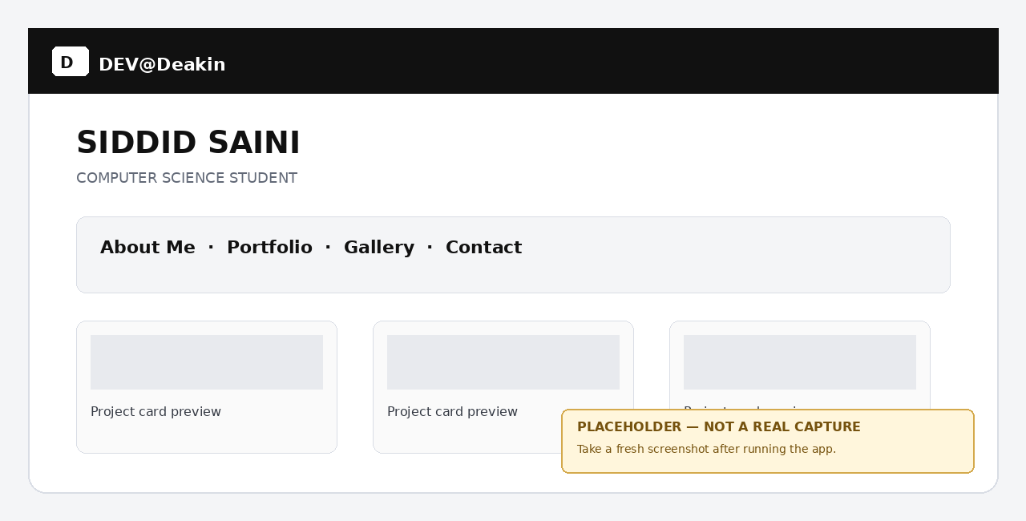

4.2 Login page
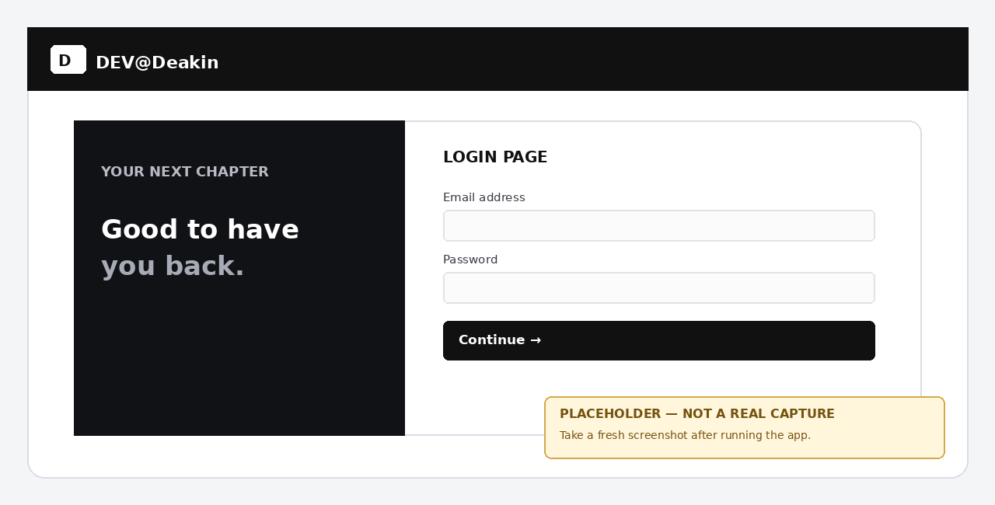

4.3 Registration page
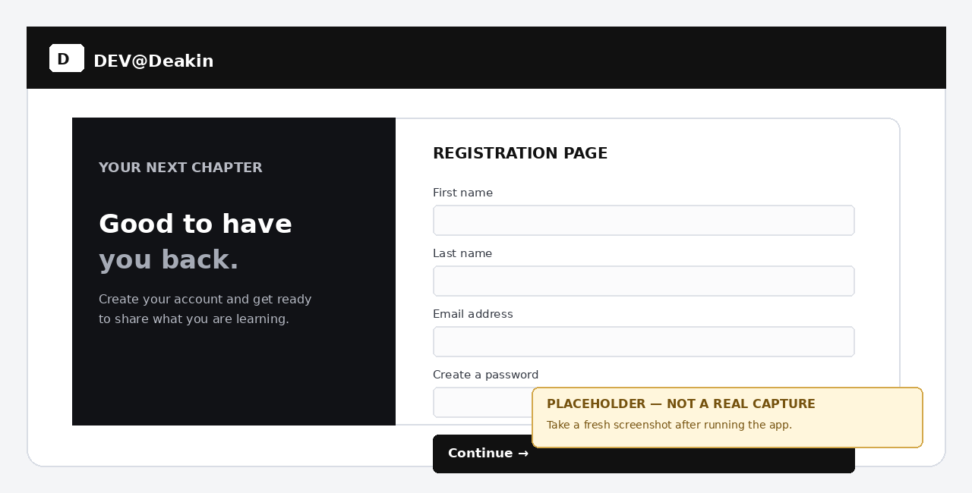

5. Testing summary
TEST | EXPECTED RESULT | RESULT
Valid registration | Auth account created; profile saved; redirected to Login. | [Pass/Fail]
Existing email | Friendly duplicate-account message. | [Pass/Fail]
Invalid email | Validation message shown. | [Pass/Fail]
Weak/mismatched password | Validation message shown. | [Pass/Fail]
Correct login | Redirected to the home page. | [Pass/Fail]
Incorrect login | Helpful error and sign-up suggestion shown. | [Pass/Fail]

6. Conclusion and final checks
The implementation adds the P4 account screens and Firebase integration while keeping the P3 portfolio as the home page. Before final submission, configure Firebase, run every test above, replace all placeholder screenshots and links, verify the Task P4 GitLab project is Internal and excludes `node_modules` and `.env`, then submit the report and video link through OnTrack.

