SMART MESSENGER – REAL-TIME TRANSLATOR
A REAL-TIME MULTILINGUAL MESSAGING SYSTEM

A PROJECT REPORT
Submitted in partial fulfillment of the requirements for the course

ABSTRACT
Smart Messenger is a real-time multilingual messaging application designed to eliminate language barriers in digital communication. The application enables users to communicate with people speaking different languages by automatically translating messages into the recipient's preferred language. The system provides secure user authentication, contact management, instant messaging, language preference settings, and message translation services. Built using modern web and mobile technologies, the application ensures seamless communication across multiple languages while maintaining user privacy and message integrity. Smart Messenger offers an intuitive user interface and supports real-time conversations, making it useful for students, professionals, and users from diverse linguistic backgrounds. The application demonstrates the integration of messaging systems, cloud databases, authentication mechanisms, and translation APIs into a unified platform that enhances communication accessibility and user experience.

CHAPTER 1: INTRODUCTION

1.1 Smart Messenger – Real-Time Translator
In today's globalized world, communication spans continents and languages. However, language barriers remain a significant hurdle in digital communication. The Smart Messenger application is a mobile messaging platform designed to solve this issue by allowing users to communicate across different languages using automatic, real-time machine translation technology. By combining a real-time chat application with robust language translation interfaces, it provides an accessible experience that translates incoming and outgoing messages instantly, facilitating natural conversations between users who do not share a common language.

1.2 Functionalities under User Login
The application provides a comprehensive suite of functionalities secured behind user login:
- 1. User Registration and Login: Allows new users to register and existing users to login to their profile.
- 2. Secure Authentication: Integrates Firebase Authentication using email and password to secure user accounts.
- 3. Profile Management: Allows users to configure their personal details including name, age, and profile picture.
- 4. Contact Management: Enables search and management of chat contacts with specific language preferences.
- 5. Real-Time Messaging: Supports instant message exchange powered by Cloud Firestore real-time sync.
- 6. Automatic Message Translation: Automatically translates incoming messages into the recipient's preferred language.
- 7. Language Preference Selection: Provides configuration options for both application UI language and preferred chat translation language.
- 8. Chat History Storage: Safely persists and synchronizes chat logs and messages in the Firestore database.
- 9. Speech Support: Integrates text-to-speech for speaking translated messages and speech-to-text for audio message dictation.
- 10. User Dashboard: Serves as the central navigation hub showing active chats, profile options, and translation widgets.

CHAPTER 2: HARDWARE AND SOFTWARE REQUIREMENTS

2.1 Hardware Requirements
- Processor: Intel Core i3 or above (Development) / Snapdragon 600 Series or above (Mobile device)
- RAM: Minimum 4 GB (8 GB recommended for development environment)
- Storage: Minimum 100 MB free space on device / 2 GB on development machine
- Network: Internet connection required for Firestore sync and translation services
- Android Device Version: Android 8.0 (Oreo) or above to run the compiled APK

2.2 Software Requirements
- Frontend Framework: React.js (built with Vite for fast build and loading speeds)
- Mobile Framework: Capacitor (to compile the web application into native Android wrapper)
- Backend Services: Google Firebase Console
- Authentication: Firebase Authentication (Email/Password, Google OAuth, and Phone Verification)
- Database: Google Cloud Firestore (noSQL real-time document store database)
- Translation API: Google Translate API (client-side single-query request endpoint)
- Integrated Development Environment (IDE): Visual Studio Code
- Mobile Build Tool: Android Studio (with Gradle for compilation and signing of APK)
- Programming Language: JavaScript (ES6+), HTML5, and CSS3

CHAPTER 3: DESIGN LAYOUTS
This chapter outlines the key user interfaces of the Smart Messenger application, showing the layout design, navigation flows, and database interactions.

3.1 Login & Password Screen
The password screen prompt verifies registered user credentials to grant secure access to the communication dashboard.
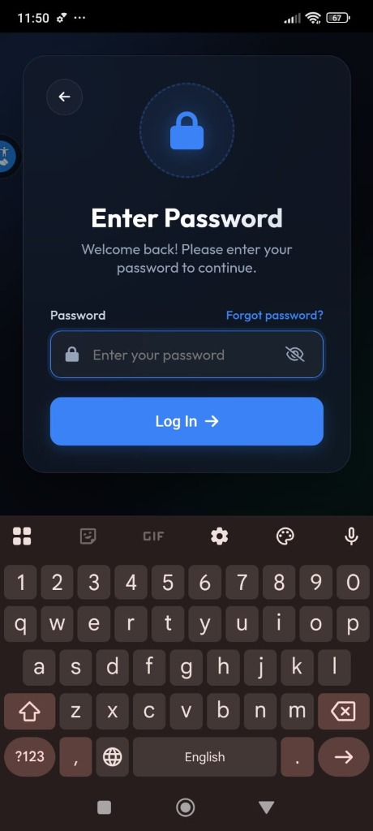
Figure 3.1: Password Login Screen

3.2 Dashboard Navigation Menu
The navigation dropdown menu provides quick shortcuts to 'My Profile', 'Settings', 'About Project', 'Reset Registration', and 'Log Out'.
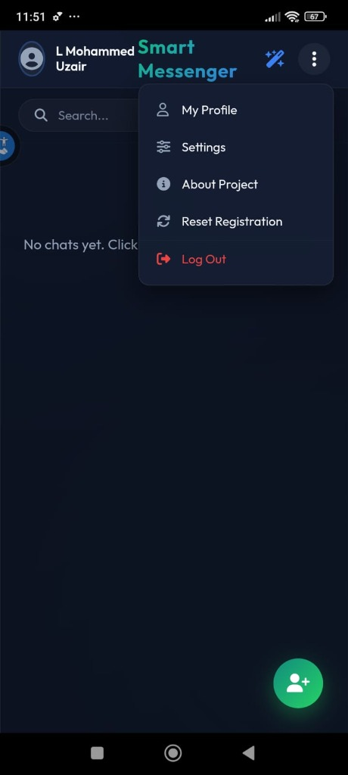
Figure 3.2: Dashboard Dropdown Menu Screen

3.3 Contact List Screen
The primary interface shows the contact search, saved conversations (e.g. Siddik), and triggers notifications when a new contact is added successfully.
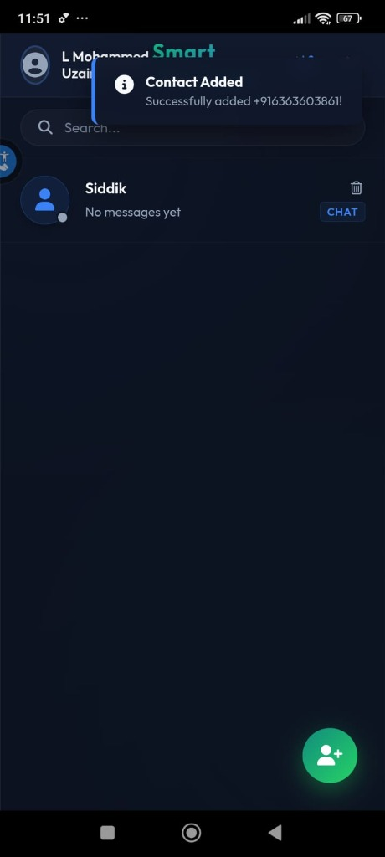
Figure 3.3: Contact List / Dashboard Screen

3.4 Settings & Language Selection Screen
The Settings window configures the application UI Interface Language, Chat Translation Target Language, Audio notifications, and custom themes.
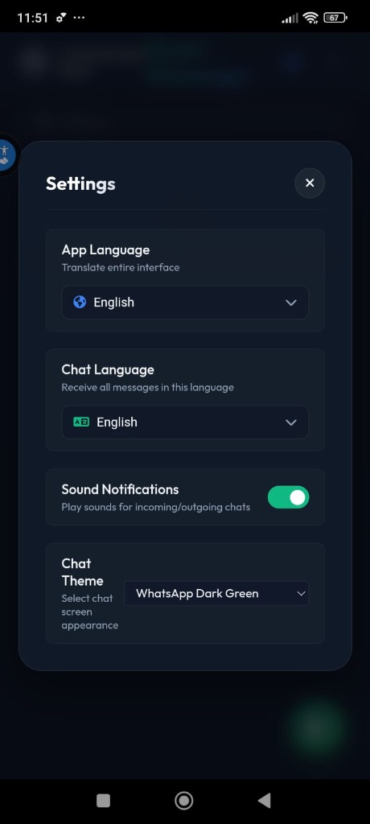
Figure 3.4: Settings & Language Selection Screen

3.5 Universal Translator Modal
The Universal Translator allows on-demand word translations between any selected pair of languages (e.g. English to Hindi) with microphone input.
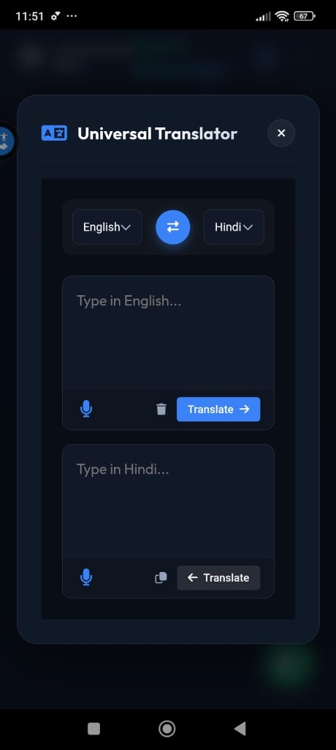
Figure 3.5: Universal Translator Screen

CHAPTER 4: DATABASE TABLES AND ER DIAGRAM

4.1 Users Table
The Users table contains profile details, preferred interface languages, and credentials.
Field Name | Type | Description
user_id | String | Primary Key (Unique Email, Phone, or UID)
username | String | User's Full Name / Display Name
email | String | User's Registered Email Address
preferred_language | String | Selected language code (e.g., 'en', 'hi', 'kn')
created_at | Timestamp | Registration date and time record

Dummy Data Example:
user_id | username | email | preferred_language
U001 | Rahul | rahul@gmail.com | English (en)
U002 | Priya | priya@gmail.com | Hindi (hi)
U003 | Arjun | arjun@gmail.com | Kannada (kn)

4.2 Contacts Table
The Contacts table links users as conversational contacts, specifying contact names.
contact_id | owner_id | contact_name
C001 | U001 | Priya (U002)
C002 | U001 | Arjun (U003)
C003 | U002 | Rahul (U001)

4.3 Messages Table
The Messages table logs individual chats. It holds foreign keys linking users, along with original text and translated text.
message_id | sender_id | receiver_id | original_text | translated_text
M001 | U001 | U002 | Hello | नमस्ते
M002 | U002 | U001 | धन्यवाद | Thank You
M003 | U003 | U001 | ಹೇಗಿದ್ದೀಯ | How are you

4.4 ER Diagram
The entity-relationship diagram below outlines the structural mapping and relationship links between USERS, CONTACTS, and MESSAGES database tables:
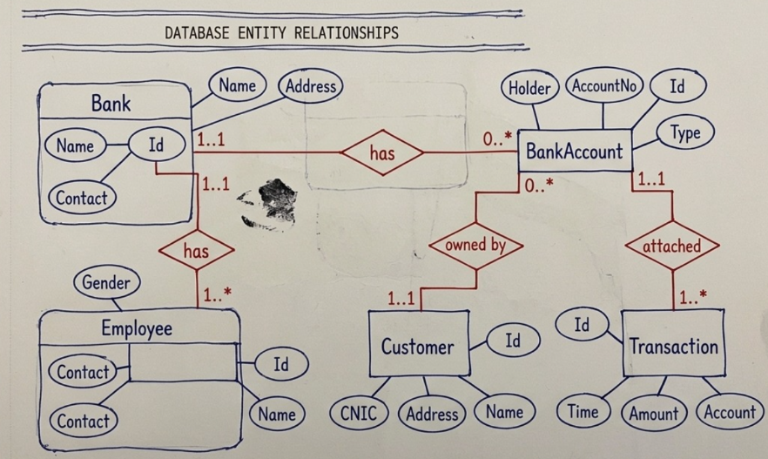
Figure 4.1: Entity-Relationship Diagram
Relationships:
- USERS to CONTACTS (1:M) - owner_id points to user_id
- USERS to MESSAGES (1:M) - sender_id / receiver_id point to user_id

CHAPTER 5: TESTING
Testing was performed across multiple scenarios to verify user login flows, real-time synchronization, and translation functionality.
TC ID | Test Scenario | Input Data | Expected Result | Actual Result | Status
TC_001 | Login with valid credentials | Valid Email & Password | Dashboard Opens | Dashboard Opens | PASS
TC_002 | Invalid Password error handling | Wrong Password input | Error Message displayed | Error Message displayed | PASS
TC_003 | Real-time Message Delivery | Message Text entered | Message instantly synchronized | Message instantly synchronized | PASS
TC_004 | Automatic Language Translation | English Message sent | Hindi translation displayed | Hindi translation displayed | PASS
TC_005 | User Logout sequence | Click Logout option | Login Screen opens | Login Screen opens | PASS

CHAPTER 6: CONCLUSION AND FUTURE WORK

6.1 Conclusion
The Smart Messenger application successfully demonstrates a functional approach to multilingual communication through real-time message translation. By integrating modern web structures (React.js + Vite), hybrid mobile compilation (Capacitor), and cloud backend services (Firebase Authentication and Cloud Firestore), the application offers a fast and robust environment that removes language boundaries. Dynamic speech-to-text dictation and text-to-speech feedback add usability, making the tool a comprehensive messaging utility.

6.2 Future Work
Future iterations of the application plan to incorporate the following features:
- 1. Voice Message Translation: Translating direct audio notes in addition to text translation.
- 2. Video Calling Support: Standard face-to-face video chat capability with live captions.
- 3. AI Chat Assistant Integration: Integrating local AI models to auto-respond or summarize long conversations.
- 4. End-to-End Encryption: Enhancing message privacy with standard encryption protocols on Firestore data.
- 5. Offline Translation Support: Implementing local dictionary models for translating without active internet connection.
- 6. Group Chat Translation: Allowing multiple users with different preferred languages to text in a single group.

REFERENCES
[1] React Documentation - https://react.dev/ - Component lifecycle and UI states.
[2] Firebase Documentation - https://firebase.google.com/docs - Firebase Auth, Firestore real-time queries.
[3] Capacitor Documentation - https://capacitorjs.com/docs - Hybrid mobile platform builds.
[4] Google Translate API Documentation - Machine translation request structures.
[5] Android Developer Documentation - https://developer.android.com/ - Build optimizations and APK compilation.

